[**DOING PHYSICS WITH MATLAB**](http://www.physics.usyd.edu.au/teach_res/mp/mphome.htm)

**MATHEMATICAL ROUTINES**

# THE UNNORMALIZED SINC FUNCTION

Ian Cooper

School of Physics, University of Sydney

ian.cooper@sydney.edu.au

[**DOWNLOAD DIRECTORY FOR MATLAB SCRIPTS**](http://www.physics.usyd.edu.au/teach_res/mp/mscripts)

**math_sinc_function.m**

mscript used to investigate the sinc function. The mscript is divided into a number of cells that should be run independently by hitting the **Ctrl** and **Enter** keys together.

**simpson1d.m**

Function to give the integral of a function using Simpson’s 1/3 rule.

**turningPoints.m**

Function to find the zero crossings of a function and its maxima and minima.

**THE UNNORMALIZED SINC FUNCTION**

The sinc function is widely used in optics and in signal processing, a field which includes sound recording and radio transmission.

In mathematics, physics and engineering, the **unnormalized** **cardinal sine function** or **sinc function**, denoted by **sinc(*x*)** is defined by



At *x* = 0 the sinc function has a value of 1.



Figure (1) shows a plot of the sinc function.

The sinc function is the **zeroth order spherical Bessel function of the first kind**



All the zero of the sinc function occur at non-zero integer multiples of *π*



Hence, the zeros of the sinc function are evenly spaced, the spacing being equal to *π* as shown in figure (2).

The local maxima and minima of the sinc function correspond to its intersections with the cosine function.

 maxima and minima

where the derivative of sin(*x*)/*x* is zero and thus a local extremum is reached as shown in figure (2).

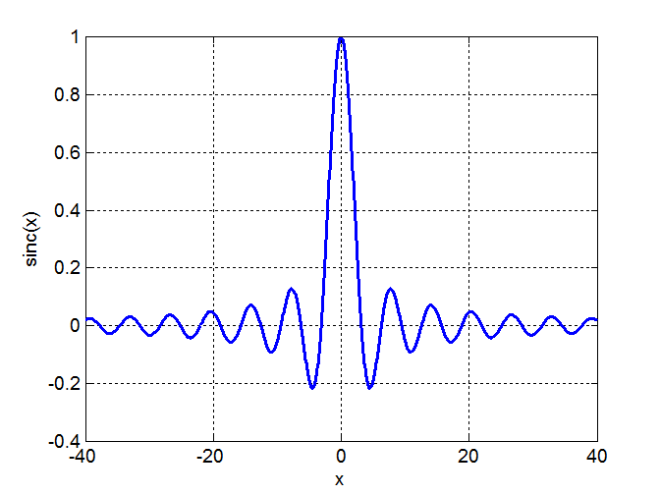

Fig. 1. The unnormalized sinc function  plotted against *x*.

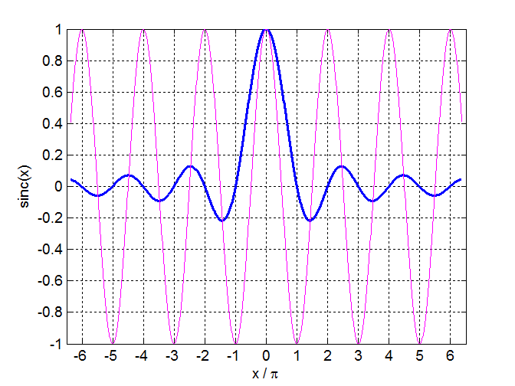

Fig. 2. The unnormalized sinc function  plotted against *x* /*π* . The zeros occur at  = ± 1, ± 2, ± 3, … . The magenta curve is the cosine function cos(*x*).

Table 1. *x* / *π* values for the max and min values of  and  as shown in figures (2) and (3).

|  |  |  |  |  |  |  |
| --- | --- | --- | --- | --- | --- | --- |
| ***x* / *π*** | 0 | ± 1.429 | ± 2.462 | ± 3.470 | ± 4.478 | ± 5.486 |
| ***ym*** | 1.000 | - 0.2172 | 0.1284 | - 0.0913 | 0. 0709 | - 0.0580 |
| ***ym*2** | 1.000 | 0.0472 | 0.0165 | 0.0083 | 0.0050 | 0.0034 |

The values for the zero crossings and minima and maxima were found using the function **turningPoints.m** .

[View document of Turning points of a function](http://www.physics.usyd.edu.au/teach_res/mp/doc/math_turning_points.pdf)

The square of the sinc function  gives the intensity distribution on a screen for the Fraunhoffer diffraction for a single slit.

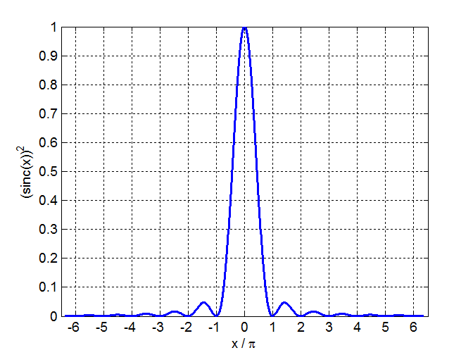

Fig. 3. The  plotted against *x* /*π* .

The **gradient** of the sinc function can be found using the Matlab gradient command

xMin = -20; % range for x values

xMax = 20;

N = 999;

x = linspace(xMin, xMax, N); % x values

y = sin(x+eps) ./(x+eps); % y values sinc(x)

yC = cos(x); % cosine function

dy_dx = gradient(y); % gradient of sinc function

The integral of the sinc function is



This integral can be computed using the function **simpson1d.m**. In executing the function **simpson1d.m** the limits of the integral and the number of partitions can be increased until the answer converges.

%% integral of sinc and (sinc)^2

clear all

close all

clc

xMin = -1500; % range for x values

xMax = 1500;

N = 99999; % number of partitons

x = linspace(xMin, xMax, N); % x values

y = sin(x+eps) ./(x+eps); % y values sinc(x)

integral = simpson1d(y,xMin,xMax)/pi

xMin = -1500 xMax = +1500 N = 9999 integral = 1.0000

xMin = -1000 xMax = +1000 N = 999 integral = 0.9996

xMin = -200 xMax = +200 N = 99 integral = 1.6703

xMin = -200 xMax = +200 N = 999 integral = 0.9985

[View document of Simpson’s 1/3 rule](http://www.physics.usyd.edu.au/teach_res/mp/doc/math_integration_1D.pdf)