[**DOING PHYSICS WITH MATLAB**](http://www.physics.usyd.edu.au/teach_res/mp/mphome.htm)

**MATHEMATICAL ROUTINES**

**TURNING POINTS OF A FUNCTION**

Ian Cooper

School of Physics, University of Sydney

ian.cooper@sydney.edu.au

[**DOWNLOAD DIRECTORY FOR MATLAB SCRIPTS**](http://www.physics.usyd.edu.au/teach_res/mp/mscripts)

**turningPoints.m**

Matlab function to determine the turning points of a function. The function outputs in a Figure Window a plot of the function showing the maxima and minima points and displays in the Command Window the indices for the maxima and minima, and the x and y values at these points.

You are often required to find the stationary points of a curve where the gradient of the curve is zero. The function **turningPoints.m** can be used to find the stationary points corresponding to points of maxima and minima of a curve.

The x and y data for the curve are passed to the function in the Command window.

For example, turningPoints(xP,WP) is entered into the Command Window to pass on the variables xP (x data) and WP (y data) to the function turningPoints.m.

function turningPoints(xData, yData)

**Sample results**

Figure Window output: the maxima are marked as red dots and the minima are marked by magenta squares.

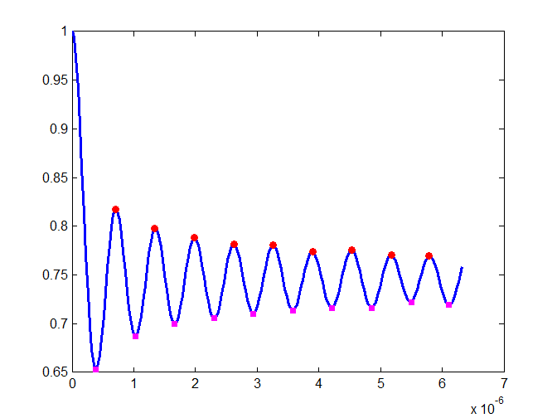

The indices and the x and y values are displayed in the Command Window.

Max values - indices / xData / yData

indexMax = 23 43 63 83 103 123 143 163 182

ans = 1.0e-05 *

0.0703 0.1342 0.1981 0.2621 0.3260 0.3899 0.4538 0.5177 0.5785

ans =

0.8174 0.7978 0.7886 0.7816 0.7804 0.7740 0.7760 0.7705 0.7693

Min values - indices / xData / yData

indexMin = 13 33 53 73 93 113 133 153 173 192

ans = 1.0e-05 *

0.0384 0.1023 0.1662 0.2301 0.2940 0.3579 0.4219 0.4858 0.5497

0.6104

ans =

0.6527 0.6873 0.6998 0.7055 0.7104 0.7138 0.7160 0.7164 0.7223

0.7190

**mscript**

function turningPoints(xData, yData)

size = length(xData); %Get the length of the dataset

a1 = yData(1,1); a2 = yData(1,2);

if a2 > a1, flag = 1; else flag = 2; end;

v = 0;

% find max

for x = 2:size-1

a1 = yData(1,x); %Get two adjacent samples of the dataset

a2 = yData(1,x+1);

if flag == 1 && a2 > a1; x = x+1; end;

if (flag == 1 && a2 < a1); v = v + 1; indexMax(v) = x; x = x+1; end;

if a2 <= a1, flag = 0; end;

if a2 > a1, flag = 1; end;

end

a1 = yData(1,1); a2 = yData(1,2);

if a2 < a1, flag = 1; else flag = 2; end;

v = 0;

% find min

for x = 2:size-1

a1 = yData(1,x); %Get two adjacent samples of the dataset

a2 = yData(1,x+1);

if flag == 1 && a2 < a1; x = x+1;

end;

if (flag == 1 && a2 > a1); v = v + 1; indexMin(v) = x; x = x+1; end;

if a2 >= a1, flag = 0; end;

if a2 < a1, flag = 1; end;

end

figure(99)

plot(xData,yData,'lineWidth',2)

hold on

hp1 = plot(xData(indexMax),yData(indexMax),'o');

set(hp1,'MarkerEdgeColor','r','MarkerFaceColor','r','MarkerSize',5);

hp1 = plot(xData(indexMin),yData(indexMin),'s');

set(hp1,'MarkerEdgeColor','m','MarkerFaceColor','m','MarkerSize',4);

disp(' ')

disp('Max values - indices / xData / yData')

indexMax

xData(indexMax)

yData(indexMax)

disp(' ')

disp(' ')

disp('Min values - indices / xData / yData')

indexMin

xData(indexMin)

yData(indexMin)