[**DOING PHYSICS WITH MATLAB**](http://www.physics.usyd.edu.au/teach_res/mp/mphome.htm)

**SOLIDS OF REVOLUTION**

# 

# 

Ian Cooper

School of Physics, University of Sydney

ian.cooper@sydney.edu.au

[**DOWNLOAD DIRECTORY FOR MATLAB SCRIPTS**](http://www.physics.usyd.edu.au/teach_res/mp/mscripts)

**math_vol_02.m**

**math_vol_03.m**

**math_vol_04.m**

**math_vol_05.m**

**math_vol_06.m**

mscripts used to produce plots for a function which defines a bounded region in the XY plane that when rotated through 360o about a rotation axis parallel to a coordinate axis generates a **solid of revolution**. A sequence of plots of the region rotated through increasing angles can be used to create an animated gif. [3D] plots can be produced using the Matlab functions **plot3**, **cylinder** and **surf**.

The mscripts are “crudely” written, but they do illustrate the way in which [3D] plots can be generated for the solids of revolution. For different functions and limits, you need to change the mscript in a number of parts. Also, you need to enter the code for the function twice.

**simpson1d.m**

The function **simpson1d.m** can be called to integrate a function to compute the volume of the solid of revolution.

**SOLIDS OF REVOLUTION**

Solid figures can be produced by rotating bounded regions in the XY plane through 360o. A solid generated by the rotation is called a [**solid of revolution**](http://www.physics.usyd.edu.au/teach_res/hsp/math/math05.htm).

We will only consider solids of revolution that are generated by rotations about axes that are parallel to the X-axis or the Y-axis (coordinates axes). Using the **plot3** Matlab function we can create an animated gif image of the rotation of a function about lines parallel to a coordinate axis. An example is shown in figure (1).



Fig. 1.

First image of the animation of a function about the X-axis to generate a solid of revolution.

**math_vol_02.m**

[View an animation of the rotation of a function about the X-axis](http://www.physics.usyd.edu.au/teach_res/hsp/math/ag_volume.gif)

**ROTATIONS ABOUT THE X-AXIS ( *yR =* 0 )**

Let be a single-valued continuous function where  in the interval . Consider the region ***R*** bounded by the function  and the X-axis (*yR =* 0) for the interval . When this region ***R*** is rotated about X-axis through the 360o rotation, a **solid of revolution** is generated. The volume *V* of the solid of revolution is given by

(1)  **rotation about X-axis**

The solid generated by the rotation must have a circular cross-section with radius *R*(*x*). Therefore, the cross-sectional area *A*(*x*) is given by



The volume *V* of the solid of revolution is

(2) 

**disk method – rotation about X-axis**

In the disk method, we sum up the volumes of an infinite number of infinitesimally thin circular disks to find the total volume of a solid. The solid has been decomposed into stacked circular disks, and by integrating the disk volumes we obtain the total volume.

**EXAMPLES**

To illustrate the graphical power of Matlab we can consider two and three dimensional plots of solids produced by the rotation of a function about lines parallel to a coordinate axis. As an example, we can find the volumes of the solids of revolution for the region bounded by the function , the X-axis and the vertical lines *xa* = 0 and *xb* = 4 for the following axes of rotation

(A) X-axis *yR* = 0

(B) Y-axis *xR* = 0

(C) *yR* = - 2

(D) *yR* = +2 limits *xa* = 2 and *xb* = 4

(E) *yR* = -2 limits *xa* = 2 and *xb* = 4

**(A) ROTATION ABOUT THE X-AXIS *yR* = 0**

The mscript **math_vol_05.m** was used to create the following figures.



Fig. 2. A plot showing the function , the region ***R*** to be rotated and the axis of rotation.



Fig. 3. A plot showing the function , the region ***R***, the region ***R*** rotated through 180o and the axis of rotation.



Fig. 4. A [3D] plot showing the outer surface of the solid of revolution. The Matlab functions **cylinder** and **surf** were used to generate the [3D] plot.

The code for producing figure (4) in the mscript **math_vol_05.m** is

figure(6) % [3D] plot -------------------------------------

set(gcf,'units','normalized','position',[0.35 0.4 0.22 0.22]);

[X,Y,Z] = cylinder(y-yR,100);

z = xA + Z.*(xB-xA);

surf(z,Y+yR,X);

axis equal

xlabel('X'); ylabel('Y'); zlabel('Z')

shading interp

box on

view(35,10);

axis off

set(gca,'Xlim',[0 4.2]);

set(gca,'Ylim',[-4.2 4.2]);

set(gca,'Zlim',[-4.2 4.2]);

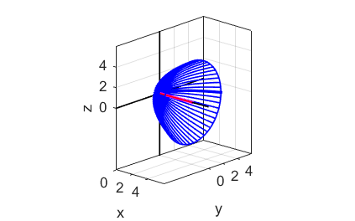

Fig. 5. A [3D] plot showing the outer surface of the solid of revolution. The Matlab function **plot3**  was used to generate the [3D] plot.

The volume can be found by analytical means using equation (2). The volume of the solid of revolution about the X-axis is

(1)  **Disk Method**

The limits of integration are *xa* = 0 and *xb* = 4

The function  in the interval [04] is



The volume of the cone is



An easy way to find the volume is to compute the integral numerically using [Simpson’s rule](http://www.physics.usyd.edu.au/teach_res/mp/doc/math_integration_1D.pdf).

% Volume calculation by disk method

fn = y.^2; a = xA; b = xB;

vol_pie = simpson1d(fn,a,b);

disp('volume/pie');

disp(vol_pie);

**(B) ROTATIONS ABOUT THE Y-AXIS ( *xR =* 0 )**

The mscript **math_vol_05.m** was used to create the following figures.

We can also visualize the solid of revolution about the Y-axis as shown in figures (6) and (7).



Fig. 6. A plot of the cross- section through the solid of revolution in the XY plane.

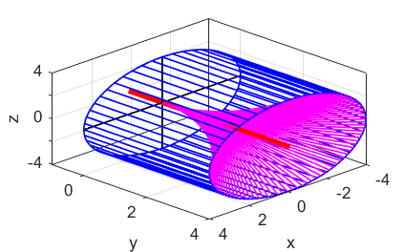

Fig. 7. A [3D] plot of the solid of revolution. The blue lines represent the outer surface of the solid and the magenta lines represent the inner surface.

**(C) ROTATIONS ABOUT THE LINE *yR* = -2**

The mscript **math_vol_06.m** was used to create the following figures.

When the region is rotated about the line *yR* = -2 which is parallel to the X-axis, a solid is generated with a hollow core as shown in the following figures.



Fig. 8. A plot showing the function , the region ***R*** to be rotated and the axis of rotation.



Fig. 9. A plot showing the function , the region ***R***, the region ***R*** rotated through 180o and the axis of rotation.



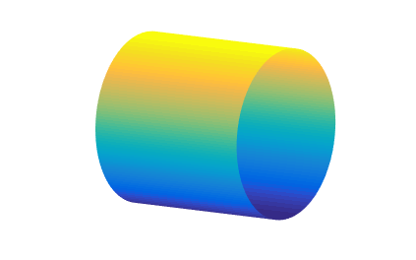

Fig. 10. A [3D] plot showing the outer surface and the inner surface of the solid of revolution.

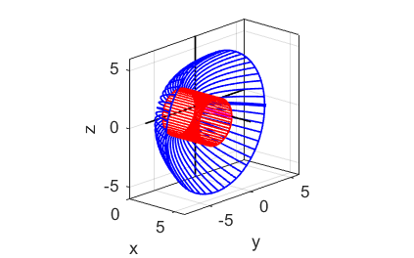

Fig. 11. A [3D] plot showing the outer surface (blue) and the inner surface (red) of the solid of revolution.

**(D) ROTATIONS ABOUT THE LINE *yR* = +2 *xa* = 2 and *xb* = 4**

The mscript **math_vol_04.m** was used to create the following figures.

When the region is rotated about the line *yR* = -2 which is parallel to the X-axis, a solid is generated with a hollow core as shown in the following figures.



Fig. 12. A plot showing the function , the region ***R*** to be rotated and the axis of rotation.



Fig. 13. A plot showing the function , the region ***R***, the region ***R*** rotated through 180o and the axis of rotation.

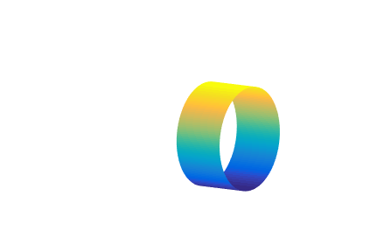



Fig. 14. A [3D] plot showing the outer surface and the inner surface of the solid of revolution.

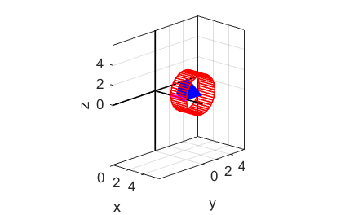

Fig. 15. A [3D] plot showing the outer surface (blue) and the inner surface (red) of the solid of revolution.

**(E) ROTATIONS ABOUT THE LINE *yR* = -2 *xa* = 2 and *xb* = 4**

The mscript **math_vol_03.m** was used to create the following figures.

When the region is rotated about the line *yR* = -2 which is parallel to the X-axis, a solid is generated with a hollow core as shown in the following figures.



Fig. 16. A plot showing the function , the region ***R*** to be rotated and the axis of rotation.



Fig. 17. A plot showing the function , the region ***R***, the region ***R*** rotated through 180o and the axis of rotation.



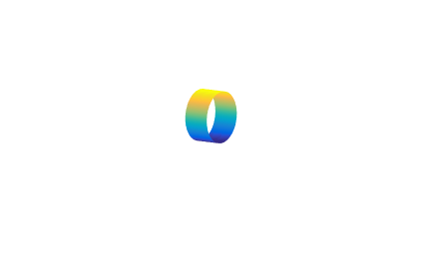

Fig. 18. A [3D] plot showing the outer surface and the inner surface of the solid of revolution.

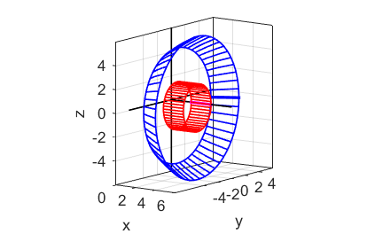

Fig. 19. A [3D] plot showing the outer surface (blue) and the inner surface (red) of the solid of revolution.