**[VISUAL PHYSICS ONLINE](http://www.physics.usyd.edu.au/teach_res/hsp/sp/spHome.htm)**

**MODELLING THE SPREAD OF THE COVID19 VIRUS**



Ian Cooper

Any comments, suggestions or corrections, please email me at

[matlabvisualphysics@gmail.com](mailto:matlabvisualphysics@gmail.com)

Revised / Updated 15 March 2020

Data for the infection spreading around the globe is from the excellent website

<https://www.worldometers.info/coronavirus/>

**What has physics to do with the spread of the covid19 virus (novel coronavirus)?**

One can apply scientific principles to create a model for the spread of the disease. Then, we can use the model to gain better understanding of how the virus spreads around the globe. We can also make predictions of the number of infections and deaths that may occur in the future and the model can provide us an insight to how we might lessen the impact of the virus.

If our political leaders had a better understanding of the scientific principles which determine the spread of the disease, their decision may have been very different. Unfortunately, political decisions have been made which are not based upon the science. Government officials in Wuhan ignored the scientific evidence. They did not want to upset their political leaders higher up the ladder. Our leaders of state governments and our federal government have not been any better. They have made political decisions to “please the public” and not made decisions based upon the scientific principles governing the spread of the disease. In China, less than 500 hundred individuals who were initially infected from an unknown source will led to at least 90 000 individuals being infected and in the order of 4000 deaths.

**MODELLING THE SPREAD OF THE VCOVID19 VIRUS**

How does a physicist approach a problem?

The real world is very complicated. For example, how the virus spreads depends upon many factors. So, to gain an understanding of the phenomenon, it is necessary to make a set of simplification and approximations.

We will consider different subsets (groups) of the population which change with time:

* **Susceptible individuals** who are not infected but could become infected. The number of susceptible individuals is represented by the variable  which is a function of time t.
* **Infected individuals** that have the virus and can transmit it to those individuals who are susceptible. The number of active cases (those that are currently infected) is represented by the variable .
* **Recovered individuals** that have recovered from the virus and are assumed to be immune from being infected again. The number of individuals who have recovered is represented by the variable .
* **Dead individuals** that have died from the infection. The number of individuals who have died as a result of the infection is represented by the variable .

It is assumed that the time scale is short enough that births and deaths (other than deaths from the virus) can be neglected and the number of deaths from the virus is small compared with the living population.

In some time interval , the numbers in each in each group will change

* A susceptible individual may become infected or remain susceptible



* An infected individual may recover, die or remain infected



In our model, we assume that in the time interval  the changes in the group populations are described by the equation

     (1)         Description: Description: Description: Description: Description: Description: Description: Description: Description: http://www.physics.usyd.edu.au/teach_res/mp/doc/sird19B_files/image025.png

     (2)         Description: Description: Description: Description: Description: Description: Description: Description: Description: http://www.physics.usyd.edu.au/teach_res/mp/doc/sird19B_files/image027.png

     (3)         Description: Description: Description: Description: Description: Description: Description: Description: Description: http://www.physics.usyd.edu.au/teach_res/mp/doc/sird19B_files/image029.png

     (4)         Description: Description: Description: Description: Description: Description: Description: Description: Description: http://www.physics.usyd.edu.au/teach_res/mp/doc/sird19B_files/image031.png

     (5)          Description: Description: Description: Description: Description: Description: Description: Description: Description: http://www.physics.usyd.edu.au/teach_res/mp/doc/sird19B_files/image033.png

The changes in the populations of each group are determined by the positive constants *a*, *b* and *d*.

From equations 1 and 2, the change in the number of infected individuals is proportional to the number of infected individuals. Therefore the rate of change of the number of infected individuals is

(6) 

Equation 6 tells us that as the number of infected individuals increase, then the rate of increase of infections also increases.

The solution to equation 6 gives an exponential increase in the number of infections. Figure 1 shows the model predictions (solid blue line) and the data for China (blue crosses). The initial number of infections in the model was 362. In only 25 days the number of infections reached the staggering number of nearly 60 000.

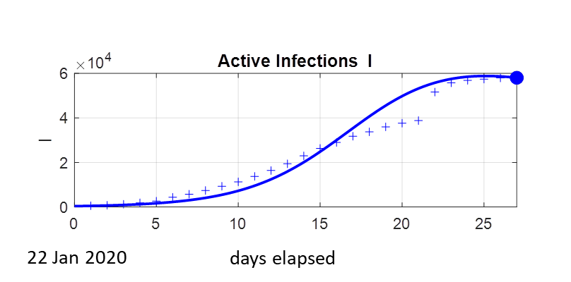

Fig. 1. The number of current infected individuals who contacted the virus in China from 22 January to 27 February. The data for China may not be very reliable, but you use see that our model prediction is in excellent agreement with the actual recorded infections.

Statements made by politicians and their so called expert advisors have made statements such as “ … our number of infections is low now. Therefore, we do not need drastic measures now”. Look at figure 1, the only conclusions to be drawn using scientific principles is that drastic action needs to be taken as early as possible. If you start with only a small number of infections, the number of infections will at first grow slowly and then grow exponentially.

In figure 1, the number of infections reaches a peak after 25 days. The reason that the number of infections starts to decline is because the number of susceptible individuals decreases. If the number of susceptible individuals does not decrease then the number of infections just gets bigger and bigger.

Figure 2 shows the prediction for number of susceptible individuals over 200 days for China. In China, drastic measures were taken to prevent the movement of infected individuals from spreading the disease and to restrict the movement of healthy individuals so that they did not become part of the susceptible population.



Fig. 2. The time evolution of the susceptible population from the 22 January. The maximum susceptible population is scaled to one.

There is no vaccine or “magic pill” for the virus. The only way to reduce the number of infections is to reduce the number of individuals that are susceptible. Our political leaders have only now passed a law, all people arriving in Australia from overseas must be placed into quarantine for 14 days (15 March). This should have been done much early. Since mid-February, most of the people who are infected came to Australia from overseas and were already infected. We know from equation 6, that the more infected people, the greater the rate of increase in infections. More importantly than this is the fact that as these individuals move about, they dramatically increase the susceptible population and this increases the rate of increase in the number of infections as given by equation 7

(7) 

Our Prime Minister made many irresponsible statements (Thursday 12 March), “ .. I am going to the football”. In large gatherings, what you are doing is increasing the number of susceptible people. We now know from equation 7, this is just about the worst possible thing you can do. Only now (15 March) is the federal government starting to introduce drastic measures to limit contact between people. One leading Professor of Medicine who is advising our governments stated that there is no need for drastic actions to be taken yet, as the numbers of infected individuals is low. This is completely incorrect, to control the spread of the virus successfully, you need drastic action when the numbers are low, otherwise it is too late since the rate of infection is proportional to both the numbers infected *I* and susceptible *S* (equation 8).

(8) 

This Professor of Medicine had little understanding of basic mathematics and physical principles.

Figure 3 shows the results of running our model for China. The number of infections peaked about 18 February and the number of infections is now slowly decreasing. The decrease only occurs when the susceptible population numbers decrease and this decrease in susceptible numbers only occurred through the drastic actions taken by the Chinese government is limiting the movement of people.





Fig. 3. CHINA: The model predictions from 22 January to 9 August.

The problem now is that new epicentres of the virus are appearing worldwide. As the virus spreads from its source, many more individuals will become infected, so the susceptible population will increase for a period of time. This increase is the susceptible population is governed by the surge factor *s* as given by equation 9. We can define a surge period when the susceptible population *S* increases continually over this time interval due to the spread of the virus

(9) 

During this surge period, instead of the number of susceptible individuals decreasing, it increases. This results in significant increases in the infected population. But, this increase in infected numbers produces a further increase in the susceptible numbers. This gives rise to a positive feedback loop leading to a very rapid rise in the number of active infected cases. Figure 4, shows the time evolution of the susceptible population for a surge period from 20 February to 30 March with *s* = 0.32. Notice that a secondary peak is produced about 54 days after 20 February.



Fig. 4. The time evolution of the susceptible population during a surge period from 20 February until the 30 March when the surge factor appearing in equation 9 is equal to 0.32.

Since the start of the surge period, the number of infected individuals has risen sharply around the globe because the susceptible population had a period when it increased.

Do the numbers predicted by the model agree with the actual published numbers and can we make reasonable prediction about the future?

In the model parameters *a*, *b*, *d* and *s* are adjusted to best fit the model predictions with the data. The model results are scaled such that after 27 days, the prediction for the number of active cases matches the recorded number of active cases. Figure 5 shows the plots for the number of active cases, recoveries, deaths and the cumulative number of infections from 22 January until 9 August. The model predictions are that by the beginning of August about 250 000 people will have been infected by the virus and nearly 20 000 people will have died. The peak in the active cases will occur around 24 March with about 120 000 people infected.





Fig. 5. The time evolution of the virus from 22 January until 9 August. The model predictions are shown as solids lines and the crosses the published data. There is excellent agreement between the model predictions and the published numbers. As new data becomes available, the model parameters *a*, *b*, *d* and *s* are adjusted to give the best fit.

**How good are the prediction?**

Only time will tell. But his is what science is about. Scientists propose a model and test it. A model is rejected when its findings do not match experimental results. If model seems OK, more evidence can be gathered to support the model. The model can be improved and complexities added to get a better agreement between the model predictions and the experimental results.

Even if our model predictions are “way-out”, the conclusions drawn from the mathematics are irrevocable. To prevent a truly world-wide catastrophe, then the number of susceptible individuals must be contained since

(8) 

For example, if governments around the world do not act using science as the basis for their decisions, the surge period could be longer and if new if new epicentres develop in South American and Africa, then the surge factor will increase. This will lead to many more infections and deaths throughout the world. Figure 6 shows the results for a longer surge period with a larger surge factor (*s* = 0.62 and surge period from 20 February to 30 May). The predictions are for about 60 000 deaths and nearly 1 000 000 infections.







Fig. 6. If governments do not act from what the science is telling them, millions could be infected and maybe hundreds of thousands of deaths.

**There is some possibility that the number of infections and deaths may be much greater than what has been predicted from my models. It is truly a worrying and dangerous situation. So we need to take every possible action to reduce the possibility of an individual becoming infected and moving about.**