[**DOING PHYSICS WITH MATLAB**](https://d-arora.github.io/Doing-Physics-With-Matlab/)



**COMPUTATIONAL OPTICS**

# 

# RAYLEIGH-SOMMERFELD DIFFRACTION INTEGRAL OF THE FIRST KIND

# ANNULAR APERTURES

# 

Ian Cooper

Please email any corrections, comments, suggestions or additions: matlabvisualphysics@gmail.com

[Matlab Download Directory](https://drive.google.com/drive/u/3/folders/1j09aAhfrVYpiMavajrgSvUMc89ksF9Jb)

**op_rs_annular.m**

Calculation of the irradiance in a plane perpendicular to the optical axis for uniformly illuminated circular - annular apertures. It uses Method 3 – one-dimensional form of Simpson’s rule for the integration of the diffraction integral. Function calls to:

**simpson1d.m** (integration)

**fn_distancePQ.m** (calculates the distance between points P and Q)

**turningPoints.m** (max, min and zero values of a function)

**RAYLEIGH-SOMMERFELD DIFFRACTION INTEGRAL OF THE FIRST KIND**

**UNIFORMLY ILLUMINATED ANNULAR APERTURES**

The Rayleigh-Sommerfeld diffraction integral of the first kind states that the electric field at an observation point P can be expressed as

(1) 

It is assumed that the Rayleigh-Sommerfeld diffraction integral of the first kind is valid throughout the space in front of the aperture, right down to the aperture itself. There are no limitations on the maximum size of either the aperture or observation region, relative to the observation distance, because **no approximations have been made**.

The **irradiance** or more generally the term **intensity** has S.I. units of W.m-2. Another way of thinking about the irradiance is to use the term **energy density** as an alternative. The use of the letter *I* can be misleading, therefore, we will often use the symbol *u* to represent the irradiance or energy density.

The irradiance or energy density *u* of a monochromatic light wave in matter is given in terms of its electric field *E* by

(2) 

where *n* is the refractive index of the medium, *c* is the speed of light in vacuum and *ε*0 is the permittivity of free space. This formula assumes that the magnetic susceptibility is negligible, i.e.  where  is the magnetic permeability of the light transmitting media. This assumption is typically valid in transparent media in the optical frequency range.

The integration can be done accurately using any of the numerical procedures based upon Simpson’s rule to compute the energy density in the whole space in front of the aperture.

The geometry for the diffraction pattern from circular type apertures is shown in figure (1).



Fig. 1. Circular aperture geometry.

The radial optical coordinate *vP* is a scaled perpendicular distance from the optical axis.

(3) 

Numerical integration of the Rayleigh-Sommerfeld diffraction integral of the first kind given by equation (1) for annular apertures can be done using a one-dimensional form of Simpson’s rule (Method 3). The aperture space is partitioned into a series of rings and values of the electric field *E­Q* are set either to zero or *EQmax* for each ring as shown in figure (2)

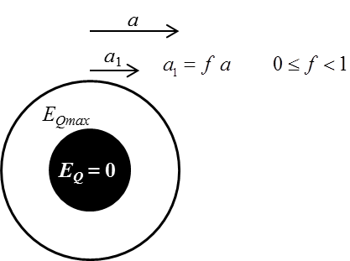

Fig. 2. An annular aperture. The radius of the aperture is *a* and the radius of the opaque disk is *a*1 where .

Consider the diffraction from an aperture with the following default parameters:

Wavelength λ = 6.328×10-7 m

Aperture space grid points *nQ* = 360800

Observation space grid points *nP* = 509

Aperture Space

radius of aperture a = 1.000×10-4 m

Energy density *uQmax* = 1.000×10-3 W.m-2

Energy from aperture *UQ*(theory) = 2.356×10-11 J.s-1

Observation Space

Max radius *rP* = 2.000×10‑2 m

Distance aperture to observation plane *zP* = 1.000 m

Rayleigh distance *dRL* = 6.321×10-2 m

Energy: aperture to screen *UP* = 2.214×10-11 J.s-1

Tables 1 and 2 give a summary of the optical coordinates *vP* for the dark rings, the percentage of the energy that is radiated from the aperture that is enclosed by the first dark ring on the observation screen, and the relative strengths of the peaks in the diffraction pattern. The figures show the diffraction pattern for the annular apertures modelled in Tables 1 and 2.

Table 1. Optical coordinate *vP* for the dark rings and percentage of the energy enclosed within the first dark ring

|  |  |  |  |  |  |  |
| --- | --- | --- | --- | --- | --- | --- |
| ***f*** | **0** | **0.20** | **0.40** | **0.60** | **0.80** | **0.98** |
| **1st** | 3.83 | 3.68 | 3.32 | 2.97 | 2.66 | 2.42 |
| **2nd** | 7.00 | 7.34 | 7.50 | 6.80 | 6.10 | 5.59 |
| **3rd** | 13.33 | 9.69 | 10.36 | 10.63 | 9.58 | 8.72 |
| **4th** | 16.46 | 13.72 | 12.67 | 14.19 | 13.06 | 11.92 |
| **% energy** | 84 | 77 | 59 | 37 | 17 | 1.6 |

Table 2. Optical coordinate *vP* for the peaks and their relative strengths

|  |  |  |  |  |  |  |
| --- | --- | --- | --- | --- | --- | --- |
| ***f*** | **0** | **0.20** | **0.40** | **0.60** | **0.80** | **0.98** |
| **1st** | 5.12  0.0175 | 5.12  0.0303 | 4.97  0.0706 | 4.65  0.1202 | 4.22  0.1527 | 3.87  0.1621 |
| **2nd** | 8.40  0.0042 | 8.44  0.0015 | 8.68  0.0033 | 8.44  0.0305 | 7.740  0.0734 | 7.08  0.0899 |
| **3rd** | 11.61  0.0016 | 11.53  0.00376 | 11.49  0.0007 | 12.08  0.0044 | 11.22  0.0401 | 10.28  0.0621 |
| **4th** | 14.78  0.0008 | 14.89  0.0004 | 14.62  0.0028 | 15.05  0.0001 | 14.70  0.0109 | 13.45  0.0474 |

***f* = 0 full circular aperture**

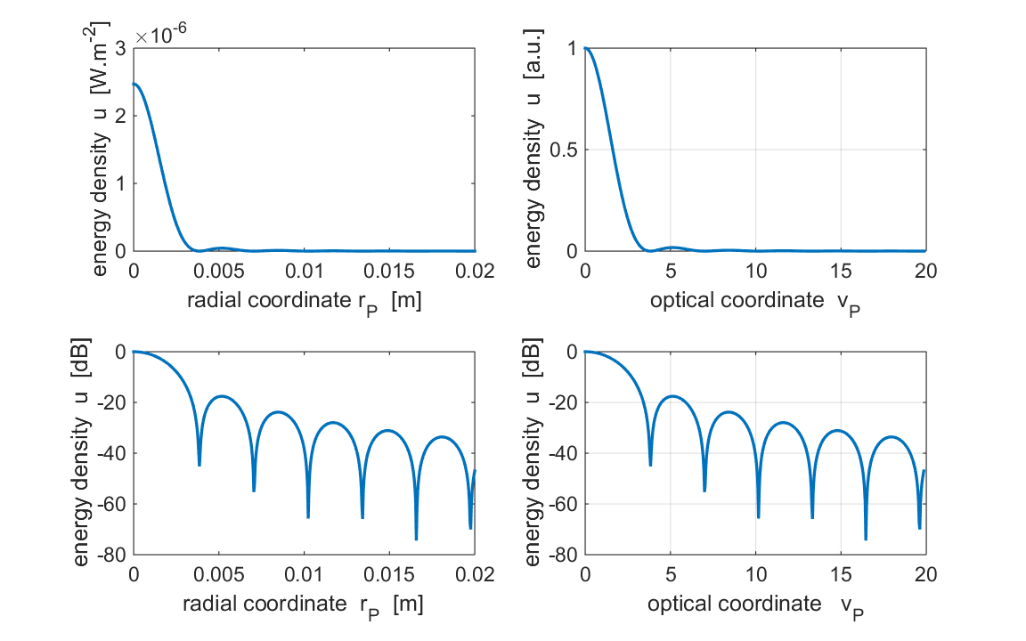

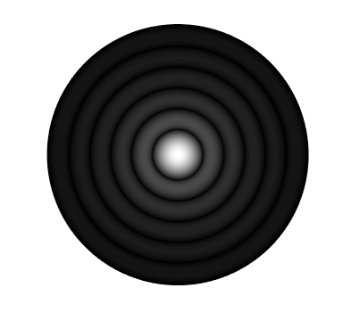

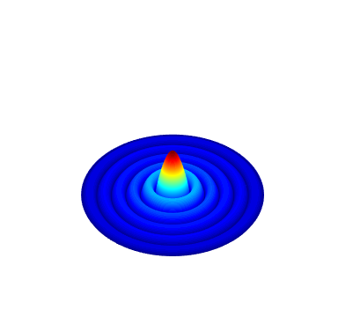

***f* = 0.20**

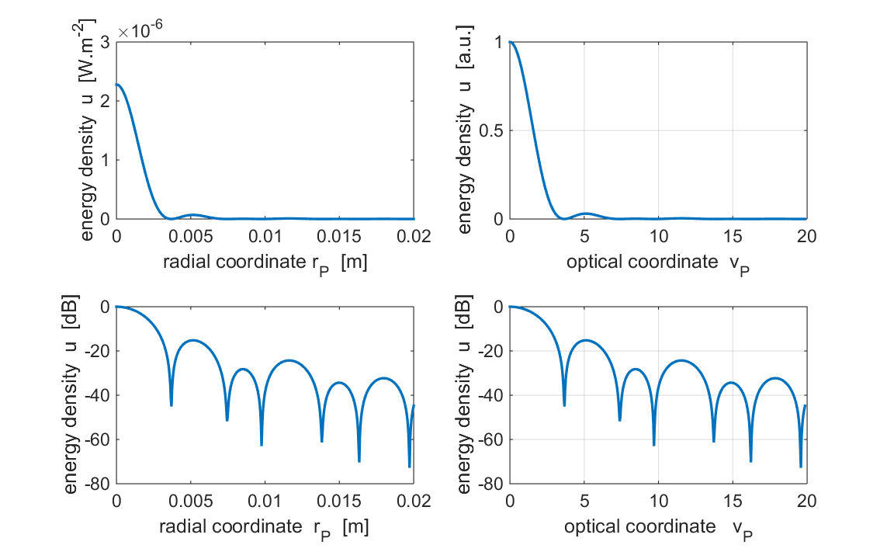

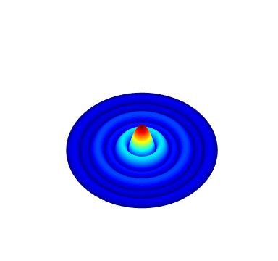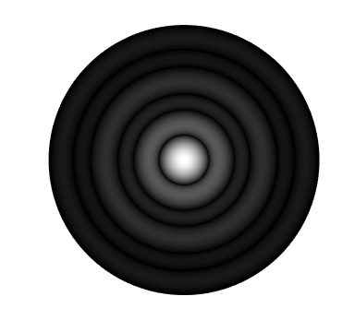

***f* = 0.40**

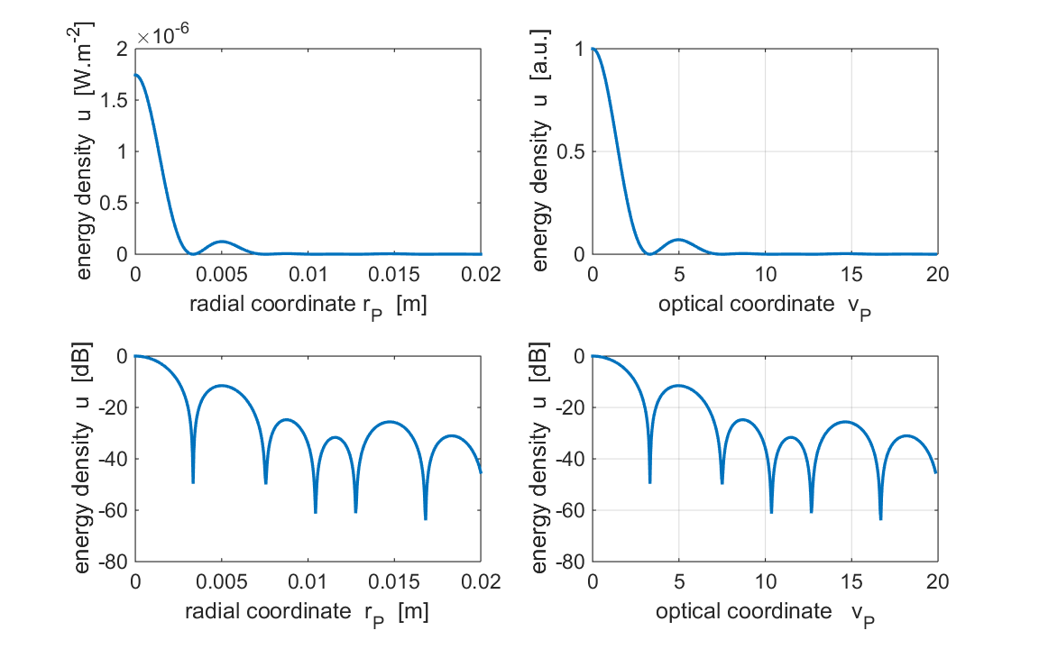

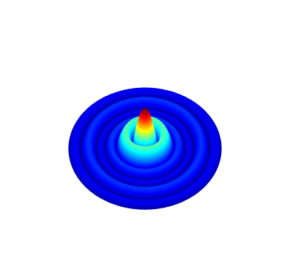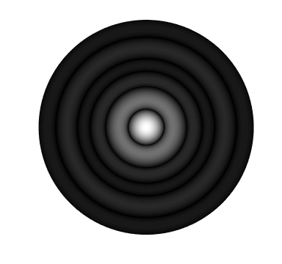

***f* = 0.60**

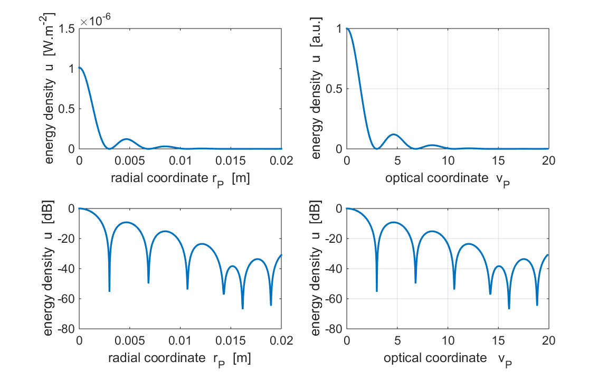

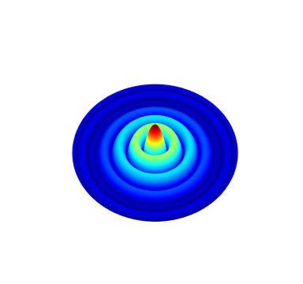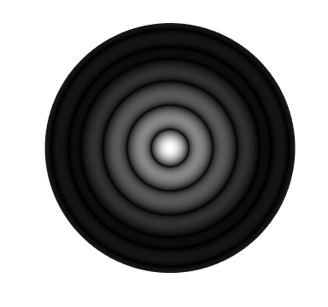

***f* = 0.80**

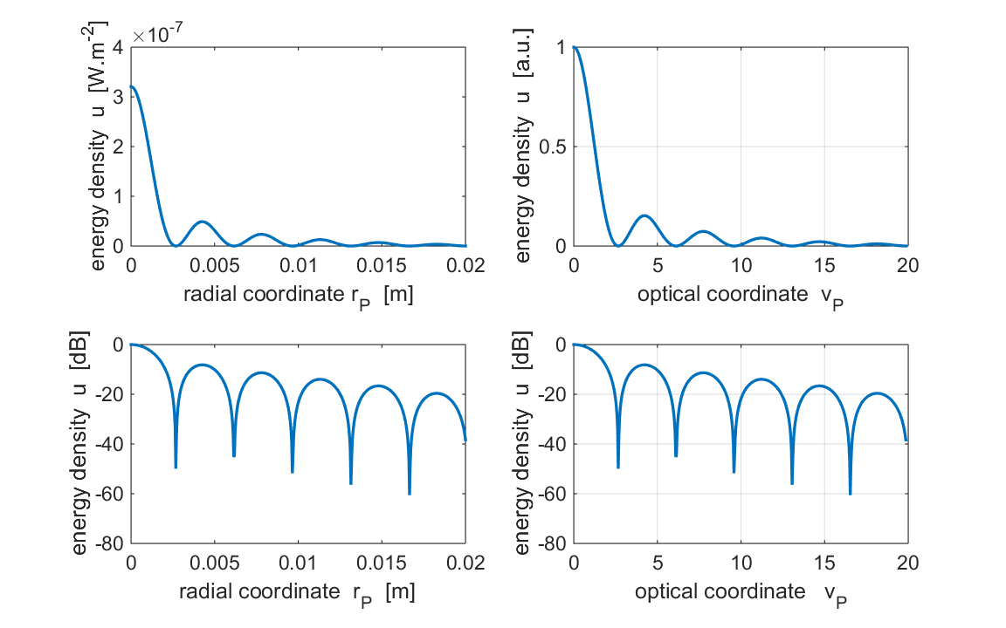

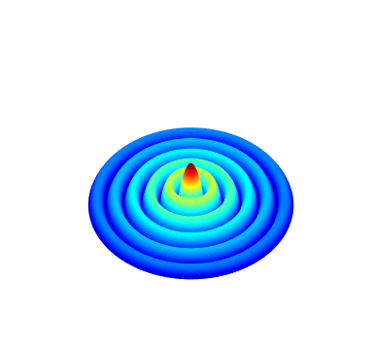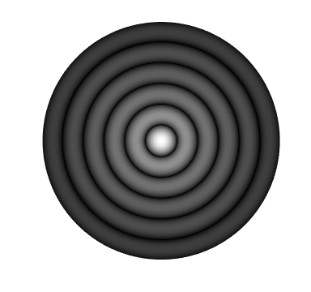

***f* = 0.98**

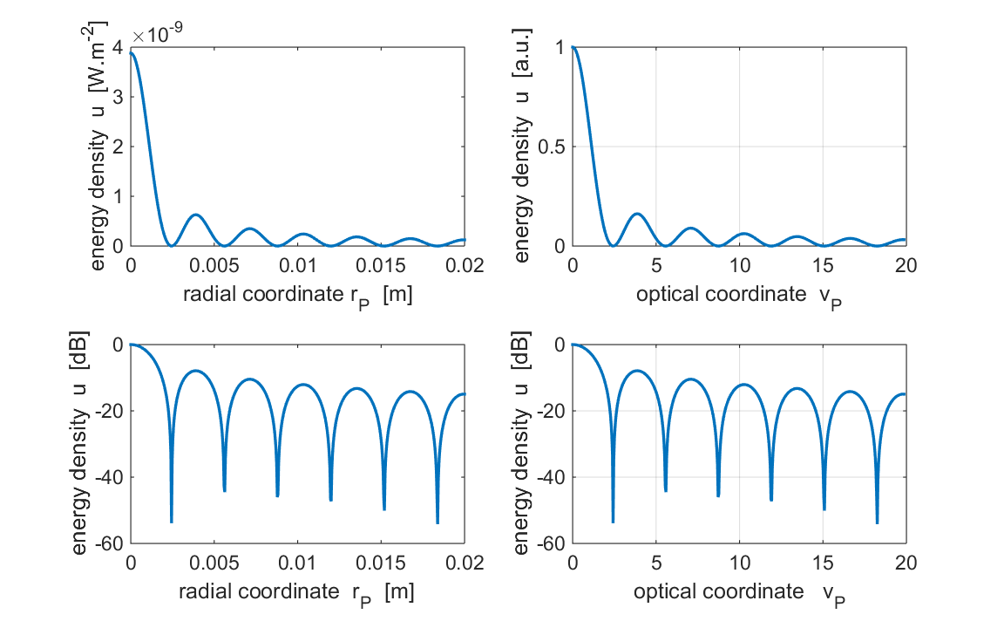

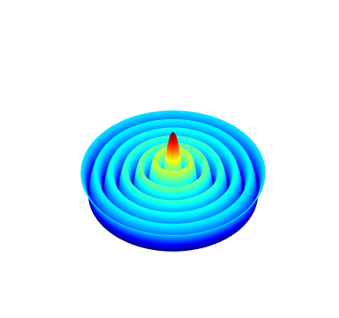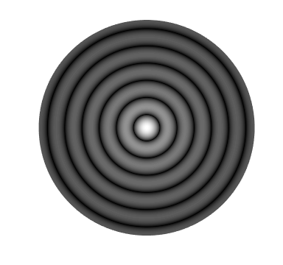

As the radius of the opaque disk increases from 0 to 1:

* The size of the Airy Disk decreases.
* Reduction in the percentage of the energy within the Airy Disk decreases.
* The relative strengths of the peaks do not necessarily decrease.
* Uneven spacing between minima and maxima.

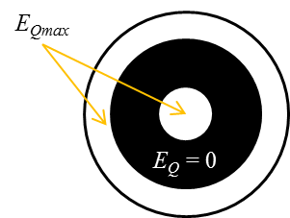**Double annular aperture**

