[**DOING PHYSICS WITH MATLAB**](https://d-arora.github.io/Doing-Physics-With-Matlab/)



**COMPUTATIONAL OPTICS**

# BESSEL FUNCTION OF THE FIRST KIND

# Fraunhofer diffraction – circular aperture

# 

Ian Cooper

Please email any corrections, comments, suggestions or additions: matlabvisualphysics@gmail.com

[Matlab Download Directory](https://drive.google.com/drive/u/3/folders/1j09aAhfrVYpiMavajrgSvUMc89ksF9Jb)

**op_bessel1.m**

* Bessel function of the first kind – calls Matlab function besselj

J1 = besselj(1,v);

* Fraunhofer diffraction pattern for a uniformly illuminated circular aperture – linear and log scale plots

IRR = (J1 ./ v).^2;

Calls the function **turningPoint.m** to find the zeros, minima and maxima of a function

[indexMin indexMax] = turningPoints(xData, yData);

**BESSEL FUNCTION OF THE FIRST KIND *J*1**

The Bessel function of the first kind *J*1 oscillates somewhat like the sine function as shown in figure 1. One difference is that the oscillations attenuate as its argument increases.

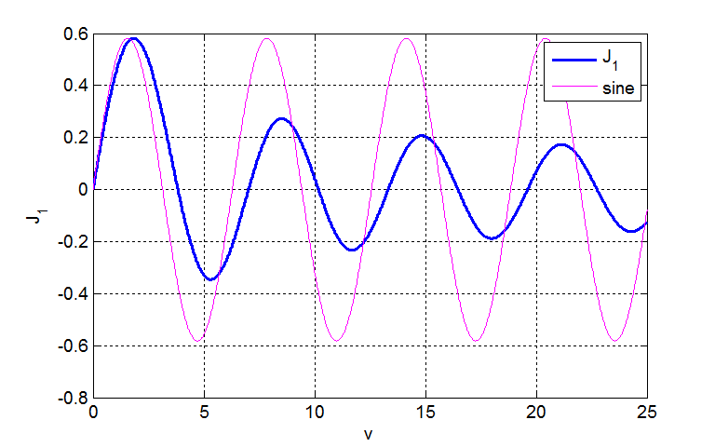

Fig.1. The Bessel function and the sine function sin(*v*).

The mscript **turningPoint. m** is called to estimate the argument *v* for the minimum, maximum and the zero crossings of the Bessel function. The values are displayed in the Command Window:

J1 BESSEL FUNCTION OF THE FIRST KIND

MINs: Radial coordinate / J1 value

5.332 -0.346

11.706 -0.233

18.015 -0.188

24.311 -0.162

30.602 -0.144

36.890 -0.131

43.177 -0.121

49.462 -0.113

MAXs: Radial coordinate / J1 value

1.841 0.582

8.536 0.273

14.864 0.207

21.164 0.173

27.457 0.152

33.746 0.137

40.033 0.126

46.319 0.117

ZEROs: Radial coordinate J1 = 0

3.832

7.016

10.174

13.324

16.471

19.616

22.760

25.904

29.047

32.190

35.332

38.475

41.617

44.759

47.901

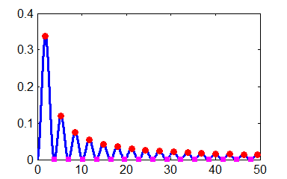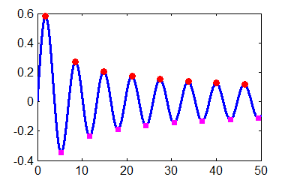

Fig. 2. The max, min and zero crossing for *J*1. The plot on the left is for *J*1 and the plot on the right is for *J*12. **turningPoints.m**

**FRAUNHOFER DIFFRACTION:**

**UNIFORMLY ILLUMINATED CIRCULAR APERTURE**

Diffraction in its simplest description is any deviation from geometrical optics (light travels in straight lines) that result from an obstruction of a wavefront of light. A hole in an opaque screen represents an obstruction. On an observation screen placed after the hole, the pattern of light may show a set of bright and dark fringes around a central bright spot.

**Fraunhofer diffraction** occurs when both the incident and diffracted waves are effectively plane. This occurs when the distance from the source to the aperture is large so that the aperture is assumed to be uniformly illuminated and the distance from the aperture plane to the observation plane is also large. This means that the curvatures of the incident wave and diffracted waves can be neglected.

The **Fraunhofer diffraction pattern for a uniformly illuminated circular aperture** is described by the **Bessel function of the first kind *J*1**. The geometry for the diffraction pattern from a circular aperture is shown in figure (3).



Fig. 3. Circular aperture geometry.

**Irradiance *I*** is the power of electromagnetic radiation per unit area (radiative flux) incident on a surface and its S.I. unit is watts per square meter [W.m-2]. A more general term for irradiance that you can use is the term **intensity**.

The irradiance *I*0 of a monochromatic light plane-wave in matter is given in terms of its electric field *E* by

(1) 

where *E* is the complex amplitude of the wave's electric field and *I*0 is a normalizing constant.

The irradiance *I* in a plane parallel to the plane of the aperture is given by

(2)  **Fraunhofer diffraction**

where *vP* is a radial optical coordinate

(3) 

The radial coordinate *vP* is a scaled perpendicular distance from the optical axis.

Figure (4) shows the irradiance as a function of the radial coordinate *vP*. In the upper plot the irradiance is normalized to 1. The lower figure shows the irradiance as a decibel scale . The diffraction pattern is characterized by a strong central maximum and very weak peaks of decreasing magnitude.

The function **turningPoint.m** is called within the mscript to find the radial coordinates for the zeros and maxima in the intensity distribution., the results are displayed in the Command Window:

IRR Fraunhofer Diffraction MAX ZEROS

MAXs: Radial coordinate / IRR value

5.136 0.01750

8.417 0.00416

11.620 0.00160

14.796 0.00078

17.960 0.00044

21.117 0.00027

24.270 0.00018

27.421 0.00012

30.569 0.00009

33.717 0.00007

36.863 0.00005

40.008 0.00004

43.153 0.00003

46.298 0.00003

49.442 0.00002

ZEROs: Radial coordinate IRR = 0

3.832

7.016

10.174

13.324

16.471

19.616

22.760

25.904

29.047

32.190

35.332

38.475

41.617

44.759

47.901

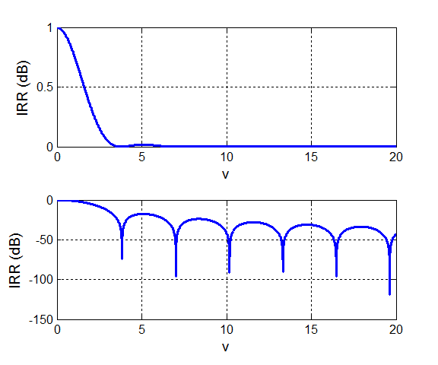

Fig. 4. Fraunhofer irradiance pattern for a circular aperture. The lower plot has a log scale for the irradiance .

The Fraunhofer diffraction pattern for the circular aperture is circularly symmetric and consists of a bright central circle surrounded by series of bright rings of rapidly decreasing strength between a series of dark rings. The bright and dark rings are not evenly spaced. The bright central region is known as the **Airy disk**. It extends to the first dark ring at *vP* = 3.831 (the first zero of the Bessel function).

The spread of the Airy disk is determined by the radial coordinate *v* = 3.831. The radial coordinate for the first dark ring is

First dark ring 

1. The larger the wavelength *λ* the greater the width of the diffraction pattern on a detection screen 
2. The larger the radius *a* of the circular aperture, the narrower the diffraction pattern on a detection screen 