[**DOING PHYSICS WITH MATLAB**](https://d-arora.github.io/Doing-Physics-With-Matlab/)

**COMPUTATIONAL OPTICS**

# CIRCULAR APERTURES

# 

Ian Cooper

Please email any corrections, comments, suggestions or additions: matlabvisualphysics@gmail.com

[Matlab Download Directory](https://drive.google.com/drive/u/3/folders/1j09aAhfrVYpiMavajrgSvUMc89ksF9Jb)

* Bessel function of the first kind
* Fraunhofer diffraction
* Rayleigh-Sommerfeld diffraction integral of the first kind

**op_bessel1.m**

mscript for plots of:

* Bessel function of the first kind – calls Matlab function besselj

J1 = besselj(1,v);

* Fraunhofer diffraction pattern for a uniformly illuminated circular aperture – linear and log scale plots

Calls the function **turningPoint.m** to find the zeros, minima and maxima of a function

[indexMin indexMax] = turningPoints(xData, yData);

Change the variables xData and yData within the script to find the zeros, min, max of different functions

**op_rs_circle_rings.m**

Calculation of the irradiance in a plane perpendicular to the optical axis for a uniformly illuminated circular aperture. The mscript can be used for annular apertures and for observation planes close to the aperture plane. The irradiance distribution needs to be radially symmetric about the optical axis.

Calls: **simpson1d.m fn_distancePQ.m turningPoints.m**

**op_rs1_circular_01.m**

Calculation of the irradiance in a plane perpendicular to the optical axis for a uniformly illuminated circular aperture using the Fraunhofer diffraction formula for a circular aperture and by evaluating the Rayleigh-Sommerfeld diffraction integral of the first kind.

**DIFFRACTION**

**UNIFORMLY ILLUMINATED CIRCULAR APERTURE**

If a small hole in an opaque screen is placed between a light source and an observation screen then the shadow of the hole does not have a sharp outline as predicted by geometrical optics. On close examination of the shadow on the observation screen, a set of bright and dark fringes around a central bright spot is observed. This departure from geometrical optics is called **diffraction**.

**Fraunhofer diffraction** occurs when both the incident and diffracted waves are effectively plane. This occurs when the distance from the source to the aperture is large so that the aperture is assumed to be uniformly illuminated and the distance from the aperture plane to the observation plane is also large. This means that the curvatures of the incident wave and diffracted waves can be neglected.

The **Fraunhofer diffraction pattern for a uniformly illuminated circular aperture** is described by the Bessel function of the first kind *J*1. The geometry for the diffraction pattern from a circular aperture is shown in figure (3).



Fig. 3. Circular aperture geometry.

**Irradiance *I*** is the power of electromagnetic radiation per unit area (radiative flux) incident on a surface and its S.I. unit is watts per square meter [W.m-2]. A more general term for irradiance that you can use is the term **intensity**.

The irradiance of a monochromatic light plane-wave in matter is given in terms of its electric field by

(1) 

where *E* is the complex amplitude of the wave's electric field, *n* is the refractive index of the medium, *c* is the speed of light in vacuum and *ε*0 is the vacuum permittivity. This formula assumes that the magnetic susceptibility is negligible, i.e.  where is the magnetic permeability of the light transmitting media. This assumption is typically valid in transparent media in the optical frequency range. Irradiance is also the time average of the component of the Poynting vector perpendicular to the surface.

(2)  

The irradiance *I* in a plane parallel to the plane of the aperture is given by

(3)  **Fraunhofer diffraction**

where *I*o is a normalizing constant and *vP* is a radial optical coordinate

(4) 

The radial coordinate *vP* is a scaled perpendicular distance from the optical axis.

Figure (4) shows the irradiance as a function of the radial coordinate *vP*. In the upper plot the irradiance is normalized to 1. The lower figure shows the irradiance as a decibel scale . The diffraction pattern is characterized by a strong central maximum and very weak peaks of decreasing magnitude.

**BESSEL FUNCTION OF THE FIRST KIND *J*1**

The Bessel function of the first kind *J*1 oscillates somewhat like the sine function as shown in figure 1. One difference is that the oscillations attenuate as its argument increases.

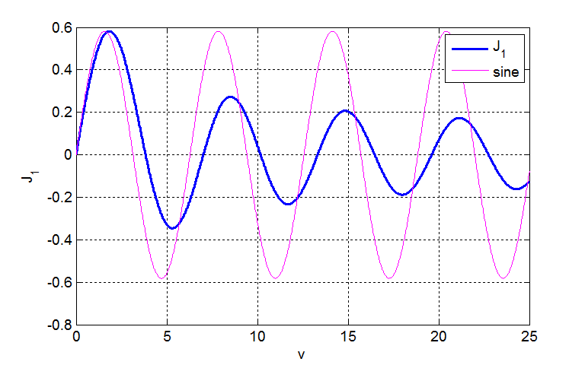

Fig.1. The Bessel function and the sine function sin(*v*). **op_bessel1.m**

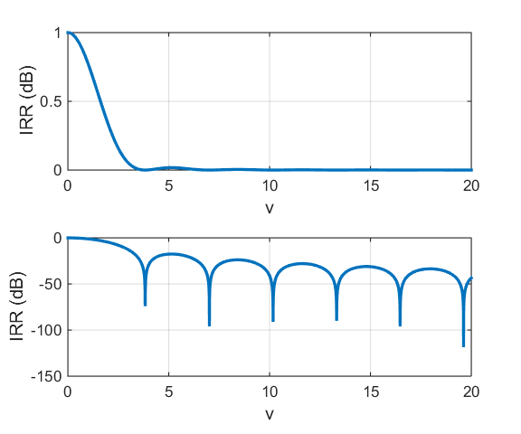

Fig.2. The irradiance in the observation plane for the Fraunhofer diffraction from a circular aperture. **op_bessel1.m**

The mscript **turningPoint. m** was used to estimate the argument *v* for the minimum, maximum and the zero crossings of the Bessel function.

Table 1: Argument *v* values for the maxima and minima.

|  |  |  |  |  |  |  |  |
| --- | --- | --- | --- | --- | --- | --- | --- |
| **Max** | 1.8404 | 8 .5367 | 14.8630 | 21.1642 | 27.4555 | 33.7467 | 40.0330 |
| **Min** | 5.3311 | 11.7073 | 18.0136 | 24.3099 | 30.6011 | 36.8924 | 43.1786 |
| **Zeros** | 3.8308 | 7.0164 | 10.1720 | 13.3227 | 16.4683 | 19.6139 | 22.7596 |

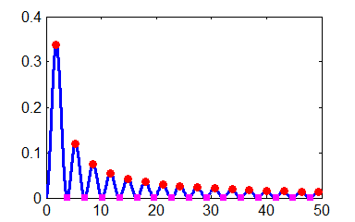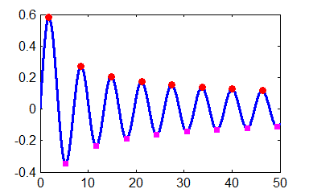

Fig. 2. The max, min and zero crossing for *J*1. The plot on the left is for *J*1 and the plot on the right is for *J*12. **turningPoints.m**

In Tables 2 and 3 are listed values of the first few maxima and zeros of the diffraction pattern that were calculated using **op_diffraction_01.m** and the function **turningPoint.m**. The function returns the values of indexMax and indexMin. Then in the Command Window the values of the radial coordinate for the peaks and zeros can be displayed

Maxima

EDU>> v(indexMax) ans = 5.1350 8.4177 11.6203 14.7950 17.9596

EDU>> IRR(indexMax) ans = 0.0175 0.0042 0.0016 0.0008 0.0004

Zeros

EDU>> v(indexMin) ans = 3.8308 7.0154 10.1740 13.3247 16.4713

Table 2. Relative irradiances of the maxima of the diffraction pattern

|  |  |  |  |  |  |  |
| --- | --- | --- | --- | --- | --- | --- |
| **peaks** | **central** | **1st** | **2nd** | **3rd** | **4th** | **5th** |
| ***v*** | 0 | 5.135 | 8.418 | 11.620 | 14.80 | 17.960 |
| ***I*/*I*o** | 1 | 0.0175 | 0.0042 | 0.0016 | 0.0008 | 0.0004 |

Table 3. Zeros in the irradiance for the diffraction pattern

|  |  |  |  |  |  |  |
| --- | --- | --- | --- | --- | --- | --- |
| **zeros** | **1st** | **2nd** | **3rd** | **4th** | **5th** | **6th** |
| ***v*** | 3.831 | 7.015 | 10.174 | 13.325 | 16.471 | 19.616 |

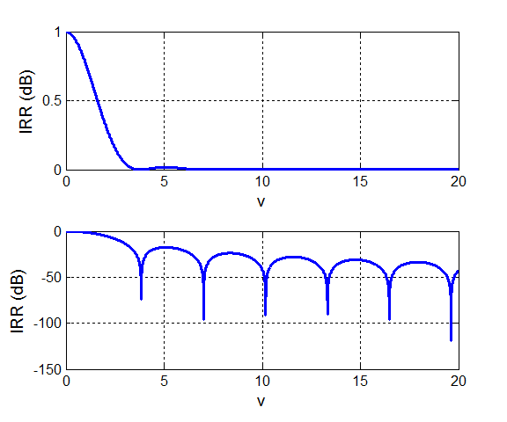

Fig. 4. Fraunhofer irradiance pattern for a circular aperture. The lower plot has a log scale for the irradiance .

The Fraunhofer diffraction pattern for the circular aperture is circularly symmetric and consists of a bright central circle surrounded by series of bright rings of rapidly decreasing strength between a series of dark rings. The bright and dark rings are not evenly spaced. The bright central region is known as the **Airy disk**. It extends to the first dark ring at *vP* = 3.831 (the first zero of the Bessel function).

The spread of the Airy disk is determined by the radial coordinate *v* = 3.831. The radial coordinate for the first dark ring is

First dark ring 

1. The larger the wavelength *λ* the greater the width of the diffraction pattern on a detection screen 
2. The larger the radius *a* of the circular aperture, the narrower the diffraction pattern on a detection screen 

**RAYLEIGH-SOMMERFELD DIFFRACTION INTEGRAL OF THE FIRST KIND**

The **Rayleigh-Sommerfeld region** includes the entire space to the right of the aperture. It is assumed that the Rayleigh-Sommerfeld diffraction integral of the first kind is valid throughout this space, right down to the aperture. There are no limitations on the maximum size of either the aperture or observation region, relative to the observation distance, because **no approximations have been made**. The Rayeigh-Sommerfeld diffraction integral of the first kind (RS1) can be expressed as

(5) 

where *EP* is the electric field at the observation point P, *EQ* is the electric field within the aperture and *rPQ* is the distance from an aperture point Q to the point P. The double integral is over the area of the aperture *S­A*.

The double integral can be estimate numerically by a [two-dimensional form of Simpson’s 1/3 rule](http://www.physics.usyd.edu.au/teach_res/mp/doc/math_integration_2D.pdf). The electric field *EP* at the point P is computed by

(6) 

where *Smn* are the Simpson’s two-dimensional coefficients and *E*0 is a normalizing constant. Each term in equation (6) can be expressed as a matrix of size *m* × *m* (*m* = *n*) and the matrices can be manipulated very easily in Matlab to give the estimate of the integral. The irradiance is proportional to the square of the magnitude of the electric field, hence the irradiance in the space beyond the aperture can be calculated by

(7) 

where *I*0 is a normalizing constant and *E*\* is the complex conjugate of *E*.

The mscript **op_RS1_circular_01.m** was used to compute the diffraction patterns in observation planes parallel to the aperture plane as shown in the following plots.

Parameters used for circular aperture:

*nP* = 199 number of observation points

*n*­*Q* = 255 number of aperture points must be **ODD**

*λ* = 632.8×10-9 m wavelength

*a*Q = 10 *λ* radius of circular aperture

*zP* = 1000 *λ* z distance between aperture plan and observation plane

*xPmin* = 0 Range of radial *x*-coordinates for P

*xPmax* = 2.0×10-4

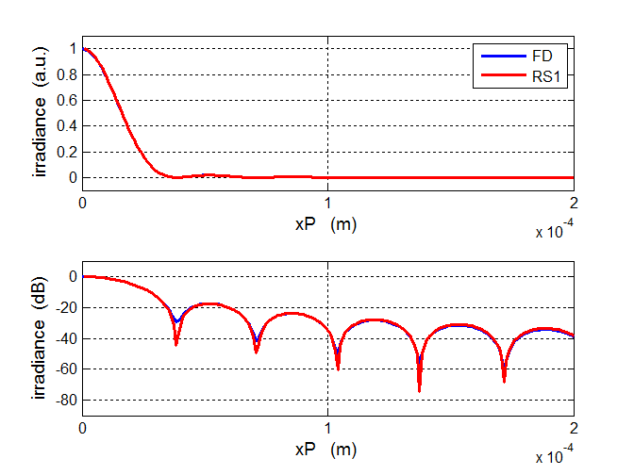

Fig. 5. Fraunhofer (blue) and RS1 (red) irradiance patterns for a circular aperture. The lower plot has a log scale for the irradiance . The agreement between the Fraunhofer and RS1 diffraction patterns is excellent for this set of parameters.

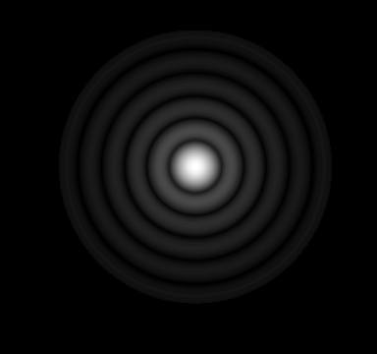

Fig.6. Diffraction pattern as computed using **op_RS1_circular.m**. The image is like a black and white photograph of the diffraction pattern that would be observed on a screen. The bright centre spot corresponds to the zeroth order of diffraction and is known as the Airy Disk.

Calculating the RS1 integral is a much more useful approach to studying diffraction then the Fraunhofer approach which is only valid in the far-field. For example, we can easily calculate the diffraction pattern in the near-field which is referred to as **Fresnel diffraction**. Consider changing only the distances to *zP* = 10 λ and *xPmax* = 6.0×10-6 m from the above quoted parameters. The new diffraction patterns in the near-field are shown in figures 7 and 8.

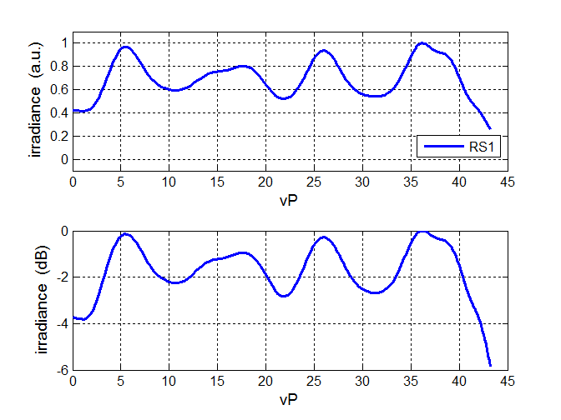

Fig. 7. Diffraction pattern in the near field.

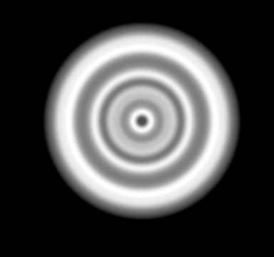

Fig. 8. Diffraction pattern in the near field showing a set of bright and dark rings but it is very different from the Fraunhofer pattern. There is no centre bright spot, in fact the centre region is dark.