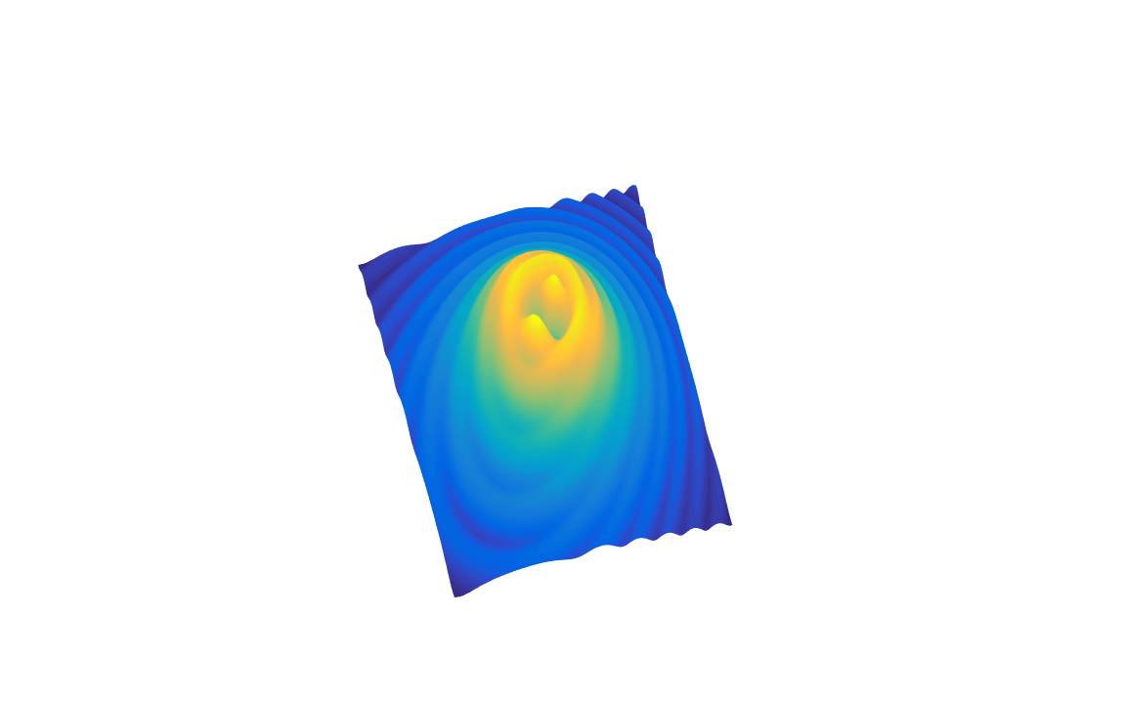

[**DOING PHYSICS WITH MATLAB**](https://d-arora.github.io/Doing-Physics-With-Matlab/)

**COMPUTATIONAL OPTICS**

# 

# GUI Simulation

# Diffraction Pattern of a Circular Aperture

# 

Ian Cooper

Please email any corrections, comments, suggestions or additions: matlabvisualphysics@gmail.com

# [Matlab Download Directory](https://drive.google.com/drive/u/3/folders/1j09aAhfrVYpiMavajrgSvUMc89ksF9Jb)

**gui_diff_circle.m**

Mscript for the GUI for the simulation of the diffraction by a circular aperture.

Inputs and recommend ranges:

wavelength in nanometers (400 to 750 nm)

aperture radius in millimetres (0.1 to 10 mm)

distance between the aperture & observation planes (0.1 to 1000 mm)

max radial distance (0.1 to 100 mm)

**gui_diff_circle_cal_z.m**

Calculation of the irradiance in the observation plane by evaluating the Rayleigh-Sommerfeld diffraction integral of the first kind - called from the GUI. The number of partitions of the aperture space and observation space can be changed by modifying the mscript.

Function calls to:

**simpson1d.m** (integration)

**fn_distancePQ.m** (calculates the distance between points P and Q)

**Colorcode.m** (matches graph colour to the colour of the wavelength)

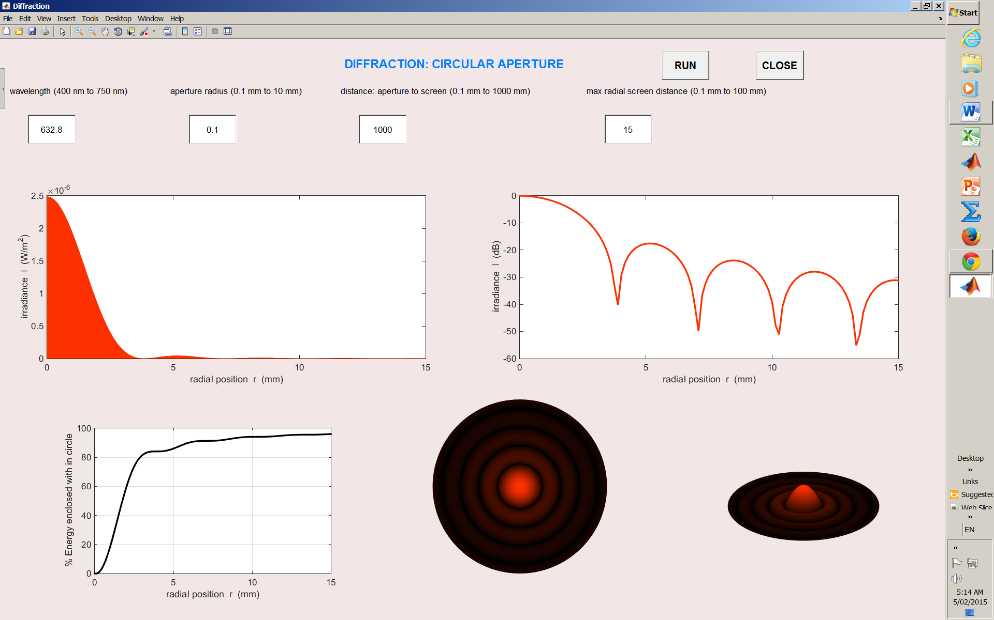

Fig. 1. GUI for the simulation of Fraunhofer diffraction of red light of wavelength 632.8 nm.

By changing the input parameters you can investigate the changes in the irradiance in the observation plane. The graphical output shows plots for:

* Irradiance (W.m-2) as a function of radial position about the optical axis in the observation plane.
* Irradiance (decibels dB) as a function of radial position about the optical axis in the observation plane.
* Energy enclosed within circles of increasing radius about the optical axis in the observation plane as a percentage of the energy incident upon the aperture.
* Time exposure photograph like image of the diffraction pattern.
* [3D] visualization of the diffraction pattern

The simulation can be used to view diffraction patterns for both Fraunhofer and Fresnel diffraction.

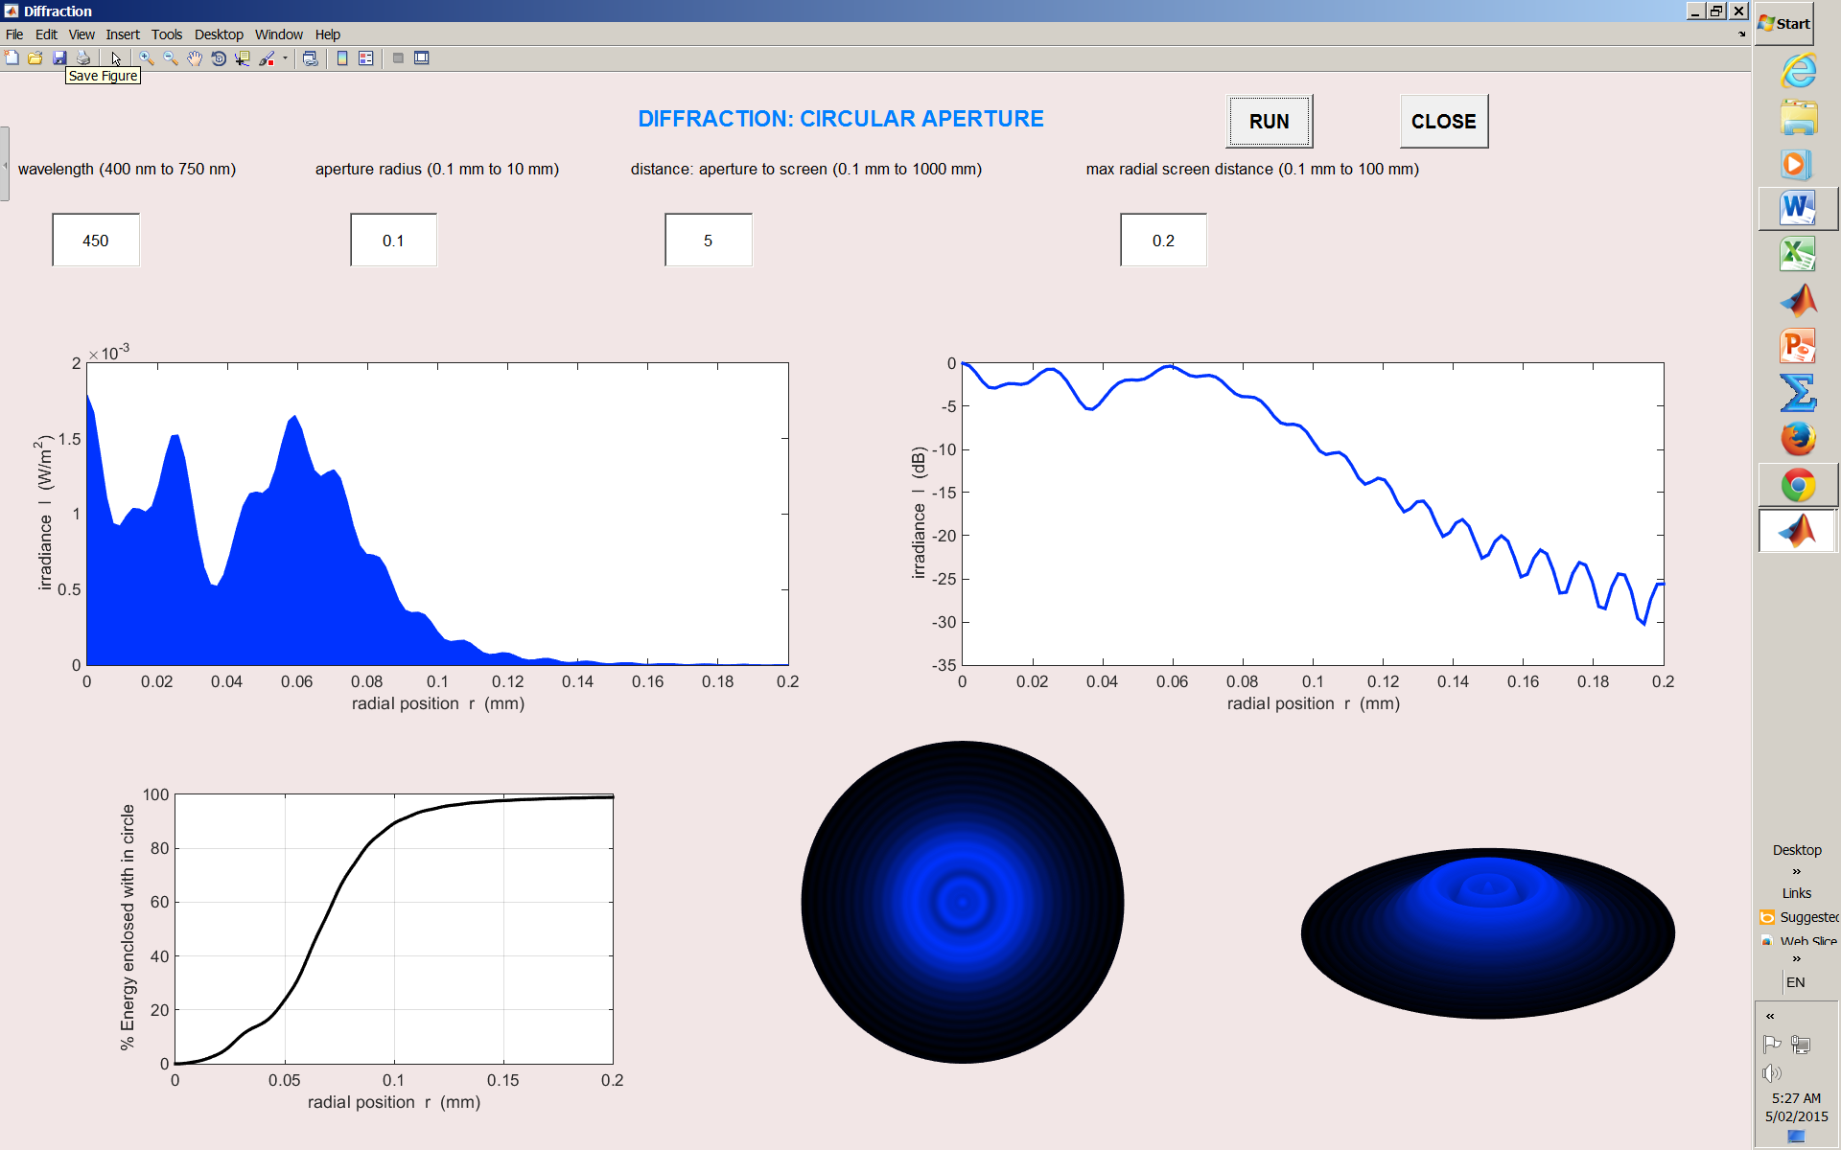

Fig. 2. GUI for the simulation of Fresnel diffraction of blue light of wavelength 450 nm.