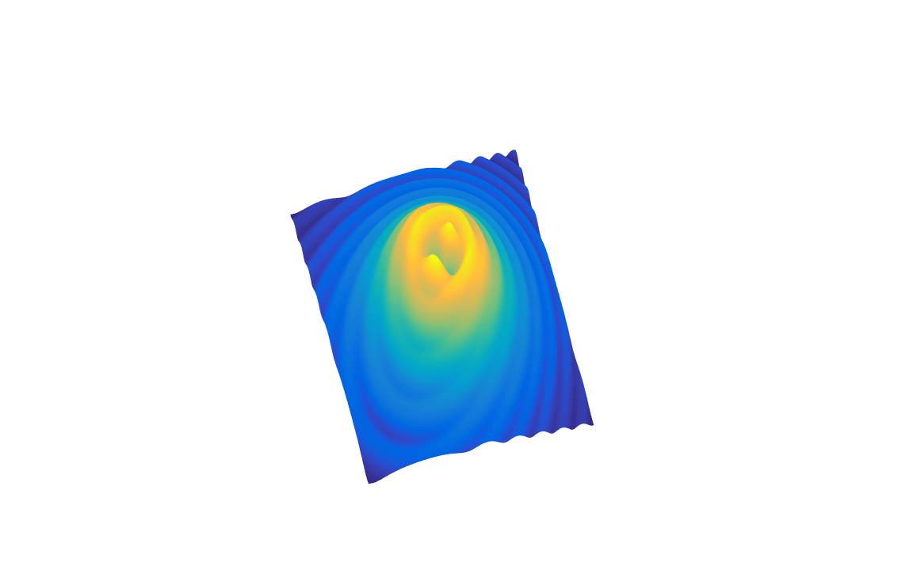

[**DOING PHYSICS WITH MATLAB**](http://www.physics.usyd.edu.au/teach_res/mp/mphome.htm)

**COMPUTATIONAL OPTICS**

# 

# GUI Simulation

# Diffraction: Focused Beams and Resolution for a lens system

# 

Ian Cooper School of Physics University of Sydney ian.cooper@sydney.edu.au

[**DOWNLOAD DIRECTORY FOR MATLAB SCRIPTS**](http://www.physics.usyd.edu.au/teach_res/mp/mscripts)

**gui_resolution.m**

Mscript for the GUI for the simulation of the diffraction of a focused beam from a simple lens from a single source or two sources. The mscript can be used to investigate the characteristics of the focussing of planes waves from either a single source or two sources.

**gui_resolution_cal.m**

Calculation of the irradiance in an observation plane by evaluating the Rayleigh-Sommerfeld diffraction integral of the first kind which is called from the GUI. The number of partitions of the aperture space and observation space can be changed by modifying the mscript. The default value for the focal length of the lens is 22. This can be changed in the mscripts.

Function calls to:

**simpson1d.m** (integration)

**fn_distancePQ.m** (calculates the distance between points P and Q)

The calculations are done numerically and therefore it may take some time for the calculations to be performed. After pressing the **RUN** button, you just have to wait until the Figure Window is updated. To end the simulation at any time, press the **CLOSE** button.

The geometry for the diffraction / resolution simulation is shown in figure 1. A plane wave incident upon a simple lens is focussed to a point in the focal plane of the lens. This focussing action of plane waves by a lens can be modelled by evaluating the Rayleigh-Sommerfeld integral he first kind where a source is taken as a point in the in the focal plane where spherical waves of the incident plane wave would be focused.

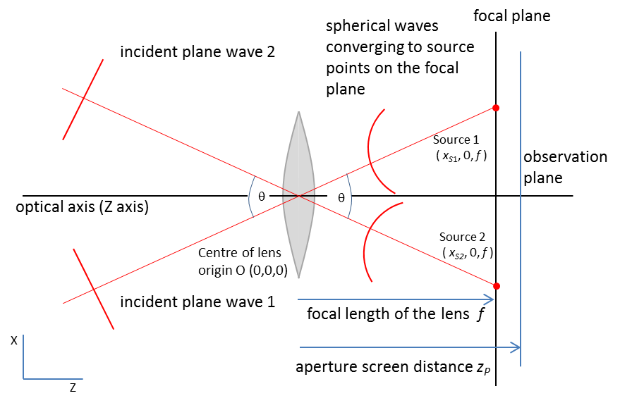

Fig. 1. Focusing action of a lens.

The input parameters and output are shown in the one Figure Window. The Figure Window can be expanded to a full screen view to maximize the graphical display.

Input parameters and recommend ranges:

Wavelength in nanometres (400 to 750 nm)

Aperture radius in millimetres (0.1 to 10 mm)

X position ( *x*S1 and *x*S2 ) of the two point sources in the focal plane of the simple lens are entered in micrometres

Source 1 ( 0 to 8 μm)

Source 2 (-8 to 0 μm)

Distance between the aperture & observation planes

(10 to 100 mm)

N.B. Mixed units are used for the input parameters

1 nm = 10-9 m 1 μm = 10-6 m 1 mm = 10-3 m

Graphical output in the observation plane for the specified aperture to screen distance *zP*[mm]:

Plots of the irradiance *we* [W.m‑2] against the radial distance from the optical axis (Z axis). The blue curve is the variation of the irradiance in on the X axis *xP* [μm] and the red curve for the irradiance variation in along the Y axis *yP* [μm].

Plots of the irradiance *we* [decibel scale dB] against the radial distance from the optical axis (Z axis). The blue curve is the variation of the irradiance along the X axis *xP* [μm] and the red curve for the irradiance variation along the Y axis *yP* [μm].

Two-dimensions plots of the irradiance variation in the XY observation plane: (1) Short time exposure to show the concentration of the light within the Airy disk. (2) A longer time exposure to show the complex irradiance pattern in the focal region.

Numerical outputs: (1) The saddle point ratio which is the ratio of the irradiance at the midpoint between the sources and the maximum irradiance. (2) The angular separation of the sources *θ* [rad and degrees].

The default values used in the simulation correspond to the lens system of the eye with a pupil of radius *a* = 1 mm and aperture / screen distance *zP* = 22 mm. The focal length is fixed at *f* = 22 mm and so for the default values, the observation plane corresponds to the focal plane ( *f* = *zP* ). The sources are located at *xS*1 = 3 μm and *xS*2 = -3 μm. The wavelength of the incident monochromatic green light is

*λ* = 550 mm.

**SINGLE POINT SOURCE – focused beam**

The focussing of a normally incident plane waves (*θ* = 0) where *xS*1 = *xS*2 = 0 μm produces a Fraunhofer diffraction pattern in the focal plane. According to the Fraunhofer diffraction theory the angular position of the first minimum or the angular radius of the Airy disk  is given by equation (1)

(1) 

where  is the wavelength and *a* is the radius of the aperture opening or pupil. For the simulation with input parameters

wavelength  = 550x10-9 m

aperture radius *a* = 1x10-3 m

sources *xS*1 = *xS*2 = 0 m

screen/ aperture distance *zP* = 221x10-3 m

(focal length *f* = 22 mm = *zP*)

Using the input parameters and equation (1), the angular radius of the Airy Disk is



Using the Data Cursor in the Matlab Figure Window, the radial position *xP* of the first minimum is *xP* = 7.4071x10-6 m. The angular radius of the Airy disk is then



which is in excellent agreement with the Fraunhofer prediction given by equation (1).

According to equation (1), the angular size of the Airy disk increases with increasing wavelength λ and decreasing pupil size. This prediction can be verified by changing the input parameters in the GUI as shown in Table 1.

Table 1. The size of the Airy disk depends upon the wavelength and aperture radius.

*a* = 1 mm *λ* = 550 nm

|  |  |
| --- | --- |
| wavelength λ [ nm] | 1st min *xP* [μm] |
| 400 | 5.56 |
| 550 | 7.41 |
| 750 | 10.0 |

|  |  |
| --- | --- |
| aperture *a* [ mm] | 1st min *xP* [μm] |
| 5 | 5 |
| 1 | 7.4 |
| 0.5 | 14.4 |

The effect of diffraction is that a point on an object is focussed as a blurred image usually with a bright centre spot surrounded by dark rings separated by bright rings of decreasing brightness as one moves away from the centre of the image. The “best” or sharpest imaging is achieved when this central bright spot has the smallest size.

Figure 1 shows a sample Figure Window for the incident plane wave normally incident upon the lens.

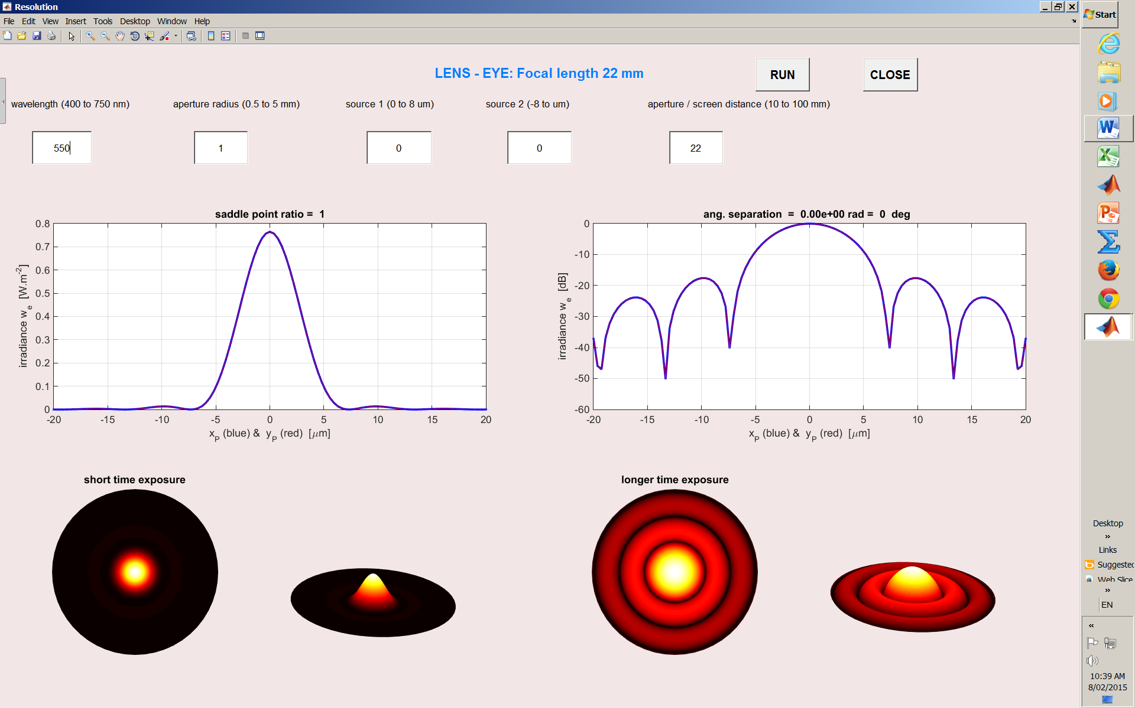

Fig. 2. Input parameters: *λ* = 550 nm, *a* = 1 mm, *xS*1 = *xS*2 = 0 μm, *zP* = *f* = 22 mm.

The Fraunhofer prediction given by equation (1) which describes the angular size of the Airy disk is only valid when the incident plane wave is perpendicular to the optical axis and the observation plane corresponds to the focal plane. However, the simulation which uses the Rayleigh-Sommerfeld diffraction integral of the first kind is valid for all input parameters.

When the observation plane does not correspond to the focal plane, the image of the point source is larger. This occurs when the eye ball is too short or too long so the light from the lens is not focussed onto the retina (focal plane) – the image is blurred more than when properly focused. This is shown in figure 3 where the observer plane is at *zP* = 22.2 mm > *f* = 22 mm. The is no distinct minimum and the size of the central spot is larger hence a more blurred image of the source.

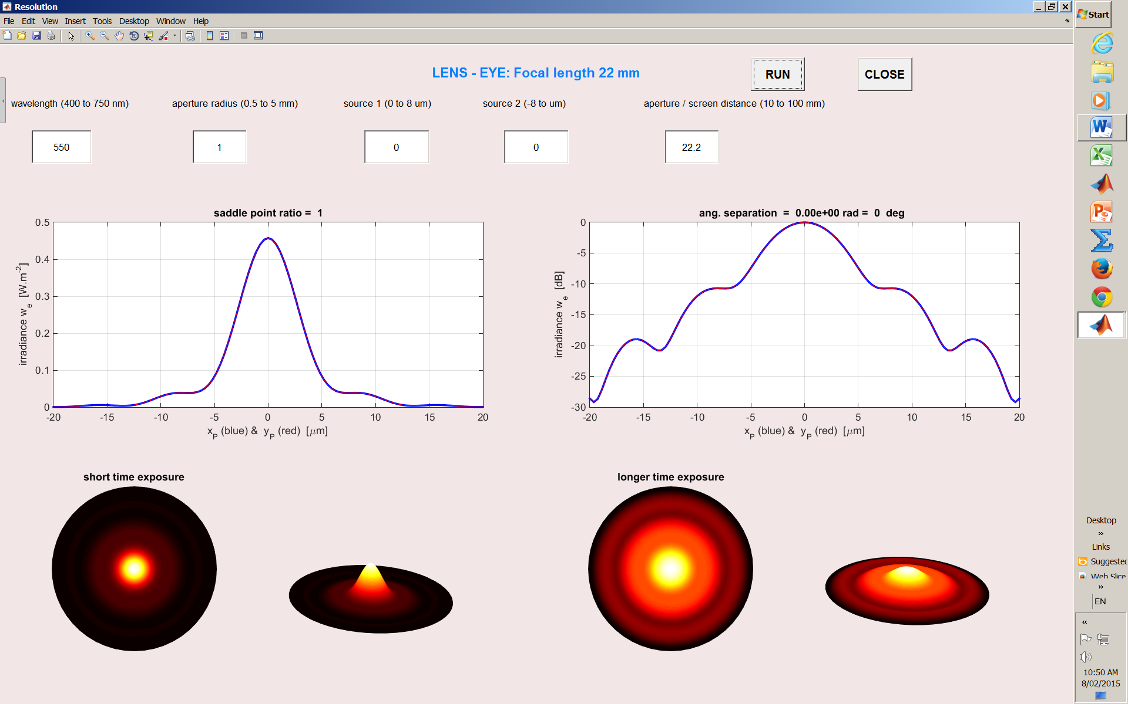

Fig. 3. Input parameters: *λ* = 550 nm, *a* = 1 mm, *xS*1 = *xS*2 = 0 μm, *zP* = 22.2 mm

*f* = 22 mm.

If even more defocussing occurs, then a more complicated diffraction pattern in the observation plane is observed and there may be no central bright spot as shown in figure 4.

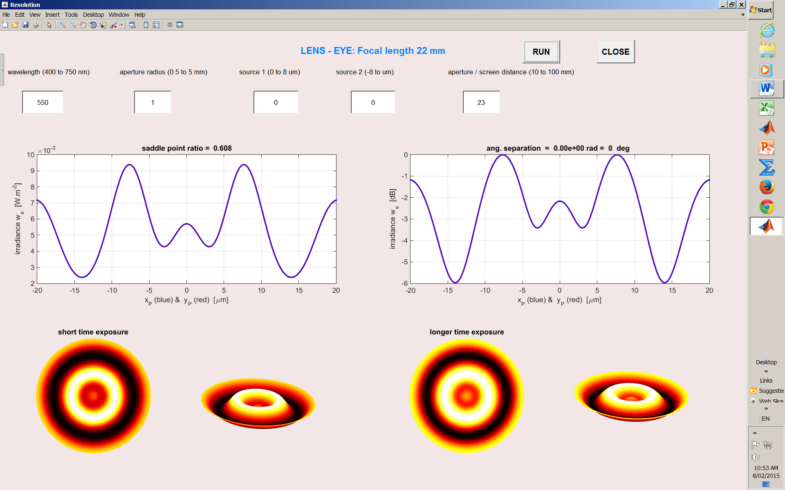

Fig. 4. Input parameters: *λ* = 550 nm, *a* = 1 mm, *xS*1 = *xS*2 = 0 μm, *zP* = 23 mm

*f* = 22 mm.

When the source is off axis as shown in figure 5, the bright spot is shifted along the X axis and the bright spot becomes elliptical in shape rather than circular. The flattening of the bright spot is not noticeable in the simulations because very small off-sets distance can be used as an input.

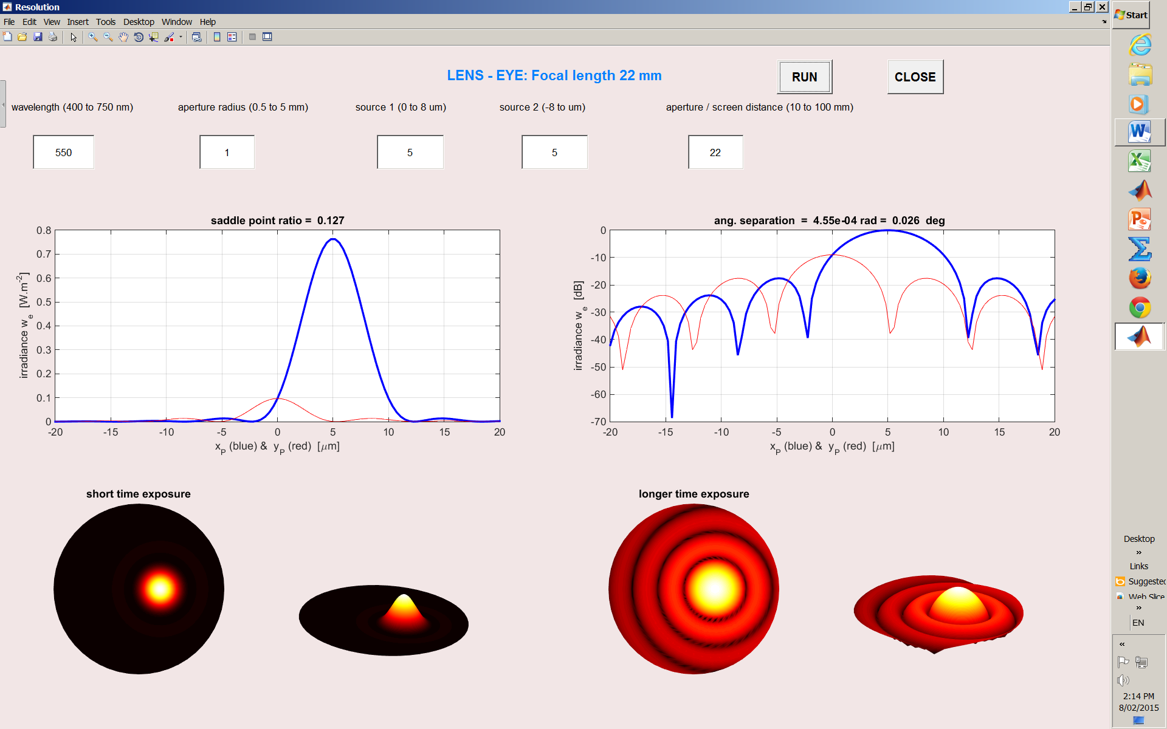

Fig. 5. Input parameters: *λ* = 550 nm, *a* = 1 mm, *xS*1 = *xS*2 = 5 μm, *zP* = *f* = 22 mm.

**TWO SOURCES – RESOLUTION**

The sharpness of a distance image is limited by the effects of diffraction. The image of a point occupies essentially the region of the airy disc. The inevitable blur that diffraction produces in the image restricts the **resolution** (ability to distinguish to separate points) of an optical system such as the eye, telescope or microscope. If the angle *θ* between two point sources is large enough, two distinct images will be clearly seen. However, as the angle *θ* is reduced, the two diffraction patterns will start to overlap substantially and it becomes difficult to resolve them as distinct point objects.

A somewhat arbitrary criterion for just resolvable images is known as **Rayleigh’s criterion**. Since the two sources are incoherent, the irradiance of the two patterns simply add. When the angle is small, the irradiance pattern has two peaks separated by a saddle point. The **saddle point ratio** is the value of the irradiance at the saddle point divided by the peak irradiance value.

**Rayleigh’s criterion**

The maximum of one pattern falls directly over the first minimum of the other. This gives the saddle point ratio a value equal to **0.74**.

Figures 6, 7 and 8 show the diffraction patterns for two point sources that are not resolved; two point sources with an angular separation where the Rayleigh criterion is just satisfied and two point sources with a large angular separation that are clearly resolved as two distinct points.

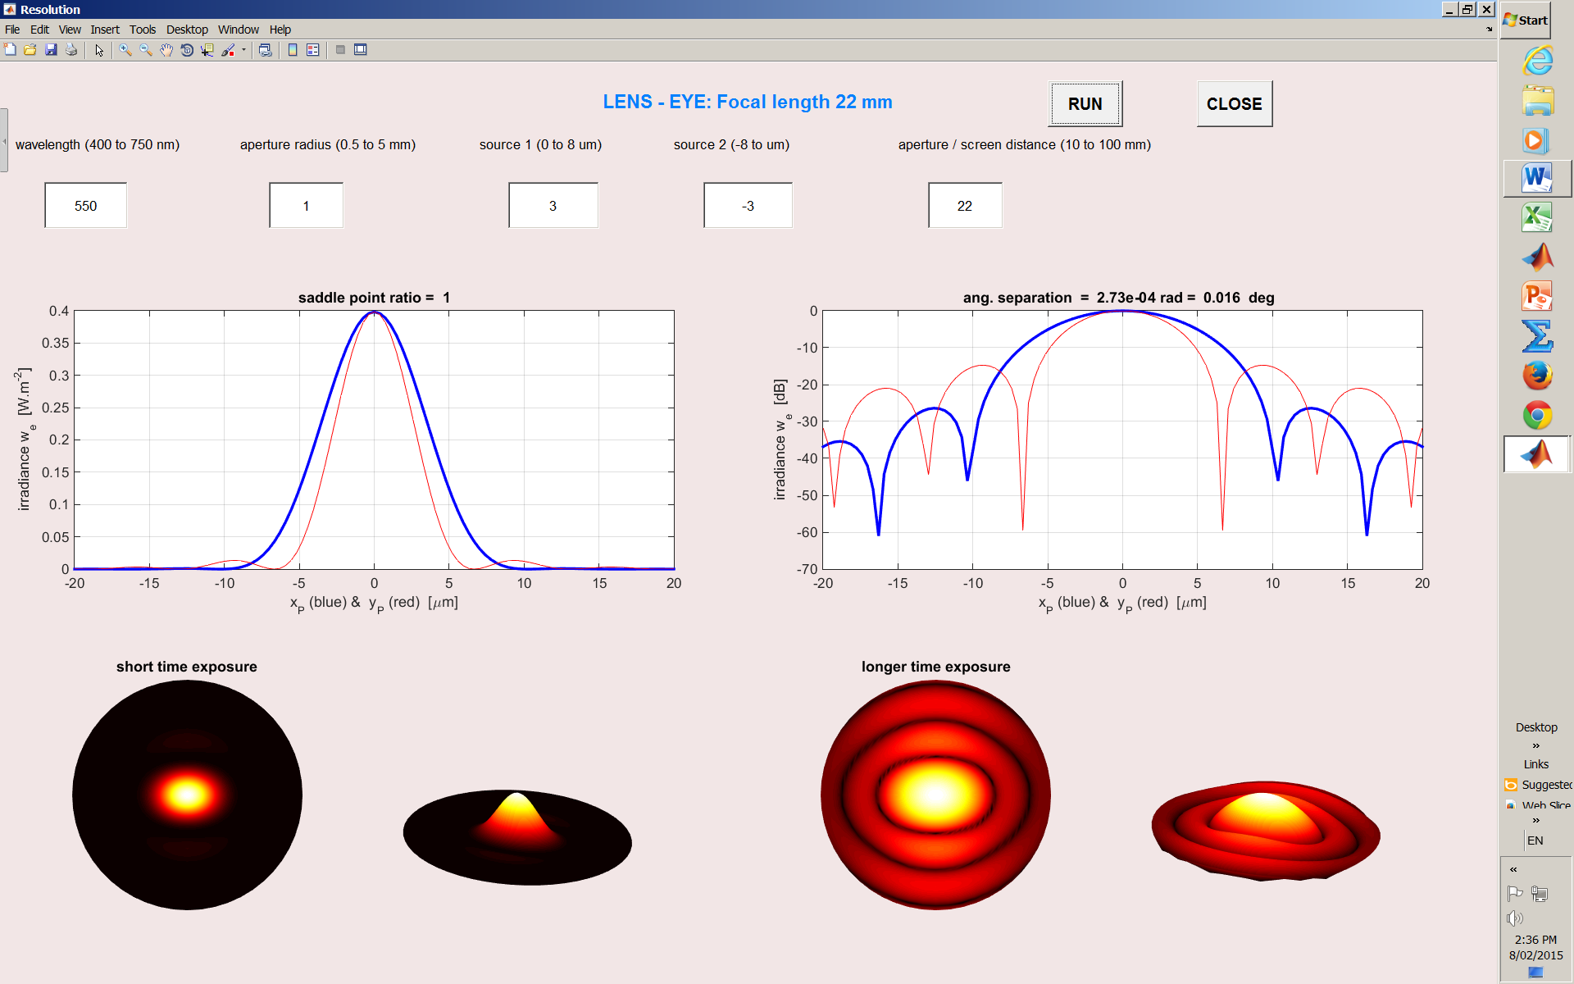

Fig. 6. *λ* = 550 nm, *a* = 1 mm, *xS*1 = 3 μm, *xS*2 = -3 μm, *zP* = *f* = 22 mm.

saddle point ratio = 1, angular separation *θ* = 2.7×10-4 rad = 0.016 degrees.

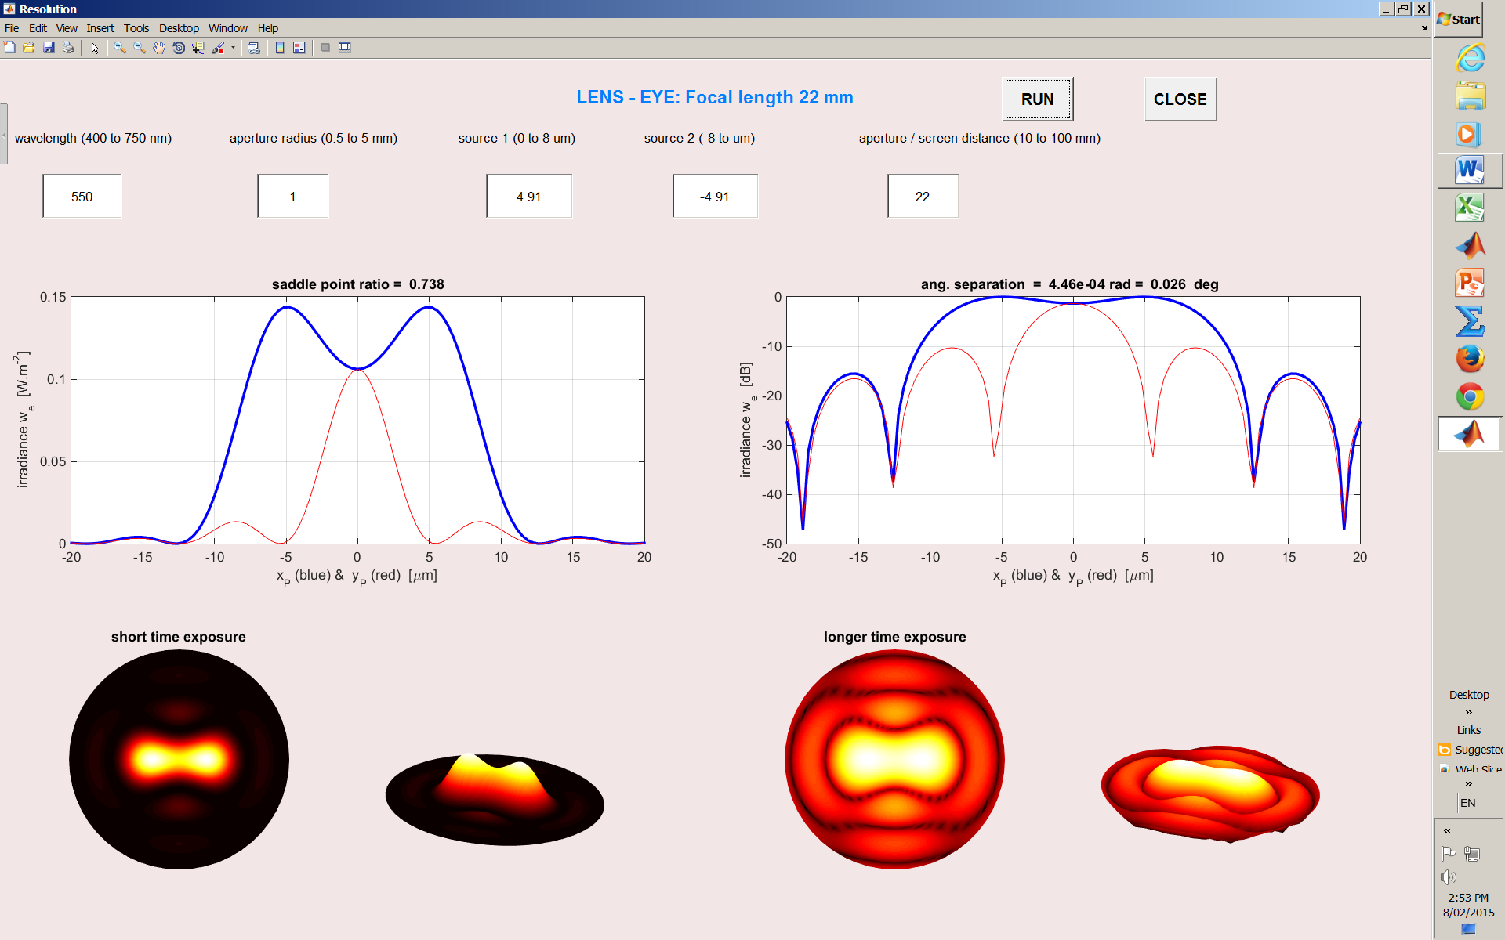

Fig. 7. *λ* = 550 nm, *a* = 1 mm, *xS*1 = 4.91 μm, *xS*2 = -4.91 μm, *zP* = *f* = 22 mm.

saddle point ratio = **0.74**, angular separation *θ* = 4.5×10-4 rad = 0.026 deg.

The angular size of the bright spot can be reduced by decreasing the wavelength or increasing the aperture radius (equation 1). This improvement in resolution is shown in figure 8.

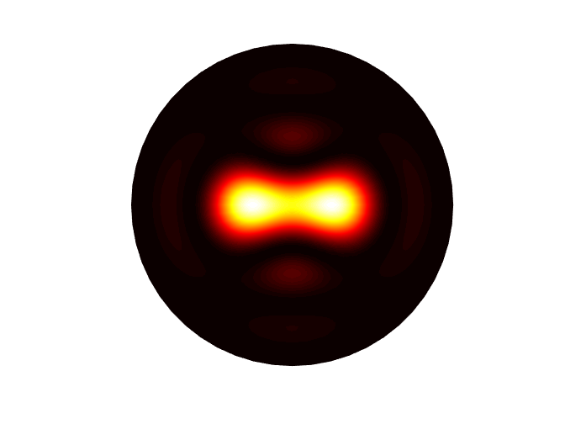

*λ* = 550 nm

*a* = 1 mm

*xS*1 = 4.91 μm, *xS*2 = -4.91 μm

*zP* = *f* = 22 mm.

saddle point ratio = 0.74 angular separation

*θ*  = 4.5×10-4 rad = 0.026 deg

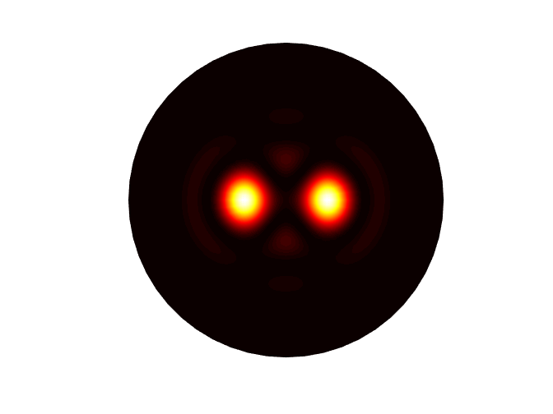

***λ* = 400 nm**

*a* = 1 mm

*xS*1 = 4.91 μm, *xS*2 = -4.91 μm

*zP* = *f* = 22 mm

**saddle point ratio = 0.02**

angular separation

*θ*  = 4.5×10-4 rad = 0.026 deg



*λ* = 550 nm

***a* = 2 mm**

*xS*1 = 4.91 μm, *xS*2 = -4.91 μm

*zP* = *f* = 22 mm

**saddle point ratio = 0.07**

angular separation

*θ*  = 4.5×10-4 rad = 0.026 deg

Fig. 8. Resolution is improved by decreasing the wavelength and increasing the size of the aperture.

In night vision, the pupil is enlarged and the size of radius of the pupil is around 4 mm and the eye is capable of higher resolution, but, unfortunately there is not enough light to take advantage of the improved resolution.

On a bright day, the pupil radius is about 1 mm and for an average wavelength 550 nm the simulation gives the angular separation of the two sources as *θ*  = 4.46×10-4 rad for the situation when the two sources can be just resolved according to the Rayleigh criterion (saddle point ration ~ 0.74). The distance *d* between these two image points on the retina is given

*d =* *f* θ = (22x10-3)( 4.46×10-4) m = 9.81×10-6 m

Hence, the distance between points on the retina to resolve two points is about 10 μm. As the distance between detecting cells on the retina is about 2 μm, evolution has produced in the eye an optical instrument with its detector well matched to the diffraction limits of the optical system of the eye.

You can check for yourself, your own resolution or visual acuity by viewing two vertical lines drawn 1 mm apart at increasing distances until they can no longer be seen as separate lines.