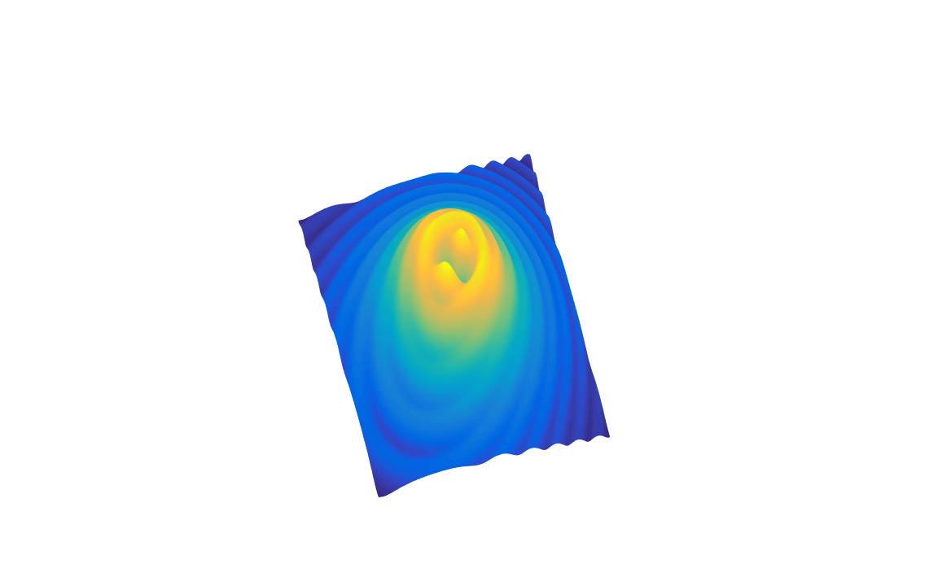

[**DOING PHYSICS WITH MATLAB**](https://d-arora.github.io/Doing-Physics-With-Matlab/)

**COMPUTATIONAL OPTICS**

# 

# POYNTING VECTOR

# IRRADIANCE *we*

# 

Ian Cooper

Please email any corrections, comments, suggestions or additions: matlabvisualphysics@gmail.com

# [Matlab Download Directory](https://drive.google.com/drive/u/3/folders/1j09aAhfrVYpiMavajrgSvUMc89ksF9Jb)

An electromagnetic wave transports energy. The **Poynting vector**  is used to represent this flow of electromagnetic energy per unit time across a unit area. The S.I. unit for the Poynting vector is J.s-1.m-2 or W.m-2.

Assuming that the medium is isotropic and that the energy flows in the direction of the propagating wave, then the Poynting vector is defined as

(1) 

We can assume that the magnetic susceptibility is negligible, i.e.  where  is the magnetic permeability of the light transmitting media. This assumption is typically valid in transparent media in the optical frequency range, hence, equation (1) becomes

(2) 

For a harmonic, linearly polarised plane wave travelling through a non-magnetic medium, the electric and magnetic fields are

(3) 

(4) 

Also, we know that





where is the permittivity of free space, is the permeability of free space, *c* is the speed of light in vacuum, *v* is the speed of light in a medium with dielectric constant , relative permittivity  and *n* is the refractive index of the medium.

Therefore, we can express the Poynting vector as

(5) 

It is clear that the Poynting vector oscillates from maxima to minima due to the cosine term squared. At optical frequencies,  is an extremely rapidly varying function of time (oscillation frequency twice that of the electric and magnetic fields). Hence, the instantaneous value of  would be an impractical quantity to measure.

We need to measure the **time-averaged value of the Poynting vector** < *S* > and this quantity is often referred to as the **irradiance** *we*. A more general term for the flow of energy per unit area per unit time is called the **intensity** *I*. In optics, it is better to use the term irradiance rather than intensity. The time-average of the cosine squared term is ½, therefore,

(6) 

where is the complex conjugate of the peak electric field .

The irradiance is always given in terms of the electric field since the electric field is considerably more effective at exerting forces and doing work on charges than the magnetic field. The irradiance is a measure of the “concentration of power”.

The time rate of flow of radiant energy is the **power** *P* or **radiant flux** *WE* where

(7) 

If we divide the radiant flux incident upon or exiting from a surface by the area of the surface, we have the **radiant flux density**. This is often just called the **flux density** or **energy density**. **Irradiance** corresponds to the flux density incident upon a surface and the **exitance** as the flux density emitted from the surface.

|  |  |  |
| --- | --- | --- |
| Instantaneous flow of electromagnetic energy per unit time per unit area **Poynting vector** |  | W.m-2 J.s-1.m-2 |
| Time-averaged flow of electromagnetic energy per unit time per unit area  irradiance  intensity  radiant flux density  flux density  energy flux density  exitance | < *S* >  *we*  *I* | W.m-2 |
| Time-average flow of electromagnetic energy per unit time  power  radiant flux  flux  energy flux | *P*  *WE* | W J.s-1 |