[**DOING PHYSICS WITH MATLAB**](http://www.physics.usyd.edu.au/teach_res/mp/mphome.htm)

**COMPUTATIONAL OPTICS**

# 

# RAYLEIGH-SOMMERFELD DIFFRACTION INTEGRAL OF THE FIRST KIND

# CIRCULAR APERTURES

# 

Ian Cooper

School of Physics, University of Sydney

ian.cooper@sydney.edu.au

[**DOWNLOAD DIRECTORY FOR MATLAB SCRIPTS**](http://www.physics.usyd.edu.au/teach_res/mp/mscripts)

**op_rs_circle_rings.m**

Calculation of the irradiance in a plane perpendicular to the optical axis for uniformly illuminated circular type apertures. The mscript can be used for annular apertures and for observation planes close to the aperture plane. It uses Method 3 – one-dimensional form of Simpson’s rule for the integration of the diffraction integral. Function calls to:

**simpson1d.m** (integration)

**fn_distancePQ.m** (calculates the distance between points P and Q)

**turningPoints.m** (max, min and zero values of a function)

**Background documents**

[C:\Users\Admin\Desktop\ap\images\hsp\Image2.gif](http://www.physics.usyd.edu.au/teach_res/mp/op/doc/op_diffraction_integrals_theory.pdf) Scalar Diffraction theory: Diffraction Integrals

[C:\Users\Admin\Desktop\ap\images\hsp\Image2.gif](http://www.physics.usyd.edu.au/teach_res/mp/op/doc/op_rs1.pdf) Numerical Integration Methods for the Rayleigh-Sommerfeld Diffraction

Integral of the First Kind

**RAYLEIGH-SOMMERFELD DIFFRACTION INTEGRAL OF THE FIRST KIND**

**UNIFORMLY ILLUMINATED CIRCULAR APERTURE**

The Rayleigh-Sommerfeld diffraction integral of the first kind states that the electric field at an observation point P can be expressed as

(1) 

It is assumed that the Rayleigh-Sommerfeld diffraction integral of the first kind is valid throughout the space in front of the aperture, right down to the aperture itself. There are no limitations on the maximum size of either the aperture or observation region, relative to the observation distance, because **no approximations have been made**.

The **irradiance** or more generally the term **intensity** has S.I. units of W.m-2. Another way of thinking about the irradiance is to use the term **energy density** as an alternative. The use of the letter *I* can be misleading, therefore, we will often use the symbol *u* to represent the irradiance or energy density.

The irradiance or energy density *u* of a monochromatic light wave in matter is given in terms of its electric field *E* by

(2) 

where *n* is the refractive index of the medium, *c* is the speed of light in vacuum and *ε*0 is the permittivity of free space. This formula assumes that the magnetic susceptibility is negligible, i.e.  where  is the magnetic permeability of the light transmitting media. This assumption is typically valid in transparent media in the optical frequency range.

The integration can be done accurately using any of the numerical procedures based upon Simpson’s rule to compute the energy density in the whole space in front of the aperture.

[C:\Users\Admin\Desktop\ap\images\hsp\Image2.gif](http://www.physics.usyd.edu.au/teach_res/mp/op/doc/op_rs1.pdf) Numerical Integration Methods for the Rayleigh-Sommerfeld Diffraction

Integral of the First Kind

The geometry for the diffraction pattern from circular type apertures is shown in figure (1).



Fig. 1. Circular aperture geometry.

The radial optical coordinate *vP* is a scaled perpendicular distance from the optical axis.

(3) 

In the far-field or Fraunhofer region, the numerical integration of equation (1) gives results that are identical to the analytical expression for the energy density given by equation (3)

(3)  **Fraunhofer diffraction**

The diffraction formula for the electric field given by equation (1) is valid in the near-field or the Fresnel region whereas equation (3) is only valid for observation points at large distances from the aperture plane.

[C:\Users\Admin\Desktop\ap\images\hsp\Image2.gif](http://www.physics.usyd.edu.au/teach_res/mp/op/doc/op_rs1.pdf) Bessel Function of the First Kind

Fraunhofer diffraction – circular aperture

**FRAUNHOFER DIFFRACTION – FAR FIELD**

The Fraunhofer diffraction pattern for the circular aperture is circularly symmetric and consists of a bright central circle surrounded by series of bright rings of rapidly decreasing strength between a series of dark rings. The bright and dark rings are not evenly spaced. The bright central region is known as the **Airy disk**.

Figure (2) shows the energy density distribution in the far-field for a uniformly illuminated circular aperture that was calculated using Method 3 (one-dimensional form of Simpson’s Rule) with the mscript **op_rs_circle_rings.m**.

A summary of the input parameters used in the modelling is shown in the Matlab Command Window

Parameter summary [SI units]

wavelength [m] = 6.328e-07

nQ = 551000

nP = 509

Aperture Space

radius of aperture [m] = 1.000e-04

energy density [W/m2] uQmax = 1.000e-03

energy from aperture [J/s] UQ(theory) = 3.142e-11

Observation Space

max radius rP [m] = 2.000e-02

distance aperture to observation plane [m] zP = 1.000e+00

Rayleigh distance [m] d_RL = 6.321e-02

energy: aperture to screen [J/s] UP = 3.043e-11

max energy density [W./m2] uPmax = 2.469e-06

Elapsed time is 93.548646 seconds.

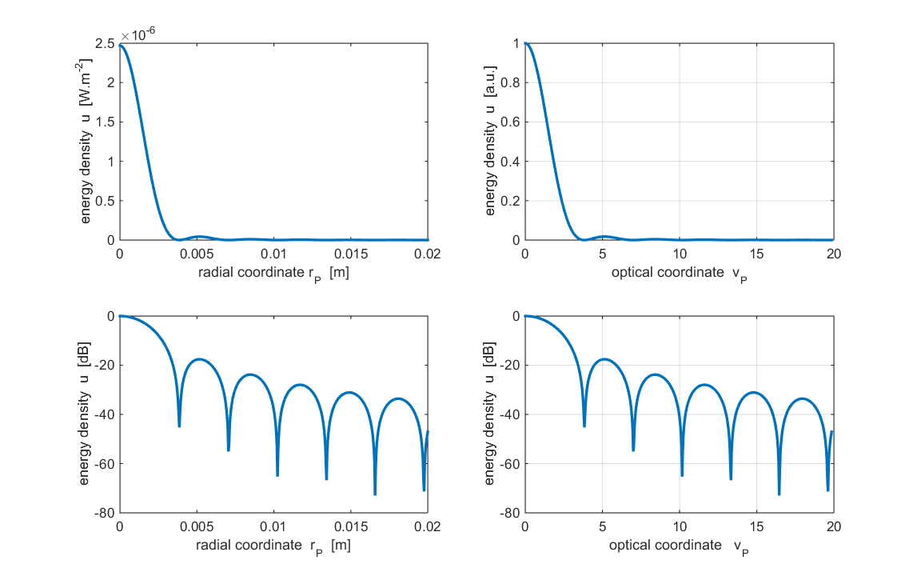

Fig. 2. The energy density distribution for a circular aperture in the far-field. The lower plots have a log scale for the irradiance . **op_rs_circle_rings.m**

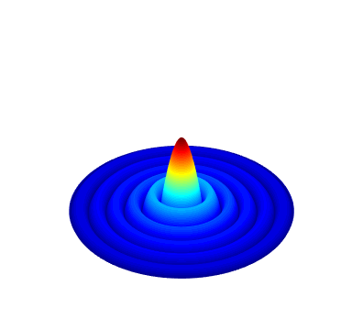

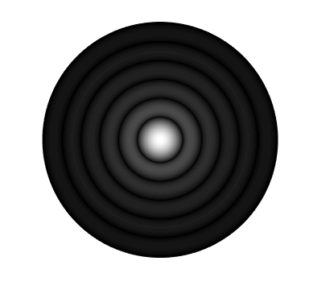

Fig.3. Diffraction pattern for a circular aperture in the far-field.

*Left*: The image represents a black and white time exposure photograph of the diffraction pattern that would be observed on an observation screen. The bright centre spot corresponds to the zeroth order of the diffraction pattern and is known as the Airy Disk. *Right*: Scaled Surf Plot of the diffraction pattern.

The mscript **op_rs_circle_rings.m** calls the function **turningPoints.m** to estimate the optical coordinates for the zeros in the diffraction pattern and the positions and relative strengths of the maxima in the diffraction pattern. The results are displayed in the Command Window.

Radial coordinates - zero positions in energy density

3.831

6.997

10.163

13.329

16.455

19.620

Radial coordinates - max positions in energy density

Relative intensities of peaks

5.121 0.0175

8.404 0.0042

11.609 0.0016

14.775 0.0008

17.940 0.0004

**Energy enclosed within the dark rings of the diffraction pattern**

Since Method 3 is based upon a one-dimensional form of Simpson’s rule where the integration is over a series of rings of increasing radius and SI units are used, it is possible to calculate the energy enclosed within a ring of a specified radius on the observation screen. Figure (4) shows the energy *UP* enclosed with circles of increasing radius which is given by the optical coordinate *vP*. Table 1 gives the energy enclosed within each dark ring. The values in Table 1 were estimated using the Matlab Data Cursor Function in the Figure Window for the plot shown in figure (4).

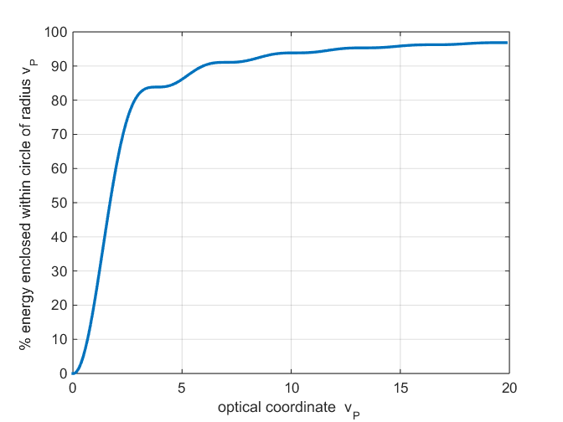

Fig. 4. Energy enclosed with a rings of increasing radius on the observation screen in the far field for a uniformly illuminated circular aperture.

Table 1. Energy enclosed within a circle defined by the radii of each dark ring. The “flat spots” shown in figure (4) correspond to the dark rings.

|  |  |
| --- | --- |
| **Dark rings *vP*** | **Energy enclosed**  **(%)** |
| 3.83 | 83.8 |
| 7.00 | 91.1 |
| 10.2 | 93.9 |
| 13.3 | 95.3 |
| 16.5 | 96.2 |
| 19.6 | 96.9 |

About 84% of the energy from the aperture to the observation screen is enclosed within the Airy Disk.

**Doubling the radius *a* of the aperture**

The effect on the energy density distribution by doubling the radius *a* of the aperture is shown in figure (5). The upper plots are for *a*1 = 1.00×10-4 m and the lower plots for the larger radius *a*2 = 2.00×10-4 m.



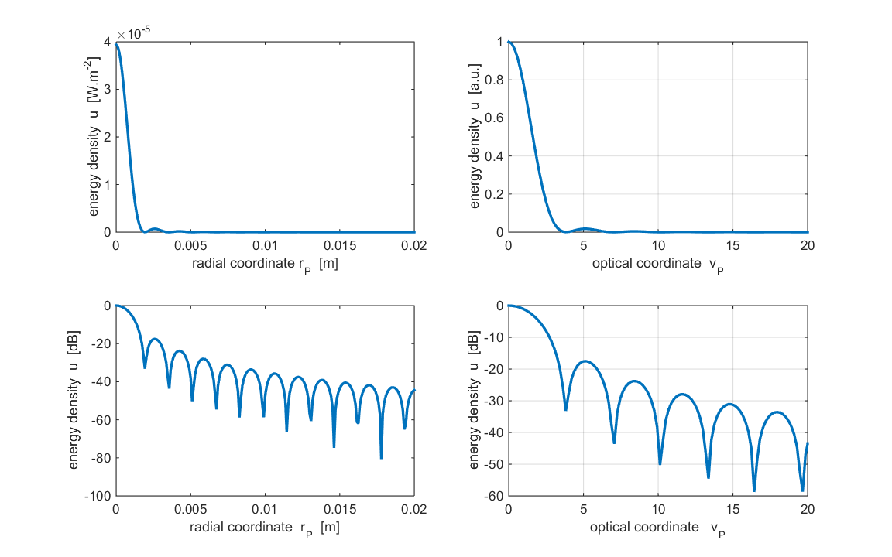

Fig. 5. Energy density plots showing the changes in the diffraction pattern when only the radius is doubled. The upper plots are for *a*1 = 1.00×10-4 m and the lower plots for the larger radius *a*2 = 2.00×10-4 m.

Aperture radius

*a*1 = 1.000×10-4 m *a*2 = 2.000×10-4 m *a*2 / *a*1 = 2.00

Energy emitted by aperture

*UQ*1 = 3.142×10-11 J/s *UQ*2 = 1.257×10-10 J/s *UQ*2 / *UQ*1 = 4.00

Peak energy density (centre peak)

*uPmax*1 = 2.469×10-6 W.m-2 *uPmax*2= 3.938×10-5 W.m-2 *uPmax*1 / *uPmax*1 = 16.1

Position of the first dark ring

*xP*1 = 3.846×10-3 m *xP*2 = 1.923×10-3 m *xP*2 / *xP*1 = 0.50

* 4 times more energy is radiated from the aperture since the energy emitted is proportional to the area of the aperture (π*a*2).
* The strength of the central peak increases by a factor of 16.
* The radius of the Airy Disk is halved - the diffraction pattern is narrow when the aperture size is increased.
* There is no change in the diffraction pattern when the normalized irradiance is plotted against the optical coordinate.

**Doubling the distance *zP* from the aperture to the observation screen**

The effect on the energy density distribution by doubling the distance *zP* from the plane of the aperture to the observation screen is shown in figure (6). The upper plots are for *zP*1 = 1.000 m and the lower plots for the longer distance *zP*2 = 2.000 m.



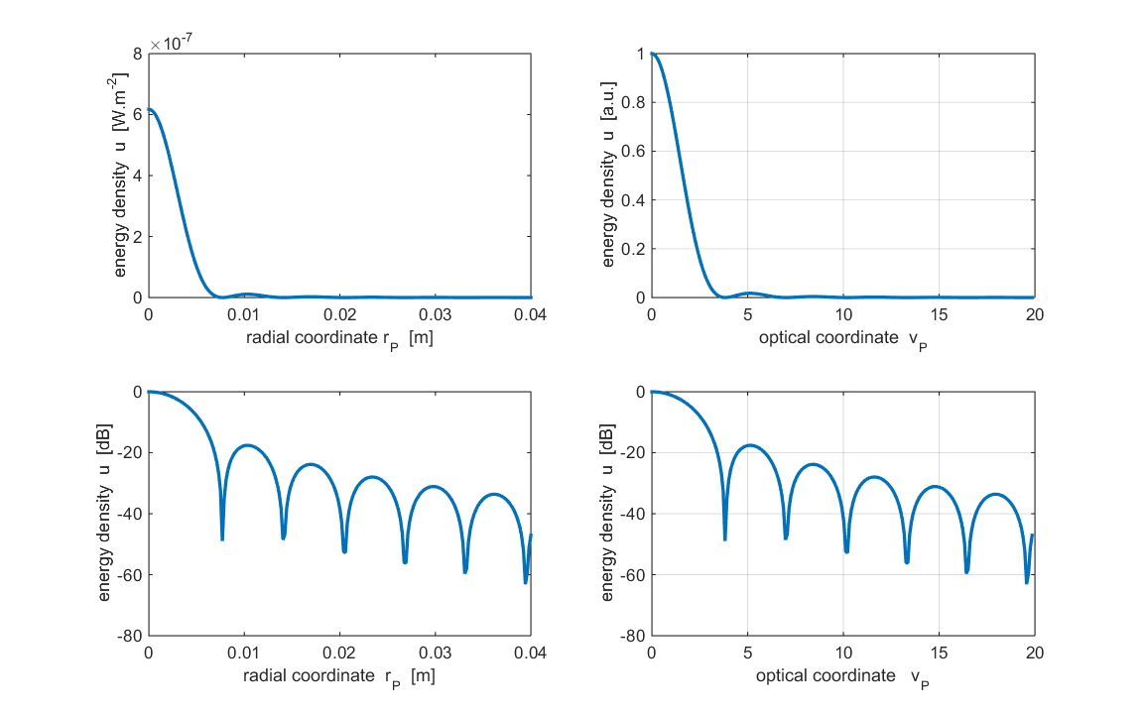

Fig. 6. Energy density plots showing the changes in the diffraction pattern when the aperture to screen distance is doubled.

The upper plots are for *zP*1 = 1.000 m and the lower plots for the larger distance *zP*2 = 2.000 m.

Aperture to screen distance

*zP*1 = 1.000 m *zP*2 = 2.000 m *zP*2 / *zP*1 = 2.00

Peak energy density (centre peak)

*uPmax*1 = 2.469×10-6 W.m-2 *uPmax*2= 6.174×10-7 W.m-2 *uPmax*1 / *uPmax*1 = 0.250

Position of the first dark ring

*xP*1 = 3.846×10-3 m *xP*2 = 7.692×10-3 m *xP*2 / *xP*1 = 2.00

* The peak energy density is reduced by a factor of 4. When the screen is a large distance from the aperture as in Fraunhofer diffraction, the aperture is like a point source and the energy density obeys the inverse square law for increasing distances between the aperture and the source.
* The radius of the Airy Disk is doubled - the diffraction pattern is broader and flatter.
* There is no change in the diffraction pattern when the normalized irradiance is plotted against the optical coordinate.

**FRESNEL DIFFRACTION – NEAR FIELD**

The Rayleigh-Sommerfeld diffraction integral of the first kind given by equation (1) is valid right up to the aperture for the calculation of the electric field at an observation point P.

The transition from Fraunhofer diffraction to Fresnel diffraction can be expressed in terms of the Rayleigh distance. The **Rayleigh distance** in optics is the axial distance from a radiating aperture to a point an observation point P at which the path difference between the axial ray and an edge ray is λ / 4. A good approximation of the Rayleigh Distance  is



where *a* is the radius of the aperture. The Rayleigh distance is also a distance beyond which the distribution of the diffracted light energy no longer changes according to the distance *zP* from the aperture.

*zP* < *dRL* Fresnel diffraction

*zP* > *dRL* Fraunhofer diffraction.

If we consider a circular aperture of radius *a*, then much of the energy passing through the aperture is diffracted through an angle of the order from its original propagation direction. When we have travelled a distance from the aperture, about half of the energy passing through the opening will have left the cylinder made by the geometric shadow if . Putting these formulae together, we see that the majority of the propagating energy in the "far field region" at a distance greater than the Rayleigh distance will be diffracted energy. In this region then, the polar radiation pattern consists of diffracted energy only, and the angular distribution of propagating energy will then no longer depend on the distance from the aperture.

Command Window summary of the parameters used to model Fresnel diffraction from the circular aperture

wavelength [m] = 6.328e-07

nQ = 781200

nP = 809

Aperature Space

radius of aperture [m] = 1.000e-04

energy density [W/m2] uQmax = 1.000e-03

energy from aperture [J/s] UQ(theory) = 3.142e-11

Observation Space

max radius rP [m] = 1.800e-04

distance aperture to observation plane [m] zP = 6.500e-04

Rayleigh distance [m] d_RL = 6.321e-02

energy: aperture to screen [J/s] UP = 3.133e-11

max energy density [W./m2] uPmax = 1.788e-03

Figures (7) and (8) show the Fresnel diffraction pattern for the parameters given above.

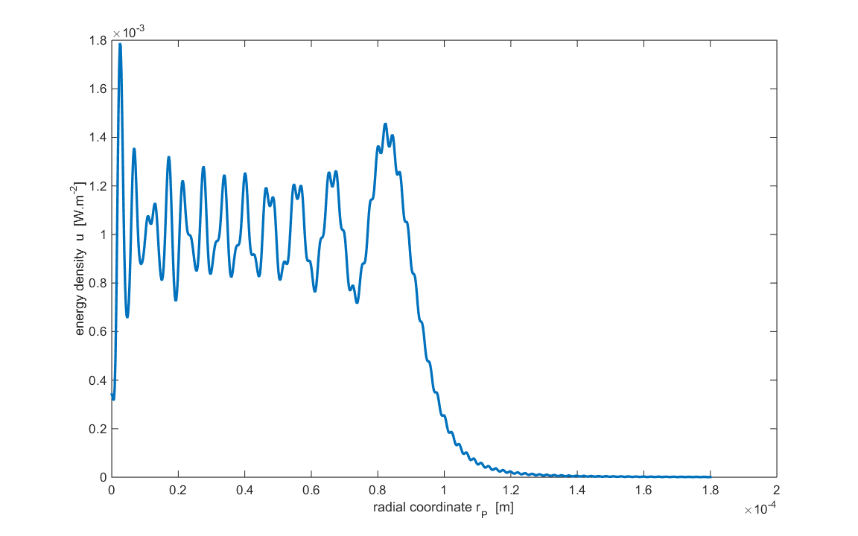

Fig. 7. Fresnel Diffraction pattern.

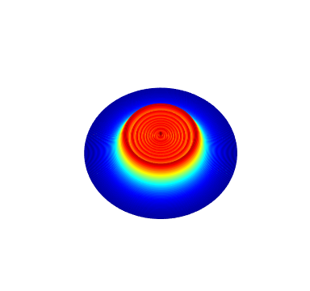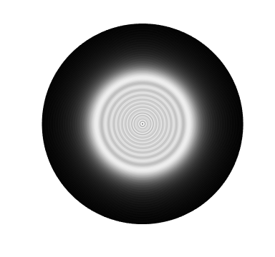

Fig. 8. Diffraction pattern in the near-field showing a set of bright and dark rings but it is very different from the Fraunhofer diifraction pattern. In this example, there is no bright centre spot, in fact, the centre region is dark.

Since the distance between the aperture and observation screen is so small, there is very little spreading of the light by diffraction. 95% of the energy density is concentrated in a circle of radius equal to aperture radius on the observation screen as shown in figure (9).

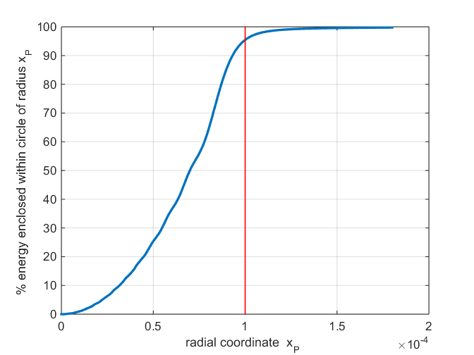

Fig. 9. % energy enclosed within a circle of radius *xP* on the observation screen. 95% of the energy is concentrated in a circle with a radius equal to the radius of the aperture *a* = 1.00×10-4 m.