[**DOING PHYSICS WITH MATLAB**](http://www.physics.usyd.edu.au/teach_res/mp/mphome.htm)

**COMPUTATIONAL OPTICS**

# 

# RAYLEIGH-SOMMERFELD DIFFRACTION INTEGRAL: CIRCULAR TYPE APERTURES

# 

Ian Cooper

School of Physics, University of Sydney

ian.cooper@sydney.edu.au

[**DOWNLOAD DIRECTORY FOR MATLAB SCRIPTS**](http://www.physics.usyd.edu.au/teach_res/mp/mscripts)

**op_rs_cxy_01.m**

Calculation of the irradiance in a plane perpendicular to the optical axis for a uniformly illuminated circular type apertures. The mscript can be used for annular apertures and for observation planes close to the aperture plane.

[View](http://www.physics.usyd.edu.au/teach_res/mp/op/doc/op_diffraction_integrals_theory.pdf) the paper on scalar diffraction theory and the numerical procedure for evaluating the Rayleigh-Sommerfeld diffraction of the first kind.

**Rayleigh-Sommerfeld diffraction integral of the first kind**

The electric field at an observation point P can be expressed as

(1) 

The Rayleigh-Sommerfeld diffraction integral of the first kind is the most useful form of diffraction integral since it is easy to approximate this integral numerically for many different type apertures and for focused beams. A matrix method to evaluate the integral is called the [Simpson two-dimensional method](http://www.physics.usyd.edu.au/teach_res/mp/doc/math_integration_2D.pdf).

(2) 

where *Smn* are the Simpson’s two-dimensional coefficients and *E*0 is a normalizing constant. Each term in equation (2) can be expressed as a matrix of size *N* × *N*  and the matrices can be manipulated very easily in Matlab to give the estimate of the integral. The irradiance is proportional to the square of the magnitude of the electric field, hence the irradiance in the space beyond the aperture can be calculated by

(3) 

where *I*0 is a normalizing constant and *E*\* is the complex conjugate of *E*.

**UNIFORMLY ILLUMINATED CIRCULAR TYPE APERTURES**

The geometry for the diffraction pattern from circular type apertures is shown in figure (1).



Fig. 1. Circular aperture geometry.

(1) 

The radial coordinate *vP* is a scaled perpendicular distance from the optical axis.

**Diffraction pattern for a uniformly illuminated circular aperture in the far field (Fraunhofer diffraction)**

[View](http://www.physics.usyd.edu.au/teach_res/mp/op/doc/op_diffraction_01.pdf) the paper on Fraunhofer diffraction for a circular aperture.

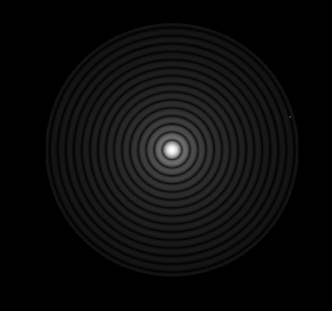

Fig.2. Diffraction pattern as computed using **op_rs_cxy_01.m**. The image is like a black and white time exposure photograph of the diffraction pattern that would be observed on a screen for a uniformly illuminated circular aperture. The bright centre spot corresponds to the zeroth order of diffraction and is known as the Airy Disk.

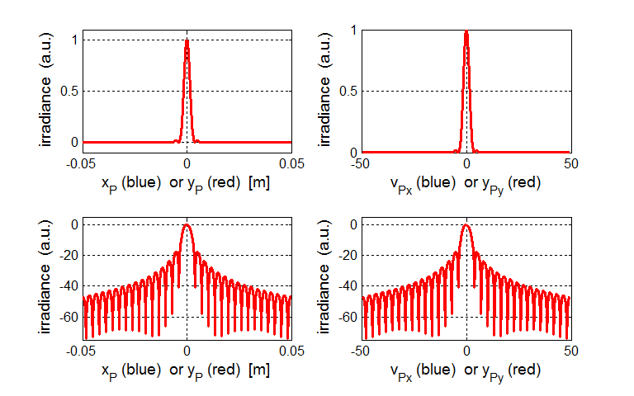

Fig. 3. The irradiance patterns along the X and Y axes for a circular aperture. The lower plot has a log scale for the irradiance . Since the pattern is symmetrical, the irradiance variation is the same in the X and Y directions. **op_rs_cxy_01.m**

In the far field, the Fraunhofer diffraction pattern for the circular aperture is circularly symmetric and consists of a bright central circle surrounded by series of bright rings of rapidly decreasing strength between a series of dark rings. The bright and dark rings are not evenly spaced. The bright central region is known as the **Airy disk**. It extends to the first dark ring at *vP* = 3.831 (the first zero of the Bessel function of the first kind).

**Energy enclosed within the dark rings of the diffraction pattern**

We can compute the energy enclosed within a ring of a given radius on the observation screen by integrating the irradiance over the circular area defined by the given radius. Table 1 gives the energy enclosed within each of the dark rings in the far field for a uniformly illuminated circular aperture. It has been assumed that 100% of the energy falls on the observation screen within the optical coordinate radius of *vP* = 50. The first dark ring is at *vP* = 3.87 and the energy within the first dark ring is 84.9%. Fig. (3) shows a plot of the energy enclosed within circles of increasing radius defined by the optical coordinate *vP* for a uniformly illuminated circular aperture.

Table 1. Energy enclosed within a prescribed radius on the observation screen in the far field for a uniformly illuminated circular aperture.

|  |  |
| --- | --- |
| **Dark rings *vP*** | **Energy enclosed**  **(%)** |
| 3.87 | 84.9 |
| 7.02 | 92.2 |
| 10.2 | 95.0 |
| 13.3 | 96.5 |
| 16.5 | 97.4 |
| 19.6 | 98.0 |
| 22.8 | 98.5 |
| 25.9 | 98.8 |
| 29.1 | 99.1 |
| 32.3 | 99.3 |
| 35.4 | 99.5 |
| 38.4 | 99.6 |
| 41.6 | 99.8 |
| 44.7 | 99.8 |
| 47.9 | 99.9 |

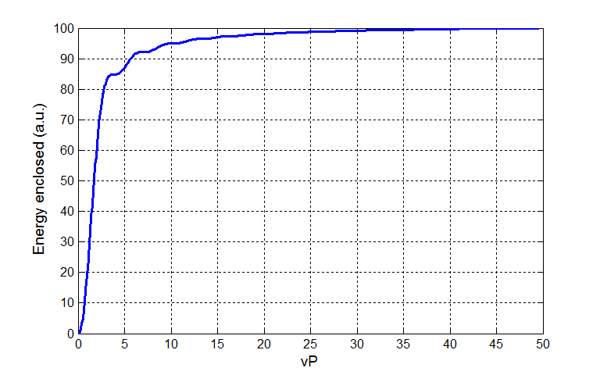

Fig. 4. Energy enclosed with a rings of increasing radius on the observation screen in the far field for a uniformly illuminated circular aperture.