[**DOING PHYSICS WITH MATLAB**](http://www.physics.usyd.edu.au/teach_res/mp/mphome.htm)

[**COMPUTATIONAL OPTICS**](http://www.physics.usyd.edu.au/teach_res/mp/ophome.htm)

# RAYLEIGH-SOMMERFELD DIFFRACTION

# RECTANGULAR APERTURES

# 

Ian Cooper

School of Physics, University of Sydney

ian.cooper@sydney.edu.au

[**DOWNLOAD DIRECTORY FOR MATLAB SCRIPTS**](http://www.physics.usyd.edu.au/teach_res/mp/mscripts)

**op_rs_rxy_01.m**

Calculation of the irradiance in a plane perpendicular to the optical axis for a uniformly illuminated rectangular aperture.

**simpsonxy_coeff.m**

Function to calculate Simpson’s two-dimensional coefficients

**fn_distancePQ.m**

Function to calculate distance between two points

**turningPoints.m**

Function to find the zero crossings of a function and its maxima and minima

**op_rs_rxy_02.m**

Updated version of **op_rs_rxy_01.m**. Calculation of the irradiance in a plane perpendicular to the optical axis for a rectangular aperture. The irradiance is not scaled but calculated in W.m-2. The energy per second from the aperture to the observation screen is calculated and the energy per second within a circle of radius equal to the position of the first minima in the X direction in the observation screen is also calculated.

**simpson2d.m**

Function to calculate the value of a two-dimensional integral using the Simpson’s [2D] method.

**fn_distancePQ.m**

Function to calculate distance between two points

**FRAUNHOFER DIFFRACTION – RECTANGULAR APERTURE**

We will consider the Fraunhofer diffraction patterns for a single rectangular aperture that is uniformly illuminated. The X and Y widths the rectangular aperture are *ax* and *a­y* respectively. The irradiance distribution *I* is given by the product of two single slit functions

(1)  **Fraunhofer diffraction**

where *I*0 is a normalizing constant and the optical coordinates *vPx* and *vPy* are

(2) 

and the angles  and  define the direction of the diffracted ray

(3) 

The geometry for the diffraction pattern from a rectangular aperture is shown in figure (1).



Fig. 1. Geometry for a rectangular aperture with dimensions *ax* x *ay*. The radial coordinates are scaled perpendicular distance from the optical axis.

The resulting diffraction pattern for the irradiance has lines of zeros when

(3a)  and 

or

(3b) 

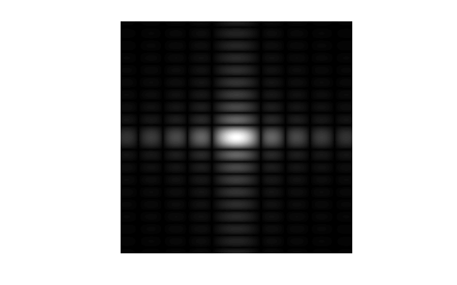

Fig. 1. Photograph like image for the Fraunhofer diffraction pattern of a rectangular aperture *ay* = 2*ax*.

However, a more versatile approach to study the diffraction from an aperture is to evaluate the **Rayleigh-Sommerfeld diffraction integral of the first kind**. No approximations need to be made and the irradiance can be calculated in the near and far fields in an XY plane and along the Z axis right. There is excellent agreement between the far field predictions of the Fraunhofer theory and the results of evaluating the Rayleigh-Sommerfeld diffraction integral.

**RAYLEIGH DIFFRACTION INTEGRAL OF THE FIRST KIND**

The **Rayleigh-Sommerfeld region** includes the entire space to the right of the aperture. It is assumed that the Rayleigh-Sommerfeld diffraction integral of the first kind is valid throughout this space, right down to the aperture. There are no limitations on the maximum size of either the aperture or observation region, relative to the observation distance, because **no approximations have been made**.

The Rayleigh-Sommerfeld diffraction integral of the first kind (RS1) can be expressed as

(4) 

where *EP* is the electric field at the observation point P, *EQ* is the electric field within the aperture and *rPQ* is the distance from an aperture point Q to the point P. The double integral is over the area of the aperture *S­A*.

**Approach 1 to evaluating The Diffraction Integral**

**op_rs_rxy_01.m**

The double integral can be estimate numerically by a [two-dimensional form of Simpson’s 1/3 rule](http://www.physics.usyd.edu.au/teach_res/mp/doc/math_integration_2D.pdf). The electric field *EP* at the point P is computed by

(5) 

where *Smn* are the Simpson’s two-dimensional coefficients and *E*0 is a normalizing constant. Each term in equation (2) can be expressed as a matrix of size *N* × *N*  and the matrices can be manipulated very easily in Matlab to give the estimate of the integral. The irradiance is proportional to the square of the magnitude of the electric field, hence the irradiance in the space beyond the aperture can be calculated by

(6) 

where *I*0 is a normalizing constant and *E*\* is the complex conjugate of *E*.

**Approach 2 to evaluating The Diffraction Integral**

**op_rs_rxy_02.m**

Instead of using arbitrary units for electric field and irradiance we can perform all calculations in S.I. units.

The **irradiance** or more generally the term **intensity** has S.I. units of W.m-2. Another way of thinking about the irradiance is to use the term **energy density** as an alternative. The use of the letter *I* can be misleading, therefore, we will use the symbol *u* to represent the irradiance or energy density.

The irradiance or energy density *u* of a monochromatic light wave in matter is given in terms of its electric field *E* by

(7) 

*n* is the refractive index of the medium, *c* is the speed of light in vacuum and *ε*0 is the permittivity of free space. This formula assumes that the magnetic susceptibility is negligible, i.e.  where  is the magnetic permeability of the light transmitting media. This assumption is typically valid in transparent media in the optical frequency range.

At a point Q in the aperture plane, the energy density is given by the symbol *uQ* and in the observation plane at a point P the symbol used is *uP*. The energy transferred *U* from the aperture plane to observation plane per second is found by integrating the energy density with respect to an area

(8a)  [W or J/s]

The energy per second radiated from the aperture is

(8b)  integration over the area of the aperture

The energy per second reaching an area *SP* of the observation plane is

(8c)  integration over the area element of the

observation plane

In the mscript **op_rs_rxy_02.m** for the aperture, the dimensions *ax* and *ay* are specified [m] and the energy density *uQ* [W.m-2]. Hence, the electric field *EQ* within the aperture is

(9) 

The integral to find the electric *EP* at a point P in the observation plane is

(4) 

where *EQ* is given by equation (9) and the integral is computed using a [two-dimensional form of Simposn’s 1/3 rule](http://www.physics.usyd.edu.au/teach_res/mp/doc/math_integration_2D.pdf).

The integrals given in equations (8) are also computed using the two-dimensional form of Simpson’s 1/3 rule.

Once *EP* is known, the energy density *uP* is calculated from equation (7) and energy *UP* from equation (8c).

**SIMULATIONS op_rs_rxy_01.m**

**Rectangular aperture (far field)**

Input parameters

nP = 495; % observation points for P must be ODD

nQ = 147; % aperture points for Q must be ODD

wL = 632.8e-9; % wavelength [m]

aQx = 1e-4; % defines aperture size [m]

aQy = 2e-4;

aP = 30e-3; % defines size of observation space [m]

zQ = 0; zP = 1; % z distance between aperture plan and

observation plane [m]

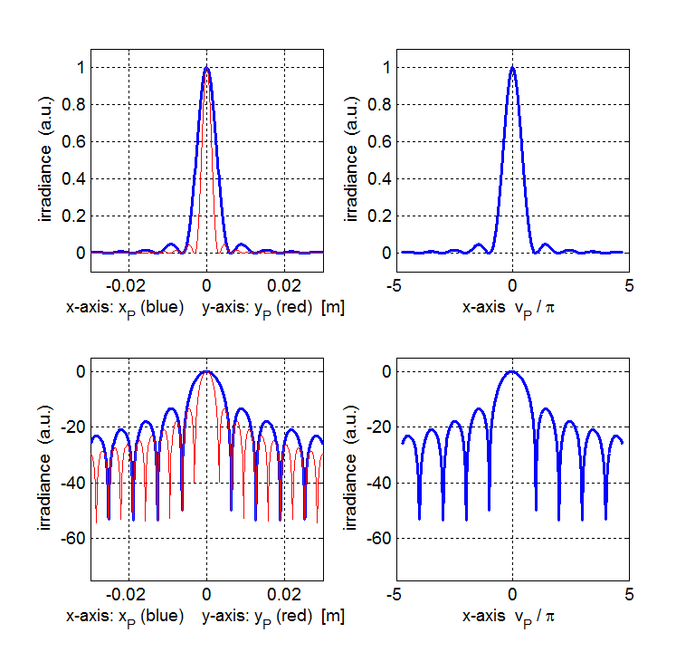

Fig. 2. Irradiance patterns in the along the *X* and *Y* axes. The maximum irradiance has been normalized to 1. The bottom curves use a log scale for the irradiance .

Figures (2) and (3) shows the irradiance for a rectangular aperture with *ay* = 2 *ax*. The diffraction pattern is characterized by a strong central maximum and very weak peaks of decreasing magnitude away from the optical axis. The separation of the dark bands along the *Y* axes is narrower than along the *X* axis. Figure (3) shows photograph like images of the diffraction pattern. The irradiance is scaled to represent the different exposure times.

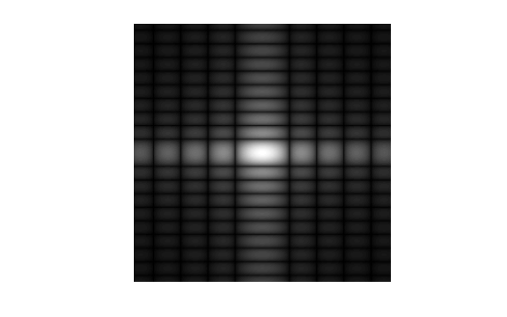

Fig. 3. Photograph like images for the diffraction patterns for a rectangular aperture. The image on the right is scaled to represent a longer exposure time.

In Tables 2 and 3 are listed values of the first few maxima and zeros of the diffraction pattern that were calculated using **op_rs_rxy_01.m** and the function **turningPoints.m**. The function returns the values of indexMax and indexMin. Then in the Command Window the values of the radial coordinates for the peaks and zeros can be displayed.

[View document of Turning points of a function](http://www.physics.usyd.edu.au/teach_res/mp/doc/math_turning_points.pdf)

The theoretical values are for the zero crossing and minima and maxima of the function  which gives the Fraunhofer diffraction pattern for a single slit.

[View document of the sinc function](http://www.physics.usyd.edu.au/teach_res/mp/doc/math_sinc_function.pdf)

Table 2. Relative irradiances of the maxima of the diffraction pattern.

|  |  |  |  |  |  |
| --- | --- | --- | --- | --- | --- |
| **peaks** | **central** | **1st** | **2nd** | **3rd** | **4th** |
| **theory** | **0** | ± 1.429 | ± 2.462 | ± 3.470 | ± 4.478 |
| ***vP* / *π*** | 0 | ± 1.440 | ± 2.457 | ± 3.473 | ± 4.470 |
| **theory** | 1.0000 | 0.0472 | 0.0165 | 0.0083 | 0.0050 |
| ***I*/*I*o** | 1.0000 | 0.0471 | 0.0165 | 0.0083 | 0.0050 |

Table 3. Zeros in the irradiance for the diffraction pattern

|  |  |  |  |  |
| --- | --- | --- | --- | --- |
| **zeros** | **1st** | **2nd** | **3rd** | **4th** |
| **theory** | **± 1** | **± 2** | **± 3** | **± 4** |
| ***vP* / π** | ± 0.9981 | ± 1.9960 | ± 2.9937 | ± 3.9910 |

How finding the zero crossings (indexMin) and maxima (indexMax) in the **Command Window** where indexMin gives the position in an array for the zeros and indexMax gives the position in arrays for the maxima. Note the Matlab variable for the irradiance is WP.

Type in the Command Window:

yData = WP(indexyP,:);

xData = xP(indexyP,:) ;

[indexMin indexMax] = turningPoints(xData,yData);

indexMin 🡪 24 55 86 117 179 210 241 272

vPx(indexyP, indexMin)./pi 🡪

-3.9910 -2.9937 -1.9960 -0.9981 0.9981 1.9960 2.9937 3.9910

indexMax 🡪 9 40 72 104 148 192 224 256 287

vPx(indexyP, indexMax)./pi 🡪

-4.470 -3.473 -2.457 -1.4440 0.0000 1.4440 2.457 3.473 4.470

WP(indexyP, indexMax) 🡪

0.0050 0.0083 0.0165 0.0471 1.0000 0.0471 0.0165 0.0083 0.0050

In a figure Window you can use the Data Cursor to find values for the zero crossings and maxima.

There is excellent agreement between the predictions of the Fraunhofer approximation and the calculations performed by evaluating the Rayleigh-Sommerfeld diffraction integral.

**Diffraction pattern in near field**

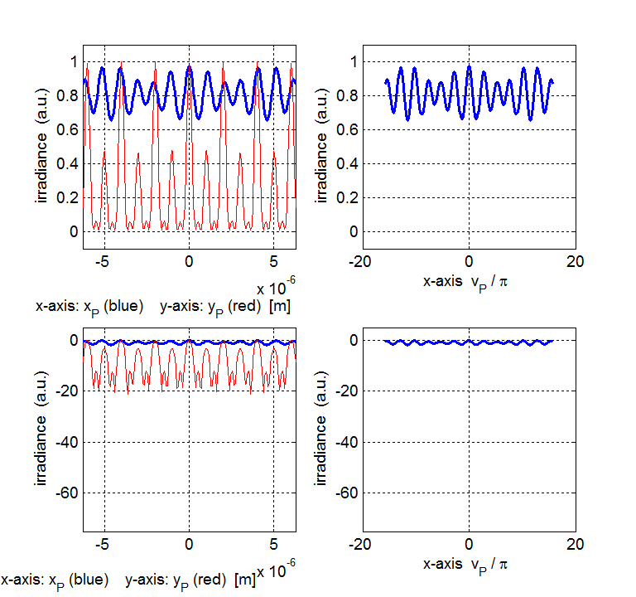

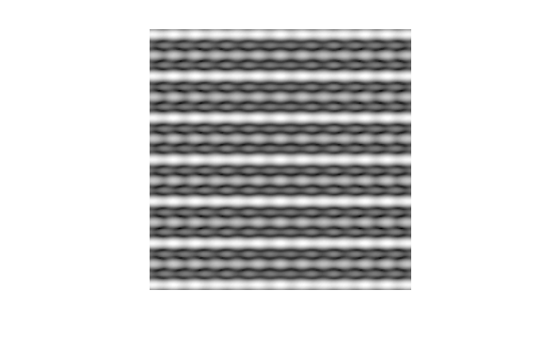

Fig. 4. Diffraction pattern from a rectangular aperture. Observation plane close to aperture plane *zP* = 100λ and observation plane dimensions 10λx10λ.

**Diffraction – single slit**

slit dimensions *ax* = 1x10-4 m *ay* = 1x10-6 m

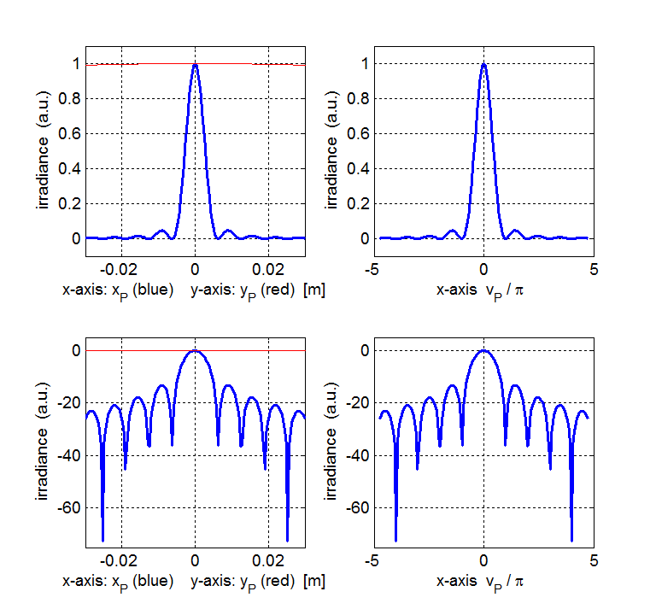

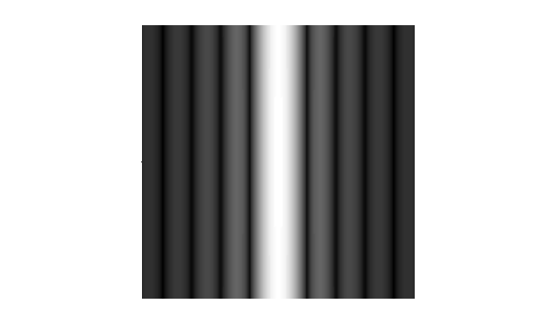

Fig. 5. Diffraction pattern from a single slit.

**Diffraction – square aperture**

slit dimensions *ax* = 1x10-4 m *ay* = 1x10-4 m

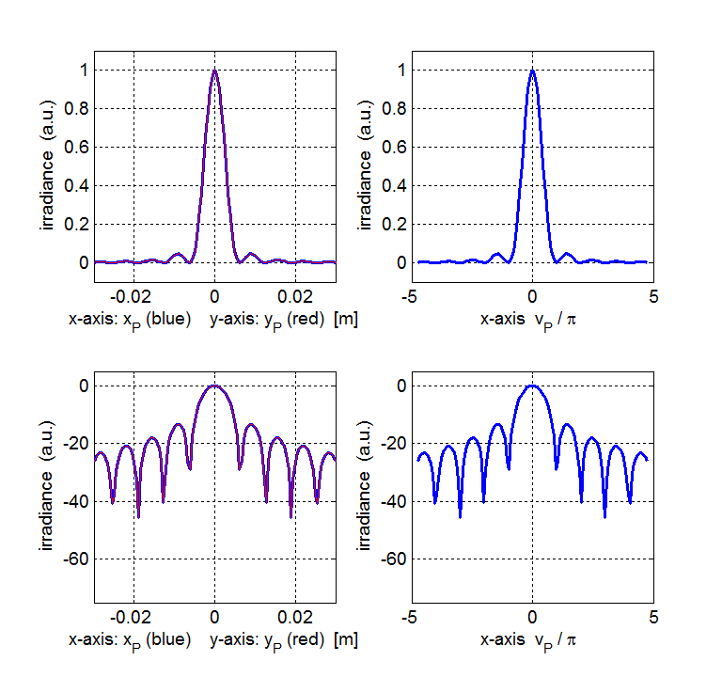

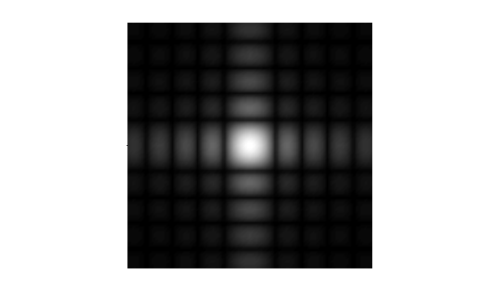 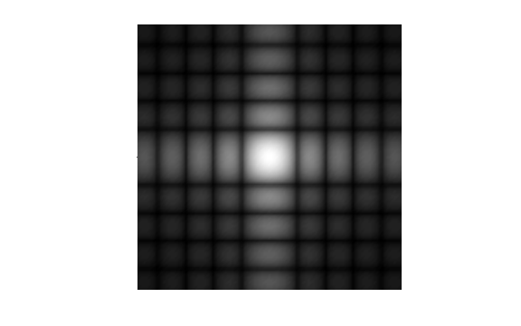

Fig. 6. Diffraction pattern from a square aperture with different scaling for the irradiance.

**SIMULATIONS op_rs_rxy_02.m**

The parameters for the aperture and observation planes are all changed within the mscript. After the program is run, a summary of the input and output parameters is shown in the Command Window.

Table 1: Parameter summary [SI units]

wavelength [m] = 6.33e-07

nQ = 099

nP = 201

Aperature Space

X width [m] = 1.000e-04

Y width [m] = 2.000e-04

energy density [W/m2] uQmax = 1.000e-03

energy from aperture [J/s] UQ(theory) = 2.000e-11

energy from aperture [J/s] UQ(calculated) = 2.000e-11

Observation Space

X width [m] = 4.000e-02

Y width [m] = 4.000e-02

distance aperture to observation plane [m] zP = 1.000e+00

Fraunhofer: position of 1st min in X direction [m] = 6.328e-03

Fraunhofer: position of 1st min in Y direction [m] = 3.164e-03

max energy density [W./m2] uPmax = 9.987e-07

energy to aperture [J/s] UP = 1.902e-11

percentage energy enclosed within circle of radius (vPx = 3.14159) = 99.5

Elapsed time is 40.470176 seconds.

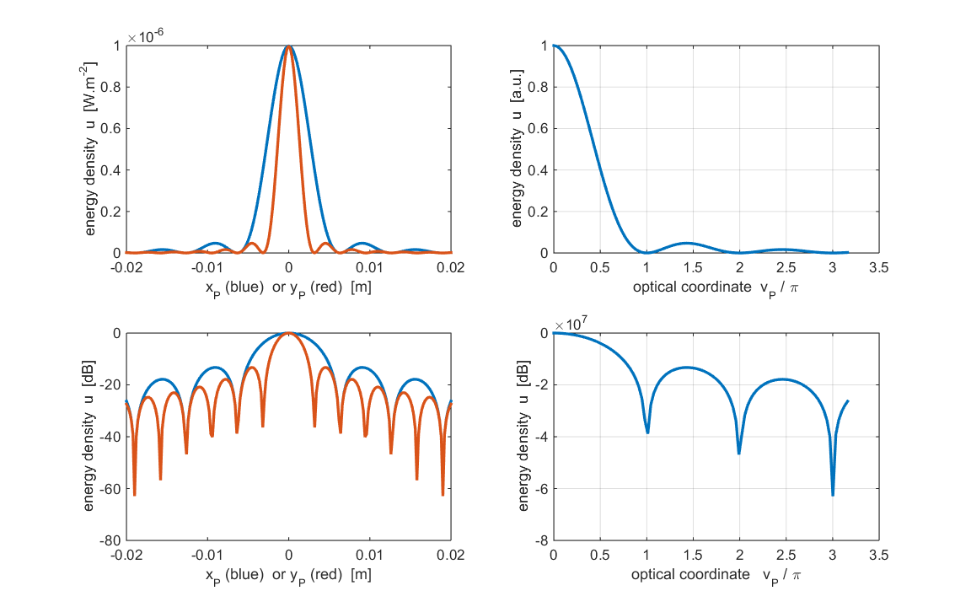

Fig. 7. The variation on the energy density along the X and Y directions. The plot was created in Matlab version 2014b which has improved graphics compared to earlier versions.

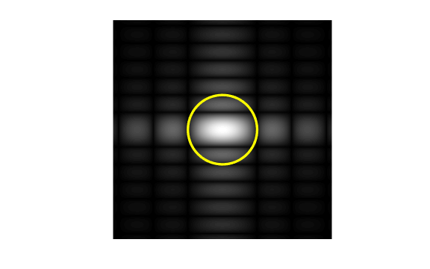

Fig. 8. Black and white photograph like time exposure of the diffraction pattern. The yellow circle has a radius equal to the position of the first zero along the X axis. 99.5% of the energy incident upon the observation screen is concentrated within this circle.

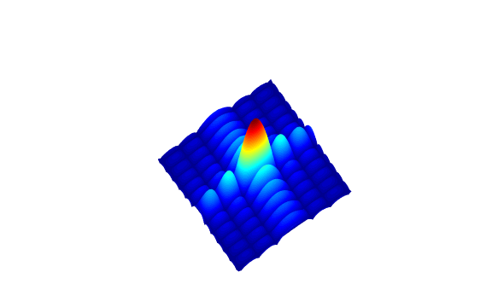

Fig. 9. A Matlab surf style plot showing the energy density in the XY observation plane.

**Investigations**

In the Fraunhofer region (far field) the **inverse square law** applies. This can be tested by doubling the aperture plane to the observation plane distance and noting that the maximum energy density at a point on the Z axis decreases by a factor of 4. For example using the data as shown in Table 1 and only varying the distance *zP*:

*zP*1 = 1

energy density *uPmax*1 = 9.987x10-7 W.m-2

1st min *x*1min = 6.328x10-3 m *y*1min = 3.164x10-3 m

*zP*2 = 2

energy density *uPmax2* = 2.3497x10-7 W.m-2

1st min *x*2min = 12.66x10-3 m *y*2min = 6.328x10-3 m

*zP*2 / *zP*1 = **2**

*uPmax*2/ *uPmax*1 = **1/4** **inverse square law satisfied**

*x*2min / *x*1min = **2.0** *y*2min / *y*1min = **2.0 pattern is wider**

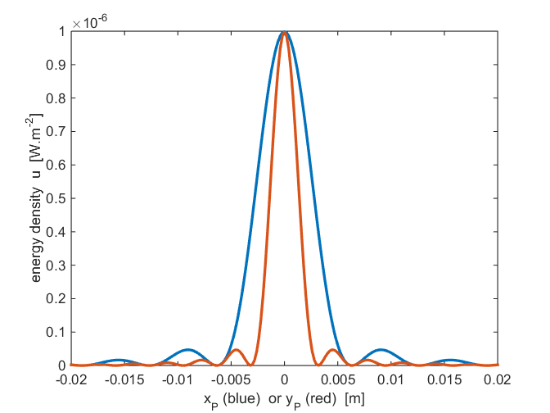

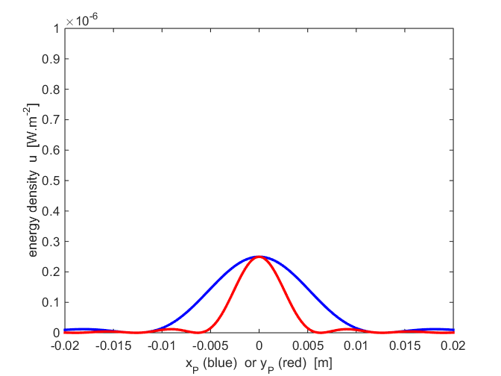

Fig. 10. Fraunhofer diffraction: upper plot *zP* = 1.0 m and lower plot *zP* = 2.0 m. As the aperture to observation plane distance increases the energy density distribution shape does not change but becomes wider and flatter.

Next, we can consider the effect of halving the area of the aperture by changing the width *ay* in the Y direction from 2x10-4 m to 1.0x10-4 m.

Width *ay*1 = 2x10-4 m *ay*2 = 1x10-2 m

Energy transferred from aperture to observation plane

*UQ*1 = 2.0x10-11 J.s-1 *UQ*2 = 1.0x10-11 J.s-1

*UQ*2 / *UQ*1 = 0.50

Maximum energy density in observation plane

*uPmax*1 = 9.987x10-7 W.m-2 *uPmax*2 = 2.497x10-7 W.m-2

*uPmax*2 / *uPmax*1 = 0.25

The effect of doubling the area of the aperture results in a doubling of the energy transferred from the aperture to the observation plane and a four-fold increase in the energy density.

**Fresnel Diffraction ⇔ Fraunhofer Diffraction**

Fraunhofer diffraction is only valid in the far field. There is a transition from Fraunhofer diffraction to Fresnel diffraction as the distance between the aperture and observation planes decreases. The distance dividing the two regimes is known as the **Rayleigh distance** 

 where *a* is the maximum of *ax* and *ay*

Fraunhofer diffraction (far field) *zP* > *dRL*

Fresnel diffraction (near field) *zP* < *dRL*

For an aperture *ax* = *ay* = 1.0x10-4 m and wavelength  = 6.33x10-7 m, the Rayleigh distance is

= 1.58x10-2 m

The mscript **op_rs_rxy_02.m** can be run a few times to investigate the transition regime when *zP* ~ *dRL* by changing the values for *zP*, *xP* and *yP* in the mscript.

**Rayleigh distance *dRL* = 0.0158 m**

|  |  |
| --- | --- |
|  |  |
|  |  |
|  |  |