[**DOING PHYSICS WITH MATLAB**](http://www.physics.usyd.edu.au/teach_res/mp/mphome.htm)

[**COMPUTATIONAL OPTICS**](http://www.physics.usyd.edu.au/teach_res/mp/ophome.htm)

# RAYLEIGH-SOMMERFELD DIFFRACTION

# DOUBLE SLIT

# 

Ian Cooper

School of Physics, University of Sydney

ian.cooper@sydney.edu.au

[**DOWNLOAD DIRECTORY FOR MATLAB SCRIPTS**](http://www.physics.usyd.edu.au/teach_res/mp/mscripts)

**op_rs_rxy_03.m**

Calculation of the energy density in a plane perpendicular to the optical axis for a double slit

**simpson2d.m**

Function to calculate the value of a two-dimensional integral using the Simpson’s [2D] method.

**fn_distancePQ.m**

Function to calculate distance between two points

Review the following website for more detail of the Rayleigh-Sommerfeld diffraction integral.

[Scalar Diffraction Theory](http://www.physics.usyd.edu.au/teach_res/mp/op/doc/op_diffraction_integrals_theory.pdf)

[Diffraction from rectangular apertures](http://www.physics.usyd.edu.au/teach_res/mp/op/doc/op_rs1_rxy_01.pdf)

[Surface [2D] integration](http://www.physics.usyd.edu.au/teach_res/mp/doc/math_integration_2D.pdf)

**RAYLEIGH DIFFRACTION INTEGRAL OF THE FIRST KIND**

The **Rayleigh-Sommerfeld region** includes the entire space to the right of the aperture. It is assumed that the Rayleigh-Sommerfeld diffraction integral of the first kind is valid throughout this space, right down to the aperture. There are no limitations on the maximum size of either the aperture or observation region, relative to the observation distance, because **no approximations have been made**.

The Rayleigh-Sommerfeld diffraction integral of the first kind (RS1) can be expressed as

(1) 

where *EP* is the electric field at the observation point P, *EQ* is the electric field within the aperture and *rPQ* is the distance from an aperture point Q to the point P. The double integral is over the area of the aperture *S­A*.

The [2D] integration is performed over a rectangular ( *ax* × *ay* ) with integration limits (to ) and ( to ). The aperture space is made up of a grid on *nQ* x *nQ* points.

1. The maximum energy density *uQmax* [W.m-2] in the aperture space is specified

uQmax = 1e-3;

2. The electric field *EQ* is calculated at each grid point

EQmax = sqrt(2*uQmax/(cL*nR*eps0));

EQ = EQmax .* ones(nQ,nQ);

3. By setting a subset of the *EQ* values to zero, the shape of the aperture can be established.

The code for the mscript **op_rs_rxy_03.m** needs to be modified for different shaped apertures by changing: values for the input parameters, the setting of the values *EQ* to 0, the output parameters, the Figure Windows, etc.

**DOUBLE SLIT**

Many aspects of the diffraction of electromagnetic radiation by a double slit arrangement can be investigated numerically by integrating the Rayleigh-Sommerfeld diffraction integral. Several examples will be given.

In the mscript, you can vary the values of the wavelength, slit widths in the X and Y directions and the separation between slits (centre to centre distance).

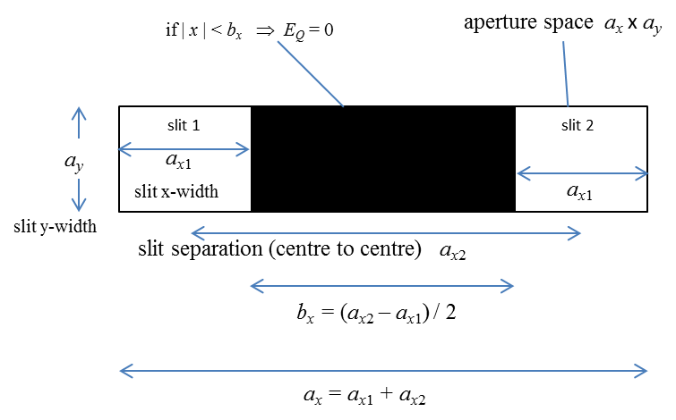

Fig. 1. Geometry for double slit simulations.

The energy density (irradiance) distribution function for two parallel slits in the Fraunhofer region is

(2)  **Fraunhofer diffraction**

where *I*0 is a normalizing constant and the optical coordinates *vPx* , *vPy* and are

(3) 

In the X direction the term

 **envelope: single slit diffraction**

is for the single slit of width *ax*1 and constitutes an envelope for the interference fringes given by the term

 **two slit interference term**

For the envelope function, the diffraction pattern for the irradiance has lines of zeros in the X direction when

(4)  **ZEROS in the envelope**

The maxima in the interference term in the X direction are given by

(5)  **MAX in the interference pattern**

You can compare the Fraunhofer predictions with the numerical predictions by running the mscript **op_rs_rxy_03.m** with different parameters.

**Simulation**

Two slits of width 0.015 mm are separated by a distance of 0.060 mm and illuminated by light of wavelength 650 nm. The distance between the aperture and the screen is 1.00 m

(1) How many bright fringes are seen in the central maximum?

(2) What are the positions of the first two minima in the X direction for the envelope?

(3) What are the positions of the first three maxima in the X direction for the diffraction distribution function?

(4) What is the spacing between the bright fringes?

***Traditional approach***

*ax*1 = 0.015x10-3 m *ax*2 = 0.060x10-3 m *zP* = 1.00 m *λ* = 650x10-9 m

(1)

First diffraction minimum



*m*th interference maxima *m* = ?



Angles are equal 



Number of bright fringes = 2*m* - 1 = **7**

(2)

Envelope minimum

 *m* = 1 and 2

1st min ***xP* = 0.0434 m** 2nd min ***xP* = 0.087 m**

The calculation can be done in the Command Window

m = [1 2]

zP * tan(asin(m.*wL ./ax1))

Diffraction / Interference maxima



1st min ***xP* = 0.0108 m** 2nd min ***xP* = 0.0217 m** 3rd min ***xP* = 0.0325 m**

The calculation can be done in the Command Window

m = [1 2 3]

zP * tan(asin(m.*wL ./ax2))

(3)

Spacing between fringes = **0.0108 m**

0 and 1 = 0.0108 m

1 and 2 = (0.0217 – 0.108) m = 0.0108 m

2 and 3 = (0.325 – 0.0217) m = 0.0108 m

***Computational approach using******op_rs_rxy_03.m***

Parameter Summary in Command Window

wavelength [m] = 6.5e-07

nQ = 059

nP = 401

Aperture Space

X width [m] = 7.500e-05

Y width [m] = 1.500e-05

Observation Space

X width [m] = 2.000e-01

Y width [m] = 2.000e-01

distance aperture to observation plane [m] zP = 1.000e+00

Elapsed time is 72.317100 seconds.

**Graphical output**

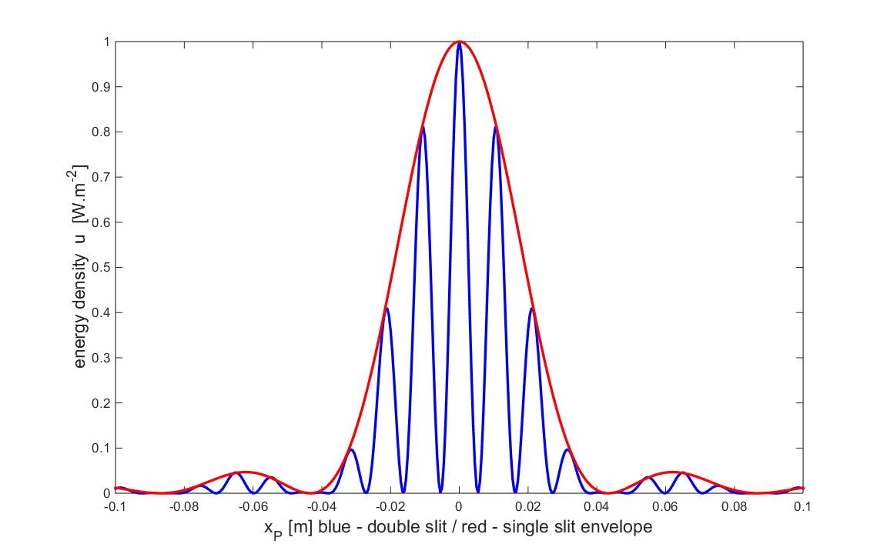

Fig. 2. Diffraction pattern for a double slit. The envelope (red) was determined by setting the width of the slit in the Y direction to be equal to width of the slit in the X direction and then plotting the variation of the energy density in the Y direction.

(1)

From figure 2, there are 7 bright fringes within the region of the central maximum.

(2)

Using the Data Cursor in the Figure Window for figure 1, the positions minima of the envelope and maxima for the interference are:

Envelope min 0.0430 m 0.087 m

Interference max 0.0105 m 0.0210 m 0.0315 m

(3)

Fringe spacing 0.0105 m

Comparing the results, there is excellent agreement between the Fraunhofer predictions and the numerical answers.

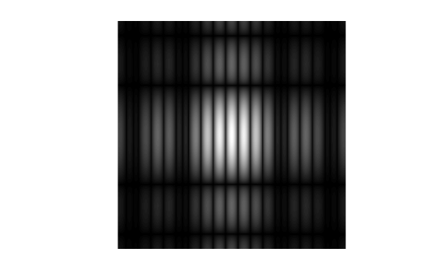

Fig. 3. Photographic-like image of the diffraction pattern for the double slit.

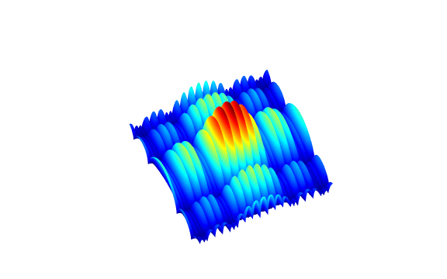

Fig. 4. Scaled surf plot of the energy density for the double slit diffraction.

The numerical approach is much more versatile than the Fraunhofer analytical approach to studying diffraction phenomena. For example, by changing a few parameters, one can observe the diffraction pattern in the near field as shown in figure 5.

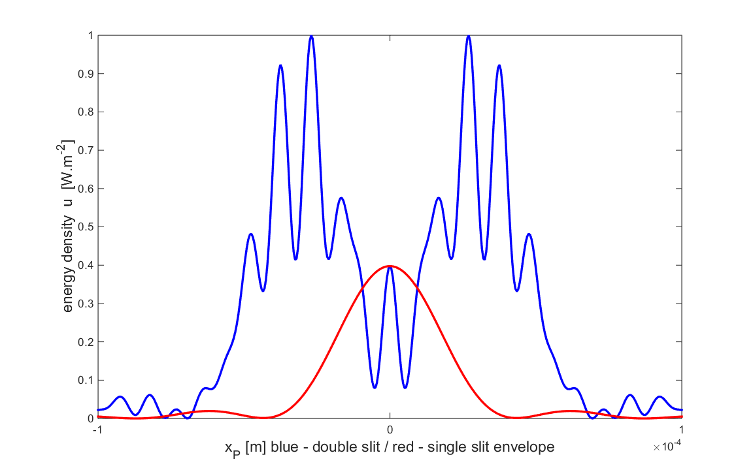

Fig.5. The diffraction pattern in the near field *zP* = 1.0 mm.