[**DOING PHYSICS WITH MATLAB**](http://www.physics.usyd.edu.au/teach_res/mp/mphome.htm)

[**COMPUTATIONAL OPTICS**](http://www.physics.usyd.edu.au/teach_res/mp/ophome.htm)

# RAYLEIGH-SOMMERFELD DIFFRACTION

# CROSS SHAPED APERTURES

# 

Ian Cooper

School of Physics, University of Sydney

ian.cooper@sydney.edu.au

[**DOWNLOAD DIRECTORY FOR MATLAB SCRIPTS**](http://www.physics.usyd.edu.au/teach_res/mp/mscripts)

**op_rs_rxy_04_man.m**

Calculation of the energy density in a plane perpendicular to the optical axis for a double slit

**simpson2d.m**

Function to calculate the value of a two-dimensional integral using the Simpson’s [2D] method.

**fn_distancePQ.m**

Function to calculate distance between two points

Review the following website for more detail of the Rayleigh-Sommerfeld diffraction integral.

[Scalar Diffraction Theory](http://www.physics.usyd.edu.au/teach_res/mp/op/doc/op_diffraction_integrals_theory.pdf)

[Diffraction from rectangular apertures](http://www.physics.usyd.edu.au/teach_res/mp/op/doc/op_rs1_rxy_01.pdf)

[Surface [2D] integration](http://www.physics.usyd.edu.au/teach_res/mp/doc/math_integration_2D.pdf)

**RAYLEIGH DIFFRACTION INTEGRAL OF THE FIRST KIND**

The **Rayleigh-Sommerfeld region** includes the entire space to the right of the aperture. It is assumed that the Rayleigh-Sommerfeld diffraction integral of the first kind is valid throughout this space, right down to the aperture. There are no limitations on the maximum size of either the aperture or observation region, relative to the observation distance, because **no approximations have been made**.

The Rayleigh-Sommerfeld diffraction integral of the first kind (RS1) can be expressed as

(4) 

where *EP* is the electric field at the observation point P, *EQ* is the electric field within the aperture and *rPQ* is the distance from an aperture point Q to the point P. The double integral is over the area of the aperture *S­A*.

The [2D] integration is performed over a rectangular ( *ax* × *ay* ) with integration limits (to ) and ( to ). The aperture space is made up of a grid on *nQ* x *nQ* points.

1. The maximum energy density *uQmax* [W.m-2] in the aperture space is specified

uQmax = 1e-3;

2. The electric field *EQ* is calculated at each grid point

EQmax = sqrt(2*uQmax/(cL*nR*eps0));

EQ = EQmax .* ones(nQ,nQ);

3. By setting a subset of the *EQ* values to zero, the shape of the aperture can be established.

The code for the mscript **op_rs_rxy_04a.m** needs to be modified for different shaped apertures by changing: values for the input parameters, the setting of the values *EQ* to 0, the output parameters, the Figure Windows, etc.

**CROSS SHAPED APERTURE**

Apertures with a uniform illumination and a cross shape are modelled using the mscript **op_rs_rxy_04_man. m** . The irradiance (energy density) in observation planes (XY plane) which are parallel to the aperture space are calculated in the near and far field.

There is a transition from Fraunhofer diffraction (far field) to Fresnel diffraction (near field) as the distance between the aperture and observation planes decreases. The distance dividing the two regimes is known as the **Rayleigh distance** 

 where *a* is the maximum of *ax* and *ay*

Fraunhofer diffraction (far field) *zP* > *dRL*

Fresnel diffraction (near field) *zP* < *dRL*

Figure (1) shows the dimensions of a cross shaped aperture in an opaque screen.

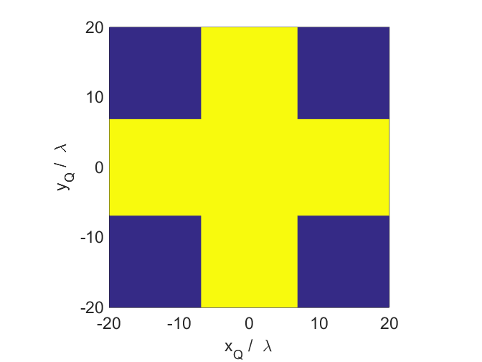

Fig. 1. Cross shaped aperture of width and height equal to 40*λ* where

*λ* = 650 nm in an opaque screen. Dark blue region *EQ* = 0 and yellow region *EQ* = constant > 0.

**Far field calculations** 

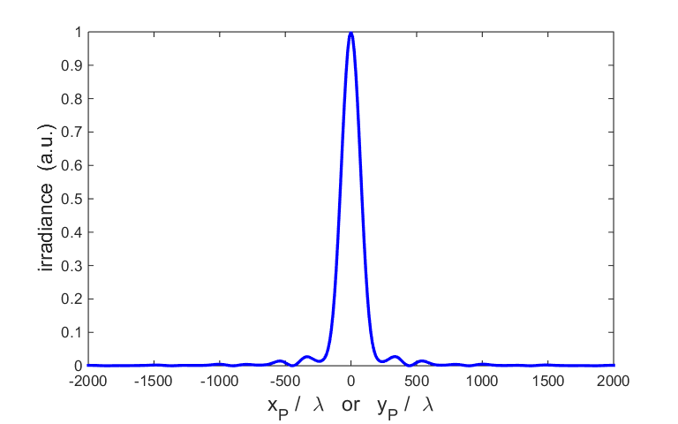

Fig. 2. Variation in the irradiance along the X axis or Y axis in the far field.

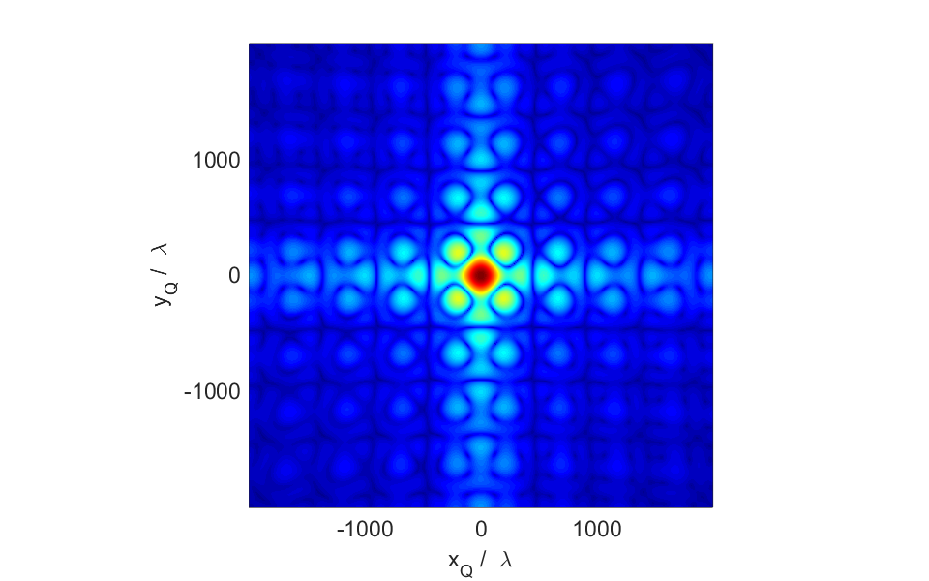

Fig 3. Scaled irradiance plot in the XY observation plane in the far field.

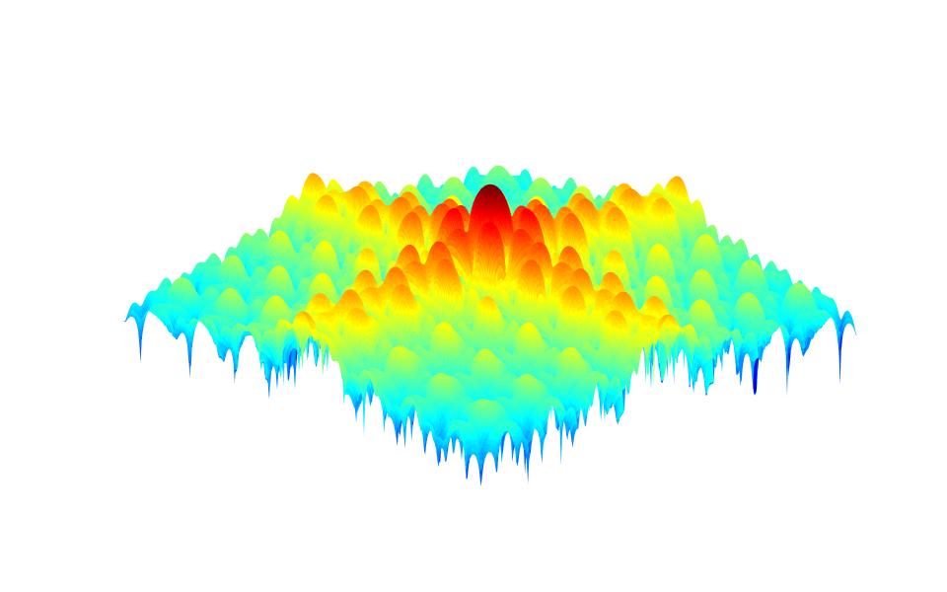

Fig 4. Scaled irradiance surf-plot in the XY observation plane in the far field.

**Near field calculations** 

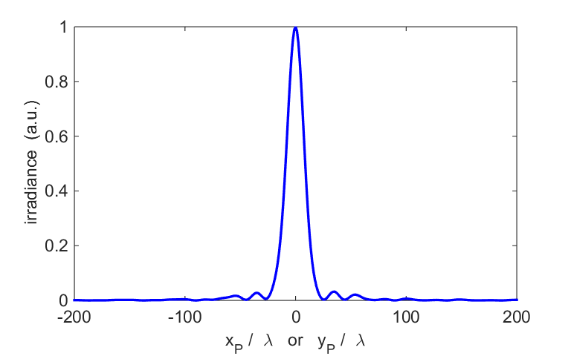

Fig. 5. Variation in the irradiance along the X axis or Y axis in the near field.

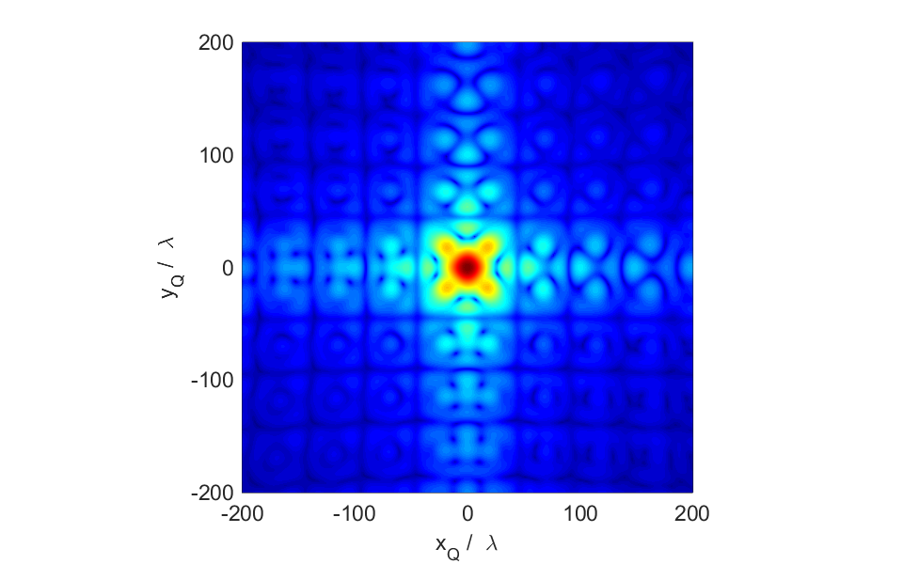

Fig 6. Scaled irradiance plot in the XY observation plane in the near field.

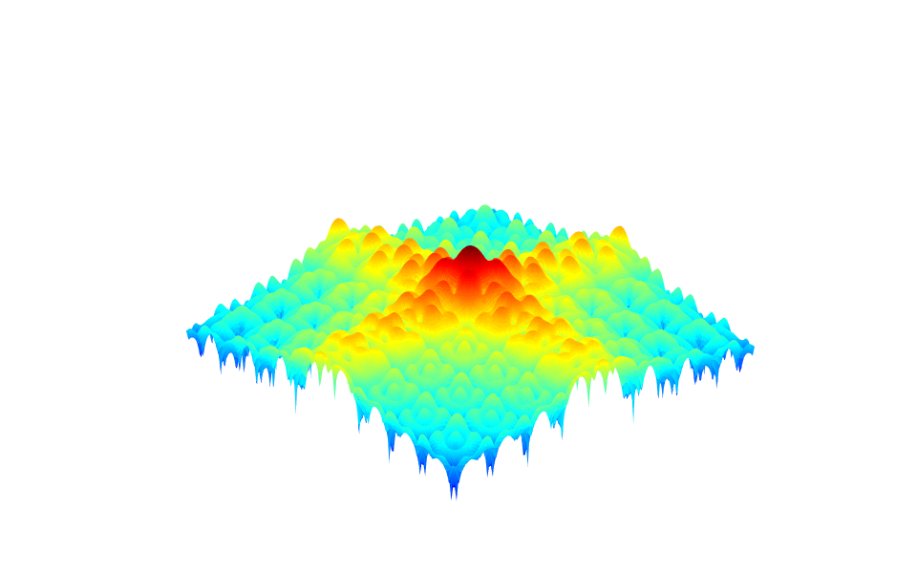

Fig 7. Scaled irradiance surf-plot in the XY observation plane in the near field.