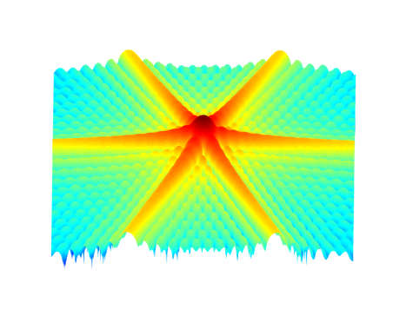

[**DOING PHYSICS WITH MATLAB**](http://www.physics.usyd.edu.au/teach_res/mp/mphome.htm)

**COMPUTATIONAL OPTICS**

# 

# RAYLEIGH-SOMMERFELD DIFFRACTION INTEGRAL OF THE FIRST KIND

# TRIANGULAR APERTURES

# 

Ian Cooper

School of Physics, University of Sydney

ian.cooper@sydney.edu.au

[**DOWNLOAD DIRECTORY FOR MATLAB SCRIPTS**](http://www.physics.usyd.edu.au/teach_res/mp/mscripts)

**op_rs_triangle.m**

Calculation of the irradiance in a plane perpendicular to the optical axis for uniformly illuminated triangular apertures. Uses a Cartesian coordinate system for the partitioning of the aperture space. It uses Method 2 – two-dimensional form of Simpson’s rule for the integration of the diffraction integral. Function calls to:

**simpson2d.m** (integration)

**fn_distancePQ.m** (calculates the distance between points P and Q)

**Background documents**

[C:\Users\Admin\Desktop\ap\images\hsp\Image2.gif](http://www.physics.usyd.edu.au/teach_res/mp/op/doc/op_diffraction_integrals_theory.pdf) Scalar Diffraction theory: Diffraction Integrals

[C:\Users\Admin\Desktop\ap\images\hsp\Image2.gif](http://www.physics.usyd.edu.au/teach_res/mp/op/doc/op_rs1.pdf) Numerical Integration Methods for the Rayleigh-Sommerfeld Diffraction

Integral of the First Kind

**RAYLEIGH-SOMMERFELD DIFFRACTION INTEGRAL OF THE FIRST KIND**

**UNIFORMLY ILLUMINATED TRIANGULAR APERTURES**

The Rayleigh-Sommerfeld diffraction integral of the first kind states that the electric field at an observation point P can be expressed as

(1) 

It is assumed that the Rayleigh-Sommerfeld diffraction integral of the first kind is valid throughout the space in front of the aperture, right down to the aperture itself. There are no limitations on the maximum size of either the aperture or observation region, relative to the observation distance, because **no approximations have been made**.

The **irradiance** or more generally the term **intensity** has S.I. units of W.m-2. Another way of thinking about the irradiance is to use the term **energy density** as an alternative. The use of the letter *I* can be misleading, therefore, we will often use the symbol *u* to represent the irradiance or energy density.

The irradiance or energy density *u* of a monochromatic light wave in matter is given in terms of its electric field *E* by

(2) 

where *n* is the refractive index of the medium, *c* is the speed of light in vacuum and *ε*0 is the permittivity of free space. This formula assumes that the magnetic susceptibility is negligible, i.e.  where  is the magnetic permeability of the light transmitting media. This assumption is typically valid in transparent media in the optical frequency range.

The integration can be done accurately using any of the numerical procedures based upon Simpson’s rule to compute the energy density in the whole space in front of the aperture.

[C:\Users\Admin\Desktop\ap\images\hsp\Image2.gif](http://www.physics.usyd.edu.au/teach_res/mp/op/doc/op_rs1.pdf) Numerical Integration Methods for the Rayleigh-Sommerfeld Diffraction

Integral of the First Kind

The aperture space is defined by assigning the electric field *EQ* to the maximum value at all grid points within a rectangle, then, setting values of *EQ* to zero at those grid points that determine the shape of the aperture’s transparent and opaque partitions. Figure (1) shows a triangular shaped aperture and its dimensions. The integration of the Rayleigh-Sommerfeld integral (equation 1) is done over the area of the rectangle using the two-dimensional form of Simpson’s rule (Method 2).

% Aperture electric field EQ

EQmax = sqrt(2*uQmax/(cL*nR*eps0));

EQ = EQmax .* ones(nQ,nQ);

flag1 = zeros(nQ,nQ);flag2 = zeros(nQ,nQ);

flag1(yQ > -(ay/2).*(xQ./ax - 1)) = 1;

flag2(yQ < (ay/2).*(xQ./ax - 1)) = 1;

EQ(flag1+flag2 == 1) = 0;

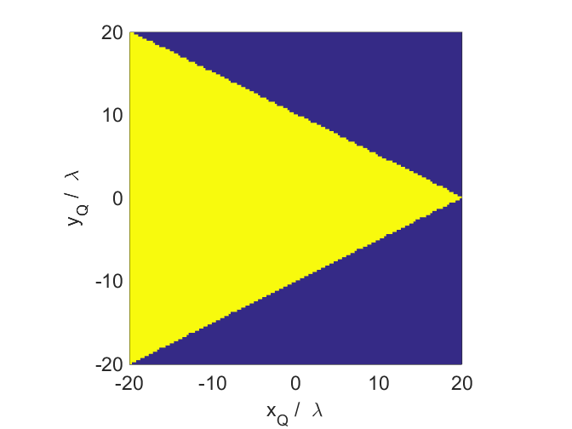

Fig. 1. A triangular shaped aperture. The yellow corresponds to the transparent partition and the blue to the opaque partition of the aperture space.

Figure (2) shows the variation of the irradiance (energy density) along the X-axis (blue) and Y-axis (red). Figures (3) and (4) shows the diffraction pattern in the XY-plane for scaled values of the irradiance (energy density).

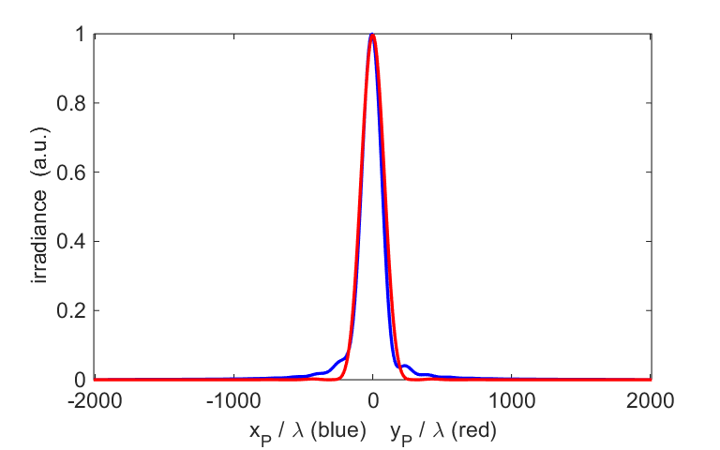

Fig. 2. Energy density variations along the X-axis (blue) and Y-axis (red).

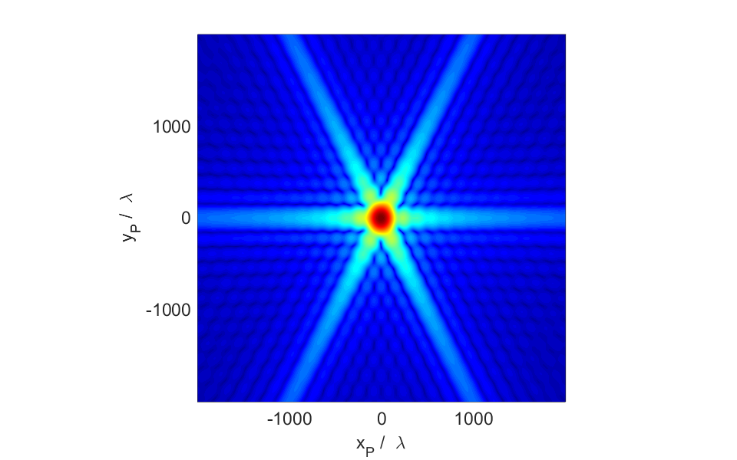

Fig. 3. Diffraction pattern for a triangular aperture.

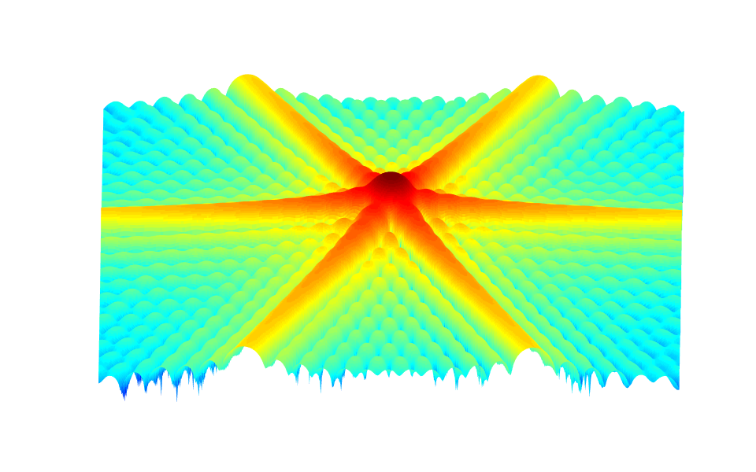

Fig. 4. Diffraction pattern for a triangular aperture.

Parameter summary [SI units]

wavelength [m] = 6.5e-07

nQ = 159

nP = 401

Aperture Space

X width [m] = 1.300e-05

Y width [m] = 1.300e-05

Observation Space

X width [m] = 2.600e-03

Y width [m] = 2.600e-03

distance aperture to observation plane [m] zP = 3.900e-03

Elapsed time is 196.541442 seconds.