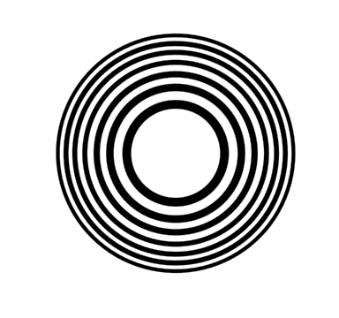

[**DOING PHYSICS WITH MATLAB**](https://d-arora.github.io/Doing-Physics-With-Matlab/)

**COMPUTATIONAL OPTICS**

# 

# RAYLEIGH-SOMMERFELD DIFFRACTION INTEGRAL OF THE FIRST KIND

# FRESNEL ZONE PLATE

# 

Ian Cooper

Please email any corrections, comments, suggestions or additions: matlabvisualphysics@gmail.com

[Matlab Download Directory](https://drive.google.com/drive/u/3/folders/1j09aAhfrVYpiMavajrgSvUMc89ksF9Jb)

**op_rs_zones.m**

Calculation of the irradiance in a plane perpendicular to the optical axis for uniformly illuminated zone plates. It uses Method 3 – one-dimensional form of Simpson’s rule for the integration of the diffraction integral.

**op_rs_zones_z.m**

Calculation of the irradiance along the optical axis for uniformly illuminated zone plates. It uses Method 3 – one-dimensional form of Simpson’s rule for the integration of the diffraction integral.

Function calls to:

**simpson1d.m** (integration)

**fn_distancePQ.m** (calculates the distance between points P and Q)

**turningPoints.m** (finds the location of zeros, min and max of function)

**Warning:** The results of the integration may look OK but they may not be accurate if you have used insufficient number of partitions for the aperture space and observation space. It is best to check the convergence of the results as the number partitions is increased. Note: as the number of partitions increases, the calculation time **rapidly** increases.

**RAYLEIGH-SOMMERFELD DIFFRACTION INTEGRAL OF THE FIRST KIND**

**FRESNEL ZONE PLATES**

The Rayleigh-Sommerfeld diffraction integral of the first kind states that the electric field at an observation point P can be expressed as

(1) 

It is assumed that the Rayleigh-Sommerfeld diffraction integral of the first kind is valid throughout the space in front of the aperture, right down to the aperture itself. There are no limitations on the maximum size of either the aperture or observation region, relative to the observation distance, because **no approximations have been made**.

The **irradiance** or more generally the term **intensity** has S.I. units of W.m-2. Another way of thinking about the irradiance is to use the term **energy density** as an alternative. The use of the letter *I* can be misleading, therefore, we will often use the symbol *u* to represent the irradiance or energy density.

The irradiance or energy density *u* of a monochromatic light wave in matter is given in terms of its electric field *E* by

(2) 

where *n* is the refractive index of the medium, *c* is the speed of light in vacuum and *ε*0 is the permittivity of free space. This formula assumes that the magnetic susceptibility is negligible, i.e.  where  is the magnetic permeability of the light transmitting media. This assumption is typically valid in transparent media in the optical frequency range.

The integration can be done accurately using any of the numerical procedures based upon Simpson’s rule to compute the energy density in the whole space in front of the aperture.

**FRESNEL ZONE PLATE**

A circular aperture in which alternate rings are transparent and opaque is called a **Fresnel zone plate**. For a plane wave normally incident upon a zone plate, the diffracted light will be concentrated at the focal points along the optical axis. The zone plate acts just like a lens (figure 1).

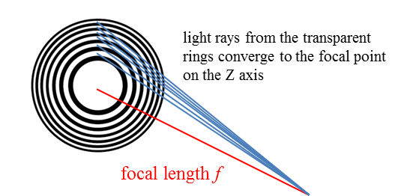

Fig. 1. Fresnel zone plate acts like a lens.

Complementary zone plates as shown in figure (2) give the same diffraction

pattern. This is an example of **Babinet’s Principle**. 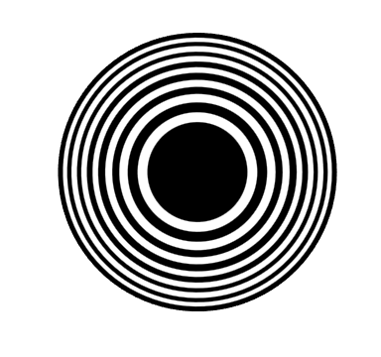

Fig. 2. Fresnel zone plates. Both zones plates give the same diffraction pattern (Babinet’s Principle). **op_rs_zones.m**

The zone radii required to make the half-period zones relative to the focal point *f*1 are given by equation (1)

(1)  radius of the *N*th zone

There are other maximum irradiance points along the optical axis and these focal points are found at

(2) 

Hence, these focal points occur along the optical axis at *zP* = *f*1, *f*1 / 3, *f*1 / 5, … .

The Matlab code below shows how the zone plate and aperture grid was constructed.

% ZONE PLATE SETUP --------------------------------------------

rz = zeros(Nzones,1);

for nc = 1 : Nzones

rz(nc) = sqrt((fzone + nc * wL / 2)^2 - fzone^2);

end

rMax = rz(end);

rMin = eps;

r = linspace(rMin, rMax, nR);

dr = r(2)-r(1);

m = (n2-n1) / (nR-1);

b = n2 - m * nR;

for c = 1 : nR

n(c) = 2*round(0.5*(m * c + b))+1;

end

nQ = sum(n);

flag = zeros(nR,1); flags = 1;

for nc = 2 : Nzones

if flags == 1; flag(r > rz(nc)) = 1; end;

if flags ~= 1; flag(r > rz(nc)) = 0; end;

flags = (-1)^(nc-1);

end

EQ = sqrt(2*uQmax/(cL*nRI*eps0)) .* EQ;

%EQ = EQ .* ~flag; % bright centre

EQ = EQ .* flag; % dark centre

**Energy density variation along the optical axis**

The mscript **op_rs_zones_z.m** was used to model the variation in the energy density along the optical axis (Z axis) for a Fresnel zone plate. A summary of the parameters used is given in the Matlab Command Window:

wavelength [m] = 6.328e-07

nQ = 562002

nP = 5309

Aperture Space

Number of zones = 16

radius of zone plate [m] = 3.182e-03

Observation Space

max radius rP [m] = 2.000

focal length of zone plate [m] f1 = 1.000

Figure 3 shows the variation in the energy density along the optical axis. The peaks show the location of the focal points. Table 1 gives the location *zP* of the peaks and their strengths. The results are in excellent agreement with the predictions of equation (2). The execution time for running the mscript **op_rs_zones_z.m** was about 15 minutes. The Data Cursor function in the Figure Window for figure (3) was used for the location and strengths of the peaks.

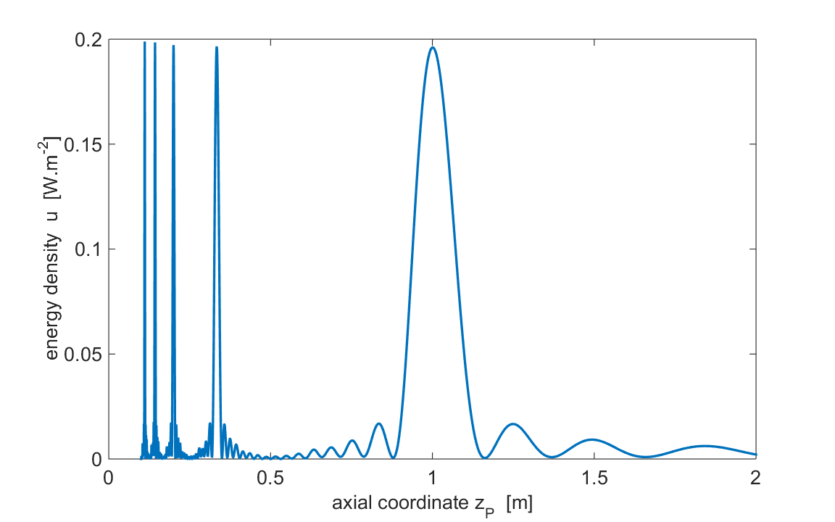

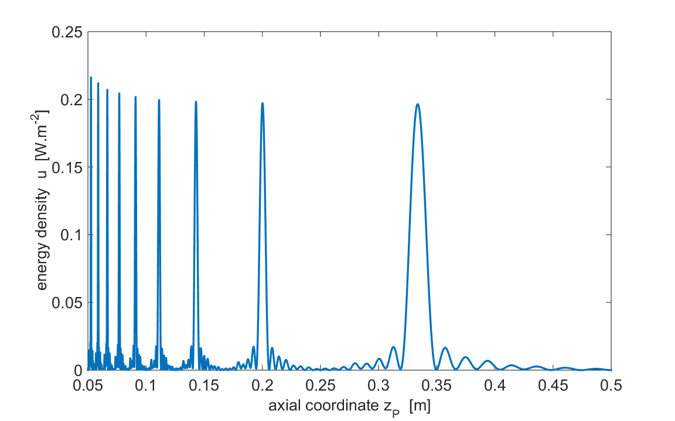

Fig. 3. Energy density along the optical axis.

Table 1. Location *zP* of the peaks and their strengths along the optical axis.

|  |  |  |  |
| --- | --- | --- | --- |
| ***m*** | **1 / (2*m* – 1)** | ***zP* [m]** | ***uP*(peak) [W.m-2]** |
| 1 | 1.0000 | 1.000 | 1.000 |
| 2 | 0.3333 | 0.333 | 0.196 |
| 3 | 0.2000 | 0.200 | 0.197 |
| 4 | 0.1429 | 0.143 | 0.198 |
| 5 | 0.1111 | 0.111 | 0.200 |
| 6 | 0.0909 | 0.0910 | 0.202 |
| 7 | 0.0769 | 0.0770 | 0.205 |
| 8 | 0.0667 | 0.0667 | 0.207 |
| 9 | 0.0588 | 0.0588 | 0.212 |
| 10 | 0.0526 | 0.0526 | 0.217 |

**Energy density variation in XY observation planes**

The mscript **op_rs_zones.m** was used to model the variation in the energy density in various XY planes for a Fresnel zone plate. A summary of the parameters used is given in the Matlab Command Window:

wavelength [m] = 6.328e-07

nQ = 701000

nP = 1309

Aperture Space

Number of zones = 16

radius of zone plate [m] = 3.182e-03

Observation Space

max radius rP [m] = 1.999e-04

focal length of zone plate [m] f1 = 1.000

**Energy density at the focal point *zP* = *f*1**

The energy density in the focal plane (XY plane) is shown in figure (4) as a function of the perpendicular distance from the optical axis (Z axis) and figure (5) shows scaled images of the diffraction pattern where *zP* = *f* 1= 1.00 m.

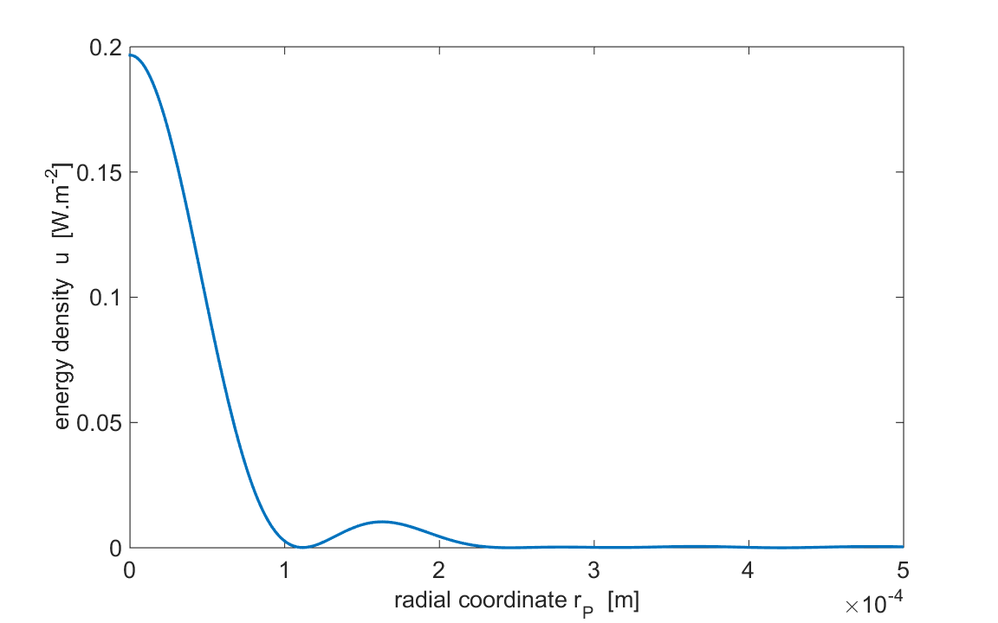

Fig. 4. Energy density variation in a radial direction for the focal plane when *zP* = *f*1 = 1.00 m.

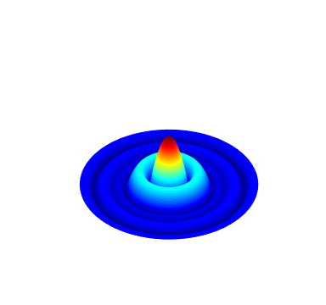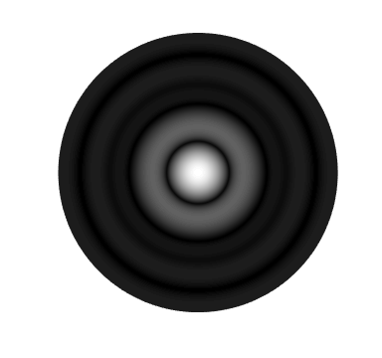

Fig.5. Scaled energy density images of the diffraction pattern in the focal plane when *zP* = *f*1= 1.00 m.

The energy density in a XY plane where *zP* > *f*1 is shown in figure (6) as a function of the perpendicular distance from the optical axis (Z axis) and figure (7) show scaled images of the diffraction pattern where *f*1 = 1.00 m and *zP* = 1.10 m.

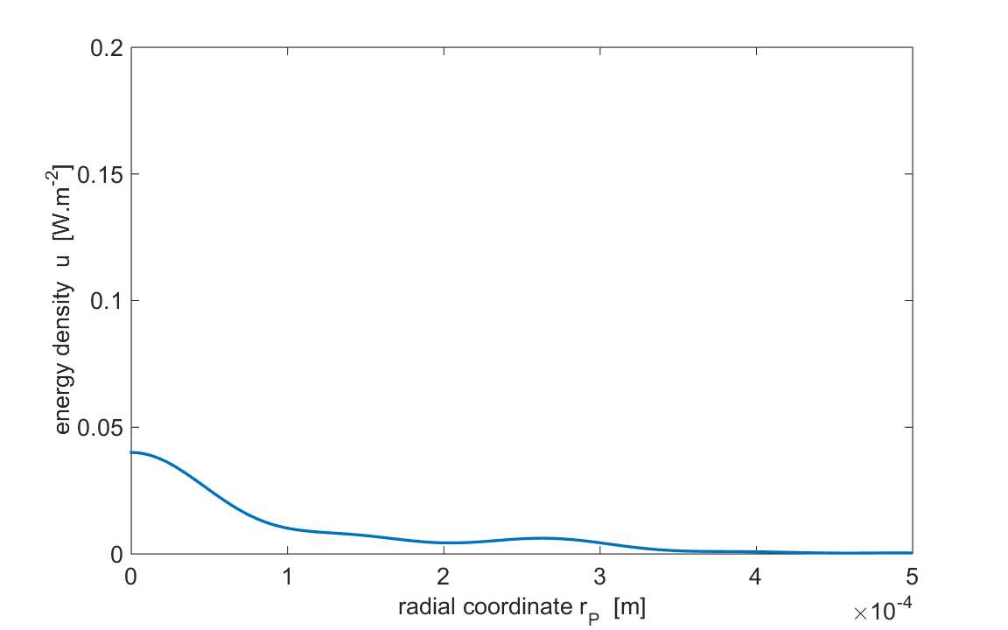

Fig. 6. Energy density variation in a radial direction when *zP* > *f*1,

*f*1 = 1.00 m and *zP* = 1.10 m.

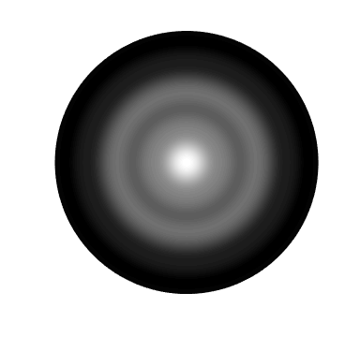

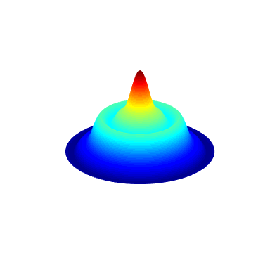

Fig. 7. Scaled energy density images of the diffraction pattern in the focal plane when *zP* > *f*1, *f*1 = 1.00 m and *zP* = 1.10 m.

The energy density in a XY plane where *zP* < *f1* is shown in figure (8) as a function of the perpendicular distance from the optical axis (Z axis) and figure (9) show scaled images of the diffraction pattern where *f* 1 = 1.00 m and *zP* = 0.80 m.

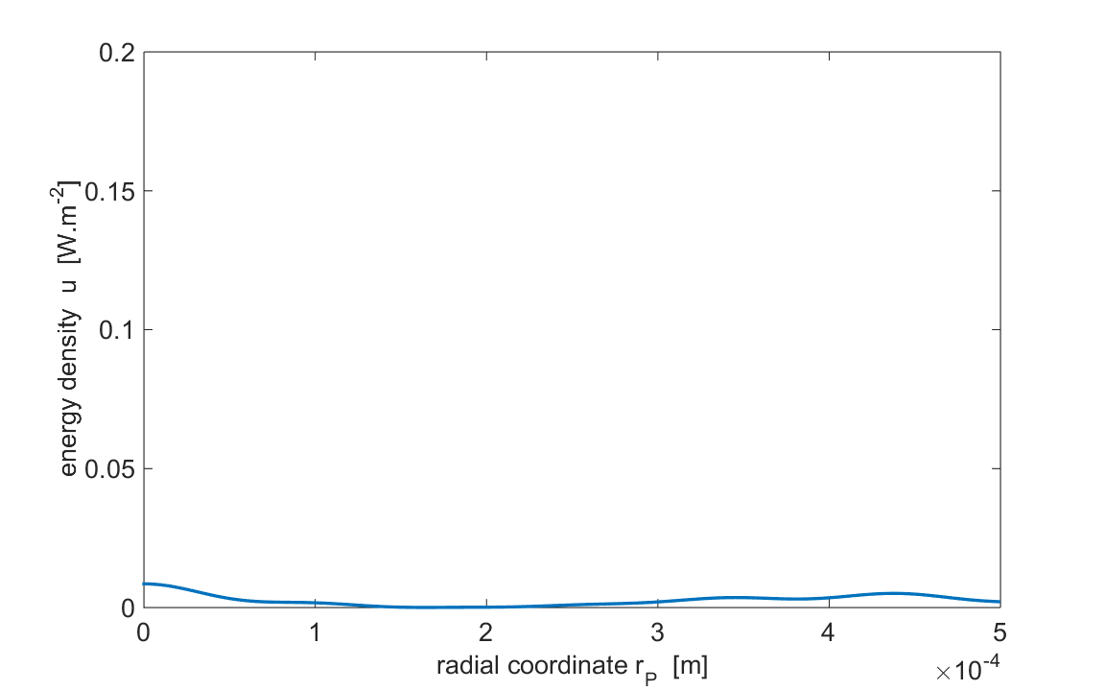

Fig. 8. Energy density variation in a radial direction when *zP* < *f*1,

*f*1 = 1.00 m and *zP* = 0.80 m.

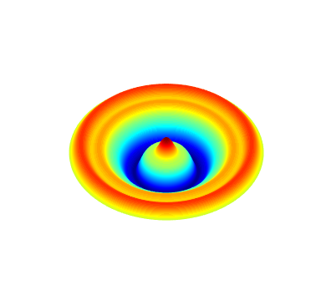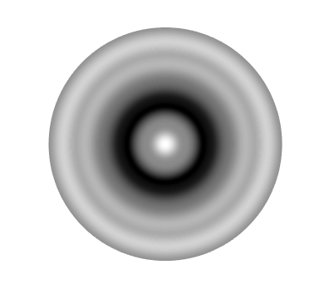

Fig. 9. Scaled energy density images of the diffraction pattern in the focal plane when *zP* < *f*1, *f*1 = 1.00 m and *zP* = 0.80 m.

Examination of the above figures clearly demonstrates how the Fresnel zone plate acts as lens. The concentration of the light at the focal point is much greater compared with just a circular aperture without the transparent and opaque zones.

**Energy density at the focal point *zP* = *f*3 = *f*1 / 5**

The energy density in the focal plane (XY plane) is shown in figure (10) as a function of the perpendicular distance from the optical axis (Z axis) and figure (11 shows scaled images of the diffraction pattern where *zP* = *f*3 = (1.00 / 5) m = 0.200 m.

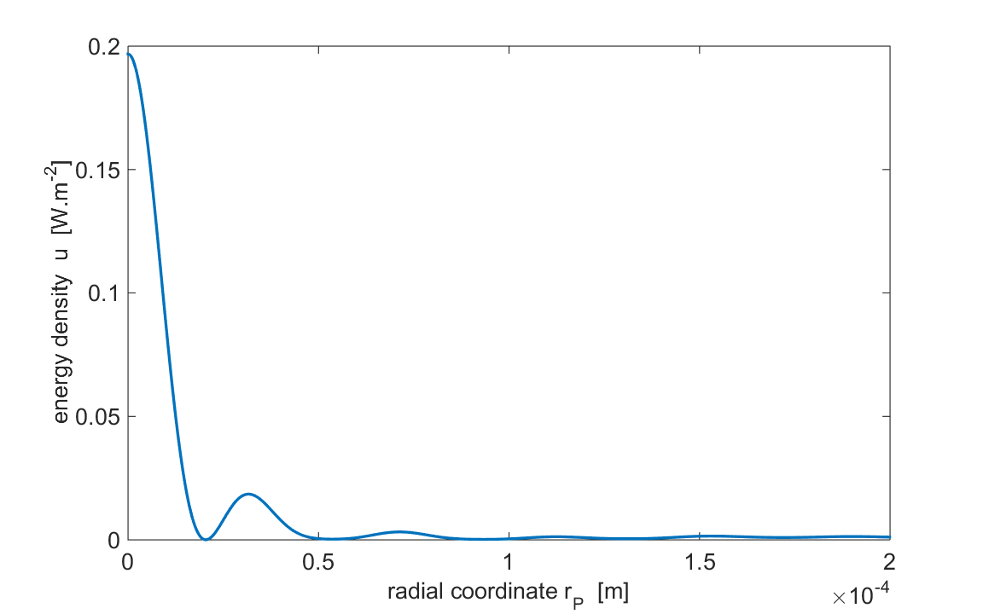

Fig. 10. Energy density variation in a radial direction for the focal plane when *zP* = *f*3 = 0.200 m.

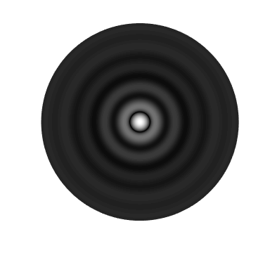

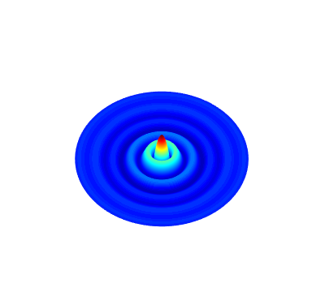

Fig. 11. Scaled energy density images of the diffraction pattern in the focal plane when *zP* = 0.200 m.



Fig. 4. Energy density variation in a radial direction for the focal plane when *zP* = *f*1 = 1.000 m.



Fig. 10. Energy density variation in a radial direction for the focal plane when *zP* = *f*3 = 0.200 m.

Examination of figures (3), (4) and (10) clearly show that the peaks become narrower as *m* becomes larger, that is, the closer the peaks are to the aperture the narrow they are.