[**DOING PHYSICS WITH MATLAB**](http://www.physics.usyd.edu.au/teach_res/mp/mphome.htm)

**OSCILLATIONS**

**BUNGEE JUMPS AND BRIDGE SWINGS**

Ian Cooper

School of Physics, University of Sydney

ian.cooper@sydney.edu.au

[**DOWNLOAD DIRECTORY FOR MATLAB SCRIPTS**](http://www.physics.usyd.edu.au/teach_res/mp/mscripts)

**osc_bungee.m**

This mscript can be used to model a bungee jump or a bridge swing. The mscript calls the function **eq_quadratic.m**. *Inspect* and *run* the mscript **osc_bungee.m**

so that you are familiar with the program and what the code does.

**eq_quadratic.m**

Function to solve a quadratic equation

**Understanding the physics of bungee jumping & bridge swings**



A bungee jump is when a person plummets off some high structure such as a tower, bridge, crane or hot air balloon. A version of the bungee jump is the bridge swing. A bungee cord is connected to one side of a bridge and the other end to the jumper in an abseiling harness on the other side of the bridge. Bungee cords are soft and springy and may stretch to more than three times their natural length. Most jumps occur without any mishap, however, there have been many serious injuries and deaths, and in some countries bungee jumping is illegal. Accidents can be traced to human error such as improper attachment of the body harness to the jumper and others to the poor understanding of the physics where there has been a mismatch between the mass of jumper, height of jump and bungee cord selected for the jump.

Simple models based upon Newton’s Second Law (equation of motion) can be used to give an insight into the physics of bungee jumping and to give estimates of jump drop, maximum speed, acceleration, forces and energies during a jump. A two dimensional model is used for the simulations of bungee jumps and bridge swings. The coordinate system is one in which the +*y*-axis is vertical up and the +*x*-axis is horizontal to the right. The origin (0,0) is the point of attachment of the bungee cord to some structure. The jumper is assumed to be a point particle of mass *m* and during the jump, the forces acting on the jumper are the gravitational force , the elastic restoring force due to the extension of the bungee cord and a dissipative force  due to friction and drag forces acting on and within the cord and on the jumper. The mass of the bungee cord is ignored.

The equation of motion for the jumper is

(1) 

where  is the acceleration of the jumper and the position of the jumper has coordinates (*x*,*y*). The natural length of the bungee cord is *L*, the extension of the cord *e* and extended length of the cord *r*

(2) .

The bungee cord acts like a weak spring with a stiffness that decreases with extension (Menz, 1993). A two-piece linear model is used to describe the stiffness (spring constant) of the bungee cord: the stiffness is *k*1 when the extension is less than *e*1 and *k*2 for extension *e* greater than *e*1 where *k*1 > *k*2. The elastic restoring force when the cord is stretched is given by

(3a) 

(3b) .

The dissipative force is assumed to depend upon the both the velocity and the square of the velocity of the jumper. The *x* and *y* components of the forces acting on the jumper are given in equation (4)

(4a)  

(4b)  

(4c) 

 (*D*1,  *D*2 constants)

The *x* and *y* components for the acceleration of the jumper are then

(5)  and .

A simple numerical method is used to calculate the velocity and displacement from the acceleration at successive time steps given a set of initial conditions. The method outlined is not the most accurate method but one in which is easy to implement. If the values of *x*(*t*), *y*(*t*), *vx*(*t*), *vy*(*t*), *ax*(*t*) and *ay*(*t*) are known at time *t* then the values at time *t* + Δ*t* are

(6a) 

(6b) 

Once the acceleration, velocity and displacement are known, it is a simple matter to calculate forces and energies. The kinetic energy of the jumper *EK*, the elastic potential energy *EP*, the gravitational potential energy *EG* and the total mechanical energy *E* are given in equation (7). The zero for the gravitational potential energy is chosen to be at *y* =  0.

(7a) 

(7b) 

(7c) 

(7d) 

Table 1 summarize the input parameters and possible range of values for running the mscript **osc_bungee.m**.

Table 1: Jump parameters: Parameters are changed within the mscript.

|  |  |  |  |
| --- | --- | --- | --- |
| **Variable** | **Symbol** | **Value** | **Unit** |
| mass of jumper | *m* | 50 to 150 | kg |
| natural length of bungee cord | *L* | 6 to 20 | m |
| stiffness of bungee cord:  stiff cord | *k*1  *k*2 | ~ 250  ~ 150 | N.m-1 |
| stiffness of bungee cord:  medium cord | *k*1  *k*2 | ~ 200  ~ 110 | N.m-1 |
| stiffness of bungee cord:  soft cord | *k*1  *k*2 | ~ 160  ~ 80 | N.m-1 |
| extension for change in stiffness of bungee cord | *e*1 | 4 to 6 | m |
| max tensile strength of bungee cord | *Smax* | ~ 2.0×104 | N |
| elongation factor | *e / L* | 2 to 4 |  |
| dissipation factor | *D*1 | 0 to 10 | N.m-1.s-1 |
| dissipation factor | *D*2 | 0 to 10 | N.m-2.s-2 |
| bridge swing: starting *x* coordinate | *x*(0) | 0 to - *L* | m |

**BUNGEE JUMP: zero dissipation *FD* = 0**

If the dissipative force *FD* = 0, the total mechanical energy is conserved

*E* = constant

From the principle of conservation of energy in this situation, we can calculate analytically the maximum free fall velocity *vff* and the maximum distance the jumper falls vertically (jump drop) *ymax*.

The total energy *E* at the start, end of free fall and the bottom of the jump are:

1. Start of jump 

2. End of free fall 

3. Bottom of jump .

The maximum free fall velocity is

(8) 

Using the principles of conservation of energy, the maximum extension, *e*max of the bungee cord and drop height, *hdrop* can be found from the quadratic equation (9a)

(9a) 

(9b) 

One has to be wary in using numerical methods because you are not always aware that the results may be inaccurate. The approximation method used in the simulations only gives reasonable results when the time increment is very small so that during any time step the acceleration does not change very much. When the time step is too large, the total mechanical energy often increases rather than being constant. Where possible you should compare your numerical results with values calculated using analytical methods. If there is disagreement, then the time step used in the numerical procedure can be decreased or it may be necessary to use a more accurate numerical method.

During the jump, the acceleration of the jumper increases and so does the net force experienced by the jumper. The magnitude of this force experience by the jumper is related to the **g-force**, which is the ratio of the **normal force** (**apparent weight**) acting on them to their weight.

 where *g* = + 9.8 m.s-2

In free fall *a* = - *g* hence g-force = 0.

**Vertical axis g-force**: sustained g-forces along the axis aligned with the spine causes significant variation in blood pressure along the length of a person's body, which limits the maximum *g*-forces that can be tolerated. Positive or "upward" g-force, drives blood downward to the feet of a seated or standing whereas a negative or “downward” g-force drives blood upward to the head.

Resistance to positive g-forces varies. A typical person can handle about 5 g (49 m.s-2) - meaning some people might pass out in some cases exceeds this point.

Resistance to "negative" or "downward" g-force which drives blood to the head, is much lower. This limit is typically in the −2 to −3 g (about −20 m.s-2 to −30 m.s-2) range. This condition is sometimes referred to as red out where vision is literally reddened due to the blood laden lower eyelid being pulled into the field of vision. Negative g-force is generally unpleasant and can cause damage, e.g., blood vessels in the eyes or brain may swell or burst under the increased blood pressure, resulting in degraded sight or even blindness.

In running the mscript for different parameters, you will find that the g-force acting is not large enough to cause the jumper any problems and more importantly it has only a large value over very short time intervals.

**Simulation: No dissipative forces FD = 0**

Consider the bungee jump for a person with a mass of 80 kg using a bungee cord of medium stiffness and length 9.0 m. The results of a simulation using **osc_bungee.m** are given in the Matlab Command Window and Figure Windows.

Input parameters

Initial x coordinate of jumper, xs = 0.00 m

Initial y coordinate of jumper, ys = 0.00 m

Mass of jumper, m = 80.00 kg

Weight of jumper, F_G = 784 N

Natural length of bungee cord, L = 9.00 m

Dissipative force constant, D_1 = 0.00 N.m^-1.s^-1

Dissipative force constant, D_2 = 0.00 N.m^-2.s^-2

Stiffness, k_1 = 200.00 N.m^1

Stiffness, k_2 = 110.00 N.m^1

Stiffness: two piece linear transition, e_1 = 5.00 m

Analytical (FD = 0) & numerical predictions

A: max free fall velocity, v_ff = 13.28 m/s

N: max free fall velocity, v_ff = 13.28 m/s

A: drop height, h_drop = 24.60 m

N: drop height, h_drop = 24.62 m

Output parameters

max velocity, v_max = 14.68 m.s^-1

max velocity, v_max = 52.85 km.h^-1

max y-acceleration, ay_max / g = 17.31 m.s^-2

max acceleration, a_max = 17.31 m.s-2

max force on jumper, F_max = 1384 N

F_max / F_G = 1.77

max vertical gforce = 2.77

max elastic restoring force by bungee cord, F_E_max = 2168 N

There is good agreement in the predictions of the maximum free fall velocity and the drop height when the analytical and numerical values are compared.

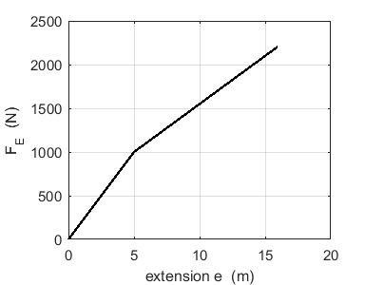

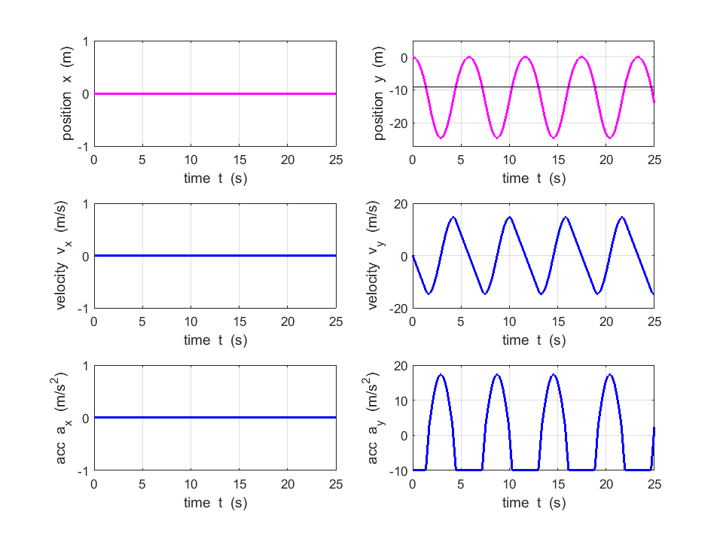

During free fall, the accleration of the jumper is -9.8 m.s-2. The maximum accleration of the jumper occurs when the they are at the bottom of the drop because the upward acting elastic restroing force is greatest at the bottom of the jump.

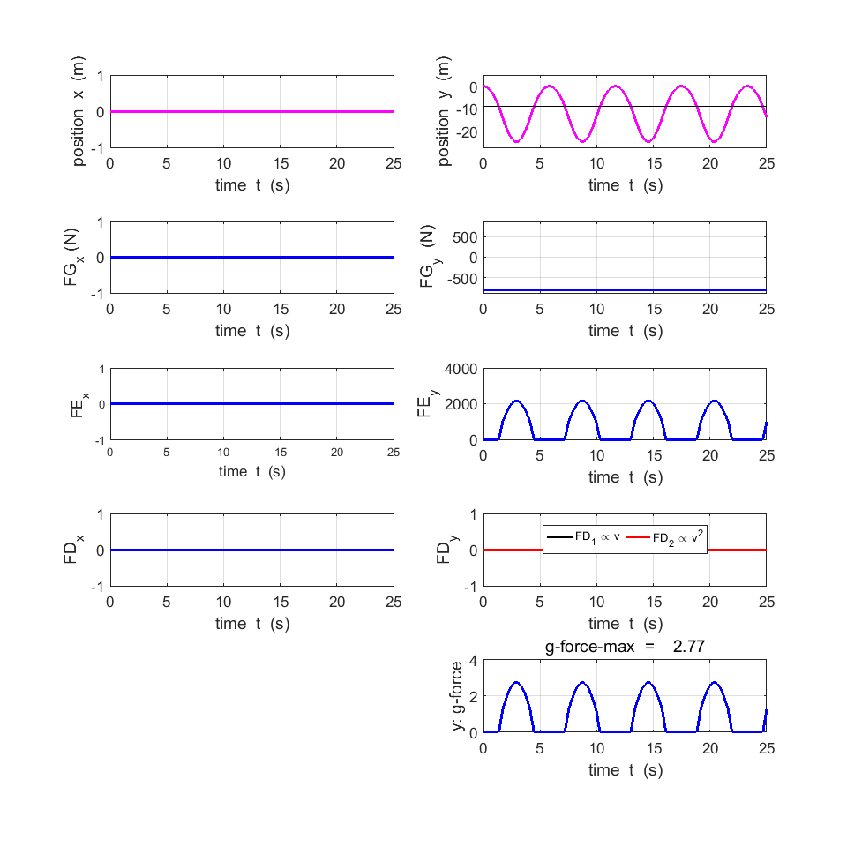

The elastic restoring force is greatest at the bottom of the jump when the cord has its maximum stretch. The g-force has a maximum value of 2.77 only for short periods of time, hence, it is unlikely that the jumper will experience any problems due to the forces and accelerations during the jump.

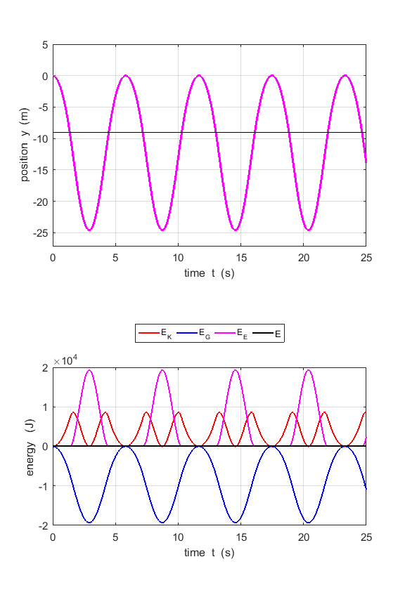

The total energy remains constant during the simulations. This is a good indictor that the numerical method is OK.

**Simulations of “real” bungee jumps**

In a real bungee jump, the duration of the jump is about 30 s and the oscillations die-away after about five bounces. The total energy of the system of the jumper and bungee cord decreases because of the dissipative forces acting.

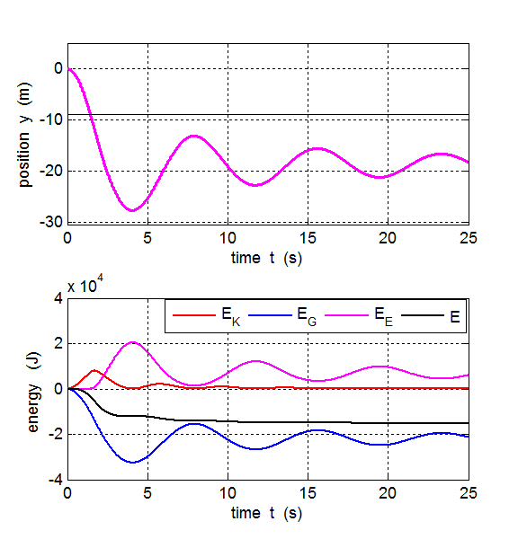

Table 2 is a summary of the results for a 80 kg person using a three different bungee cords of length 9.0 m and *e*1 = 5.0 m. The coefficients *D*1 = 4.0 and *D*2 = 5.0 were chosen so that the about five oscillations died away in about 25 s.

Table 2.

|  |  |  |  |
| --- | --- | --- | --- |
| **Parameters** | **Stiff** | **Medium** | **Soft** |
| *k*1 (N.m-1) | 250 | 200 | 160 |
| *k*2 (N.m-1) | 150 | 110 | 80 |
| velocity max (m.s-1) | 10.2 | 10.2 | 10.3 |
| velocity max (km.h-1) | 36.8 | 36.8 | 37.0 |
| g-force max | 2.1 | 1.9 | 1.7 |
| drop height (m) | 16.8 | 18.4 | 28.8 |

The maximum speed reached by the jumper does not depend upon the stiffness of the bungee cord. The stiffer the bungee cord, then the greater the g-force experienced by the jumper and the smaller value for the drop height.

Table 3 is a summary of the results for two jumpers of masses 60 kg and 120 kg using a soft bungee cord (length 9.0 m, *k*1 = 160 N.m-1, *k*2 = 80 N.m-1, *e*1 = 5.0 m). The coefficients *D*1 = 4.0 and *D*2 = 5.0 were chosen so that the about five oscillations died away in about 25 s.

Table 3.

|  |  |  |
| --- | --- | --- |
| **Parameters** | **60 kg** | **120 kg** |
| velocity max (m.s-1) | 9.4 | 11.5 |
| velocity max (km.h-1) | 33.7 | 41.5 |
| g-force max | 1.8 | 1.6 |
| drop height (m) | 17.1 | 27.7 |

The jumper with the larger mass certainly has a much greater maximum speed and the drop height is significantly greater. Serious injuries and even deaths have occurred during a bungee jump when a heavy person has been given the wrong bungee cord so that the drop height was more than the distance to the ground below – the jumper may hit the ground at a considerable speed.

**Simulations of bridge swings**

A bridge swing is a version of a bungee jump where the bungee cord is connected to a structure and the other end to the jumper in an abseiling harness to one side of the structure.

The following figures and data are for a bridge swing for an 80 kg jumper using a soft bungee cord.

Input parameters

Initial x coordinate of jumper, xs = -9.00 m

Initial y coordinate of jumper, ys = 0.00 m

Mass of jumper, m = 80.00 kg

Weight of jumper, F_G = 784 N

Natural length of bungee cord, L = 9.00 m

Dissipative force constant, D_1 = 4.00 N.m^-1.s^-1

Dissipative force constant, D_2 = 5.00 N.m^-2.s^-2

Stiffness, k_1 = 160.00 N.m^1

Stiffness, k_2 = 80.00 N.m^1

Stiffness: two piece linear transition, e_1 = 5.00 m

Analytical (FD = 0) & numerical predictions

A: max free fall velocity, v_ff = 13.28 m/s

N: max free fall velocity, v_ff = 0.00 m/s

A: drop height, h_drop = 28.78 m

N: drop height, h_drop = 18.86 m

Output parameters

max elongation factor r_max / L = 2.10

max velocity, v_max = 9.16 m.s^-1

max velocity, v_max = 32.98 km.h^-1

max y-acceleration, ay_max / g = 5.55 m.s^-2

max acceleration, a_max = 9.80 m.s-2

max force on jumper, F_max = 784 N

F_max / F_G = 1.00

max vertical g-force = 1.57

max elastic restoring force by bungee cord, F_E_max = 1189 N

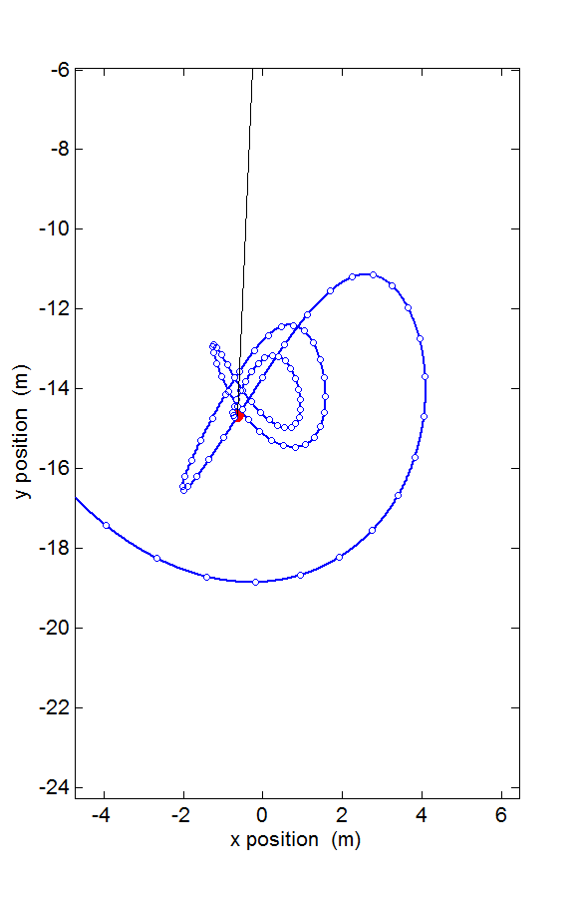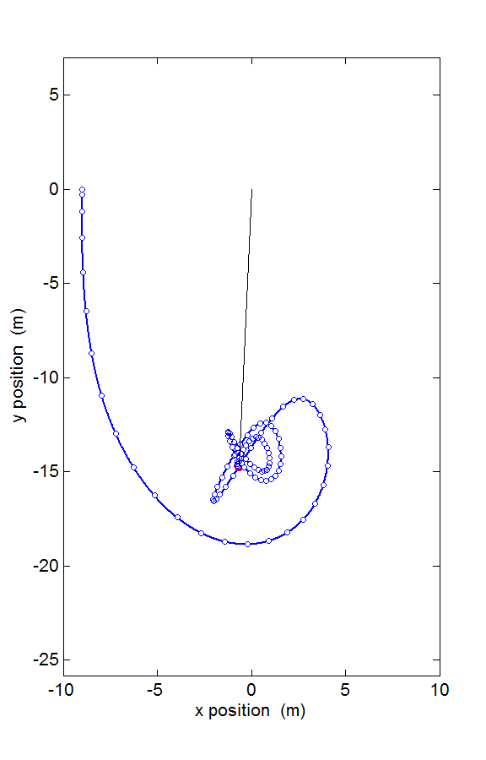

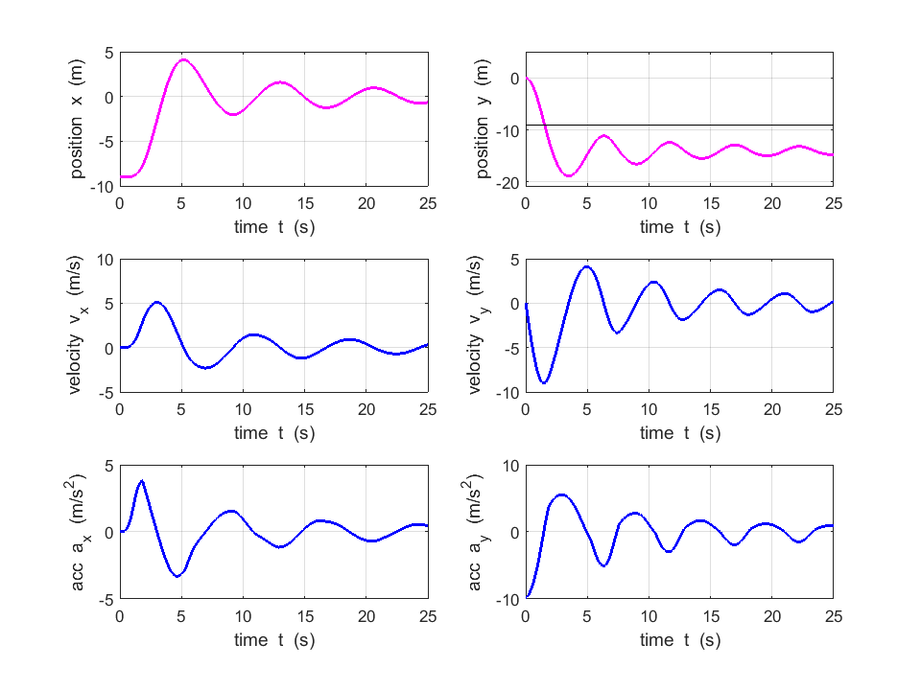

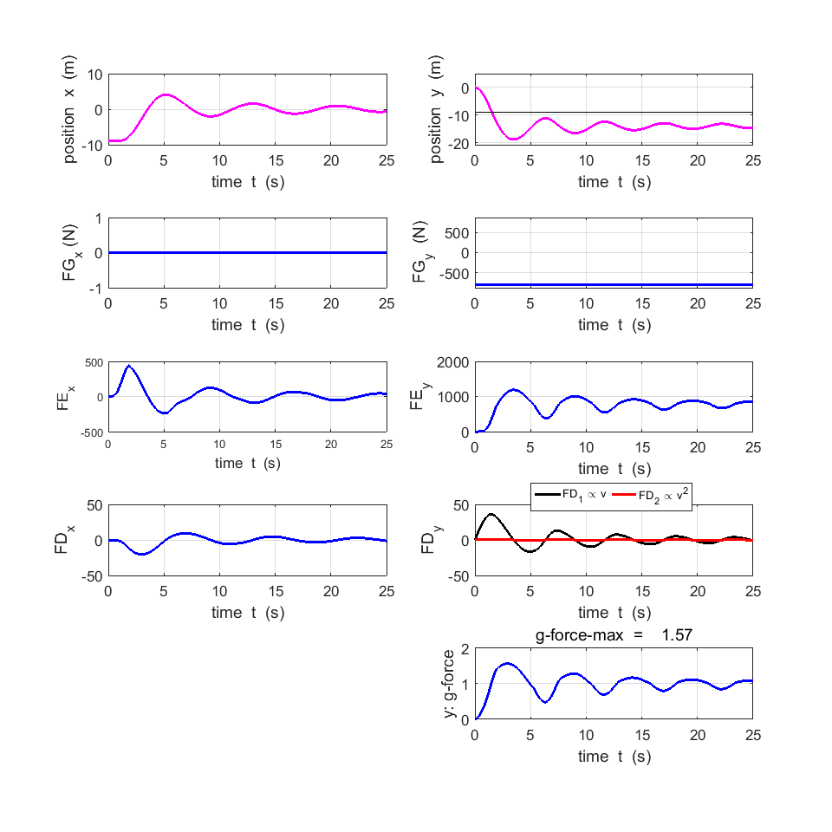

**Investigations and Questions**

Simulate a bungee jump (start: *xs* = 0, *ys* = 0) with a zero dissipation force.

1.1 Vary the number of time steps *nt*. What is the minimum value for *nt* so that the total mechanical energy, *E* is conserved. How well do the analytical and numerical predictions agree?

1.2 Explain the shapes of the position, force and energy graphs. Comment on when values of position, force, energy are a maximum, minimum or zero.

1.3 For a typical bungee jump, is the acceleration experience by the jumper excessive? (A person can blackout when their acceleration greater than about 5g’s).

1.4 Is it likely that a bungee cord will snap? (The maximum tensile strength of a bungee cord is ~2.0×104 N.)

1.5 How does the vertical distance fallen by the jumper (jump drop), *hdrop*, depend upon the mass of the jumper, *m*? Repeat the simulation with increasing mass and tabulate the jump drop.

1.6 What are the differences in jump drops for bungee cords of varying stiffness? Consider stiff, medium and soft bungee cords.

1.7 Simulate a bungee jump with a non-zero dissipative force. How does this change the motion of the jumper? Adjust the value of the constants *D*­1 and *D*2 to simulate as close as possible a real jump.

1.8 What is the mostly likely reason a person could suffer a serve accident assuming there where no attachment problems associated with the harness and cord?

1.9 If the stiffness of the bungee cord obeys Hooke’s law in extension (*e*1 = 0 and *k*1 = *k*2), how does it affect the jump drop. Is this significant?

Simulate a bridge swing with zero and non-zero dissipative forces. Check that the time step is small enough so that the total energy is conserved and that the numerical and analytical values agree.

1.10 Explain the shapes of the position, force and energy graphs. Comment on when values of position, force, energy are a maximum, minimum or zero. The figure for the trajectory shows the position of the jump at fixed time intervals like in a strobe photograph, hence comment on the velocity of the jumper during the swing.

1.11 You can make your own bungee cord by using a length of latex tubing or by stringing together many elastic bands. Use you home-made bungee cord with an object attached to one end to carry out a bridge swing. How does the trajectory of your bride swing compare with the computer model? You can change the parameters in the simulation to match those in your bungee swing using your home made cord.

1.12 Design a jump so that the maximum velocity of the jumper exceeds 80 km.h-1. What is the corresponding jump drop?

**References**

Menz, P.G.,, *The Physics of Bungee Jumping*, The Physics Teachers, Vol. 31, No. 8, November 1993.