**[DOING PHYSICS WITH MATLAB](http://www.physics.usyd.edu.au/teach_res/mp/mphome.htm)**

**MODELLING A MASS / SPRING SYSTEM**

**Free oscillations, Damping, Force oscillations (impulsive and sinusoidal)**

[**Download Directory: Matlab mscripts**](http://www.physics.usyd.edu.au/teach_res/mp/mscripts/)

**osc_harmonic01.m**

The script uses the finite difference method to solve the equation of motion for a mass / spring System. The displacement, velocity, acceleration and kinetic energy are computed. The potential energy and total energy of the System are also computed. The mass and spring constant can be changed within the script. In running the script, the user inputs through the Command Window the values for the damping constant, the type of driving force, the driving forced frequency and maximum simulation time interval. The results off the computation are presented graphically.

**osc_harmonic02.m**

Plot of the response curve (amplitude *A*  vs driving frequency *fD* / *f*0) for the oscillations of a mass / spring System. The peak response of the System is dependent upon the damping.

The response of a mass (*m*) / spring (*k*) System can be investigated using the scripts **osc_harmonic01.m** and **osc_harmonic02.m**. The damping of the System is determined by the damping coefficient *b* and the oscillations are determined by the driving force *FD*(*t*). The equation of motion for the System is

(1) 

The differential equation is solved using the **finite difference method** (see Appendix).

**Free oscillations with or without damping**

The System is given an initial displacement and the subsequent motion computed.

The resonance or natural frequency is assumed to be given by

(2) 

where *m* is the mass of the oscillating object and *k* is the spring constant.

The default values are



You can explore the free oscillations of the System, underdamping, critical damping and overdamping.

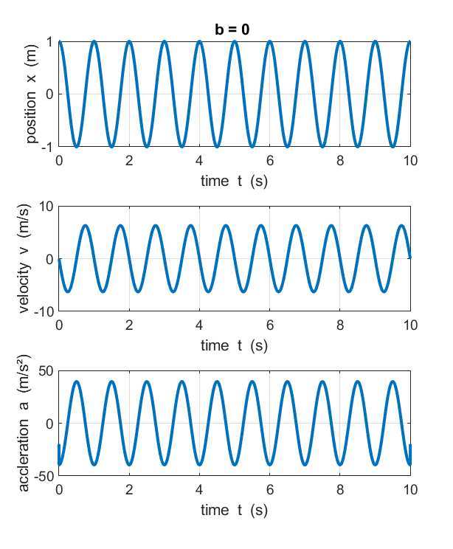

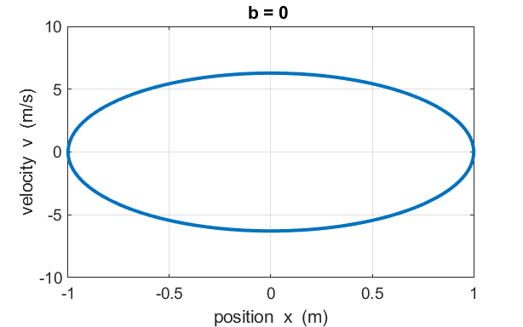

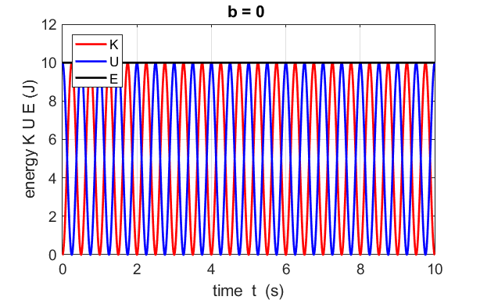

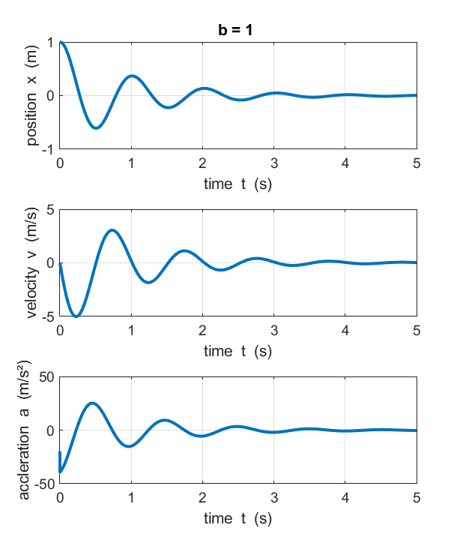

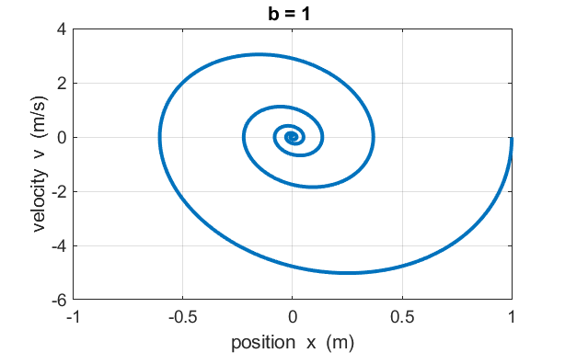

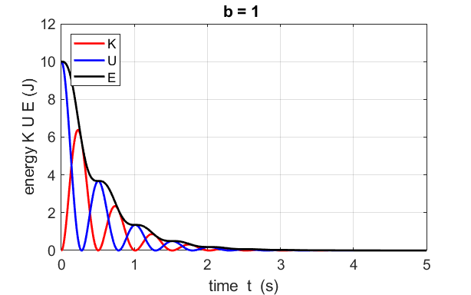

**Impulsive driving force**

The System is disturbed from its equilibrium position for a short time interval by the action of a constant force which acts to give a non-zero displacement of the mass. The System then oscillates at its natural frequency of vibration about an equilibrium position which is determined by the applied impulsive force.

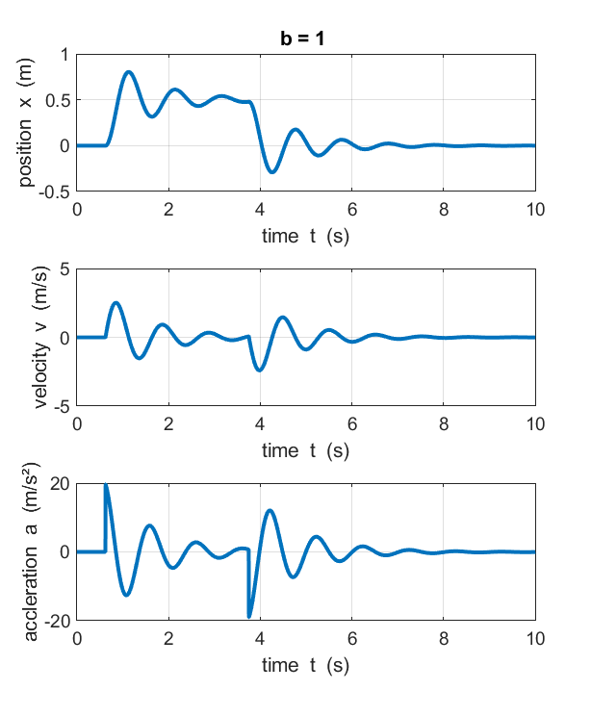

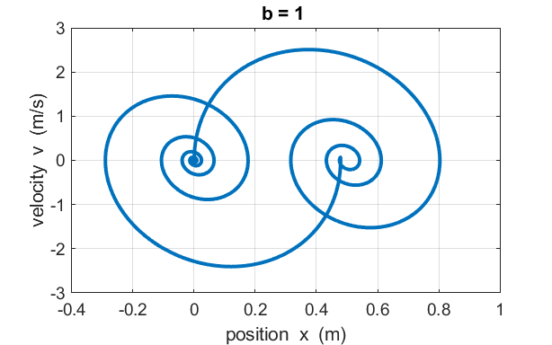

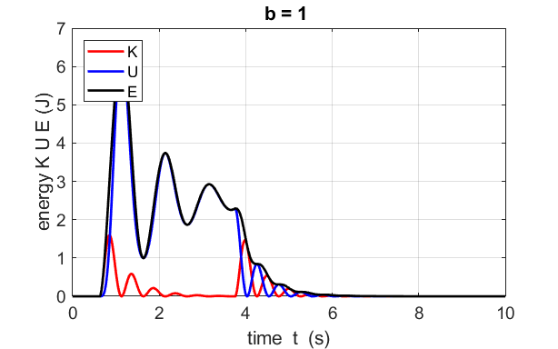

**Sinusoidal driving force**

You can explore the response of the System to a sinusoidal driving force. You can change the frequency of the driving force and see immediately the response of the System. The System will vibrate at the frequency of the driving force. When the driving frequency is near the natural frequency, large amplitude oscillates result with the maximum amplitude occurring very near the natural frequency as given by equation 2. However, the peak amplitude is slightly affected by the damping parameter *b.* This phenomenon is called **resonance**.

With zero damping, energy is continuously added to the System and the amplitude of the oscillations increases with time. When there is damping, a steady state situation is achieved in which the amplitude of the oscillation reaches a fixed value.

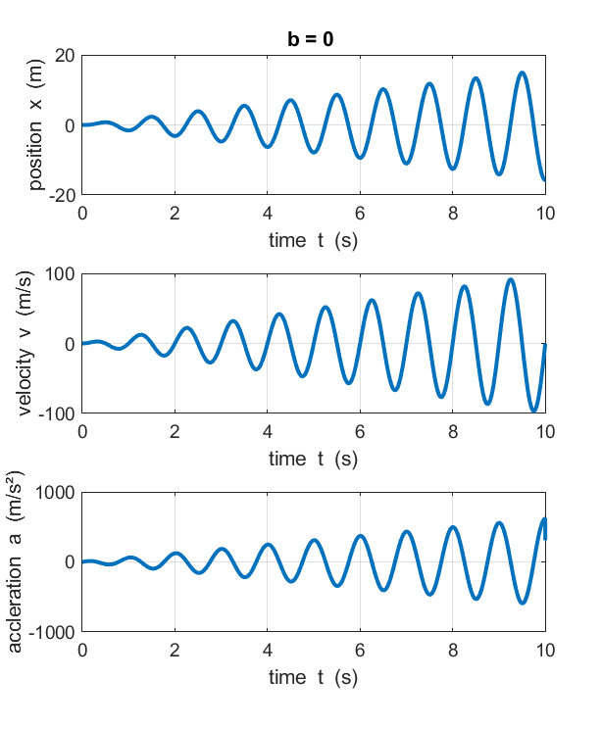

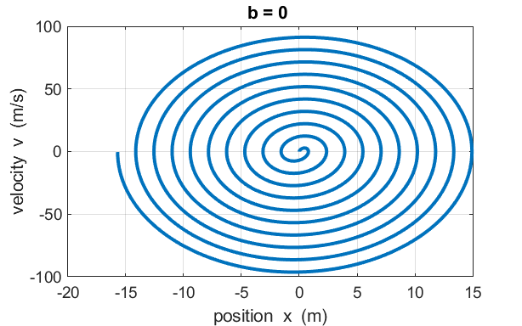

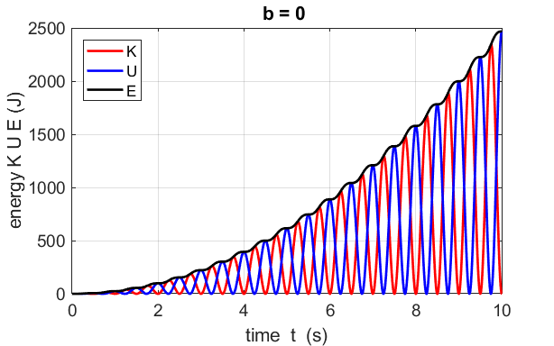

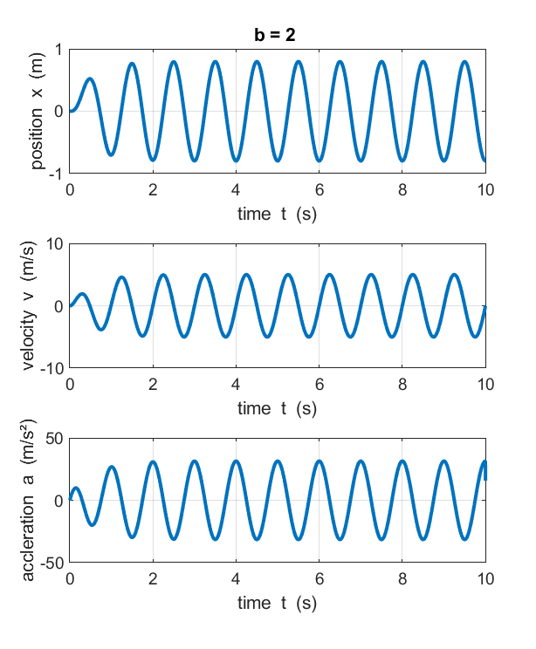

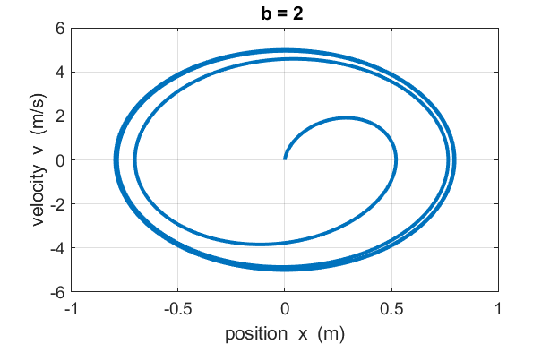

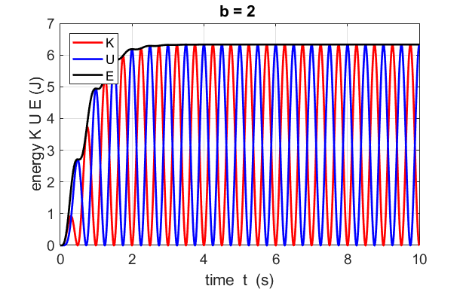

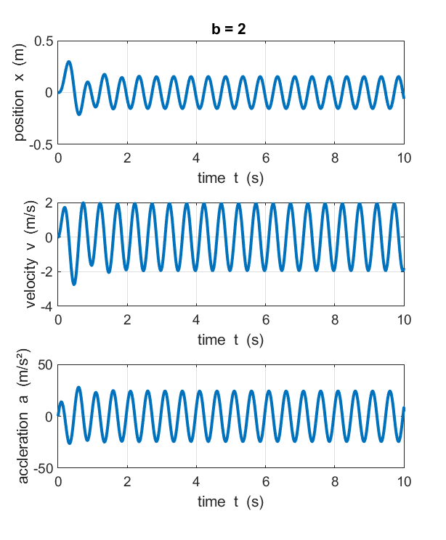

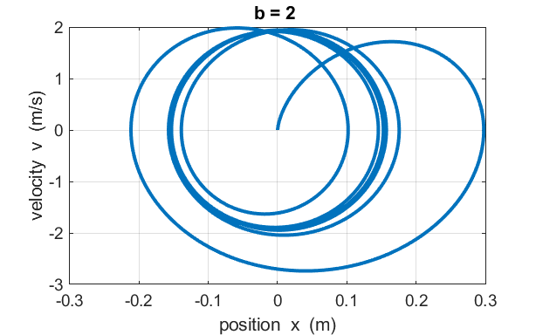

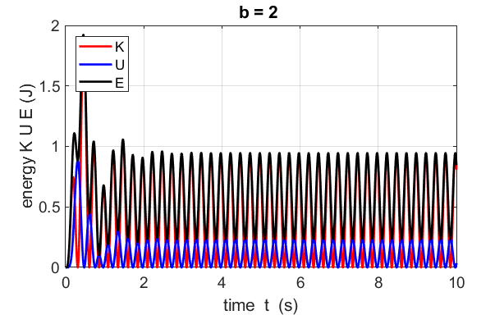

The response curve for the oscillations of the mass / spring System is given by the equation

(3) 

The response curve is computed using the script **osc_harmonoic02.m**

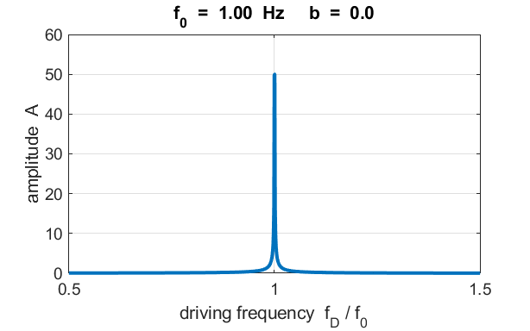

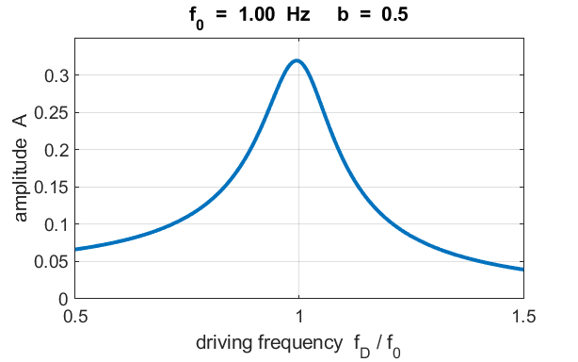

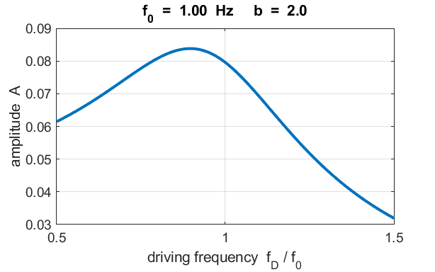

Note: the peak amplitude is not equal to the natural frequency of vibration given by equation 2 when the System is damped.

**APPENDIX Finite Difference Method**

The equation of motion to be solved is

(4) 

The first and second derivatives for the velocity and acceleration can be approximated at the time step *n* by the equations



(5)



Substituting our approximations into the equation of motion, and after some tedious algebra, we get the displacement at time step (*n+*1)

(6) 

where

(7) 

To start the computational procedure, the initial value of the displacement *x*(1) at time step *n* = 1 is specified and then the value of the displacement at time step *n* = 2 is approximated. Equation 6 is then used to calculate the displacement at all later time steps.

|  |
| --- |
| % Coefficients  c0 = 1 + (b/m)*(dt/2);  c1 = (2-(k/m)*dt*dt)/c0;  c11 = (2-(k/m)*dt*dt);  c2 =((b/m)*(dt/2)-1)/c0;  c3 = (dt*dt/m)/c0;    % Finite difference Calculations  % Position  for c = 3 : nmax  x(c) = c1*x(c-1) + c2*x(c-2) + c3*FD(c-1);  end |

Once we know the displacement at all time steps, it is a simple matter to calculate the velocity, acceleration, kinetic energy of the mass and the potential energy and total energy of the System.

|  |
| --- |
| % Velocity  v(1) = (x(2)-x(1))/dt;  v(nmax) = (x(nmax)- x(nmax-1))/dt;  for n = 2 : nmax-1  v(n) = (x(n+1)- x(n-1))/(2*dt);  end    % Acceleration  a(1) = (v(2)-v(1))/dt;  a(nmax) = (v(nmax)- v(nmax-1))/dt;  for n = 2 : nmax-1  a(n) = (v(n+1)- v(n-1))/(2*dt);  end    % Energies  K = (0.5*m).*v.^2;  U = (0.5*k).*x.^2;  E = K + U; |

Ian Cooper

ian.cooper@sydney.edu.au

School of Physics, University of Sydney

N.S.W. Australia

Please email if you have any comments, corrections or suggestions.