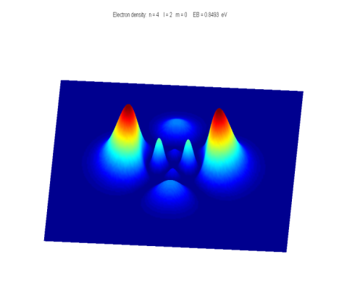[**DOING PHYSICS WITH MATLAB**](http://www.physics.usyd.edu.au/teach_res/mp/mphome.htm)

**QUANTUM MECHANICS**

**THEORY OF ALPHA DECAY**

Ian Cooper

School of Physics, University of Sydney

ian.cooper@sydney.edu.au

[**DOWNLOAD DIRECTORY FOR MATLAB SCRIPTS**](http://www.physics.usyd.edu.au/teach_res/mp/mscripts)

**qp_alpha_theory.m**

This mscript is used to compute the half-life of an unstable nucleus which emits an alpha particle. The radioactive isotope is specified by its atomic number *Z* and its mass number *A*. The half-life *t*1/2 is computed from an analytical expression for a given value of the kinetic energy *E*α of the emitted alpha particle.

**se_fdm_barrier.m**

The wavefunction for a rectangular barrier is computed by solving the Schrodinger Equation by a [finite difference method](http://www.physics.usyd.edu.au/teach_res/mp/doc/qp_se_fdm.pdf). The code is a modification of the mscript **se_fdm.m**.

**se_fdm_alpha.m**

This mscript is used to compute the half-life of an unstable nucleus which emits an alpha particle. The radioactive isotope is specified by its atomic number *Z* and its mass number *A*. The half-life *t*1/2 is computed from a given value of the kinetic energy *E*α of the emitted alpha particle. The probability of the alpha particle tunnelling through the potential barrier is found by solving the Schrodinger Equation using a finite difference method.

**ALPHA DECAY**

A radioactive substance becomes more stable by: **alpha decay** (helium nucleus 4He2), or **beta decay** (electron e- or positron e+) or **gamma decay** (high energy photon). If a radioactive substance at time *t*= 0 contains *N*0 radioactive nuclei, then the number of nuclei *N* remaining after a time interval *t* is

(1) 

where is the **decay constant** which is the probability per unit time interval that a nucleus will decay. The **half-life** *t*1/2 is defined as the time required for half of a given number of nuclei to decay. The decay constant and half-life are related by

(2) 

In alpha decay, a nucleus emits a helium nucleus 4He2 which consists of 2 protons and 2 neutrons. Therefore, the atomic number *Z* decreases by 2 and the mass number *A* decreases by 4.  If X is the parent nucleus and Y is the daughter nucleus then the decay can be written as



The attractive forces binding the nucleons together within the nucleus are of short range and the total binding force is approximately proportional to its mass number *A*. The repulsive electrostatic force between the protons is of an unlimited range and the disruptive force in a nucleus is approximately proportional to the square of the atomic number. Nuclei with *A* > 210 are so large that the short range strong nuclear force barely balances the mutual repulsion of their protons. Alpha decay occurs in such nuclei as a means of reducing their size and increasing the stability of the resulting nuclei after the decay has occurred. A simple model for the potential energy *U*(*r*) of the alpha particle as a function of distance *r* from the centre of the heavy nucleus is shown in figure (1).

The potential well is modelled as a three dimensional deep attractive well associated with the strong nuclear force and beyond the range of this force an electrostatic repulsion due to the Coulomb force between the daughter nucleus and the alpha particle as given by

(3) 

where *r* is the distance from the centre of the nucleus, *Z* is the atomic number of the parent nucleus and (*Z*-2) is the atomic number of the daughter nucleus.

Fig. 1. The potential energy of an alpha particle and nucleus as a function of the distance from the centre of the nucleus.

From a classical point of view, an alpha particle does not have sufficient energy to escape from the potential well. The barrier height is typically in the order of 30 MeV and the decayed alpha particles have energies only in the range 4 to 9 MeV. This range of energies from 4 to 9 MeV is very small, but the half-lifes of the radioactive alpha emitters range from ~10-7 s to ~1018 s, while the energy changes by a factor of 2, the change in the half-lifes is about **25 orders of magnitude** **!!!**. Our goal is explain, how an alpha particle can escape from a nucleus and find a relationship between the energy of the alpha particle and its half-life.

We will do this by (1) analytical means and (2) by solving the Schrodinger equation numerically for an alpha particle in a potential well as shown in figure (1).

Classical arguments fail to account for alpha decay, but quantum mechanics provides a straight forward explanation based upon the concept of **tunnelling** where a particle can be found in a classically forbidden region. The theory of alpha decay was developed in 1928 by Gamow, Gurney and Condon and provided confirmation of the power of quantum mechanics. We will develop simplified models to account for alpha decay and compare our predictions with those of experiments.

**ANALYTICAL MODEL**

Assume that an alpha particle exists as a particle in constant motion with velocity *vα* contained inside the heavy nucleus by a surrounding potential barrier. There is a small probability that the alpha particle can escape each time it encounters the barrier. The decay constant gives the decay probability per unit time

(4) 

where *f* is the number of times per second an alpha particle strikes the potential barrier at *r* = *R*0 and *P* is the probability that the particle passes through the barrier. The probability can be determined from the wavefunction. Inside the potential well (0 ≤ *r* ≤ *R*0) the wavefunction has an oscillatory nature and its amplitude is *Ain*. In the barrier region (*R*0 < *r* ≤ *R*1) the wavefunction decreases exponentially. When the alpha particle has escaped (*r* > *R*1) the wavefunction is approximately sinusoidal with and amplitude *Aout* , therefore, the probability *P* that the alpha particle strikes the barrier and escapes is

(5) 

An example of tunnelling through a barrier is shown in figure (2). Classically the particle does not have sufficient energy to pass through the barrier and upon striking the barrier the particle would be reflected. 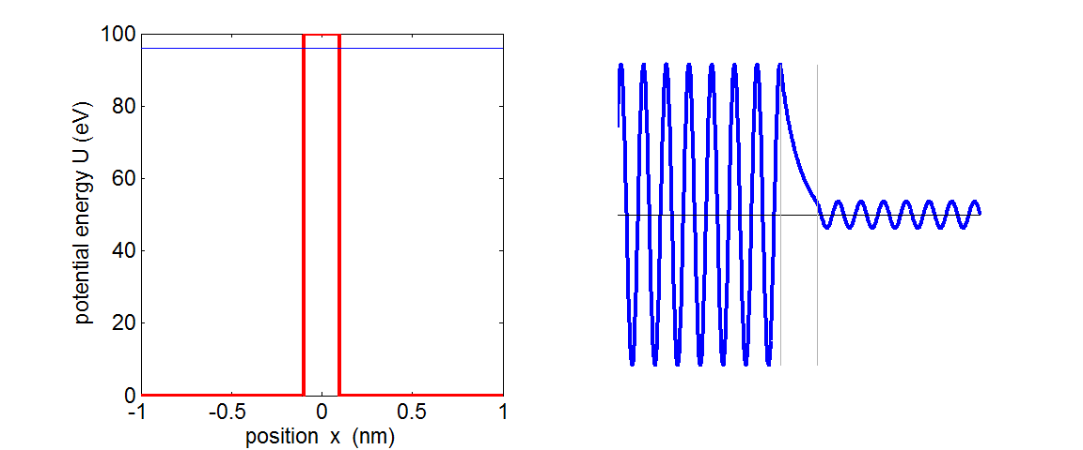

Fig. 2. The wavefunction for a barrier of finite width. The particle is incident upon the barrier from the left. There is a small probability that the particle is located to the right of the barrier.

**se_fdm_barrier.m**

Assume that the alpha particle moves back and forth in the nucleus of radius *R*0 . We can estimate the radius *R*0 assuming that it is equal to the radius of the alpha particle and the daughter nucleus (figure 1)

(6) 

where *A* is the mass number of the parent nucleus.

Then the frequency *f* of striking the barrier is

(7) 

where *vα* is the alpha particle velocity when it escapes from the nucleus and is determined from the kinetic energy of the emitted alpha particle whose mass is 

(8) 

For the barrier region, *U* > *E* and *K* < 0, classical physics predicts a transmission probability *P* = 0. However, in the quantum picture, the particle behaves as a wave and there is a non-zero probability of the particle escaping from the potential well, *P* > 0. The particle escapes the barrier at *U* = *E* at the position *R*1 where

(9)  

After much “hard work” it can be shown that the probability of an alpha particle escaping our potential well is

(10)



assume *R*0 << *R*1

We are now in a position to estimate the half-life of an alpha emitting unstable nucleus given the atomic number *Z* and the mass number *A* of the parent nucleus and the mass *mα* and kinetic energy *E*α of the escaped alpha particle.

The half-life *t*1/2 can be computed from the known parameters of *Z*, *A* and *Eα*.

1: Calculate *R*0 from Eq. (6) 

2: Calculate *v*α from Eq. (8) 

3: Calculate *f* from Eq. (7) 

4: Calculate P from Eq. (10)  

5: Calculate γ from Eq. (4) 

6: Calculate *t*1/2 from Eq. (2) 

We can rewrite the expression for the half-life as



(11) 

Equation (11) is a straight line when  [y-axis] is plotted against [x-axis].

Figure 1 shows a plot of equation (11) for the isotopes of Polonium Po (*Z* = 84). The straight blue line is the linear relationship between  and  for *A*= 218 and *E*α ranging from 4.0 MeV to 10.0 MeV. The y-axis plots log10( *t*1/2 ) and not loge( t*1/2* ) to **emphasize the huge change of about 20 orders of magnitude in the half-life when the change in kinetic energy of the alpha particle is only from 4 to 10 MeV**. The red dots represent the accepted measured values of the half-life and the kinetic energy of the emitted alpha particle for the various isotopes of Polonium used in the modelling. The blue dots represent the calculated values for of the half-lifes using the mass number *A* specific to each isotope. The number **1.07** used in equation (6) is only a rough estimate and the half-life is very dependent upon the value of *R*0. So considering we have used “rough” approximations, there is good agreement between the experimental values and the computed values of the half-lifes.



Fig. 3. Plot of log10 (*t*1/2 ) against *Eα*-1/2 for six isotopes of Polonium. The mass number *A* is shown next to each data point. The blue straight line is the linear relationship given in equation (11) with *A* = 218 and *Z* = 84. The red dots represent the experimental values and the blue dots represent the computed values of *t*1/2 for each isotope with differing values of *A*. Note: x-axis - the kinetic energy decreases to the right. The plot was created with the mscript **qp_alpha_theory.m** . The data for the experimental values and computed values are stored in arrays embedded in the code.

Table 1: Polonium *Z* = 84

|  |  |  |  |  |  |  |
| --- | --- | --- | --- | --- | --- | --- |
| ***A*** | ***E*α**  **(MeV)** | ***t*1/2**  **expt.** | ***t*1/2**  **computed** | ***f***  **(x1021 s-1)** | ***P*** | ***R*0**  **(x10-15 m)** |
| 210 | 5.40 | 1.2x108 | 2.7x106 | 1.0 | 2.6x10-28 | 8.0 |
| 218 | 6.12 | 183 | 365 | 1.1 | 1.8x10-24 | 8.1 |
| 216 | 6.89 | 0.20 | 0.20 | 1.1 | 3.1x10-21 | 8.1 |
| 215 | 7.50 | 1.8x10-3 | 1.2x10-3 | 1.2 | 5.0x10-19 | 8.1 |
| 214 | 7.83 | 1.5x10-4 s | 9.6x10-5 | 1.2 | 6.0x10-18 | 8.1 |
| 212 | 8.95 | 3.0x10-7 | 5.5x10-8 | 1.3 | 9.8x10-15 | 8.0 |

**NUMERICAL ANALYSIS**

We can compute the half-life *t*1/2 for the radioactive decay of the nucleus which emits an alpha particle by solving the Schrodinger Equation by a [finite difference method](http://www.physics.usyd.edu.au/teach_res/mp/doc/qp_se_fdm.pdf).

The input parameters for the calculation are the energy of the alpha particle *Eα* in MeV and the mass number *A* and atomic number *Z* for the parent nucleus. From equation (2) and (4), the half-life is

(12) 

The frequency *f* is given by equation (7)

(7) 

where *vα* and *R*0 are given by equations (8) and (6) respectively

(8) 

(6) 

The probability is given by equation (5)

(5) 

So, we need to solve the Schrodinger Equation for the a potential energy function representing the system of the parent nucleus and the alpha particle (figure 1) to find the amplitude *Ain* of the wavefunction inside the potential well (*r* < *R*0) and the amplitude *Aout* of the wavefunction outside the well (*r* > *R*1) . Once, *Ain* and *Aout* have been computed, then it east to calculate the half-life *t*1/2 from equation (12).

The **time-independent Schrodinger Equation in one dimension** can be expressed as

(13) 

For nuclear systems it is more convenient to measure lengths in fm (femometers) and energies in MeV. We can use the scaling factors

length: *Lse* = 1×10-15 to convert m into fm

energy: *Ese* = 1.6×10-13 to convert J into MeV

so we can write equation (13) as

(14) 

where *m* is the mass of the alpha particle.

In the finite difference method, the second derivative of the wavefunction is approximated by

(16) 

The mscript **se_fdm_alpha.m** can be used to solve the Schrodinger Equation and compute the half-life from the input variables of *Eα*, *A* and *Z*. All energies are expressed MeV and distances in fm.

Sample code for the calculation of the potential energy function

N = 59009; % number of x values - must be ODD

x0 = 1.07 * (4^(1/3) + (A-4)^(1/3));

U0 = -40; ]

U = U0 .* ones(1,N);

for n = 2:N

if x(n) > x0, U(n) = 9e9 * 2 * (Z-2) * e^2 / (Ese * Lse *

x(n));

end;

end

Sample code for solving the Schrodinger Equation

psi = zeros(1,N);

psi(N) = 1; psi(N-1) = 2;

for n = N-1:-1:2

SEconst = Lse^2 .* Ese .* (2*me/hbar^2).*(E - U(n)).* dx^2;

psi(n-1) = (2 - SEconst) * psi(n) - psi(n+1);

end

**Note:** The finite difference method in this instance must be iterated **backwards** starting from the right at *x*(*N*) and finishing at *x*(*1*).

In running the mscript **se_fdm_alpha.m**, the input parameters are entered in the Matlab Command Window:

Enter data for alpha particle and the parent nucleus:

Enter the alpha particle energy E in MeV 5.4

Enter the mass number A for the parent nucleus 210

Enter the atomic number Z for the parent nucleus 84

Some of the values computed within the mscript are displayed in the Matlab Command Window:

E = 5.4000

A = 210

Z = 84

x0 = 8.0179

vA = 1.6126e+07

f = 1.0056e+21

Ain = 0.4819

Aout = 7.2982e-15

P = 2.2931e-28

gamma = 2.3061e-07

half_life = 3.0057e+06

Figure 4 shows the graphical output for the input parameters of the element Polonium: *A* = 210 and *Z* = 84 and *Eα* = 5.40 MeV.

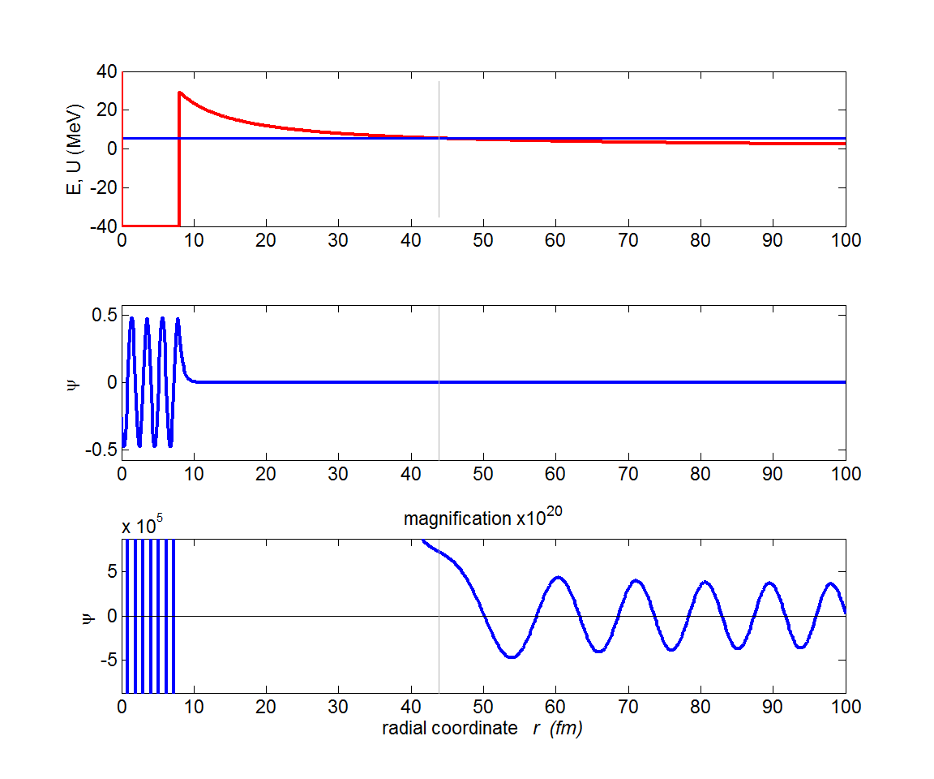

Fig. 4. The top plot shows the potential energy function (red) and the kinetic energy of the escaped alpha particle (blue). The centre plot shows the wavefunction and the bottom graph shows a magnified view (x1020) of the wavefunction. Note the enormous magnification factor indicting the extremely small probability of the alpha particle tunnelling through the barrier.

Table 2: Polonium  *Z* = 84 *N* = 59009 *L* = 120 fm

|  |  |  |  |  |  |
| --- | --- | --- | --- | --- | --- |
| ***A*** | ***E*α**  **(MeV)** | ***t*1/2**  **expt.** | ***t*1/2**  **Eq. (12)** | ***t*1/2**  **SE1** | ***t*1/2**  **SE2** |
| 210 | 5.40 | 1.2x108 | 2.7x106 | 2.9x106 | 1.1x107 |
| 218 | 6.12 | 183 | 365 | 602 | 2.4x103 |
| 216 | 6.89 | 0.20 | 0.20 | 0.45 | 1.7 |
| 215 | 7.50 | 1.8x10-3 | 1.2x10-3 | 2.4x10-5 | 5.3x10-5 |
| 214 | 7.83 | 1.5x10-4 s | 9.6x10-5 | 4.6x10-5 | 8.7x10-4 |
| 212 | 8.95 | 3.0x10-7 | 5.5x10-8 | 3.7x10-8 | 7.7x10-8 |

Table 2 is a summary of the half-lifes and the kinetic energies of the alpha particle. Column (3) are the experimental results. Column (4) are the half-lifes calculated from equation (12). Column (5) are the computed values found by solving the Schrodinger Equation: *Aout* is the maximum value of the wavefunction in the region where *E* > *U* (*r* > *R*1). Column (6) are the computed values found by solving the Schrodinger Equation: *Aout* is the maximum value of the wavefunction in the region of the regular sinusoidal variation in the wavefunction *r* > 2*R*1.

The numerical solution of the Schrodinger Equation confirms the linear relation between loge( *t*1/2 ) and  as given by equation (12). Figure (5) shows the plot for the data in Table 2. There is excellent agreement between all the different ways in which the half-lifes were determined except for *Eα* = 7.50 MeV where the value computed by solving the Schrodinger Equation is too low (why ???). Not too much weight can be placed upon the actual values for the detemrinations of the half-lifes by solving the Schrodinger equation because the number you obtain is very dpendent on many parmaeters: it is not so clear on how to measure *Aout* (take its maximumium to the right of the barrier where *E* > *U* or take the value when the wavefunction oscillates in a more regular manner); the number of data points used in the calculations; the maximum value of the radial coordinate; the radius of the parent nucleus; the depth of the potential well and the sensitivity of the haf-life computation as a function of the energy of the alpha particle. In figure (5) the y-axis is plotted as log10 and not loge to emphsize the extreme variation in the half-life for small changes in the energy of the alpha particle. You can see clearly that there is an increase of about 15 orders of magntide in the half-life as the the kinetic energy increases from about 4 to 9 MeV.

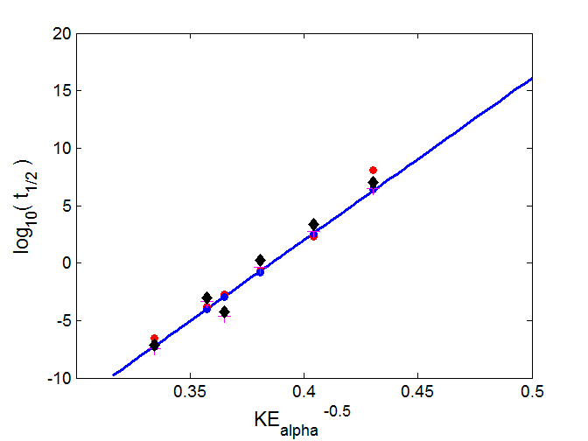

Fig. 5. Plot of log10 (*t*1/2 ) against *Eα*-1/2 for six isotopes of Polonium as shown in figure 3 . The blue straight line is the linear relationship given in equation (12) with *A* = 218 and *Z* = 84. The red dots represent the experimental values and the blue dots represent the computed values of *t*1/2 for each isotope with differing values of *A*.

Result from solving the Schrodinger Equation: red crosses **+** (Table 2, column 5 and black diamonds ♦ (Table 2, column 6). The plot was created with the mscript **qp_alpha_theory.m** . The data for the experimental values and computed values are stored in arrays embedded in the code.