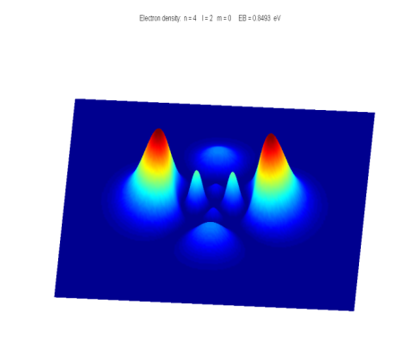[**DOING PHYSICS WITH MATLAB**](http://www.physics.usyd.edu.au/teach_res/mp/mphome.htm)

**QUANTUM MECHANICS**

**THEORY OF ALPHA DECAY**

|  |  |
| --- | --- |
| Ian Cooper  School of Physics  University of Sydney  ian.cooper@sydney.edu.au | Badr Eddine El Fatehy Chfira  University of Murcia (UMU, Spain) <https://www.um.es/>  badreddine.el@um.es |

[**DOWNLOAD DIRECTORY FOR MATLAB SCRIPTS**](http://www.physics.usyd.edu.au/teach_res/mp/mscripts)

**MATLAB**

**qp_alphaB.m**

The Script can be used to compare Experimental, Analytical and Numerical values for the half-life values as a function of the kinetic energy of the escaped alpha particles for the isotopes of polonium and uranium. The Experimental values of the kinetic energies T and half-lives h are stored in arrays (polonium: kinetic energy T1_E; half-life h1_E and uranium: kinetic energy T2_E; h2_E). The Geiger-Nuttall law is used to calculate the half-life values (Analytical values h_A). A [finite difference method](http://www.physics.usyd.edu.au/teach_res/mp/doc/qp_se_fdm.pdf) is used to solve the Schrodinger Equation for a nuclear potential function (Numerical values h_N). The Script can easily be changed to model the alpha decay of other elements.

**se_fdm_barrier.m**

The wavefunction for a rectangular barrier is computed by solving the Schrodinger Equation by a [finite difference method](http://www.physics.usyd.edu.au/teach_res/mp/doc/qp_se_fdm.pdf). The code is a modification of the mscript **se_fdm.m**. The height of the barrier is set at 100 eV. The total energy of the system is entered via the Command Window (E < 100 eV).

**se_fdm_alpha_A.m**

This Script is used to compute the half-life of an unstable nucleus which emits an alpha particle. The radioactive isotope is specified by its atomic number *Z* and its mass number *A*. The half-life *t*1/2 is computed from a given value of the kinetic energy *T*of the emitted alpha particle. The probability *P* of the alpha particle tunneling through the potential barrier is found by solving the Schrodinger Equation using a finite difference method.

Input variables:

Atomic number Z; mass number A; escape kinetic of alpha particle T; radius factor Rf (~1 to ~1.5. Value can be adjusted to get better agreement between the experimental value of the half-life and the computed value); angular momentum quantum number LA; switch to choose a square well or the Woods-Saxon nucleus potential flagWS; diffuseness parameter a (~0.25 to ~1); well depth U0 (U0 < 0); maximum radial coordinate xMax; and number of grid points for calculations N (N =999999, need to use a very large number).

Computations:

The Schrodinger equation is solved using a finite difference method to find the wavefunction psi and transmission probability P of tunneling through the potential barrier for the selected potential energy function. The results of the computations are displayed in the Command Window as tables and in a graphical output.

Scripts by Badr Eddine El Fatehy Chfira [badreddine.el@um.es](mailto:badreddine.el@um.es)

**qp_alpha3D.m**

Computation of the half-live for the nuclear potential energy function which includes contributions from Woods-Saxon nuclear potential, centrifugal potential (angular momentum) and Coulomb potential for the repulsion of the alpha particle. The execution of the Script calculates the half-lives for a set of diffuseness parameters and angular momentum values.

**qp_alphaWKB.m**

Computation of the half-life using the WKB approximation. The WKB approximation is not discussed in the notes.

**ALPHA DECAY**

A radioactive substance becomes more stable by: **alpha decay** (helium nucleus 4He2) or **beta decay** (electron e- or positron e+) or **gamma decay** (high energy photon). If a radioactive substance at time *t*= 0 contains *N0* radioactive nuclei, then the number of nuclei *N* remaining after a time interval *t i*s

(1) 

where  is the **decay constant** which is the probability per unit time interval that a nucleus will decay. The **half-life**  is defined as the time required for half of a given number of nuclei to decay. The decay constant and half-life are related by

(2) 

In **alpha decay**, a nucleus emits a helium nucleus 4He2 which consists of 2 protons and 2 neutrons. Therefore, the atomic number *Z* decreases by 2 and the mass number *A* decreases by 4.  If X is the parent nucleus and Y is the daughter nucleus then the decay can be written as



The attractive forces binding the nucleons together within the nucleus are of short range and the total binding force is approximately proportional to its mass number *A*. The repulsive electrostatic force between the protons is of an unlimited range and the disruptive force in a nucleus is approximately proportional to the square of the atomic number. Nuclei with *A* > 210 are so large that the short range strong nuclear force barely balances the mutual repulsion of their protons. Alpha decay occurs in such nuclei as a means of reducing their size and increasing the stability of the resulting nuclei after the decay has occurred. A simple model for the potential energy  of the alpha particle as a function of distance *r* from the centre of the heavy nucleus is shown in figure 1.

The potential well is modelled as a three dimensional deep attractive well associated with the strong nuclear force and beyond the range of this force an electrostatic repulsion due to the Coulomb force between the daughter nucleus and the alpha particle as given by

(3) 

where *r* is the distance from the centre of the nucleus, *Z* is the atomic number of the parent nucleus and (*Z-*2) is the atomic number of the daughter nucleus.

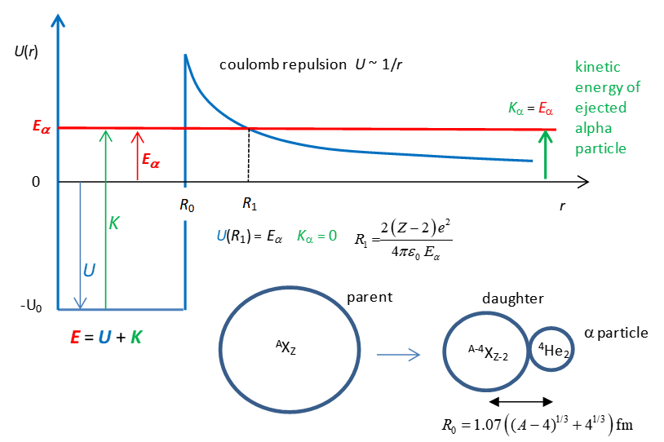

Fig. 1. The potential energy *U* of an alpha particle and nucleus as a function of the distance *r* from the centre of the nucleus. Total energy *E,* potential energy *U*, kinetic energy *K* and kinetic energy of escaped alpha particle is .  is the width of the potential well and is equal to radius of the alpha particle plus the radius of the daughter nucleus.  is the radius at which the alpha particle escapes from the parent nucleus (*K* = 0).

From a classical point of view, an alpha particle does not have sufficient energy to escape from the potential well. The barrier height is typically in the order of 30 MeV and the decayed alpha particles have energies only in the range 4 to 9 MeV. This range of energies from 4 to 9 MeV is very small, but the half-lives of the radioactive alpha emitters range from ~10-7 s to ~1018 s, while the energy changes by a factor of 2, the change in the half-lives is about **25 orders of magnitude** **!!!**. Our goal is explain, how an alpha particle can escape from a nucleus and find a relationship between the energy of the alpha particle and its half-life.

We will do this by (1) Analytical means and (2) Numerically by solving the Schrodinger equation using a finite difference method for an alpha particle in a potential well as shown in figure (1).

Classical arguments fail to account for alpha decay, but quantum mechanics provides a straight forward explanation based upon the concept of **tunnelling** where a particle can be found in a classically forbidden region. The theory of alpha decay was developed in 1928 by Gamow, Gurney and Condon and provided confirmation of the power of quantum mechanics. We will develop simplified models to account for alpha decay and compare our predictions with those of experiments.

**ANALYTICAL MODEL**

Reference: *Concepts of Modern Physics*, Arthur Beiser

Assume that an alpha particle exists as a particle in constant motion with velocity *vα* contained inside the heavy nucleus by a surrounding potential barrier. There is a small probability that the alpha particle can escape each time it encounters the barrier. The decay constant gives the decay probability per unit time of an escape

(4) 

where *f* is the number of times per second an alpha particle strikes the potential barrier at *R0* and *P* is the probability that the particle passes through the barrier. The probability can be determined from the wavefunction. Inside the potential well (0 ≤ *r* ≤ *R*0) the wavefunction has an oscillatory nature and its amplitude is *Ain*. In the barrier region (*R*0 < *r* ≤ *R*1) the wavefunction decreases exponentially. When the alpha particle has escaped (*r* > *R*1) the wavefunction is approximately sinusoidal with and amplitude *Aout*, therefore, the probability *P* that the alpha particle strikes the barrier and escapes is

(5) 

An example of tunnelling through a barrier is shown in figure 2. Classically the particle does not have sufficient energy to pass through the barrier and upon striking the barrier the particle would be reflected.

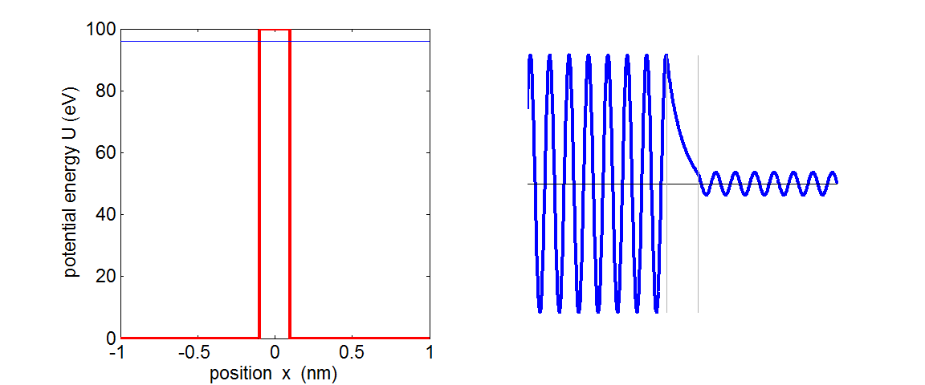

Fig. 2. The wavefunction for a barrier of finite width. The particle is incident upon the barrier from the left. There is a small probability that the particle is located to the right of the barrier. **se_fdm_barrier.m**

Assume that the alpha particle moves back and forth in the nucleus of radius *R0*. We can estimate the radius *R0* assuming that it is equal to the radius of the alpha particle plus the daughter nucleus (figure 1)

(6) 

where *A* is the mass number of the parent nucleus and *RF* is a radius factor. The nuclear radius *R0* is not a well-defined quantity. It is often found by fitting experimental data to a theoretical fit when  is plotted against .

Then the frequency *f* of striking the barrier is

(7) 

where  is the alpha particle velocity inside the parent nucleus

(8) 

The alpha particle goes one way while the daughter nucleus recoil in the opposite direction. So, it may be better to use the reduced mass  rather than the mass of the alpha particle  where



For the barrier region, *U* > *E* and *K* < 0, classical physics predicts a transmission probability *P* = 0. However, in the quantum picture, the particle behaves as a wave and there is a non-zero probability of the particle escaping from the potential well, *P* > 0. The particle escapes the barrier at *U* = *E* at the position *R*1 where

(9)  

After much “hard work” and assuming that  it can be shown that the probability of an alpha particle escaping our potential well is

(10)



We are now able to estimate the half-life of an alpha emitted from an unstable nucleus given the atomic number *Z* and the mass number *A* of the parent nucleus and the mass  and kinetic energy *T* of the escaped alpha particle.

The half-life *t*1/2 can be computed from the known parameters of *Z*, *A*, *T,* and *R*0*.*

1: Calculate *R*0 from Eq. (6) 

2: Calculate  from Eq. (8) 

3: Calculate *f* from Eq. (7) 

4: Calculate *P* from Eq. (10) 

5: Calculate γ from Eq. (4) 

6: Calculate *t*1/2 from Eq. (2) 

We can rewrite the expression given by equation 6 for the half-life as







(11) 

Equation (11) is approximately a straight line when  [y-axis] is plotted against  [x-axis].



This expression is known as the **Geiger-Nuttall rule**.

**NUMERICAL ANALYSIS**

We can compute the half-life *t*1/2 for the radioactive decay of a nucleus which emits an alpha particle by solving the Schrodinger Equation by a [finite difference method](http://www.physics.usyd.edu.au/teach_res/mp/doc/qp_se_fdm.pdf) to find the wavefunction as a function of the radial coordinate. The Script **se_fdm_alphaA.m** can be used to solve the Schrodinger Equation and compute the half-life.

We need to solve the Schrodinger Equation for the a potential energy function representing the system of the parent nucleus and the alpha particle (figure 1) to find the amplitude *Ain* of the wavefunction inside the potential well (*r* < *R*0) and the amplitude *Aout* of the wavefunction outside the well (*r* > *R*1) . Once, *Ain* and *Aout* have been computed, then it east to calculate the half-life *t*1/2 as was describe in the Analytical method.

The **time-independent Schrodinger Equation in one dimension** can be expressed as (*x* is used as the radial coordinate and not *r)*

(13) 

For nuclear systems it is more convenient to measure lengths in fm (femometre) and energies in MeV. We can use the scaling factors

length: *Lse* = 1×10-15 to convert m into fm

energy: *Ese* = 1.6×10-13 to convert J into MeV

So, we can write equation (13) as

(14) 

where *m* is the reduced mass.

In the finite difference method, the second derivative of the wavefunction is approximated by

(16) 

The Schrodinger Equation must be solved backwards starting from a far-away point.

% Wavefunction

for n = N-1:-1:2

SEconst = (T - U(n)).* dx^2./Cse;

psi(n-1) = (2 - SEconst) * psi(n) - psi(n+1);

end

The point at which the potential is equal to the kinetic energy of the alpha particle is found using the Matlab function **solve**

x1 = max(double(**solve**(@(z) LA.*(LA+1).*Cse./(z.^2) + 2.*(Z-2).*e.^2./ (4.*pi.*eps0.*Ese.* Lse.* z) == T)));

The amplitudes of the wavefunction inside and outside the potential well are found by using Matlab **find** function from which the half-life is computed. The kinetic energy of the alpha particle can be calculated from the total energy and from the wavelength of the wavefuction using the Matlab function **findpeaks**

% CALCULATIONS ================================================

% Position in arrays

% index for x position when E = U outside well

index = find(x>x1, 1 );

% index for position outside well

index1 = find(x>x0, 1 );

% index for position to calc Aout

index2 = round(0.9*N);

% velocity of alpha particle inside well

v_in = sqrt(2*(T-U0)*Ese/mR);

% frequency at which particles strike barrier on the RHS of well

f = v_in / (2*x0*Lse);

% amplitude of wavefunction inside and outsie nucleus

Ain = max(abs(psi(1:index1)));

Aout = max(abs(psi(index2:N)));

% probability of alpha particle escaping

P = (Aout / Ain)^2;

% decay constant

gamma = f * P;

% half-life

half_life = log(2) / gamma;

% Wavelength --> kinetic energy

[~, z2] = findpeaks(psi(1:index1));

wLin = (x(z2(end))-x(z2(1)))/(length(z2)-1);

[z1, z2] = findpeaks(psi(index2:N));

wLout = (x(z2(end)+index2)-x(z2(1)+index2))/(length(z2)-1);

p_in = h/(wLin*1e-15);

T_in = p_in^2/(2*mR)/(e*1e6);

p_out = h/(wLout*1e-15);

T_out = p_out^2/(2*mR)/(e*1e6);

% kinetic energy T - U

K_in = T - U0;

K_out = T - U(end);

Umax = max(U);

**MATLAB SIMULATIONS**

**qp_alphaB.m**

Comparison of the Experimental, Analytical values and Numerical values for the half-lives of polonium and uranium isotopes.

The results are displayed in the Command Window using the Matlab function **table**.

The tables columns are A (mass numbers), T (kinetic energy of escaped alpha particle), experimental half-lives (h_E), analytical half-lives (h_A), ratio of experimental to analytical half-lives (R_EA), numerical half-lives (h_N) and ratio of experimental to numerical half-lives (R_EN). The energies are in MeV and half-lives in s.

Isotopes of polonium

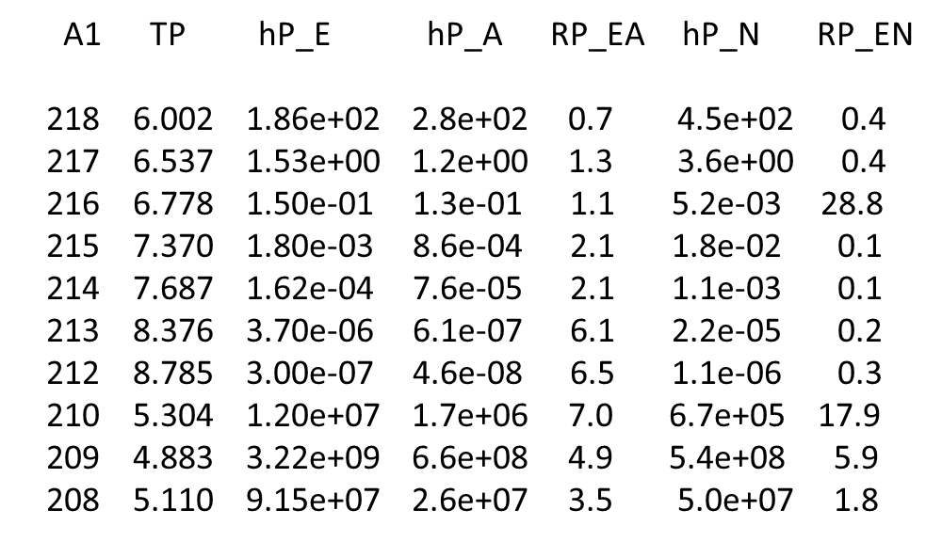

Notice the enormous range of half_lives values. For T = 4.883 MeV t1/2 ~ 109 s. However, when T = 8.785 MeV, t1/2 ~ 10-7 s. For a doubling of the alpha particle energy, the half-life decreases by ~16 orders of magnitude.

Isotopes of uranium

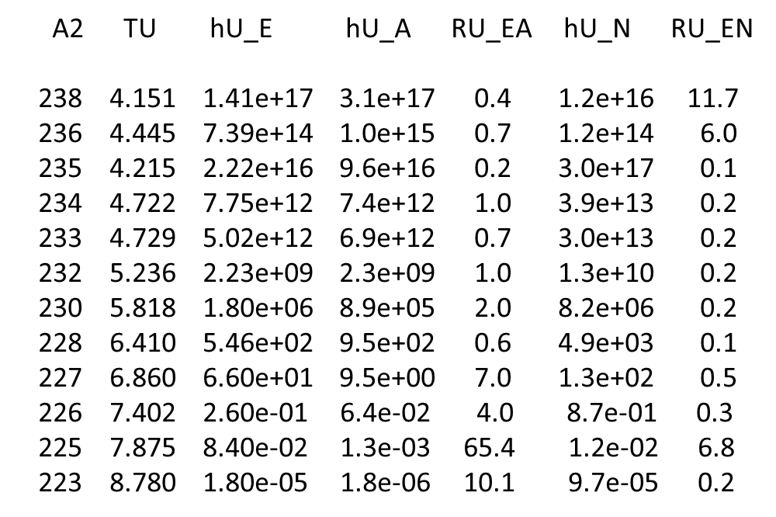

Generally, the agreement between the experimental values and the computed values is within an order of magnitude.

The values for the radius factor Rf were adjusted to give a best fit between the experimental values and the computed values.

polonium Rf = 1.07 uranium Rf = 1.15

There is some doubt over the experimental values quoted. When searching the internet is was difficult to find consistent value. The sources of the experimental data were

<http://www.kayelaby.npl.co.uk/atomic_and_nuclear_physics/4_6/4_6_1_part08_080_089.html>

<http://www.kayelaby.npl.co.uk/atomic_and_nuclear_physics/4_6/4_6_1_part09_090_099.html#Pa>

The results are also displayed in two Figure Windows (figures 3 and 4)

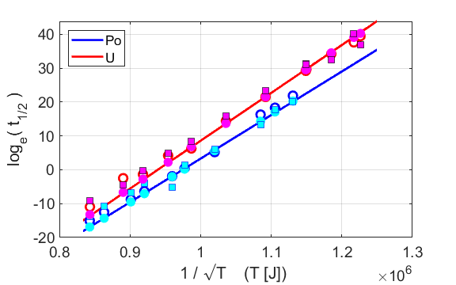

Fig. 3. The straight lines show the predictions of the Geiger-Nuttall rule: . The open circles are the Experimental values, the coloured circles are the Analytical values and the squares are the Numerical values.

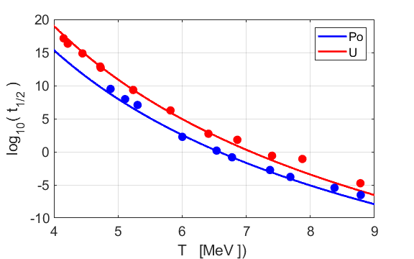

Fig. 4. The Geiger-Nuttall relationship for the isotopes of polonium and uranium. The circles are the experimental values.

How good is the fit? The agreement is really excellent which is quite an achievement considering the sensitive of the results on the transmission probability with the kinetic energy of the ejected alpha particle. Quantum mechanics via the concept of tunnelling can account for the fact that a doubling of the alpha particle energy leads to a change in half-life of 25 orders of magnitude. It is not possible to predict with great accuracy the computed value of a half-life because of many factors such as: the radius of an isotope is not an exact quantity (some uncertainly in both the radius factor Rf and the width of the nuclear well); the shape of the nuclear potential; the energy spectrum of the alpha emitters has a fine structure because an alpha-active nucleus may go over to any number of several different quantized energy levels of its daughter with each having a different energy and the emitted alpha particle may have a non-zero angular momentum.

**se_fdm_alphaA.m**

The Script is used to solve the Schrodinger Equation for different nuclear potential energy models to compute the hafl-life of the specified isotope. The variable flagWS is used to select either the square well potential or the Woods-Saxon and you can change the angular momentum LA of the emitted alpha particle. The input variables are changed within the Script.

% INPUTS ======================================================

% Atomic number of element

Z = 92;

% Mass number of element

A = 236;

% Kinetic energy of escaped alpha particle [MeV]

T = 4.445;

% Nuclear radius factor polonium (1.07) uranium (1.15)

Rf = 1.15;

% Angular momentum quantum number LA [0, 1, 2, ... ]

LA = 0;

% Woods Saxon Nuclear Potential flagWS = 1 / square well flagWS = 0;

% diffuseness parameter a [0.25 to 1]

flagWS = 0;

a = 0.5;

% Depth of potential well [-40 MeV]

U0 = -40;

% Max radial coordinate [250 fm]

xMax = 250;

% Number of grid points

N = 1e6;

A summary of the computed values is displayed in a table in the Command Window. For example, the isotope of uranium 236:

atomic number Z = 92

mass number A = 236

kinetic energy (escaped alpha particle) T = 4.445 MeV

radius factor Rf = 1.15

calculations N = 1x106

diffuseness a = 0.5

half-life = 5.5082x1014 s

gamma = 1.1934x10-15 s-1

tunneling probability P = 4.4583x10-37

radius potential well x0 = 8.8918 fm

max potential energy Umax = 29.182 MeV

radial position when K = 0 x1 = 58.378 fm

velocity inside well v_in = 4.6662x107 m.s-1

collision frequency f = 2.6239x1021 s-1

From wavelength estimates

T_in = 4.4387 MeV T_out = 3.3597 MeV

From K = T – U estimates

K_in = 4.4445 MeV K_out = 3.407 MeV

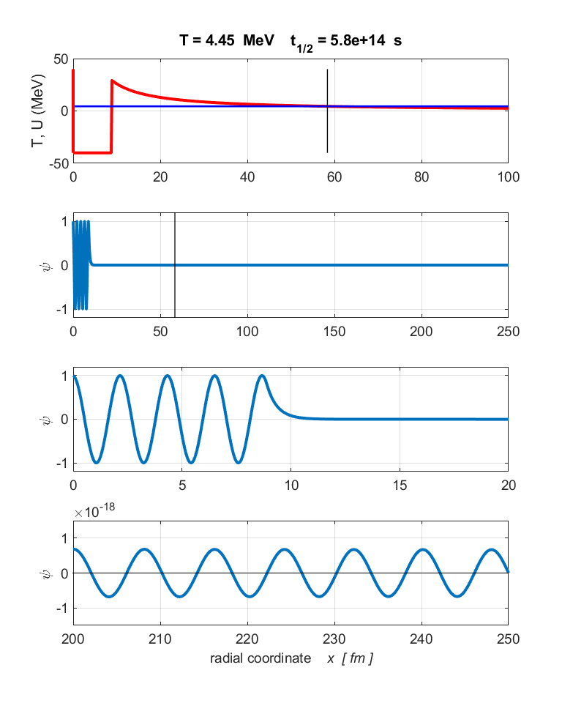

Fig. 5. Graphical output for the input parameters of the element uranium: *A* = 236 and *Z* = 92 and *T* = 4.45 MeV. The top plot shows the potential energy function (red) and the kinetic energy of the escaped alpha particle (blue). The lower plot shows the wavefunction. Note the enormous magnification factor for the wavefunction inside and outside the potential well, indicating the extremely small probability of the alpha particle tunnelling through the barrier.

How do slight changes in the numerical model with the square potential well and the Coulomb potential as shown in figure1 affect the half-life value?

We will consider the results for the isotope of polonium 236U92 with the default values and change only a single variable in any one simulation.

Default values

|  |
| --- |
| Z = 92; A = 2236; **t1/2(experiment) = 7.39x1014 s**  T = 4.445; Rf = 1.15, LA = 0; flagWS = 0; U0 = -40; xMax = 250 N =1x106  **t1/2 = 5.8x1014 s** |

N = 1x104 **t1/2 = 5.2x1014 s**

Rf = 1.25  **t1/2 = 2.5x1014 s** Rf = 1.07   **t1/2 = 8.1x1014 s**

Decreasing the value of Rf increases the estimate of the half-life. value.

U0 = -30 **t1/2 = 7.3x1014 s**

xMax = 125 **t1/2 = 2.4x1013 s**

T = 4.8 **t1/2 = 7.70x1012 s half-life very sensitive to T value**

**NUCLEAR POTENTIAL ENERGY FUNCTION**

The alpha decay process involves an interaction between the wavefunction and the nuclear potential energy function. The nuclear potential energy function  can be approximated by the summation of the functions for the potential well , the Coulomb repulsion and a centrifugal term.



where 

*l* is the angular momentum quantum number (*l* = 0, 1, 2, …)



In figure 1, the nuclear potential was a simple square well function. A more complex model is the shape of the nuclear potential energy function is given by the Woods-Saxon curve

 diffuseness parameter a

The theory in the Analytical section presented above neglects the effects of angular momentum in that it assumes the alpha particle carries off no orbital angular momentum (*l =* 0). If alpha decay takes place to or from an excited state, some angular momentum may be carried off by the particle with a resulting change in the half-life. For *l* > 0, the alpha particle must tunnel through a wider well and higher barrier.

The following plots created ( **se_fdm_alphaA.m** ) show the changes in the nuclear potential energy and half-life for *l* > 0 and using the Woods-Saxon potential (flagWS = 1) for the uranium isotope Z = 92, A = 236, T = 4.445 MeV.

Square well *l =* 0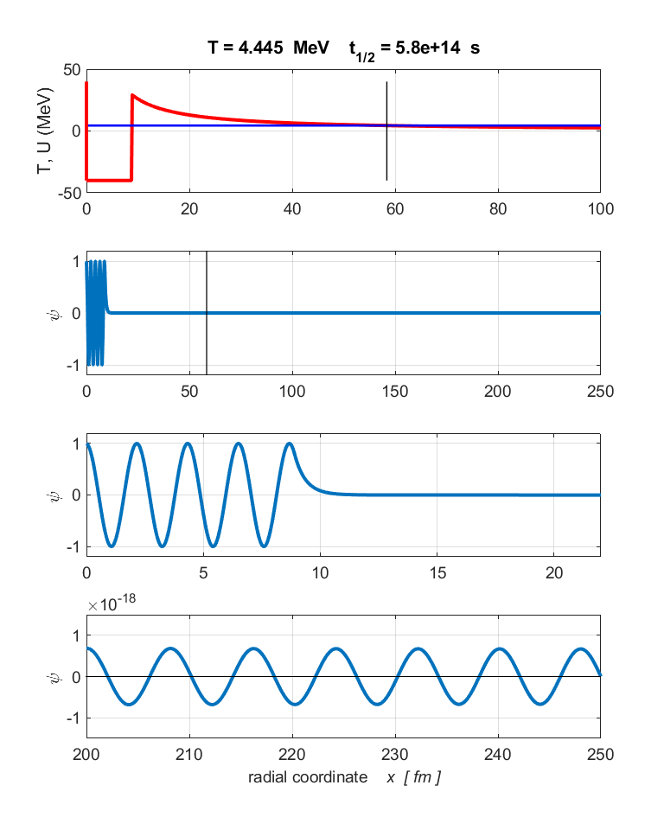

t1/2 = 5.8x1014 s x0 = 8.89 fm x1 = 58.38 Umax = 29.18 MeV

Square well *l =* 5

t1/2 = 4.1x1016 s x0 = 8.89 fm x1 = 58.99 Umax = 31.12 MeV

Woods-Saxon a = 1 *l* = 0

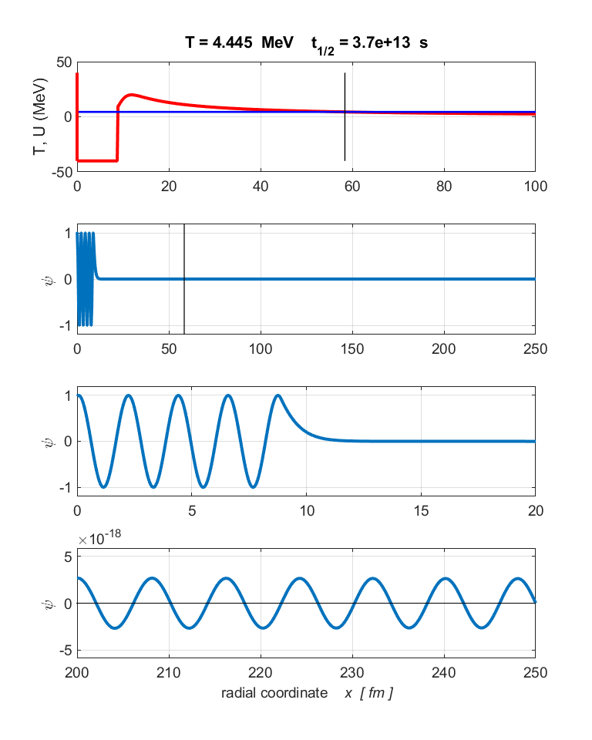

t1/2 = 3.7x1013 s x0 = 8.89 fm x1 = 58.84 Umax = 19.92 MeV

Woods-Saxon a = 1 *l* = 5

t1/2 = 2.9x1015 s x0 = 8.89 fm x1 = 58.99 Umax = 21.07 MeV

You can use the Script **qp_alpha_fdm_BE.m** to compute the half-lives using the Wood-Saxon with many different a and *l* values in the one execution of the Script.

Run the Script **qp_alphaWKB.m** to compute the half-life using the WKB approximation. Typical parameters:

E=8.78; A=212; Z=84; U0=0; L= 0  2.4317e-07 s.

The experimental value is 3.0e-07  quite good agreement

**REFERENCES**

[http://ocw.mit.edu/courses/electrical-engineering-and-computer-science/6-728-applied-quantum-and-statistical-physics-fall-2006/study-materials/wkb_tunneling2.pdf](https://protect-au.mimecast.com/s/VeTiCYWL1viM3wMoIGuXql?domain=ocw.mit.edu)  
  
[https://fenix.tecnico.ulisboa.pt/downloadFile/3779576931836/Ex8Serie1/](https://protect-au.mimecast.com/s/yrcUCZYM2VFlM0lnCKInev?domain=fenix.tecnico.ulisboa.pt).

[http://hal.in2p3.fr/in2p3-00637971/document](https://protect-au.mimecast.com/s/in1WC1WZXri3pl3wTXURqS?domain=hal.in2p3.fr)

<https://www.researchgate.net/publication/239535664_a_particle_preformation_in_heavy_nuclei_and_penetration_probability>