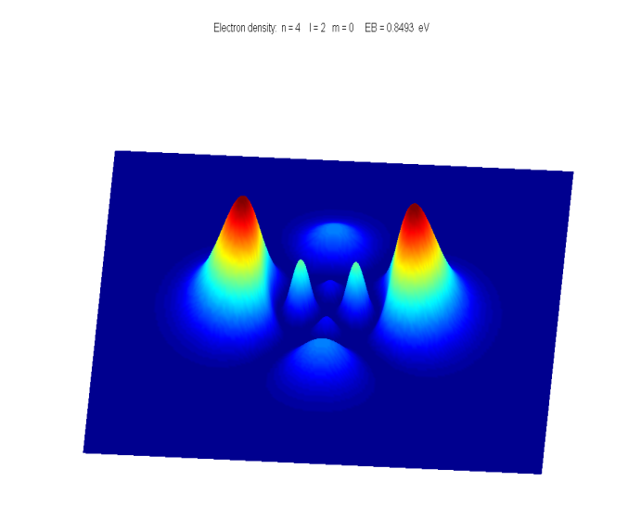[**DOING PHYSICS WITH MATLAB**](http://www.physics.usyd.edu.au/teach_res/mp/mphome.htm)

**QUANTUM PHYSICS**

**HYDROGEN ATOM**

**SELECTION RULES**

**TRANSITION RATES**

Ian Cooper

School of Physics, University of Sydney

ian.cooper@sydney.edu.au

[**DOWNLOAD DIRECTORY FOR MATLAB SCRIPTS**](http://www.physics.usyd.edu.au/teach_res/mp/mscripts)

**qp_rules.m**

Calculates for a hydrogen atom, the transition rate and lifetime for a transition from an initial state (*n*1 *l*1 *ml*1) to the final state (*n*2 *l*2 *ml*2). The azimuthal wavefunction is given by an analytical expression, the angular wavefunction is found using the Matlab command **legendre** and the radial wavefunction is solved by the Matrix Method using the function **qp_fh.m**. Integrations use the function **simpson1d.m.** The mscript also can be used to create **animated gifs** for the oscillation of the probability of compound states. The states have to be changed within the mscript by editing the statement **state = [5 1 1 1 0 0];** The first three numbers are *n*, *l*, *ml* for State 2 (final State) and the second set of three numbers give the *n*, *m*, *ml* values for State 1 (initial State).

**qp_fh.m** included within qp_rules.m

Function used to solve the radial Schrodinger Equation for the hydrogen atom

[ EB(1), R1, r] = qp_fh(n(1), L(1),num, r_max);

[ EB(2), R2, r] = qp_fh(n(2), L(2),num, r_max);

Within this mscript you can change the maximum radial coordinate and the number of data pints for the calculations.

**simpson1d.m (must have an odd number of grid points)** included within qp_rules.m

Function for doing integrations using Simpson’s rule, for example

% Normalize radial wavefunctions

N(1) = simpson1d((R1 .* R1),0,max(r));

N(2) = simpson1d((R2 .* R2),0,max(r));

R1 = R1 ./ sqrt(N(1));

R2 = R2 ./ sqrt(N(2));

In the input section of the script **qp_rules.m** you specify:

* The initial and final states.
* The saving of an animated gif of the probability cloud.
* The display of the animation of the probability cloud. Can select a contour plot or a surf plot.
* The maximum radial distance for the radial wavefunction r_max. This is an important variable for accurate predicts of the lifetime of the excited state. The value of r_max cannot be too small or too large when implementing the numerical procedure to solve the radial wave equation. Figure 1 shows the plot of the radial function functions for the initial and final states for one simulation with r_max = 30x10-9 m. The plots show that the wavefunctions approaches zero in an appropriate fashion. The calculated lifetime is 1168 ns. Figure 2 shows the wavefunction plots for r_max=10x10-9 m. The tail is not a good representation of the wavefunction and the calculated of the lifetime is 246 ns and is not an accurate result.

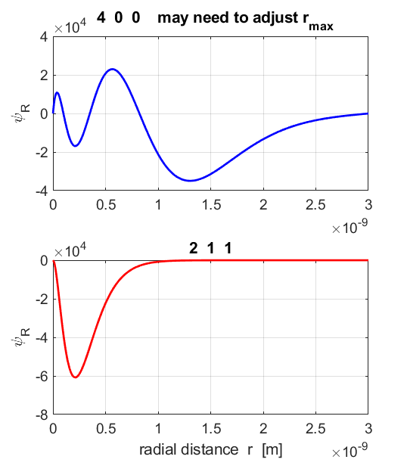

Fig. 1. Accurate plots of the wavefunctions when r_max = 30x10-9 m.

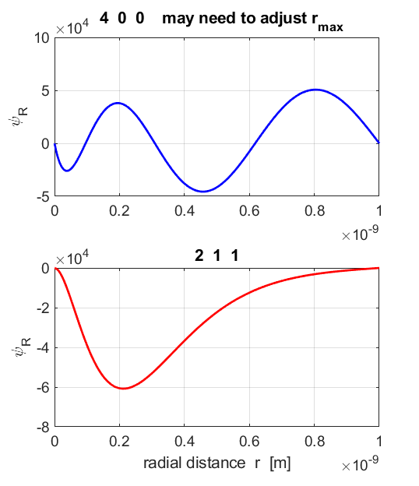

Fig. 2. Incorrect plots of the wavefunctions when r_max = 10x10-9 m.

**Excited states and transition rates in a hydrogen atom**

If a hydrogen atom is excited to a higher energy level, it will at some later time spontaneously make transitions to successively lower energy levels. In a transition from a higher energy state (1) to a lower energy state (2), the frequency and wavelength of the emitted photon is

(1)  

The discrete wavelengths emitted in all transitions that take place constitute the lines in the emission spectrum. But, **not** all possible transitions take place. Photons are observed only with frequencies corresponding to transitions between states whose quantum numbers satisfy the **selection rules**

(2) 

These selection rules are found to apply to all one-electron atoms.

***Why are some transitions forbidden?***

We can answer this question by using a mix of classical and quantum physics.

A **transmission rate** *Rt* is the probability per second that an atom in a certain energy level will make a transition to some other lower energy level.

Typical allowed transition rates are ~108 s-1. This means that in about 10-8 s, the probability that the transition has occurred is about one. This time interval is called the **lifetime** *tL*.

(3) 

The eigenfunctions represent stationary states, that is, they do not vary with time. However, for compound states where the wavefunction is a combination of two stationary states of energies *E*1 and *E*2, then, the probability density function contains a term that oscillates in time at frequency



Hence, the electron charge distribution must also oscillate at a frequency *f12* and this is precisely the frequency of the emitted photon in the transition between the states.

View animations of compound states at

<http://www.physics.usyd.edu.au/teach_res/mp/doc/qp_se_time.htm>

The atom’s evolving charge distribution can be modeled as an **oscillating electric dipole**.



The **electric dipole moment** for the oscillating charge distribution is the product of the electron charge *e* and the expectation value of its displacement value from the nucleus.

A charge distribution that is constant in time will not emit electromagnetic radiation, while a charge distribution with an oscillating electric dipole moment emits radiation at the frequency of the oscillator. The oscillating electric dipole is the most efficient radiator of electromagnetic radiation.

We can use a classical formula for the rate of emission of energy by an oscillating electric dipole

(4) 

where *p* is the amplitude of its oscillating electric dipole moment and *f* is the frequency of the oscillation. *Rt* is the **atomic transition rate**, it gives the probability per second that a photon is emitted and thus it is equal to the probability per second that the atom has undergone the transition.

Relative to the Origin at the nucleus, the atomic electric dipole moment of a one electron atom is

(5) 

where  is the position vector from the nucleus at the Origin.

We can calculate the expectation value of to obtain an expression for the amplitude *p* of the oscillating electric dipole moment of the atom in a compound state as shown in the following arguments:

(6) 

(7) 

where and are both normalized wavefunctions.

The time independent parts of the wavefunctions are of the form

(8) 

where is the solution of the radial **Schrodinger Equation**

(9) 

The solutions for the **angular equation** are polynomials in cos*θ* known as the ***associated Legendre polynomials*** 

where *l* = 0, 1, 2, … and *ml* = 0, ±1, ±2, ±3, … . 

The normalized solution to equation (6) can be written as

(10) 

where is an appropriate normalization constant such that

(11) 

The normalized solution of the **azimuthal equation** is

(12) 

The time independent part of the normalized wavefunctions that can be expressed as

(13) 

where is also normalized and both *g*(­*r*) and are real quantities.

Since the probability of finding the electron is 1, then

integrating over a volume element 

The electric dipole moment can be expressed as

(14) 

This is a vector quantity and has components (*px*, *py*, *pz*) where

(15) 

(16)







Let





(17) 







Therefore



(18) 



(19) 

(20) 

The radial wavefunction *g*(*r*) can be found numerically by solving the radial equation (equation 9) by the [Matrix Method](http://www.physics.usyd.edu.au/teach_res/mp/doc/qp_se_matrix.pdf) and the associated Legendre functions  can be evaluated using the Matlab command **legendre**. The normalization constants can be found by numerical integration using Simpson’s rule. The integrals in the set of equations (17) are computed numerically to find the numerical value of the amplitude of the oscillating electric dipole moment *p*. Then from equation (3) and equation (4) the transition rate *Rt* and *tL* can be calculated respectively. A summary of the calculations is given in Table 1.

The mscript **qp_rules.m** is used for the electric dipole calculations.

Table 1. Data for the transition from a higher energy level to a lower level. The initial and final states are given by the set of quantum numbers (*n l ml*). The mscript **qp_rules.m** is used to calculate the binding energies of the two states (*EB* = - *E*), the integrals given by equation (17), the lifetime *tL* of the higher energy state and the wavelength *λ* of the photon emitted in the transition. Only the integral *IP* components for the azimuthal coordinate are shown in the table. Published values are given for the lifetime so that the model results can be compared to accepted values. Reference*:

<http://www.nist.gov/srd/upload/jpcrd382009565p.pdf>

|  |  |  |  |  |  |  |  |  |  |
| --- | --- | --- | --- | --- | --- | --- | --- | --- | --- |
| final  state  *n*2 *l*2 *ml*2 | initial  state  *n*1 *l*1 *ml*1 | lifetime  *tL* (ns)  web* | lifetime  *tL* (ns)  simulation | *IPx* | *IPy* | *IPz* | *EB2*  (eV) | *EB*1  (eV) | *λ*  (nm) |
| **Forbidden transitions | Δ*l |* ≠ 1** | | | | | | | | | |
| 1s (1 0 0) | 2s (2 0 0) | ~ ∞ | ~ ∞ | 0 | 0 | 0 | 13.58 | 3.40 |  |
| 1s (1 0 0) | 3s (3 0 0) | ~ ∞ | ~ ∞ | 0 | 0 | 1 | 13.58 | 1.51 |  |
| 1s (1 0 0) | 3d (3 2 0) | ~ ∞ | ~ ∞ | 0 | 0 | 0 | 13.58 | 1.51 |  |
| 1s (1 0 0) | 3d (3 2 1) | ~ ∞ | ~ ∞ | 0.5 | 0 | 0 | 13.58 | 1.51 |  |
| 1s (1 0 0) | 3d (3 2 2) | ~ ∞ | ~ ∞ | 0 | 0 | 0 | 13.58 | 1.51 |  |
| 3p (3 1 1) | 4f (4 3 0) | ~ ∞ | ~ ∞ | 0.5 | 0 | 0 | 1.51 | 0.85 |  |
| **Forbidden transitions | Δm*l |* ≠ 0 or 1** | | | | | | | | | |
| 3d (3 2 0) | 4d (4 3 2) | ~ ∞ | ~ ∞ | 0 | 0 | 0 | 1.51 | 0.85 | 1877 |
| **Allowed transitions | Δ*l |* = 1 and | Δm*l |* = 0 or 1** | | | | | | | | | |
| 1s (1 0 0) | 2p (2 1 0) | 1.60 | 1.60 | 0 | 0 | 1 | 13.58 | 3.40 | 122 |
| 1s (1 0 0) | 2p (2 1 1) |  | 1.60 | 0.5 | 0 | 0 | 13.58 | 3.40 | 122 |
| 1s (1 0 0) | 3p (3 1 0) | 5.98 | 6.00 | 0 | 0 | 1 | 13.58 | 1.51 | 102 |
| 1s (1 0 0) | 3p (3 1 1) |  | 6.00 | 0.5 | 0 | 0 | 13.58 | 1.51 | 102 |
| 1s (1 0 0) | 4p (4 1 0) | 14.5 | 12.1 | 0 | 0 | 1 | 13.58 | 0.85 | 97 |
| 2s (2 0 0) | 3p (3 1 0) | 44.5 | 44.6 | 0 | 0 | 1 | 3.40 | 1.51 | 658 |
| 2s (2 0 0) | 3p (3 1 1) |  | 44.6 | 0.5 | 0 | 0 | 3.40 | 1.51 | 658 |
| 2s (2 0 0) | 4p (4 1 0) | 103.4 | 103.5 | 0 | 0 | 1 | 3.40 | 0.85 | 487 |
| 2s (2 0 0) | 4p (4 1 1) |  | 103.5 | 0.5 | 0 | 01 | 3.40 | 0.85 | 487 |
| 2p (2 1 0) | 3s (3 0 0) | 475 | 478 | 0 | 0 | 1 | 3.40 | 1.51 | 657 |
| 2p (2 1 1) | 3s (3 0 0) |  | 478 | 0.5 | 0 | 0 | 3.40 | 1.51 | 657 |
| 2p (2 1 0) | 3d (3 2 0) |  | 23.3 | 0 | 0 | 1 | 3.40 | 1.51 | 657 |
| 2p (2 1 0) | 3d (3 2 1) |  | 31.0 | 0.5 | 0 | 0 | 3.40 | 1.51 | 657 |
| 2p (2 1 1) | 3d (3 2 0) |  | 93.1 | 0.5 | 0 | 0 | 3.40 | 1.51 | 657 |
| 2p (2 1 1) | 3d (3 2 1) |  | 31.0 | 0 | 0 | 1 | 3.40 | 1.51 | 657 |
| 2p (2 1 0) | 4s (4 0 0) | 1171 | 1168 | 0 | 0 | 1 | 3.40 | 0.85 | 487 |
| 2p (2 1 1) | 4s (4 0 0) |  | 1168 | 0.5 | 0 | 0 | 3.40 | 0.85 | 487 |

From Table 1, it is quite clear that not all transitions give rise to spectral emissions where spectral lines are not observed or very weak. For the case of dipole radiation, the transition rates are zero when the dipole matrix elements are zero. This gives rise to a set of **selection rules** which are conditions on the quantum numbers of the eigenfunctions of the initial state (state 1) and the final state (state 2) energy levels. For the dipole radiation, allowed transitions ( *p* ≠ 0 ) are given by the selection rules

**Allowed transitions**  and 

Transitions rates of atom are typically *Rt* ~ 108 s-1.

If these conditions are **not** satisfied, *p* = 0 and the transition is called **forbidden**.

Selection rules arise because of the symmetry properties of the oscillating charge distribution of the atom. The compound state formed by the superposition of two stationary states must have an oscillating charge distribution which oscillates as the same frequency of the emitted photon. Also, for the system of the atom and the emitted photon, angular momentum must be conserved. The angular momentum of the emitted photon in units of  is one, hence the change in the angular momentum quantum number of the atom should be .

Selection rules do not absolutely prohibit transitions that violate them, but only make such transitions very unlikely. The transition may occur through some other mechanism such as magnetic dipole moment radiation or electric quadrupole moment radiation.

From the links below, you can view schematic animations of compound states showing the variation in electron probability for the oscillations between two stationary states. The animations were created with the mscript **qp_rules.m**. Two frames of one of the animations are shown below

|  |  |  |
| --- | --- | --- |
| **Transitions** | **Type of animated plot** | |
| (1 0 0)  (511) | [pcolor](http://www.physics.usyd.edu.au/teach_res/mp/images/ag_100511p.gif) | [surf](http://www.physics.usyd.edu.au/teach_res/mp/images/ag_100511s.gif) |
| (3 2 0)  (4 1 1) | [pcolor](http://www.physics.usyd.edu.au/teach_res/mp/images/ag_320411p.gif) | [surf](http://www.physics.usyd.edu.au/teach_res/mp/images/ag_320411s.gif) |
| (2 0 0)  (3 1 0) | [pcolor](http://www.physics.usyd.edu.au/teach_res/mp/images/ag_200310p.gif) | [surf](http://www.physics.usyd.edu.au/teach_res/mp/images/ag_200310s.gif) |

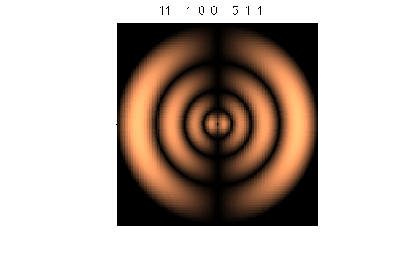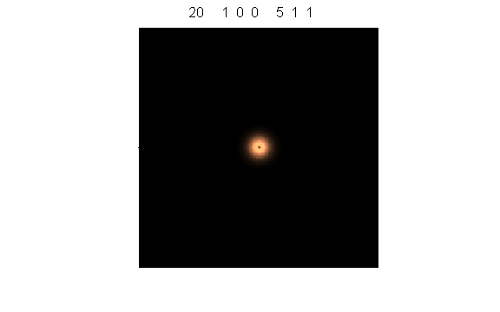

A summary of the numerical quantities is shown in a Figure Window

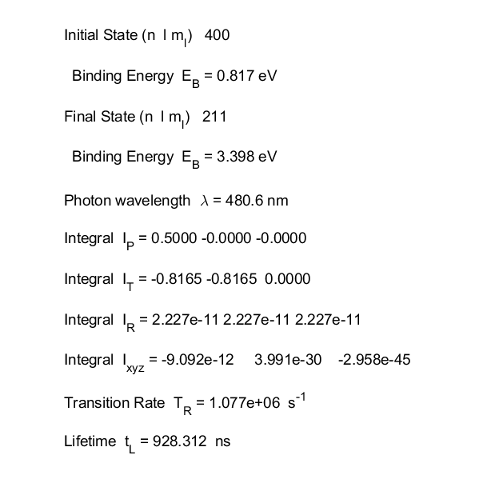

**Reference**

<http://farside.ph.utexas.edu/teaching/qmech/Quantum/node122.html>

<https://www.nist.gov/sites/default/files/documents/srd/jpcrd382009565p.pdf>

**Acknowledgements**

Thanks to Duncan for comments and corrections to the script **qp_rules.m**

Duncan Carlsmith

Professor of Physics

University of Wisconsin-Madison

[duncan@hep.wisc.edu](https://webmail.sydney.edu.au/owa/redir.aspx?C=9IK57zCSu-JW4ncIijkUPqLmZccQ4qZOqYdcoYgebkJXz2Lk1InVCA..&URL=mailto%3aduncan%40hep.wisc.edu)