[**DOING PHYSICS WITH MATLAB**](http://www.physics.usyd.edu.au/teach_res/mp/mphome.htm)

**QUANTUM PHYSICS**

# 

# THE TIME DEPENDENT SCHRODINGER EQUATIUON

# Solving the [1D] Schrodinger equation using the finite difference time development method

# 

Ian Cooper

School of Physics, University of Sydney

ian.cooper@sydney.edu.au

[**DOWNLOAD DIRECTORY FOR MATLAB SCRIPTS**](http://www.physics.usyd.edu.au/teach_res/mp/mscripts)

**se_fdtd.m**

**simpson1d.m** (function to compute the integral of a function)

The mscript **se_fdtd.m** is a versatile program used to solve the one-dimensional time dependent Schrodinger equation using the Finite Difference Time Development method (FDTD). For different simulations you need to modify the mscript by changing parameters and commenting or uncommenting lines of code.

The Schrodinger equation is solved for the real and imaginary parts of the wavefunction  in the region from with the boundary conditions  and . The initial values for the wavefunction must be specified to describe the wave packet representing a particle. A Matlab Figure window gives a summary of the simulation parameters as shown in figure A. You have the option to save an animated gif file for the time evolution for the wavefunction.

[view animation scattering of a wave packet](http://www.physics.usyd.edu.au/teach_res/mp/images/ag_se_fdtd_14.gif)

You also have the option to view or not to view the time evolution of the wavefunction.

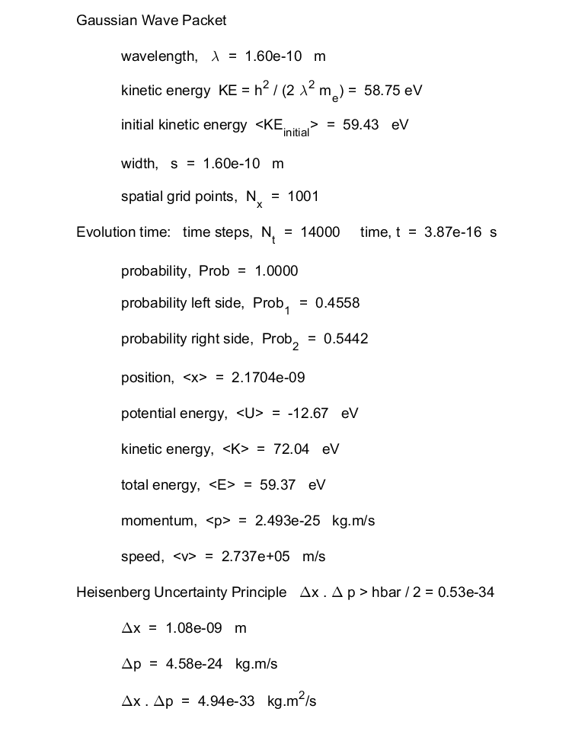

Fig. A. Matlab Figure window showing the input and computed values of the parameters for a simulation.

A graphical output of the wavefunction at the end of the simulation is shown in a Matlab Figure window (figure B).

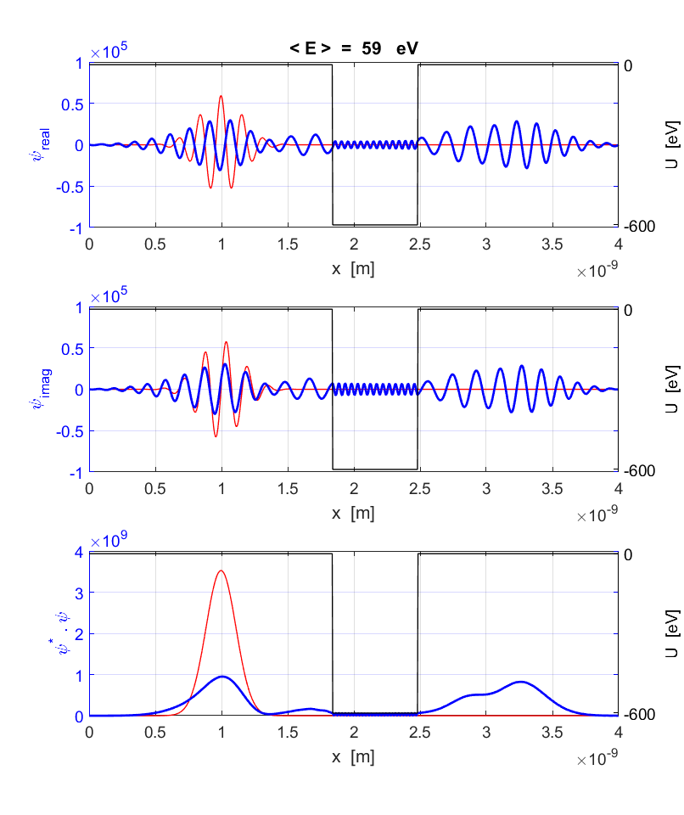

Fig. B. Graphical output of the wavefunction at the end of the simulation. The red curve shows the initial wavefunction and the blue curve the wavefunction at the end of the simulation.

**Using the mscript se_fdtd.m**

For each simulation you need to specify the input parameters, for example:

% =====================================================================

% INPUTS

% =====================================================================

Nx = 1001; % [1001] must be an odd number - number of grid points

Nt = 14000; % [10000] number of time steps

You need to specify the numbers for the Y axis values

% max value for PE / limits for PE vs x plot

U0 = -600; U1 = -610; U2 = 10;

UyTick = [-600 0];

%UyTick = [0 100];

% Graphics: limits and tick spacing

yL1 = -1e5; yL2 = 1e5; yL = yL2/2; % [1e5] wavefunction

yLL1 = 0; yLL2 = 4e9; yLL = 1e9; % [6e9] prob density

The variable flagU is used to select the potential energy function

% Potential energy function U -------------------------------------

U = zeros(1,Nx);

switch flagU

case 2 % potential step

U(round(NxC):end) = U0;

case 1

U = zeros(1,Nx); % zero PE - free wave packet

case 3 % accelerating / retarding potential

U = -(U0/L).* x + U0;

a = e*U0 / (me * L);

F = me * a;

v1 = 7.1287e+06;

v2 = v1 + a * T;

x1 = 9.9620e-10;

x2 = x1 + v1 * T-dt + 0.5 * a * (T-dt)^2;

W = F * (x2-x1)/e;

case 4 % potential hill / well

w1 = -80;

U(NxC-2*40/2:NxC+2*40/2-w1) = U0;

w = NxC+2*40/2-w1 - (NxC-2*40/2);

case 5 % parabolic well

a = 4*abs(U0)/L^2; b = -4*abs(U0)/L; c = 0;

U = a .* x.^2 + b .* x + c;

period = 2*pi*sqrt(me / (2*a*e));

Nt_period = period/dt ;

end

Specifying the initial wavefunction

% ====================================================================

% INITIAL WAVE PACKET

% ====================================================================

for nx = 1 : Nx

yR(nx) = exp(-0.5*((x(nx)-x(nx0))/s)^2)*cos(2*pi*(x(nx)-x(nx0))/wL);

yI(nx) = exp(-0.5*((x(nx)-x(nx0))/s)^2)*sin(2*pi*(x(nx)-x(nx0))/wL);

%yR(nx) = exp(-0.5*((x(nx)-x(nx0))/s)^2);

%yR(nx) = sin(2*pi*(x(nx))/wL);

% yR(nx) = 1*sin(2*pi*(x(nx))/(2*L/5)) + 3*sin(2*pi*(x(nx))/(2*L/4));

end

% yI(1:Nx) = 0;

% Normalize initial wave packet

y2 = yR.^2 + yI.^2;

A = simpson1d(y2,0,L);

yR = yR ./ sqrt(A); yI = yI ./ sqrt(A);

prob_density = yR.^2 + yI.^2;

yR1 = yR; yI1 = yI; yP11 = prob_density;

% Kinetic energy KE

fn = zeros(1,Nx-2);

for nx = 2 : Nx-1

fn(nx) = C3 * (yR(nx) - 1i * yI(nx)) * ...

(yR(nx+1) - 2 * yR(nx) + yR(nx-1)+ 1i *(yI(nx+1) - 2 * yI(nx) + yI(nx-1)));

end

K1avg = simpson1d(fn,0,L);

View animation flag1

% Show figure 2 for animation (0 no) (1 yes) for flag1

flag1 = 1;

fs = 14; % fontsize

time_step = 200; % jump frames

Save animation flag2

% Save animation as a gif file (0 no) (1 yes) for flag2

flag2 = 1;

% file name for animated gif

ag_name = 'ag_se_fdtd_14.gif';

% Delay in seconds before displaying the next image

delay = 0.0;

% Frame to start

frame1 = 0;

**The Schrodinger Equation and the FDTD Method**

The Schrodinger Equation is the basis of quantum mechanics. The state of a particle is described by its wavefunction which is a function of position and time *t*. The wavefunction is a complex variable and one can’t attribute any distinct physical meaning to it.

We will consider solving the [1D] time dependent Schrodinger Equation using the Finite Difference Time Development Method (FDTD).

The one dimensional time dependent Schrodinger equation for a particle of mass *m* is given by

(1) 

where  is the potential energy function for the system.

The wavefunction is best expressed in terms of its real and imaginary parts is

(2) 

Inserting equation 2 into equation 1 and separating real and imaginary parts results in the following pair of coupled equations

(3a) 

(3b) 

We can now apply the finite difference approximations for the first derivative in time and the second derivative in space. The time step is  and the spatial grid spacing is . Time, position and the wavefunction are expressed in terms of the time index  and the spatial index 

Time 

Grid positions 

Wavefunction is calculated at each time step *nt*



where the symbol *y* is used for the wavefunction in the coding of the mscript.

(4) 

(5) 

The second derivative of the wavefunction given by equation 5 is not defined at the boundaries. The simplest approach to solve this problem is to set the wavefunction at the boundaries to be zero. This can cause problems because of reflections at both boundaries. Usually a simulation is terminated before the reflections dominate.

Substituting equations 4 and 5 into equations 3a and 3b and applying the discrete times and spatial grid gives the latest value of the wavefunction expressed in terms of earlier values of the wavefunction

(6a) 

(6b) 

where the constants *C*1and *C2* are

(7)  and 

The potential *U* is given in electron-volts (eV) and to convert to joules, the charge of the electron *e* is included in the equation for the constant *C*2*.*

In equations 6a and 6b, the *y* variables on the RHS gives the values of the wavefunction at time  and the *y* variables on the LHS are the values of the wavefunction at time *t.* Hence, given the initial values of the wavefunction, equations 6a and 6b explicitly determine the evolution of the system. The FDTD method can “blow-up” if appropriate time increments or grid spacings are not used. For a given grid spacing we will set  which means the time increment is determined by

(8) 

We will model the an electron in a system with a potential energy function  in the region  to . We will consider the potential energy function to be time independent. However, you can easily input a potential energy function that does depend upon time.

To simulate an electron, we will initiate a particle at a wavelength  in a Gaussian envelope of width *s* given by the expressions

(9) 

where  is the position of the centre of the wave packet (or pulse) at time .

The probability of finding the electron is one, hence, the initial wavefunctions given by equation 9 must be normalized to satisfy

(10) 

**Matlab coding**

Evaluating the wavefunction given by equation 6

for nt = 1 : Nt

for nx = 2 : Nx - 1

yR(nx) = yR(nx) - C1*(yI(nx+1)-2*yI(nx)+yI(nx-1)) +

C2*U(nx)*yI(nx);

end

for nx = 2 : Nx-1

yI(nx) = yI(nx) + C1*(yR(nx+1)-2*yR(nx)+yR(nx-1)) –

C2*U(nx)*yR(nx);

end

end

The initial wavefunction given by equations 9

for nx = 1 : Nx

yR(nx) = exp(-0.5*((x(nx)-x(nx0))/s)^2)*

cos(2*pi*(x(nx)-x(nx0))/wL);

yI(nx) = exp(-0.5*((x(nx)-x(nx0))/s)^2)*

sin(2*pi*(x(nx)-x(nx0))/wL);

end

Normalizing the initial wavefunction using equation 10

The [integration](http://www.physics.usyd.edu.au/teach_res/mp/doc/math_integration_1D.pdf) is done using the call to the function **simpson1d.m**

% Normalize initial wave packet

y2 = yR.^2 + yI.^2;

A = simpson1d(y2,0,L);

yR = yR ./ sqrt(A); yI = yI ./ sqrt(A);

prob_density = yR.^2 + yI.^2;

yR1 = yR; yI1 = yI;

The various potential energy functions can be selected and changed within the mscript. The variable flagU is used to set the potential energy function.

% Potential energy function U -------------------------------------

U = zeros(1,Nx);

switch flagU

case 2 % potential step

U(round(NxC):end) = U0;

case 1

U = zeros(1,Nx); % zero PE - free wave packet

case 3 % accelerating / retarding potential

U = -(U0/L).* x + U0;

a = e*U0 / (me * L);

F = me * a;

v1 = 7.1287e+06;

v2 = v1 + a * T;

x1 = 9.9620e-10;

x2 = x1 + v1 * T-dt + 0.5 * a * (T-dt)^2;

W = F * (x2-x1)/e;

case 4 % potential hill / well

w1 = -80;

U(NxC-2*40/2:NxC+2*40/2-w1) = U0;

w = NxC+2*40/2-w1 - (NxC-2*40/2);

case 5 % parabolic well

a = 4*abs(U0)/L^2; b = -4*abs(U0)/L; c = 0;

U = a .* x.^2 + b .* x + c;

period = 2*pi*sqrt(me / (2*a*e));

Nt_period = period/dt ;

end

**Expectation Values of the Observables**

The wavefunction itself has no definite physical meaning, however, by performing mathematical operations on the wavefunction we can predict the mean values and their uncertainties of physical quantities such as position, momentum and energy.

Since an electron does exist within the system, the probability of finding the electron is 1.

(11) 

The quantity  is called the **probability density function**.

The probability of finding the electron in the region from  to  is

(12) 

Consider *N* identical one electron systems. We make *N* identical measurements on each system of the physical parameter *A*. In a quantum system, each measurement is different. From our *N* measurements, we can calculate the mean value  and the standard deviation  of the parameter *A*. We do not have complete knowledge of a system, we only can estimate probabilities.

The mean value of an observable quantity *A* is found by calculating its **expectation value**  by evaluating the integral

(13) 

where  is the quantum-mechanical operator corresponding to the observable quantity *A.*

and its **uncertainty** by estimating the standard deviation of *A*. The uncertainty can be given by

(14) 

where

(15) 

The quantity represents the **probability distribution** for the observable *A* and is often shown as a probability density vs position graph. Probability distributions summarize the extent to which quantum mechanics can predict the likely results of measurements. The probability distribution is characterized by two measures – its **expectation value** which is the mean value of the distribution and its **uncertainty** which is the represents the spread in values about the mean.

For our [1D] system, a particle in any state must have an uncertainties in position  and uncertainties in momentum  that obeys the inequality called the **Heisenberg Uncertainty Principle**

(16) 

The Uncertainty Principle tells us that it is impossible to find a state in which a particle can has definite values in both position and momentum. Hence, the classical view of a particle following a well-defined trajectory is demolished by the ideas of quantum mechanics.

|  |  |  |
| --- | --- | --- |
| **Observable** | **Operator** | **Expectation Value** |
| probability | 1 |  |
| position | *x* |  |
| momentum |  |  |
| Potential energy | *U* |  |
| Kinetic energy | *T* |  |

Matlab coding

% ===================================================================

% EXPECTATION VALUES

% =====================================================================

C3 = -hbar^2 / (2 * me * dx^2 * e);

% PROBABILITY

fn = (yR - 1i*yI) .* (yR + 1i*yI);

prob = simpson1d(fn,0,L);

prob1 = simpson1d(fn(1:NxC),0,L/2);

prob2 = simpson1d(fn(NxC:end),L/2,L);

% POSITION x

fn = x .* (yR.^2 + yI.^2);

xavg = simpson1d(fn,0,L) ;

% Potential energy U

fn = U .* (yR.^2 + yI.^2);

Uavg = simpson1d(fn,0,L);

% Kinetic energy T

for nx = 2 : Nx-1

fn(nx) = C3 * (yR(nx) - 1i * yI(nx)) * ...

(yR(nx+1) - 2 * yR(nx) + yR(nx-1)+ 1i *(yI(nx+1) - 2 * yI(nx) + yI(nx-1)));

end

Tavg = simpson1d(fn,0,L);

% Total energy

Eavg = Uavg + Tavg;

% Momentum p and speed v

dyRdx = zeros(1,Nx); dyIdx = zeros(1,Nx);

dyRdx(1) = (yR(2) - yR(1))/dx; dyRdx(Nx) = (yR(Nx) - yR(Nx-1))/dx;

dyIdx(1) = (yI(2) - yI(1))/dx; dyIdx(Nx) = (yI(Nx) - yI(Nx-1))/dx;

for nx = 2 : Nx-1

dyRdx(nx) = (yR(nx+1) - yR(nx-1))/(2*dx);

dyIdx(nx) = (yI(nx+1) - yI(nx-1))/(2*dx);

end

fn = - hbar .* (yI .* dyRdx - yR .* dyIdx + ...

1i .* yR .* dyRdx + yI .* dyIdx );

pavg = simpson1d(fn,0,L) ;

vavg = pavg / me;

% Uncertainty - position

fn = x .* x .* (yR.^2 + yI.^2);

x2avg = simpson1d(fn,0,L);

delta_x = sqrt(x2avg - xavg^2);

% Unceratinty - momentum

C3 = -hbar^2/dx^2;

for nx = 2 : Nx-1

fn(nx) = C3 * (yR(nx) - 1i * yI(nx)) * ...

(yR(nx+1) - 2 * yR(nx) + yR(nx-1)+ 1i *(yI(nx+1) - 2 * yI(nx) + yI(nx-1)));

end

p2avg = simpson1d(fn,0,L);

delta_p = sqrt(p2avg - pavg^2);

% Uncertainty Principle

dxdp = delta_x * delta_p;

**SIMULATIONS**

In all the simulations described in this paper, we will consider an electron confined to the X axis in the region from  to . The electron is represented by a **wave packet** to localize it. For example, at time the wave packet may be given by

(9) 

Equation 9 gives the most common wave packet used in the simulations.

The real and imaginary parts of the wavefunction correspond to a particle with wavelength  in a Gaussian envelope of width *s* and  is the position of the centre of the wave packet at time . *An* is a normalizing constant. Our equation for the wave packet needs to be a solution of the Schrodinger Equation and also satisfy the boundary conditions where the wavefunction vanishes at boundaries



When the wave packet strikes a boundary, reflections occur. This may cause problems, so it may be necessary to terminate a simulation before any reflections occur.

The initial kinetic energy *K* and its momentum *p* of our electron (mass *m)* can be estimated from its wavelength 



The default values for the simulations are





The accuracy of the FDTD method is improved as  and  are made smaller. You can start a simulation with  ( should always be an odd number, otherwise the integrations by Simpson’s rule will give wrong results). You then should increase until the numerical predictions become more consistent.

For example, in the simulation of the motion of a free electron with an initial kinetic energy of 149 eV, simulation results give



The numerical predictions are more accurate and consistent with the larger value of .

**Free-particle wave packets**

A free particle is one that is not subject to any forces. This is a region in which the potential energy function is a constant

(17) 

It is easy to predict the motion of a free particle in classical physics, but the corresponding task is less straightforward in quantum mechanics. The solution of the time dependent Schrodinger Equation predicts how the wave function evolves in time. The Matlab code for the initial wavefunction is

yR(nx) = exp(-0.5*((x(nx)-x(nx0))/s)^2)*cos(2*pi*(x(nx)-x(nx0))/wL);

yI(nx) = exp(-0.5*((x(nx)-x(nx0))/s)^2)*sin(2*pi*(x(nx)-x(nx0))/wL);

Figure 1 shows the time evolution of the free-particle wave packet - the initial wave packet (red) and the wave packet after 10 000 time steps (blue). Table 1 is a summary of the simulation results for three time intervals.

Table 1. Summary of the simulation results for a free electron.



|  |  |  |  |
| --- | --- | --- | --- |
| Observable |  |  |  |
| Time *t* [s] | 2.79x10-20 | 1.40x10-16 | 2.79x10-16 |
| Probability | 1.000 | 1.000 | 1.000 |
| [eV] | 150.3 | 150.1 | 150.1 |
| [kg.m.s-1] | 6.6x10-24 | 6.6x10-24 | 6.6x10-24 |
| [m.s-1] | 7.1x106 | 7.1x106 | 7.1x106 |
| [m] | 1.0x10-9 | 2.0x10-10 | 3.0x10-9 |
| [m] | 0.71x10-10 | 1.3x10-10 | 2.3x10-10 |
| [kg.m.s-1] | 1.1x10-24 | 1.1x10-25 | 1.1x10-24 |
| [kg.m2.s-1] | 7.9x10-35 | 1.26x10-34 | 2.6x10-34 |

The simulation results show that the probability and total energy of the system is conserved in the implementation of the FDTD method in solving the Schrodinger equation with 1001 spatial grid points. The time evolution of the system shows that the wave packet spreads as it propagates. There is nothing mysterious about the wave packet spreading. It merely reflects the initial uncertainty in position and momentum of the wave packet. The uncertainty in position increases with time but the uncertainty in momentum does not increase since there is no force acting on the electron to change its momentum.

In the time evolution of the wave packet the Heisenberg Uncertainty Principle is satisfied. You can decrease the width of the wave packet and run a simulation. You will notice that decreasing the spatial width of the initial wave packet increases the spread of momenta and therefore increases the rate at which the wave packet spreads.

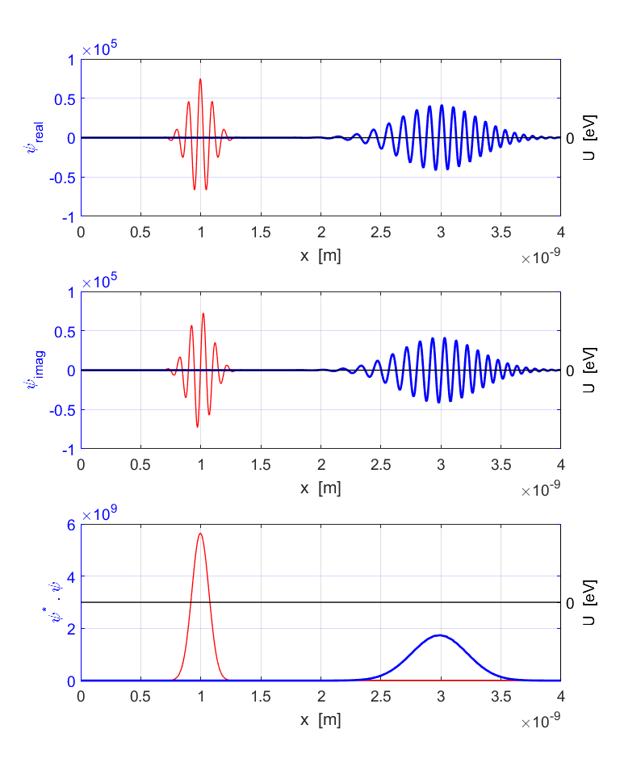

Fig. 1. The time evolution of a free particle wave packet shown at (red) and after 10 000 time steps (blue).

All that can happen to a classical particle is that it can move from one position to another. But, a quantum mechanical wave packet undergoes a more complicated evolution with time in which the whole probability distribution shifts and spreads with time. The **Ehrenfest’s theorem** is a general statement about the rates of change of  and  in quantum-mechanical systems.

**Ehrenfest’s theorm**

If a particle of mass *m* is in a state described by a normalized wave function in a system with a potential energy function , the expectation values of position and momentum of the particle obey the equations

(18) 

In our simulation with  , you can see that Ehrenfest’s theorem is satisfied. The momentum and its uncertainty remain constant. The distance *d* that the peak of the probability distribution moves in the time interval  is



The displacement *d* of the probability density is clearly shown in figure 1.

[view animation of the wave packet](http://www.physics.usyd.edu.au/teach_res/mp/images/ag_se_fdtd_01.gif)

We can model the time evolution of an initial wave packet that is Gaussian in shape with its imaginary part being zero.

yR(nx) = exp(-0.5*((x(nx)-x(nx0))/s)^2);

yI(1:Nx) = 0;

The expectation value of the momentum is zero at all times. The wave packet does not propagate along the X axis, it simply spreads with time. The wave function develops real and imaginary parts, both of which develop lots of wiggles, however, the probability function turns out to also Gaussian in shape with a width that increases with time. The expectation value of the total energy of the electron does not change with time and has a non-zero value of 1.89 eV. In a quantum system the total energy of a particle is always greater than zero and its lowest value is called its zero-point energy.

Figure 2 shows the real and imaginary parts of the wavefunction and the probability density distribution after the first time step (red) and after 20 000 time steps (blue) for a free electron when the potential energy function is zero.

[view animation of the wave packet](http://www.physics.usyd.edu.au/teach_res/mp/images/ag_se_fdtd_02.gif)

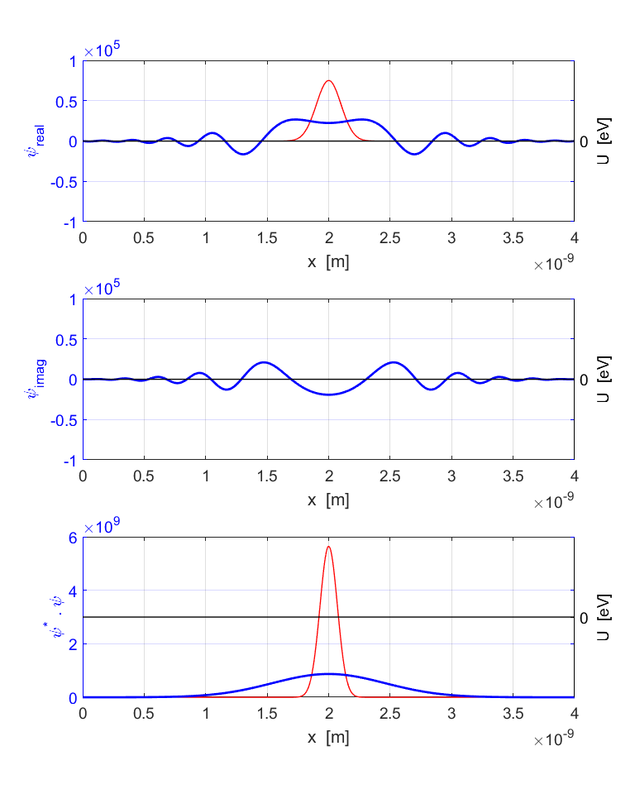

Fig. 2. Time evolution of a wave packet described initially by a real function which is Gaussian in shape.

**Motion of an electron in a uniform electric field**

We can simulate the motion of a wave packet representing an electron in a uniform electric field. The force acting on the electron is derived from the potential energy function 

(19) 

For a uniform electric field, the force acting on the electron is constant, therefore, the potential energy is a linear function with position *x* of the form

(20) 

where *L* is the width of the simulation region and is a constant.

The linear potential is chosen within the mscript by setting flagU = 3

case 3 % accelerating / retarding potential

U = -(U0/L).* x + U0;



We can apply Ehrenfest’s theorem to calculate the changes in expectation values, that is, we can apply the principles of classical physics only to expectation values and not instantaneous values.

From equation (19) and (20), and Newton’s Second Law of motion, the constant acceleration of the electron is

(21) 

We can use the equations of uniform acceleration to predict the expectation values and position of the probability density distribution from the initial conditions and the value of the acceleration *a* after a time interval *t*

(22) 

(23) 

The force due to the interaction of the charged electron and the electric field does work *W* on the electron to change its kinetic energy

(24) 

We compare the classical predictions given in equations 22, 23 and 24 with the expectation values calculated from the solution of the Schrodinger Equation.

Our wave packet is a sinusoidal function with a Gaussian envelope. The simulation parameters are:

Simulation region, 

Wavelength, 

Width Gaussian pulse, 

Initial kinetic energy, 

Initial expectation value kinetic energy, 

Table 2 gives a summary of the results of three simulations: (1) zero electric field,  (2) accelerating electric field,  and (3) retarding electric field, . The time evolution for the three simulations are shown in figures 3, 4 and 5. The number of time steps and spatial grid points used are  and . The classical predict values are computed in the mscript in the section where the potential energy function is calculated. You can get the numerical values for any of these parameters from the Matlab Command Window.

Table 2 shows that there is excellent agreement between the classical predictions and the numerical results from the solution of the Schrodinger Equation. Even though we don’t know exactly where the electron is or its exact velocity at any instant, we can predict with certainty the time evolution of the probability distribution function and expectation values.

The result summary also shows the classical concept of conservation of energy holds in our quantum system. The total energy of the system is time independent and any change in the expectation value of the potential energy is accompanied by a corresponding change in the expectation value of the kinetic energy. For example, the electric force does work on the electron to increase its kinetic energy and this is shown by the increase in the expectation value of the kinetic energy and the decrease in the expectation value of the potential such that the expectation value of the total energy does not change.

[view animation of the wave packet](http://www.physics.usyd.edu.au/teach_res/mp/doc/se_fdtd_ag_01.htm)

Table 2. Summary of the simulation results 

|  |  |  |  |
| --- | --- | --- | --- |
| Observable | Zero field | Accelerating field | Retarding field |
| *initial* [m] | 0.996x10-9 | 0.996x10-9 | 0.996x10-9 |
| *initial*  [m.s-1] | 7.13x106 | 7.13x106 | 7.13x106 |
| *initial*  [eV] | 149 | 149 | 149 |
| *initial*  [eV] | 0 | 150 | -150 |
| *initial*  [eV] | 149 | 299 | -1 |
| *a*  [m.s-2] | 0 | + 8.71x1021 | - 8.71x1021 |
| *t*  [s] | 2.79x10-16 | 2.79x10-16 | 2.79x10-16 |
| simulation  *final*  [m] | 2.99.0x10-9 | 3.31x10-9 | 2.66x10-9 |
| classical prediction  *final*  [m] |  | 3.32x10-9 | 2.65x10-9 |
| simulation  *final*  [m.s-1] | 7.13x106 | 9.45x106 | 4.75x106 |
| classical prediction  *final*  [m.s-1] |  | 9.56x106 | 4.70x106 |
| *final*  [eV] | 149 | 265 | 66.1 |
| *final*  [eV] | 0 | 34 | -67.3 |
| *final*  [eV] | 149 | 299 | -1.2 |
| [eV] | 0 | 116 | **-83** |
| [eV] | 0 | -116 | 83 |
| *W*  [eV] |  | 116 | -83 |

* The slight discrepancy in the final velocity values can be reduced by increasing the value for *Nx* (). Increasing *Nx* increases the computation time. You often need to consider accuracy and computation time.

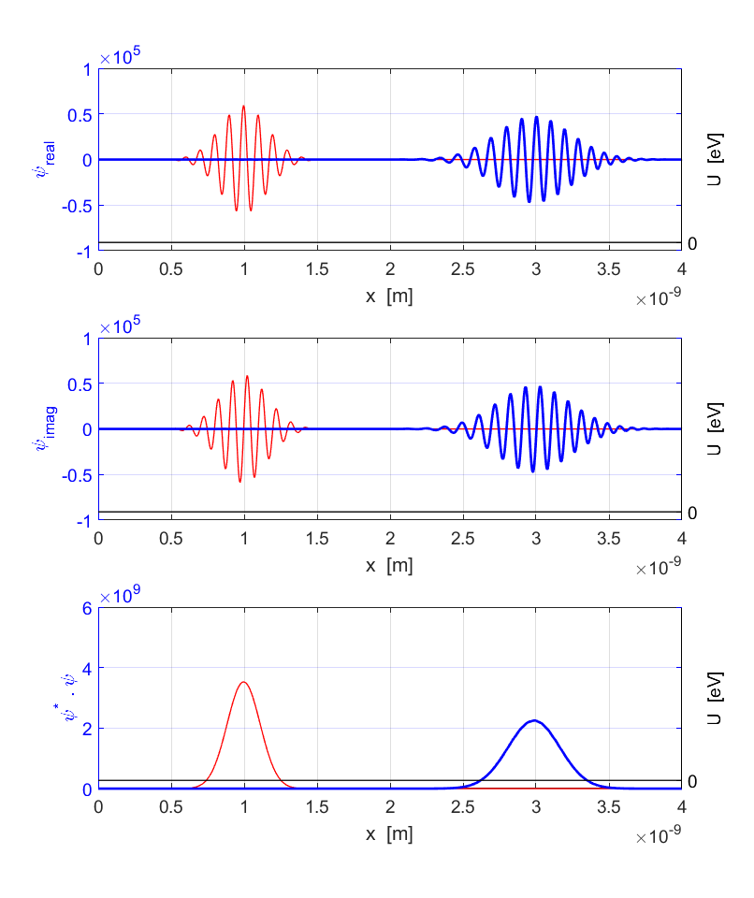

Fig. 3. Wave packet motion for zero electric field.

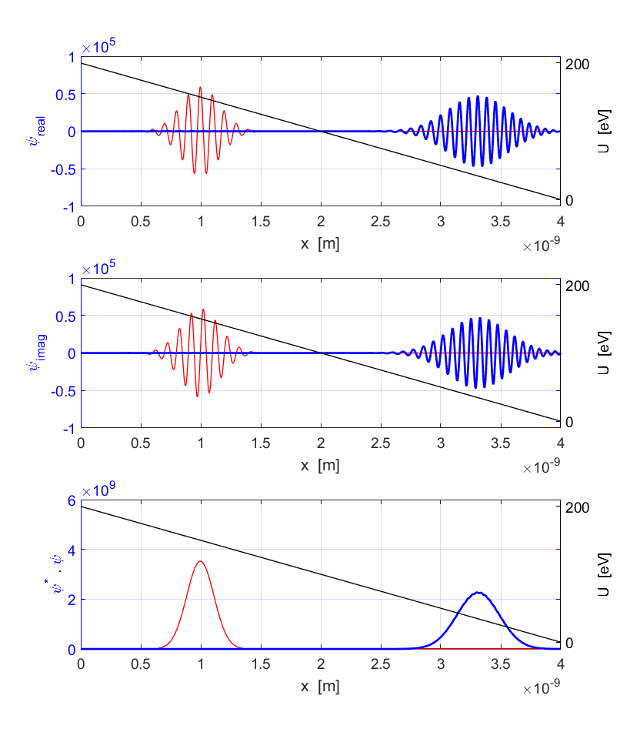

Fig.4. Motion of wave packet under the influence of a constant applied electric field to accelerate the electron.

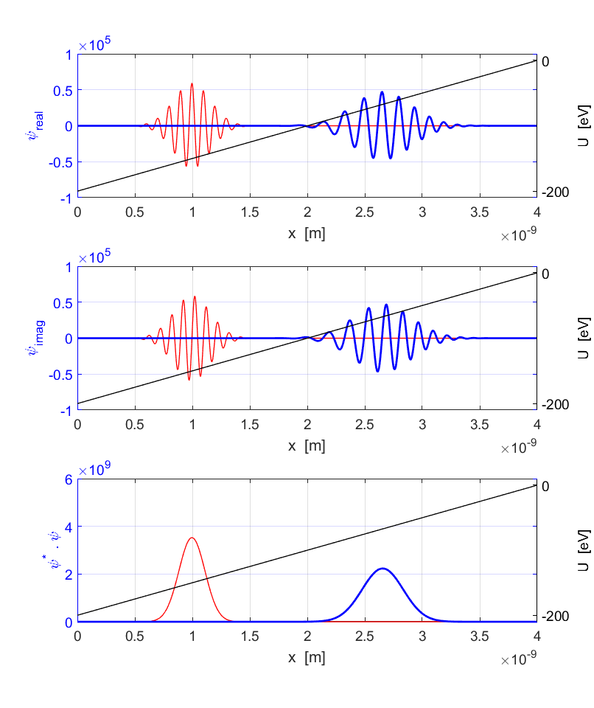

Fig. 5. Motion of wave packet under the influence of a constant applied electric field to deaccelerate the electron.

The electron can be though as a particle and the classical laws of physics can be used to predict the time evolution of expectation values. But the wave nature of the electron means that we do not know the precise values of position and velocity at an instant. We can’t predict the path of an electron, we can only predict the probability of finding the electron at each instant within a range of x values. Thus, we can conclude that the expectation value for position tracks the classical trajectory.

**BOUND STATES Particle in a box**

In our model the wavefunction is set to zero at the boundaries and this implies that the potential function is infinite at the boundaries



The particle is thus confined to move only along the X axis from  to  due to the repulsive force acting on the particle at the boundaries. When a particle is restricted to moving in a limited region, the solution of the Schrodinger Equation predicts that only certain discrete values of the energy are possible (eigenvalues) and only certain wavefunctions are allowed (eigenfunctions). For a particle confined to an infinite square well potential as in the model we are using, the physically acceptable solutions of the [1D] Schrodinger Equation that satisfy the boundary conditions give the predictions

Quantum state specified by the integer *n*  *n* = 1, 2, 3, …

(25) Wavelength 

(26) Energy eigenvalues 

Eigenfunctions (spatial part only)

(27) 

The finite difference time development method described in this paper can’t be used to find the eigenvalues and eigenfunctions since we need to specify a wavefunction at time that satisfies the Schrodinger Equation and boundary conditions. But, what we can do is to enter a known eigenfunction to start the time evolution and to calculate the expectation values at time *t.*

We can also show that if we start with a wavefunction that does not satisfy the Schrodinger Equation at time  the simulation results give physically unacceptable results.

Any linear combinations of eigenfunctions is also a solution of the Schrodinger Equation. Therefore, a wave packet must represent a linear combination of eigenfunctions

(28) 

where *A* is a normalizing constant and  is the frequency of a free particle matter wave.

The numerical results for a simulation for the quantum state *n* = 4 are given below and figure 6 shows the time evolution of the system. The best way to view the time evolution is to click the link to the animated gif file.

[view animation of the bound state](http://www.physics.usyd.edu.au/teach_res/mp/images/ag_se_fdtd_06.gif)

Simulation parameters

Length of confinement 

Wavelength 

Total energy 

Angular frequency 

Period 

Grid spacing 

Time steps 

Simulation predictions

Evolved time 

Position 

Momentum 

Uncertainty Principle 

Period 

Potential energy 

Kinetic energy 

Total energy 

There is excellent agreement between the theoretical predictions and the results computed by solving the time dependent Schrodinger equation.

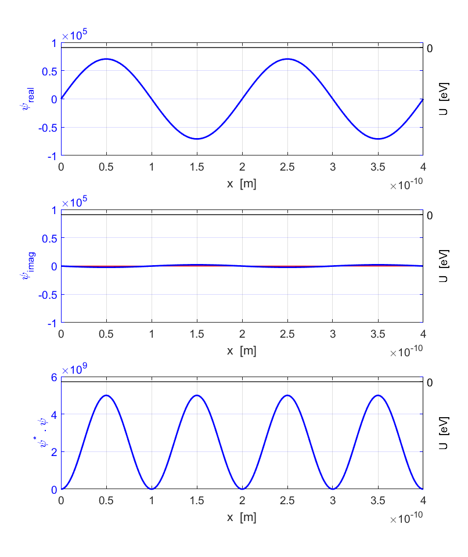

Fig.6. An electron confined to a box - the time evolution of the wavefunction and probability density function for the bound state .The red curves are the initial state () and the blue curves are the final state (). Although the wavefunction – real and imaginary parts vary with time, the probability density function is time independent.

We will now consider the superposition of two eigenstates given by the quantum numbers  and . The initial wavefunction is of the form

(29) 

where  and  are constants.

The two energy eigenvalues from equation 26 are



Let 

When a measurement is made on our system, the measurement must correspond to an eigenvalue. If we measure the total energy the result must be 37.60 eV or 58.75 eV. Since  there is an equal probability that the electron will be in the state  or , so 50% of the measurements will give 37.60 eV and the other 50% will be 58.75 eV. The average measurement will be



From the simulation, the expectation value for the total energy is



which is the average values of the measurements.

Fig. 7 shows the initial wavefunction (red) and the final wavefunction (blue) after a time interval of 1.38x10-16 s.

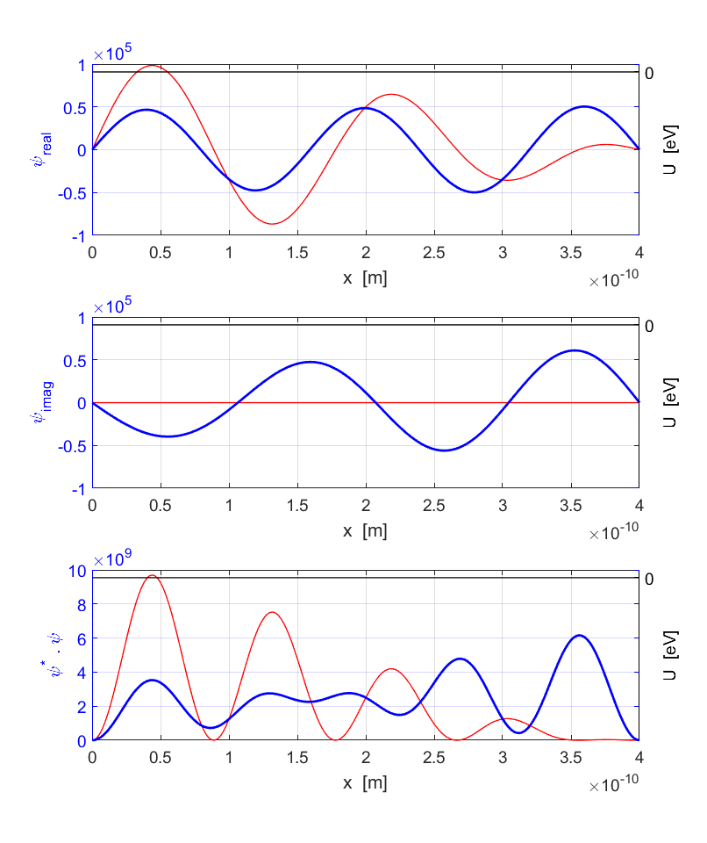

Fig. 7. Initial wavefunction (red) and final wavefunction (blue) after 1.38x10-16 s for a mixed state. The wavefunction (real and imaginary parts) and the probability density all vary with time.

[view animation of the mixed state](http://www.physics.usyd.edu.au/teach_res/mp/images/ag_se_fdtd_07.gif)

Let 

Again, when a measurement is made the electron will be either the  or . The probability of being a state *n* is proportional to the coefficient  . In this example, the average of the total energy made from a set of measurements on the system is



From the simulation, the expectation value for the total energy is



which is the average values of the measurements.

Fig. 8 shows the initial wavefunction (red) and the final wavefunction (blue) after interval of 1.38x10-16 s.

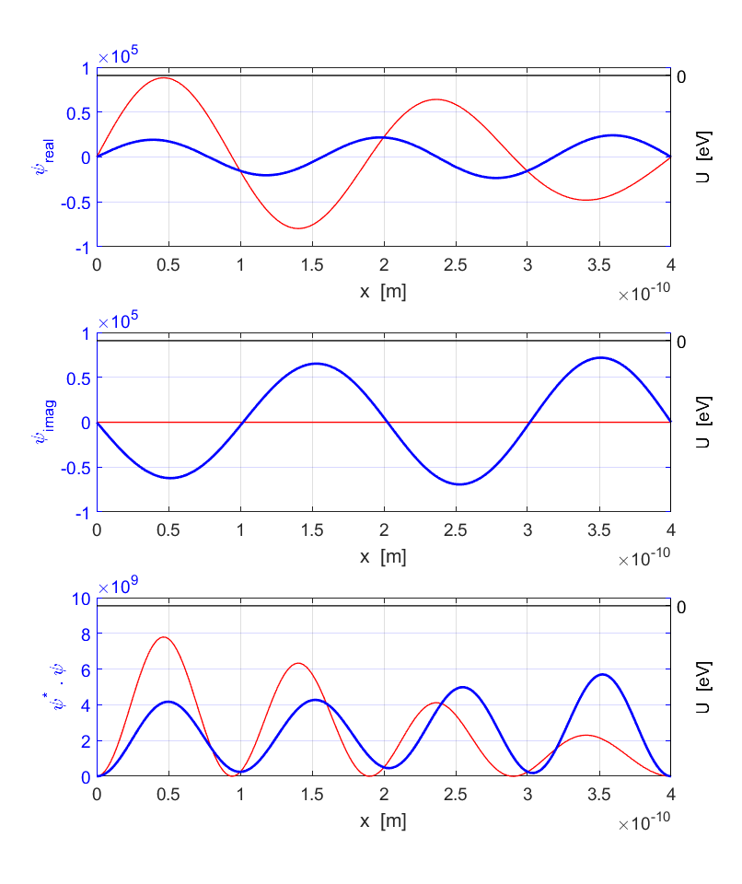

Fig. 8. Initial wavefunction (red) and final wavefunction (blue) after 1.38x10-16 s for a mixed state. The wavefunction (real and imaginary parts) and the probability density all vary with time.

[view animation of the mixed state](http://www.physics.usyd.edu.au/teach_res/mp/images/ag_se_fdtd_08.gif)

**Step Barrier**

Consider the system of a sinusoidal wave packet with a Gaussian envelop with a step potential energy function



Such a potential step does not exist in nature, but it is a reasonable approximation to the instantaneous potential between the dees of a cyclotron when  is negative (attractive potential) or to the potential barrier at the surface of a metal when  is positive (repulsive potential).

The electron starts in the zero potential region with a total energy *E* and moves towards the step in the potential.

**Case 1** 

Simulation parameters

Grid spacing 

Time steps 

Simulation time 

Length of confinement 

Wavelength 

Initial kinetic energy 

Initial potential energy 

Initial Total energy 

Final kinetic energy 

Final potential energy 

Final Total energy 

Prob  

Prob  

As the wave packet travels to the right it starts to spread but its kinetic energy remains the same. When the wave packet strikes the barrier, part of the wave packet penetrates into the barrier while part of the wave packet is reflected. This does not mean that the electron has split into two. What it mean, is that we have a certain probability of locating the electron to the left of the barrier (reflection: ) and a certain probability of finding the electron to the right of the barrier (transmission: )

(30a) Probability of reflection 

(30b) Probability of transmission 

In the region  the electron gains kinetic energy as the potential decreases. At all times the total energy is conserved.

Figure 9 shows the wavefunction and probability function. The red curves correspond to time  and the blue curves give the results at time after 10 000 time steps.

[view animation wave packet and potential step](http://www.physics.usyd.edu.au/teach_res/mp/images/ag_se_fdtd_09.gif)



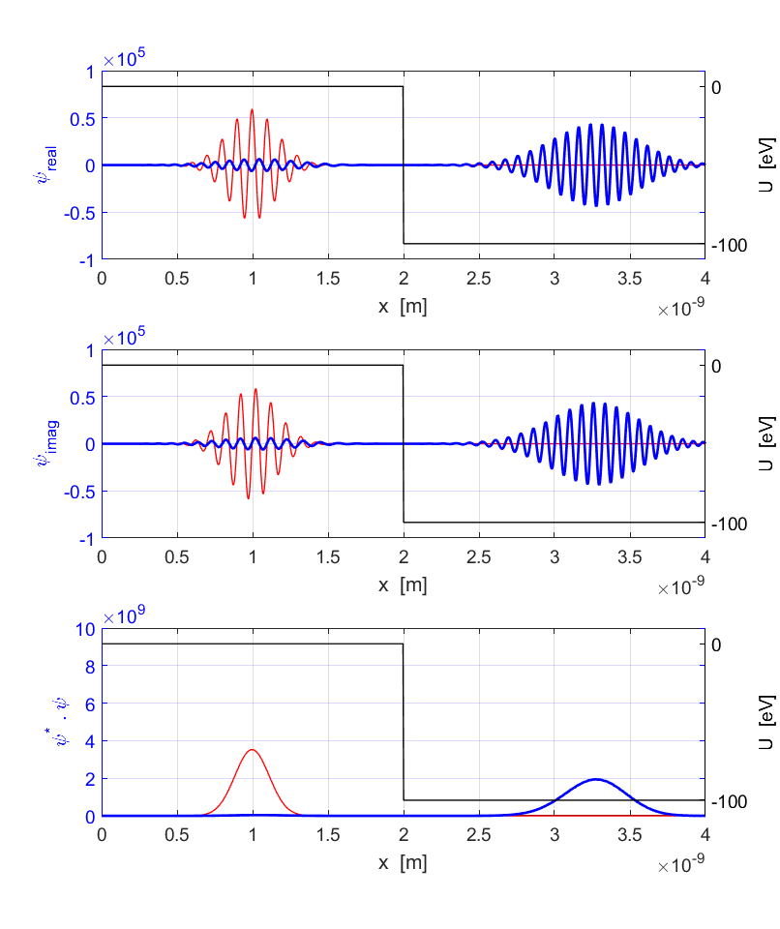

Fig. 9. Simulation of an electron moving in free space and then striking an attractive potential step. When the electron is in free space, all its energy is in the form of kinetic energy. After it strikes the step, the expectation value for the potential energy decreases as the electron’s expectation value for the kinetic energy increases.

**Case 2** 

Simulation parameters

Grid spacing 

Time steps 

Simulation time 

Length of confinement 

Wavelength 

Initial kinetic energy 

Initial potential energy 

Initial Total energy 

Final kinetic energy 

Final potential energy 

Final Total energy 

Prob  

Prob  

As the wave packet travels to the right it starts to spread but its kinetic energy remains the same. When the wave packet strikes the barrier, part of the wave packet penetrates into the barrier while part of the wave packet is reflected. This does not mean that the electron has split into two. What it mean, is that we have a certain probability of locating the electron to the left of the barrier (reflection: ) and a certain probability of finding the electron to the right of the barrier (transmission: )

Figure 10 shows the wavefunction and probability function. The red curves correspond to time  and the blue curves give the results at time after 10 000 time steps.

[view animation wave packet and potential step](http://www.physics.usyd.edu.au/teach_res/mp/images/ag_se_fdtd_10.gif)



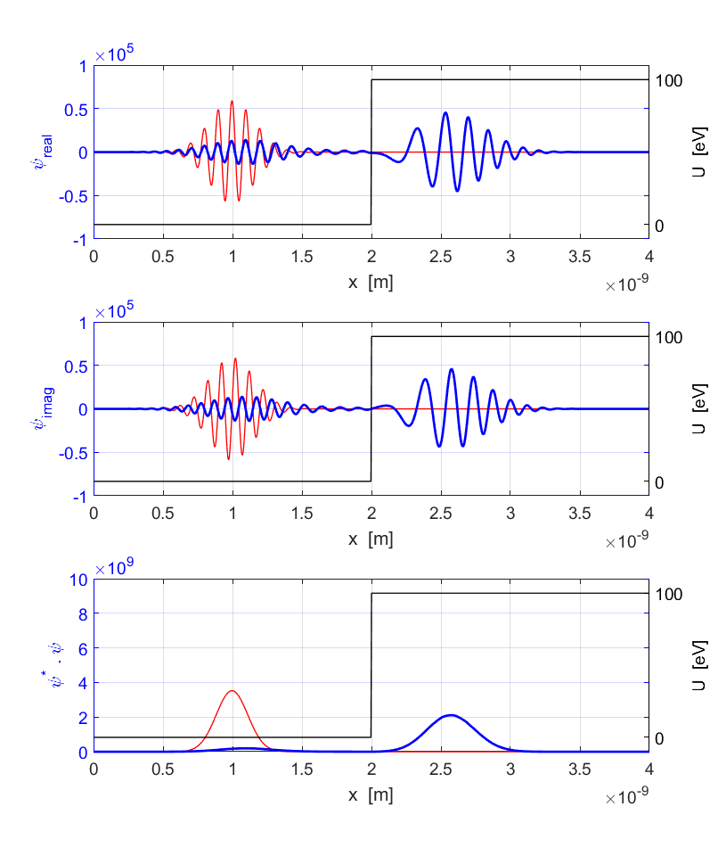

Fig. 10. Simulation of an electron moving in free space and then striking a repulsive potential step. When the electron is in free space, all its energy is in the form of kinetic energy. After it strikes the step, the expectation value for the potential energy increases as the electron’s expectation value for the kinetic energy decreases. However, at all times the total energy is conserved. There is some probability that the electron was reflected and some probability that it penetrated the potential barrier.

**Case 3** 

Simulation parameters

Grid spacing 

Time steps 

Simulation time 

Length of confinement 

Wavelength 

Initial kinetic energy 

Initial potential energy 

Initial Total energy 

Final kinetic energy 

Final potential energy 

Final Total energy 

Prob  

Prob  

As the wave packet travels to the right it starts to spread but its kinetic energy remains the same. When the wave packet strikes the barrier, part of the wave packet penetrates into the barrier while part of the wave packet is reflected. There is a very small probability that the electron is found in the classically forbidden region  where kinetic energy is negative



Figure 11 shows the wavefunction and probability function. The red curves correspond to time  and the blue curves give the results at time after 10 000 time steps.

[view animation wave packet and potential step](http://www.physics.usyd.edu.au/teach_res/mp/images/ag_se_fdtd_11.gif)



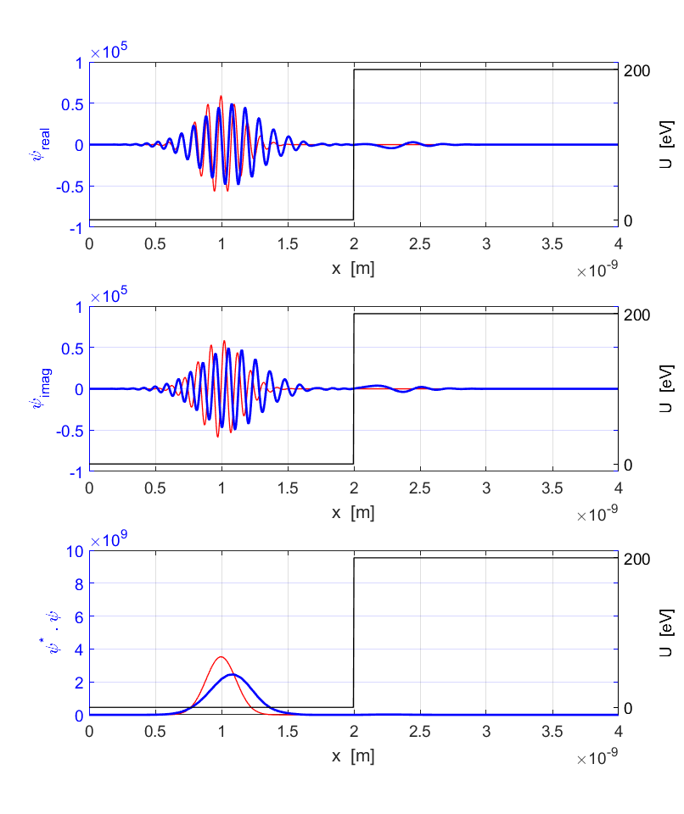

Fig. 11. Simulation of an electron moving in free space and then striking a repulsive potential step. When the electron is in free space, all its energy is in the form of kinetic energy. After it strikes the step, the expectation value for the potential energy increases as the electron’s expectation value for the kinetic energy decreases. However, at all times the total energy is conserved. There is some probability that the electron was reflected and a small probability that it penetrated the potential barrier into the classical forbidden region.

**Case 4 Wave packet interacting with step barrier**

The parameters for the simulation are given in figure 12 and figure 13 shows the graphical output for a wave packet striking a potential step.

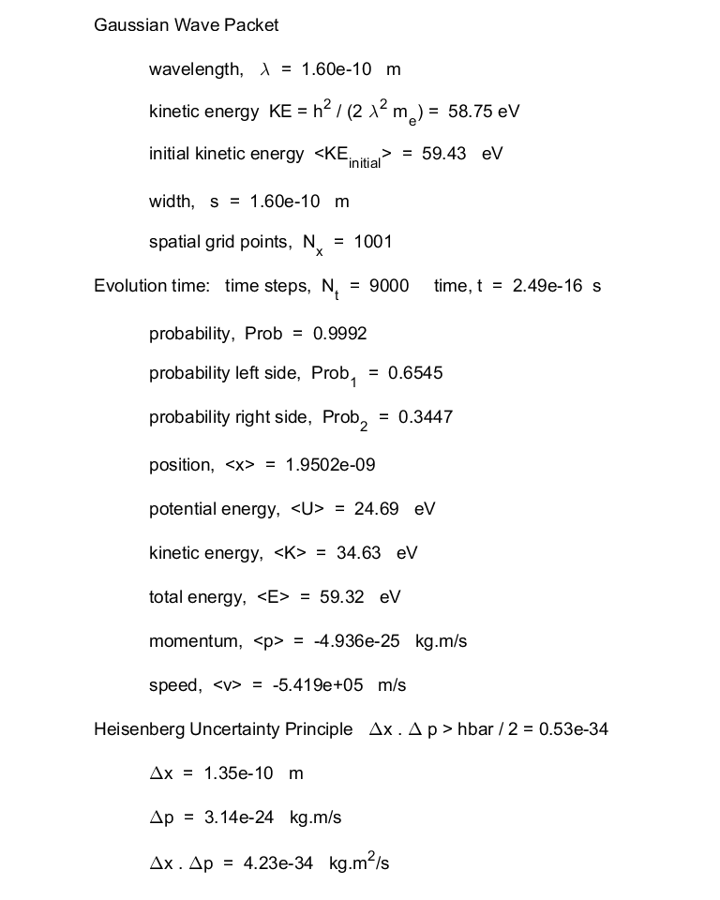

Fig. 12. Summary of parameters for wave packet striking potential step.

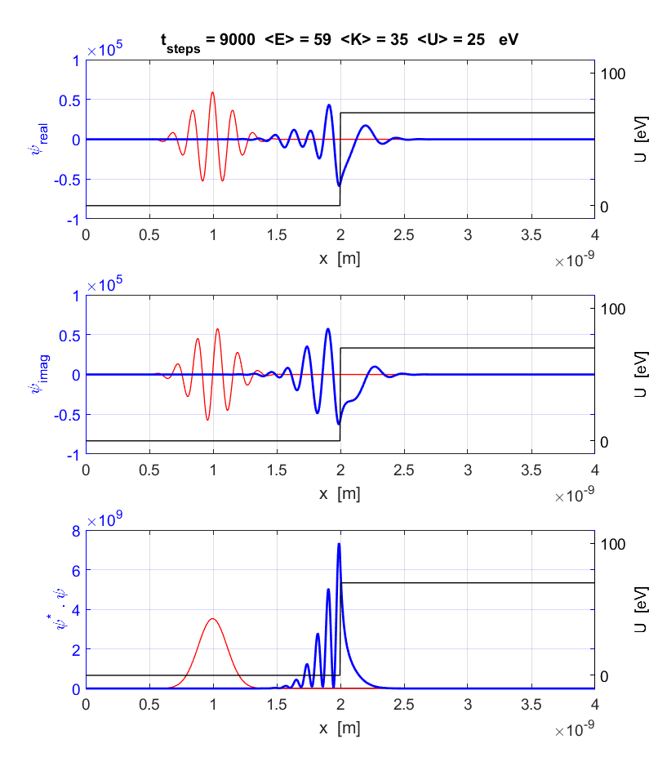Fig. 13. Wavefunction for wave packet striking a potential step.

Figure 13 shows some of the most surprising aspects of quantum physics: (1) Particles have the ability to enter regions that are classically forbidden. (2) Initially, as the wave packet approaches the barrier, the probability of locating the electron is located in a single “blob” flowing from left to right. However, when the wave packet encounters the barrier, the probability distribution develops closely spaced peaks. These peaks are a consequence of reflection. Part of the wave packet is advancing towards the barrier and part of it is retreating from the barrier due to reflection. This leads to interference effects which by the superposition principle results in the closely spaced spikes in the probability distribution.

**Square well**

Consider the propagation of our sinusoidal wave packet with a Gaussian envelop incident upon a square well of depth and width *w*. When the wave packet strikes the barrier, part of the wave packet penetrates into and through the well, while part of the wave packet is reflected as shown in figure 14.

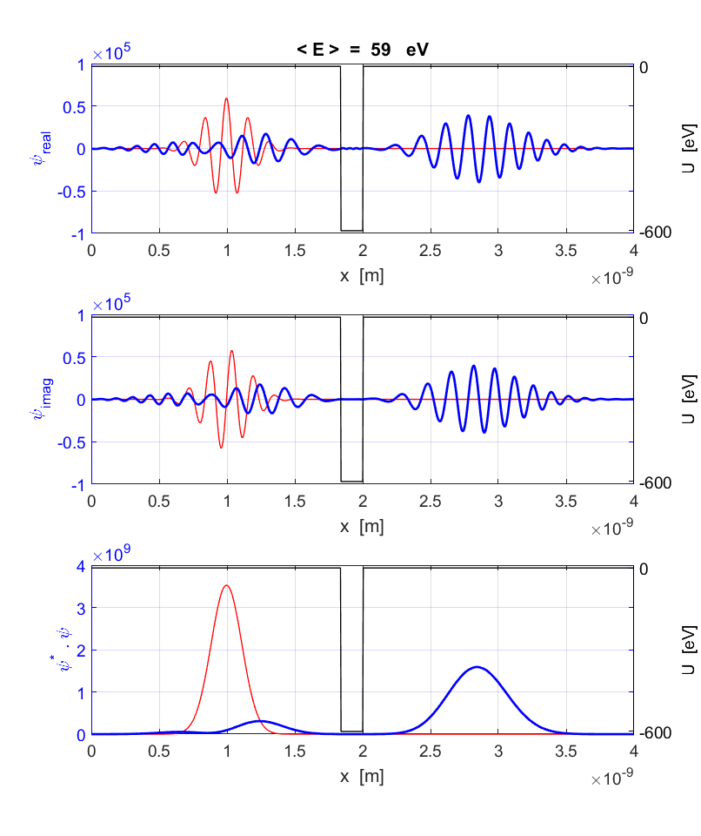

Fig. 14. Wave packet striking a square well.

  



We can calculate the probability that the electron can be found on the left or right of the centre using equation (30). The transmission coefficient *T i*s equal to the percentage probability of finding the electron to the right of the well. For the square well shown in figure 14, the transmission coefficient is . The transmission coefficient is sensitive to small changes in the total energy, the depth and width of the square well. Figure 15 shows the rapid variation in the transmission coefficient *T* with small changes in the width *w o*f the well.

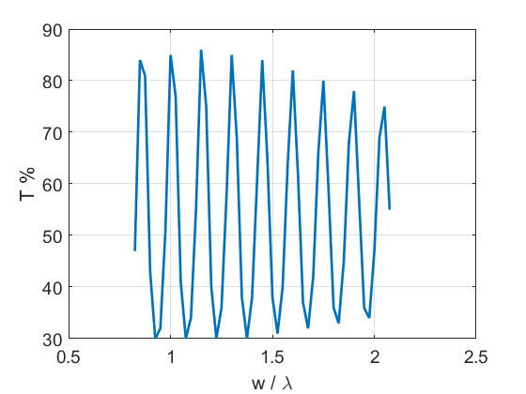

Fig. 15. Periodic variation in the transmission coefficient *T* as the width *w* of the square well increases.

[view animation wave packet and potential well](http://www.physics.usyd.edu.au/teach_res/mp/images/ag_se_fdtd_12.gif)

**Potential Hill (Rectangular Barrier)**

In quantum physics, a particle may penetrate into a region where its total energy is less than the potential energy of the system and therefore the particle’s kinetic energy would be negative



This leads to the tunnelling of particles through thin barriers which are classically impenetrable. Suppose an electron represented by a wave packet is incident from the left on a rectangular barrier (potential hill) of height  and width *w.* We can calculate the transmission coefficient *T* for the electron penetrating the barrier from the solution of the Schrodinger equation. The sensitivity of the dependence of the transmission coefficient on the height of the barrier and the width of the hill can be easily investigated using the FDTD method to solve the Schrodinger equation.

Modelling the electron as a sinusoidal wave packet with a Gaussian envelope with a total energy  incident upon a potential hill of height , we can compute the transmission coefficient *T* for varying width *w* as shown in Table 3.

Table 3. Variation of *T* with *w.*

|  |  |  |  |  |
| --- | --- | --- | --- | --- |
| Width | 0.25 | 0.50 | 0.75 | 1.00 |
| T % | 20 | 2 | 0.4 | 0.1 |

As the width increases there is a very rapid decrease in the transmission coefficient.

Figure 16 shows the wavefunction for potential hill of height 100 eV and width  after a time interval of 3.87x10-16 s.

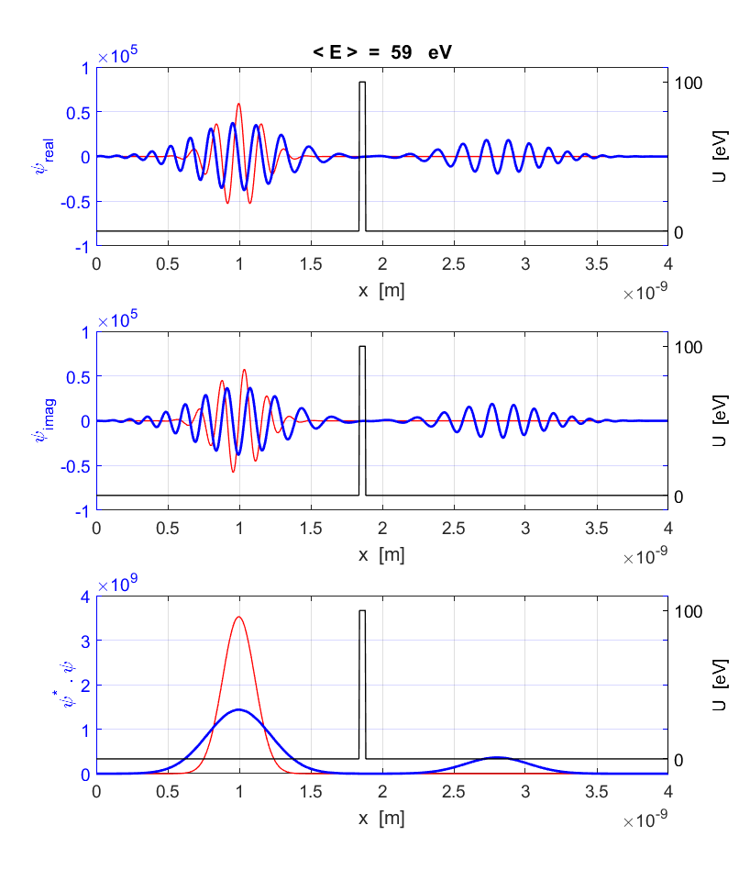

Fig. 16. The wavefunction after a time interval of 3.87x10-16 s.



[view animation wave packet and potential hill](http://www.physics.usyd.edu.au/teach_res/mp/images/ag_se_fdtd_13.gif)

**QUANTUM BOUNCER 1 Parabolic Well**

We can animate the time development of a sinusoidal Gaussian wave packet for an electron trapped in a parabolic potential well. The electron bounces backward and forward similar to a classical particle.

An electron in a parabolic well is subjected to a force that is always directed towards the centre of the well. The electron does not penetrate the walls of the well and is trapped. The wave packet continually **spreads and reforms original shape** with the probability density function being widest during the refection phase of its motion.

The potential energy is given by the function



The effective spring *k* constant of the system is

 where  is in the units of eV

The electron trapped in the parabolic potential well exhibits periodic motion with a period *T*



For the simulation with the parameters



When the simulation is run, the wave packet almost returns to its initial position in a time interval approximately equal to the period *T* showing an excellent agreement between the classical prediction and the quantum physics prediction.

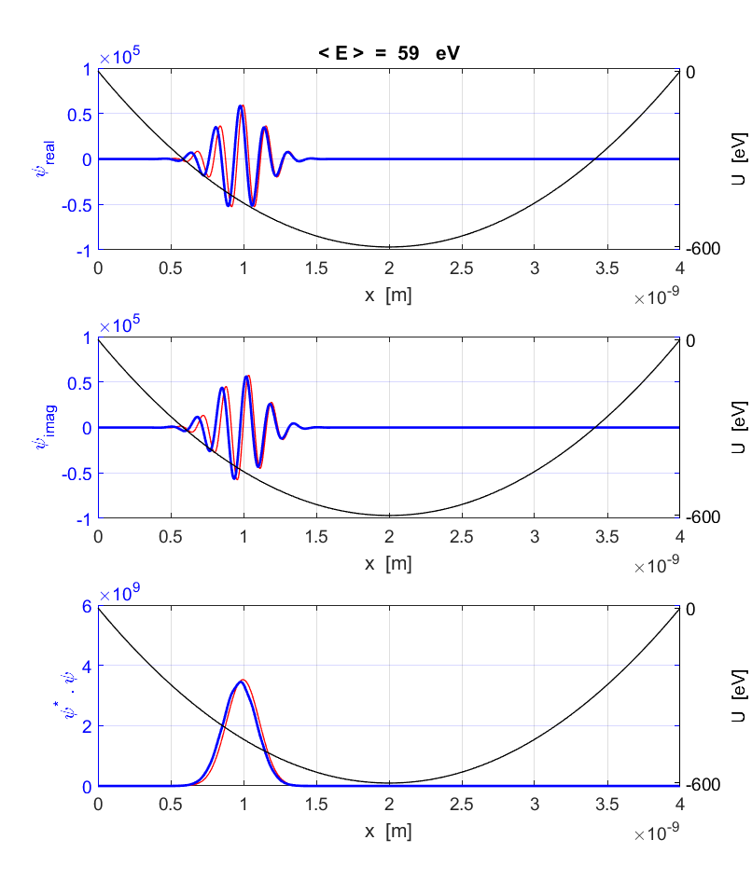

Fig. 17. An electron trapped in a parabolic potential well. The wave packet returns to its initial position (red) in a time interval as predicted by the classical physics calculation for the period *T* of a simple harmonic oscillator.

[view animation wave packet in parabolic well](http://www.physics.usyd.edu.au/teach_res/mp/images/ag_se_fdtd_15.gif)

The total energy is conserved during the motion of the electron within the well, therefore, it loses potential energy and gains kinetic energy in moving towards the centre of the well and gains potential energy and loses kinetic energy as it approaches the walls. The expectation values for the wave packet satisfy the classical equations of motion. For the initial position of the wave packet at positions  and , the expectation values for energy at different times are given in Table 4.

Table 4. Expectation values at different times .

|  |  |  |  |  |
| --- | --- | --- | --- | --- |
| Time | nm | eV | eV | eV |
| 0 | 2.00 | -538.7 | -598.1 | 59.4 |
| ~1/4 | 2.63 | -538.8 | -540.7 | 1.9 |
| ~1/2 | 2.00 | -538.7 | -598.1 | 59.4 |
| ~3/4 | 1.37 | -538.4 | -540.4 | 1.9 |
| ~1 | 2.00 | -538.7 | -598.1 | 59.4 |
| 0 | 1.00 | -387.5 | -446.9 | 59.4 |
| ~1/4 | 2.61 | -387.5 | -543.3 | 155.8 |
| ~1/2 | 3.01 | -387.5 | -443.5 | 56.0 |
| ~3/4 | 1.41 | -387.5 | -546.6 | 159.0 |
| ~1 | 0.97 | -387.5 | -440.25 | 52.7 |

**QUANTUM BOUNCER 2 Electron bouncing off a wall**

We can animate the time development of a sinusoidal Gaussian wave packet of a quantum bouncer for an electron subjected to a uniform force and bouncing off an impenetrable wall (classical analogue - tennis ball repeatedly falling and bouncing off the floor with elastic collisions between ball and floor). The expectation value for the position tracks the classical trajectory, while the wave packet spreads.

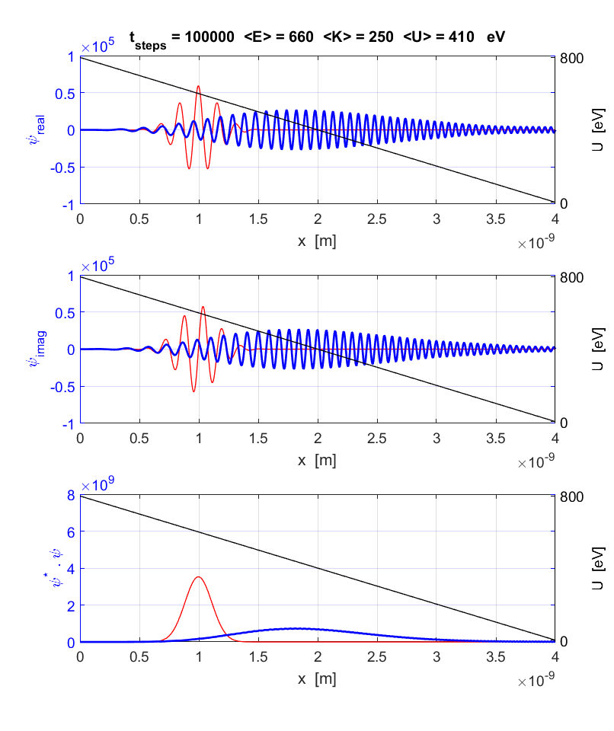

Fig. 18. Initial wavefunction (red) and wavefunction after 100000 time steps (blue) for bouncing electron.

[view animation wave packet motion](http://www.physics.usyd.edu.au/teach_res/mp/images/ag_se_fdtd_16.gif)