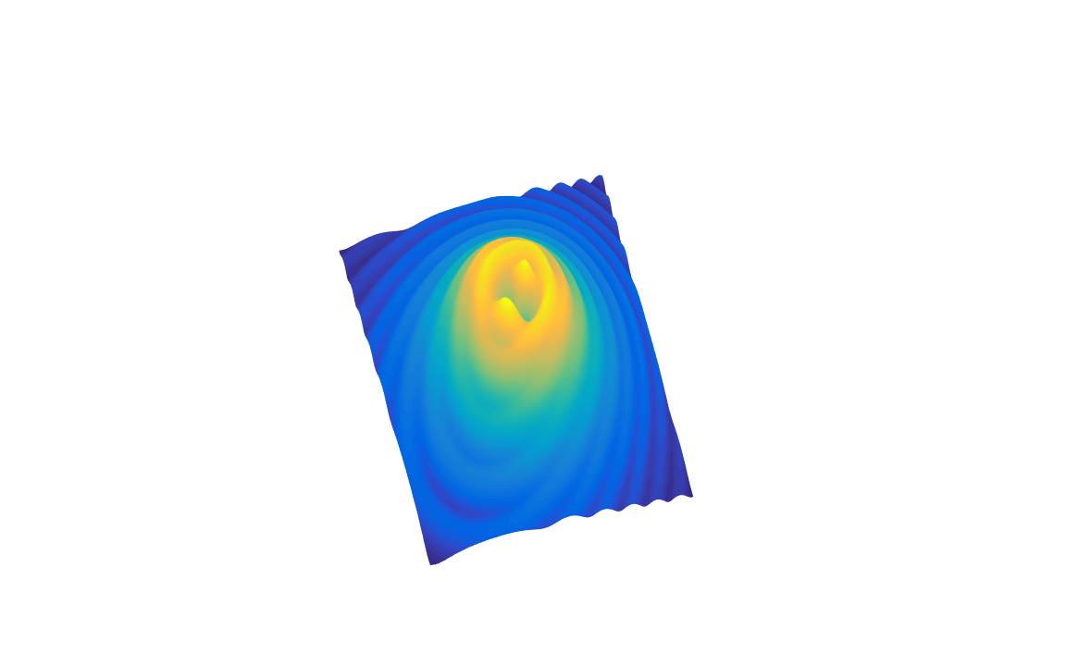

[**DOING PHYSICS WITH MATLAB**](http://www.physics.usyd.edu.au/teach_res/mp/mphome.htm)

**THERMAL PHYSICS**

# 

# ENERGY TRANSFER BY CONDUCTION THROUGH COMPOSITE MATERIALS

# 

Ian Cooper School of Physics University of Sydney ian.cooper@sydney.edu.au

[**DOWNLOAD DIRECTORY FOR MATLAB SCRIPTS**](http://www.physics.usyd.edu.au/teach_res/mp/mscripts)

It is necessary to modify the mscripts and comment or uncomment lines of code to run the simulations with different input and output parameters.

**tp_rod_11.m**

Calculation of the temperature profile and energy flux through a uniform rod when the end temperatures of the rod and remain constant. Graphical output shows the time evolution of the temperature and energy flux density. In the mscript you can change the length and radius of the rod and give the thermal conductivity, specific heat capacity and density for the material.

**tp_rod_12.m**

Similar to the mscript to tp_rod_11.m but the rod is composed of two different material in series.

**tp_rod_13.m**

Similar to the mscript to tp_rod_12.m but the rod is composed of three different material in series. Because of limitations of the numerical method, only the actual values of the thermal conductivity of three materials are used. Values of the heat capacity and density are set to give an appropriate time scale in solving the differential equations. The steady-state temperature profile along the rod and the energy flux density only depend upon the length of the three segments and thermal conductivities of the three materials making up the composite rod.

**tp_rod_21.m**

A two segment rod with internal heating is modelled.

The transfer of heat is very important in industry, in the home and in biological systems. At times it is desirable to obtain the maximum heat transfer, at other times to reduce it. It is essential that the thermal properties of materials from the lowest to the highest temperatures are known. Then systems can be designed to meet the requirements of maximum or minimum transfer of energy. For example, what is the purpose of the large cooling towers in a power station? How can we keep our home warm in winter? How does our body try to keep us cool during a hot summer day? On a very hot day you pick up two bars lying on the ground in the sun, one is made of wood, the other metal, what would you feel and why? In answering these questions you have to consider, what produces a transfer of energy, and what causes a change

in temperature. Your answers may include the terms hot, cold, temperature, heat, energy, energy transfer, power, energy flux, and energy flux density but what do these terms mean? Can you clearly differentiate the concepts associated with each of these terms?

You can gain a deeper and better understanding of these concepts, by modelling the transfer of energy along a rod by running the simulations with a wide range of input parameters.

***Heat is a misleading term***

**Heat** is the term used to describe the transfer of energy due to a temperature difference.

A better alternative is to simply use the term **energy** and so on most occasions the word energy will be used and not the term heat. The **rate of energy transfer** across a surface is be referred to as the **power** or **energy flux**. The **energy flux density** *J* is a very useful term because it is independent of the cross-sectional area *A* of the rod. The energy flux density *J* is defined as

(1) 

We will model the one-dimensional heat transfer along a rod. The model can be used to compute both the temperature and the transfer of energy as functions of time and position along a rod.

The rate of energy transfer through a rod is dependent upon the thermal conductivity *k* of the material, the cross-sectional area *A* of the rod and the temperature gradient as described by the differential equation

(2) 

Using equations (1) and (2), the energy flux density is

(3) 

When energy is transferred to or from an object its temperature may change. The change in temperature *dT* depends upon the object’s mass *m*, its specific heat capacity *c* and the net amount of energy *Qnet* gained or lost by the object. The change in temperature is given by

(4) 

and the time rate of change of temperature is

(5) 

We can consider the rod to be made up of many cylindrical elements of length *dx*. The density of an element is and its volume is . Then the mass *m* of an element is

(6) 

Combing equations (1), (4) and (5), the time rate of change of the temperature of an element is

(7) 

where the net energy flux density  is given by

(8) 

*Jcond* is the contribution to the energy flux density due to the conduction of energy along the rod, *Jint* is the internal heating of the rod (for example, an electric heating element) and *Jenv* is the due to the transfer of energy to and from an element to the surrounding environment (for example, by thermal radiation or convection).

We can find the temperature *T* and energy flux density *Jnet* as functions of time *t* and position *x* along the rod by solving the two differential equations (3) and (7) using a **finite difference approach**

(3) 

(7) 

For convenience, to simply the notation, we will use *J* to represent the energy flux density due to conduction .Consider a rod of length *L* divided into *N* cylindrical elements and the width of each element is. It is assumed all the properties of an element are uniform throughout the volume of the element. For the *n*th element (*n* = 1 , 2, …, *N*), it is characterised by its radius *R*(*n*), thermal conductivity *k*(*n*), specific heat capacity *c*(*n*) and its density *ρ*(*n*). The time dependent variables are its temperature *T*(*t*, *n*) and energy flux densities *J*int(*t*, *n*) and *J*env(*t*, *n*). All these variables are measured at the mid-point of the element .

Energy is transferred across the interface between elements by the process of conduction. The energy flux density into the *n*th element is *J*(*t*, *n*) at position

 and the energy flux density existing the element is *J*(*t*, *n*+1) at position . Figure 1 shows the parameters for the element with index *n* at time *t*.

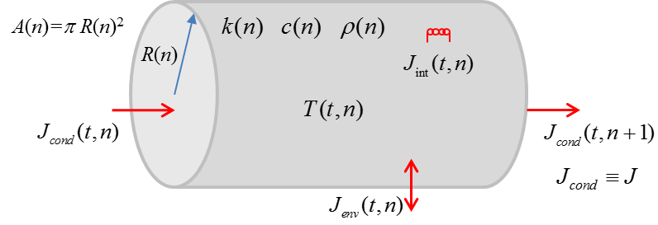

Fig. 1. Parameters for the element with index *n* at time *t*.

The differential equation (3) for the energy flux density can be expressed as a finite difference equation for the *n*th element at time *t* as

(8) 

The differential equation (7) for the temperature can be expressed as a finite difference equation for the *n*th element at time  as

(9) 

We can solve this pair of finite difference equations (8) and (9) given the initial values at time *t* = 0 and the boundary conditions imposed on the rod.

For stability of the numerical method we have the condition



The smaller the value *dx* for the increment in *x* then the smaller the time step *dt* in the simulation.

For composite rods made of more than one material, it may not be possible to use actual values for the heat capacity and density as they the set time scale in solving the differential equations. The steady-state temperature profile along the rod and the energy flux density only depend upon the length and thermal conductivity of the materials making up the composite rod, therefore, values of the heat capacity and density can be chosen to give an appropriate time step.

**Simulation 1 Uniform insulated rof**

**tp_rod_11.m**

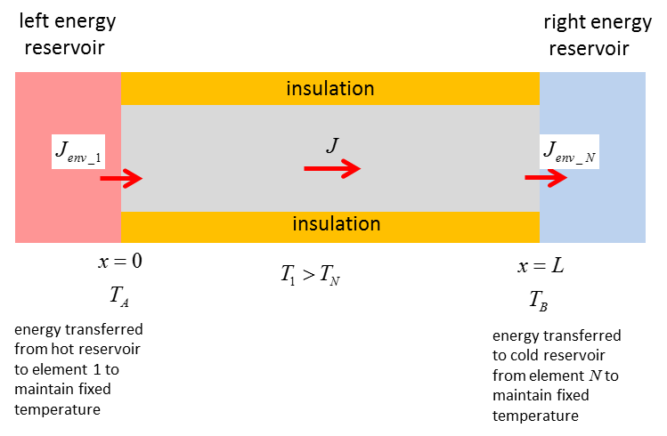

Fig. 2. Energy transfer through a rod with fixed temperatures maintained at the ends.

We will consider a cylindrical rod composed of a single uniform material and of a constant radius that is fully insulated along its length  and zero internal heating . The ends of the rod are maintained at all times are fixed temperatures *TA* and *TB*. If the temperatures of the end elements are to remain constant, then the net flux through these elements must be zero.

Initial conditions and boundary conditions:

T(*t*, 1) = *TA* T(*t*, *N*) = *TB* *T*(0, *n*) = Tintial for *n* = 2 to *N*-1

*J*(*t*, 1) = *J*(*t*, 2) and *J*(*t*, *N*) = *J*(*t*, *N*+1)

We can compare the results of the simulation for the energy transferred through a copper rod and a glass rod

Length *L* = 0.2 m Radius *R* = 0.01 m

*TA* = 100 oC and *TB* = 20 oC

Copper rod

Thermal conductivity *k* = 400 W.m-1.K-1

Specific heat capacity *c* = 380 J.kg-1.K-1

Density ρ = 8900 kg.m-3

Glass rod

Thermal conductivity *k* = 1 W.m-1.K-1

Specific heat capacity *c* = 840 J.kg-1.K-1

Density ρ = 2600 kg.m-3

**Results of the simulation mscript tp_rod_11.m**

The temperature gradient is constant

*dT/dx* = - 405 oC.m-1

Steady-state energy flux density

Copper *Jcopper* = 1.62x105 W.m-2

Glass *Jglass* = 405 W.m-2

It is difficult to determine the time to reach the steady state situation from the graphs. To have a consistent means to estimate this time, we can calculate the time interval for the temperature at the centre of the rod to reach 63% of its final value. This time interval is called the time constant *τ*. The time to reach the steady-state is then defined to be equal to 5*τ* for our simulation

 

 

Copper is a good thermal conductor whereas glass is a very poor thermal conductor. The copper rod quickly reaches its steady-state whereas the glass takes many hours because of the small value for the energy flux along the glass rod.

**Theoretical calculations**

The temperature should be a linear function of position along the rod and the temperature gradient should be a constant given by



In the equilibrium state, the energy flux density through the rod should be uniform with a value determined from equation (3)





The agreement between the model and the theoretical results is very good.

Graphical results for temperatures and energy flux densities are shown in the figures below:

Copper Rod

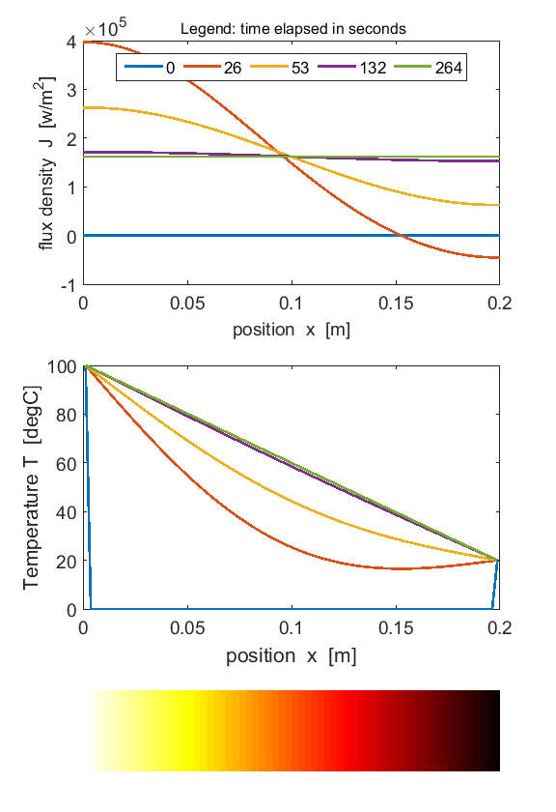

Copper rod

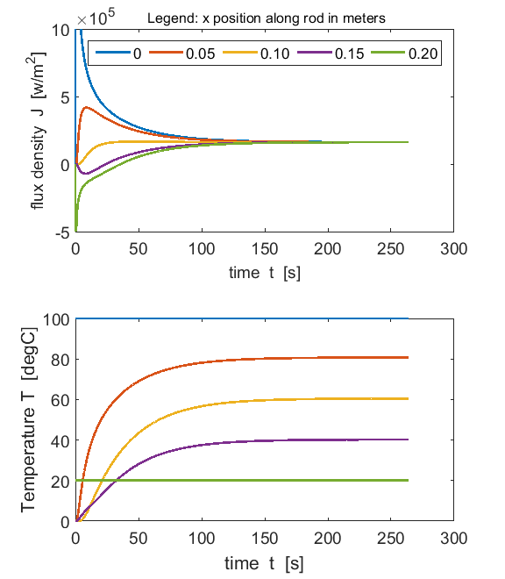

Glass rod

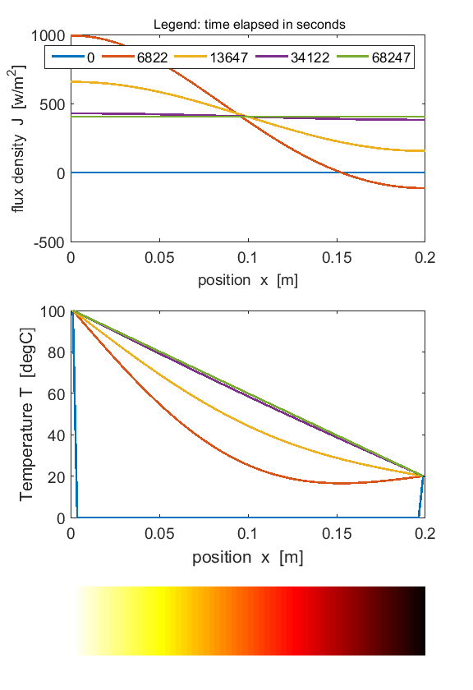

Glass rod

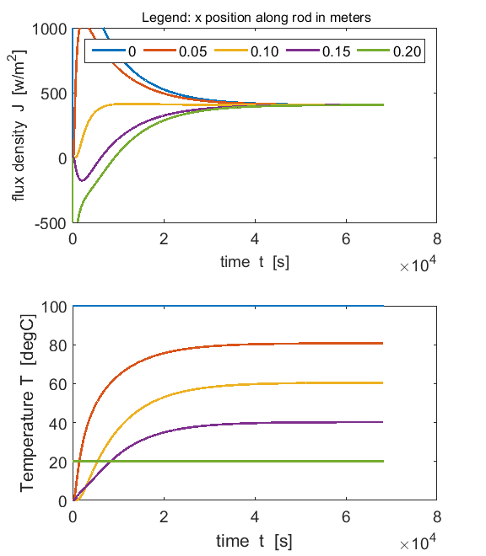

Energy is transferred through the rod from the hot reservoir to the cold reservoir.

Initially a large amount of energy is transferred through the rod in the direction of decreasing temperature, heating the rod which results in the rise in temperature along its length. Finally a steady-state situation is established with a linear variation in temperature along the rod and a constant energy flux density through it.

In equation (2)

(2) 

the significance of the minus sign ( **-** ) is that the energy transfer is in the direction of decreasing temperature, i.e., heat always flows spontaneously from the location of higher temperature to locations of lower temperature.

We can investigate the physics of heat conduction by running the simulation for a wide range of input parameters. The best way to start is simply to change only one of the input parameters at a time. For each simulation, predict the changes that would occur then check your predictions by observing the results of the simulation.

**Changing one parameter at a time *TA* = 100 oC *TB* = 0 oC**

|  |  |  |  |  |
| --- | --- | --- | --- | --- |
| ***L* = 1 m *r* = 0.01 m *k* = 1 W.m-1.oC-1 *c* = 1 J.kg-1.oC-1 *ρ* = 1 kg.m-3** | | | | |
| **dT/dx**  **[oC.m-1]**  **-100** | **A**  **[m2]**  **3.14×10-4** | **J**  **[W.m-2]**  **100** | **dQ/dt**  **[W]**  **3.14×10-2** | **5*τ***  **[s]**  **0.851** |

|  |  |  |  |  |
| --- | --- | --- | --- | --- |
| ***L* = 2 m** *r* = 0.01 m *k* = 1 W.m-1.oC-1 *c* = 1 J.kg-1.oC-1 *ρ* = 1 kg.m-3 | | | | |
| dT/dx  [oC.m-1]  -50 | A  [m2]  3.14×10-4 | J  [W.m-2]  50 | dQ/dt  [W]  1.57×10-2 | 5*τ*  [s]  3.41 |
| *change* ×  (1/2) | 1 | (1/2) | (1/2) | 4 |

Increasing the length: decreases the temperature gradient; decreases the energy transfer through the rod; takes much longer to reach steady state.

|  |  |  |  |  |
| --- | --- | --- | --- | --- |
| *L* = 1 m ***r* = 0.02 m** *k* = 1 W.m-1.oC-1 *c* = 1 J.kg-1.oC-1 *ρ* = 1 kg.m-3 | | | | |
| dT/dx  [oC.m-1]  -100 | A  [m2]  12.6×10-4 | J  [W.m-2]  100 | dQ/dt  [W]  12.6×10-2 | 5*τ*  [s]  0.851 |
| *change* ×  1 | 4 | 1 | 4 | 1 |

Increasing the radius: no changes in temperature gradient, energy flux density and time to reach steady-state; increase in area and energy flux.

|  |  |  |  |  |
| --- | --- | --- | --- | --- |
| *L* = 1 m *r* = 0.01 m ***k* = 2 W.m-1.oC-1**  *c* = 1 J.kg-1.oC-1 *ρ* = 1 kg.m-3 | | | | |
| dT/dx  [oC.m-1]  -100 | A  [m2]  3.14×10-4 | J  [W.m-2]  200 | dQ/dt  [W]  6.28×10-2 | 5*τ*  [s]  0.426 |
| *change* ×  1 | 1 | 2 | 2 | (1/2) |

Increasing the thermal conductivity: no changes in temperature gradient and area; increase in energy flux density and energy flux; decrease in time to reach steady-state.

|  |  |  |  |  |
| --- | --- | --- | --- | --- |
| *L* = 1 m *r* = 0.01 m *k* = 2 W.m-1.oC-1 ***c* = 1 J.kg-1.oC-1** *ρ* = 1 kg.m-3 | | | | |
| dT/dx  [oC.m-1]  -100 | A  [m2]  3.14×10-4 | J  [W.m-2]  100 | dQ/dt  [W]  3.14×10-2 | 5*τ*  [s]  1.066 |
| *change* ×  1 | 1 | 1 | 1 | 2 |

Increasing the specific heat capacity: no changes in temperature gradient, area, energy flux density and energy flux; increase in time to reach steady-state.

|  |  |  |  |  |
| --- | --- | --- | --- | --- |
| *L* = 1 m *r* = 0.01 m *k* = 2 W.m-1.oC-1 *c* = 1 J.kg-1.oC-1 ***ρ* = 1 kg.m-3** | | | | |
| dT/dx  [oC.m-1]  -100 | A  [m2]  3.14×10-4 | J  [W.m-2]  100 | dQ/dt  [W]  3.14×10-2 | 5*τ*  [s]  1.066 |
| *change* ×  1 | 1 | 1 | 1 | 2 |

Increasing the density: no changes in temperature gradient, area, energy flux density and energy flux; increase in time to reach steady-state.

**Simulation 2 Conduction through a composite slab**

**tp_rod_12.m**

Consider a rod consisting of two different materials connected in series. The temperature at the ends of the rod are kept constant at *TA* and *TB*. The rod’s temperature will evolve with time from its initial temperature to a steady-state situation when the energy flux density is uniform along the length of the rod, that is, the rate of energy transfer through the two materials must be equal. Therefore, we can write

(10) 

We can model a rod of length *L* = 0.2 m and radius *R* = 0.01 m made of copper and iron in which the temperatures at the end of the rod are *TA* = 100 oC and *TB* = 0 oC. The junction between the cooper and the iron is at the centre of the rod.

Copper Iron

*k*1 = 400 W.m-1.K-1 *k*2 = 50 W.m-1.K-1

*c*1 = 380 J.kg-1.K-1 *c*2 = 450 J.kg-1.K-1

*ρ*1 = 8900 kg.m-3 *ρ*2 = 7900 kg.m-3

We can calculate the theoretical temperature *TC* at the centre of the rod from equation (10)



Using equation (10), the theoretical steady-state energy flux density *Jcond* is



From the simulation, the results are

*TC* = 88 oC and 

Again, we get good agreement between the theoretical predictions and the results of the simulation.

To get accurate results in running the simulations, the time interval Δ*t* must be small and the smaller you make the position increment Δ*x*, the smaller must Δ*t* be.

The graphical results for the simulation are shown in the following figures.

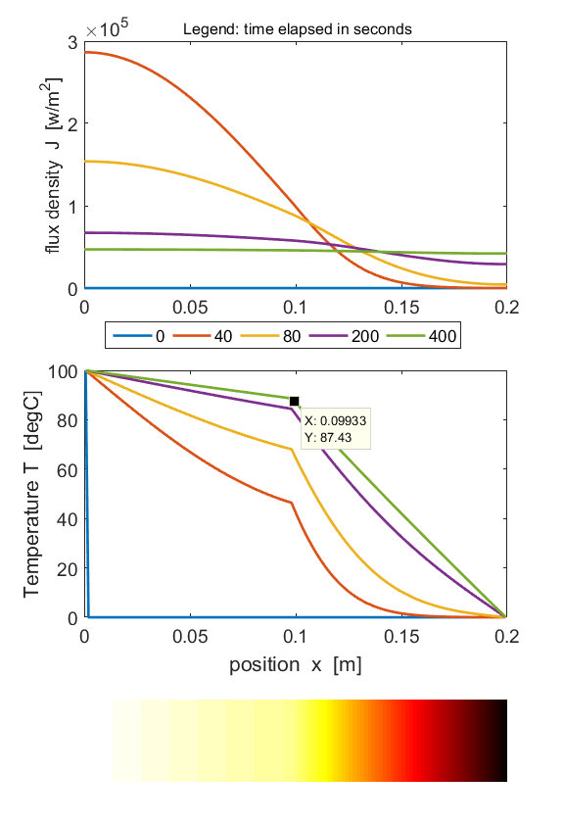

Note the larger drop in temperature across the section of the rod with the lower thermal conductivity.

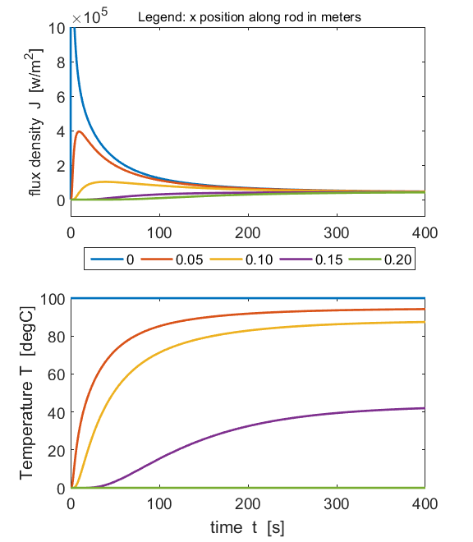

**Simulation 3 Conduction through a composite wall**

**tp_rod_13.m**

Energy flow calculations often involve composite walls that are composed of more than one material. For insulation purposes, these composite walls have a layer of a material with low thermal conductivity.

We will consider a specific example of a composite furnace wall made from three different materials – fire brick (*k* = 0.072 W.m-1.K-1 and width = 0.117 m), air space (*k* = 0.034 W.m-1.K-1 and width = 0.033 m) and building brick (*k* = 1.330 W.m-1.K-1 and width = 0.100 m).

The aim of this simple model is to predict the energy flux density through the wall, the temperature gradient in the three materials and the junction (interface) temperatures when the furnace wall temperature is 1200 oC and the outside brick temperature is 50 oC. The result of the calculations for the energy flux density and temperature distribution only depend upon the width and the thermal conductivities of the of the materials and they do not depend upon the specific heat capacities or densities of the materials. We can’t use the actual values for the heat capacities and densities of the materials because if we did so, the time increment would be too small. We can select arbitrary values for the heat capacities and densities to give a suitable time scale for the calculations.

The Matlab mscript **tp_rod_13.m** is used to model the wall. A summary of the furnace wall parameters and calculations are displayed in a Matlab figure window (figure 3). Figure 4 shows the time evolution of the energy flux density and temperature distribution. The number of time steps is chosen so that the system reaches a steady state situation. This is indicated when the energy flux density for the first and last elements are approximately equal. The final temperature distribution and the position of the junctions is shown in figure 5.

The temperature gradient is significantly greater in the air gap then in either brick segment. The temperature drop in the fire brick is 174 oC, in the air space it is 905 oC and in the building brick it is 71 oC. Thus, the air space provides the most effective insulation.

This is only a simple model, and does not account for convection and radiation losses and the thermal conductivity is a function of temperature and not a constant as used in our model.

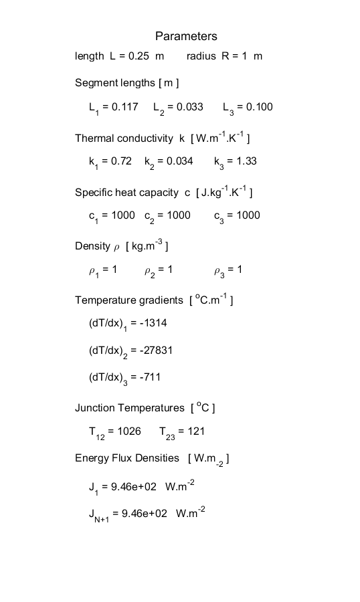

Fig. 3. Input and output parameters for the conduction through the composite wall.

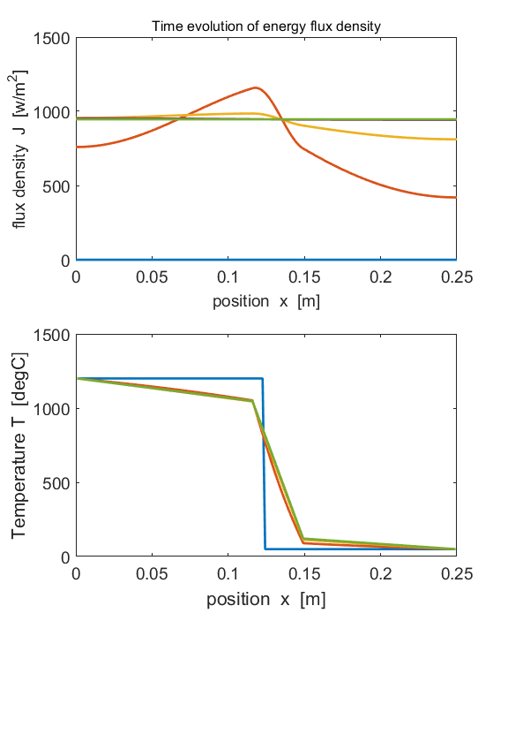

Fig. 4. Time evolution of the energy flux density and temperature distribution. Steady state is reaches when the energy flux density is constant through the material.

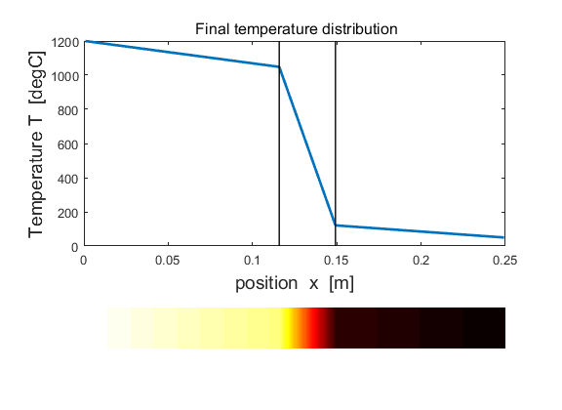

Fig. 5. Final temperature distribution.

**Simulation 4 Conduction through a composite rod due to internal heating.**

**tp_rod_21.m**

We can model a two segment rod that is subjected to internal heating in the volume centred around the junction of the two materials. Let the junction be at the centre of the rod. Material 1 (left) has a higher thermal conductivity than material 2 (right). The rod is insulated along its length. The ends of the rods are held at fix temperatures *TA* and *TB*. The internal heating of the rod increases the temperature of each element of the rod and energy is transferred from the rod to the surroundings through the ends of the rod at elements 1 and *N*.

**Parameter used for the simulation**

Number of time steps = 120000

Length of rod = 0.20 m

Radius of cylindrical rod = 0.010 m

Number of elements = 150

Internal heating of elements from 65 to 85

Rate of internal heating = 10 W

Initial temperature of all elements = 0 oC

Fixed end temperatures *TA* = 0 oC and *TB* = 0 oC

Material 1 (copper: elements 1 to 74)

*k*1 = 400 W.m-1.K-1 *c*1 = 380 J.kg-1.K-1 *ρ*1 = 8900 kg.m-3

Material 2 (iron: elements 75 to 150)

*k*2 = 50 W.m-1.K-1 *c*1 = 450 J.kg-1.K-1 *ρ*1 = 7900 kg.m-3

**Output parameters for the simulation**

A steady-state situation is approached after about 400 s

The copper becomes hotter than the iron.

Max temperature in the cooper segment = 141 oC at *x* = 0.099 m

Max temperature in the iron segment = 164 oC at *x* = 0.110 m

Max energy flux density in the copper segment = -5.7×105 W.m-2

(energy flows from the right to the left)

Max energy flux density in the iron segment = +9.6×104 W.m-2

(energy flows from the left to the right)

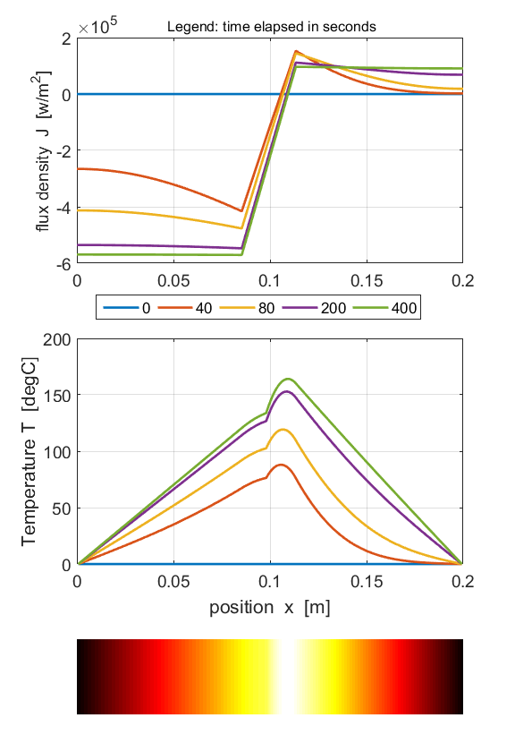

Fig. 6. The energy flux density and temperature distribution along the rod as functions of time. The coloured bar shows the final temperature profile.

The hot spot in the iron is because the iron is a poorer thermal conductor than the cooper. Less energy is transferred away from the iron elements due to internal heating compared with the equivalent copper elements.

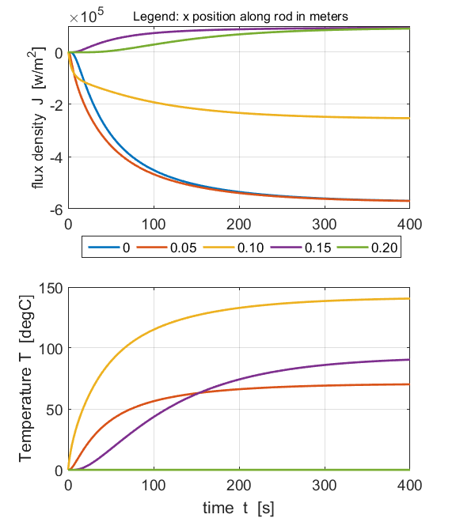

Fig. 7. The time evolution of the energy flux density and temperature at fixed positions along the length of the rod.