[**DOING PHYSICS WITH MATLAB**](http://www.physics.usyd.edu.au/teach_res/mp/mphome.htm)

**VISUALIZATION OF QUANTUM MECHANICAL PHENOMENA**

**COMPLEX VALUED FUNCTIONS**

Ian Cooper

School of Physics, University of Sydney

ian.cooper@sydney.edu.au

[**DOWNLOAD DIRECTORY FOR MATLAB SCRIPTS**](http://www.physics.usyd.edu.au/teach_res/mp/mscripts)

Download and inspect the scripts and make sure you can follow the structure of the programs.

visualization

**wm_spectrum.m**

Color plot of the visible spectrum for the wavelength range from 380 nm to 780 nm.

Calls the function **ColorCode.m**

**Colorcode.m**

Function to give the RGB values for a given wavelength color.

Is it assumed the supplied lambda is within the range 380-780 nm.

Smaller or higher values are set notionally to the extreme values.

The script **wm_spectrum.m** can be used to produce a plot of the visible spectrum for the wavelength range from 380 nm to 780 nm. The script uses the **area** plot function to give the spectrum. The color for each wavelength is calculated from the function **ColorCode.m**.

**STATIONARY PLANE WAVE**

We start our study of visualizing quantum mechanical phenomena by considering a complex periodic function representing a plane wave in [1D]. A stationary plane wave can be presented by the wavefunction  with wave number 

(1) 

Each wavefunction  has a spatial period of 2*L,* therefore, you only need to consider the interval [-*L L*].



The term  is a normalizing factor

(2) 

The complex valued stationary plane wavefunction can be visualized in several ways using the Matlab script **vqm0001.m**. A color is assigned to the phase in the interval  as shown in figure 1. 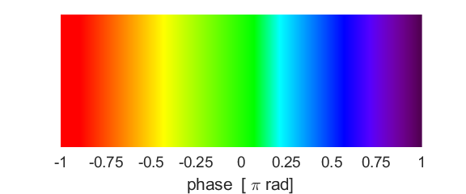

Fig. 1. The phase of a complex function is assigned a color code.

The real and imaginary parts of the wavefuction and its absolute value for *n* = 4 and *L* = 50 are shown in figure 2 as separate plots.

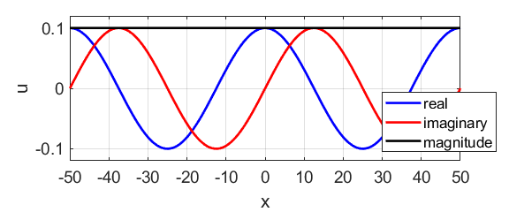

Fig. 2. The real and imaginary parts of the complex function and its absolute value.

The wavefunction  can be displayed as space curve in a [3D] as shown in figure 3.

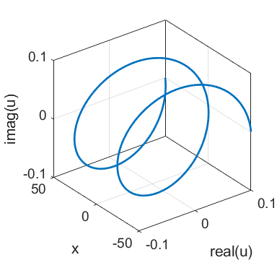

Fig.3. Space curve of the wavefunction  in the interval .

The phase of the complex function can be computed using the Matlab function **angle**. A plot of the variation in the phase of the wavefunction  in the interval  is shown in figure 4. The lower plot gives the value of the absolute of the wavefunction  and the phase is given by the color as shown in figure 1.

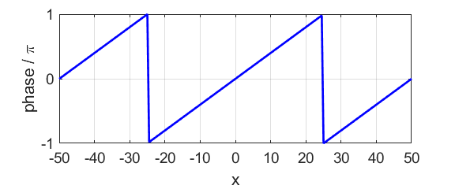

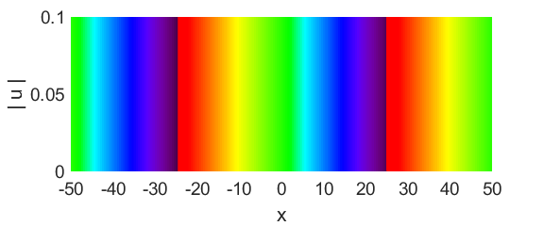

Fig. 4. The phase of the wavefunction as a function of position.

Examination of figures 2 and 4 show that the spatial period (wavelength ) is equal to 50.

(3) 



You can check that the wavefunction is normalized by integrating the function given by equation 2 using the script **simpson1d.m**

An = simpson1d(conj(psi).*psi,-L,L);

% check normalization

The value An computed is displaced in the Command Window:

An = 1.000