[**DOING PHYSICS WITH MATLAB**](http://www.physics.usyd.edu.au/teach_res/mp/mphome.htm)

**OSCILLATIONS**

# Graphical User Interface (GUI):

# Simple Harmonic Motion and the Sine Function

Ian Cooper

School of Physics, University of Sydney

ian.cooper@sydney.edu.au

[**DOWNLOAD DIRECTORY FOR MATLAB SCRIPTS**](http://www.physics.usyd.edu.au/teach_res/mp/mscripts)

**wav_shm_sine.m wav_shm_sine_cal.m**

mscripts are used to investigate simple harmonic motion through the sine function using a GUI. They also provide a template for creating your own simple GUI using input boxes.

**SIMPLE HARMONIC MOTION (SHM)**

Linear simple harmonic motion is motion in a straight line with an acceleration proportional to the distance from an equilibrium position and directed towards that equilibrium point.

Consider SHM along the Y-axis and the equilibrium position corresponding to the origin at *y* = 0. In SHM, an object will oscillate around the equilibrium position with an amplitude *A* and period *T*. The frequency *f* and angular frequency  for the motion are



The displacement *y*(*t*) at any time *t* is given by the sine function which can be expressed as



where  is the initial phase angle [radians]. It gives the value of *y* at time *t* = 0

initial position 

If then the displacement y can be expressed as



To illustrate the dependence of the displacement *y* on time *t*, period *T* and initial phase angle  you can run the mscript **wav_shm_sine.m** . This mscript uses a GUI to input the parameters and to view the graphical response. The figures below show the Figure Window for the GUI.

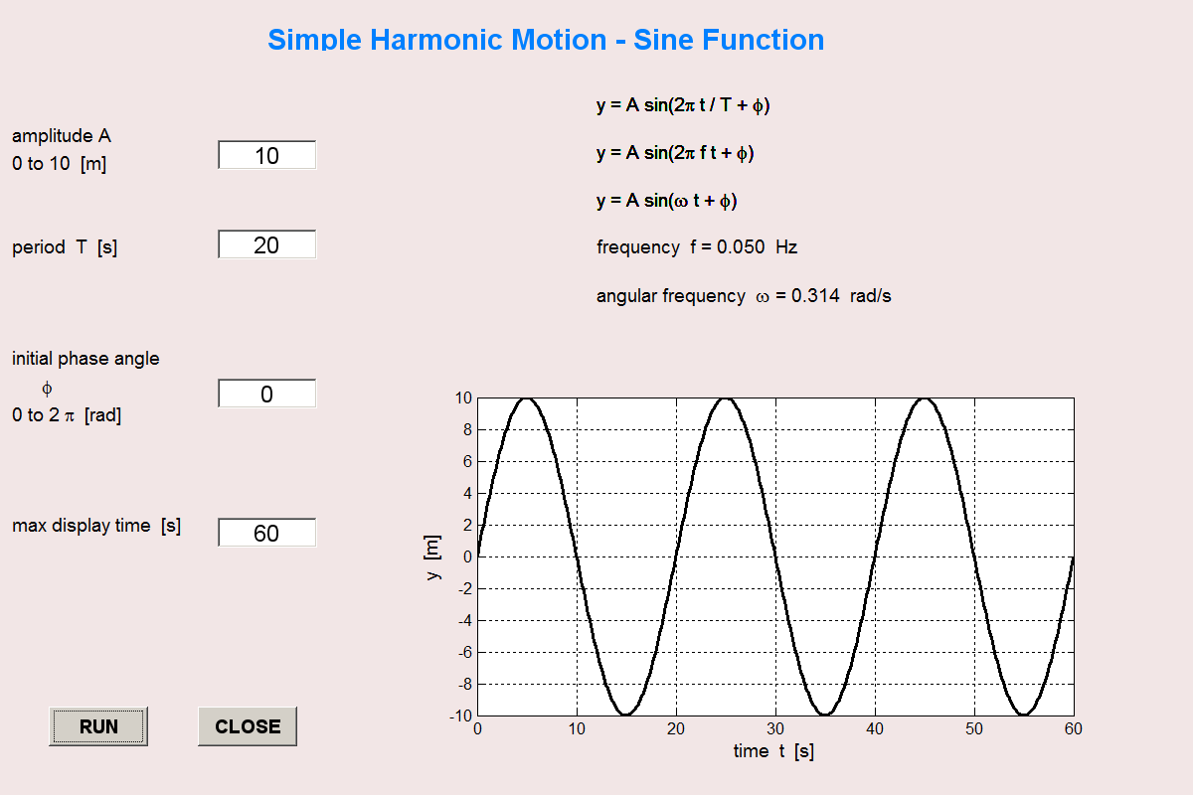

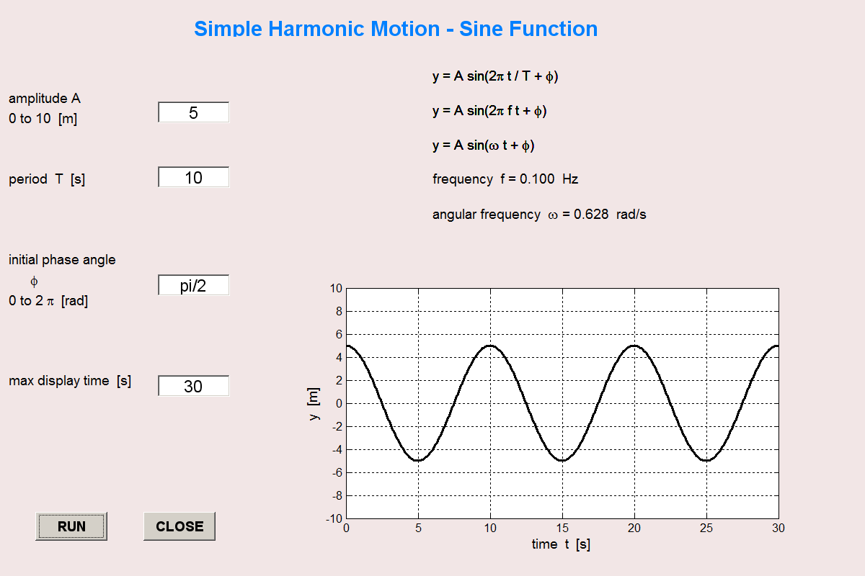

**THE Graphical User Interface**

You can use the two mscripts **wav_shm_sine.m** and **wav_shm_sine.m** as templates to create a simple GUI for your own simulations.



Step 1 Create the Figure Window

Size of Window: origin at (xF, yF) width xL height yL

xF = 20; yF = 50; xL = 1200; yL = 800;

% Main figure window -------------------------------------------

f1 = figure('Color',[0.95 0.9 0.9],'Name','SHM', ...

'NumberTitle','off','Position',[xF yF xL yL]);

Step 2 Create the main heading

% heading ----------------------------------------------------

pos = [250 750 600 30];

colorBG = [0.95 0.9 0.9];

colorFG = [0 0.5 1];

fs = 18;

textD = 'Simple Harmonic Motion - Sine Function';

t1 = uicontrol(gcf,'Style','text','Position',pos, ...

'String',textD,'FontSize',fs, ...

'HorizontalAlignment','center','FontWeight','bold', ...

'BackgroundColor',colorBG,'ForegroundColor',colorFG);

Step 3 Initial values for input boxes and create input boxes A, B, C and D

% Input Initial Data

ym = 10; T = 5; phi = 0; tMax = 30; Nt = 500;

boxA = ym; boxB = T; boxC = phi; boxD = tMax;

% box 1 A -----------------------------------------------------------

pos = [220 630 100 30];

colorBG = [1 1 1];

colorFG = [0 0 0];

fs = 14;

Edit_A = uicontrol(gcf,'Style','edit','Position',pos, ...

'String',boxA,'FontSize',fs,'BackgroundColor',colorBG, ...

'Callback','boxA = str2num(get(Edit_A,''String''));');

% box 2 B ---------------------------------------------------------

pos = [220 540 100 30];

colorBG = [1 1 1];

colorFG = [0 0 0];

fs = 14;

Edit_B = uicontrol(gcf,'Style','edit','Position',pos, ...

'String',boxB,'FontSize',fs,'BackgroundColor',colorBG, ...

'Callback','boxB = str2num(get(Edit_B,''String''));');

% box 3 C -----------------------------------------------------------

pos = [220 390 100 30];

colorBG = [1 1 1];

colorFG = [0 0 0];

fs = 14;

Edit_C = uicontrol(gcf,'Style','edit','Position',pos, ...

'String',boxC,'FontSize',fs,'BackgroundColor',colorBG, ...

'Callback','boxC = str2num(get(Edit_C,''String''));');

% box 4 D -----------------------------------------------------------

pos = [220 250 100 30];

colorBG = [1 1 1];

colorFG = [0 0 0];

fs = 14;

Edit_D = uicontrol(gcf,'Style','edit','Position',pos, ...

'String',boxD,'FontSize',fs,'BackgroundColor',colorBG, ...

'Callback','boxD = str2num(get(Edit_D,''String''));');

Step 4 Create and position pushbuttons RUN and CLOSE

% PUSHBUTTONS ++++++++++++++++++++++++++++++++++++++++++++++++++++

pushbutton_run = uicontrol(gcf,'Style','pushbutton','Position',...

[50 50 100 40], 'FontSize',12,'FontWeight','bold', 'String','RUN', ...

'CallBack', 'wav_shm_sine_cal');

pushbutton_close = uicontrol(gcf,'Style','pushbutton','Position',...

[200 50 100 40], 'FontSize',12,'FontWeight','bold', 'String','CLOSE', ...

'CallBack', 'close');

Step 5 Create subplot regions for text and graphs

Description of input parameters

plot1 = subplot('Position',[0.01 0.2 0.2 0.7]);

set(gca,'Xlim',[0 10]);

set(gca,'Ylim',[0 10]);

text(0,9,'amplitude A','FontSize',12');

text(0,8.5,'0 to 10 [m]','FontSize',12');

text(0,7,'period T [s]','FontSize',12');

text(0,5,'initial phase angle','FontSize',12');

text(0,4.5,' \phi ','FontSize',12');

text(0,4,'0 to 2 \pi [rad]','FontSize',12');

text(0,2,'max display time [s]','FontSize',12');

axis off

Output parameters

plot1 = subplot('Position',[0.4 0.6 0.5 0.3]);

set(gca,'Xlim',[0 10]);

set(gca,'Ylim',[0 10]);

text(2,9,'y = A sin(2\pi t / T + \phi)','FontSize',12');

text(2,7,'y = A sin(2\pi f t + \phi)','FontSize',12');

text(2,5,'y = A sin(\omega t + \phi)','FontSize',12');

tm1 = 'frequency f = ';

tm2 = num2str(f,'%3.3f\n');

tm3 = ' Hz';

tm = [tm1 tm2 tm3];

text(2,3,tm,'FontSize',12');

tm1 = 'angular frequency \omega = '; tm2 = num2str(w,'%3.3f');

tm3 = ' rad/s';

tm = [tm1 tm2 tm3];

text(2,1,tm,'FontSize',12');

axis off

Plot

plot1 = subplot('Position',[0.4 0.1 0.5 0.4]);

xP = t; yP = y;

plot(xP,yP,'k','lineWidth',2);

axis on; grid on;

xlabel('time t [s]','FontSize',12');

ylabel('y [m]','FontSize',12');

set(gca,'Ylim',[-10 10]);

Step 6 Create the mscript for the CallBack for the RUN pushbutton

Reads values entered into input boxes, calculates output parameters and updates graph and output parameters

% wav_shm_sine_cal.m

% CallBack mscript for wav_shm_sine.m

% Reads values from input boxes -----------------------------------------

ym = boxA;

T = boxB;

phi = boxC;

tMax = boxD;

t = linspace(0,tMax,Nt);

y = ym .* sin(2*pi*t/T + phi);

f = 1 / T; w = 2*pi*f;

% PLOT ++++++++++++++++++++++++++++++++++++++++++++++++++++++++++++

plot1 = subplot('Position',[0.4 0.1 0.5 0.4]);

xP = t; yP = y;

plot(xP,yP,'k','lineWidth',2);

axis on; grid on;

xlabel('time t [s]','FontSize',12');

ylabel('y [m]','FontSize',12');

set(gca,'Ylim',[-10 10]);

% Output parameters ------------------------------------------------

plot1 = subplot('Position',[0.4 0.6 0.5 0.3]);

set(gca,'Xlim',[0 10]);

set(gca,'Ylim',[0 10]);

text(2,9,'y = A sin(2\pi t / T + \phi)','FontSize',12');

text(2,7,'y = A sin(2\pi f t + \phi)','FontSize',12');

text(2,5,'y = A sin(\omega t + \phi)','FontSize',12');

colorBG = [0.95 0.9 0.9];

tmA = 'yyyyyyyyyyyyyyyyyyyyyyyyyyyyyy';

text_h = text(2,3,tmA,'FontSize',16','color',colorBG,'EdgeColor',colorBG, ...

'BackgroundColor',colorBG);

tm1 = 'frequency f = ';

tm2 = num2str(f,'%3.3f\n');

tm3 = ' Hz';

tm = [tm1 tm2 tm3];

text(2,3,tm,'FontSize',12');

text_h = text(2,1,tmA,'FontSize',16','color',colorBG,'EdgeColor',colorBG, ...

'BackgroundColor',colorBG);

tm1 = 'angular frequency \omega = '; tm2 = num2str(w,'%3.3f');

tm3 = ' rad/s';

tm = [tm1 tm2 tm3];

text(2,1,tm,'FontSize',12');

axis off