[**DOING PHYSICS WITH MATLAB**](http://www.physics.usyd.edu.au/teach_res/mp/home.htm)

**DOPPLER EFFECT**

Ian Cooper

School of Physics, University of Sydney

ian.cooper@sydney.edu.au

[**MATLAB SCRIPTS**](http://www.physics.usyd.edu.au/teach_res/mp/mscripts/) **(download files)**

**wm_doppler.m**

The Matlab mscript is for a simulation of Doppler Effect. The Command Window is used to input the speed of the sound source and a Figure Window displays the radiation of circular wavefronts as the source moves across the screen. **Sounds** of pure tones are played for the source and for a listen in front and behind the moving source. The animation of the wave pattern for the moving source can be saved as an animated gif.

**wav_SoundRecordings.m**

The mscript can be used to generate and save sound files .wav

[View notes on the Doppler Effect](http://www.physics.usyd.edu.au/teach_res/hsp/sp/mod31/doppler.pdf)

[View animation of the wave patterns for a moving source](http://www.physics.usyd.edu.au/teach_res/hsp/sp/mod31/m31_doppler_ag.htm)

**DOPPLER EFFECT**

When a source of sound and a listener are in relative motion to each other, the frequency heard by the listener is different to the source frequency. This phenomenon is called the ***Doppler Effect***. The equation accounting for the change in the frequency observed by the listener due to the motion of the source and/or listener along the line joining them is

(1) 

where *fS* is the frequency of the source, *fL* is the frequency observed by the listener, *v* is the velocity of sound in air, *vS* is the velocity of the source and *vL* is the velocity of the listener. Whether you use the + sign or – sign depends upon whether the frequency increases or decreases based upon:

* If the listener moves towards the source the frequency increases (+*vL*) and when the listener moves away from the source the frequency decreases (–*vL*).
* If the source moves towards the listener the frequency increases (–*vS*) and when the source moves away from the listener the frequency decrease (+–*vL*).

**mscript wm_doppler.m**

The m-script **wm_doppler.m** is used for the simulation of a moving source and a stationary listener. The frequency of the source is fixed at *fS* = 1000 Hz and the speed of sound in air is

*vS* = 340 m.s-1. The speed of the source is entered via the Command Window. The circles drawn on the plot represent the “wave crests” spreading out from the source. Each time the spacebar is pressed, the time is advanced with the source moving to the right and a new wave is generated. At the end of the simulation the frequency of the source is played followed by the sound heard by the listener directly in front of the source and then directly behind the source.

**Sample Results**

Figure 1 shows the wave crests at the end of the simulation and the frequencies of the sounds played.

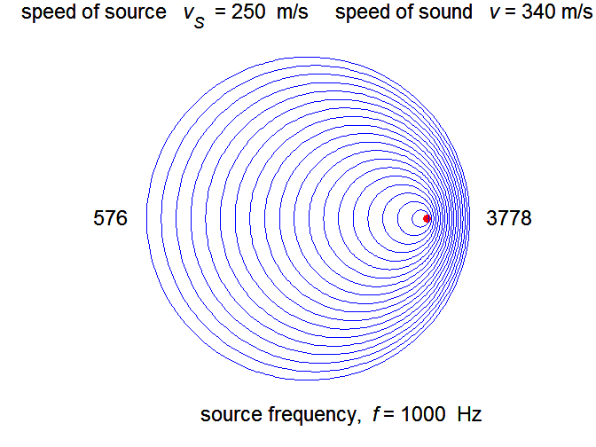

Fig. 1 Doppler Effect for a moving source and a stationary observer.

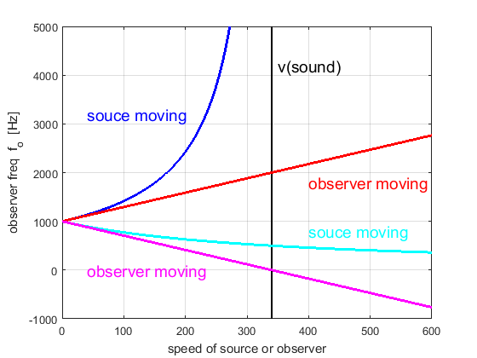

Fig. 2. Doppler shifted frequency versus speed for a 1000 Hz source. **Black curve**: speed of sound is 340 m.s-1. **Blue curve**: source moving towards a stationary observer - the frequency grows without limit as the speed of the source approaches the speed of sound, if the source moves faster than the speed of sound it produces not a pure tone but a shock wave. **Cyan curve**: source moving away from a stationary observer – frequency decreases with increasing speed of recession. **Red curve**: observer moving towards a stationary source – approximately a linear increase in frequency with speed. **Magenta curve**: observer moving away from stationary source – approximately a linear decrease in frequency with speed of recession.

**Investigations and Questions**

*Inspect* and *run* the m-script **doppler.m** so that you are familiar with what the program and the code does. For a range of input parameters, view the plots and listen to the sounds. How does a plot relate to the sound heard by a listener in front and at the rear of the moving source?

1 Start with a stationary source. Then increase the wave speed in increments of 50 m.s-1 up to 250 m.s-1. For each value of velocity use equation (1) to calculate the frequency *fL* heard by a listener directly in front and at the rear of the moving source and compare your results with those displayed in the plots.

2 Enter values of the speed of the source *vS* from 260 m.s-1 to 320 m.s-1 in steps of 20 m.s-1. Explain the experience of a ***sonic boom*** caused by an airplane flying overhead faster than the speed of sound. What is meant by a ***shock wave***?

3 When *vS* > *v*, the source of sound is ***supersonic***. Why is the Doppler Effect, equation (1) no longer valid?

4 What is meant by the term **Mach number**?

5 What is the wavelength of the wave in front and behind the moving source?