# 

[**DOING PHYSICS WITH MATLAB**](http://www.physics.usyd.edu.au/teach_res/mp/mphome.htm)

**DYNAMICS OF SYSTEMS**

**PHASE PLANE ANALYSIS FOR NONLINEAR SYSTEMS**

# 

Ian Cooper

School of Physics, University of Sydney

ian.cooper@sydney.edu.au

[**http://www.physics.usyd.edu.au/teach_res/mp/mphome.htm**](http://www.physics.usyd.edu.au/teach_res/mp/mphome.htm)

*Arguably the most broad-based evolution in the world view of science in the twentieth century will be associated with chaotic dynamics.*

S.N. Rasband Chaotic Dynamics of nonlinear Systems*.*

[**DOWNLOAD DIRECTORY FOR MATLAB SCRIPTS**](http://www.physics.usyd.edu.au/teach_res/mp/mscripts)

**chaos10.m** **Linear systems**

**chaos11.m Linear and nonlinear systems**

The script lets you study the dynamics of linear and nonlinear systems by the method of **phase plane analysis**. The state variables x and y are found by solving a pair of coupled first order differential equations with constant real coefficients using a finite difference method. A phase plane is plotted showing the vector field of the state variables and the nullclines. Parameter are set in the INPUT section of the script. Sample differential equations are specified and selected by using the variable flagC. You can edit an equation or add new equation. However, the script must be changed in a few places in each of the switch/case statements. For stability, the number of calculations N needed is enormous and N may have to be greater than 50e6. The duration of a simulation is given by tMax (if too large, the solution may become unstable). The dimensions of the phase space plot is LxL. The initial values for the state variables x and y are specified using the ginput: click to select the initial values of x(1) and y(1) in the phase space plot Figure Window. The number of trajectories plotted is given by numT. When numT = 1, only one trajectory is plotted. When all the trajectories have been plotted, time evolution of x & y are plotted for the last set of initial conditions.

% Choose coupled D.E *********************************

flagC = 5;

% 1 dx/dt = x*(x^2-1) dy/dt = y

% 2 dx/dt = (x+1)*y dy/dt = y

% 3 dx/dt = x - y dy/dt = 2x - y -x^2

% 4 dx/dt = (2+x)*(-x+y) dy/dt = (2-x)*(x+y)

% 5 dx/dt = x - 2y -1 dy/dt = 2x - 3y -3 linear

**PHASE PLANE ANALYSIS**

The pair of coupled first order differential equation are expressed in terms of the two state variables  and  as

(1) 

Our starting point to look at the dynamics of a system is to set up a **phase plane**. A phase plane plot for a two-state variable system consists of curves of one state variable versus the other state variable , where each curve called a **trajectory** is based on a different initial condition. The graphical representation of the solutions is often referred to as a **phase portrait**. The phase portrait is a graphical tool to visualize how the solutions of a given system of differential equations would behave in the long run.

We can set up a **vector field** which is constructed by assigning the following vector to each point on the  plane:



The slope of these vectors is



Thus, the vector field can be computed without knowing the solutions  and . This allows you to visualize the solution of the system for any given initial condition  as the vector field must be **tangential** to any solutions at all point of the system.

Next we can plot the  and  **nullclines** of the phase plane plot, where the nullclines are curves lines determined by:

-nullcline 

-nullcline 

Theses nullclines lines show the points where  is independent of time  and the points where  is also no longer changing with time. The interscetion of any two nullclines represent **steady-state values** of fixed equililrium points of the system and such points are called **critical points** (figure 1).

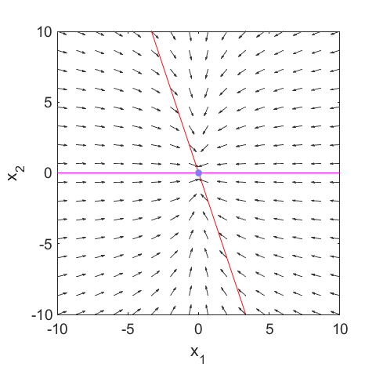

Fig. 1. Vector field (**quiver** function) and **x** and **y** nullclines. The arrows point in the direction of increasing time *t.* The **critical point** is at the intersection of the two nullclines.

**LINEAR SYSTEMS**

<http://www.physics.usyd.edu.au/teach_res/mp/doc/chaos10.pdf>

**Phase plane analysis** is one of the most important techniques for studying the behaviour of nonlinear systems, since there are usually no analytical solutions.

Consider the solutions to a pair of coupled first order differential equations with real and constant coefficients for the state variables  of the general form

(2) 

If  then we have a homogeneous system, otherwise an inhomogeneous system.

The solution to the homogenous system can be expressed in terms of the two 2x2 matrices for the **eigenfunctions** a and **eigenvalues** b of the matrix K. The solutions can be written as

(3A) 

where *C*1 and *C*2 are determined by the initial conditions .

The final solution is expressed as

(3B) 

The eigenfunctions a and eigenvalues b are computed using the function **eig**

[a, b] = eig(K)

The coupled differential equations (equation 2) are specified by the matrix K and the solution for the two state variables depends upon the eigenvalues b and eigenfunctions a of the matrix K. The nature of the eigenvalues (real / imaginary) determine the type of equilibrium for the system. If the eigenvalue is greater than zero, then the term increases exponentially with time and if less than zero, the term decreases exponentially with time, since a solution is of the form: 

where *b*1 and *b2* are the eigenvalues.



The larger the eigenvalue, the faster the response and the smaller the value of the eigenvalue, the slower the response.

Due to the two-dimensional nature of the parametric curves, we will classify the type of those critical points by the shape formed of the trajectories about the critical point.

For distinct real eigenvalues, the trajectories either move away from the critical point to an infinite-distant away (when the eigenvalues are both positive) or move toward from infinite-distant out and eventually converge to the critical point (when eigenvalues are both negative). This type of critical point is called a **node**. It is asymptotically stable if eigenvalues are both negative, unstable if both are positive values.

Classification of various trajectories is descripted in the following table.

|  |  |  |  |
| --- | --- | --- | --- |
| **Eigenvalues**  ***b*1 *b*2** | **Description** | **Behavior** | **Stability** |
|  | real, distinct, both positive | node - outgoing | unstable |
|  | real, distinct, opposite sign | saddle point | unstable |
|  | real, distinct, both negative | node- ingoing | stable |
|  | real, repeated positive | node - degenerate | unstable |
|  | real, repeated, negative | node - degenerate | stable |
|  | complex, positive real part | spiral - outgoing | unstable |
|  | complex, negative real part | spiral -ingoing | stable |
|  | complex - pure imaginary | center 🡪  ellipse | stable |

The above description of the behavior of the trajectories near a critical point not only applies to the linear homogeneous system but also applies to linear inhomogeneous systems and nonlinear systems.

**NONLINEAR SYSTEMS**

When we have a pair of nonlinear coupled differential equations, then the local behavior near a critical point in nearly the same as for the linear case. However, away from the critical points, the behavior can become much more complex.

The study of nonlinear systems using phase plane analysis is illustrated in the following examples.

**Simulation #1 LINEAR SYSTEM**

**flagC = 5**

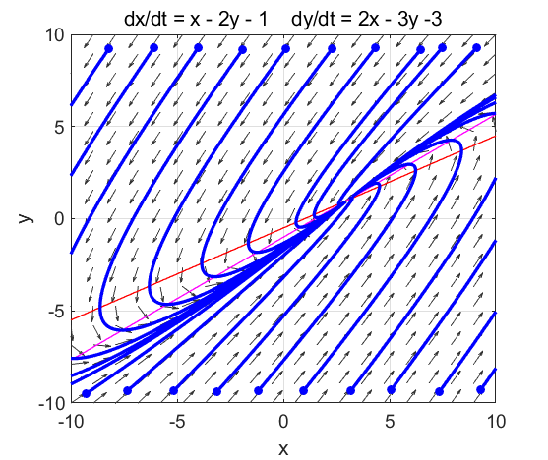

Fig. 1.1. The phase portrait for the linear case (numT = 20). This phase portrait is identical to figure 2.3 in the [document](http://www.physics.usyd.edu.au/teach_res/mp/doc/chaos10.pdf) for the linear case where the differential equations were solved analytically (repeated real eigenvalues  and the critical point at (3, 1) ). **The critical point is an asymptotically stable improper (degenerate) ingoing node**.

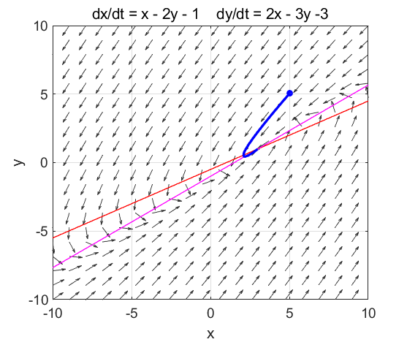

Fig. 1.2. The phase portrait for a single trajectory (numT = 1).

Figures 1.3, 1.4 and 1.5 show the time evolution of the two state variables x and y for increasing values of the number of calculations N. If N to too small, then the computations become unstable. Increasing the value of N improves the results of the computation. However, everything slows down by increasing the N value. You need to experiment with the values of L, N and tMax to get the best results. The state variables x and y evolve with time t to the critical point (fixed equilibrium point) at **(3,1)**.

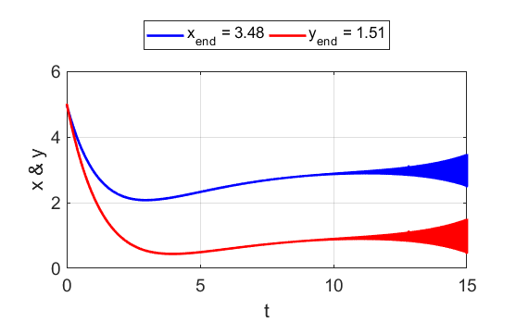

Fig. 1.3. **N = 50e4**. The solutions become unstable with time.

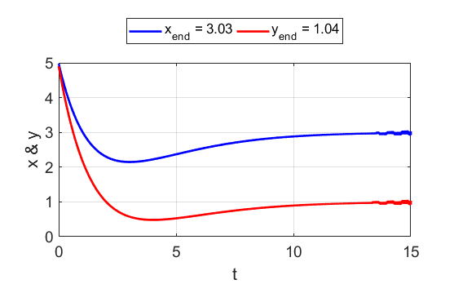

Fig. 1.4. **N = 50e5**. The solutions start to be become unstable near the end of the simulation time.

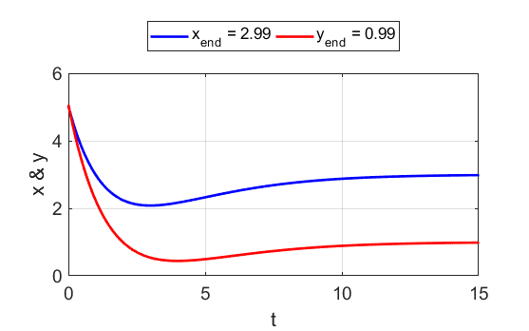

Fig. 1.5. **N = 50e6**. For the simulation time of 15 s, the solution is stable, and the state variables x and y approach the critical point **(3,1)**.

**Simulation #2 NONLINEAR SYSTEM**

**flagC = 1**

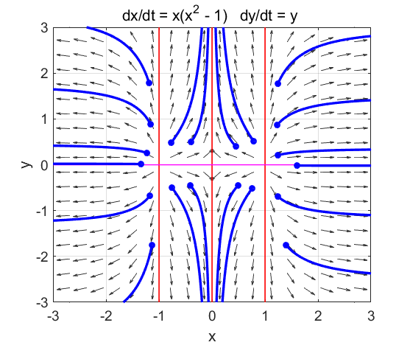

Fig. 2.1. There are **three** critical points:

(-1, 0) outgoing node

(0, 0) saddle point

(1, 0) outgoing node

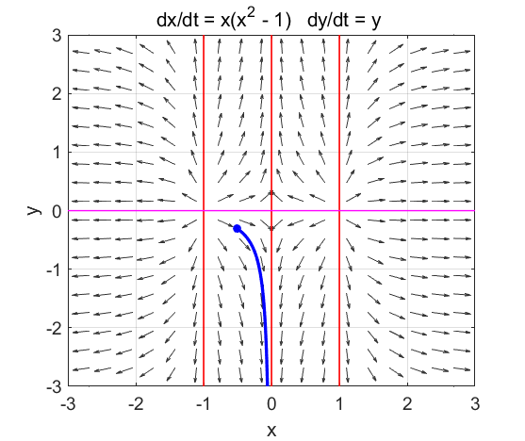

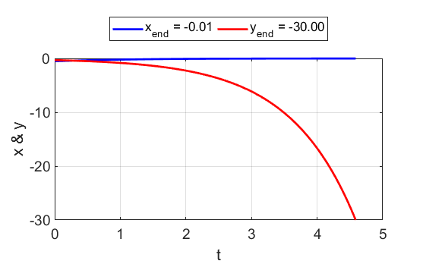

Fig 2.2. Single trajectory and the time evolution of the state variables. 

**Simulation #3 NONLINEAR SYSTEM**

**flagC = 2**

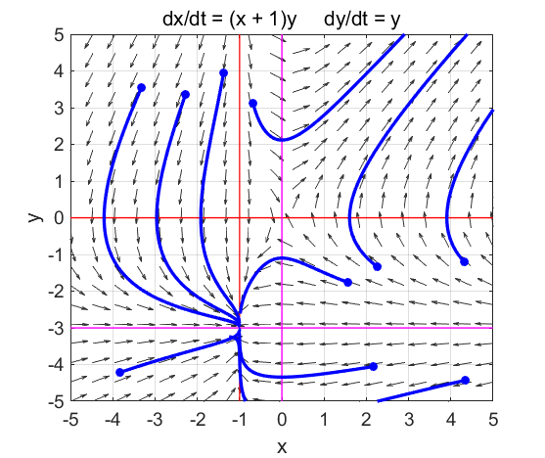

Fig. 3.1. There are **two** critical points:

(0, 0) saddle point

(-1, -3) ingoing node

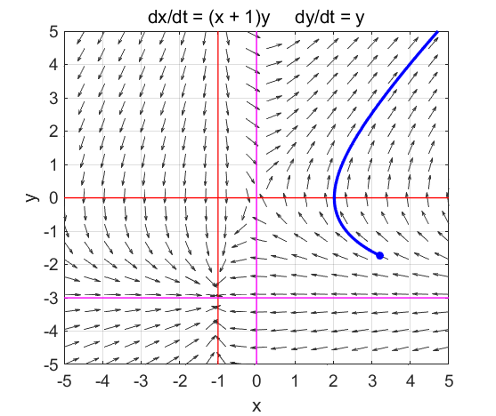

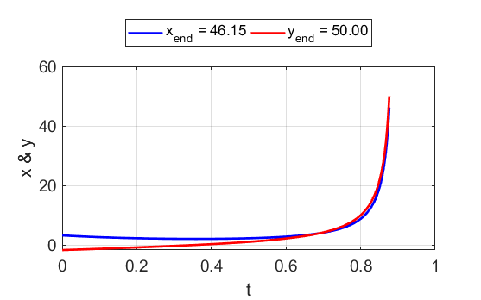

Fig. 3.2. Single trajectory and the time evolution of the state variables near the **saddle point** (0, 0). 

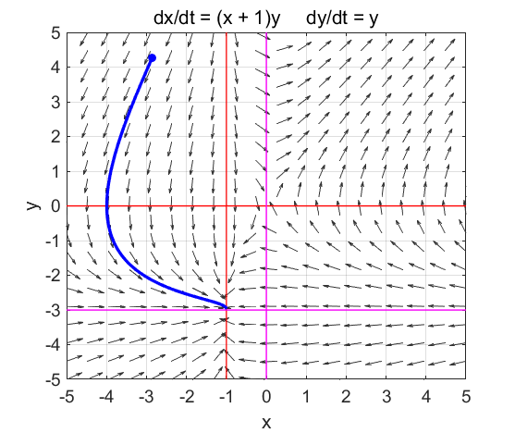

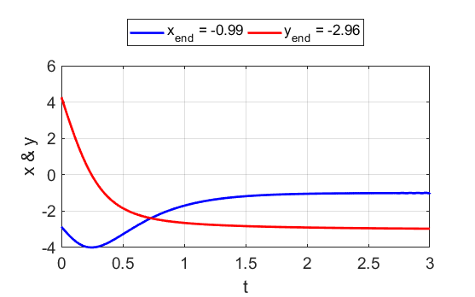

Fig 3.2. Single trajectory and the time evolution of the state variables for the ingoing node at (-1, -3). 

**Simulation #4 NONLINEAR SYSTEM**

**flagC = 3**

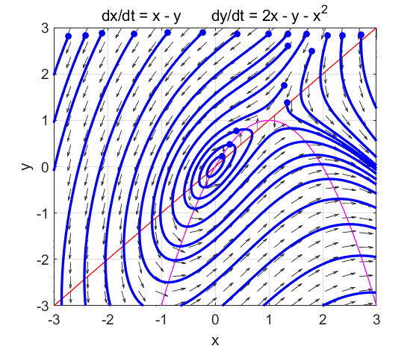

Fig. 4.1. There are **two** critical points:

(0, 0) **center** – closed periodic orbits about the center point

(1, 1) **saddle** point

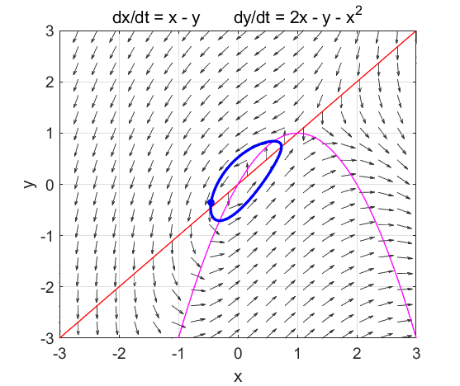

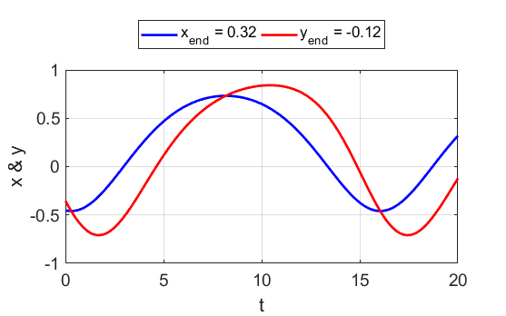

Fig 4.2. Single trajectory and the time evolution of the state variables for the periodic orbit about the **center** at (0, 0).

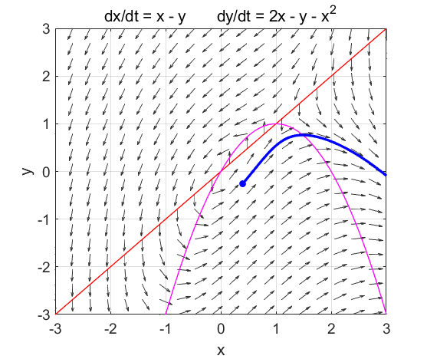

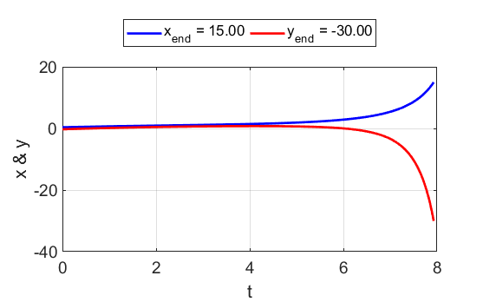

Fig 4.3. Single trajectory and the time evolution of the state variables near the saddle point at (1, 1).



**Simulation #5 NONLINEAR SYSTEM**

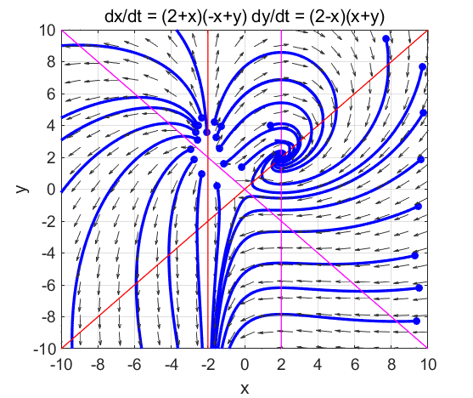

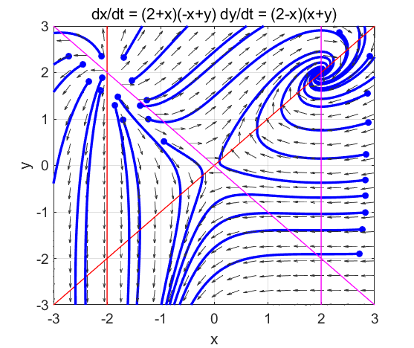

Fig. 5.1. There are three critical points

(-2, 2) outgoing node

(0, 0) saddle point

(2, 2) ingoing node

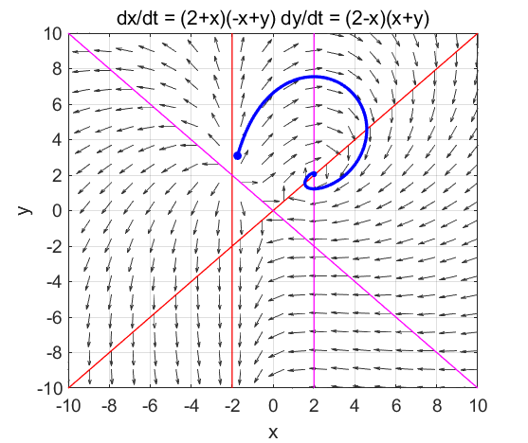

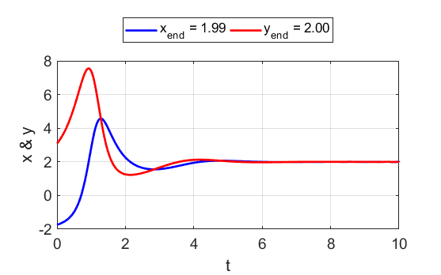

Fig. 5.2. Trajectory near the outgoing node at (-2, 2) and near the ingoing node at (2, 2).



By observing the plotting of a few trajectories for different time intervals you should observe the fact the time rate of change near a critical point is much slower than away from a critical point (N.B. the time rate of change of both state variables is zero at a critical point). Figure 5.3 shows two trajectories for a 1.0 s time interval.

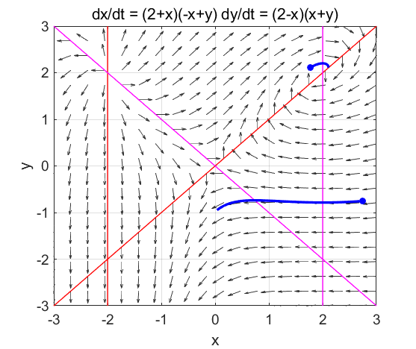

Fig. 5.3. The time rate of change of the two state variables is much slower near a critical point and faraway.