Week 6

Master Schedule
This is the current plan for the entire project. It showcases the current progress and upcoming intention; however, the future weeks' plans are subject to change as the project is further developed.
Week | Phase / Focus | Key Deliverable | Status
Week 1 | Core Architecture | Project Initialization, Pipeline, ESP-IDF Setup, & Ordering Hardware | Completed
Week 2 | System Design | I/O Specs, Hardware Architecture Planning & Electronics Power Plans | Completed
Week 3 | Drivetrain Prototyping | ESP32 Motor Firmware & H-Bridge Integration | Completed, no further hardware issues observed so far
Week 4 | Sensor Integration | Hardware Power Architecture Finalization & Final PID/Jetson Camera Prep | Completed
Week 5 | Kinematics & Vision | Odometry & Start of Computer Vision | Completed
Week 6 | Navigation & SLAM | Stereo Calibration, Isaac ROS & Nav2 MVP | Pending at Nav2
Week 7 | Semantic Navigation | TensorRT Object Detection & Target Routing
Week 8 | System Integration | Full Search & Rescue Loop (Navigate + Report)
Week 9 | Field Testing | Drift Metrics, Nav Success Rate & Benchmark
Week 10 | Final Presentation | Final Documentation, Video Demo & Code Freeze

Week 6: Stereo Vision, Isaac ROS SLAM, and Nav2 MVP
Current Status: Core navigation stack complete; obstacle-avoidance costmap carried into Week 7
Task / Feature | Status | Description
Stereo Camera Calibration | Completed | We mounted the second IMX219 camera horizontally to the first one, using the standard 8.3cm distance between them, to be used for a synchronized stereo image pair. This is a technique to accurately calculate depth information and 3D reconstruction from the slight differences (disparities) between each camera's viewing angle.  We successfully calibrated the pinhole camera models to eliminate lens distortion and calculate the precise physical offset between the lenses.
Isaac ROS SLAM Integration | Completed | Configured and launched NVIDIA's GPU-accelerated Visual SLAM (isaac_ros_visual_slam) inside a Docker container on the Jetson. The system successfully initialized the tracking pipeline and began publishing visual odometry (vo_pose) at a stable 30 Hz.  This is used for the robot to draw a mental map of its surroundings and locate itself on this map as it starts moving around. We used Isaac ROS as it is a specific software package by NVIDIA to speed up the localization math.
Nav2 Closed-Loop MVP | Core loop complete; obstacle-avoidance pending | Implemented the standard ROS2 navigation stack (Nav2) ahead of schedule. Because the SLAM map is still undergoing debugging, we configured Nav2 to run directly off the ESP32's wheel odometry (/odom), proving the robot can accept a 2D goal coordinate in RViz2 and autonomously drive toward it.

Comments
- What went well: Merging the Nav2 Minimum Viable Product (MVP) ahead of our original schedule was great. By writing a custom Python script (odom_to_tf.py) to bridge the ESP32's data into the format Nav2 expects, we proved our foundational drivetrain architecture works. The robot can now physically drive itself to a clicked target using purely its own wheel tracking.
- What was a struggle: We ran into a bizarre calibration error where our software calculated the distance between our two cameras to be 10.1cm instead of the physical 8.3cm (a 22% error). We spent time trying to fix this with complex math models (like a fisheye distortion model) before realizing the math was never the problem.
- The SLAM Scale Bug: We spent a multi-day "marathon session" fighting a bug where the SLAM AI exaggerated the robot's physical movement by 3 to 5 times. We methodically ruled out frame synchronization timing and TF baseline configurations, only to discover that the AI tracker was permanently breaking whenever we physically touched or bumped the robot during testing.
- Engineering Insight (Hardware over Software): The 22% camera calibration error was ultimately caused by a slightly loose CSI ribbon cable, not a software bug. Reseating the cable fixed the math instantly. This reinforced a recurring lesson in this project: when sensor math yields a plausible but wrong number, check the physical hardware connectors before rewriting the code.
- Engineering Insight (Testing Protocols): Through investigating the SLAM scale bug, we learned that visual SLAM algorithms are incredibly sensitive to human handling. Physically pushing the robot caused motion blur and frame jumps that the tracker could not recover from. We had to establish a strict "hands-off" testing protocol, deciding to only validate the SLAM data when the robot is driving itself smoothly via motor commands.

Figures
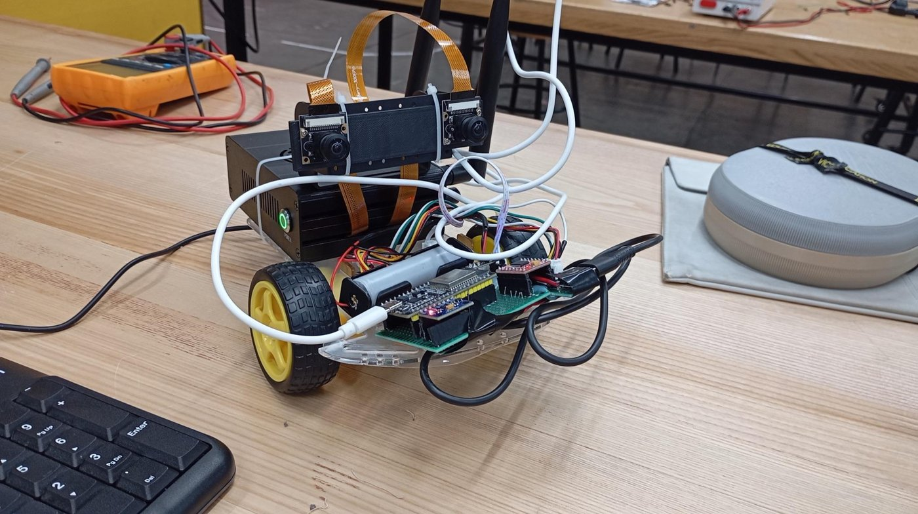
Figures: New robot hardware showing the stereo camera, the precise 8.3cm calibration piece, and the 18650 battery to power the motors.

