Week 8

Master Schedule
This is the current plan for the entire project. It showcases the current progress and upcoming intention; however, the future weeks' plans are subject to change as the project is further developed.
Week | Phase / Focus | Key Deliverable | Status
Week 1 | Core Architecture | Project Initialization, Pipeline, ESP-IDF Setup, & Ordering Hardware | Completed
Week 2 | System Design | I/O Specs, Hardware Architecture Planning & Electronics Power Plans | Completed
Week 3 | Drivetrain Prototyping | ESP32 Motor Firmware & H-Bridge Integration | Completed
Week 4 | Sensor Integration | Hardware Power Architecture Finalization & Final PID/Jetson Camera Prep | Completed
Week 5 | Kinematics & Vision | Odometry & Start of Computer Vision | Completed
Week 6 | Navigation & SLAM | Stereo Calibration, Isaac ROS & Nav2 MVP | Completed
Week 7 | Navigation Hardening & Mission Scoping | Nav2 Obstacle Costmap, IMU Diagnostics & Search-and-Rescue Mission Defined | Completed
Week 8 | System Integration | Real Stereo Distance, Room Calibration & Motor/PID Bug Fixes | Completed
Week 9 | Field Testing | Drift Metrics, Nav Success Rate & Benchmark
Week 10 | Final Presentation | Final Documentation, Video Demo & Code Freeze

Week 8: Making the Mission Actually Work
Current Status: Fully completed
Week 8 is all about turning last week's mission MVP into something that actually works reliably in the real room, not just in theory. This includes upgrading how the robot estimates distance to its target, hardening the vision pipeline against a subtle accuracy bug, calibrating the mission to the real physical room, and chasing down two stacked motor/PID bugs that were quietly capping how well the robot could turn.
Task / Feature | Status | Description
Real Stereo Distance Estimation | Completed | We upgraded how the robot estimates distance to the duck. Before, it used one camera and assumed the duck's height was already known. Now it uses both cameras together, a method called stereo triangulation. Each camera detects the duck on its own, and the robot compares how far apart the two detections appear (called the disparity) to calculate distance. This new method doesn't need to know an object's size ahead of time. That's an important step toward a robot that could search for more than just ducks.
Vision Pipeline Hardening | Completed | We found and fixed a bug in our detection pipeline. The camera images were being corrected for lens distortion (a process called rectifying) before being fed to the detection model. But our model was only ever trained on raw, uncorrected images. Feeding it rectified images confused it, and accuracy dropped once the stereo pipeline went live.  We also reduced how much CPU power the vision pipeline was using, since vision processing was competing with the robot's control loop for the same CPU. We made three changes: skipping the second camera's detection when the first camera sees nothing, moving detection off the robot's main control thread, and capping and logging how often detection actually runs.
Room Calibration & Patrol Fixes | Completed | Adapted the mission's hardcoded waypoints to the real, physically measured demo room (1m × 2.23m) and corrected the wheel diameter used in the odometry math.
Motor & PID Bug Fixes | Completed | Live-testing the mission's in-place turns surfaced two separate bugs hiding behind one "the robot is too weak" symptom.  First: one wheel's direction pins were only ever set once at boot to "forward" and never updated again, so any turn that needed that wheel to reverse just left it stalled at zero instead of actually spinning backward. It looked exactly like a motor too weak to turn the robot, when really the wheel was just stuck facing the wrong way.  Second, once that was fixed: PWM output still plateaued well below its max. That turned out to be the mission's own conservative speed caps combined with a small hardcoded limit on the PID's integral term, which capped the loop's output before it could out-power the motor's load. Fixed the direction-pin bug in firmware, raised the speed caps, and made the PID's gains and integral limit live-tunable from the dashboard instead of fixed in firmware, so tuning no longer requires a full reflash each time.

Comments
- What went well: The live-tunable PID dashboard was one of the best investments of the week. Once gains could be pushed to the robot and tested in seconds instead of a recompile-and-reflash cycle, tuning went from a slow guessing game to something we could actually iterate on quickly. Fixing the raw-vs-rectified detection bug also recovered accuracy we hadn't even realized the stereo upgrade had cost us.
- Insight: This week's "weak PID" complaint is a good reminder that a single symptom can have more than one cause stacked on top of each other. Raising the speed caps fixed the first, obvious layer, but only exposed a second, more subtle one underneath: the integral windup cap. If we'd stopped debugging the moment the symptom changed, we'd have shipped a robot that still couldn't reliably turn under harder conditions. The lesson: don't stop at the first fix that helps; confirm the actual root cause is gone.

Figures
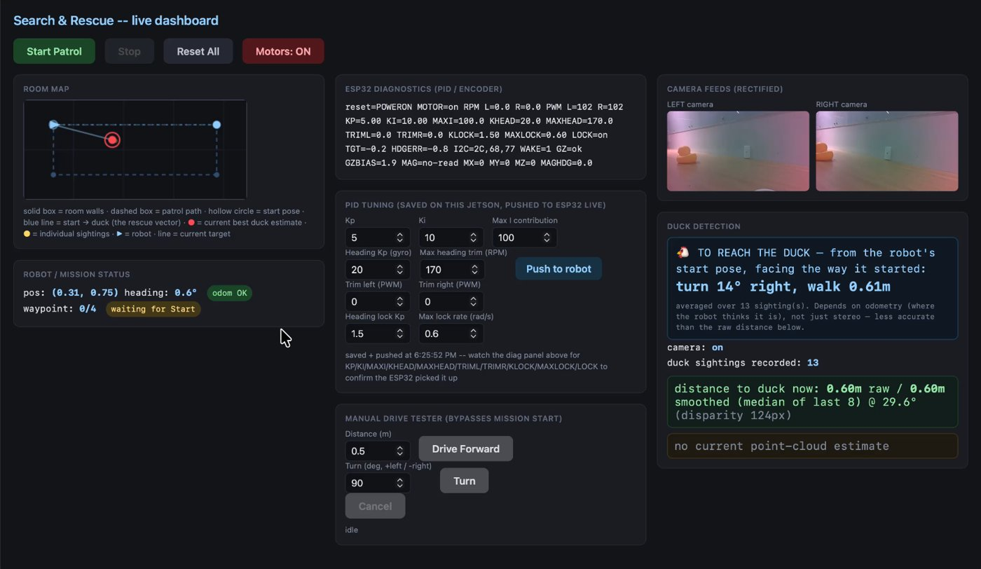
Figure 1: Local website interface to report live results, telemetry, and send over tuning updates
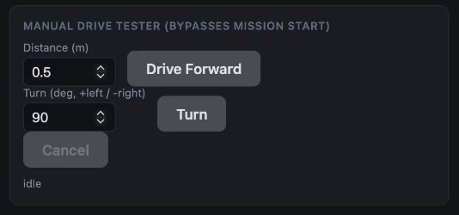
Figure 2: Manual drive command section to test PID tuning in basic drive-forward and turning maneuvers
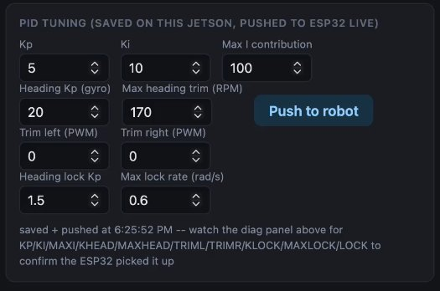
Figure 3: PID tuning interface, allowing viewing and updating of various PID parameters live
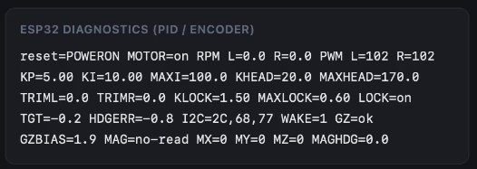
Figure 4: Robot's physical telemetry data, including current RPM, PWM, and sensor initialization, to show whether the issue is software or hardware
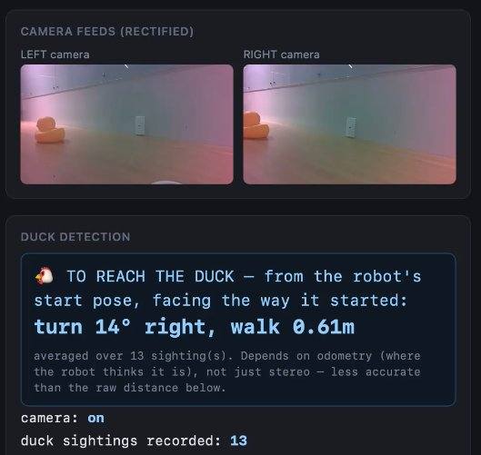
Figure 5: Computer vision panel: stereo camera feed, live object detection, and stereo distance estimation results
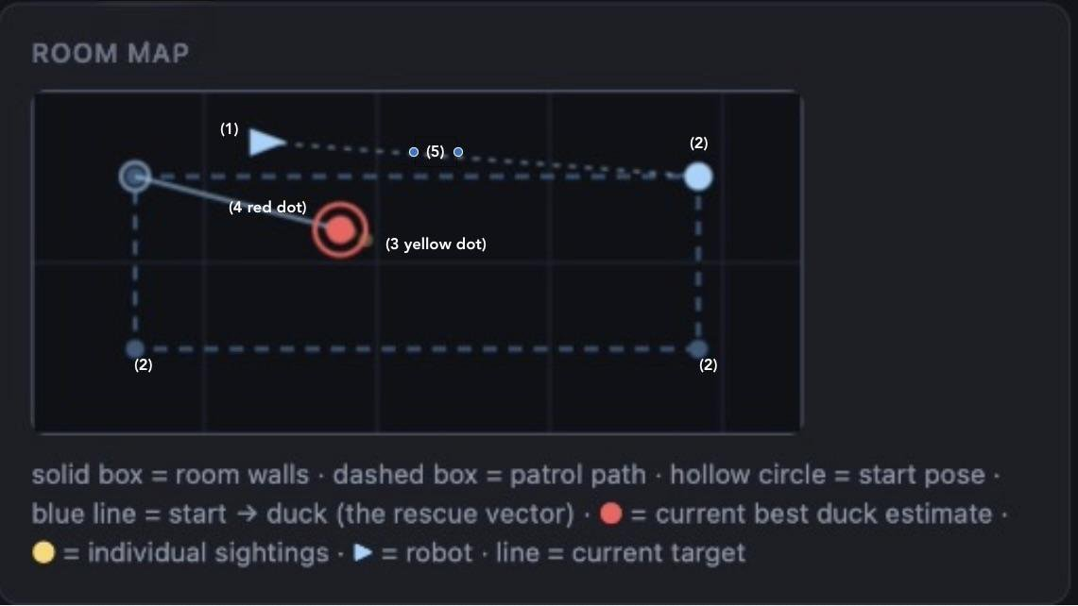
Figure 6: Live mission map, showing the robot's position (1), target waypoints (2), individual duck sightings (3), averaged duck position (4), and intended course based on the robot's position (5)

