Week 1

Master Schedule
This is the current plan for the entire project. It showcases the current progress and upcoming intention; however, the future weeks' plans are subject to change as the project is further developed.
Week | Phase / Focus | Key Deliverable | Status
Week 1 | Core Architecture | Project Initialization, Pipeline, ESP-IDF Setup, & Ordering Hardware | Completed; hardware delays
Week 2 | System Design | I/O Specs, Hardware Architecture Planning & Electronics Power Plans
Week 3 | Drivetrain Prototyping | ESP32 Motor Firmware & H-Bridge Integration
Week 4 | Sensor Integration | Encoders, ISR Pulse Counting & Power Decoupling
Week 5 | Kinematics & Vision | PI Velocity Control, Odometry & YOLOv8 Duck Dataset
Week 6 | Navigation & SLAM | Stereo Calibration, Isaac ROS & Nav2 MVP
Week 7 | Semantic Navigation | TensorRT Object Detection & Target Routing
Week 8 | System Integration | Full Search & Rescue Loop (Navigate + Report)
Week 9 | Field Testing | Drift Metrics, Nav Success Rate & Benchmark
Week 10 | Final Presentation | Final Documentation, Video Demo & Code Freeze

Week 1: Core Architecture and Micro-ROS Integration
Current Status: Fully completed
Week 1 is all about setting up and doing the background work, so that when the robot hardware arrives, we are set to start working right away. This includes setting up the GitHub repository where code sync and documentation are done, ESP-IDF, and ordering the hardware.
Task / Feature | Status | Description
GitHub repository initialization | Setup completed; details will be added as we go along | Set up the core version control repository to serve as the central hub for our codebase and documentation.  It will also allow for future collaborative work where the code space needs to be edited and synced by many people.  We also set the repository to public mode, so all the work done can be accessed and utilized by many others.
ESP-IDF Setup | Complete | Installed and configured the ESP-IDF framework. This is used to program the ESP32.
Hardware Procurement | Delayed | Ordered the Jetson Orin Nano Super, motor drivers, and cameras. Encountered significant shipping delays and received broken components (camera and motor drivers) upon testing.

Comments
- What went well: GitHub and ESP-IDF configurations went very well! Getting the software environment configured early meant we had a solid foundation ready to go. Even without the robot built, having the workspace completely set up saved us headaches down the line.
- What was a struggle: The logistics were a problem. We spent a lot of time waiting for hardware components like the Jetson Orin Nano Super and motor drivers. Once components arrived, we carried out quick testing but encountered issues with the Jetson's camera and motor drivers. Likely broken components, and we will troubleshoot further.
- Insight: The shipping delays turned out to be more significant than we expected, and unlike the software environment, they weren't something we could control. So instead of losing Week 1 to waiting, we focused on the one thing we could move forward on. That decision, to work on what's controllable rather than what isn't, became a pattern we'd return to any time hardware let us down later in the project, and proved to be an effective way to navigate obstacles throughout the build.

Figures
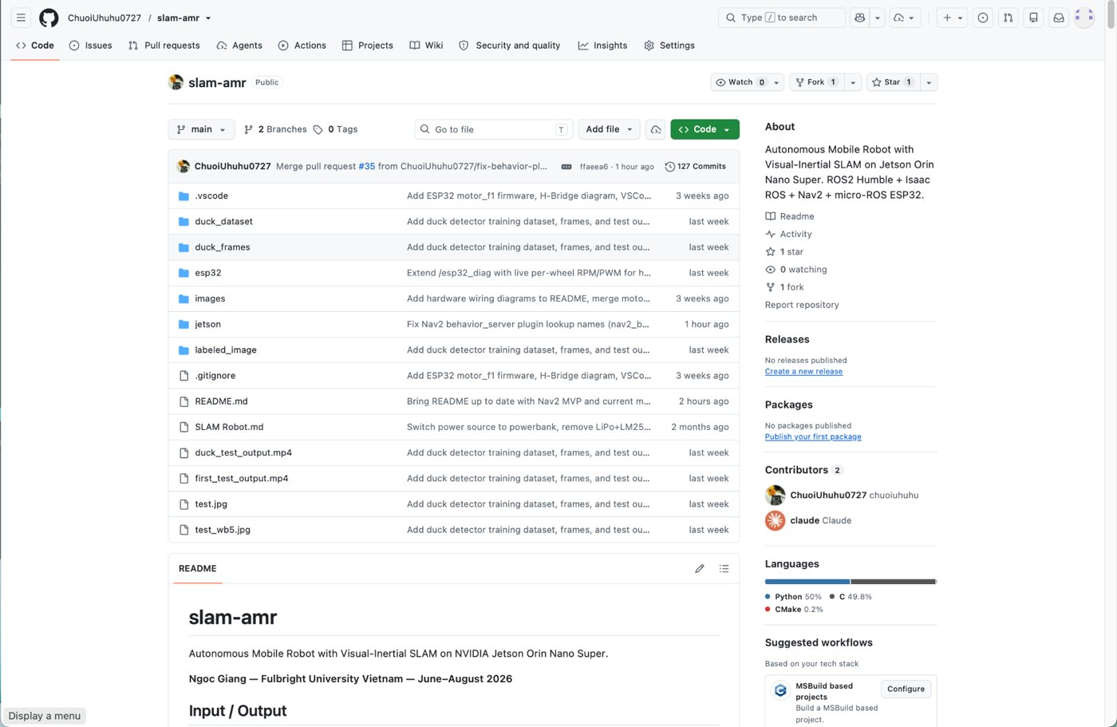
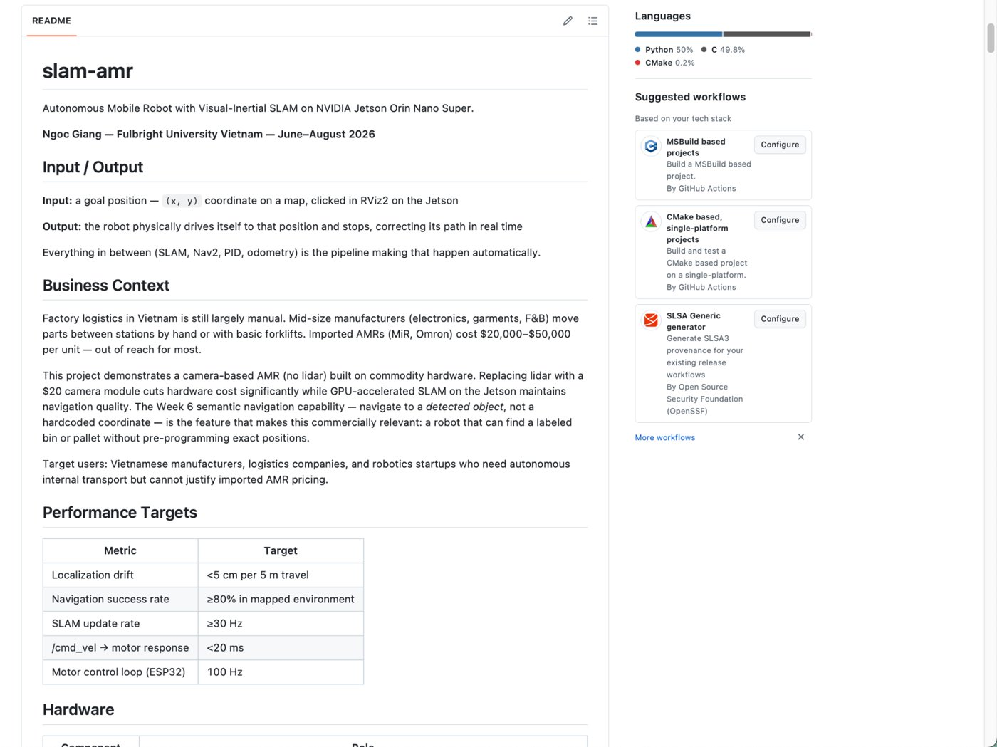
Figure 1: GitHub repository created and README written

