Week 3

Master Schedule
This is the current plan for the entire project. It showcases the current progress and upcoming intention; however, the future weeks' plans are subject to change as the project is further developed.
Week | Phase / Focus | Key Deliverable | Status
Week 1 | Core Architecture | Project Initialization, Pipeline, ESP-IDF Setup, & Ordering Hardware | Completed
Week 2 | System Design | I/O Specs, Hardware Architecture Planning & Electronics Power Plans | Completed
Week 3 | Drivetrain Prototyping | ESP32 Motor Firmware & H-Bridge Integration | Completed; unreliable wire connections present, likely needs future revisit
Week 4 | Sensor Integration | Encoders, ISR Pulse Counting & Power Decoupling
Week 5 | Kinematics & Vision | PI Velocity Control, Odometry & YOLOv8 Duck Dataset
Week 6 | Navigation & SLAM | Stereo Calibration, Isaac ROS & Nav2 MVP
Week 7 | Semantic Navigation | TensorRT Object Detection & Target Routing
Week 8 | System Integration | Full Search & Rescue Loop (Navigate + Report)
Week 9 | Field Testing | Drift Metrics, Nav Success Rate & Benchmark
Week 10 | Final Presentation | Final Documentation, Video Demo & Code Freeze

Week 3: Drivetrain Prototyping and Basic Firmware
Current Status: Fully completed
Week 3 is all about turning the paper plan into a physical, moving robot. This includes wiring all the components together: the ESP32 to the motor driver, encoders, and IMU on a protoboard, and assembling the platform. Afterwards, writing and testing the first firmware to get the motors spinning, and documenting the wiring so the physical setup has one clear source of truth going forward.
Task / Feature | Status | Description
Drivetrain and Hardware Construction | Completed, but unreliable wire connections are observed despite well-soldered joints. Hardware issue currently solved by resoldering a different type of wire over the old unreliable ones. | Physically wired the ESP32 microcontroller to the 2 encoders, IMU, and motor driver on a protoboard.  Assembled the robot platform, wheels, and motors.
F1 Firmware Milestone | Completed; this test illustrated the unreliable wiring causing failure sometimes. | Wrote and flashed the initial motor_f1 firmware to achieve basic open-loop motor spin at a fixed 50% PWM.  After a few bug fixes (specifically bad encoder reading, causing erratic PID movement), the PID system is now successfully able to drive the robot forward more or less straight.
Wiring Documentation | Completed | Created explicit wiring diagrams mapping the ESP32 pins to the motor driver, encoders, and IMU to serve as a single source of truth for the physical hardware. This is great for future reference.

Comments
- What went well: Getting the hardware in hand and making the motors spin for the first time was great! Condensing the complex flowchart into a clean, readable pin-mapping table also made physically wiring the protoboard much less error-prone.
- What was a struggle: Unreliable wiring was also observed. We found out the specific wires used on the protoboard somehow don't mix with the solder, causing a bad electrical connection even though solder joints are made properly. Currently, we soldered better wires over the old unreliable ones as a temporary solution, but we're a bit concerned more wires will start loosening up and causing similar problems in the future too. The hardware works well enough for further testing, so we will keep going for now.

Figures
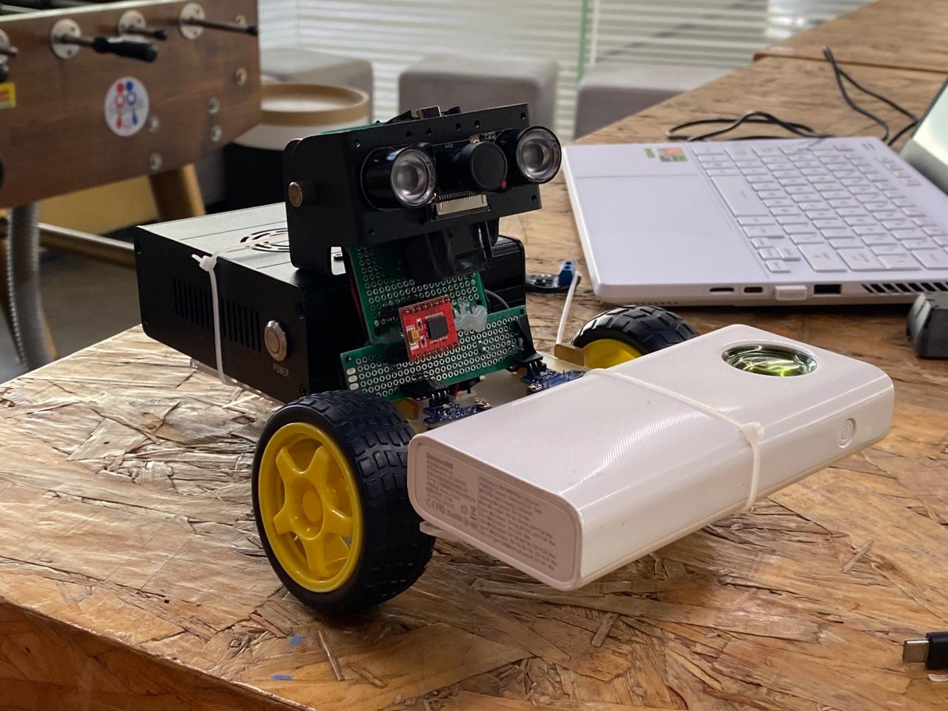
Figure 1: First assembly and video check-in 1
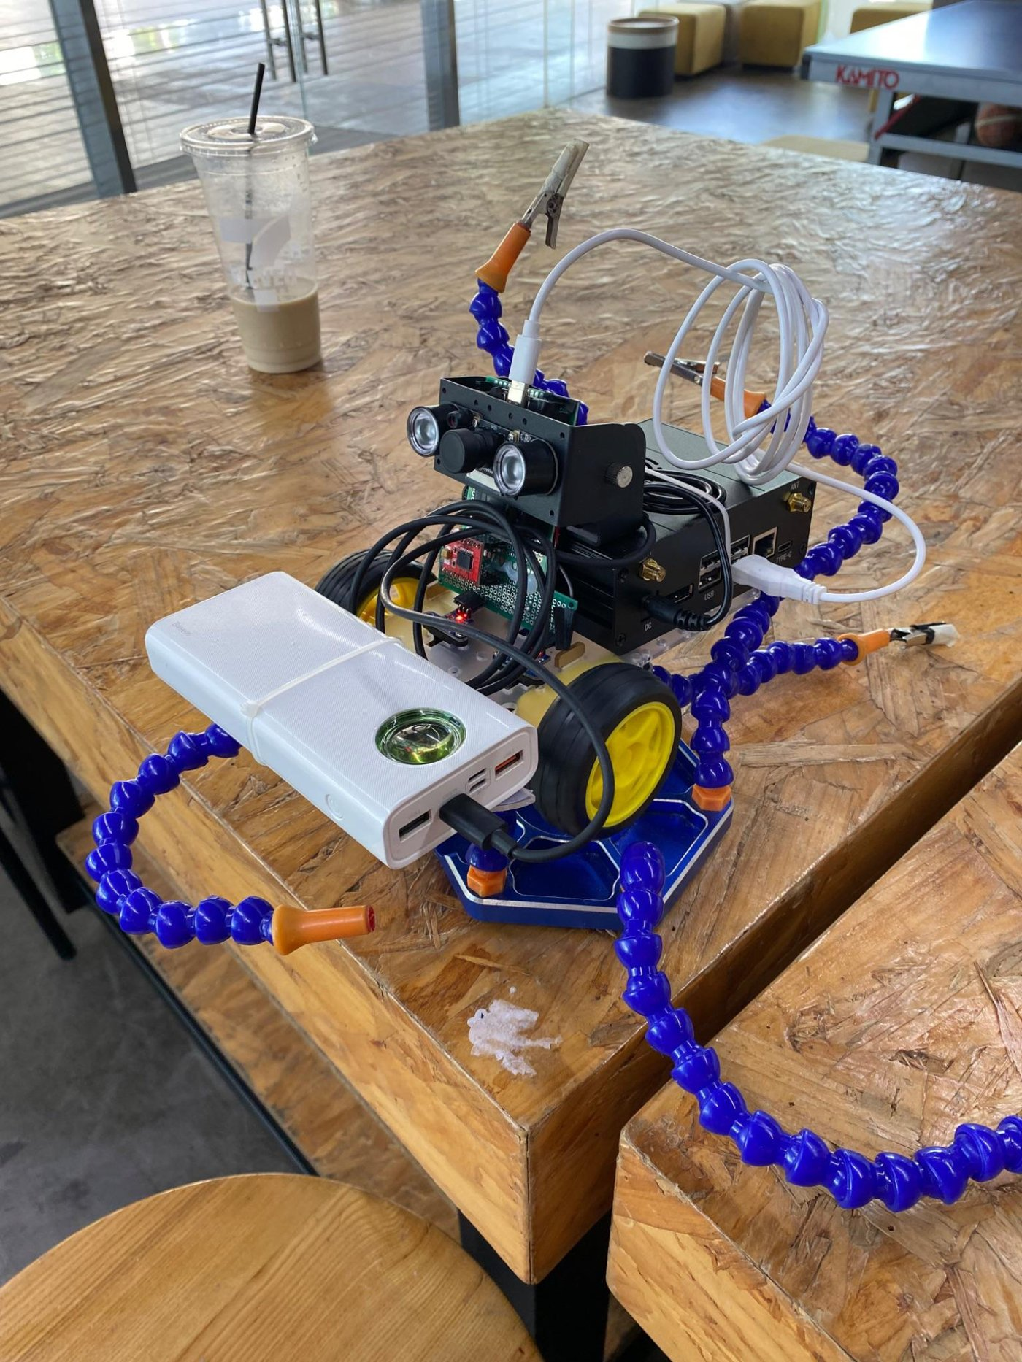
Figure 2: Octopus arm to elevate the robot and observe wheel rotations
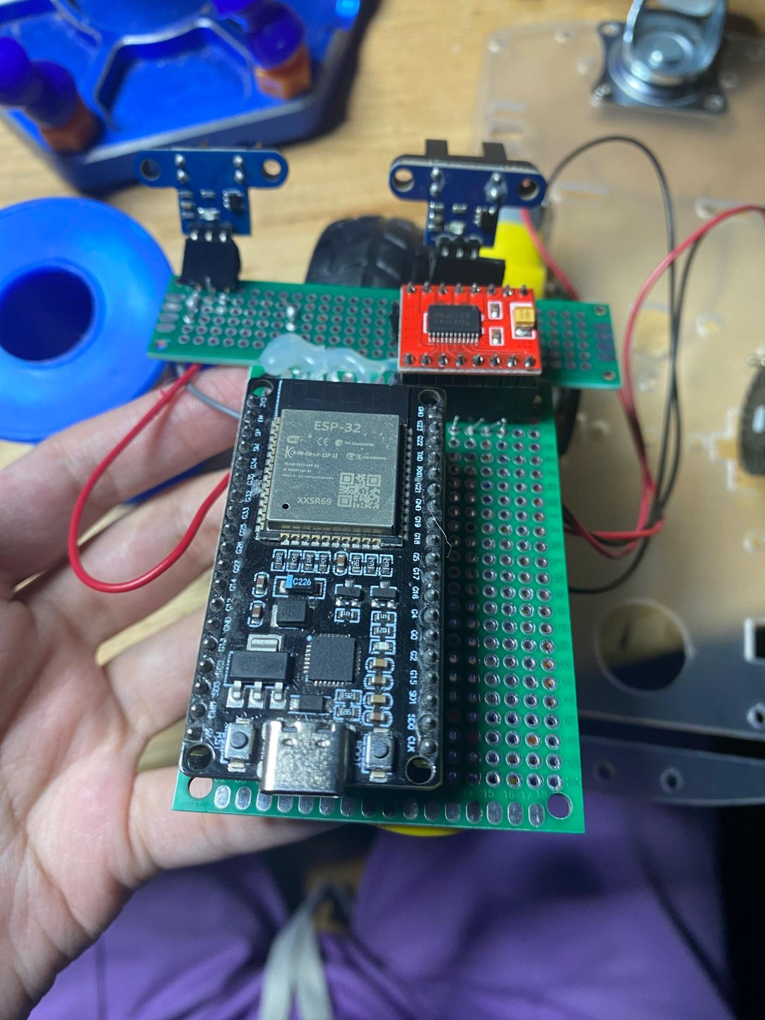
Figure 3: Early protoboard
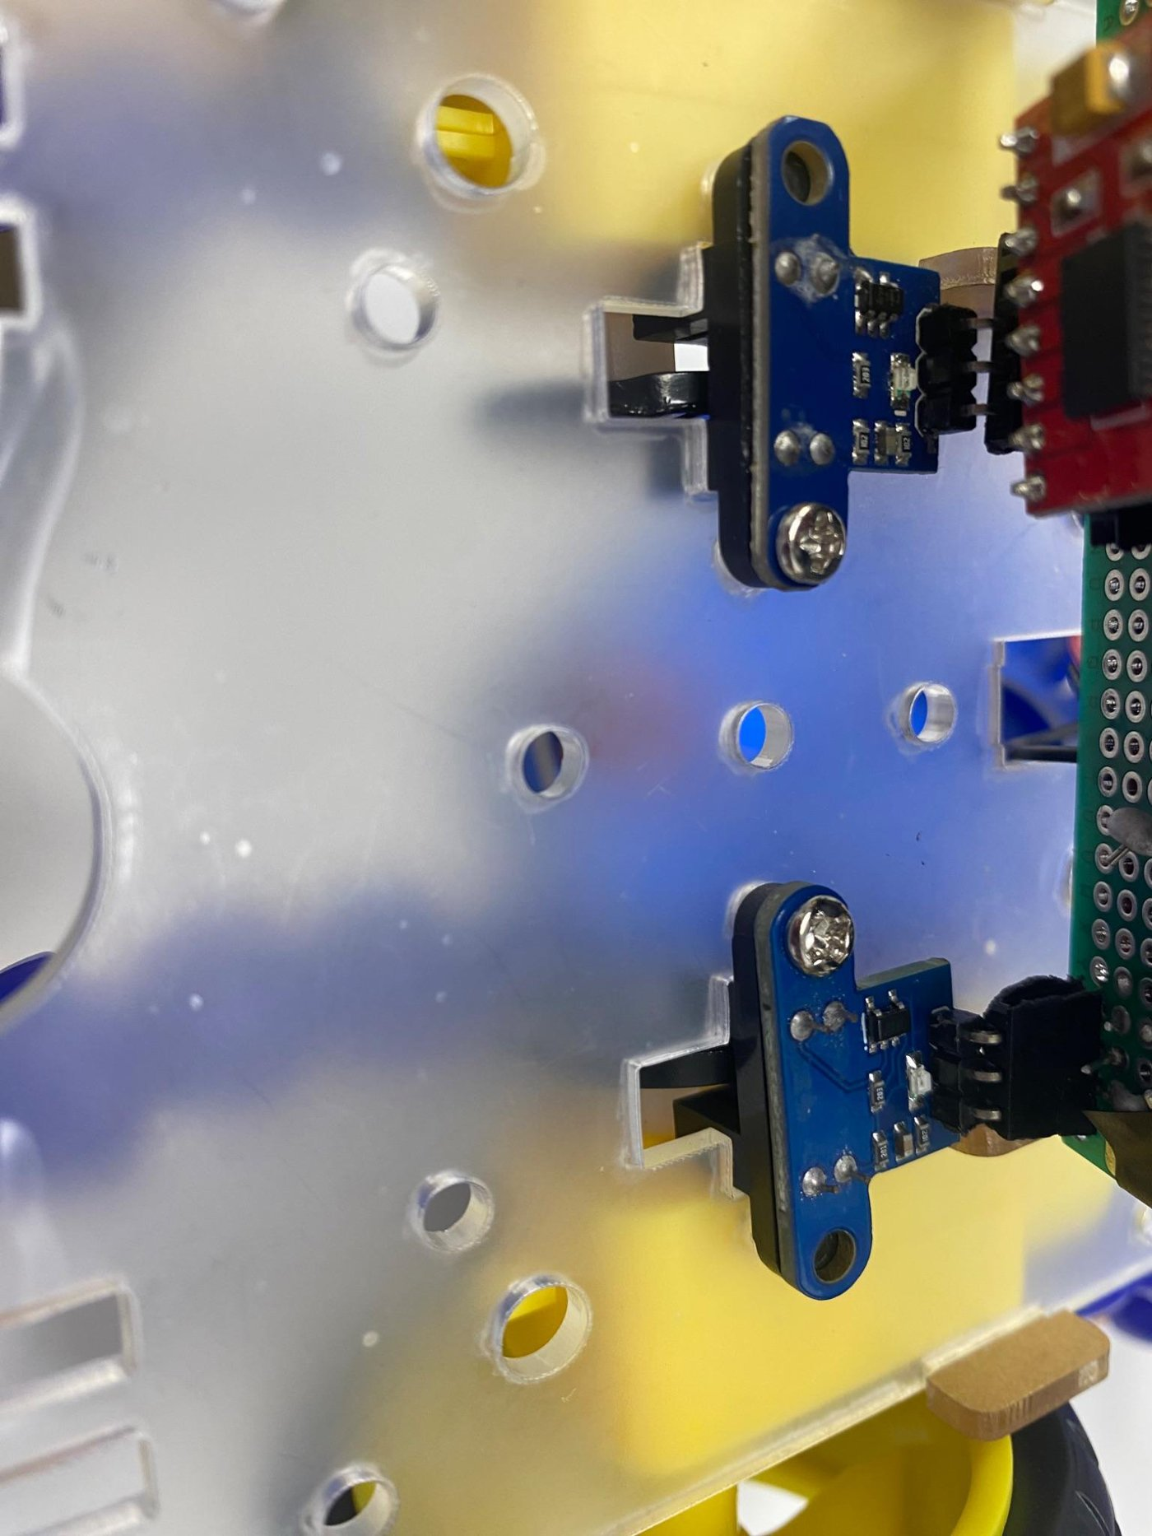
Figure 4: Mounted enclosure

