Week 2

Master Schedule
This is the current plan for the entire project. It showcases the current progress and upcoming intention; however, the future weeks' plans are subject to change as the project is further developed.
Week | Phase / Focus | Key Deliverable | Status
Week 1 | Core Architecture | Project Initialization, Pipeline, ESP-IDF Setup, & Ordering Hardware | Completed
Week 2 | System Design | I/O Specs, Hardware Architecture Planning & Electronics Power Plans | Completed
Week 3 | Drivetrain Prototyping | ESP32 Motor Firmware & H-Bridge Integration
Week 4 | Sensor Integration | Encoders, ISR Pulse Counting & Power Decoupling
Week 5 | Kinematics & Vision | PI Velocity Control, Odometry & YOLOv8 Duck Dataset
Week 6 | Navigation & SLAM | Stereo Calibration, Isaac ROS & Nav2 MVP
Week 7 | Semantic Navigation | TensorRT Object Detection & Target Routing
Week 8 | System Integration | Full Search & Rescue Loop (Navigate + Report)
Week 9 | Field Testing | Drift Metrics, Nav Success Rate & Benchmark
Week 10 | Final Presentation | Final Documentation, Video Demo & Code Freeze

Week 2: System Design and Architecture Planning
Current Status: Fully completed
Week 2 is all about designing the system on paper before the hardware takes over, so that once parts arrive we already know how everything should fit together. This includes defining the goal of our system, input and output (a clicked map coordinate in, self-correcting motor movement out), planning the power architecture (what voltage each component needs and how we'll supply it), and documenting the overall pipeline and performance targets for the project.
Task / Feature | Status | Description
System I/O Definition | Fully completed; however, specific details will need to be further refined as we move along | Defined the exact system pipeline: input is a 2D coordinate on a map via RViz2 running on the Jetson Orin Nano Super, and the output is physical, self-correcting motor movement using PID on the ESP32 without the use of expensive LiDAR.
Power Architecture Planning | Under discussion | Mapped out the powering plan for the system. The ESP32 and motors require 5V, which should be easy enough to supply. However, the Jetson runs with a 19.5V adapter. Research shows it could handle 9 to 12V. We plan on using a power bank with Power Delivery (PD) with a PD trigger module to feed clean 12 to 15V to the Jetson.  This will be tested soon.
Hardware Documentation | Completed | Added the system pipeline diagrams, business context, and performance targets to the repository documentation.

Comments
- What went well: Nailing down the exact performance targets (like aiming for a 100 Hz motor control loop and <5 cm drift per 5m) gave the project strict engineering constraints. The theoretical architecture phase allowed us to anticipate power draw issues before plugging anything in.
- What was a struggle: We were still heavily limited by hardware availability, which meant we were relying on theoretical diagrams and data sheets rather than physical prototyping. It is difficult to validate a power architecture plan when you cannot physically measure the motor inrush current yet.
- Insight: Committing to hard numeric targets before the hardware even existed (specifically a 100 Hz control loop and <5 cm drift per 5 m) forced us to design with discipline instead of vague intentions. But designing on paper doesn't always translate well into real life. That gap between theoretical planning and physical performance is exactly what caught up with us once assembly began.

Figures
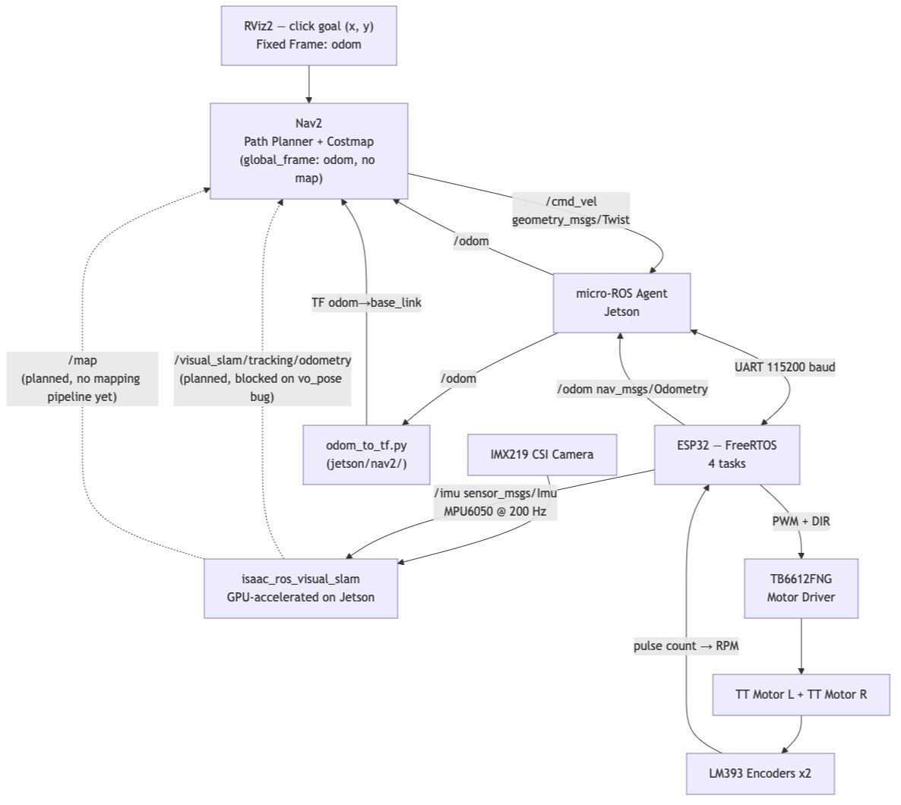
Figure 1: Current system pipeline plans, covering the distribution of tasks between the Jetson & the ESP32 and the relevant hardware/software solutions
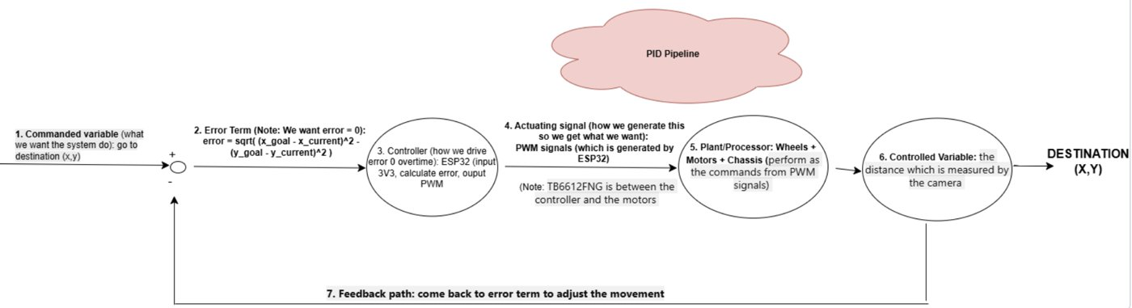
Figure 2: PID summary pipeline in preparation to set up the PID system on the ESP32

