Week 3

Master Schedule
This is the current plan for the entire project. It showcases the current progress and upcoming intention; however, the future weeks' plans are subject to change as the project is further developed.
Week | Phase / Focus | Key Deliverable | Status
Week 1 | Core Architecture | Project Initialization, Pipeline, ESP-IDF Setup, & Ordering Hardware | Completed
Week 2 | System Design | I/O Specs, Hardware Architecture Planning & Electronics Power Plans | Completed
Week 3 | Drivetrain Prototyping | ESP32 Motor Firmware & H-Bridge Integration | Completed; unreliable wire connections present, likely needs future revisit
Week 4 | Sensor Integration | Encoders, ISR Pulse Counting & Power Decoupling
Week 5 | Kinematics & Vision | PI Velocity Control, Odometry & YOLOv8 Duck Dataset
Week 6 | Navigation & SLAM | Stereo Calibration, Isaac ROS & Nav2 MVP
Week 7 | Semantic Navigation | TensorRT Object Detection & Target Routing
Week 8 | System Integration | Full Search & Rescue Loop (Navigate + Report)
Week 9 | Field Testing | Drift Metrics, Nav Success Rate & Benchmark
Week 10 | Final Presentation | Final Documentation, Video Demo & Code Freeze

Week 3: Drivetrain Prototyping and Basic Firmware
Current Status: Fully completed
Week 3 is all about turning the paper plan into a physical, moving robot. This includes wiring all the components together.
Task / Feature | Status | Description
Drivetrain and Hardware Construction | Completed, but unreliable wire connections are observed despite well-soldered joints. | Physically wired the ESP32 microcontroller to the 2 encoders, IMU, and motor driver on a protoboard.  Assembled the robot platform, wheels, and motors.
F1 Firmware Milestone | Completed; this test illustrated the unreliable wiring causing failure sometimes. Hardware issue currently solved by resoldering a different type of wire over the old unreliable ones. | Wrote and flashed the initial motor_f1 firmware to achieve basic open-loop motor spin at a fixed 50% PWM.
Wiring Documentation | Completed | Created explicit wiring diagrams mapping the ESP32 pins to the motor driver, encoders, and IMU to serve as a single source of truth for the physical hardware. This is great for future reference.

Comments
- What was a struggle: We hit a board-specific quirk right away: our ESP32 board used a non-standard crystal frequency, which caused garbled serial output and a boot loop until we baked a fix into the SDK config.
- Unreliable wiring: Unreliable wiring was also observed. Turns out the specific wires used on the protoboard somehow don't mix with the solder, causing a bad electrical connection even though solder joints are made properly. Currently, we soldered better wires over the old unreliable ones. The hardware works well enough for further testing.
- Insight: This week gave us our first real lesson in trusting hardware only as far as we could verify it. A visually correct solder joint turned out not to guarantee a working electrical connection, and a "standard" ESP32 board turned out to ship with a non-standard crystal that gave us a lot of trouble getting clean serial monitor output. Neither issue showed up by inspection, only by testing. It was a lesson we'd need to relearn more than once before the project was done.

Figures
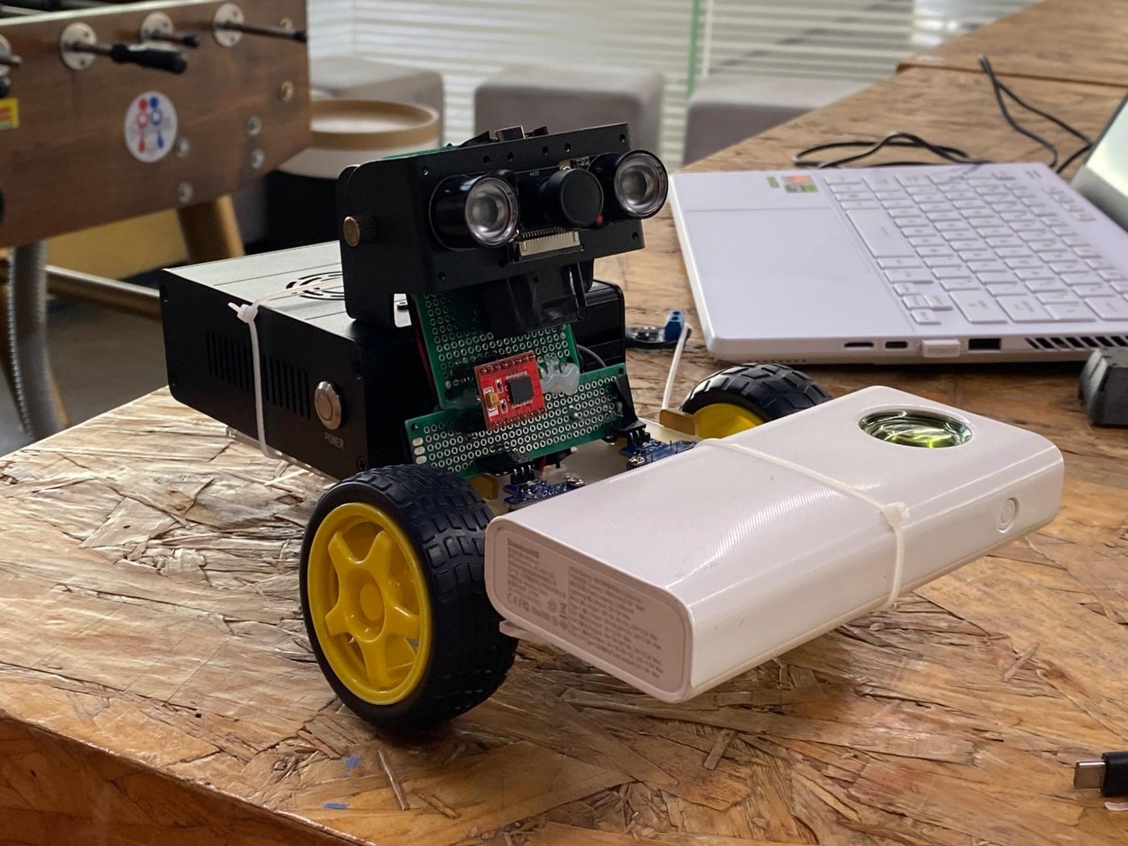
Figure 1: "Quack Quack" (our robot name) Version 1!
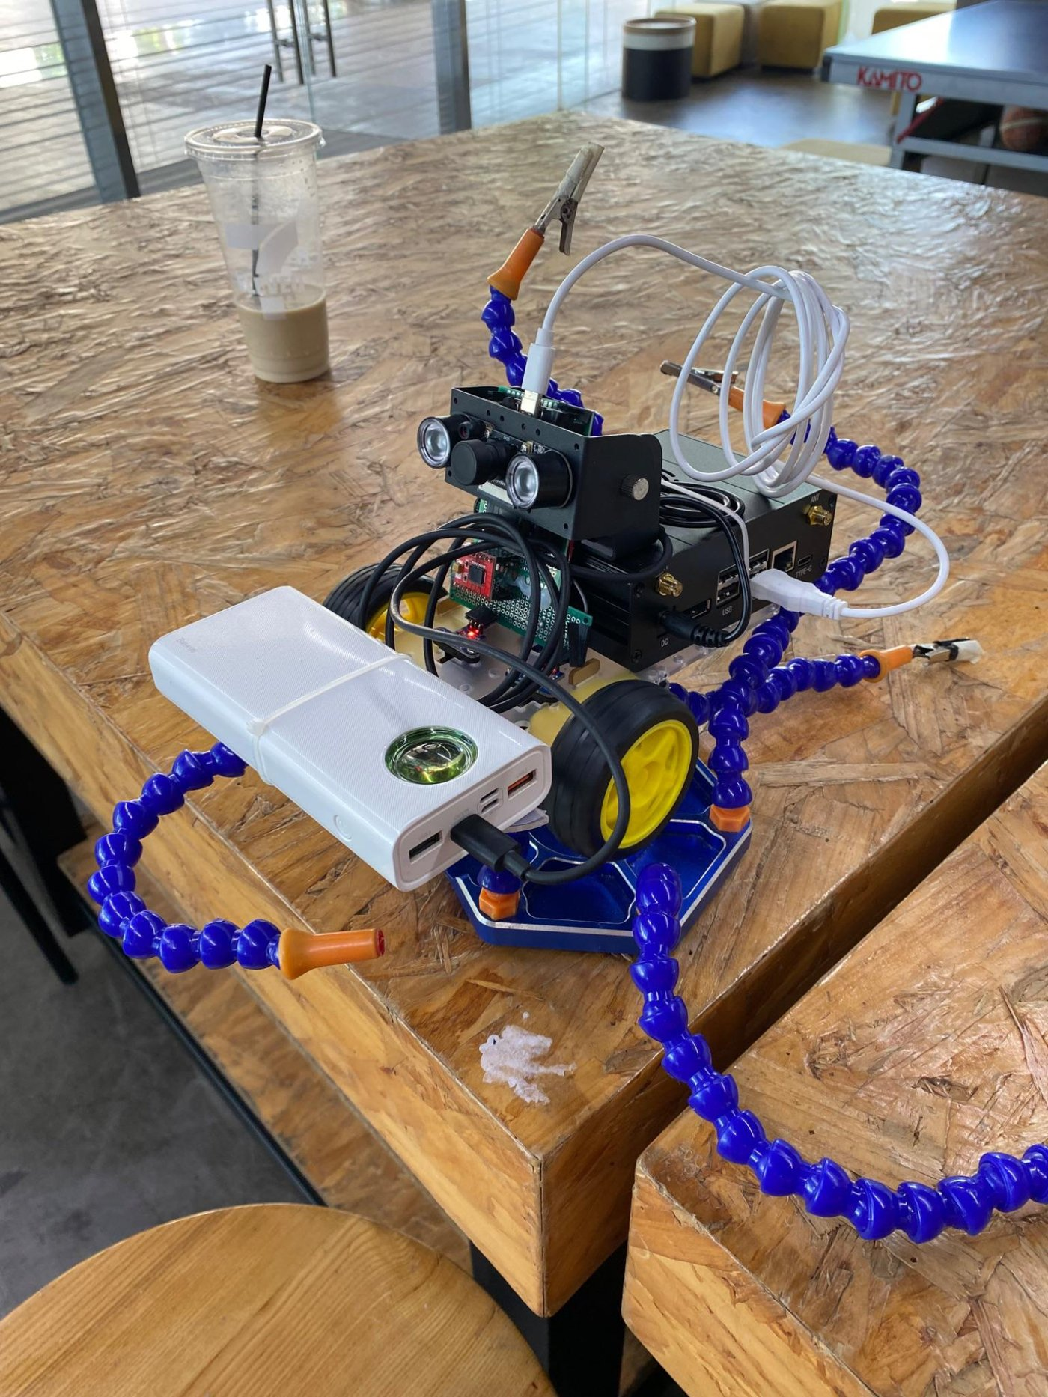
Figure 2: Octopus arm to elevate the robot and observe wheel rotations
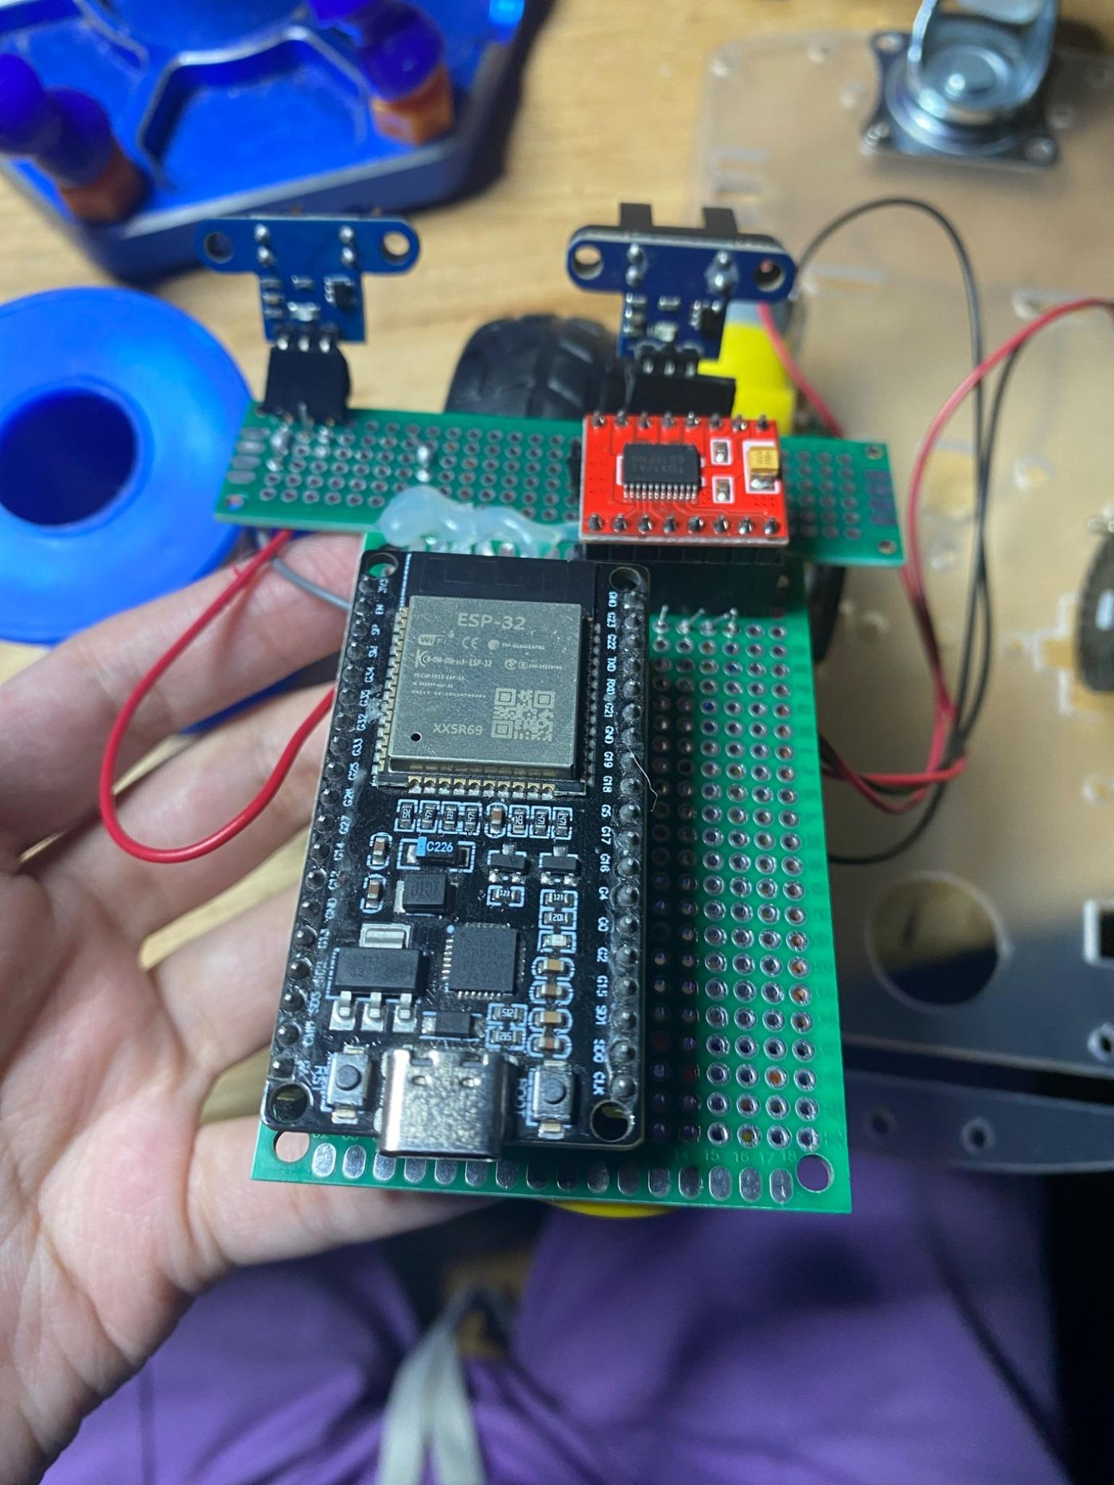
Figure 3: Early protoboard
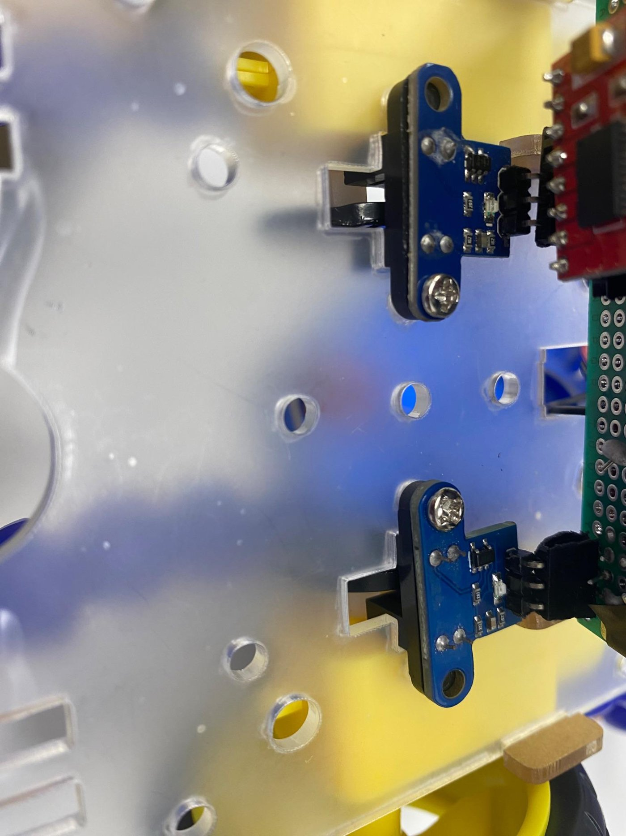
Figure 4: Mounted enclosure

