BẢNG ÍT
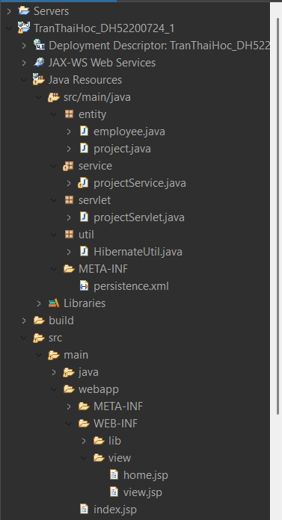

ENTITY
@Entity
public class employee {
@Id
@GeneratedValue(strategy = GenerationType.IDENTITY)
private int id;
private String fullname;
private boolean gen;

@ManyToOne
@JoinColumn(name = "project_id")
private project pro;

public employee() {
super();
// TODO Auto-generated constructor stub
}

public int getId() {
return id;
}

public void setId(int id) {
this.id = id;
}

public String getFullname() {
return fullname;
}

public void setFullname(String fullname) {
this.fullname = fullname;
}

public boolean isGen() {
return gen;
}

public void setGen(boolean gen) {
this.gen = gen;
}

public project getPro() {
return pro;
}

public void setPro(project pro) {
this.pro = pro;
}

}

@Entity
public class project {
@Id
@GeneratedValue(strategy = GenerationType.IDENTITY)
private int id;
private String name;
private Date deadline;

@OneToMany(mappedBy = "pro",fetch = FetchType.EAGER)
private List<employee> listemp = new ArrayList<employee>();

public project() {
super();
// TODO Auto-generated constructor stub
}

public int getId() {
return id;
}

public void setId(int id) {
this.id = id;
}

public String getName() {
return name;
}

public void setName(String name) {
this.name = name;
}

public Date getDeadline() {
return deadline;
}

public void setDeadline(Date deadline) {
this.deadline = deadline;
}

public List<employee> getListemp() {
return listemp;
}

public void setListemp(List<employee> listemp) {
this.listemp = listemp;
}
}

META-INF:
Persistence.xml
<?xml version="1.0" encoding="UTF-8"?>
<persistence xmlns="http://xmlns.jcp.org/xml/ns/persistence"
xmlns:xsi="http://www.w3.org/2001/XMLSchema-instance"
xsi:schemaLocation="http://xmlns.jcp.org/xml/ns/persistence
http://xmlns.jcp.org/xml/ns/persistence/persistence_2_2.xsd"
version="2.2">
<persistence-unit name="tranthaihoc_dh52200724" transaction-type="RESOURCE_LOCAL">
<class>entity.employee</class>
<class>entity.project</class>
<properties>
<property name="javax.persistence.jdbc.url" value="jdbc:mysql://localhost:3306/db_cuoiky"/>
<property name="javax.persistence.jdbc.user" value="root"/>
<property name="javax.persistence.jdbc.password" value="01228923505"/>

<property name="javax.persistence.jdbc.driver" value="com.mysql.jdbc.Driver"/>
</properties>
</persistence-unit>
</persistence>

UTIL
HibernateUtil.java
public class HibernateUtil {
private static EntityManagerFactory emf =null;

public static EntityManagerFactory getEMF() {
if(emf==null)
emf=Persistence.createEntityManagerFactory("tranthaihoc_dh52200724");
return emf;
}
}

Service
projectService.java
public class projectService {
EntityManagerFactory emf = HibernateUtil.getEMF();

public List<project> getAll(){
EntityManager em =emf.createEntityManager();
List<project> listpro=new ArrayList<project>();
try {
listpro = em.createQuery("from project").getResultList();
} catch (Exception e) {
e.printStackTrace();
}
em.close();
return listpro;
}

public void insert(project pro) {
EntityManager em= emf.createEntityManager();
try {
em.getTransaction().begin();
em.persist(pro);
em.getTransaction().commit();
em.close();
} catch (Exception e) {
e.printStackTrace();
}
}

public project findById(int id) {
EntityManager em = emf.createEntityManager();
project pro = new project();
try {
pro=em.find(project.class, id);

} catch (Exception e) {
// TODO: handle exception
e.printStackTrace();
}
em.close();
return pro;
}
}

Servlet
projectServlet.java
@WebServlet("/projectServlet")
public class projectServlet extends HttpServlet {
private static final long serialVersionUID = 1L;
private static final projectService PROJECT_SERVICE = new projectService();

/**
* @see HttpServlet#HttpServlet()
*/
public projectServlet() {
super();
// TODO Auto-generated constructor stub
}

/**
* @see HttpServlet#doGet(HttpServletRequest request, HttpServletResponse response)
*/
protected void doGet(HttpServletRequest request, HttpServletResponse response) throws ServletException, IOException {
// TODO Auto-generated method stub
String action = request.getParameter("action");
if(action==null)
action="load";
switch (action) {
case "load":
{
List<project> listpro = PROJECT_SERVICE.getAll();
request.setAttribute("listpro", listpro);
RequestDispatcher dispatcher = request.getRequestDispatcher("./WEB-INF/view/home.jsp");
dispatcher.forward(request, response);
break;
}
case "add":
{
String name = request.getParameter("name");
String _deadline=request.getParameter("deadline");
if(name!=null&&_deadline!=null) {
SimpleDateFormat sdf= new SimpleDateFormat("yyyy-MM-dd");
Date deadline= new Date();
try {
deadline=sdf.parse(_deadline);
} catch (Exception e) {
// TODO: handle exception
e.printStackTrace();
}
project pro=new project();
pro.setName(name);
pro.setDeadline(deadline);
PROJECT_SERVICE.insert(pro);
response.sendRedirect("./index.jsp");

}

break;
}
case "view":
{

int id =Integer.parseInt(request.getParameter("id"));
project pro = PROJECT_SERVICE.findById(id);
request.setAttribute("pro", pro);
RequestDispatcher dispatcher = request.getRequestDispatcher("./WEB-INF/view/view.jsp");
dispatcher.forward(request, response);
break;
}
default:
break;
}
}

/**
* @see HttpServlet#doPost(HttpServletRequest request, HttpServletResponse response)
*/
protected void doPost(HttpServletRequest request, HttpServletResponse response) throws ServletException, IOException {
// TODO Auto-generated method stub
doGet(request, response);
}

Index.jsp
<%@ page language="java" contentType="text/html; charset=UTF-8"
pageEncoding="UTF-8"%>
<!DOCTYPE html>
<html>
<head>
<meta charset="UTF-8">
<title>Insert title here</title>
</head>
<body>
<jsp:forward page="projectServlet"></jsp:forward>
</body>
</html>

Home.jsp
<%@taglib uri="http://java.sun.com/jsp/jstl/core" prefix="c"%><%@taglib
uri="http://java.sun.com/jsp/jstl/fmt" prefix="fmt"%><%@ page language="java" contentType="text/html; charset=UTF-8"
pageEncoding="UTF-8"%>
<!DOCTYPE html>
<html>
<head>
<meta charset="UTF-8">
<title>Insert title here</title>
</head>
<body>

<h1>Add project</h1>
<hr>
<form action="projectServlet?action=add" method="post">
<table>
<tr>
<td>Name:</td>
<td><input type="text" name="name"></td>
</tr>
<tr>
<td>Deadline:</td>
<td><input type="date" name="deadline"></td>
</tr>
<tr>
<td></td>
<td><input type="submit" value="ADD"></td>
</tr>
</table>
</form>

<br>
<table border="1">
<caption><b>List Project</b></caption>
<tr>
<th>Id</th>
<th>Name</th>
<th>Deadline</th>
<th>Employee size</th>
<th>Action</th>
</tr>

<c:forEach items="${listpro}" var="pro">
<tr>
<td>${pro.id}</td>
<td>${pro.name}</td>
<fmt:formatDate value="${pro.deadline}" var="deadline" pattern="dd/MM/yyyy"/>
<td>${deadline}</td>
<td>${pro.listemp.size()}</td>
<c:if test="${pro.listemp.size() >0 }">
<td><a href="projectServlet?action=view&id=${pro.id}">View</a></td>
</c:if>
</tr>
</c:forEach>
</table>
</body>
</html>

View.jsp
<%@taglib uri="http://java.sun.com/jsp/jstl/core" prefix="c"%><%@ page language="java" contentType="text/html; charset=UTF-8"
pageEncoding="UTF-8"%>
<!DOCTYPE html>
<html>
<head>
<meta charset="UTF-8">
<title>Insert title here</title>
</head>
<body>
<h1>Project:${pro.name}</h1>

<table border="1">
<tr>
<th>id</th>
<th>fullname</th>
<th>gen</th>
</tr>

<c:forEach items="${pro.listemp}" var="emp">
<tr>
<td>${emp.id}</td>
<td>${emp.fullname}</td>
<td>${emp.gen?"Nữ":"Nam"}</td>
</tr>
</c:forEach>
</table>
</body>
</html>

BẢNG NHIỀU
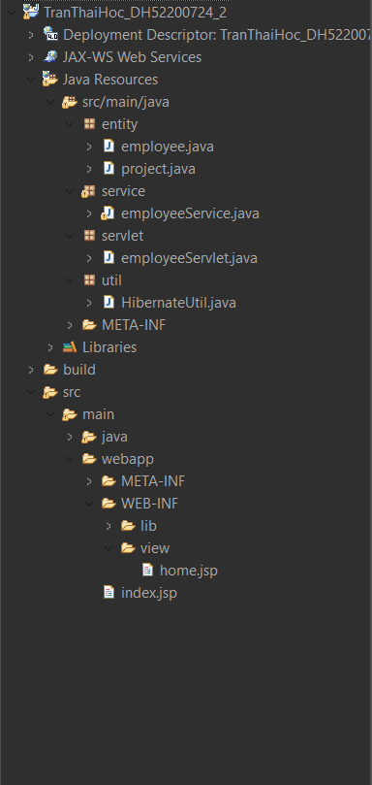

ENTITY
@Entity
public class employee {
@Id
@GeneratedValue(strategy = GenerationType.IDENTITY)
private int id;
private String fullname;
private boolean gen;

@ManyToOne
@JoinColumn(name = "project_id")

private project pro;
public employee() {
super();
// TODO Auto-generated constructor stub
}

public int getId() {
return id;
}

public void setId(int id) {
this.id = id;
}

public String getFullname() {
return fullname;
}

public void setFullname(String fullname) {
this.fullname = fullname;
}

public boolean isGen() {
return gen;
}

public void setGen(boolean gen) {
this.gen = gen;
}

public project getPro() {
return pro;
}

public void setPro(project pro) {
this.pro = pro;
}
}

@Entity
public class project {
@Id
@GeneratedValue(strategy = GenerationType.IDENTITY)
private int id;
private String name;
private Date deadline;

@OneToMany(mappedBy = "pro",fetch = FetchType.EAGER)
private List<employee> listemp = new ArrayList<employee>();

public project() {
super();
// TODO Auto-generated constructor stub
}

public int getId() {
return id;
}

public void setId(int id) {
this.id = id;
}

public String getName() {
return name;
}

public void setName(String name) {
this.name = name;
}

public Date getDeadline() {
return deadline;
}

public void setDeadline(Date deadline) {
this.deadline = deadline;
}

public List<employee> getListemp() {
return listemp;
}

public void setListemp(List<employee> listemp) {
this.listemp = listemp;
}
}

META-INF
<?xml version="1.0" encoding="UTF-8"?>
<persistence xmlns="http://xmlns.jcp.org/xml/ns/persistence"
xmlns:xsi="http://www.w3.org/2001/XMLSchema-instance"
xsi:schemaLocation="http://xmlns.jcp.org/xml/ns/persistence
http://xmlns.jcp.org/xml/ns/persistence/persistence_2_2.xsd"
version="2.2">
<persistence-unit name="tranthaihoc_dh52200724" transaction-type="RESOURCE_LOCAL">
<class>entity.employee</class>
<class>entity.project</class>
<properties>
<property name="javax.persistence.jdbc.url" value="jdbc:mysql://localhost:3306/db_cuoiky"/>
<property name="javax.persistence.jdbc.user" value="root"/>
<property name="javax.persistence.jdbc.password" value="01228923505"/>

<property name="javax.persistence.jdbc.driver" value="com.mysql.jdbc.Driver"/>
</properties>
</persistence-unit>
</persistence>

Util
HibernateUtil
public class HibernateUtil {

private static EntityManagerFactory emf =null;

public static EntityManagerFactory getEMF() {
if(emf==null)
emf = Persistence.createEntityManagerFactory("tranthaihoc_dh52200724");
return emf;
}
}

Service
employeeService.java
public class employeeService {

EntityManagerFactory emf = HibernateUtil.getEMF();

public List<employee> getAll(){
EntityManager em= emf.createEntityManager();
List<employee> listemp =new ArrayList<employee>();
try {
listemp = em.createQuery("from employee").getResultList();
} catch (Exception e) {
// TODO: handle exception
e.printStackTrace();
}
em.close();
return listemp;
}

public void delete(int id ) {
EntityManager em = emf.createEntityManager();
try {
em.getTransaction().begin();
em.remove(em.find(employee.class, id));
em.getTransaction().commit();
em.close();

} catch (Exception e) {
e.printStackTrace();
}
}

public List<project> getAllProject(){
EntityManager em = emf.createEntityManager();
List<project> listpro= new ArrayList<project>();

try {
listpro = em.createQuery("from project").getResultList();
} catch (Exception e) {
// TODO: handle exception
e.printStackTrace();
}
em.close();
return listpro;
}

public void insertEMP(employee emp) {
EntityManager em = emf.createEntityManager();
try {
em.getTransaction().begin();
em.persist(emp);
em.getTransaction().commit();
em.close();

} catch (Exception e) {
e.printStackTrace();
}
}

public project findProjectById(int id) {
EntityManager em = emf.createEntityManager();
project pro = new project();
try {
pro = em.find(project.class, id);
} catch (Exception e) {
// TODO: handle exception
e.printStackTrace();
}
em.close();
return pro;
}

}

Servlet
employeeServler.java
@WebServlet("/employeeServlet")
public class employeeServlet extends HttpServlet {
private static final long serialVersionUID = 1L;
private static final employeeService EMPLOYEE_SERVICE = new employeeService();

/**
* @see HttpServlet#HttpServlet()
*/
public employeeServlet() {
super();
// TODO Auto-generated constructor stub
}

/**
* @see HttpServlet#doGet(HttpServletRequest request, HttpServletResponse response)
*/
protected void doGet(HttpServletRequest request, HttpServletResponse response) throws ServletException, IOException {

String action = request.getParameter("action");
if(action==null)
action="load";
switch (action) {
case "load":
{
List<project> listpro=EMPLOYEE_SERVICE.getAllProject();
request.setAttribute("listpro", listpro);
List<employee> listemp = EMPLOYEE_SERVICE.getAll();
request.setAttribute("listemp", listemp);
RequestDispatcher dispatcher = request.getRequestDispatcher("./WEB-INF/view/home.jsp");
dispatcher.forward(request, response);
break;
}
case "delete":
{
int id =Integer.parseInt(request.getParameter("id"));
EMPLOYEE_SERVICE.delete(id);
response.sendRedirect("./index.jsp");

break;
}

case "add":
{
String fullname= request.getParameter("fullname");
String _gen= request.getParameter("gen");
String _project_id=request.getParameter("project_id");
if(fullname!=null&&_gen!=null&_project_id!=null) {
boolean gen = Boolean.parseBoolean(_gen);
int project_id=Integer.parseInt(_project_id);
project pro = new project();
pro = EMPLOYEE_SERVICE.findProjectById(project_id);
employee emp = new employee();
emp.setFullname(fullname);
emp.setGen(gen);
emp.setPro(pro);
EMPLOYEE_SERVICE.insertEMP(emp);
response.sendRedirect("./index.jsp");

}
}

default:
break;
}

}

/**
* @see HttpServlet#doPost(HttpServletRequest request, HttpServletResponse response)
*/
protected void doPost(HttpServletRequest request, HttpServletResponse response) throws ServletException, IOException {
// TODO Auto-generated method stub
doGet(request, response);
}

Index.jsp
<%@ page language="java" contentType="text/html; charset=UTF-8"
pageEncoding="UTF-8"%>
<!DOCTYPE html>
<html>
<head>
<meta charset="UTF-8">
<title>Insert title here</title>
</head>
<body>
<jsp:forward page="employeeServlet"></jsp:forward>
</body>
</html>

Home.jsp
<%@taglib uri="http://java.sun.com/jsp/jstl/core" prefix="c"%><%@ page language="java" contentType="text/html; charset=UTF-8"
pageEncoding="UTF-8"%>
<!DOCTYPE html>
<html>
<head>
<meta charset="UTF-8">
<title>Insert title here</title>
</head>
<body>

<h1>ADD EMPLOYEE</h1>
<hr>
<form action="employeeServlet?action=add" method="post">
<table>
<tr>
<td>Fullname:</td>
<td><input type="text" name="fullname"></td>
</tr>
<tr>
<td>Gen:</td>
<td><input type="radio" name="gen" value="true">Nam
<input type="radio" name="gen" value="false">Nữ
</td>
</tr>
<tr>
<td>Project:</td>
<td>
<select name="project_id">
<c:forEach items="${listpro}" var="pro">
<option value="${pro.id}">${pro.name}</option>

</c:forEach>
</select>
</td>
</tr>
<tr>
<td></td>
<td><input type="submit" value="ADD"></td>
</tr>
</table>
</form>

<table border="1">
<caption>LIST EMPLOYEE</caption>
<tr>
<th>ID</th>
<th>Fullname</th>
<th>Gen</th>
<th>ProjectName</th>
<th>Action</th>
</tr>

<c:forEach items="${listemp}" var="emp">

<tr>
<td>${emp.id}</td>
<td>${emp.fullname}</td>
<td>${emp.gen?"Nữ":"Nam"}</td>
<td>${emp.pro.name}</td>
<td><a href="employeeServlet?action=delete&id=${emp.id}">Delete</a></td>
</tr>

</c:forEach>
</table>
</body>
</html>

