UpStream Documentation

Public Beta Version 1.0 (pbv1.0_08092021)



# Copyright

UpStream Forestry Carbon and LCA Tool, Beta-Version

Copyright (c) 2021 ZGF Architects LLP, Chuou Zhang, Indroneil Ganguly, University of Washington, and Tomás Méndez Echenagucia University of Washington All rights reserved.

Licensed under The 3-Clause BSD License – available for download at: <https://github.com/UpStream-LCA/UpStreamForestryCarbonLCA>

# Acknowledgements

**This project would not have been possible without the research, support, and effort of the following individuals:**

* Special thanks to the University of Washington’s Applied Research Consortium (ARC) program Teri Thomson Randall and Dean Renée Cheng – without the ARC program and its ability to provide student researchers while bringing together diverse faculty stakeholders for advising, UpStream would not be where it is today. Todd Stine and Victoria Nichols at ZGF – Todd and Victoria’s leadership around seeing the value of research at an Architecture firm was paramount to UpStream’s success
* David Diaz at Ecotrust – Ecotrust’s research provided the first data and proofs of concept for UpStream around connecting landscape level carbon impacts to wood products.
* Frances Yang and Raphael Sperry at Arup - their research on applying the earliest and published versions of the Ecotrust factors to ZGF projects formed the foundation of our A0 work (check out their write here: [https://www.arup.com/perspectives/publications/research/section/forestry-embodied-carbon-methodology](https://nam10.safelinks.protection.outlook.com/?url=https%3A%2F%2Fwww.arup.com%2Fperspectives%2Fpublications%2Fresearch%2Fsection%2Fforestry-embodied-carbon-methodology&data=04%7C01%7Cjacob.dunn%40zgf.com%7Cf59abd26c7c6458854d508d9590372d5%7C9515471981f140739ca6f8adfbbb57b5%7C0%7C0%7C637638693656382590%7CUnknown%7CTWFpbGZsb3d8eyJWIjoiMC4wLjAwMDAiLCJQIjoiV2luMzIiLCJBTiI6Ik1haWwiLCJXVCI6Mn0%3D%7C1000&sdata=FJD0VvW8zDRNMWQ54mzAtGiWq7TmRxgQMEdIPqyBF%2Bw%3D&reserved=0)
* Roderick Bates at KieranTimberlake – for being open to exploring how UpStream engages wood LCA with Tally data and being willing to explore data use permissions for our tool. Also, for trailblazing the way for architecture firms to research and create robust LCA tools.
* Steph Carlisle at Carbon Leadership Forum (CLF) – Steph provided some of the earliest feedback to the tool during client meetings and also provided the letter of support for UpStream for CLF incubation.
* ZGF Project Performance Team (PPT) – the ZGF PPT provided countless hours of review, critique, and suggestions to help advance UpStream as it was being piloted on internal ZGF projects. Specific folks to thank include Chris Chatto, Lona Rerick, Baha Sadreddin, and Vidya Rajendran.
* Maggie Wildnauer at Sphera – for helping the UpStream team better understand Tally’s underlying assumptions and advising on the creation of Tally factors for use in UpStream
* Marty Brennan – for being a leader and guide at our firm on all things carbon, and also for advising the team on tool development (he’s the only one at the firm who’s actually developed a tool at this scale before – check out Lark Spectral lighting on Food4Rhino.com)

**Documentation Authors:**

* Jacob Dunn (ZGF)
* Chuou Zhang (University of Washington and ZGF)

**UpStream Tool Authors:**

* Jacob Dunn (ZGF)
* Chuou Zhang (University of Washington and ZGF)
* Indroneil Ganguly (University of Washington),
* Tomás Méndez Echenagucia (University of Washington)

# Location of Tool and Resources

GitHub repository: [UpStream-LCA/UpStreamForestryCarbonLCA (github.com)](https://github.com/UpStream-LCA/UpStreamForestryCarbonLCA)

Table of Contents

Copyright 2

Acknowledgements 2

Location of Tool and Resources 3

Table of Contents 4

Forward - Why UpStream? 6

1.0 Introduction 6

1.1 Future Plans 6

2.0 Step by Step Guidance and Documentation 7

2.1 Interface and Layout 7

2.2 Step 1 – Define Product Information 8

Step 1 Overview and Inputs 8

2.3 Step 2 – Compare to a Baseline Case 8

Step 2 Overview and Inputs 8

Step 2 Related Outputs 9

2.4 Step 3 – Calculate Modules A1-A3 10

Step 3 Overview and Inputs 10

Step 3 Outputs 11

2.5 Step 4 – Calculate Modules A4 - Transportation 12

Step 4 Overview and Inputs 12

2.6 Step 5 – Calculate Module C2-4 – End of Life Emissions 13

Step 5 Overview and Inputs – Base Options 13

Step 5 Overview and Inputs – Custom Options 16

Step 5 Outputs 23

2.7 Step 6 – Calculate Module D – Benefits Outside of Boundary 25

Step 6 Overview and Inputs 25

Step 6 Outputs 26

2.8 Step 7 – Calculate Module A0 – Impacts from Forestry 26

Step 7 Overview and Inputs 26

Step 7 Outputs 29

2.9 Step 8 – Calculate Uncertainty Factor – Add Factor to Net GWP 32

Step 8 Overview and Inputs 32

References 33

# Forward - Why UpStream?

Does the building industry really need *another* wood life cycle analysis calculator? In a space already saturated with tools – both LCA tools and wood-specific calculators – ZGF and the University of Washington still felt the answer was a resounding “yes”. Besides, we haven’t developed a whole new tool, rather we’ve put together a rapid, carbon-focused analysis platform specifically for the design community (architects, engineers, contractors, etc.) that combines different streams of data from diverse tools and data sets. What we've learned is that the wide variability unique to wood LCA suggests that intentionality is paramount when modeling assumptions, scope boundary interpretations, and underlying datasets make such a big difference in the results.

Thus, UpStream advances the wood LCA conversation in the following ways:

* **Forest practices matter** - Upstream adds an “A0” module (forest carbon impacts) to wood products in component-based or whole building life cycle analyses. It builds upon the net neutrality assumption of current LCA Standards for forest practices and attempts to account for the complex temporal and spatial relationship between carbon in the forest and the built environment. What we’ll find is that a lot of our forests are doing a good job adding carbon to the landscape while balancing ecology with timber output. Instead of viewing all forests as the same, we should be claiming this carbon benefit of wood construction that often gets overlooked.
* **End of Life Flexibility** – once LCAs include the biogenic carbon stored in wood products, it behooves us as modeling stewards to dive into the messiness of end-of-life disposal pathways, scenario distributions, and even such details like landfill decomposition rates. Most tools oversimplify assumptions and/or provide rigid end of life scenarios. UpStream allows for rapid comparison of baseline end of life assumptions from various methodologies and provides fully flexible input scenarios with different underlying datasets.
* **Transparency and Openness** – UpStream was conceived as a transparent, agnostic, and open-source project. “Transparent” in its attempt to document clearly where data is coming and its underlying assumptions. “Agnostic” in being inclusive of all tools and factors, especially with A0 as many different research teams are endeavoring to figure out how to attribute landscape-level carbon impacts to wood products. As these factors come out with documentation, they can be easily incorporated into future versions of UpStream or input manually in the meantime. . Finally, UpStream is “open” to the LCA community to contribute to, take ownership of, and advance the tool as the wood LCA world continues to rapidly evolve.

From my research and travels, I’m not sure what’s messier – forestry or wood LCA. One thing to me is clear, however, that we cannot wait until standards catch up or until everything gets figured out to move forward because we’re in a climate crisis now. Given our ever-shortening time to impact the worst effects of climate change, combined with the magnitude of impact buildings or forest management can have on global carbon, we must continue to transparently advance wood LCA in an open way—together.



**Jacob Dunn – Associate Principal - ZGF Architects**

# Introduction

The UpStream Forestry & LCA Tool is designed to advance three different aspects of wood life cycle analysis:

1. Integration of carbon impacts from forest management into cradle-to-grave life cycle analysis of wood products in buildings.
2. Ability to compare how different tools and data sources calculate biogenic carbon throughout different live cycle analysis modules and scope/boundary interpretations ---- especially end of life.
3. Capability to define custom end of life distributions scenarios across different LCA scope and boundary interpretations from a variety of tools and data sources.

The tool pulls data and outputs from Environmental Product Declarations (EPDs) and Tally (version 2020.06.09.01) to create ISO 21930:2017-compliant cradle-to-gate or cradle-to-grave analyses with a variety of different biogenic carbon assumptions around storage and end of life (Table 1, below). To create more customizable end of life scenarios, UpStream pulls data from Tally’s mix of end of life sources or EPA WARM (version 15). In the current Beta 1.0 version of the tool, forest factors are included as a blank input field in kilograms of CO2 per meters cubed output of roundwood. This allows the user to input custom factors from any source as a proof of concept while the UpStream development team evaluates existing forest factor research by Ecotrust and forest certification programs. It’s important to note that when including upstream forest carbon impacts, we step out of the bounds of the ISO 21930:2017 standards. Thus, this information is reported in an A0 module (not included in net calculation of product) so the impact can be separately accessed until rules and standards formally define how to both include forest carbon and determine where to report it.

Table 1 UpStream Scope Table: Life Cycle Stages as Defined by EN 15978 (except for A0)

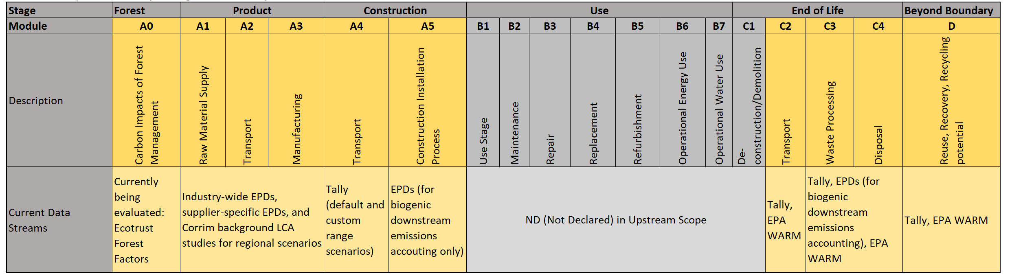

## Future Plans

UpStream was recently accepted into the Carbon Leadership Forum’s incubation program, which will provide support for forest factor methodology review around Ecotrust’s forest factor research, forthcoming research from certification programs, and a comprehensive look at forest harvesting sustainability metrics. Additionally, a second University of Washington’s Applied Research Consortium cycle will be utilized for tool and research development starting in the fall of 2021. Below is a list of additional future development plans for these development pathways and other research support provided by ZGF:

* Ecotrust and other forest certification forest factor review through CLF incubation
* Evolving the current spreadsheet interface into an online tool
* More options for module A1 based on forest management types
* Species biogenic carbon modifiers
* Additional data streams from tools like Athena and OneClick LCA
* Building module calculations based on Simapro and other LCI databases, instead of relying on existing tool outputs
* Dynamic LCA and other temporal considerations for biogenic carbon calculations

# 2.0 Step by Step Guidance and Documentation

## 2.1 Interface and Layout

The current form of UpStream is a simple Excel spreadsheet that does not utilize macros or other types of custom scripting. Below is a description of its various tabs and instructions:

* + Primary Tabs:
    - **Disclaimers and Credits** – this tab outlines any salient data permissions, copyright data, credits, and acknowledgements. It also contains information about the current version and version history of the tool.
    - **Intro + Documentation** – this tab contains a link to download this document and also links to other types of training materials like videos and tutorials.
    - **Inputs and Outputs** – this is the main tab of the tool which contains all of the inputs required for building LCA wood scenarios along with the tool’s primary outputs. Cells are color-coded; green represents a user input, while light blue represents a calculated value. Various modules can be turned “on” or “off” as the input instructions walk the user through a series of drop downs and field inputs while the various charts and tables update in real time.
    - **Reference Library** – this tab contains a link to all the current EPDs used in the tool.
  + Background Tabs:
    - **Sorting Tables** – this tab contains all of the excel sorting tables that use dynamic functions to create cascading, dependent dropdown lists for the “Inputs and Outputs” tab.
    - **Calculation Factors** – this tab contains the table of reference data and the calculation equations that connect the user inputs to the data fields using concatenated ‘keys’ based on user selections and XLOOKUP functions that references the key’s to the factors in the table.
    - **End of Life Factors** – contains the custom end of life factors and calculation engines for UpStream’s various data sources and scenarios for modules C and D. This tab also contains detailed charts that break down the various impact sources into biogenic emissions, non-biogenic emissions, and module D reporting categories.
    - **Tally C-D kg factors** – given that Tally does not have updated EPD’s for wood products, Tally-based end of life factors are applied to updated EPDs or other A1-A3 data sources on a per kilogram basis.
    - **Transportation Factors** – this tab breaks down the Tally transportation factors by source and distance, which allows for both a Tally ‘default’ A4 scenario, or a custom scenario based on the Tally data where a user can custom input a custom distance and transportation type.
    - **A0 Factors** – contains all of the A0 factors and calculation references that tie to the “inputs and outputs” tab, which is currently only has the ability to define a custom input while other factors are being evaluated for inclusion in future beta versions of UpStream.

## 2.2 Step 1 – Define Product Information

### Step 1 Overview and Inputs

**Overview:** this section of the tool houses the primary inputs that user needs to start the analysis: net cubic volume of wood and product type.

**Input:** What type of product would you like to analyze?

* **Options:** CLT, Glulam, LSL/OSL, LVL, PSL, heavy timber, wood framing
  + **Description:** A dropdown is provided that contains all of the different product types available in UpStream. For products to be included in the tool, they either need an accompanying EPD or must be defined by Tally.

**Input:** What is the net installed volume of product?

* **Sub-Input:** Choose Volume Units:
  + **Options:** cubic foot, cubic yards, board feet, meters cubed
* **Sub-Input:** Input Volume (net installed):
  + **Input field:** user inputs a number here based on the volume units chosen previously. Important to note this represents the net installed volume, not nominal.

**Calculation:** Final Volume Converted to Meters Cubed:

* **Description:** The tool applies the appropriate conversion factor and outputs the final volume in cubic meters, which serves as a basis for most of the calculations behind the tool as a volume input, or this volume gets converted to kilograms based on the EPD or A1-A3 data source. Future versions of UpStream will explore adding species input options that will drive mass calculations.

## 2.3 Step 2 – Compare to a Baseline Case

### Step 2 Overview and Inputs

**Overview:** this part of UpStream allows the user to compare their wood analysis numbers against a baseline. This baseline designation can be used to compare UpStream wood outputs against a different material (a steel baseline, for example), or even a previous wood scenario analyzed with the UPStream tool. Furthermore, it can be used for assembly vs. assembly analysis, or whole building numbers against an isolated wood substitution case.

**Input:** Would you like to compare your analysis to a baseline case? (Can be data from an external tool or from UpStream).

* **Options:** yes, no
  + **Description:** a ‘no’ input grays out the module in the tool, while a ‘yes’ input illuminates the next step in the process.

**Input:** Input Total Global Warming Potential (GWP) for the baseline case:

* **User field**: the user inputs here a number that represents the kgCO2e GWP impact from a previous analysis.

**Input:** For your wood scenario, enter impacts from non-wood elements (like steel connections, hybrid steel structures, etc.) to be added to GWP totals for comparison.

* **User field:** this field allows the user to enter the GWP portion of the wood assembly or building that is not wood (like steel connections, hybrid steel structures, etc.). This provides a way to comprehensively analyze a wood scenario while including non-wood impacts when comparing to a baseline scenario.

### Step 2 Related Outputs

**Output:** Comparison of Scenarios for Net GWP (kgCO2e)

* **Description:** Figure 1 below reports the baseline GWP in kgCO2e versus the analyzed case that gets built up as you move through the spreadsheet. Thus, the second stacked bar shows both the net impact of the wood and the non-wood impact. The final bar reports the net GWP in kgCO2e of these two values and the percent savings from the baseline.

Figure 1 Comparison of Scenarios for Net GWP (kgCO2e)

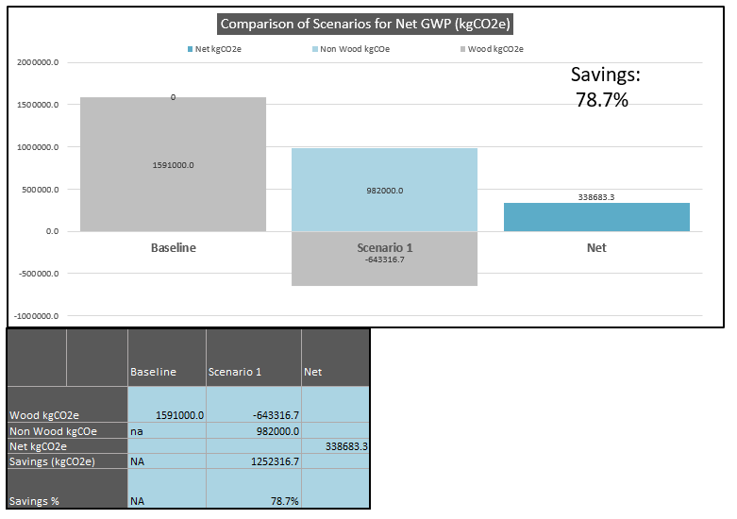

## 2.4 Step 3 – Calculate Modules A1-A3

### Step 3 Overview and Inputs

**Overview:** this module starts the analysis process by first walking the user through the type of EPD data source to include and ends in allowing the user to toggle turning biogenic carbon storage in the product on or off.

**Input:** Would you like to include modules A1-A3 in your analysis?

* **Options:** yes, no
  + **Description:** a ‘no’ input grays out the module in the tool, while a ‘yes’ input illuminates the next step in the process.

**Input:** Choose the type of EPD for Analysis

* **Options:** depending on the product, this dropdown includes Industry-Wide EPDs, supplier-specific EPDs, and in some cases the regional LCA studies behind the Industry-Wide EPDs.

**Input:** Choose the Specific EPD for Analysis

* **Options:** Depending on the input above, different vintages of EPDs or regional studies are available for analysis, usually with their year included in the input option for posterity.

**Input:** Include Biogenic Carbon Storage in the Product?

* **Options:** yes/no –
  + **Description:** a ‘yes’ input reports the biogenic carbon storage in the product as a negative kgCO2e. The amount is based on how the EPD reports the biogenic flows from A1, A2, A3, A5, and C3/C4, and takes the difference between the carbon stored in the incoming logs and the net emissions from A1-A5 as the amount of biogenic carbon stored in the product (American and Canadian Wood Council, 2020). For example, Table 1 shows the net positive emissions in C3/C4 represents the amount of biogenic carbon stored in the final product. It is important to note that if the user selects ‘yes’ it is highly recommended to include End of Life LCA modules later in the tool to fully account for end of life biogenic and fossil-based emissions.

Table 2 Carbon Emissions and Removals for 1M3 of North American Glulam - table 11 (American and Canadian Wood Council, 2020)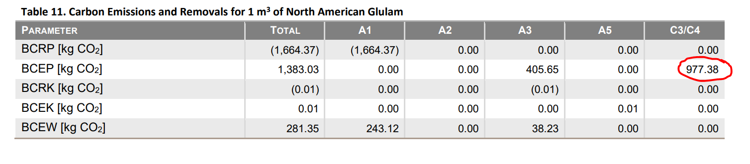

### Step 3 Related Outputs

**Output:** Scenario 1 – kgCO2e By Life Cycle Stage

* **Description:** Figure 2 represents the main output of UPStream, and as the user completes each calculation section of the spreadsheet, the chart updates with 3 main pieces of information: 1) The kgCO2e values disaggregated for each LCA module and sub-module, 2) the overall net kgCO2e of all declared modules, and 3) the underlying datasource/assumption which is referenced in the table below the chart.

Figure 2 Scenario 1 – kgCO2e By Life Cycle Stage

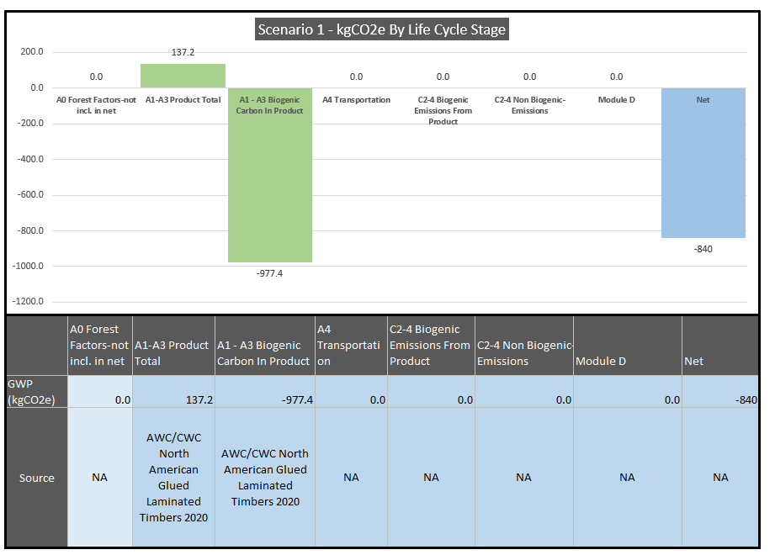

## 2.5 Step 4 – Calculate Modules A4 - Transportation

### Step 4 Overview and Inputs

**Overview:** this module allows the user to include GWP impacts of transportation from fabricator to project site, either using the Tally default values for distance and transportation type, or the user can input a custom distance and transportation type.

**Input:** Would you like to go beyond cradle-to-gate analysis and include A4 Transportation as part of a cradle-to-grave analysis?

* **Options:** yes, no
  + **Description:** a ‘no’ input grays out the module in the tool, while a ‘yes’ input illuminates the next step in the process.

**Input:** Use Default Values (select if you don’t know transportation distances yet)

* **Option 1**: Yes
  + **Description:** This defaults to Tally’s transportation distances included for wood, which typically range from 383-468 kilometers depending on the product. It also uses the ‘by truck’ transportation type and applies the kgCO2e/kg ODW impact from Tally (based on GaBi) to the mass of whatever was modeled in UPStream according to the EPD.
* **Option 2**: No (custom)
  + **Description:** This allows the user to input a custom distance by transportation type (truck, barge, rail, etc.). This option still uses the Tally data (based on GaBi), but broken down into a kgCO2e/kg ODW/kilometer traveled for each transportation type to allow for the custom distance input.

## 2.6 Step 5 – Calculate Module C2-4 – End of Life Emissions

### Step 5 Overview and Inputs – Base Options

**Overview**: This section calculates the emissions for LCA modules C2-4 and breaks them down into biogenic emissions and non-biogenic emissions. The user currently can select between 3 base options that contain various end of life scenario distributions, assumptions, and datasets. The user can also select between 2 custom pathway datasets with flexible distributions for their constituent end of life scenarios. Either the EPA WARM model can be used for the custom pathway, or the Tally factors which which use a blend between EPA WARM and GaBI data.

**Input:** Would you like to go beyond cradle-to-gate analysis and include C2-4 End of Life (fossil and biogenic emissions) as part of a cradle to grave analysis?

* **Options:** yes, no
  + **Description:** a ‘no’ input grays out the module in the tool, while a ‘yes’ input illuminates the next step in the process.

**Input:** End of Life Data Source

* **Option 1:** EPD V1 – Biogenic Carbon Net Neutral
  + **Description:** This option represents one of the more common LCA boundaries and scopes, i.e., cradle-to-manufacturing gate where biogenic carbon storage and emissions follow the ‘net neutrality’ principle as per ISO 21930 7.2.7 and 7.2.12. Based on these accounting rules, all carbon removed from the atmosphere in module A1 is emitted in modules A1-5 and C3-4. Even though this approach represents a cradle-to-gate boundary, it's important to note that for biogenic emissions and removals modules A5 and C3/C4 are reported to ensure a net neutral biogenic carbon balance. As per ISO 21930, this type of net neutral accounting can only be used if the forest can demonstrate carbon removals with a factor of -1 kgCO2e/kgCO2 (American and Canadian Wood Council, 2020). This standard points to the United Nations Framework Convention on Climate Change (UNFCC) annual report to demonstrate that all North American forests meet these criteria (UNFCCC, 2020).

This option represents a conservative approach to carbon accounting for wood products in that it eliminates any benefit of biogenic carbon storage in the product by assuming it all is emitted back into the atmosphere. This does not account for any biogenic carbon still stored in the built environment across harvest cycles, or long-term carbon storage in landfills, or substitution benefits of incineration or landfill gas recovery. It also ignores any benefit or penalty of carbon dynamics at the forest or landscape level.

* **Option 2**: EPD V2 – w/Long Term Biogenic Carbon Sequestration
  + **Description:** In the post-2020 American Wood Council EPDs, there is now a section called “Cradle-to-Grave Carbon Sequestration.” This section acknowledges the “conservative assumption” of the ISO 21930 net neutral accounting methodology, and attempts define an end-of-life scenario that includes the permanent sequestration of biogenic carbon from landfilling. This section references the ‘UL PCR Part A: Life Cycle Assessment Calculation Rules and Report Requirements’ Section 2.8.5 to define a 100% landfill default disposal pathway due to the end-of-life fate of wood generally being unknown. While the UL PCR Part A defines the disposal pathway, the ‘UL PCR Part B: Structural and Architectural Wood Products EPD Requirements’ outlines how to calculate the landfilling emissions based on the United States EPA WARM model. It uses the EPA WARM model’s assumptions around decomposition rate (12%) to determine the methane and CO2 emitted from fugitive landfill gas. Appendix A of the UL PCR Part B defines guidance on the landfill modeling for biogenic carbon since the WARM model does not directly report the factors required to calculate landfill greenhouse gas emissions for LCA or EPD purposes; the WARM model adheres to the net neutrality principle and thus does not report CO2 landfill gas leakage from wood decay. The appendix outlines a derivation methodology of both CO2 and methane emissions based on the 12% decomposition rate for lumber. These two factors are reported as 3.53E-03 MT CH4/MT Dry Wood for methane, and 2.06E-01 MTCO2/MT Dry Wood for carbon dioxide. Calculations for medium-density fiberboard and flooring are also included in the addendum but not used in UpStream. It is important to note that these factors are based on a landfill model without gas recovery and does not include any fossil emissions from transport or heavy landfill equipment.

Using this methodology, the 2020 American Wood Council’s Glued Laminated Timbers EPD reports in their cradle-to-grave carbon sequestration section a net -820.60 kg CO2e for 1 cubic meter of glulam when considering the carbon sequestered in the product at manufacturing gate (-977.38 kgCO2e) and 47.01 and 109.77 kgCO2e emissions from methane and CO2 fugitive landfill gas, respectively. This represents an 84% factor of permanent carbon storage when considering this disposal pathway and the PCR’s assumptions. This is likely overpredicting the long-term storage benefit due to a relatively low decomposition rate, not including the fossil emissions associated with C modules, and not factoring in other common wood disposal pathways like incineration, which are not as carbon-optimal as this particular landfill model.

* **Option 3:** – Tally W/Biogenic Carbon
  + **Description:** This option utilizes a wood end of life scenario whose distribution between landfill (63.5%), recycling (14.5%), and incineration (22%) is determined by the 2014 Municipal Solid Waste and Construction Demolition Wood Waste Generation and Recovery in the United States report. Tally uses the EPA WARM model to determine landfill emissions and various GABI LCIs for incineration. For the landfill model, Tally assumes an average 50% decomposition rate as per the 2006 IPCC Guidelines for National Greenhouse Gas Inventories, Section 3.2.3. Furthermore, 80% of the fugitive landfill gas is recovered as methane, while 20% is released as CO2. Of the 80% methane, 31% is flared, 36% is released as an emission, and 33% is used for energy recovery (Alison G. Kwok, 2019). Transportation and heavy equipment fossil emissions is included from the warm model as well. For incineration, Tally uses GaBi LCI data to calculate CH4 emissions from burning wood and transportation emissions, while any biogenic carbon content of any incinerated wood is counted as a biogenic emission. For recycling, no process energy is included so that particular impact is captured in the next product, thus there is no emission accounted for recycling in module C. There are, however, module D emissions associated with biogenic carbon leaving the LCA scope boundary; refer to the Module D section later in this document for more documentation on that subject.
* **Option 4:** Tally w/o Biogenic Carbon
  + **Description:** This selection utilizes the same end of life scenario distribution as “w/ Biogenic carbon” (63.5% landfill, 14.5% recycling, 22% incineration), but the emissions profiles differ slightly without factoring in biogenic carbon. For instance, the Landfill module C3-4 includes transportation, heavy landfill equipment emissions, and the biogenic methane emissions from the landfill scenarios---but biogenic CO2 from decay is excluded. For incineration, the biogenic carbon stored in the wood that is emitted during burning is not included, but the biogenic methane is included. And for recycling, there is no impact on C3-4, but in module D there is now a credit for the avoided burden of production and well as the emissions associated with processing. It appears that most of the impact in C3-4 without biogenic carbon comes down to the methane emissions associated with landfilling. For instance, Figure 3 shows that the net impact of 1 cubic meter of Tally’s landfill end of life scenario is 369.2 kgCO2e, while the methane emissions from the wood decay accounts for 282.3 kgCO2e of these emissions, or 76.5%.

Figure 3 1 Cubic Meter of Glulam, Tally 100% Landfill Blend End of Life Scenario Impacts

* **Option 5:** Custom
  + **Description:** see next section below for guidance on custom inputs for modules C2-4.

### Step 5 Overview and Inputs – Custom Options

**Overview:** Choosing the ‘custom’ option for the ‘End of Life Data Source’ input allows the user to designate what percentage of their wood goes to a variety of end-of-life scenarios based on two different data sources: EPA WARM, and Tally factors (which subsequently use EPA WARM and GaBi data).

**Sub input:** Pick a Custom Data Source

* **Custom Data Source Option 1:** EPA Warm
  + **Description:** Selecting the EPA WARM data source utilizes factors extracted from EPA WARM Software Version 15 outputs. To arrive at these factors, one short ton of wood was input into the tool. Any output emissions were then converted to kilogram of CO2e, while the short ton input was converted first to a metric ton and then to kilograms to ultimately come up with a kgCO2e/kg of wood factor that can be applied to the wood volume and mass inputs defined in UpStream. EPA WARM currently has data for dimensional lumber, MDF, and hardwoods, but UpStream only utilizes factors for the dimensional lumber outputs.

UpStream pulls outputs from EPA WARM for 5 different end of life scenarios, which include 3 different landfill options, one incineration scenario, and one recycling scenario. The user inputs the “% of Wood Package Volume” for each scenario and the resultant volume based on earlier total wood volume is calculated and applied to the analysis modules.

It is important to note that the EPA WARM model is consistent with IPCC guidance and thus does not report the biogenic CO2e emissions from wood end of life scenarios. For processes with CO2 end of life emissions, if the emissions are from biogenic materials that are grown on a sustainable basis (according to the same UNFCCC protocols that govern the carbon neutrality principles of ISO 29307), those emissions are considered to net neutral from the carbon sequestered by the regenerated forest over time. In other words, they return to the atmosphere CO2 that was originally removed by photosynthesis and thus for EPA WARM the CO2 emissions are not counted. However, the methane emitted from biogenic sources is counted and reported in EPA WARM, since although they are considered biogenic, they are anthropocentric in origin meaning they would not have occurred if not for the landfilling of wood (US Environmental Protection Agency - Office of Resource Conservation and Recovery, 2020).

* + **Option 1 – EPA WARM Scenarios**

**Scenario 1 – Landfill:** The EPA WARM landfill model captures anthropocentric emissions from methane, landfill equipment, and transportation to the landfill based on an average 20 km travel distance. For emissions associated with landfill heavy equipment usage and transportation, WARM relies on assumptions from FAL (1994) for the equipment emissions and NREL USLCI, respectively. The NREL emission factor assumes a diesel, short-haul truck.

EPA WARM also calculates landfill carbon storage, but these numbers are not used in UpStream, as the net carbon storage calculated by UpStream is the net of the of end-of-life emissions/credits and the biogenic carbon credit in the wood. Selecting the “landfill” option in UpStream actually represents the no-landfill gas recovery option in EPA WARM, as when selecting the “National Average” option, the values were very close to the no landfill gas recovery option. Future version of UpStream will break these two versions out separately. Table 2 shows the factors extracted from EPA WARM and used in UpStream, broken down by source and then organized into which LCA module they impact, i.e., C2-4 Biogenic Emissions, C2-4 Non-Biogenic Emissions, and Module D. Given that EPA WARM does not directly report carbon dioxide landfill gas (since it’s a biogenic emission), the “landfill gas CO2 emissions” factors were calculated according to the “PCR Part B: Structural and Architectural Wood Products EPD Requirements, Appendix A: Guidance on Landfill Modeling for Biogenic Carbon.” This reference calculates the amount of methane and carbon dioxide emissions based on the average 12% decomposition rate in EPA WARM. Thus, everything but the “landfill gas CO2 emissions” factor were taken directly from the EPA WARM model, which is typical for all three EPA WARM landfill scenarios.

Table 3 EPA WARM Factors for Landfill (No Landfill Gas Recovery) Scenario

|  |  |  |  |  |
| --- | --- | --- | --- | --- |
| **Source** | **Landfill - No Landfill Gas Recovery** | | | **Unit** |
| **C2-4 - Non-Biogenic Emissions** | **C2-5 biogenic emissions** | **Module D** |
| landfill gas CO2e emissions |  | 0.206 |  | kgCO2/kg ODW |
| landfill gas CH4 emissions | 0.098 |  |  | kgCO2/kg ODW |
| CO2e emissions from CH4 converted to CO2e through soil |  | 0.022 |  |  |
| heavy equipment | 0.022 |  |  | kgCO2/kg ODW |
| transport | 0.004 |  |  | kgCO2/kg ODW |

* + - **Scenario 2 – Landfill with Landfill Gas Energy** **Recovery:** This option pulls the factors from EPA WARM for landfills with methane gas energy recovery systems and uses the national average efficiency factor of 75%. Future versions of UpStream will allow users to modify this efficiency as it’s a flexible input in the Excel spreadsheet version of EPA WARM. This would allow users to fine tune this input based on available research for their state or even local municipal waste facility (Dr. Morton Barlaz & Christopher Evans, 2009). Table 3 shows that compared to the “no landfill gas recovery option”, the landfill gas CH4 emissions is indeed lower due to the landfill gas capture (.050 kgCO2e/kgODW vs. .098 kgCO2e/kgODW) and thus the CO2 emissions from converted CH4 through the soil is also reduced. Finally, a Module D impact shows up as a credit from the exported energy from the gas recovery. This is also the national average value, and future versions of UpStream will allow a state-level or grid region level input.

Table 4 EPA WARM Model Factors for Landfill with Landfill Gas Recovery Scenario

|  |  |  |  |  |
| --- | --- | --- | --- | --- |
| **Source** | **Landfill - w/Landfill Gas Recovery** | | | **unit** |
| **C2-4 - Non-Biogenic Emissions** | **C4-5 biogenic emissions** | **Module D** |
| landfill gas CO2e emissions |  | 0.206 |  | kgCO2/kg ODW |
| landfill gas CH4 emissions | 0.050 |  |  | kgCO2/kg ODW |
| CO2e emissions from CH4 converted to CO2e through soil |  | 0.011 |  |  |
| heavy equipment | 0.022 |  |  | kgCO2/kg ODW |
| transport | 0.004 |  |  | kgCO2/kg ODW |
| exported elec credit (CO2e fossil) |  |  | -0.011 | kgCO2/kg ODW |

* + - **Scenario 3 – Landfill with Flare:** This selection pulls data from the EPA WARM model for landfill flaring which reduces the amount of methane emitted but does not report the conversion of this methane to CO2 through the flaring process since its of biogenic origin. Thus, the PCR Addendum Part B methodology is applied to the “CO2 emissions” factor. Table 4 shows the reduction of methane emissions from this scenario (.060 kgCO2e/kgODW vs. .098 kgCO2e/kgODW), which represents a significant reduction but not as much as the landfill gas recovery option.

Table 5 EPA WARM Model Factors for Landfill with Flare Scenario

|  |  |  |  |  |
| --- | --- | --- | --- | --- |
| **Source** | **Landfill - w/Flare** | | | **unit** |
| **C2-4 - Non-Biogenic Emissions** | **C4-5 biogenic emissions** | **Module D** |
| CO2e emissions |  | 0.206 |  | kgCO2e/kgODW |
| CH4 emissions | 0.060 |  |  | kgCO2e/kgODW |
| CO2e emissions from CH4 converted to CO2e through soil |  | 0.022 |  |  |
| heavy equipment | 0.022 |  |  | kgCO2e/kgODW |
| transport | 0.004 |  |  | kgCO2e/kgODW |
| elec credit (CO2e fossil) |  |  |  | kgCO2e/kgODW |
| thermal energy credit |  |  |  | kgCO2e/kgODW |

* + - **Scenario 4 - Incineration:** The EPA WARM incineration scenario, or “combustion” as it's referred to in its documentation, accounts for the transportation emissions to the waste-to-energy (WTE) facility, and any combustion-related non-biogenic greenhouse gasses like CO2 and NO2. For module D, exported electricity is counted as a credit based on the WTE plant’s system efficiencies, carbon content of the material being combusted, and a factor for national average utility baseload CO2 emissions avoided per kWh of electricity delivered by the WTE plant (note: Module D impacts are not counted unless this module is turned on in UpStream) . Biogenic CO2 emissions from burning the wood are not included from EPA WARM, but UpStream includes these emissions based on counting 100% of the biogenic carbon in the wood being incinerated as an emission. Table 5 shows the different factors pulled from WARM and how biogenic emissions from incineration are calculated, i.e., “biogenic carbon dioxide equivalent in wood is released as an emission”.

Table 6 EPA WARM Model Factors for Incineration Scenario

|  |  |  |  |  |
| --- | --- | --- | --- | --- |
| **Source** | **Incineration** | | | **unit** |
| **C2-4 - Non-Biogenic Emissions** | **C4-5 biogenic emissions** | **Module D** |
| process (combustion) | 0.044 |  |  | kgCO2e/kgODW |
| biogenic emissions from incineration |  | biogenic carbon dioxide equivalent in wood is released as an emission |  | kgCO2e/kgODW |
| elec credit (CO2e fossil) |  |  | -0.694 | kgCO2e/kgODW |
| elec credit (CH4 fossil) |  |  |  | kgCO2e/kgODW |
| steam credit |  |  |  | kgCO2e/kgODW |
| transport | 0.011 |  |  | kgCO2e/kgODW |

* + - **Scenario 5 - Recycling:** For EPA WARM, when a material is recycled, it is used in place of virgin inputs in the manufacturing process, rather than being disposed of and managed as waste. The EPA WARM model accounts for transportation-related emissions from recycling for transit to the recycling center, and re-transport of recycled materials to remanufacturing. EPA WARM also calculates the avoided impacts from the transport of raw materials and the emissions associated with the production of virgin material. To calculate the avoided production burden, EPA WARM considers dimensional lumber a closed-loop product and takes the net difference between the GHG emissions from manufacturing a material with 100 percent recycled inputs, and the GHG emissions from manufacturing an equivalent amount of the material 100 percent virgin inputs (US Environmental Protection Agency - Office of Resource Conservation and Recovery, 2020). Table 6 shows the factors split out between reprocessing and transportation emissions in Module C2-4, and the avoided transportation and production burden credits in Module D.

Table 7 EPA WARM Model Factors for Recycling Scenario

|  |  |  |  |  |
| --- | --- | --- | --- | --- |
| **Source** | **Recycling** | | | **unit** |
| **C2-4 - Non-Biogenic Emissions** | **C4-5 biogenic emissions** | **Module D** |
| reprocessing and transportation | 0.364 |  |  | kgCO2e/kgODW |
| avoided transportation and production burden |  |  | -0.121 | kgCO2e/kgODW |

* **Custom Data Source Option 2:** Tally
  + **Description:** Selecting the Tally option for the custom end of life data source pulls data from EPA WARM for landfill scenarios, GaBi for incineration, and boundary assumptions for recycling. Factors used in UpStream were created from Figure 3 below, which was a table presented for a training webinar on Tally and biogenic carbon (Thinkstep, 2020). First, these factors were scaled to represent a 100% use case instead of being broken down by the default Tally distribution assumptions (63.5% landfill, 22% incineration, 14.5% recycling). For instance, the .27 kgCO2e/kg represents this impact if 14.5% of 1kg of wood was recycled, so these factors were divided by their percent distribution (14.5% in this case) to understand their scaled impact for the full 1 kg of wood. Next, each factor was mapped into the appropriate modules used for UpStream reporting (C2-4 Biogenic Emissions, C2-4 Non-Biogenic Emissions, and Module D) for the three end of life scenarios available in this option.

Figure 4 Tally Lumber Example for Disaggregated End of Life Factors with Biogenic Carbon

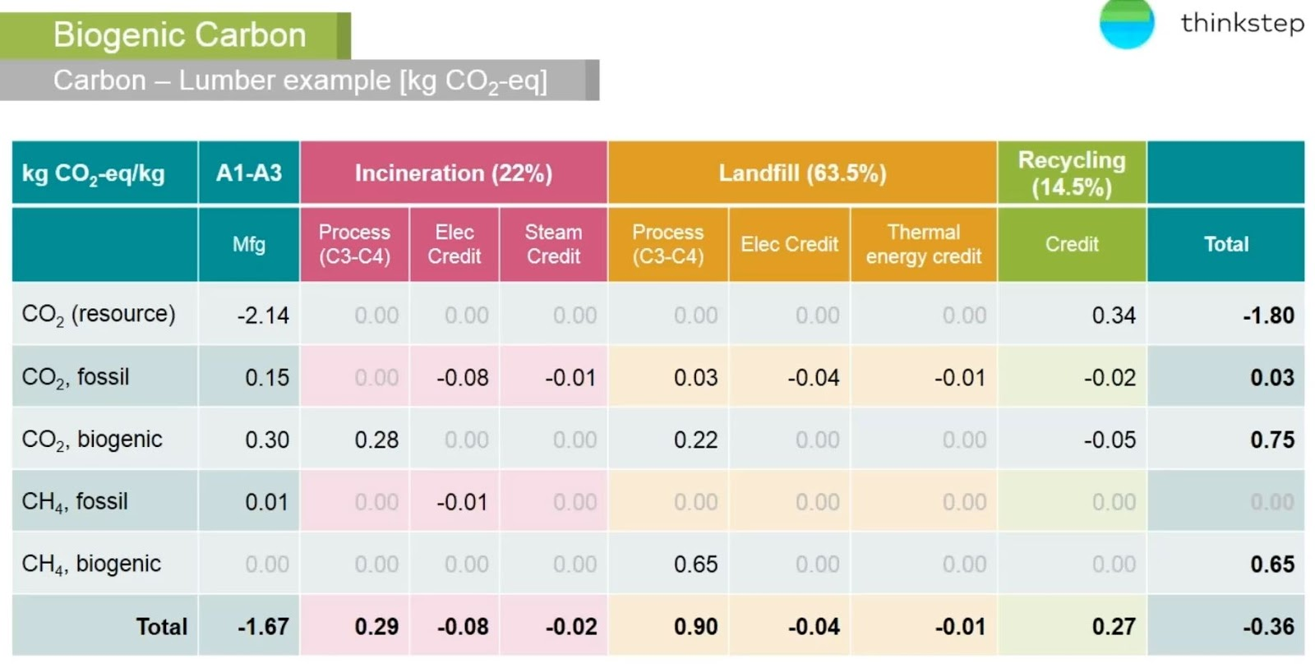

* + **Option 2:** Tally Scenarios
    - **Scenario 1 - Landfill Blend:** As discussed in earlier sections, Tally’s landfill scenario is actually a blend of 31% landfill with flare, 36% no capture, and 33% landfill with energy recovery. Tally uses the EPA WARM model to derive these factors, but uses a 50% decomposition rate based on IPCC recommendations (IPCC, 2006), much higher than EPA WARM’s default 12%. This increased decomposition rate drastically increases the emissions factors of this option versus the default EPA WARM option. Table 7 below shows the “CO2 emissions” factor broken out by non-biogenic (transportation and heavy equipment) and biogenic emissions (CO2 gas leakage, CO2 emissions converted from flaring). Methane emissions are mapped to the C2-4 Non-Biogenic Emissions column. Finally, an electricity credit shows up in Module D based on the EPA Warm landfill with gas recovery methodology. A credit also shows up for avoiding thermal energy associated with natural gas (Alison G. Kwok, 2019).

Table 8 Tally Factors for Landfill Blend Scenario

|  |  |  |  |  |
| --- | --- | --- | --- | --- |
| **Source** | **100% landfill - Tally** | | | **unit** |
| **C2-4 - Non Biogenic Emissions** | **C2-4 biogenic emissions** | **Module D** |
| CO2e emissions | 0.047 | 0.346 |  | kgCO2e/kgODW |
| CH4 emissions | 1.024 |  |  | kgCO2e/kgODW |
| elec credit (CO2e fossil) |  |  | -0.063 | kgCO2e/kgODW |
| thermal energy credit |  |  | -0.016 | kgCO2e/kgODW |

* + - **Scenario 2 - Incineration:** Tally uses data from various GaBi LCIs to determine the various energy credits for this end-of-life scenario. GaBi also doesn’t report the biogenic CO2e emissions from the biogenic carbon released when burning wood, so these emissions are calculated as equivalent to the biogenic carbon in the wood. Table 8 shows the credit factors for avoided electricity and steam energy production including how the CO2e biogenic emissions are calculated.

Table 9 Tally Factors for Incineration Scenario

|  |  |  |  |  |
| --- | --- | --- | --- | --- |
| **Source** | **100% Incineration - Tally** | | | **unit** |
| **C2-4 - Non Biogenic Emissions** | **C2-4 biogenic emissions** | **Module D** |
| CO2e emissions |  | biogenic carbon dioxide equivalent in wood is released as an emission |  | kgCO2e/kgODW |
| CH4 emissions |  |  |  | kgCO2e/kgODW |
| elec credit (CO2e fossil) |  |  | -0.364 | kgCO2e/kgODW |
| elec credit (CH4 fossil) |  |  | -0.045 | kgCO2e/kgODW |
| steam energy credit |  |  | -0.045 | kgCO2e/kgODW |

* + - **Scenario 3 - Recycling:** Tally doesn’t use any data sources for recycling, and instead interprets the LCA boundary to pass along any re-processing emissions to the next LCA, so there isn’t a net avoided burden of production or transportation impact. Additionally, other emissions associated with transportation or biogenic emissions get exported to the next LCA, so they end up as a credit in Module D since they leave the boundary. This holds true for the biogenic carbon in the product as well, except since its typically a credit it becomes a large biogenic CO2 emission when it leaves the LCA scope boundary. Table 9 shows these two credits, and also the biogenic carbon leaving the boundary as a positive emission in the “CO2 (resource)” row.

Table 10 Tally Factors for Recycling Scenario

|  |  |  |  |  |
| --- | --- | --- | --- | --- |
| **Source** | **100% Recycling** | | | **unit** |
| **C2-4 - Non Biogenic Emissions** | **C2-4 biogenic emissions** | **Module D** |
| CO2 (fossil) |  |  | -0.138 | kgCO2e/kgODW |
| CO2 (biogenic) |  |  | -0.345 |  |
| CO2 (resource) |  |  | 2.345 | kgCO2e/kgODW |

### Step 5 Outputs

There are three different outputs and charts that are relevant to the end-of-life module calculations.

**Output:** Scenario 1 – kgCO2e by Life Cycle Stage

* **Description:** Figure 4 is the main output of UpStream, and as you complete the Module C inputs, the “C2-4 Biogenic Emissions from Product” and “C2-4 Non-Biogenic Emissions” update based on user selections. The table below the chart also updates to call out the data source or programs that inform the calculations.

Figure 5 Example Output for 1 Meter Cubed of Glulam

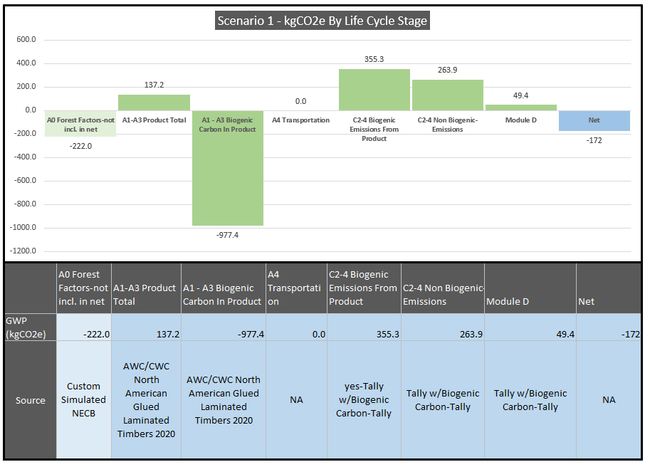

**Output:** Custom End of Life Scenarios – kgCO2e by Module

* **Description:** Figure 5 below gets populated only if the user selects the ‘custom’ end of life pathway. It shows each of the five different scenarios available in UpStream, and breaks down the data into the biogenic emissions, non-biogenic emissions, module D impacts (if the module is turned on), and the net both for each scenario and the total. The latter of which gets relayed up into the main UpStream overview chart.

Figure 6 Example Custom End of Life Chart based on 1 Meter Cubed of Glulam Evenly Distributed Across the Five UpStream Custom Scenarios.

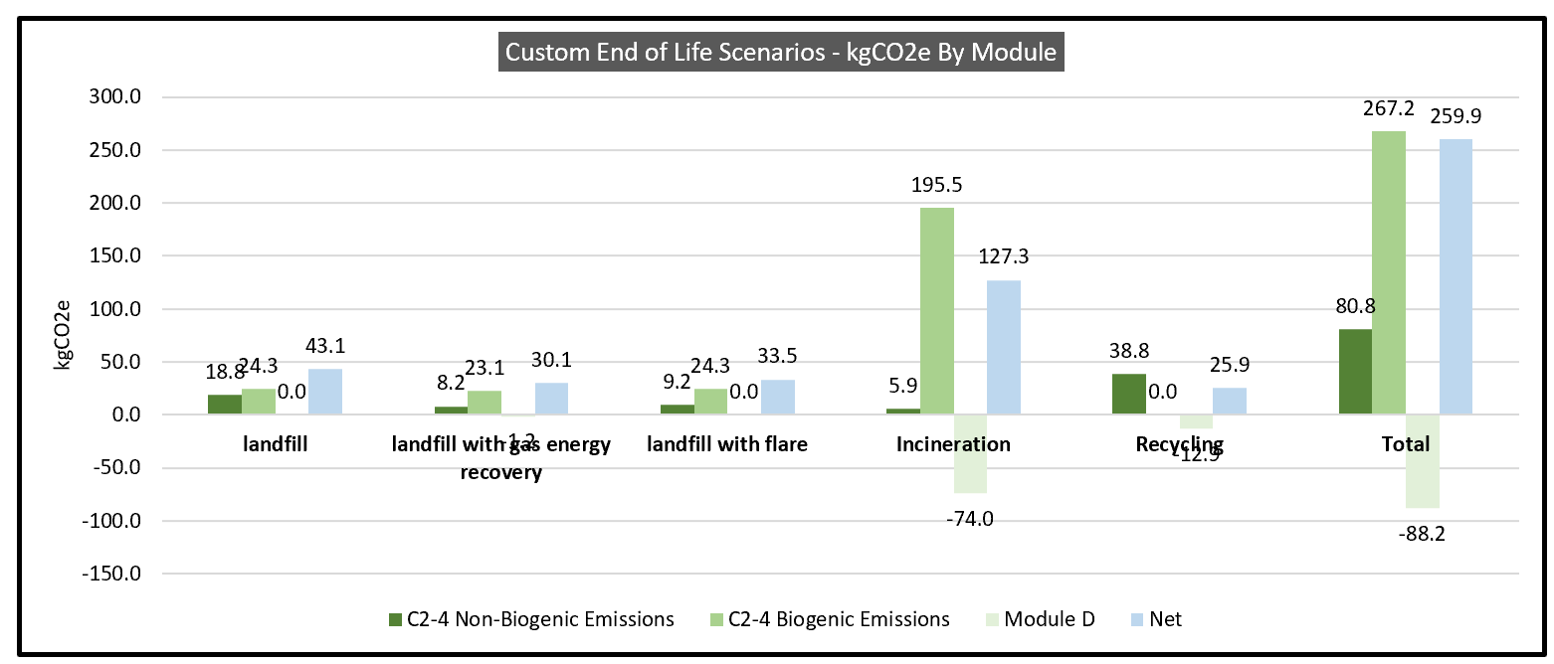

**Output:** EPA WARM – Landfill w Landfill Gas Energy Recovery Calculations

* **Description:** For a deeper dive into how each scenario maps the factors from custom data sources to the UpStream reporting format (biogenic emissions vs. non-biogenic emissions), the “End of Life Factors” tabs contains tables and charts of each scenario for both current data sources (EPA WARM and Tally). The first table shows the kgCO2e/kgODW factors for each scenario, while the second table calculates the overall kgCO2e based on the volume and mass inputs from UpStream. Figure 6 below reflects the overall kgCO2e calculations and breaks the data down into source information, UpStream reporting, and the overall kgCO2e net impact.

Figure 7 Example Output for Custom End of Life Scenario, EPA WARM Landfill w/Landfill Gas Recovery Scenario – 20% Distribution for 1 Meter Cubed of Glulam

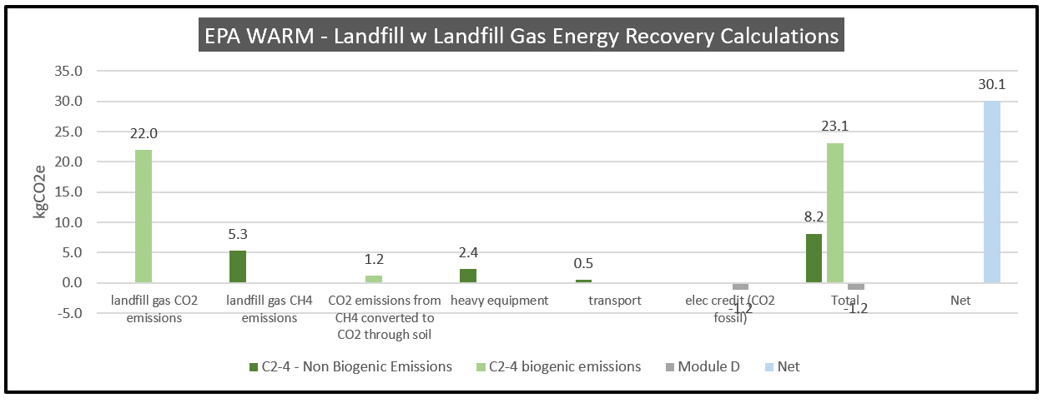

## 2.7 Step 6 – Calculate Module D – Benefits Outside of Boundary

### Step 6 Overview and Inputs

**Overview:** This calculation section turns on or off the Module D impacts in all of the previous end of life calculations. Thus, there is only a yes/no option for user input. The list below represents how turning Module D on impacts the 5 different end of life selection options and more detail can be found in the section above on C2-4 End of Life:

* **Option 1 – EPD V1 – Biogenic Carbon Net Neutral**
  + **Description:** No impact
* **Option 2 – EPD V2 – w/Long Term Biogenic Carbon Sequestration**
  + **Description:** No impact – the PCR addendum does not define a way to capture any Module D impacts from its 100% landfill assumption in its modified cradle-to-gate analysis.
* **Option 3 – Tally W/Biogenic Carbon**
  + **Description:** Avoided emission from energy production (electricity and natural gas) show up based on landfill gas energy recovery and incineration (electricity and steam credit). For recycling, the biogenic carbon in the product is counted as an emission when it leaves the boundary, and similarly any transportation and processing emissions are claimed as credits as they get applied to the next LCA.
* **Option 4 – Tally W/O Biogenic Carbon**
  + **Description:** Landfill and incineration avoided energy productions are the same as with biogenic carbon turned on, but recycling is substantially different. Credit is given for the avoided burden of material production.
* **Option 5 – Custom – EPA WARM**
  + **Description:** An exported electricity credit is given for landfill gas recovery scenarios and incineration, and for the avoided emissions from transport and production for recycling.
* **Option 5 – Custom – Tally**
  + **Description:** Selecting this custom data source applies the same module D impacts according to the “Tally W/Biogenic Carbon” scenario as outlined above.

### Step 6 Outputs

**Overview:** Same outputs as the “Step 5 Calculate Module C2-4 – End of Life Emissions” as outlined previously, but now numbers are populated for “Module D” labels and legend items instead of being blank.

## 2.8 Step 7 – Calculate Module A0 – Impacts from Forestry

### Step 7 Overview and Inputs

**Overview:** This calculation section is designed to integrate the carbon impacts from forest management into cradle-to-grave life cycle analysis. While other calculation modules pull data from Environmental Product Declarations (EPDs) and Tally to create ISO 21930:2017-compliant cradle-to-gate or cradle-to-grave analyses, it’s important to note that when including upstream forest carbon impacts we step out of the bounds of the ISO 21930:2017 rules. While the latest version of the American Wood Council’s EPDs describe the importance of eventually considering forest management, current product category rules (PCRs) do not provide a standardized way to calculate or integrate them into LCA. For instance, from Section “4. LCA Interpretation” of the 2020 American Wood Council’s Environmental Product Declaration North American Glued Laminated Timber:

*While this EPD does not address all forest management activities that influence forest carbon, wildlife habitat, endangered species, and soil and water quality, these potential impacts may be addressed through other mechanisms such as regulatory frameworks and/or forest certification systems, which, combined with this EPD, will give a more complete picture of environmental and social performance of wood products.*

For now, ISO 21930 currently uses the concept of “carbon neutrality” to deal with forest carbon, citing the UNFCCC guidance saying that if forests demonstrate carbon removals with a factor of -1 kg CO2e/kg CO2, forest practices can be considered carbon neutral due to regeneration equaling harvest removals. This method relies on the fact that North American forests in aggregate meet this criterion, but it does not address the differences that might exist between the wide array of forest practices engaged across the landscape between ownership type. Including forest factors in UpStream relies on going beyond the assumption of carbon neutrality and calculating the carbon differences between different forest management methods.

Until PCRs or some other industry-adopted standard define a standardized method of including forest management in EPDs and their constituent LCAs, Upstream aims to include any forest factors available to understand the magnitude of their impact and facilitate discussion. Current factors included in this public Beta 1.0 version were limited solely to the custom user input (in kilograms of CO2e per meter cubed of roundwood) until Ecotrust’s factors and others under development were reviewed through Carbon Leadership Forum incubation.

**Input:** Would you like to go beyond cradle-to-gate AND cradle-to-grave ISO-approved LCA methodologies and include carbon impacts at the forest in your LCA analysis?

* **Options:** yes, no
  + **Description:** a ‘no’ input grays out the module in the tool, while a ‘yes’ input illuminates the next step in the process.

**Input:** Choose your forestry factor data source:

* **Option 1:** Custom
  + **Overview:** This option allows the user to input any forest factor from any reference that isn’t included as a base dataset in UpStream. The only caveat at this point is that the factor needs to be in kgCO2e per cubic meters of roundwood for all the calculation modules to work.
  + **Input:** Input Custom Factor (kgCO2 per meters cubed of industrial roundwood)
    - **Options:** userinput field

### Step 7 Outputs

If the A0 module is turned on, the primary barchart and table will now show the calculated impact and data source. Figure 8 below shows the updated bar chart with the inclusion of A0, but flags in its title color that its value is not included in the overall net calculation attr ibuted to the product.

Figure 8 Primary UpStream Output Barchart and Table - For 1 Cubic Meter of Glulam

* 

## 2.9 Step 8 – Calculate Uncertainty Factor – Add Factor to Net GWP

### Step 8 Overview and Inputs

**Overview:** This step was added with an EC3 post-processing workflow in mind. Given that a user might try to match the A1-A3 module outputs from a different tool before adding forestry or custom end of life factors, this input allows the user to include an “uncertainty” factor that adds more carbon to the A1-A3 calculation based on the variability of the source (if it's an industry wide EPD or a supplier-specific EPD, for instance). This number can be found within the EC3 tool and then transferred to UpStream, or a user could input their own uncertainty factor based on other references or judgement calls.

**Input:** Would you like to add an uncertainty factor?

* **Options:** yes, no
  + **Description:** a ‘no’ input grays out the module in the tool, while a ‘yes’ input illuminates the next step in the process.

**Input:** Enter uncertainty factor as a % of A1-3 to add to the net GWP.

* **Options:** this is a number input in percentage. For instance, a 20% input would be (.2)*(A1-A3 Total GWP), which would then get added to the rest of the module calculations to form the net kgCO2e total.

# References

Alison G. Kwok, H. Z. (2019). *Cross-Laminated Timber Buildings: A WBLCA Case Study Series.*

American and Canadian Wood Council. (2020). *Environmental Product Declaration - North American Glued Laminated Timber.*

Dr. Morton Barlaz, N. C., & Christopher Evans, A. (2009, October 30). *www.epa.gov.* Retrieved from www.epa.gov: https://www.epa.gov/sites/default/files/2016-03/documents/warm_decay_rate_structure_10_30_2009.pdf

FAL. (1994). *The Role of Recycling in Integrated Solid Waste Management for the Year 2000. Franklin Associates, Ltd. (Samford, CT: Keep America Beautiful, Inc), September, pp. 1-27, 30, and 31.*

IPCC. (2006). *2006 IPCC Guidelines for National Greenhouse Gas Inventories.*

National Renewable Energy Laboratory. (2015). *"U.S. Life Cycle Inventory Database." Retrieved from https://www.lcacommons.gov/nrel/search.*

Thinkstep. (2020, January 16). *Webinar*. Retrieved from Choose Tally: https://choosetally.com/webinars/

U.S. Environmental Protection Agency - Office of Resource Conservation and Recovery. (2020). *Documentation for Greenhouse Gas Emission and Energy Factors Used in the Waste Reduction Model (WARM) - Management Practices Chapters.*

UL. (2019). *Product Category Rules for Building-Related Products and Services - Part B: Structural and Architectural Wood Products, EPD Requirements V10010-9v.10.*

US Environmental Protection Agency - Office of Resource Conservation and Recovery. (2020). *Documentation for Greenhouse Gas Emission and Eneryg Factors Used in the Waste Reduction Model (WARM) - Background Chapters.*