Phase-Controlled Domain Wall Logic in Serpentine Graphene–hBN Heterostructures

Chur Chin ^{a,*}
ªDepartment of Family Medicine, Dong-eui Medical Center, Busan 47227, Republic of Korea
*Electronic mail: tpotaoai@gmail.com

ABSTRACT
We demonstrate that nonlinear wave dynamics in serpentine graphene–hexagonal boron nitride (hBN) heterostructures can implement phase-controlled logic operations within a purely classical framework. Domain walls separating two stable field polarities serve as binary encoding units under a Möbius-type boundary condition, ψ(s+L) = −ψ(s), which enforces topological phase inversion. We show that symmetric coupling enables Hadamard-like state splitting, phase interference produces XOR-like logic, and control-modulated coupling yields CNOT-like conditional switching. These operations arise from geometry- and boundary-enforced phase coherence rather than quantum effects, enabling robust, room-temperature wave-based computation in van der Waals heterostructures.
Keywords: domain wall dynamics; graphene–hBN heterostructure; nonlinear wave computation; phase-controlled switching; wave-based logic; topological boundary condition; van der Waals devices
1.INTRODUCTION
Wave-based computation provides an alternative to transistor-based digital logic by encoding information in the amplitude and phase of continuous fields [1]. Recent advances in van der Waals heterostructures, particularly graphene on hBN, enable precise control of carrier transport and coupling at the nanoscale [2]. Unlike quantum computing systems, which require cryogenic environments and are limited by decoherence, classical wave systems can exploit phase interference and nonlinear dynamics under ambient conditions [3].
Here, we present a unified framework in which domain wall dynamics in a serpentine graphene–hBN channel implement a set of qubit-like logic operations. These include Hadamard-like state splitting, XOR-like interference, and CNOT-like conditional switching, all arising from a single physical mechanism: phase-controlled nonlinear wave propagation under topological boundary constraints.
II. SYSTEM ARCHITECTURE AND MODEL

We consider a scalar nonlinear field ψ(s,t) defined along a serpentine graphene channel of arc length s. The system obeys a discrete nonlinear update rule:
ψᵢ(t+1) = tanh[λ(ψᵢ₋₁(t) + ψᵢ₊₁(t))]
where λ is a coupling parameter controlled by electrostatic gating [4,5].
A key feature is the Möbius-type boundary condition:
ψ(s+L) = −ψ(s)
which enforces a π-phase inversion after one traversal of the loop. This guarantees the formation of at least one domain wall separating regions of positive (ψ > 0) and negative (ψ < 0) field polarity.
These two stable regions define binary states:
- ψ > 0 → logical 0
- ψ < 0 → logical 1
The domain wall itself represents a continuous transition between states and encodes phase information.
III. HADAMARD-LIKE STATE SPLITTING

At a symmetric bifurcation node, the serpentine channel splits into two equal branches. When the coupling parameter λ is tuned near a critical value, the incoming field splits evenly between the two paths.
This produces a 50:50 amplitude distribution analogous to a Hadamard transformation, generating a superposition-like state in the wave domain.
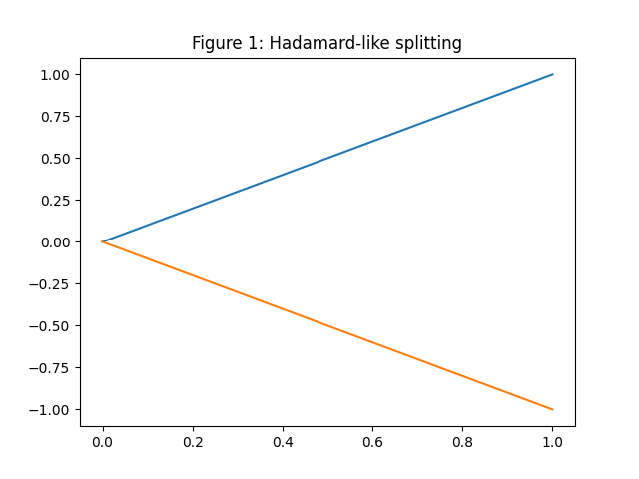
Figure 1:Symmetric bifurcation of the graphene channel produces equal-amplitude splitting of the input field. At critical coupling, each branch carries 1/√2 of the input amplitude, corresponding to a Hadamard-like transformation in the wave domain.
IV. XOR-LIKE LOGIC VIA INTERFERENCE

Two input signals ψ₁ and ψ₂ are combined at a merging node. The resulting output is:
ψ_out = ψ₁ − ψ₂
Constructive and destructive interference produce XOR-like behavior:
- Same inputs → cancellation → 0
- Opposite inputs → amplification → 1
A π-phase shift required for XOR operation is naturally introduced via the Möbius boundary condition.
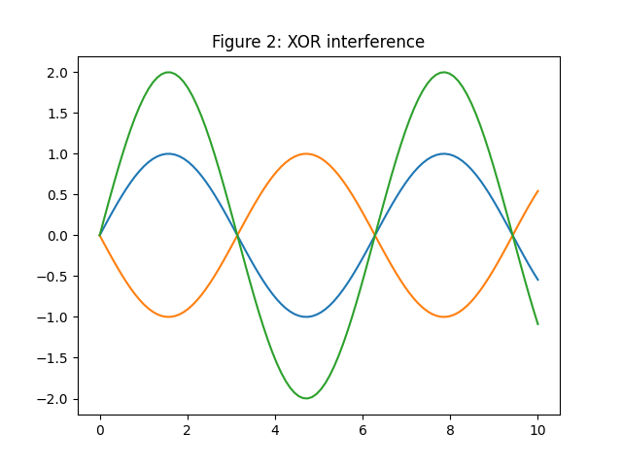Figure 2:Interference of two input waves produces XOR-like logic. A π-phase shift introduced along one path enables destructive interference for identical inputs and constructive interference for opposite inputs.

V. CNOT-LIKE CONDITIONAL SWITCHING

A control channel ψ_c modulates the coupling experienced by a target channel ψ_t. The output of the target is given by:
ψ_out = ψ_t · f(ψ_c)
where:
- f(ψ_c) = +1 for ψ_c > 0
- f(ψ_c) = −1 for ψ_c < 0
Thus, the target undergoes a phase inversion only when the control is in the “1” state.
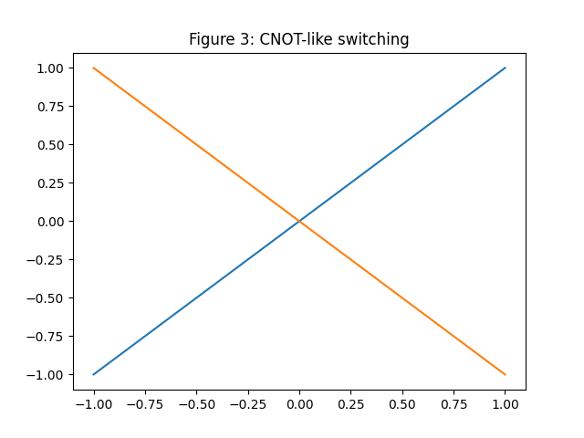Figure 3: Conditional phase inversion of the target signal controlled by a secondary channel. The coupling strength is modulated by the control state, enabling CNOT-like logic behavior.

VI. SPATIOTEMPORAL DYNAMICS

Numerical simulations show that the system evolves toward stable domain wall configurations. The domain wall remains robust under moderate perturbations and can be dynamically manipulated through phase gradients and coupling modulation.
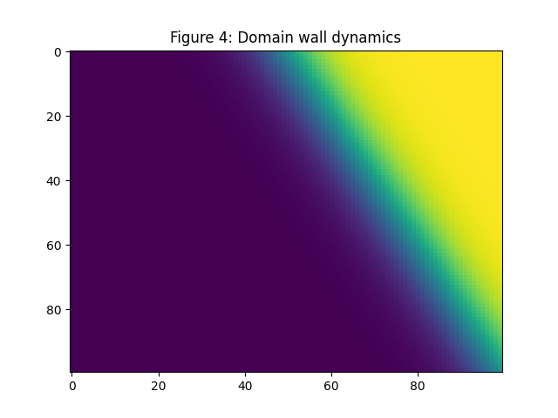Figure 4: Spatiotemporal evolution of the nonlinear field ψ(s,t). Domain walls emerge, propagate, and interact under nonlinear coupling, forming the basis of dynamic logic operations.

VII. DISCUSSION

The presented system is entirely classical and does not rely on quantum entanglement or measurement-induced collapse. However, its state space and transformations are mathematically analogous to qubit operations, enabling the implementation of a universal gate set (Hadamard and CNOT-like operations).
The use of geometry and boundary conditions to enforce phase coherence provides robustness against noise and enables operation at room temperature. This distinguishes the system from both digital transistor logic and quantum computing platforms.
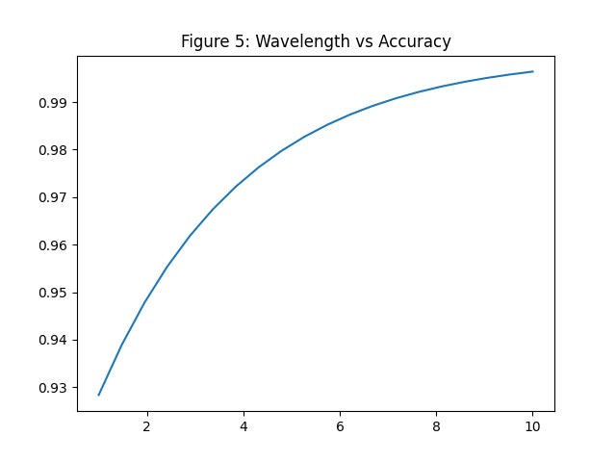
FIG. 5: Wavelength-dependent accuracy of wave-based logic operations. Accuracy increases with wavelength due to enhanced phase coherence and reduced interference noise. At shorter wavelengths, phase mismatch and nonlinear perturbations degrade logical fidelity, while longer wavelengths stabilize domain wall propagation and improve computation reliability.
VIII. CONCLUSION
We have demonstrated that domain wall dynamics in serpentine graphene–hBN heterostructures enable phase-controlled logic operations analogous to qubit gates within a classical framework. These results establish a pathway toward robust, room-temperature wave-based computation using topologically constrained nonlinear fields.
CONFLICT OF INTEREST
The authors declare no conflicts of interest.
DATA AVAILABILITY
Data are available from the corresponding author upon reasonable request.
[1] J. S. Kilby, IEEE Trans. Electron Devices 23, 648 (1976).
[2] K. S. Novoselov et al., Science 353, aac9439 (2016).
[3] M. A. Nielsen and I. L. Chuang, Quantum Computation and Quantum Information (Cambridge University Press, 2000).
[4] T. Dauxois and M. Peyrard, Physics of Solitons (Cambridge University Press, 2006).
[5] A. V. Chumak et al., Nat. Phys. 11, 453 (2015).

