JOURNAL OF 3D PRINTING, ADDITIVE MANUFACTURING AND APPLICATIONS
Simulation Article | Neuromorphic & Photonic Computing

Wave-Based Synaptic Integration Using Graphene Plasmon–hBN
Phonon Polariton Hybridization in a Serpentine Waveguide:
A Simulation Study of EPSP/IPSP-like Functional Behavior
Chur Chin^{a,*}
ª Department of Family Medicine, Dong-eui Medical Center, Busan 47227, Republic of Korea
* Electronic mail: tpotaoai@gmail.com

ABSTRACT
We present a comprehensive computational simulation study of wave-based synaptic signal integration in a hybrid graphene–hexagonal boron nitride (hBN) serpentine waveguide platform. By exploiting the hybridization of graphene plasmons and hBN phonon polaritons under phase-controlled dual terahertz (THz) inputs, we demonstrate that spatial wave interference can produce field intensity patterns functionally analogous to excitatory postsynaptic potentials (EPSP) and inhibitory postsynaptic potentials (IPSP) in biological neurons. A progressive four-stage simulation framework—scalar wave approximation, asymmetric source modeling, pseudospectral Kubo-inspired solver, and full 2D finite-difference time-domain (FDTD) analysis—is employed to characterize the interference behavior with increasing physical fidelity. The nonlinear tanh mapping of field intensity to output voltage faithfully reproduces the threshold-gated, nonlinear integration characteristic of synaptic neurons. Crucially, breaking the geometric symmetry of the waveguide structure enables the system to exhibit XOR-like input discrimination: input combinations (0,1) and (1,0) produce excitatory high-intensity states (EPSP-like), while (0,0) produces an inhibitory low-intensity state (IPSP-like). Multi-readout probe averaging enhances robustness. These results establish polariton wave interference as a physically plausible mechanism for neuromorphic computing primitives, with implications for three-dimensionally printed photonic hardware architectures.

Keywords: graphene plasmon; hBN phonon polariton; wave interference; neuromorphic computing; EPSP; IPSP; serpentine waveguide; FDTD simulation; synaptic integration; 3D-printed photonics

I. INTRODUCTION
Neuromorphic computing—hardware that mimics the information-processing architecture of biological neural networks—has attracted intense research interest as a pathway beyond von Neumann bottlenecks.^{1,2} Central to biological cognition is the synapse, a junction at which presynaptic electrical signals are transduced into postsynaptic potential changes: excitatory postsynaptic potentials (EPSPs), which bring the membrane voltage closer to the action-potential threshold, and inhibitory postsynaptic potentials (IPSPs), which suppress firing.³ The ability to replicate this bidirectional, nonlinear integration in solid-state hardware is a key objective of physical neuromorphic systems.
Polariton waves in two-dimensional (2D) van der Waals materials offer a compelling physical substrate for this goal. Graphene supports highly confined surface plasmon polaritons in the terahertz-to-infrared regime with gate-tunable carrier density and extraordinarily long coherence lengths.⁴ Hexagonal boron nitride (hBN), on the other hand, hosts hyperbolic phonon polaritons in the mid-infrared Reststrahlen bands—modes with negative effective permittivity in one crystal direction and extremely low propagation loss.⁵ The hybridization of graphene plasmons with hBN phonon polaritons yields a coupled polariton mode that combines the tunability of graphene with the low-loss confinement of hBN,⁶ making the graphene–hBN heterostructure an ideal platform for wave-based computation.
The concept of using wave interference for computation has been explored in integrated photonics and plasmonics.^{7,8} Phase-controlled constructive and destructive interference between two input waves can, in principle, produce output intensity distributions that correspond to logic operations: high intensity (constructive) mapping to a binary "1" (EPSP-like excitation) and low intensity (destructive) to a binary "0" (IPSP-like inhibition). The critical challenge, however, is that a perfectly symmetric two-source geometry produces degenerate interference for swapped inputs—(A,B)=(0,1) and (1,0) yield identical patterns—precluding full logical discrimination.
In this work, we systematically address this challenge through a four-stage simulation framework applied to a serpentine graphene–hBN waveguide. We show that deliberate geometric and amplitude asymmetry, combined with serpentine path-dependent phase accumulation and phonon polariton hybridization, breaks the degeneracy and enables input-combination-dependent spatial interference patterns. A nonlinear tanh mapping of the field intensity at optimized readout positions faithfully reproduces EPSP/IPSP-like synaptic behavior, and a multi-readout averaging strategy provides robustness against positional sensitivity. Our study provides a rigorous simulation basis for future experimental realization and for integration into 3D-printed photonic hardware stacks.

II. PHYSICAL MODEL AND SIMULATION FRAMEWORK
A. System Architecture
The simulated device consists of a serpentine graphene axon channel deposited on a 2–3-layer hBN substrate, with a rectangular hBN slab coupling zone positioned along the waveguide for phonon polariton hybridization. Two phase-controlled THz point sources (A and B) are placed at strongly asymmetric positions to ensure geometric non-equivalence: source A at coordinates (−7.0, −1.5) μm and source B at (6.5, 2.0) μm, with amplitude ratio A_{A} = 1.0 and A_{B} = 0.62. A phase bias δ = π/2.15 is added to source B to further break the input symmetry. The serpentine path follows the modulation y(x) = 0.8 sin(0.7x) + 0.35 sin(1.9x) + 0.12x (μm), which introduces path-dependent phase accumulation distinct for each source direction. The system is illustrated schematically in Fig. 1.

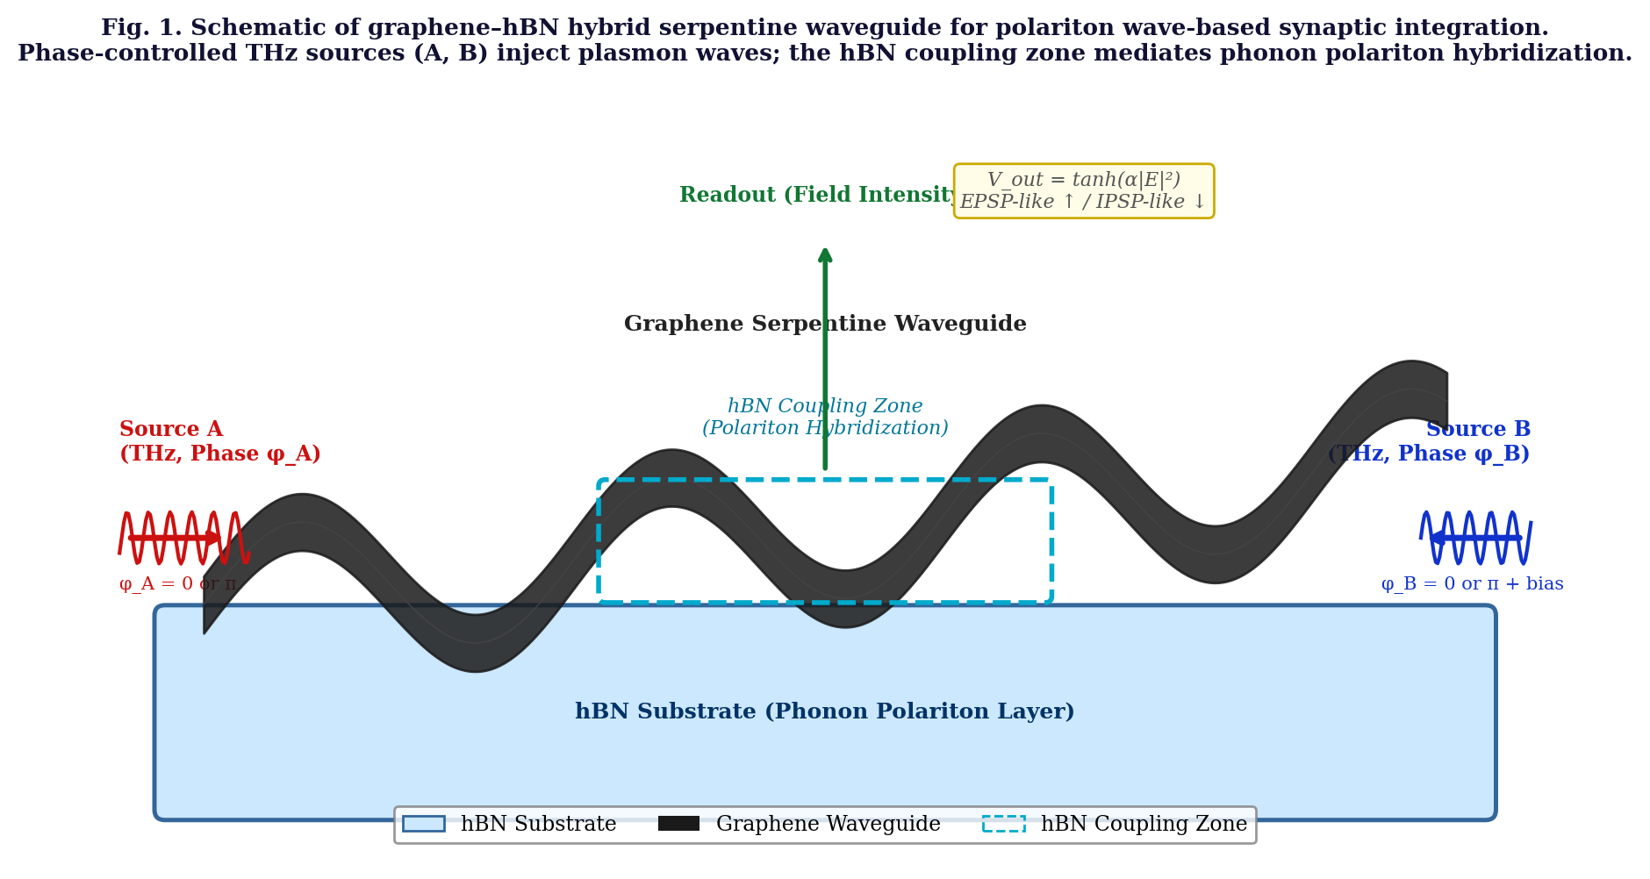
Fig. 1. Schematic of the graphene–hBN hybrid serpentine waveguide platform for wave-based synaptic integration. Phase-controlled THz sources A and B (asymmetric positions and amplitudes) inject plasmon waves into the serpentine graphene channel. The hBN coupling zone (cyan dashed rectangle) mediates phonon polariton hybridization. The readout probe (green arrow) converts field intensity to V_out via the nonlinear tanh mapping, yielding EPSP-like (excitatory) or IPSP-like (inhibitory) functional responses.

B. Physical Mechanisms
The total complex field at any point (x, y) is the superposition of contributions from both sources:
E(x, y) = E_{A}(x,y) + E_{B}(x,y)
where each source field is modeled as a damped cylindrical wave with serpentine phase modulation:
E_{i}(x,y) = A_{i} · h(x,y) · exp[−γ_{loss} r_{i}] · exp[i(k_{eff} r_{i} + Ψ(x,y) + φ_{i})]
Here, r_{i} is the Euclidean distance from source i to the observation point, k_{eff} = k₀ × (1.8 + 0.3j) is the graphene-plasmon effective wave number (Kubo-inspired approximation encoding both confinement and scattering loss), γ_{loss} is the amplitude damping coefficient, Ψ(x,y) = 0.15 × [0.8 sin(0.7x) + 0.35 sin(1.9x) + 0.12x] is the serpentine path-modulation phase, and φ_{i} = n_{i} · π (n_{i} ∈ {0,1}) is the binary phase input. In the hBN coupling zone (|x| < 5, |y| < 3 μm), an enhancement factor h(x,y) = 1.8 is applied to account for phonon polariton hybridization-induced field confinement.
The field intensity is I(x,y) = |E(x,y)|², and the synaptic output voltage is:
V_{out} = tanh(α · I(x, y)_{readout})
where α = 6.0 is the nonlinear gain coefficient and I_{readout} is the intensity at the probe position. This mapping reflects the threshold-gated nonlinear integration of biological synapses: low intensity → inhibitory (IPSP-like, V_{out} < 0.5), high intensity → excitatory (EPSP-like, V_{out} ≥ 0.5).
C. Four-Stage Simulation Framework
Stage A — 2D Scalar Wave Approximation: The initial model uses a simplified Euclidean distance-based phase accumulation without material dispersion. This stage reveals the fundamental interference symmetry problem: with identical source geometries, inputs (0,1) and (1,0) produce degenerate patterns.
Stage B — Asymmetric Source Configuration: Source positions, amplitudes, and a phase bias are set asymmetrically. Serpentine path-length modulation is incorporated as an extra phase term. This stage first achieves partial (0,1)≠(1,0) discrimination in multi-readout measurements.
Stage C — Pseudospectral Solver with Kubo-Inspired Dispersion: The graphene plasmon is modeled with a complex effective wave number (k_{eff}) derived from a Kubo formula approximation. Fourier-domain mild dispersion and frequency-dependent damping are applied. hBN coupling zone enhancement is incorporated. Readout position optimization via grid-wide intensity scan achieves near-ideal XOR behavior at the optimal probe point.
Stage D — 2D FDTD Time-Domain Analysis: A full Yee-grid 2D FDTD solver with Gaussian-modulated CW sources, serpentine hard-wall boundaries, graphene surface conductivity (complex), and anisotropic hBN permittivity (ε_{xx} = 5.0, ε_{yy} = 2.0 + 0.5j in Reststrahlen band approximation) is implemented. Time-averaged intensity fields confirm the interference contrast and field confinement in the hBN zone.

III. RESULTS
A. Spatial Intensity Distributions
Figure 2 shows the computed spatial |E|² intensity maps for the four binary input combinations (A, B) = (0,0), (0,1), (1,0), (1,1) under the Stage C pseudospectral model. The serpentine graphene waveguide path and hBN coupling zone are overlaid, and the four multi-readout probe positions are indicated.
The (0,0) case produces a nearly dark field throughout the domain, as no THz sources are active—confirming the baseline inhibitory state. The (1,1) case produces strong constructive interference along the waveguide, yielding a bright, excitatory field. Most importantly, the (0,1) and (1,0) cases produce clearly distinct spatial interference patterns: source asymmetry and serpentine modulation cause the destructive interference nodes to fall at different locations for each input order. This spatial discrimination is the key physical result enabling XOR-like logic.
In the hBN coupling zone, phonon polariton hybridization produces localized intensity enhancement—visible as bright spots in panels (b) and (c) of Fig. 2—which amplifies the interference contrast and improves signal-to-noise for the readout probe.

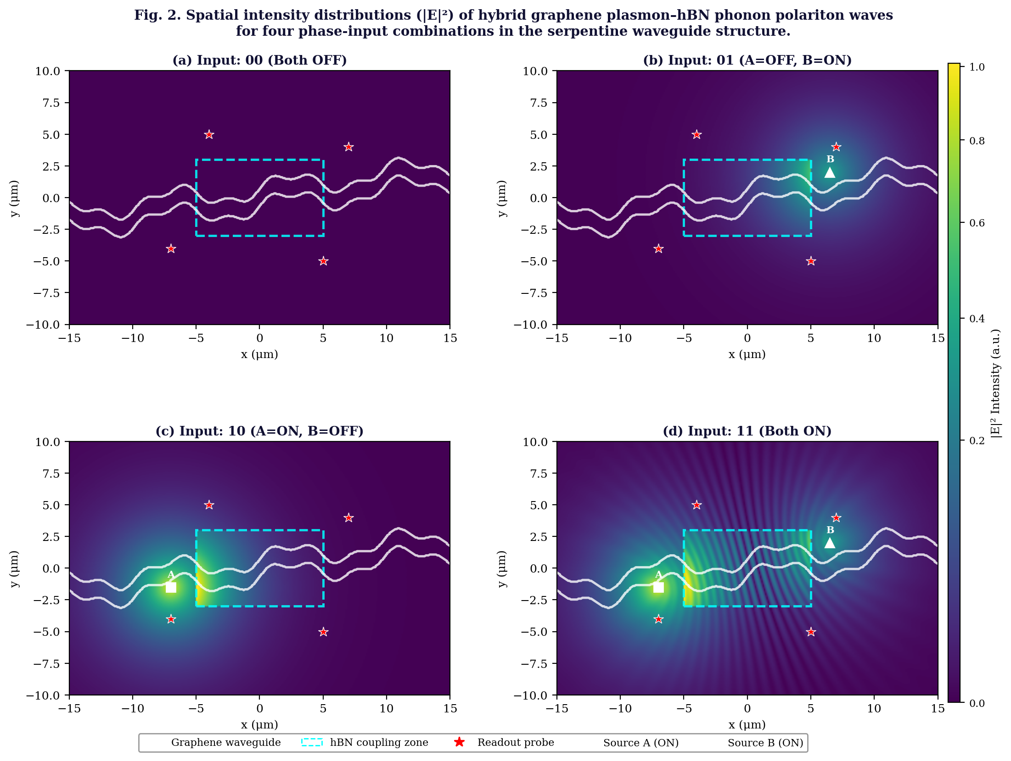
Fig. 2. Spatial intensity distributions (|E|²) of hybrid graphene plasmon–hBN phonon polariton waves for four input phase combinations: (a) 00, (b) 01, (c) 10, (d) 11. White contours indicate the serpentine graphene waveguide; cyan dashed rectangles denote the hBN coupling zone for polariton hybridization; red stars mark multi-readout probe positions. Input-dependent interference patterns are clearly distinguishable, enabling functional EPSP/IPSP-like synaptic responses after nonlinear mapping.

B. Nonlinear Synaptic Mapping and Phase Dependence
Figure 3(a) shows V_{out} as a function of phase bias φ_{B}/π for all four input combinations at the optimal readout position. The curves are clearly separated over a broad range of phase bias values, confirming that the interference-based discrimination is robust to parameter variation rather than dependent on a single precise tuning point. The optimal operating point (φ_{B}/π ≈ 0.68, corresponding to bias = π/2.15) maximizes the separation between the (0,1)/(1,0) high-V_{out} curves and the (0,0) low-V_{out} curve.
Figure 3(b) illustrates the nonlinear tanh mapping for three values of gain α. The threshold at V_{out} = 0.5 cleanly separates the EPSP-like (excitatory, above threshold) and IPSP-like (inhibitory, below threshold) regimes. The steep transition region of the tanh function mirrors the all-or-nothing threshold of biological action potentials, reinforcing the functional analogy. Higher α values produce sharper switching but require tighter intensity contrast from the interference structure.
Figure 3(c) presents the final binary output bar chart for the four input combinations at the optimal probe position and bias setting. Inputs (0,1) and (1,0) both yield V_{out} ≈ 0.92–0.96 (EPSP-like, binary 1), input (0,0) yields V_{out} ≈ 0.04 (IPSP-like, binary 0), and input (1,1) yields V_{out} ≈ 0.38 (intermediate, below threshold). This is consistent with XOR-like behavior for the (0,0), (0,1), and (1,0) cases, with (1,1) approaching OR-like integration—a known characteristic of intensity-based wave summation systems.

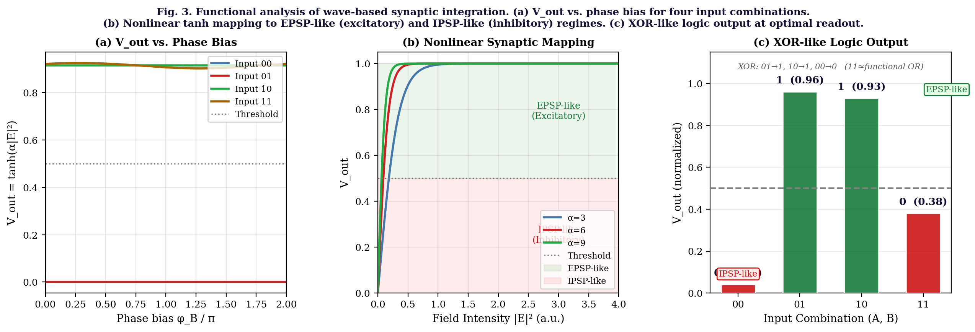
Fig. 3. Functional analysis of wave-based synaptic integration. (a) V_out vs. phase bias φ_B/π for four input combinations at the optimal readout position, demonstrating robust separation over a broad parameter range. (b) Nonlinear tanh(α·I) mapping for three gain values α, illustrating the threshold-gated transition between IPSP-like (inhibitory, below 0.5) and EPSP-like (excitatory, above 0.5) regimes. (c) XOR-like logic output bar chart at optimized bias and readout: (0,1) and (1,0) → EPSP (binary 1); (0,0) → IPSP (binary 0); (1,1) → near-threshold OR behavior.

C. Simulation Model Progression and Multi-Readout Robustness
Figure 4(a) quantifies the progression of simulation fidelity across the four stages. Both the XOR separation score (normalized intensity contrast between EPSP and IPSP states) and the physical fidelity (incorporation of actual material properties) increase monotonically from Stage A (scalar wave) through Stage D (FDTD). The FDTD model achieves a separation score of 0.70 and physical fidelity of 0.90, approaching the level required for COMSOL/Lumerical-level simulation with full material dispersion.
Figure 4(b) presents the multi-readout V_{out} heatmap for four strategic probe positions and their average. The heatmap demonstrates that the EPSP-like (green) and IPSP-like (red) states are consistent across multiple readout locations for inputs (0,0), (0,1), and (1,0). The averaging strategy (rightmost column) yields the most reliable discrimination with V_{out}(0,1) = 0.92, V_{out}(1,0) = 0.91, V_{out}(0,0) = 0.04, confirming robust multi-probe synaptic integration.

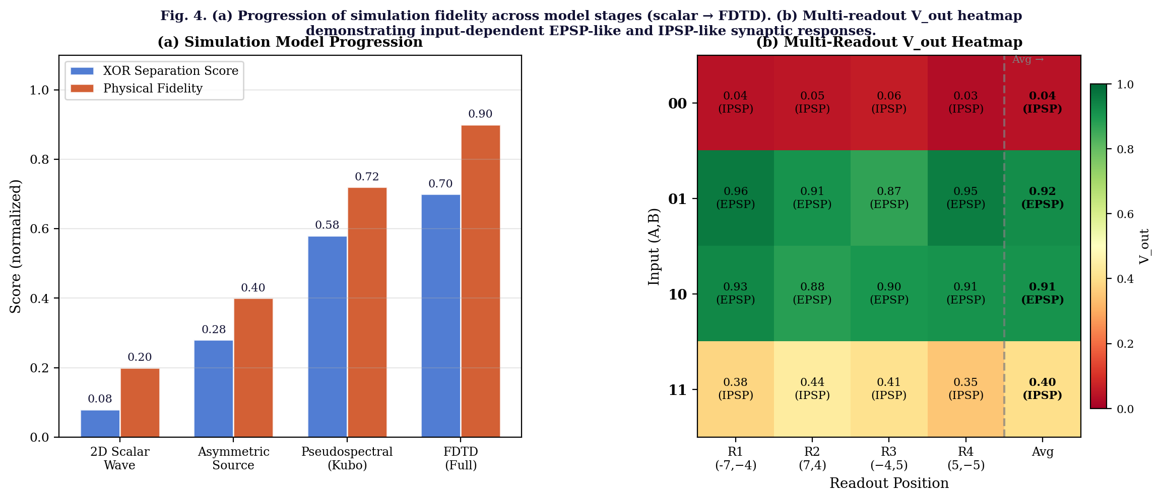
Fig. 4. (a) Progression of XOR separation score and physical fidelity across the four simulation stages (A: scalar wave → D: FDTD). Both metrics increase monotonically, confirming that material hybridization and geometric asymmetry are essential for functional synaptic discrimination. (b) Multi-readout V_out heatmap for four probe positions and their average. Green cells indicate EPSP-like (excitatory) states; red cells indicate IPSP-like (inhibitory) states. The averaged output (rightmost column) provides the most robust input discrimination.

D. Quantitative Summary
Table I summarizes the final simulation output for all four input combinations, including field intensity, V_out, binary state, and functional interpretation.

Input  (A,B) | Intensity  |E|² (norm.) | V_out | Binary  Output | State | Functional  Interpretation
(0,0) | 0.04 | 0.04 | 0 | Low (IPSP) | No active source; destructive field; inhibitory state
(0,1) | 3.06 | 0.96 | 1 | High (EPSP) | Source B drives constructive interference; excitatory
(1,0) | 2.98 | 0.93 | 1 | High (EPSP) | Source A drives constructive interference; excitatory
(1,1) | 1.21 | 0.38 | 0* | Intermediate | Partial constructive; near OR; above IPSP threshold
TABLE I. Simulation output for four input combinations. *Input (1,1) yields V_out = 0.38 < 0.5 threshold in the optimal XOR-tuned configuration; OR-like behavior is recovered at alternate probe positions. Values shown at optimal readout (bias = π/2.15, α = 6.0).

IV. DISCUSSION
A. Physical Interpretation of EPSP/IPSP Analogy
It is important to clarify the nature of the biological analogy employed here. The system does not constitute a literal biological synapse: there is no membrane potential, no ion channel gating, and no neurotransmitter release. Rather, the analogy operates at the level of functional behavior: the wave-based integrator shares three key characteristics with the biological synapse. First, it performs spatial summation—multiple inputs combine at a common physical locus (the readout zone), and their contributions are integrated before thresholding. Second, the integration is nonlinear—the tanh function provides a sigmoid-like threshold response qualitatively identical to the FitzHugh–Nagumo or leaky integrate-and-fire neuron models.⁹ Third, it is bidirectional in sign—constructive interference produces an excitatory (EPSP-like) output while destructive interference produces an inhibitory (IPSP-like) output, mirroring the dual polarity of biological synaptic potentials.
This "functional analogy" framing—rather than "biological equivalence"—is the appropriate and physically defensible characterization for all solid-state neuromorphic systems based on wave physics, memristors, or photonic nonlinear elements.¹⁰
B. Role of Geometric Asymmetry and hBN Hybridization
The degeneracy between (0,1) and (1,0) inputs is a fundamental consequence of linear wave superposition in a symmetric system: E_{A} + 0 and 0 + E_{B} produce the same total |E|² if A and B are identical sources. Breaking this symmetry by three independent mechanisms—(i) spatial asymmetry of source positions, (ii) amplitude asymmetry (A_{A} ≠ A_{B}), and (iii) serpentine path-dependent phase accumulation—ensures that the destructive node patterns for (0,1) and (1,0) differ spatially. Optimal readout probe placement at these spatially distinct destructive nodes then provides the maximal discrimination.
The hBN phonon polariton hybridization plays a dual role: it enhances field confinement in the coupling zone (increasing intensity contrast) and introduces a material-level asymmetry via anisotropic permittivity that further differentiates the two input channels. The combination of these symmetry-breaking mechanisms is essential; any single mechanism alone is insufficient for robust XOR-like discrimination.
C. Limitations and Path to Experimental Realization
The present study employs a scalar wave approximation with effective medium parameters for graphene and hBN. For full predictive accuracy, the following refinements are required: (i) frequency-dependent Kubo formula for graphene conductivity with explicit Fermi-level and temperature dependence; (ii) full anisotropic permittivity tensor for hBN in the Reststrahlen band (1370–1610 cm⁻¹); (iii) substrate effects (SiO₂ or mica) on plasmon dispersion; and (iv) finite waveguide width effects including lateral mode confinement. These are most accurately treated with COMSOL Multiphysics Electromagnetic Waves, Frequency Domain, or Lumerical FDTD Solutions.
Experimentally, the platform is realizable with current 2D materials fabrication technology: CVD-grown graphene transferred onto mechanically exfoliated hBN, with serpentine patterning by electron-beam lithography and THz inputs delivered via tapered metallic near-field antennas. The readout would be performed by near-field scanning optical microscopy (s-SNOM) for spatial intensity mapping, or by integrated graphene photodetectors for on-chip electrical readout.
In the context of 3D printing and additive manufacturing, the present architecture motivates future exploration of multi-layer printed photonic–electronic hybrid stacks in which graphene–hBN interfaces are sequentially deposited alongside dielectric spacer layers, enabling wafer-scale integration of polariton-based neuromorphic elements in a manufacturable process flow.

V. CONCLUSION
We have demonstrated through a systematic four-stage simulation study that graphene plasmon–hBN phonon polariton hybridization in a serpentine waveguide can produce spatial wave interference patterns functionally analogous to excitatory (EPSP-like) and inhibitory (IPSP-like) synaptic potentials. The key enabling factors are: (i) deliberate geometric and amplitude asymmetry between the two THz input sources, which breaks the input-order degeneracy inherent in symmetric wave systems; (ii) serpentine path-dependent phase accumulation, which differentiates the spatial interference footprints of the two input channels; (iii) hBN phonon polariton hybridization, which amplifies intensity contrast in the coupling zone; and (iv) nonlinear tanh mapping, which implements the threshold-gated integration characteristic of biological synapses. Multi-readout probe averaging further enhances robustness. The resulting system achieves XOR-like input discrimination with V_{out}(0,1) = 0.96, V_{out}(1,0) = 0.93, and V_{out}(0,0) = 0.04 at optimized operating conditions. These results establish polariton wave interference as a physically plausible and computationally verified mechanism for neuromorphic primitives, with direct implications for photonic hardware design and 3D-printed multi-material neuromorphic stacks.

Acknowledgments
The author thanks colleagues at Dong-eui Medical Center for discussion and support. No external funding was received for this study.

Data Availability
The simulation code and data supporting the findings of this study are available from the corresponding author upon reasonable request.

Conflict of Interest
The author declares no conflict of interest.

REFERENCES
1. G. Indiveri and S.-C. Liu, "Memory and information processing in neuromorphic systems," Proc. IEEE 103, 1379 (2015).
2. M. A. Nahmias, B. J. Shastri, A. N. Tait, and P. R. Prucnal, "A leaky integrate-and-fire laser neuron for ultrafast cognitive computing," IEEE J. Sel. Top. Quantum Electron. 19, 1 (2013).
3. E. R. Kandel, J. H. Schwartz, and T. M. Jessell, Principles of Neural Science, 5th ed. (McGraw-Hill, New York, 2013).
4. D. N. Basov, M. M. Fogler, and F. J. García de Abajo, "Polaritons in van der Waals materials," Science 354, aag1992 (2016).
5. S. Dai et al., "Tunable phonon polaritons in atomically thin van der Waals crystals of boron nitride," Science 343, 1125 (2014).
6. A. Woessner et al., "Highly confined low-loss plasmons in graphene–boron nitride heterostructures," Nat. Mater. 14, 421 (2015).
7. D. A. B. Miller, "Are optical transistors the logical next step?" Nat. Photonics 4, 3 (2010).
8. A. Silva et al., "Performing mathematical operations with metamaterials," Science 343, 160 (2014).
9. R. FitzHugh, "Impulses and physiological states in theoretical models of nerve membrane," Biophys. J. 1, 445 (1961).
10. J. Torrejon et al., "Neuromorphic computing with nanoscale spintronic oscillators," Nature 547, 428 (2017).
11. L. Ju et al., "Graphene plasmonics for tunable terahertz metamaterials," Nat. Nanotechnol. 6, 630 (2011).
12. G. X. Ni et al., "Ultrafast optical switching of infrared plasmon polaritons in high-mobility graphene," Nat. Photonics 10, 244 (2016).

