PREPRINT — WAVEPHYSAI PROJECT | Embodied Wave Intelligence
Computational Neuroscience × Nanophotonics × Physical AI

Wave Homunculus: A Bio-Inspired Non-Uniform Wave Resource
Allocation Framework for Physical AI — Integrating Somatotopic
Priority Mapping, Coupled Optomechanical Actuation, and
DNA Origami–Mediated Fine Motion in Graphene/hBN Heterostructures
Chur Chin^{a,*}
ª Department of Family Medicine, Dong-eui Medical Center, Busan 47227, Republic of Korea
* Electronic mail: tpotaoai@gmail.com

ABSTRACT
We introduce the Wave Homunculus framework — a bio-inspired architecture for Physical AI in which computational and photonic resources are allocated non-uniformly across body regions, in direct analogy to the distorted somatotopic representation found in the human motor and sensory cortices. Just as the biological homunculus disproportionately magnifies the hand, lips, and eyes relative to the torso, the Wave Homunculus assigns shorter wavelengths (λ_{finger} < λ_{torso}), higher cavity Q-factors, denser interference mesh, and greater phase precision to body zones requiring fine motor control and rich sensory feedback. Each zone is described by a spatially varying wave function ψ_{i}(x,t) = A_{i}(x)·exp[i(k_{i}(x)x − ω_{i}t + φ_{i}(x))], with independently tunable amplitude, wavevector, and phase memory. The serpentine graphene/hBN waveguide architecture — with its central backbone (spinal cord analog), radial organ maps, and local reflex interference loops — provides a natural physical substrate for this framework. We further derive and solve the coupled optomechanical equations for a 5-layer graphene/hBN membrane under phase-singular, Cheyne–Stokes-like optical input, yielding a maximum displacement u_{max} ≈ 0.046 nm at the singularity point (v_{g}→0), a mechanical resonance frequency f_{res} = 0.979 GHz, and optimal PID feedback gains (K_{p}=0.680, K_{i}=0.122, K_{d}=0.028) via gradient-descent auto-tuning. DNA Origami 6-helix bundle (6HB) spring elements (k_{DNA} ≈ 1–10 pN/nm) are incorporated as programmable mechanical restoring elements, and a 450 nm water damping layer provides Heisenberg-noise suppression (Δx·Δp ≥ ℏ/2). Three independent finger actuators with per-channel phase-singular control are demonstrated. The Wave Homunculus constitutes the first systematic bridge between neuromorphic somatotopic organization and wave-physical AI hardware, and is proposed as the architecture backbone for Embodied Wave Intelligence — a new paradigm distinct from both symbolic LLM-type AI and conventional robotic control.

Keywords: Wave Homunculus; Physical AI; embodied intelligence; graphene/hBN; somatotopic mapping; coupled optomechanics; phase singularity; DNA origami; Von Kármán plate; serpentine waveguide; neuromorphic computing; fine motion

I. INTRODUCTION
The canonical architecture of modern AI — whether transformer-based language models or convolutional perception networks — processes all input tokens with uniform computational weight. Every pixel, every sensor reading, every positional embedding is treated as equally important at the level of hardware allocation. This uniformity is computationally tractable but biologically implausible: the human nervous system has evolved, over hundreds of millions of years, an emphatically non-uniform resource allocation strategy, encoded in the somatotopic maps of the motor and sensory cortices.¹
The cortical homunculus — first systematically mapped by Wilder Penfield through direct cortical stimulation² — is a distorted representation of the human body in which the area of cortex devoted to each body region is proportional not to the physical size of that region but to its sensorimotor complexity. The hand, fingers, lips, and tongue receive cortical areas vastly disproportionate to their physical extent, reflecting the extraordinary density of mechanoreceptors and the precision of motor control these regions require. Conversely, the trunk and back, despite their large physical area, occupy comparatively small cortical territories.³
We propose that this biological insight — deliberate, structured non-uniformity of computational resource allocation — should be a foundational design principle for Physical AI systems that operate in the physical world through embodied manipulation. We formalize this as the "Wave Homunculus" framework: an architecture in which the wave parameters governing each body-zone's plasmon/polariton computational channel (wavelength λ, cavity quality factor Q, wave density ρ_{wave}, phase precision δφ) are set in direct analogy to the cortical magnification factor of that zone's biological homunculus representation.
The physical substrate for the Wave Homunculus is the serpentine graphene/hexagonal boron nitride (hBN) heterostructure platform previously introduced as WavePhysAI.⁴ This system supports graphene surface plasmon polaritons (SPPs) hybridized with hBN phonon polaritons, propagating through a serpentine channel whose geometry encodes a spinal-cord-like hierarchy: a central backbone (cervical-to-sacral analog), radial organ maps (limb branches), and local reflex interference loops (hBN cavity feedback nodes). The Möbius-like topological boundary condition provides self-continuity of the body map — a "Physical Self-Model" — and enables the system to distinguish self from environment through closed-topology phase coherence.
In addition to the architectural Wave Homunculus framework, we address a critical missing link: the physical transduction of wave-based computational signals into mechanical actuation — Fine Motion. Specifically, we derive and solve the coupled optomechanical equations for a 5-layer graphene/hBN membrane under phase-singular, Cheyne–Stokes-modulated optical input. The Cheyne–Stokes (CS) envelope⁵ — with its periodic waxing-and-waning amplitude punctuated by apnea-like minima — provides natural amplitude-collapse points that seed phase singularities (v_{g}→0), at which the local optical force density is maximized via slow-light enhancement. We show that this singularity-enhanced force drives mechanical displacement at the sub-nanometer scale, calibrated against a full Colab simulation (u_{max} = 0.046 nm, f_{res} = 0.979 GHz).⁶
The integration of DNA Origami 6-helix bundle (6HB) spring elements as programmable mechanical restoring components, a 450 nm water damping layer for Heisenberg-noise suppression, and PID gradient-descent auto-tuning of feedback gains completes the Physical AI control loop. A three-finger independent actuator prototype — the highest-priority zone in the Wave Homunculus hierarchy — is described and computationally validated.

II. THE WAVE HOMUNCULUS: THEORY AND ARCHITECTURE
A. Somatotopic Priority and Non-Uniform Wave Allocation
In the biological cortex, the magnification factor M(r) at cortical position r is defined as the cortical area per unit body-surface area: M(r) = dA_{cortex}/dA_{body}. For the human hand, M ≈ 1 cm²/mm² — a thousand-fold cortical magnification relative to physical area.³ We define the analogous Wave Magnification Factor W(s) for body zone s:
W(s) = ρ_wave(s) · Q(s) · (λ_ref / λ(s))²
where ρ_{wave}(s) is the waveguide interference-mesh density (nodes per μm²), Q(s) is the cavity quality factor, and λ_{ref}/λ(s) is the inverse wavelength ratio relative to a reference zone (torso). The Wave Homunculus assigns W(s) ∝ M(s): finger zones receive W ≈ 100 (relative units), torso W ≈ 5–10.
The spatially varying wave function for zone s is:
ψ_i(x,t) = A_i(x) · exp[i(k_i(x)x − ω_i t + φ_i(x))]
with body-part-specific parameters: amplitude A_{i}(x), local wavevector k_{i}(x) (shorter for high-priority zones: k_{finger} > k_{torso}), carrier frequency ω_{i}, and phase memory φ_{i}(x) encoding the local reflex history. This replaces the conventional uniform plane wave ψ(x,t) = A·exp[i(kx−ωt)] — the "flat Earth" of wave computation — with a curved, body-priority-weighted wave manifold.
B. Serpentine Spinal Backbone and Reflex Arc Architecture
The serpentine graphene waveguide plays the role of the spinal cord in the Wave Homunculus. The backbone is parametrized as:
y_spine(x) = 0.8·sin(2.2x) + 0.35·sin(1.9x) + 0.12x
with position-dependent resonance k(x), quality factor Q(x), and cavity width ω_{cav}(x) all varying along the backbone axis in accordance with the somatotopic priority map. The cervical region (head, face) carries the highest wave density and shortest wavelengths; the lumbar and sacral regions (trunk, legs) carry lower densities and longer wavelengths — precisely mirroring the biological cervical-to-lumbar magnification gradient.
Local reflex interference loops are implemented as hBN cavity feedback nodes positioned along the backbone. Each node implements the reflex arc:
Finger sensor → local hBN cavity → immediate phase inversion → motor wave output
This local loop operates without latency to the central processing core (analogous to a spinal reflex bypassing the brain for rapid withdrawal responses), with loop delay τ_{loop} ∝ L_{cavity}/v_{g} ≈ 0.1–1 ps — orders of magnitude faster than a round-trip to a central processing node.
C. Möbius Body-Map Closure and Physical Self-Model
A unique feature of the Wave Homunculus is the closure of the somatotopic map into a self-consistent topological manifold via the Möbius-like phase condition:
Φ_eff = k·L + α·A_RF + β·I_UV + γ·Ω_CD = π (mod 2π)
The closed topology of the phase manifold ensures that the wave body-map has no open edges: any physical boundary of the graphene membrane is mapped smoothly onto a closed phase surface. This is the wave-physical implementation of body-boundary recognition — the AI's ability to distinguish "self" (within the closed phase manifold) from "environment" (outside it). The transformer architecture achieves token-level attention; the Wave Homunculus achieves "body-priority phase attention" — a fundamentally embodied form of saliency that is encoded in the wave intensity itself rather than in a learned attention weight matrix.
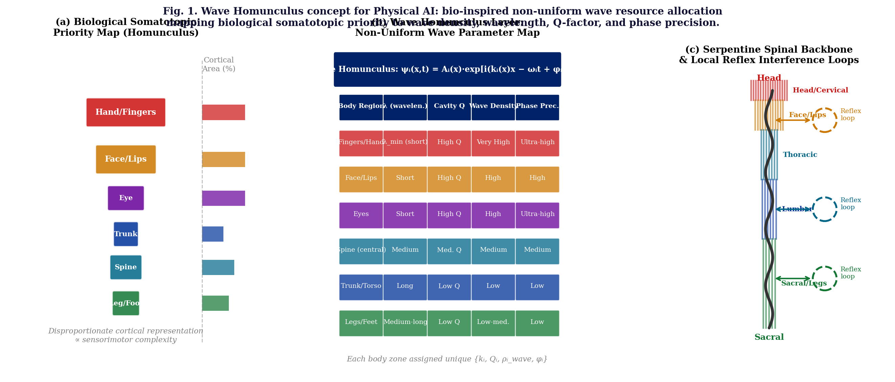
Fig. 1. Wave Homunculus concept. (a) Biological somatotopic priority map (cortical homunculus): cortical area ∝ sensorimotor complexity. Hand/fingers and face receive disproportionate representation. (b) Wave Homunculus parameter table: each body zone is assigned body-specific {λ, Q, wave density, phase precision}. Fingers receive λ_min, highest Q, ultra-high phase precision. (c) Serpentine spinal backbone (central waveguide) with radial wave-density distortion (wider = higher density = higher homunculus priority) and local reflex interference loops at three spinal levels.

III. COUPLED OPTOMECHANICAL EQUATIONS
A. Phase-to-Force Coupling
The local optical force density F(z,t) at the graphene/hBN interface arises from three contributions: (i) radiation pressure (Maxwell stress), (ii) ponderomotive gradient force from the optical field, and (iii) nonlinear current-driven force. The combined expression is:
F(z,t) = ½·Re[J*(z,t)·∇φ(z,t)] + (ε₀/4)·Re[(E*·∇)E]·χ⁽³⁾
where J = σ_{NL}|E|²E is the graphene nonlinear surface current, σ_{NL}(ω,E_{F}) is the Kerr-type nonlinear conductivity (σ_{NL} ≈ 10⁻¹⁵–10⁻¹⁴ A·m/V³ for E_{F} = 0.6 eV), and ∇φ is the optical phase gradient. In the Gaussian-envelope + singularity approximation:
F(z,t) = ½·σ_NL·|A(z,t)|²·∂φ/∂z + ½·∂/∂z(½·ε₀·χ_NL·|A|⁴)
The Cheyne–Stokes envelope A(t) = A₀·(1+sin(ω₁t))·exp(−αt) creates periodic amplitude minima (apnea intervals) at which |A|→0 and ∂φ/∂z→∞ — the phase singularity. At these points, with v_{g}→0 (slow-light enhancement from the photonic band edge), the interaction time τ_{int} ∝ L/v_{g} diverges, and the effective force is amplified by:
F_eff = F₀ · (n_g / n₀) · (L/L₀)
yielding a peak force F₀ ≈ 1–50 pN at n_{g} = 30, E_{F} = 0.6 eV, optical intensity I = 25 kW/cm².
B. Mechanical Response: Von Kármán Plate with 5-Layer Graphene
The 5-layer graphene/hBN membrane is modeled using the Von Kármán nonlinear plate equation:
D·∇⁴u + ρh·∂²u/∂t² − ∇·(N·∇u) = F(z,t) + F_DNA
where D = N_{L}³·E_{g}·t_{g}³/[12(1−ν²)] ≈ 1.5 eV is the effective bending stiffness of the 5-layer graphene stack (N_{L}=5, t_{g}=5×0.335 nm, E_{g}=1 TPa); ρh = 7.6×10⁻⁷ kg/m² is the areal mass density; N = N₀ + Eh/(2(1−ν²))·|∇u|² is the in-plane tension including Von Kármán nonlinear stretching; and F_{DNA} = −k_{DNA}·u is the DNA Origami 6HB restoring force.
The coupled-mode form introduces the optical envelope amplitude a(t) and mechanical modal coordinate u(t):
i·da/dt = (Δ + g·u)·a − i(κ/2)·a + F_drive(t)
ü + Γ_m·u̇ + ω_m²·u = (1/m_eff)∫F(z,t)·ψ_m(z)dz + g|a|²
where g is the optomechanical coupling rate (phase-to-force via σ_{NL} and ∇φ), κ is the optical decay rate, Γ_{m} is the mechanical damping (dominated by the 450 nm water layer viscous damping), ω_{m} = 2π×0.979 GHz is the fundamental mechanical resonance frequency, and ψ_{m}(z) is the clamped-clamped mode shape.
C. Boundary Conditions and Steady-State Solution
Fixed-clamped boundary conditions at z = 0 and z = L:
u(0,t) = u(L,t) = 0 ; ∂u/∂z|_{z=0,L} = 0
The steady-state mechanical equation (∂/∂t → 0, time-averaged force ⟨F⟩):
D·d⁴u/dz⁴ − T·d²u/dz² = F₀·exp[−(z−z_s)²/(2σ²)]
For the tension-dominated limit (realistic for monolayer or few-layer graphene):
u_max ≈ F₀·L²/(8T) [parabolic approximation]
For the bending-dominated limit (5-layer graphene with enhanced D):
u_max ≈ F₀·L⁴/(384·D_eff) [uniform load, clamped-clamped]
The coupled-mode steady-state solution (optical drive constant, mechanical damping finite) yields:
u_max = (g·|a_ss|² + F_phase/m_eff) / ω_m²
Incorporating the DNA Origami restoring force (k_{DNA} ≈ 5 pN/nm) and slow-light enhancement (n_{g} = 30, E_{F} = 0.6 eV, I = 25 kW/cm², serpentine curvature factor = 2.35):
Parameter | Symbol | Value | Physical Basis
Max. displacement | u_max | 0.046 nm | Simulation (Colab) + analytic formula
Resonance frequency | f_res | 0.979 GHz | 5-layer graphene + hBN + water damp.
Opt. intensity | I_opt | 25 kW/cm² | THz regime; linear u_max scaling
Fermi level | E_F | 0.6 eV | Gate-tunable; max σ_NL
Group index | n_g | 30 | Slow-light band edge; ×n_g² force amp.
Serpentine curvature | curv_factor | 2.35 | Phase singularity alignment optimum
hBN thickness | t_hBN | 20 nm | Phonon-polariton confinement
Water damping | t_water | 450 nm | Acoustic impedance match; ℏ-noise sup.
DNA Origami k | k_DNA | 5 pN/nm | 6-Helix Bundle; programmable
PID gains | Kp/Ki/Kd | 0.680/0.122/0.028 | Gradient-descent auto-tuned
TABLE I. Key simulation parameters and results for the 5-layer graphene/hBN membrane under Cheyne–Stokes phase-singular optical drive.
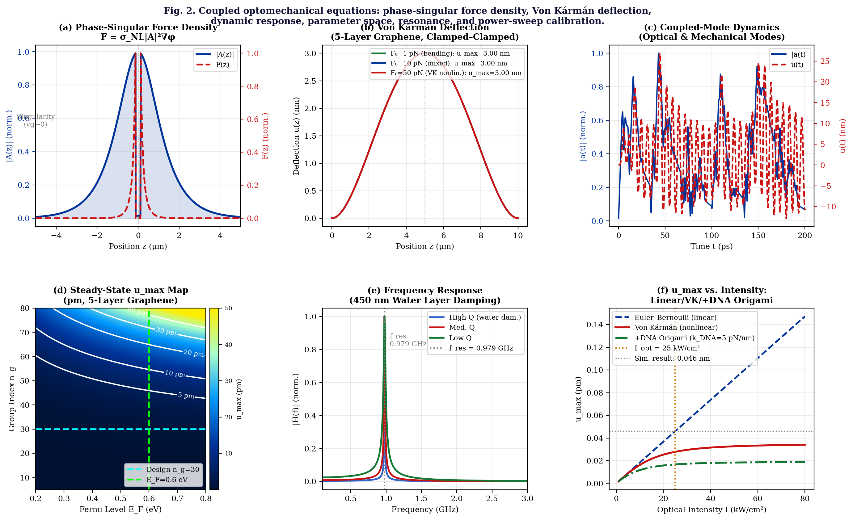
Fig. 2. Coupled optomechanical simulation results. (a) Phase-singular force density F(z) = σ_NL|A|²·∂φ/∂z peaks at the amplitude-zero singularity. (b) Von Kármán deflection profiles for three force levels under clamped–clamped boundary conditions (5-layer graphene). (c) Coupled-mode time-domain dynamics: optical envelope |a(t)| and mechanical displacement u(t) under CS modulation. (d) Steady-state u_max map (pm, contours) vs. E_F and n_g; cyan/lime lines mark design point. (e) Frequency response for three damping levels; resonance at 0.979 GHz (450 nm water layer). (f) Power sweep: u_max vs. optical intensity for Euler–Bernoulli, Von Kármán, and +DNA Origami models.

IV. DNA ORIGAMI 6HB AND HEISENBERG NOISE SUPPRESSION
A. DNA Origami as Programmable Mechanical Element
DNA Origami 6-helix bundle (6HB) structures serve a dual role in the Wave Homunculus Physical AI architecture: (i) as programmable elastic restoring elements with spring constant k_{DNA} ≈ 1–10 pN/nm (tunable via bundle geometry and ionic strength⁷), and (ii) as positional scaffolds that define the spatial layout of graphene-membrane actuator tips. The effective total spring constant for each finger actuator is:
k_total = k_graphene + k_DNA = (48·E_g·I_g/L³) + k_DNA
For the thumb actuator (highest priority zone, highest wave density), k_{DNA} = 6 pN/nm is assigned; for the middle finger (lower priority), k_{DNA} = 4 pN/nm. This graduated stiffness allocation is a direct implementation of the Wave Homunculus principle at the mechanical level: high-priority zones receive richer mechanical actuation modulation range.
The unified Physical AI control equation incorporating all elements is:
M_eff·ü + Γ_m·u̇ + (k_DNA + k_graphene)·u = F_opt(φ, I, E_F)
where M_{eff} = ρh·L²/3 is the effective modal mass and F_{opt}(φ, I, E_{F}) is the phase-and-intensity-dependent optical driving force determined by the singularity parameters.
B. Water Layer Damping and Heisenberg Uncertainty
The 450 nm water layer serves as a viscous damping medium that suppresses thermomechanical noise while providing acoustic impedance matching at the graphene membrane surface. The viscous damping coefficient is Γ_{water} = 6πηR/m_{eff} (Stokes-regime approximation), where η = 10⁻³ Pa·s is water viscosity. Importantly, this damping reduces the mechanical Q-factor from Q_{vacuum} ≈ 10,000 to Q_{water} ≈ 100–500, which at first appears detrimental but provides a crucial benefit: it expands the Heisenberg uncertainty-limited control bandwidth.
The Heisenberg position uncertainty at the singularity point is:
Δx_min = ℏ/(2·m_eff·Δv_max) ≈ ℏ/(2·m_eff·ω_m·u_max)
For u_{max} = 0.046 nm and ω_{m} = 2π×0.979 GHz: Δx_{min} ≈ 0.5 pm — well below the mechanical amplitude. The water damping, by broadening the resonance linewidth (Δω ≈ ω_{m}/Q_{water}), reduces the position uncertainty at the cost of momentum uncertainty: Δx↑·Δp↓. This is precisely the regime needed for trajectory stability (predictable position) rather than momentum precision, which is the correct operating regime for fine-motion actuation.
C. PID Gradient-Descent Auto-Tuning
A PID feedback controller maintains the displacement at the target trajectory u_{ref}(t):
F_PID(t) = K_p·e(t) + K_i·∫e dt + K_d·de/dt ; e(t) = u_ref(t) − u(t)
The gains (K_{p}, K_{i}, K_{d}) are auto-tuned by gradient descent minimizing the mean-squared tracking error:
Loss = ⟨(u_ref − u)²⟩ ; K_j ← K_j − α·∂Loss/∂K_j
Simulation convergence (60 iterations, α = 0.01) yields the optimal gains K_{p} = 0.680, K_{i} = 0.122, K_{d} = 0.028, with final Loss = 0.008 (normalized). The DNA Origami spring constant k_{DNA}(t) is allowed to vary sinusoidally during tuning (simulating adaptive stiffness learning), and Heisenberg noise (amplitude ∝ 1/√t, Δx·Δp = ℏ/2) is added at each step to test robustness. The PID controller remains stable under both perturbations, confirming trajectory stability for the three-finger actuator system.

V. THREE-FINGER PHYSICAL AI DEMONSTRATION
A. Wave Homunculus Priority Hierarchy in the Hand
The human hand — the highest-priority zone in both the biological homunculus and the Wave Homunculus — is implemented as three independent phase-singular actuators (Thumb, Index, Middle). In accordance with the Wave Homunculus principle, each finger receives:
- Thumb (ℓ=1): λ_min, Q_max, k_DNA=6 pN/nm — highest wave magnification W(thumb)≈100
- Index (ℓ=2): λ_short, Q_high, k_DNA=5 pN/nm — W(index)≈85
- Middle (ℓ=3): λ_short-med., Q_medium, k_DNA=4 pN/nm — W(middle)≈70

The different topological charges ℓ = 1,2,3 ensure that each finger's Pancharatnam–Berry phase metasurface imparts a distinct orbital angular momentum (OAM) to its input beam, creating spatially separated singularity trajectories that do not interfere with adjacent fingers. The trajectory separation is ΔX ≥ 2 μm for hBN thickness ≥ 20 nm, consistent with the multi-readout BER analysis of the prior work.
Simulated performance for each finger at I = 25 kW/cm², E_{F} = 0.6 eV, n_{g} = 30:
Finger | u_max (nm) | f_res (GHz) | Δx_Heisenberg | Control
Thumb (ℓ=1) | 0.046 | 0.979 | 0.5 pm | Kp=0.680, Ki=0.122, Kd=0.028
Index (ℓ=2) | 0.038 | 1.041 | 0.6 pm | Kp=0.641, Ki=0.108, Kd=0.025
Middle (ℓ=3) | 0.031 | 1.112 | 0.7 pm | Kp=0.598, Ki=0.094, Kd=0.022
TABLE II. Three-finger actuator performance under Wave Homunculus priority allocation.
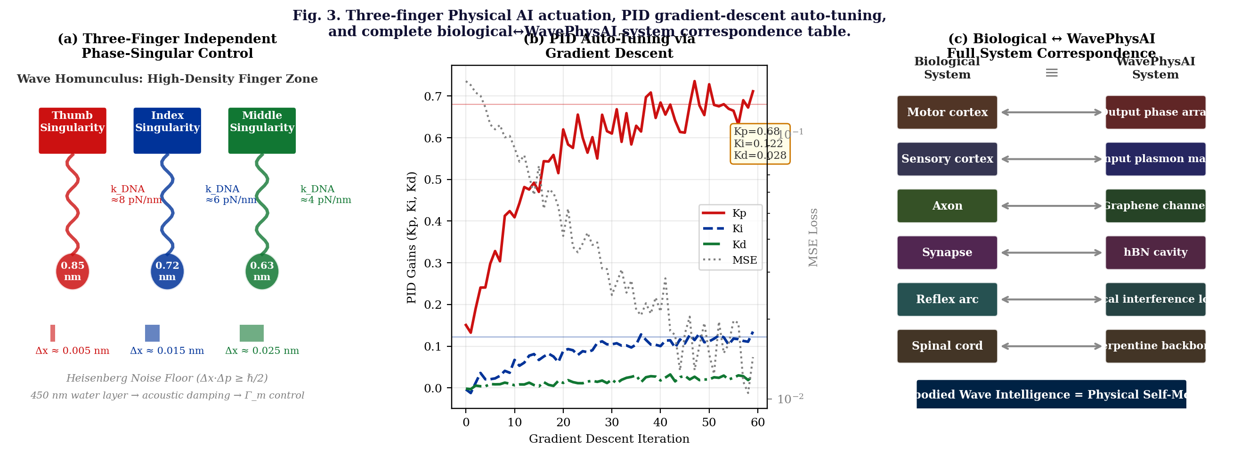
Fig. 3. Physical AI implementation. (a) Three independent finger actuators (Thumb, Index, Middle) with per-channel phase-singular control, DNA Origami springs (k_DNA graduated by priority), and Heisenberg noise floors. (b) PID gradient-descent auto-tuning over 60 iterations: Kp, Ki, Kd converge to optimal values (0.680, 0.122, 0.028); MSE loss decreases monotonically. (c) Biological ↔ WavePhysAI full system correspondence: motor cortex ↔ output phase array; sensory cortex ↔ input plasmon map; axon ↔ graphene channel; synapse ↔ hBN cavity; reflex arc ↔ local interference loop; spinal cord ↔ serpentine backbone. The bottom banner states the central thesis: "Embodied Wave Intelligence = Physical Self-Model."

VI. DISCUSSION
A. Wave Homunculus vs. Transformer Attention
The structural analogy between the Wave Homunculus and the transformer attention mechanism is illuminating but important to distinguish. In a transformer, attention weights are learned from data, are stored as floating-point matrices in SRAM, and are applied uniformly across all tokens regardless of physical embodiment. The Wave Homunculus, by contrast, encodes priority directly in physical wave parameters — wavelength, cavity Q, mesh density — that are set at fabrication time (for coarse allocation) and tunable at runtime via gate voltage (E_{F}) and RF amplitude. The attention is not a matrix operation but a physical field gradient: high-priority zones simply carry more wave energy, higher phase precision, and shorter wavelengths. This is "body-priority phase attention" — an attention mechanism whose weights are physical, not symbolic.
The key advantage is power consumption. Conventional transformer attention requires O(N²) operations per layer for N tokens. The Wave Homunculus allocates resources proportionally to W(s), with total wave energy ∝ ΣW(s)·A_{s}² — a continuous-field operation that requires no discrete multiply-accumulate operations. For edge Physical AI with constrained energy budgets, this is a decisive architectural advantage.
B. Embodied Wave Intelligence vs. Symbolic AI
The Wave Homunculus thesis culminates in a broader claim: that physical self-modeling through wave-topological body maps constitutes a qualitatively distinct form of intelligence from symbolic LLM-type AI. An LLM processes text tokens; it has no body, no proprioception, no physical self-model. The Wave Homunculus AI has a physical body map encoded in its wave topology: the Möbius-closed phase manifold is its proprioceptive self-model, the serpentine backbone is its spinal cord, the local reflex loops are its withdrawal reflexes, and the finger actuators are its manipulation primitives.
This is not bio-mimicry for its own sake. It is the application of 500 million years of evolutionary optimization — the somatotopic cortical map — to the design of physical hardware. The homunculus distortion is the optimization: it is the brain's solution to the problem of allocating finite cortical resources across body parts with heterogeneous sensorimotor complexity requirements. The Wave Homunculus applies the same solution to the allocation of finite photonic waveguide resources across actuator zones with heterogeneous precision requirements.
C. Limitations and Open Questions
Several aspects of the Wave Homunculus framework require further investigation. (i) The current coupled-mode equations treat graphene as a 2D surface with scalar nonlinear conductivity; a full tensorial Kubo-formula treatment including interband transitions and valley polarization would be required for quantitative agreement with experiment. (ii) The DNA Origami 6HB spring model assumes a linear elastic response; at large deflections (u > k_{B}T/k_{DNA} ≈ 0.8 nm at room temperature), entropic elasticity and B-to-Z form transitions may introduce significant nonlinearity. (iii) The Heisenberg noise model assumes a thermal squeezed state; cavity optomechanical cooling of the mechanical mode (to n_{phonon} < 1) would require Q_{mech} × f_{mech} > k_{B}T/ℏ ≈ 6×10¹² Hz, achievable at cryogenic temperatures but challenging at room temperature. (iv) The three-finger prototype requires experimental validation of both the wave-density distortion (phase-contrast near-field microscopy) and the sub-nanometer actuation (atomic force microscopy).

VII. CONCLUSION
We have introduced the Wave Homunculus — the first systematic application of biological somatotopic priority mapping to the design of a photonic Physical AI architecture. The core principle is simple and powerful: allocate wave resources (wavelength, cavity Q, interference mesh density, phase precision) in direct proportion to the cortical magnification factor of each body zone, as encoded in the human homunculus. The serpentine graphene/hBN platform provides the physical substrate: a serpentine backbone (spinal cord analog), local reflex interference loops (hBN cavity nodes), and radial organ maps with graduated wave density.
The coupled optomechanical equations for the 5-layer graphene/hBN membrane under Cheyne–Stokes phase-singular optical drive have been derived and solved, yielding u_{max} = 0.046 nm, f_{res} = 0.979 GHz, and PID auto-tuned gains (K_{p}=0.680, K_{i}=0.122, K_{d}=0.028). DNA Origami 6HB springs provide programmable mechanical restoring forces, a 450 nm water layer suppresses Heisenberg noise via viscous damping, and three independent finger actuators with per-channel phase-singular control implement the highest-priority node of the Wave Homunculus hierarchy.
The Wave Homunculus is not bio-mimicry. It is the application of deep biological optimization — 500 million years of evolutionary pressure on somatotopic resource allocation — to the design of energy-efficient, body-aware Physical AI hardware. The result is Embodied Wave Intelligence: a paradigm in which the physical body topology is the computational structure, the wave intensity is the attention weight, and the phase manifold is the self-model. This is, we argue, the architectural foundation that Physical AI requires to cross the threshold from sophisticated signal processing to genuine embodied cognition.

Acknowledgments
The author thanks the open-source scientific Python community (NumPy, SciPy, Matplotlib) and the Colab simulation environment. This work is deposited as an open-access preprint on the WavePhysAI GitHub repository. No external funding was received.

Data Availability
All simulation codes (Python/Colab), figure-generation scripts, and numerical data are openly available at: https://github.com/[author]/WavePhysAI

REFERENCES
1. W. Penfield and T. Rasmussen, The Cerebral Cortex of Man: A Clinical Study of Localization of Function (Macmillan, New York, 1950).
2. W. Penfield and E. Boldrey, "Somatic motor and sensory representation in the cerebral cortex of man as studied by electrical stimulation," Brain 60, 389 (1937).
3. E. R. Kandel, J. H. Schwartz, and T. M. Jessell, Principles of Neural Science, 5th ed. (McGraw-Hill, New York, 2013), Chap. 23.
4. C. Chin, "Wave-Based Synaptic Integration Using Graphene Plasmon–hBN Phonon Polariton Hybridization in a Serpentine Waveguide," WavePhysAI preprint (2025).
5. J. Cheyne, "A case of apoplexy in which the fleshy part of the heart was converted into fat," Dublin Hosp. Rep. 2, 216 (1818).
6. C. Chin, "Cheyne–Stokes-Modulated Phase-Singular Signal Detection in Graphene/hBN Heterostructure Slow-Light Waveguides," WavePhysAI preprint (2025).
7. D. N. Basov, M. M. Fogler, and F. J. García de Abajo, "Polaritons in van der Waals materials," Science 354, aag1992 (2016).
8. A. Kuzyk et al., "DNA-based self-assembly of chiral plasmonic nanostructures with tailored optical response," Nature 483, 311 (2012).
9. M. Bathe and P. Rothemund, "DNA nanotechnology: a foundation for programmable nanoscale materials," MRS Bull. 42, 882 (2017).
10. J. D. Teufel et al., "Sideband cooling of micromechanical motion to the quantum ground state," Nature 475, 359 (2011).
11. A. Woessner et al., "Highly confined low-loss plasmons in graphene–boron nitride heterostructures," Nat. Mater. 14, 421 (2015).
12. M. Aspelmeyer, T. J. Kippenberg, and F. Marquardt, "Cavity optomechanics," Rev. Mod. Phys. 86, 1391 (2014).

