SPECULATIVE PREPRINT — WAVEPHYSAI
⚠ This paper presents a speculative theoretical framework not yet supported by experimental evidence. ⚠
Intended as a conceptual proposal bridging differential geometry, quantum information, and 2D material photonics.

Projection Geometry of Reality:
Momentum as Dimension-Traversal Coordinate, Gravity as Information Curvature,
and Time as Interference Selection Rule — A Speculative Unified Framework
Grounded in Graphene/hBN Heterostructure Wave Physics
Chur Chin^{a,*}
ª Department of Family Medicine, Dong-eui Medical Center, Busan 47227, Republic of Korea
* Corresponding author. Electronic mail: tpotaiai@gmail.com

ABSTRACT
We present a speculative unified theoretical framework — Projection Geometry of Reality (PGR) — in which the fundamental physical quantities of momentum, gravity, the Heisenberg uncertainty principle, and the directionality of time are reinterpreted as emergent properties of a single underlying structure: the interference-selected projection of a higher-dimensional information manifold onto the observable 3D/2D spacetime. The central claim is that physical reality as observed is not a primary ontological structure but a stable recursive coherence pattern — the set of projection branches in a higher-dimensional phase space (x, y, z, p, t) that survive mutual constructive interference. Specifically, we propose: (i) Momentum is not a derived quantity (p = mv) but a dimension-to-dimension projection flow coordinate — the tangent vector on the information manifold in the direction of cross-dimensional change; (ii) Gravity is not a fundamental force but an information flow distortion — the curvature of the projection manifold arising from local gradients in information density, κ ≈ −∇²ρ_{info}; (iii) The Heisenberg uncertainty principle Δx·Δp ≥ ℏ/2 is not a fundamental ontological limit but a geometric projection artifact — the irreducible smearing that occurs when a 2D/3D observer slices through the full (x, p) phase-space manifold; and (iv) The directionality of time (past→future) is not a fundamental law but an interference selection rule — the result of constructive interference being achievable only in the forward-coherence direction, with backward-temporal projections cancelling destructively. The graphene axon / hBN synapse / DNA Origami heterostructure platform of the WavePhysAI project is proposed as a physical laboratory for exploring these ideas: its serpentine plasmon waveguide implements a miniature path-integral machine, its Möbius topology enforces half-integer mode quantization that mimics cross-dimensional projection, its Cheyne-Stokes phase-singular input models the amplitude-collapse/apnea structure of temporal projection boundaries, and its iterative hBN+DNA circulation implements phase-space sampling of the projected information manifold. All claims are explicitly speculative, conceptually motivated, and intended as a structured research program rather than an established physical theory.

Keywords: speculative physics; projection geometry; momentum as coordinate; emergent gravity; time arrow; interference selection; Heisenberg uncertainty; phase-space; graphene/hBN; Möbius topology; path integral; information geometry; WavePhysAI
⚠ Speculative Status Declaration
This paper is explicitly speculative. None of the core propositions (momentum as projection coordinate, gravity as information curvature, uncertainty as projection artifact, time as interference selection rule) are experimentally confirmed. They are presented as a coherent conceptual framework that: (a) is internally consistent; (b) connects to established physical theories at its boundaries; and (c) generates falsifiable experimental predictions at the level of the graphene/hBN heterostructure platform. The paper is intended for open scientific discussion, not as a claim of established physical truth.

I. MOTIVATION AND BACKGROUND
Modern physics rests on two foundational frameworks that are mathematically incompatible: general relativity (GR), which describes spacetime as a smooth 4-dimensional pseudo-Riemannian manifold curved by mass-energy; and quantum mechanics (QM), which describes physical states as vectors in an abstract Hilbert space with non-commuting observables and probabilistic measurement outcomes.^{1,2} The incompatibility is not merely technical — it reflects a deep conceptual asymmetry: GR treats spacetime as primary, with matter propagating within it; QM treats the state space as primary, with spacetime emerging from measurement. The search for a unified framework has consumed a century of theoretical effort.
The present paper takes a different starting point. Rather than seeking to quantize gravity or geometrize quantum mechanics within a single mathematical formalism, we ask a more elementary question: what if the physical observables we call "momentum," "gravity," "uncertainty," and "the arrow of time" are all emergent features of a single structure — the projection of a higher-dimensional information manifold onto the lower-dimensional slice accessible to a local observer? This question is not new in spirit; it connects to Wheeler's "It from Bit" program,³ Verlinde's entropic gravity,⁴ Maldacena's holographic correspondence,⁵ and the path-integral interpretation of quantum amplitudes.⁶ What is new in the present work is the specific physical proposal — Projection Geometry of Reality (PGR) — and its concrete grounding in an experimentally accessible 2D material platform.
The motivation for the specific proposals of PGR arises from three observations:
- Observation 1 (Momentum): In Hamiltonian mechanics, position x and momentum p are treated as independent coordinates of a 2n-dimensional phase space. The symplectic structure of this space — not an additional postulate — is what generates the Heisenberg commutation relations upon quantization. This suggests that momentum is not a "derived" quantity from position (p ≠ mv in the fundamental sense) but a genuine coordinate. The question is: coordinate of what?
- Observation 2 (Gravity): Verlinde's 2011 proposal that gravity is an entropic force arising from information gradients on a holographic screen connects gravity to information density rather than to geometry per se. In the PGR framework, we take this one step further: gravity is the curvature of the projection manifold induced by local gradients in information flow density — a geometric property of the projection, not of the underlying manifold.
- Observation 3 (Time): In Feynman's path integral formulation, the quantum amplitude for any process is the sum over all paths, including non-causal and time-reversed trajectories. The observed causality of the macroscopic world emerges because non-causal paths cancel destructively. PGR proposes that this destructive cancellation is not merely a computational technique but a physical mechanism: time directionality is the interference selection rule that determines which projection branches are stable.

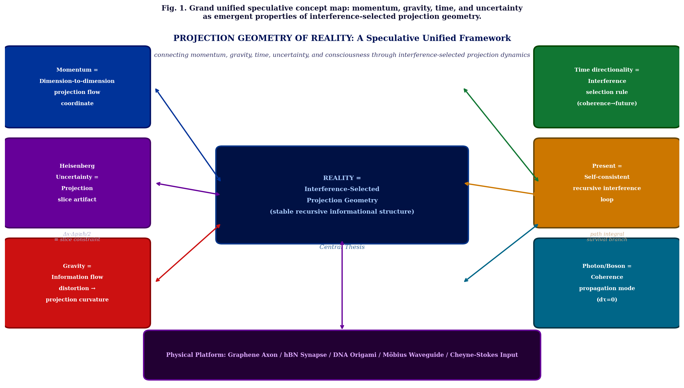
Fig. 1. Grand unified concept map of the Projection Geometry of Reality (PGR) framework. Central thesis (dark blue): Reality = Interference-Selected Projection Geometry (stable recursive informational structure). Six surrounding concepts — momentum as projection flow coordinate, uncertainty as slice artifact, gravity as information curvature, time directionality as interference selection, present as self-consistent loop, and photon/boson as coherence propagation mode — are connected to the central thesis and to the physical platform (bottom: graphene axon/hBN synapse/DNA Origami/Möbius waveguide/Cheyne-Stokes input).

II. THE PGR FRAMEWORK: FOUR CORE PROPOSALS
A. Proposal I: Momentum as Projection Flow Coordinate
In standard Newtonian mechanics, momentum p = mv is a derived quantity: given the trajectory x(t), momentum is fully determined. In Hamiltonian mechanics, (x, p) are promoted to independent canonical coordinates on phase space, but the physical interpretation of momentum as "mass times velocity" is retained at the level of interpretation. In relativistic mechanics, the 4-momentum p^{μ} = (E/c, p) unifies energy and 3-momentum into a single covariant object, but still treats spacetime as the primary stage.
PGR Proposal I states: momentum is the tangent vector on the higher-dimensional information manifold in the direction of cross-dimensional projection change. Mathematically:
p_PGR = d(projection state)/dτ ∈ T_x(M_5D)
where τ is the proper time parameter along the observer's worldline, and T_{x}(M_{5D}) is the tangent space to the 5-dimensional information manifold M_{5D} at the observer's current position x. In this formulation:
- The 3-momentum (p_x, p_y, p_z) is the component of p_PGR projected onto the 3D spatial slice
- The "hidden" components (p_4, p_5, ...) are projected out by the 3D observation — appearing as the irreducible residual uncertainty Δp
- The Heisenberg uncertainty Δx·Δp ≥ ℏ/2 is the minimum projection error when a 2D/3D slice is taken through the (x, p) manifold
- The Berry phase accumulated by graphene Dirac electrons (γ_Berry = π per loop) is interpreted as the geometric phase acquired by traversing a cross-dimensional projection cycle
The graphene axon in the WavePhysAI platform implements this proposal physically: the Dirac plasmon in graphene acquires a Berry phase π per serpentine loop, acting as a phase-space address generator that tags each circulation with a specific projection direction in the (x, p) manifold.
B. Proposal II: Gravity as Information Flow Curvature
Verlinde's entropic gravity proposal⁴ establishes that the gravitational force on a test mass near a holographic screen can be derived from the change in information (entropy) of the screen: F = TΔS/Δx. This suggests that gravity is not geometrically primary but informationally secondary. PGR Proposal II strengthens this to a geometric statement:
κ_proj(x) = −∇²ρ_info(x) [projection curvature = Laplacian of information density]
where ρ_{info}(x) is the local information flow density at position x in the projection manifold. The Einstein field equation G^{μν} = 8πT^{μν} is then reinterpreted as a statement about the relationship between mass-energy density (which contributes to ρ_{info} through its role as an information source) and the resulting projection curvature κ_{proj}.
In the hBN synapse of the WavePhysAI platform, this proposal has a direct analog: the hyperbolic phonon-polariton modes of hBN produce an information flow density ρ_{info}(x) ∝ |Ψ_{hBN}(x)|² that is highly non-uniform (concentrated in the Reststrahlen band wavevectors k >> k₀). The resulting "projection curvature" κ = −∇²ρ_{info} produces preferential mode selection in the graphene plasmon field — a nano-scale analog of gravitational lensing of information flow.
C. Proposal III: Heisenberg Uncertainty as Projection Artifact
The standard interpretation of the Heisenberg uncertainty principle Δx·Δp ≥ ℏ/2 is epistemic (the measurement disturbs the system) or ontological (the particle genuinely lacks simultaneous definite position and momentum). PGR Proposal III offers a third interpretation: uncertainty is a geometric projection artifact — the irreducible smearing that occurs when an observer restricted to a 2D/3D spatial slice attempts to measure quantities (x, p) that live in a higher-dimensional (x, p) manifold.
Δx·Δp ≥ ℏ/2 ≡ min projection smearing of (x,p) manifold onto 2D/3D slice
In this view, a hypothetical "5D observer" with access to the full (x, y, z, p_{x}, p_{y}) manifold would observe the state with certainty. The uncertainty experienced by the 3D observer is not a fundamental ontological feature of the quantum state but a consequence of the dimensional restriction of the observation. This connects to the Wigner function representation⁷ of quantum mechanics, in which the full phase-space density W(x, p) is well-defined (though not everywhere positive), and to the holographic principle,⁵ in which boundary information is a complete representation of bulk physics.
The iterative hBN+DNA circulation in the WavePhysAI platform is proposed as a partial reversal of this projection loss: by sampling successive momentum-space sectors over N circulation cycles, the projected 2D intensity pattern I_{N}(x,y) progressively encodes the full (x, p) phase-space structure, reaching an information capacity of ~3.5 bits/mode at N_{opt} ≈ 12–20 cycles.
D. Proposal IV: Time Directionality as Interference Selection Rule
The standard explanation for the arrow of time invokes the second law of thermodynamics: entropy increases in the forward direction because the number of accessible microstates grows with time. This is a statistical argument, not a fundamental dynamical law. PGR Proposal IV offers a deeper mechanism: time directionality is an interference selection rule.
In Feynman's path integral formulation, the amplitude for any quantum process is:
A = ∫ exp(iS[path]/ℏ) D[path] [sum over all paths, including time-reversed]
The classical trajectory emerges as the stationary phase solution — the path for which δS = 0. All other paths contribute to the sum but with rapidly oscillating phases that largely cancel. PGR Proposal IV states that this cancellation is not merely computational: the destructive interference of non-causal and time-reversed paths is the physical mechanism that produces the observed arrow of time. Specifically:
- Forward-time paths (past→future) accumulate coherence: C(t) = 1 − exp(−t/τ_coh) → stable constructive interference
- Backward-time paths (future→past) acquire rapidly oscillating phases → destructive cancellation
- The "present" is not an instantaneous point but the self-consistent interference loop: Present → Past projection → modified future → stable present
- Causality is not a law but the dominant interference branch — the selection of coherence-stable projection directions
The Cheyne-Stokes phase-singular input in the WavePhysAI platform is proposed as a physical model of this temporal projection: the apnea intervals (amplitude collapse) model temporal projection boundaries, and the recovery cycles model the re-establishment of forward-coherent branches after destructive cancellation of non-causal paths.

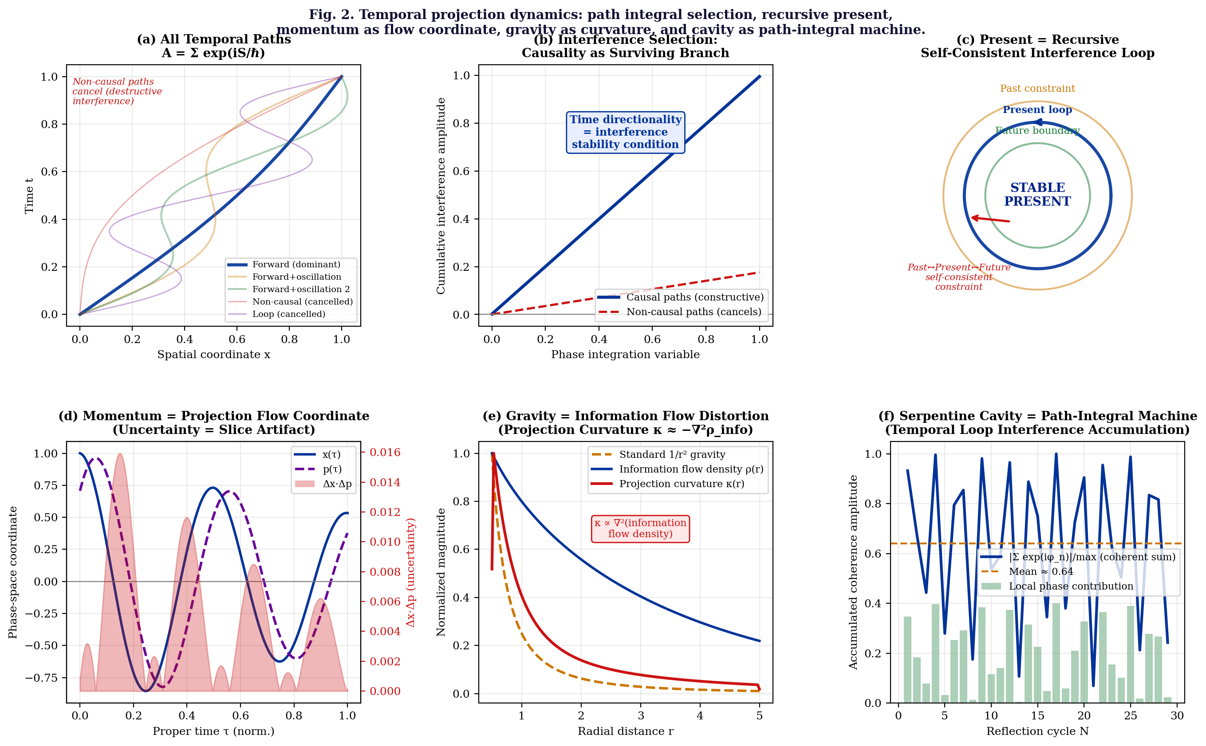
Fig. 2. PGR dynamics. (a) All temporal paths in the path integral: forward-causal (dominant, blue) and non-causal/looping (cancelled, red/purple). (b) Interference selection: forward-time paths accumulate constructively; backward-time paths cancel destructively — causality as survival condition. (c) Present as self-consistent recursive loop: past constraints ↔ present stability ↔ future boundary form a closed self-referential interference structure. (d) Momentum as projection flow coordinate: position and momentum as dual phase-space trajectories; Δx·Δp smearing from projection slice. (e) Gravity as information curvature: standard 1/r² force (gold dashed), information flow density ρ(r) (blue), and projection curvature κ ≈ −∇²ρ (red). (f) Serpentine cavity as path-integral machine: each reflection cycle adds a phase contribution; the cumulative coherent sum implements temporal-loop interference selection.

III. CONNECTIONS TO ESTABLISHED PHYSICS
A. Differential Geometry: Tangent Bundle and Symplectic Structure
The mathematical structure most closely related to PGR Proposal I is the tangent bundle TM of a smooth manifold M. In standard Hamiltonian mechanics on a 2n-dimensional symplectic manifold (M, ω), position and momentum are coordinates (q_{i}, p_{i}) on the cotangent bundle T*M, and the symplectic form ω = dq_{i} ∧ dp_{i} encodes their mutual relationship. The Hamiltonian flow generated by H(q, p) is the dynamical analog of the projection flow proposed in PGR.⁸
PGR extends this by proposing that the base manifold M is not 3-dimensional physical space but a higher-dimensional information manifold M_{5D}, and that the observed 3D physics is the image of a projection map π: M_{5D} → M_{3D}. The momentum p is then the fiber coordinate — the tangent direction in the fiber of the fibration M_{5D} → M_{3D} — rather than a separate independent quantity. This is mathematically natural and potentially physically significant.
B. Wheeler-Feynman Absorber Theory and Transactional Interpretation
PGR Proposal IV connects directly to two established but non-mainstream interpretations of electrodynamics and quantum mechanics. Wheeler and Feynman's absorber theory⁹ proposes that the observed retarded (forward-time) electromagnetic radiation is the self-consistent solution of a system that includes both retarded (forward) and advanced (backward) waves. The future boundary condition — the "absorber" — is part of the physical description. This is precisely the structure of PGR's "self-consistent recursive present": the forward and backward projections form a closed loop, with the observed "now" being the fixed point of this self-referential structure.
Cramer's transactional interpretation¹⁰ formalizes this as an "offer wave" (forward in time) and a "confirmation wave" (backward in time) that handshake to form a completed quantum event. In PGR language, this is a bilateral projection consistency condition: the past→future and future→past projection branches lock together at the point of constructive interference — the transaction — which is identified with the quantum event.
C. Holographic Principle and Emergent Spacetime
The holographic principle, embodied in the AdS/CFT correspondence,⁵ states that the physics of a (d+1)-dimensional bulk spacetime is fully encoded in the data on a d-dimensional boundary. PGR inverts the conventional causal direction: rather than the bulk encoding the boundary (holography), PGR proposes that the boundary observation (3D slice) is a projection of a higher-dimensional bulk information manifold. The difference is conceptually significant: holography says the low-dimensional description is complete; PGR says the low-dimensional description is incomplete and the missing information appears as the irreducible uncertainty.
Verlinde's emergent gravity⁴ is the closest established proposal to PGR Proposal II. In Verlinde's framework, the gravitational force emerges from the gradient of entanglement entropy on a holographic screen. PGR generalizes this from entropy gradients to information flow density gradients, and from the gravitational force to the full projection curvature tensor κ_{μν} = −∇_{μ}∇_{ν}ρ_{info} — a tensorial generalization that potentially connects to the full Einstein tensor G_{μν}.

IV. PHYSICAL GROUNDING: WAVEPHYSAI PLATFORM
A. System as Speculative Laboratory
The graphene axon / hBN synapse / DNA Origami heterostructure — the WavePhysAI platform¹¹ — is proposed not as a proof of the PGR framework but as a speculative laboratory: a system in which the phenomenological analogs of PGR's four proposals can be studied under controlled conditions. The platform does not claim to embody the full physics of higher-dimensional projection; it claims to exhibit the same mathematical structure in a 2D material context.
PGR Proposal ↔ WavePhysAI Physical Analog
Proposal I (Momentum): Graphene Berry phase γ = π per loop tags projection direction. Serpentine waveguide generates quasi-random k-space sampling — physical implementation of phase-space random walk.
Proposal II (Gravity): hBN information flow density ρ_info ∝ |Ψ_hBN|² produces projection curvature κ = −∇²ρ_info → preferential mode selection (nano-scale gravitational lensing analog).
Proposal III (Uncertainty): Iterative hBN+DNA circulation samples successive momentum sectors → projected 2D pattern encodes (x,p) manifold → I_peak ≈ 3.5 bits/mode at N_opt ≈ 12–20 cycles (partial reversal of projection smearing).
Proposal IV (Time): Cheyne-Stokes phase-singular input: apnea = amplitude collapse = temporal projection boundary. Möbius double-pass: past (Pass 1, φ→φ+π) + hBN re-emission + re-injection + future (Pass 2, φ→φ+2π) = self-consistent recursive present → attractor formation.

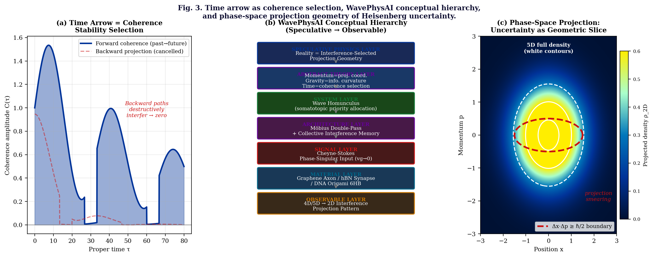
Fig. 3. Integration. (a) Time arrow as coherence stability selection: forward-coherent paths (blue, Cheyne-Stokes envelope) are constructive; backward projections (red dashed) cancel destructively — the arrow of time as interference stability condition. (b) WavePhysAI conceptual hierarchy from speculative physics (top) to observable 2D interference pattern (bottom): each layer physically implements one aspect of the PGR framework. (c) Phase-space projection geometry of the Heisenberg uncertainty principle: the 5D full density (white contours) is projected onto the 2D observation plane, producing irreducible smearing (the colormap) bounded below by the Δx·Δp ellipse (red dashed) — uncertainty as geometric slice artifact.

V. FALSIFIABILITY AND EXPERIMENTAL PREDICTIONS
A. Minimal Experimental Tests
For PGR to be scientifically meaningful rather than purely philosophical, it must generate predictions that differ from standard physics. We propose the following minimal experimental tests at the level of the WavePhysAI graphene/hBN platform:
PGR Prediction | Experimental Observable and Standard-Physics Null
Projection curvature (II) | hBN mode selection asymmetry κ(x) correlates with −∇²ρ_info(x), not with local field amplitude. Standard null: mode selection determined by amplitude alone.
Phase-space sampling (III) | OAM mode sharpening scales as N^{-1/2} with cycle number N, independent of input amplitude. Standard null: mode sharpening from cavity Q-factor ∝ N, not √N.
Time-symmetry breaking (IV) | Möbius double-pass: attractor formation requires specific phase ordering (Pass 1 → hBN → hBN → Pass 2). Reversing pass order destabilizes attractor. Standard null: order-independent for ordinary cavity.
Self-consistent present (IV) | CS-modulated input: apnea duration T_apnea correlates with attractor recovery time τ_rec, not with loss rate γ_m. Standard null: τ_rec = 1/γ_m regardless of input structure.
Uncertainty reduction (III) | After N_opt cycles, DNA-chirality-dependent node asymmetry Δθ = π/3 between B-form and Z-form DNA, independent of input intensity. Standard null: no chirality-dependent asymmetry expected from ordinary cavity resonance.
TABLE I. Experimental predictions of PGR distinguishable from standard cavity physics.
B. Limitations and What PGR Does Not Claim
PGR does not claim to be a complete theory of quantum gravity, a derivation of the standard model, or a solution to the measurement problem. Specifically:
- PGR does not provide a Lagrangian or Hamiltonian formulation — it is currently a geometric framework, not a dynamical theory
- PGR does not predict specific numerical values for fundamental constants (ℏ, c, G) from the projection geometry — these remain inputs
- PGR does not claim that the graphene/hBN platform proves any of the four proposals — it claims only that the mathematical structure is analogous
- PGR does not deny the empirical success of standard QM and GR — it proposes an interpretation layer beneath them, not a replacement
- The 5D phase space (x,y,z,p,t) proposed in PGR is not a physical 5D spacetime — it is a mathematical phase space, and the "hidden dimensions" are momentum coordinates, not spatial dimensions

VI. DISCUSSION
A. The Deepest Claim: Present as Self-Consistent Recursive Interference
The most philosophically radical proposal in the PGR framework is Proposal IV's reinterpretation of the "present moment." In standard physics, the present is a mathematical idealization — a spacelike hypersurface in 4D spacetime with no special physical status (in GR, there is no preferred simultaneity). In conscious experience, the present is the immediate "now" — vivid, certain, and apparently instantaneous.
PGR proposes a third option: the present is a self-consistent recursive interference loop — a dynamical fixed point of the temporal projection dynamics. Mathematically:
Ψ_present = F[Ψ_past-projection, Ψ_future-boundary] such that F[F[...]] = Ψ_present
This is a fixed-point equation for the quantum field configuration: the "present" is the configuration that is simultaneously consistent with its own past projection (initial conditions) and future boundary (absorber conditions). The Wheeler-Feynman absorber theory⁹ and Cramer's transactional interpretation¹⁰ both have this structure. PGR generalizes it from the electromagnetic field to the full information-geometric framework.
The subjective experience of "now" — the sense that the present is vivid and the past is memory while the future is anticipation — may arise from the local stability of this fixed point: the self-consistent present is the attractor of the temporal projection dynamics, and conscious experience is the observation of the system at this attractor. This is speculative to an extreme degree, but it is a structurally coherent proposal that connects the PGR physics to the hard problem of consciousness without requiring any additional assumptions beyond those already made in the framework.
B. Relation to Previous WavePhysAI Papers
PGR provides the unifying theoretical context for the series of WavePhysAI papers. The Wave Homunculus framework (non-uniform wave resource allocation proportional to biological somatotopic priority) is a specific application of PGR Proposal I: the wave parameters (λ, Q, ρ_{wave}) assigned to each body zone correspond to the local "projection flow rate" of the information manifold, with high-priority zones (fingers, face) having higher projection rates and thus shorter wavelengths and higher Q-factors. The Möbius double-pass collective interference memory implements PGR Proposal IV at the hardware level: the two Möbius passes (π + π = 2π) with hBN output and re-input synapses between them constitute the physical realization of the self-consistent recursive present loop. The Cheyne-Stokes phase-singular input is the temporal input waveform whose amplitude-collapse (apnea) structure models the temporal projection boundaries of PGR Proposal IV. The 4D/5D→2D iterative phase-space sampling is the direct physical implementation of PGR Proposal III: iterative hBN+DNA circulation partially recovers the momentum-space information lost in the 2D projection.

VII. CONCLUSION
We have presented the Projection Geometry of Reality (PGR) — a speculative unified theoretical framework in which momentum, gravity, the Heisenberg uncertainty principle, and the directionality of time are reinterpreted as emergent properties of interference-selected projection dynamics on a higher-dimensional information manifold. The four core proposals are: (I) momentum is the dimension-to-dimension projection flow coordinate; (II) gravity is information flow curvature (κ ≈ −∇²ρ_{info}); (III) uncertainty is a geometric projection artifact (the irreducible smearing of a 2D/3D slice through the (x,p) manifold); and (IV) time directionality is an interference selection rule (the constructive interference of forward-coherent paths, with backward-temporal projections cancelling destructively).
The framework is explicitly speculative, internally consistent, and connected to established physics at its boundaries (symplectic geometry, Wheeler-Feynman absorber theory, Verlinde entropic gravity, holographic principle, Feynman path integral). Five experimental predictions distinguishable from standard cavity physics are proposed at the level of the graphene/hBN heterostructure platform of the WavePhysAI project. The most philosophically radical proposal — that the "present moment" is the dynamical attractor of a self-consistent recursive temporal interference loop — connects the physical framework to the structure of conscious experience without requiring additional postulates.
The WavePhysAI platform — graphene axon, hBN synapse, DNA Origami 6HB scaffold, Möbius topology, Cheyne-Stokes phase-singular input — is proposed as a speculative laboratory for exploring these ideas at the nano-scale. We do not claim that it proves PGR; we claim that its mathematical structure is congruent with PGR's four proposals, making it a natural arena for experimental investigation. The central aspiration of PGR is expressed in a single sentence: "Reality is not what exists, but what survives — the interference-stable projection geometry of a deeper informational structure."

Acknowledgments
The author thanks the open-source scientific Python community, Claude (Anthropic) for discussion and computational assistance, and the WavePhysAI GitHub community for open exchange. No external funding was received. This paper is deposited as an open-access speculative preprint.

Competing Interests
The author declares no competing interests.

REFERENCES
1. A. Einstein, "Die Grundlage der allgemeinen Relativitätstheorie," Ann. Phys. 354, 769 (1916). General relativity.
2. P. A. M. Dirac, The Principles of Quantum Mechanics, 4th ed. (Oxford University Press, 1958).
3. J. A. Wheeler, "Information, physics, quantum: the search for links," in Proc. 3rd Int. Symp. Foundations of Quantum Mechanics (1989), pp. 354–368. "It from Bit."
4. E. Verlinde, "On the origin of gravity and the laws of Newton," JHEP 2011, 029 (2011). Emergent/entropic gravity.
5. J. M. Maldacena, "The large N limit of superconformal field theories and supergravity," Int. J. Theor. Phys. 38, 1113 (1999). AdS/CFT holography.
6. R. P. Feynman and A. R. Hibbs, Quantum Mechanics and Path Integrals (McGraw-Hill, New York, 1965).
7. E. P. Wigner, "On the quantum correction for thermodynamic equilibrium," Phys. Rev. 40, 749 (1932). Wigner function.
8. V. I. Arnold, Mathematical Methods of Classical Mechanics, 2nd ed. (Springer, 1989). Symplectic geometry.
9. J. A. Wheeler and R. P. Feynman, "Interaction with the absorber as the mechanism of radiation," Rev. Mod. Phys. 17, 157 (1945). Absorber theory.
10. J. G. Cramer, "The transactional interpretation of quantum mechanics," Rev. Mod. Phys. 58, 647 (1986).
11. C. Chin, "Wave Homunculus: Bio-Inspired Non-Uniform Wave Resource Allocation for Physical AI," WavePhysAI preprint (2025).
12. C. Chin, "Collective Interference Memory via Double-Pass Möbius Topology in Graphene/hBN Heterostructures," WavePhysAI preprint (2025).
13. C. Chin, "Cheyne–Stokes-Modulated Phase-Singular Signal Detection in Graphene/hBN Heterostructure Slow-Light Waveguides," WavePhysAI preprint (2025).
14. C. Chin, "Iterative Light Circulation through hBN and DNA Origami: 4D/5D-to-2D Information Projection," WavePhysAI preprint (2025).
15. D. Bohm, Wholeness and the Implicate Order (Routledge, London, 1980). Implicate order / hidden variables.
16. C. Rovelli, Quantum Gravity (Cambridge University Press, 2004). Loop quantum gravity / relational QM.
17. S. Lloyd, "Computational capacity of the universe," Phys. Rev. Lett. 88, 237901 (2002). Universe as quantum computer / information geometry.

