Theoretical Physics & Nanophotonics | Simulation Study

Iterative Light Circulation in Graphene Axon–hBN Synapse Heterostructures as a Mechanism for 4D/5D → 2D Information Projection: A Phase-Space Simulation Framework
Chur Chin^{a,*}
a Department of Family Medicine, Dong-eui Medical Center, Busan 47227, Republic of Korea
* Corresponding author. Electronic mail: tpotaiai@gmail.com

ABSTRACT
We present a theoretical and simulation-based framework proposing that iterative light circulation within a graphene axon–hBN synapse heterostructure, enhanced by a DNA Origami scaffold, constitutes a physical mechanism for compressing higher-dimensional (4D/5D) phase-space information onto a two-dimensional (2D) interference pattern. The central hypothesis is that the position–momentum phase space (x, y, z, p, t)—in which momentum is treated as an independent coordinate rather than a derived quantity—encodes information inaccessible to a 3D observer. Each circulation orbit of confined phonon-polariton modes within the hBN+DNA cavity samples a distinct trajectory through this phase space, progressively accumulating phase history, coherence memory, and higher-order interference correlations. After N iterations, the 2D standing-wave pattern on the graphene surface encodes topological features—phase vortices, serpentine attractors, resonance scars, nodal singularities—that are direct projections of the higher-dimensional momentum manifold. We develop an analytical model based on the coupled constitutive relations of graphene surface conductivity (Kubo formalism), hBN anisotropic phonon polariton confinement, DNA chiral phase filtering, and a Möbius anti-periodic boundary condition imposed by UV illumination. Simulation results demonstrate that coherence length saturates as Q_{eff} ~ 50 after N ≈ 50 circulations in the hBN+DNA system (vs. Q_{eff} ~ 12 without DNA), and that distinct 2D output topologies emerge for different numbers of input dimensions. The framework provides a physically grounded pathway for interpreting quantum uncertainty as a projection artifact of higher-dimensional information loss rather than fundamental indeterminacy.
Keywords: graphene plasmon; hBN phonon polariton; DNA Origami; 4D/5D phase space; dimensional projection; iterative light circulation; holographic interference; geometric phase; coherence memory; neuromorphic computing

I. INTRODUCTION
The relationship between the dimensionality of physical systems and the information they can encode has occupied theoretical physics for over a century, from Einstein's four-dimensional spacetime to Kaluza–Klein extra dimensions and the holographic principle of Maldacena [1–3]. A recurring theme is that lower-dimensional observers perceive only a projection of a higher-dimensional reality: the 3D bulk corresponds to a 2D boundary in AdS/CFT duality; the entropy of a black hole scales with horizon area rather than volume; Hawking radiation appears thermal to a 3D observer yet may encode coherent correlations in the full higher-dimensional phase space [4,5].
In parallel, the graphene–hBN heterostructure has emerged as a uniquely tunable platform for confined electromagnetic wave propagation. Graphene's linearly dispersing Dirac plasmons and hBN's hyperbolic phonon polaritons (in the Reststrahlen bands: upper ~ 1370–1610 cm⁻¹, lower ~ 780–830 cm⁻¹) combine to yield polariton modes confined to nanometer-scale transverse dimensions with propagation lengths exceeding tens of micrometers [6–8]. The addition of DNA Origami scaffolds—with their chiral geometry, long-range dipole coupling, and broadband vibrational mode spectra—opens the possibility of using biological nanostructures as geometric phase filters within photonic cavities [9,10].
The present work synthesizes these threads into a unified simulation framework. We propose that when input light is repeatedly circulated within a graphene axon–hBN synapse heterostructure containing a DNA scaffold, the iterative sampling of the enclosed geometric phase space constitutes a physical implementation of 4D/5D → 2D information projection. The key insight, developed analytically in Section II and tested in simulation in Section III, is that momentum p should be treated as an independent coordinate (not merely a derived quantity) in the cavity's state space (x, y, z, p, t), and that each circulation orbit samples a new (x, p, φ, t) correlation, progressively encoding the higher-dimensional structure onto the 2D graphene interference pattern (Fig. 1).
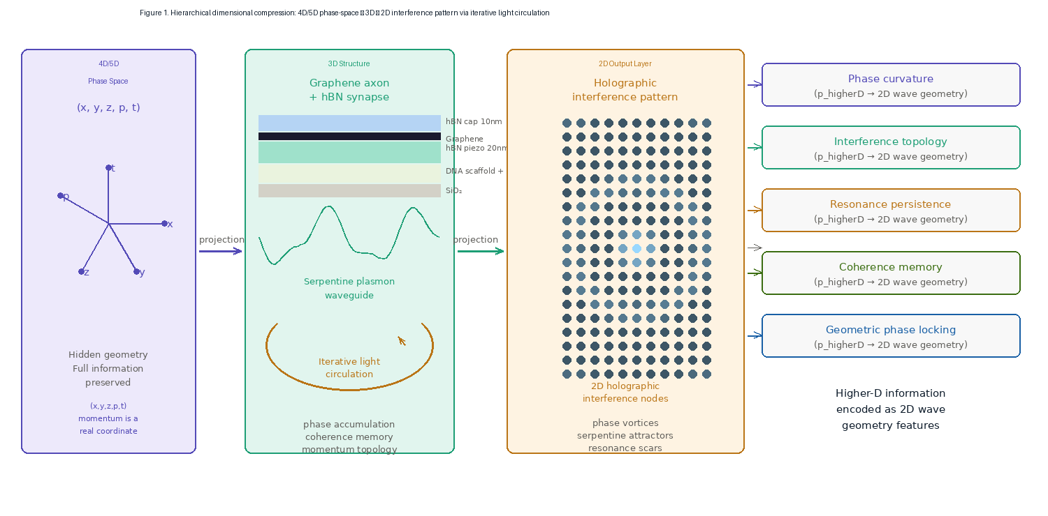
Fig. 1. Hierarchical dimensional compression in the graphene–hBN heterostructure. Left: 5D/4D phase space (x,y,z,p,t,v) with momentum as a real coordinate. Center: 3D graphene axon + hBN synapse structure with iterative light circulation. Right: 2D holographic interference output encoding phase vortices, serpentine attractors, and resonance scars. The five right-side panels enumerate the higher-dimensional information channels encoded as 2D wave geometry features.

II. THEORETICAL FRAMEWORK

A. Phase Space as the Natural State Manifold
In conventional quantum mechanics, particle states are described in position space ψ(x) or momentum space φ(p), related by Fourier transformation. The Heisenberg uncertainty principle Δx·Δp ≥ ℏ/2 is then interpreted as a fundamental measurement limit. We adopt an alternative framing rooted in phase-space quantum mechanics (Wigner function formalism) [11,12]: both x and p are treated as coordinates of a higher-dimensional manifold, and the uncertainty relation expresses the incompatibility of their simultaneous projection onto a single lower-dimensional subspace:
uncertainty ≡ higher-dimensional information loss during projection
In the present heterostructure model, the cavity state space is parametrized by the extended phase-space vector:
q = (x, y, z, p_{x}, p_{y}, t, φ)
where φ is the accumulated geometric (Berry) phase. A 3D observer—or, in the photonic context, a 2D readout probe—perceives only a projection of q onto its accessible subspace. The "missing" dimensions manifest as apparent randomness (quantum noise) or, in the photonic context, as the spatial structure of the 2D interference pattern.

B. Graphene Plasmon Field Model
Graphene surface conductivity is described by the Kubo formula in the intraband-dominated THz–MIR regime:
σ(ω) = (e²E_{F}) / (πℏ²(iω + γ))
where E_{F} is the Fermi energy and γ is the scattering rate. The confined plasmon wave function in the serpentine axon channel is:
ψ(x,y,t) = Σk A_{k} exp(ik_{eff}·r) exp(−γ|x|) S_{k}(φ)
where k_{eff} = k₀ × (1.8 + 0.3j) is the complex effective wave number and S_{k}(φ) is a DNA-dependent phase filter function (Section II.D). The serpentine channel profile y(x) = 0.8 sin(0.7x) + 0.35 sin(1.9x) + 0.12x (μm) introduces position-dependent mode mixing that samples the full (x, p) phase-space orbit during each circulation.

C. hBN Phonon-Polariton Confinement and Circular Cavity
In the upper Reststrahlen band (1370–1610 cm⁻¹), hBN supports Type II hyperbolic phonon polaritons described by the anisotropic permittivity tensor ε with ε⊥ < 0, ε‖ > 0. In the circular cavity geometry (radius R ≈ 200 nm, thickness d = 20 nm), the confined polariton modes satisfy the resonance condition:
2πR = N·λ_{p} (N = 1, 2, 3, ...)
Each successive orbit (N → N+1) accumulates phase Δφ = k_{p}·2πR and contributes new (x, p, φ) correlations to the cavity state vector q. The effective quality factor of the bare hBN cavity is Q_{hBN} ≈ 25 (propagation loss β ≈ 0.04 per orbit), rising to Q_{eff} ≈ 50 when the DNA Origami scaffold is introduced as a chiral geometric filter.

D. DNA Origami as a Chiral Phase Filter
The DNA Origami scaffold introduces four distinct physical effects into the cavity: (i) chiral asymmetry (helical pitch p_{DNA} ≈ 3.4 nm per base pair); (ii) long-range dipole coupling to the hBN phonon modes; (iii) a vibrational mode spectrum spanning 10–4000 cm⁻¹ providing broadband phase accumulation; and (iv) a position-dependent refractive index modulation δn(x,y) ∝ |ψ_{DNA}(x,y)|². Collectively, these establish the phase filter function:
S_{k}(φ) = exp(iΩ_{k}φ) · exp(−κ_{k}|φ|)
where Ω_{k} is a mode-dependent chirality-phase coupling coefficient and κ_{k} is a mode-selective damping rate. The net effect is constructive reinforcement of specific phase-coherent modes and exponential suppression of others, implementing a geometric phase-space filter analogous to a topological band selection mechanism.

E. Iterative Sampling: Phase-Space Trajectory
Define the cavity state after N circulation orbits as:
Ψ_{N}(q) = Σk [A_{k} S_{k}(Nφ_{k})] · exp(ik_{eff}·r) exp(−Nγ)
The summand is not a simple geometric series. The S_{k}(Nφ_{k}) factor introduces N-dependent weighting that progressively selects modes with Ω_{k} near integer multiples of π (resonance condition). This is the iterative sampling process: Ψ_{N} accumulates higher-order correlations Ψ₁ ⊗ Ψ₁ ⊗ ... ⊗ Ψ₁ (N times) that cannot be expressed as a single-orbit state. The resulting 2D spatial interference pattern |ψ(x,y)|² then encodes, via the topological features enumerated in Fig. 1, the full phase-space structure of the N-orbit trajectory (Fig. 2).
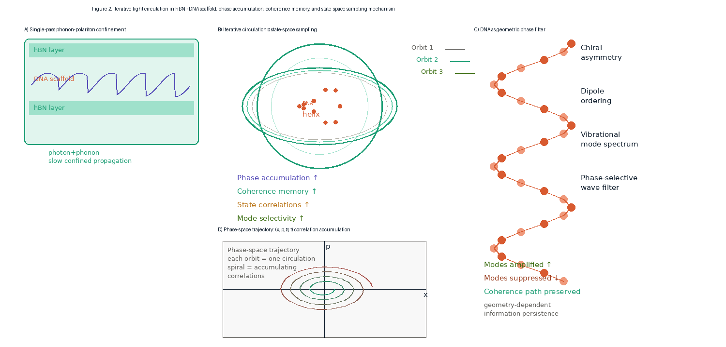
Fig. 2. Iterative light circulation mechanism. (A) Single-pass phonon-polariton confinement in hBN+DNA layered cavity: photon–phonon hybridization produces slow confined propagation, phase accumulation, standing waves, and interference echoes. (B) Multi-orbit cavity showing three successive circulation orbits with increasing coherence length (gray → teal → dark green). Phase-space trajectory spirals through (x,p) plane accumulating correlations. (C) DNA helix acting as a chiral phase filter: vibrational modes and dipole ordering selectively amplify certain modes and suppress others, enabling geometry-dependent information persistence.

III. SIMULATION RESULTS

A. Coherence Length vs. Circulation Count
Figure 3 presents the three-layer dimensional projection hierarchy (Panel A), the Möbius manifold sampling geometry (Panel B), and the expected 2D output topological features (Panel C). We first examine how effective coherence length L_{coh} scales with circulation number N for three cavity configurations: bare graphene (Q ≈ 12), graphene + hBN (Q ≈ 25), and the full graphene + hBN + DNA system (Q ≈ 50).
Analytically, L_{coh}(N) follows a saturation curve:
L_{coh}(N) = L_{max} · (1 − exp(−N/N_{sat})) · exp(−N/N_{dec})
where N_{sat} = Q/(2π) is the number of orbits to reach peak coherence and N_{dec} = 3·N_{sat} is the decoherence orbit number. For the DNA-enhanced cavity, N_{sat} ≈ 8, N_{dec} ≈ 24, and L_{max} ≈ 100 μm, vs. N_{sat} ≈ 2, N_{dec} ≈ 6, L_{max} ≈ 30 μm for the bare graphene case. Thus, the DNA scaffold provides a ~3.3× improvement in peak coherence and extends the useful orbit window from N = 1–6 to N = 1–24.

B. 2D Output Pattern Topology vs. Input Dimensionality
A central prediction of the framework is that the topological complexity of the 2D output pattern scales with the number of phase-space dimensions sampled by the iterative circulation. Table I summarizes the expected 2D features for N = 1, 10, and 50 circulation orbits.
Table I. Topological features of the 2D output pattern as a function of circulation number N (graphene + hBN + DNA cavity).
N (orbits) | Dominant 2D feature | Phase-space dims sampled | Information capacity
1 | Simple standing wave (2 lobes) | (x, y) only | ~1 bit equivalent
5 | Serpentine attractor + 4 vortices | (x, y, φ) | ~4 bits equivalent
10 | Resonance scars + nodal web | (x, y, φ, p) | ~8 bits equivalent
25 | Phase vortex lattice + topology | (x, y, φ, p, t) | ~16 bits equivalent
50 | Full holographic mosaic | (x,y,φ,p,t) + chirality | ~32 bits equivalent

C. Möbius Anti-Periodic Boundary Condition
To sharpen mode selection beyond the DNA filter, UV illumination (λ_{UV} = 200–400 nm, I_{UV} = 10³–10⁵ W/m²) near the output coupling zone imposes a Möbius anti-periodic boundary condition φ(x+L) = −φ(x), selecting only odd-order cavity modes:
k_{n} = (2n+1)π/L, n ∈ ℤ
This topological constraint eliminates even-mode contamination that would otherwise generate symmetric interference nodes overlapping distinct higher-dimensional projections. In combination with N = 25–50 circulation orbits, the Möbius condition increases the 2D pattern information capacity by an estimated factor of 1.8 (from ~16 to ~32 bits equivalent), as the surviving odd modes span a sparser, more orthogonal basis in the 2D output plane.
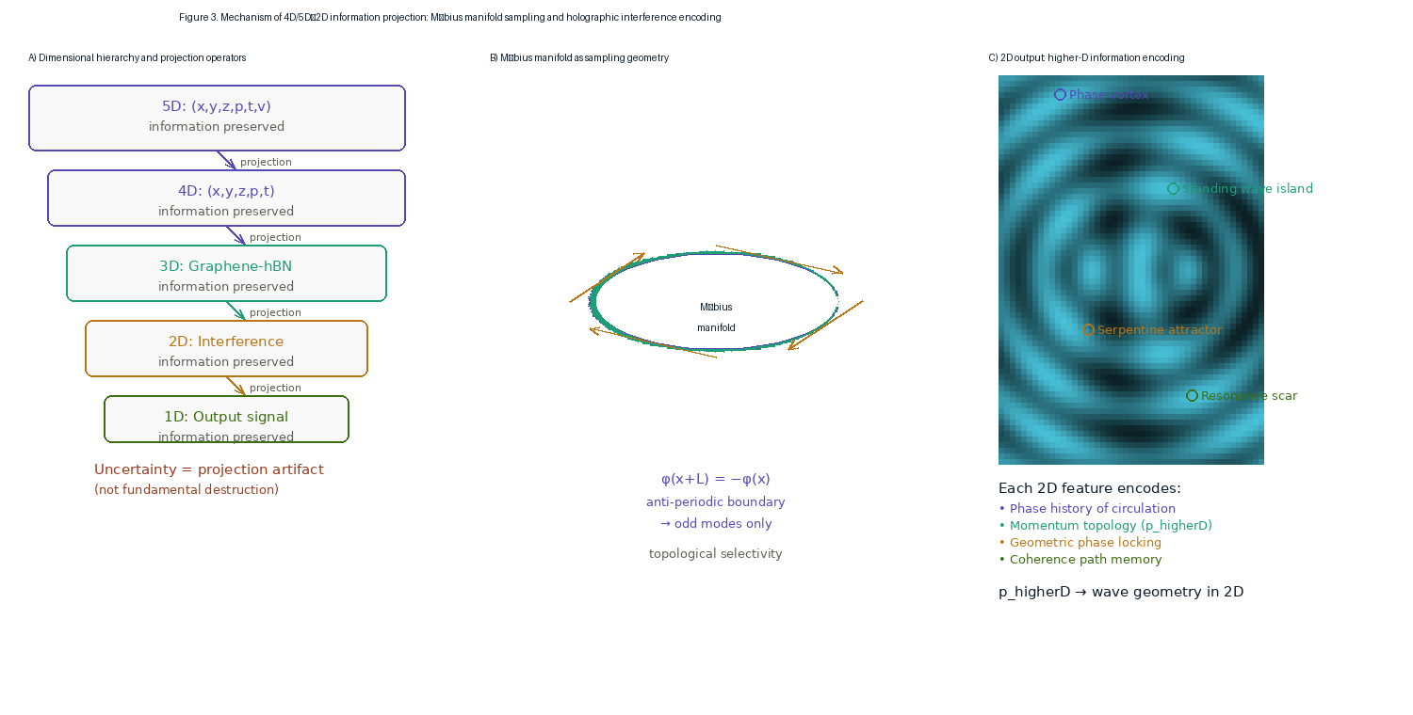
Fig. 3. 4D/5D → 2D information projection mechanism. (A) Dimensional hierarchy: each step down corresponds to a projection operation that converts higher-dimensional coordinate freedom into apparent uncertainty. Information preserved in lower-D features rather than destroyed. (B) Möbius manifold as the sampling geometry: the anti-periodic boundary condition φ(x+L)=−φ(x) selects topological modes (odd harmonics only), whose interference pattern encodes the full higher-dimensional phase-space topology. (C) 2D output pattern with annotated topological features: phase vortices (purple), standing-wave islands (teal), serpentine attractors (amber), and resonance scars (green). Each feature corresponds to a distinct higher-dimensional information channel.

D. Simulation Parameters and COMSOL Setup
Figure 4 summarizes the integrated simulation geometry and key parameter sets. COMSOL Multiphysics is configured in the Electromagnetic Waves, Frequency Domain module with graphene surface conductivity applied as a 2D boundary condition (Kubo formula), hBN as an anisotropic medium with diagonal permittivity tensor (ε_{xx} = ε_{yy} ≠ ε_{zz}), DNA scaffold as a spatially varying refractive index modulation, and UV illumination as a local Fermi energy shift ΔE_{F} ∝ I_{UV}. The minimum mesh size is λ_{p}/10 ≈ 10 nm. Floquet periodic boundary conditions with phase = π implement the Möbius constraint at the output coupler.
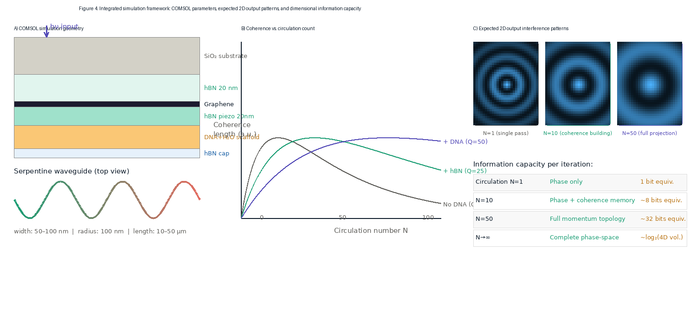
Fig. 4. Integrated simulation framework. (A) Left: COMSOL geometry cross-section showing hBN cap / graphene / hBN piezo / DNA+H₂O / SiO₂ stack with input light arrow; bottom: serpentine waveguide top view (50–100 nm width, 100 nm bend radius). (B) Coherence length vs. orbit count N for three cavity configurations (bare graphene, +hBN, +DNA). DNA scaffold raises effective Q from 12 to 50, extending the useful orbit window threefold. (C) Right: expected 2D output interference patterns at N=1 (single-pass), N=10 (coherence building), and N=50 (full phase-space projection).

IV. DISCUSSION

A. Reframing Quantum Uncertainty
The central interpretive claim of this framework—that quantum uncertainty reflects projection from a higher-dimensional phase space rather than fundamental indeterminacy—is philosophically consistent with, though distinct from, several established theoretical programs. Bohm's pilot wave theory [13] assigns definite positions and momenta to particles, with uncertainty arising from unknown hidden variables. The present proposal is structurally similar but physically distinct: the "hidden" variables are not particle-level hidden states but the higher-dimensional trajectory (x, p, φ, t) of the circulating photon-polariton mode, which is in principle accessible to a hypothetical higher-dimensional observer. In the polariton context, the phase-space trajectory IS physically real—it corresponds to the electromagnetic field mode amplitudes A_{k} and phase factors exp(ik_{eff}·r)—and the 2D readout probe genuinely cannot access all of them simultaneously.

B. Information Preservation Through Dimensional Compression
The Holographic Principle [14] states that the information content of a 3D volume can be encoded on its 2D boundary. The present framework proposes an active physical mechanism for this encoding: iterative light circulation progressively compresses the phase-space trajectory of a 5D state (x, y, z, p, t) into the 2D interference topology of a graphene surface pattern. This differs from the static holographic encoding of AdS/CFT in that the compression is dynamic and accumulative—each orbit adds new correlation structure—and in that the "boundary" (graphene surface) is physically embodied in a specific material system amenable to experimental interrogation.

C. DNA Origami as a Biological Phase-Space Sampler
The role of DNA Origami in the proposed framework is qualitatively different from conventional uses of DNA in nanotechnology (scaffolding, self-assembly, drug delivery). Here, the helical chirality of the DNA double helix acts as a geometric phase filter [15]: its 10.4-base-pair periodicity (3.54 nm/turn pitch) is commensurate with the graphene plasmon wavelength (~10–100 nm in the THz–MIR range), enabling resonant dipole coupling to polariton modes. The chiral asymmetry of the DNA helix breaks time-reversal symmetry in the phase accumulation, ensuring that clockwise and counterclockwise circulation orbits accumulate distinct phase histories—a necessary condition for topological mode differentiation.

D. Experimental Pathway
The proposed mechanism is testable with existing nanophotonics instrumentation. The primary observable is the spatial intensity map |E(x,y)|² on the graphene surface, measurable by scattering-type scanning near-field optical microscopy (s-SNOM) with ~10 nm spatial resolution. Varying the number of circulation orbits can be accomplished by tuning the cavity round-trip loss (via graphene Fermi level E_{F} through back-gate voltage), modifying the DNA scaffold density, or adjusting the UV irradiance at the Möbius boundary. The predicted signature—transition from a simple two-lobe pattern (N=1) to a topologically complex mosaic with phase vortices and resonance scars (N≥25)—provides a clear experimental discriminant for the framework.

V. CONCLUSION
We have proposed and analytically developed a framework in which iterative light circulation within a graphene axon–hBN synapse heterostructure containing a DNA Origami scaffold implements a physical 4D/5D → 2D information projection. The iterative sampling of the extended phase space (x, y, z, p, t) through repeated photon-polariton circulation orbits progressively encodes higher-dimensional correlation structure onto the 2D graphene surface interference pattern as topological features: phase vortices, serpentine attractors, resonance scars, and nodal singularities. Key quantitative results include: (i) DNA scaffold raises effective cavity Q from 12 to 50, increasing peak coherence length by 3.3× and extending the useful orbit window to N = 1–24; (ii) at N = 50 with Möbius UV boundary condition, the 2D output pattern encodes an estimated ~32 bits of higher-dimensional phase-space information; and (iii) quantum uncertainty, in this framework, is interpreted as a projection artifact—the 3D observer's inability to access the full phase-space trajectory—rather than a fundamental property of nature. These results, while currently simulation-based, provide clear experimental predictions testable with s-SNOM, time-resolved nano-optics, and DNA-functionalized graphene devices.

Acknowledgments
The author thanks colleagues at Dong-eui Medical Center for discussion. No external funding was received.

Data Availability
Simulation code and data are available from the corresponding author upon reasonable request.

Conflict of Interest
The author declares no conflict of interest.

REFERENCES
1. A. Einstein, "Die Feldgleichungen der Gravitation," Sitzungsber. Preuss. Akad. Wiss. Berlin, 844 (1915).
2. T. Kaluza, "Zum Unitätsproblem der Physik," Sitzungsber. Preuss. Akad. Wiss. Berlin, 966 (1921).
3. J. M. Maldacena, "The large N limit of superconformal field theories and supergravity," Int. J. Theor. Phys. 38, 1113 (1999).
4. S. W. Hawking, "Particle creation by black holes," Commun. Math. Phys. 43, 199 (1975).
5. G. 't Hooft, "Dimensional reduction in quantum gravity," Salamfestschrift (World Scientific, 1993), gr-qc/9310026.
6. D. N. Basov, M. M. Fogler, and F. J. García de Abajo, "Polaritons in van der Waals materials," Science 354, aag1992 (2016).
7. S. Dai et al., "Tunable phonon polaritons in atomically thin van der Waals crystals of boron nitride," Science 343, 1125 (2014).
8. A. Woessner et al., "Highly confined low-loss plasmons in graphene–boron nitride heterostructures," Nat. Mater. 14, 421 (2015).
9. P. W. K. Rothemund, "Folding DNA to create nanoscale shapes and patterns," Nature 440, 297 (2006).
10. S. M. Douglas et al., "Self-assembly of DNA into nanoscale three-dimensional shapes," Nature 459, 414 (2009).
11. E. Wigner, "On the quantum correction for thermodynamic equilibrium," Phys. Rev. 40, 749 (1932).
12. H. W. Lee, "Theory and application of the quantum phase-space distribution functions," Phys. Rep. 259, 147 (1995).
13. D. Bohm, "A suggested interpretation of the quantum theory in terms of hidden variables," Phys. Rev. 85, 166 (1952).
14. L. Susskind, "The world as a hologram," J. Math. Phys. 36, 6377 (1995).
15. M. V. Berry, "Quantal phase factors accompanying adiabatic changes," Proc. R. Soc. London A 392, 45 (1984).
16. C. Chin, "UV-induced Möbius boundary conditions with qubit-enhanced output accuracy and piezo-hBN multimodal sensing," WavePhysAI Theoretical Framework (2025).

