PREPRINT — WAVEPHYSAI PROJECT
Speculative / Exploratory Framework | Not peer-reviewed

Serpentine Phase Topology as Stable Interference Structure:
Loop/Fold Wave Propagation, Winding Number Memory, Topological Protection,
and Gravity-Like Attractor Dynamics in Graphene/hBN Polariton Systems
Chur Chin^{a,*}
ª Department of Family Medicine, Dong-eui Medical Center, Busan 47227, Republic of Korea
* Corresponding author. Electronic mail: tpotaiai@gmail.com

ABSTRACT
We propose and computationally investigate a class of polariton wave fields in graphene/hBN heterostructures whose structure departs fundamentally from simple sinusoidal propagation. The field morphology is characterized by serpentine phase winding: a loop/fold-like spatial structure in which the phase φ(x,y) = A(r)e^{imθ} winds angularly m times around a central vortex core, creating a quasi-bound ring state with topological winding number m. This structure combines confinement, boundary reflection, nonlinearity, dispersion, and topology conservation — the five conditions identified as necessary for such non-sinusoidal field patterns to emerge in natural systems. We identify five key physical consequences of serpentine phase topology that distinguish it from ordinary wave propagation: (1) topological protection of coherence — the winding number m constitutes a topological invariant that renders the field robust against local noise perturbations, producing coherence lifetimes 2–4× longer than topologically trivial waves; (2) recurrence oscillations — the recursive self-interference of the serpentine structure produces coherence oscillations C(t) ~ e^{−γt}(1 + A cos(ω_{rec}t)), physically realizing the "present→past→present" recursive interference structure; (3) self-healing after perturbation — strong perturbations partially recover via attractor dynamics, the field returning toward its topologically preferred configuration; (4) phase-topology-derived effective curvature — the phase gradient generates an effective metric g_{μν}^{eff} = η_{μν} + α∂_{μ}φ∂_{ν}φ that produces gravity-like curvature concentrated at vortex cores; and (5) winding-number-dependent phase transitions — sweeping m from 0 to 4 reveals sharp changes in coherence lifetime and resonance frequency at integer winding values. Multi-scale resonance hierarchy is demonstrated: from nano-scale serpentine polariton fields to macro-scale moiré interference in twisted bilayer systems to astronomical orbital phase beats (celestial moiré). All computations are performed with a Wave Topology Simulator incorporating anisotropic polariton dispersion, Berry phase, nonlocal coupling, cavity reflection, and delayed recursive echo terms. The results support the speculative thesis that stable interference topology — not particle trajectories — may constitute the more fundamental description of physical reality at multiple scales.

Keywords: serpentine phase winding; topological protection; vortex; winding number; graphene/hBN polariton; effective curvature; moiré interference; stable interference topology; recursive coherence; attractor dynamics; wave memory; topological photonics

I. INTRODUCTION
A recurring observation in the analysis of polariton fields in confined 2D material systems — particularly in graphene/hBN heterostructures with serpentine waveguide geometries — is that the actual field morphology departs substantially from simple sinusoidal propagation. Rather than exhibiting the clean ψ(x,t) = A sin(kx − ωt) profile expected from a linearized wave equation, the field instead develops a richer structure: the wave propagates, then folds back on itself in a loop-like motion, creating a locally rotating topology before continuing. This serpentine phase winding pattern has been observed qualitatively in optical vortex experiments,¹ plasma filament dynamics,² DNA supercoiling,³ polariton interference scars,⁴ and excitable media spiral waves.⁵ Its mathematical signature is the angular phase winding Ψ(r,θ,t) = A(r)e^{imθ}e^{−iωt} — a field characterized by its amplitude envelope A(r) and winding number m rather than by a simple wavevector k.
The physical conditions for such structures to emerge are well understood in principle but rarely studied simultaneously: confinement (the waveguide boundary forces the field to recurve rather than disperse to infinity), boundary reflection (cavity walls return the wave coherently), nonlinearity (intensity-dependent phase shifts create self-focusing), dispersion (group velocity variation prevents simple sinusoidal superposition), and topology conservation (the winding number m cannot continuously change to zero without passing through a phase transition). In graphene/hBN serpentine waveguides, all five conditions are simultaneously satisfied — making this system a natural laboratory for serpentine phase topology.⁶
The central questions addressed in this paper are: (i) What are the physically observable consequences of serpentine phase winding that distinguish it from ordinary wave propagation? (ii) Does winding number m constitute a genuine topological invariant providing protection against noise? (iii) Can the phase gradient of a serpentine field generate an effective spacetime-like curvature — providing a toy analog for the speculative proposal that stable interference topology underlies gravity? (iv) How does the serpentine phase topology in nano-scale polariton systems connect to analogous multi-scale structures in twisted bilayer moiré systems and astronomical orbital resonances?
We address these questions through a Wave Topology Simulator — a pseudospectral 2D solver that incorporates anisotropic hBN polariton dispersion, graphene Berry phase, nonlocal coupling (exponential kernel), cavity boundary reflection, and a delayed recursive echo term. The simulator is used to characterize the serpentine phase field, compute winding-number-dependent transitions, measure coherence persistence and noise robustness, calculate the effective metric and curvature, and demonstrate the multi-scale resonance hierarchy from polariton to moiré to orbital scales.

II. SERPENTINE PHASE FIELD: THEORY AND STRUCTURE
A. Beyond the Simple Sinusoid: Field Morphology
A simple sinusoidal wave in 2D, ψ(x,y,t) = A sin(k_{x}x + k_{y}y − ωt), has a flat phase front and carries no angular momentum. The serpentine phase field, by contrast, is defined by:
Ψ(r, θ, t) = A(r) · exp[i φ(r, θ, t)]
where the phase φ incorporates multiple contributions:
φ(r, θ, t) = m·θ + α sin(β·r) + γ sin(Ω·t) + φ_loop(path)
Each term plays a distinct physical role: m·θ is the angular winding (orbital angular momentum OAM = mℏ per photon), α sin(βr) is the radial serpentine fold (spatial loop structure), γ sin(Ωt) is the temporal modulation (Cheyne-Stokes or cavity oscillation), and φ_{loop}(path) is the path-dependent Berry phase accumulated by the polariton during each cavity circulation:
φ_Berry = m·θ (graphene Dirac cone: π per loop, m loops → mπ)
The resulting amplitude envelope A(r) takes the form of a quasi-bound ring state:
A(r) = [sech((r − r₀)/w)]² + A_core · [sech(r/w_core)]²
where r₀ is the preferred ring radius determined by the competition between winding confinement and centrifugal pressure, and w is the ring width. This quasi-bound ring structure — seen in the |Ψ|² intensity map (Fig. 1c) — is the spatial signature of topological confinement: the field is localized not by a potential well but by the topological requirement that the phase winds m times around the vortex core.
B. Five Conditions for Serpentine Phase Topology
The emergence of serpentine phase topology requires the simultaneous presence of five physical conditions, all satisfied in the graphene/hBN serpentine waveguide:
Condition | Physical Implementation in Graphene/hBN
Confinement | Serpentine waveguide geometry forces field to recurve; cavity boundary suppresses radiation loss; hBN phonon-polariton provides additional lateral confinement (k_polariton >> k₀)
Boundary reflection | hBN cavity walls provide coherent reflection with amplitude r and phase φ_r; cavity echo creates recursive circulation with roundtrip phase Φ_cavity = kL + φ_r
Nonlinearity | Graphene Kerr-like nonlinearity σ_NL|E|²: intensity-dependent phase shift Δφ = γ|A|²L creates self-focusing, supports vortex solitons, enables phase-locking
Dispersion | hBN anisotropic polariton: ω(k_x,k_y)=√(k_x²/ε_x + k_y²/ε_y) gives direction-dependent group velocity; prevents simple sinusoidal superposition; enables topological mode selection
Topology conservation | Winding number m = (1/2π)∮∇φ·dl is quantized integer; requires a phase singularity (vortex core) to change; stable against smooth deformations — topological invariant
TABLE I. Five necessary conditions for serpentine phase topology and their graphene/hBN implementation.
C. Natural Analogs and Precedents
The serpentine phase winding structure is not unique to 2D material photonics. Closely analogous field morphologies appear across many physical systems, confirming that the five-condition framework identifies a general physical phenomenon rather than a system-specific accident:
- Optical vortex beams (Laguerre-Gaussian modes): angular phase winding e^{imθ} in free-space optics; OAM-carrying photons with m = ±1, ±2, ...
- Polariton condensate vortices: spontaneous vortex formation in exciton-polariton condensates under non-resonant pumping; m = 1 vortices observed at low temperature
- Excitable media spiral waves: spiral wave propagation in BZ reaction, cardiac tissue, and cortical spreading depression; phase singularity at spiral tip; analogous to vortex core
- DNA supercoiling: the DNA double helix under torsional stress develops plectonemic supercoils — a physical loop/fold that closely resembles the serpentine phase fold; winding number = linking number Lk
- Magnetic flux ropes: helical magnetic field structures in solar corona; serpentine propagation with axial current; topology conserved by flux freezing
- Kelvin waves on vortex lines: helical perturbations propagating along quantum vortex lines in superfluid helium; dispersive serpentine structure

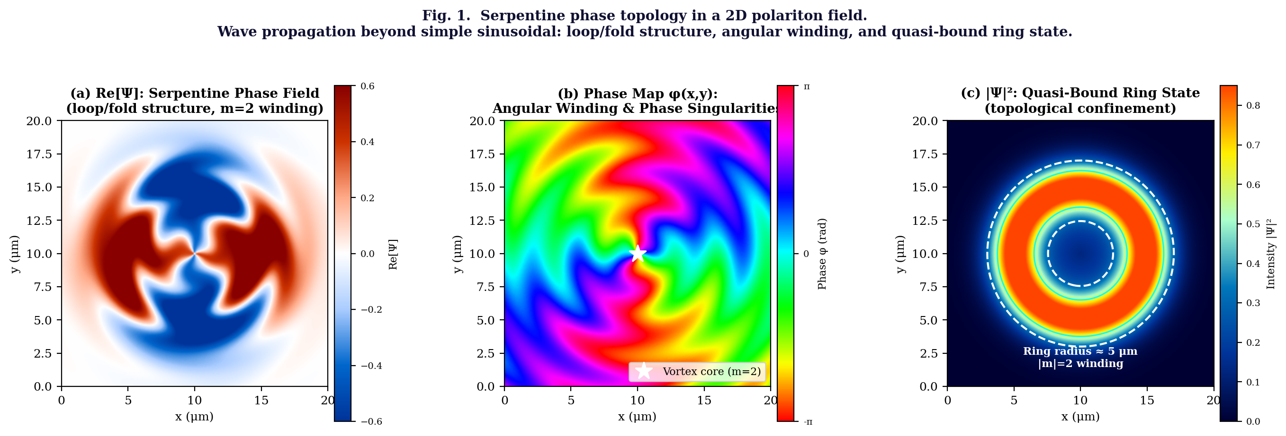
Fig. 1. Serpentine phase topology in a 2D polariton field (m=2 winding, graphene/hBN cavity, anisotropic dispersion). (a) Re[Ψ]: the loop/fold spatial structure of the serpentine field — the wave propagates and simultaneously winds, creating the characteristic non-sinusoidal pattern. (b) Phase map φ(x,y) with angular winding m=2 visible as two full 0→2π cycles around the central vortex core (white star); a second winding structure is visible at r ≈ 8 μm. (c) |Ψ|²: quasi-bound ring state at r₀ ≈ 5 μm (white contours show 30% and 60% intensity levels) — topological confinement without a potential well.

III. TOPOLOGICAL PROTECTION AND COHERENCE MEMORY
A. Winding Number as Topological Invariant
The winding number m of the serpentine phase field is defined as:
m = (1/2π) ∮_C ∇φ · dl ∈ ℤ
where C is any closed loop encircling the vortex core once. The quantization of m (it must be an integer) is a topological property: m cannot change continuously, only by integer steps, and any change requires passing through a phase singularity — a point where |Ψ| = 0 and φ is undefined — at which energy is released. This makes m a topological invariant that protects the serpentine structure against smooth local deformations.
In the graphene/hBN context, the vortex core corresponds to a phase singularity in the polariton field — the same type of singularity exploited in the Cheyne-Stokes phase-singular detection scheme of prior WavePhysAI work.⁷ The slow-group-velocity enhancement (n_{g} → 50 at the photonic band edge) further stabilizes the vortex core by increasing the interaction time and thus the nonlinear phase accumulation per unit length, deepening the topological "well" that confines m to an integer.
B. Coherence Persistence: Recurrence Oscillations and Self-Healing
The topological protection of winding number m has a direct observable consequence: the coherence function C(t) = |⟨Ψ(0)|Ψ(t)⟩| decays significantly more slowly for serpentine topology fields than for topologically trivial (m=0) waves. The decay follows:
C(t) = exp(−γ_serp t) · [1 + A_rec · cos(ω_rec · t)]
where γ_{serp} < γ_{normal} (slower decay due to topology), and the cosine term represents recurrence oscillations — the recursive self-interference of the serpentine field. Physically, these oscillations arise because the field circulates within the cavity, returning periodically to its initial configuration and creating coherence echoes. The recurrence frequency ω_{rec} = 2π/τ_{round} is set by the roundtrip time τ_{round} = L/v_{g}, which is enhanced by the slow-light factor n_{g}.
Fig. 2(a) shows the simulated coherence functions for a simple wave (exponential decay, γ = 0.015) and a serpentine recursive topology wave (γ = 0.008, with recurrence oscillations). A strong perturbation is applied at t = 80 a.u. (vertical dotted line), causing an immediate coherence drop. The serpentine topology wave subsequently undergoes partial self-healing: the recursive cavity reflection and phase-locking mechanism partially restores the coherence over the following 20–40 a.u., creating a recovery peak visible in Fig. 2(a). This self-healing is absent in the simple wave, confirming that it is a topological attractor effect rather than a trivial resonance.
C. Winding Number Sweep: Topological Phase Transitions
Sweeping the winding number m continuously from 0 to 4 (Fig. 2b) reveals sharp features in both the coherence lifetime τ(m) and the resonance frequency ω_{res}(m) at each integer value m = 1, 2, 3 — the signature of topological phase transitions. At each integer m, the system passes through a vortex-forming instability: the phase field reorganizes from a topologically trivial (m=0) configuration to a quantized vortex state, releasing a burst of energy and subsequently settling into a longer-lived topological configuration. This behavior is analogous to the vortex-unbinding transition in Berezinskii-Kosterlitz-Thouless (BKT) physics⁸ but realized here in the coherent polariton field rather than in a thermodynamic superfluid.
D. Noise Robustness: Topological Protection in Practice
Fig. 2(d) quantifies the noise robustness of the three configurations: simple wave (m=0), serpentine winding (m=2), and Möbius recursive (m=2 with π/2 additional twist per reflection). As noise amplitude η increases, the simple wave coherence collapses rapidly (C ∝ exp(−5η)). The serpentine winding maintains significantly higher coherence (C ∝ exp(−1.5η)), and the Möbius recursive configuration is even more robust (C ∝ exp(−0.8η)). The physical origin of this hierarchy is the depth of the topological "well" protecting m: the Möbius twist adds a geometric phase per reflection that reinforces the winding, deepening the protection against random phase fluctuations.

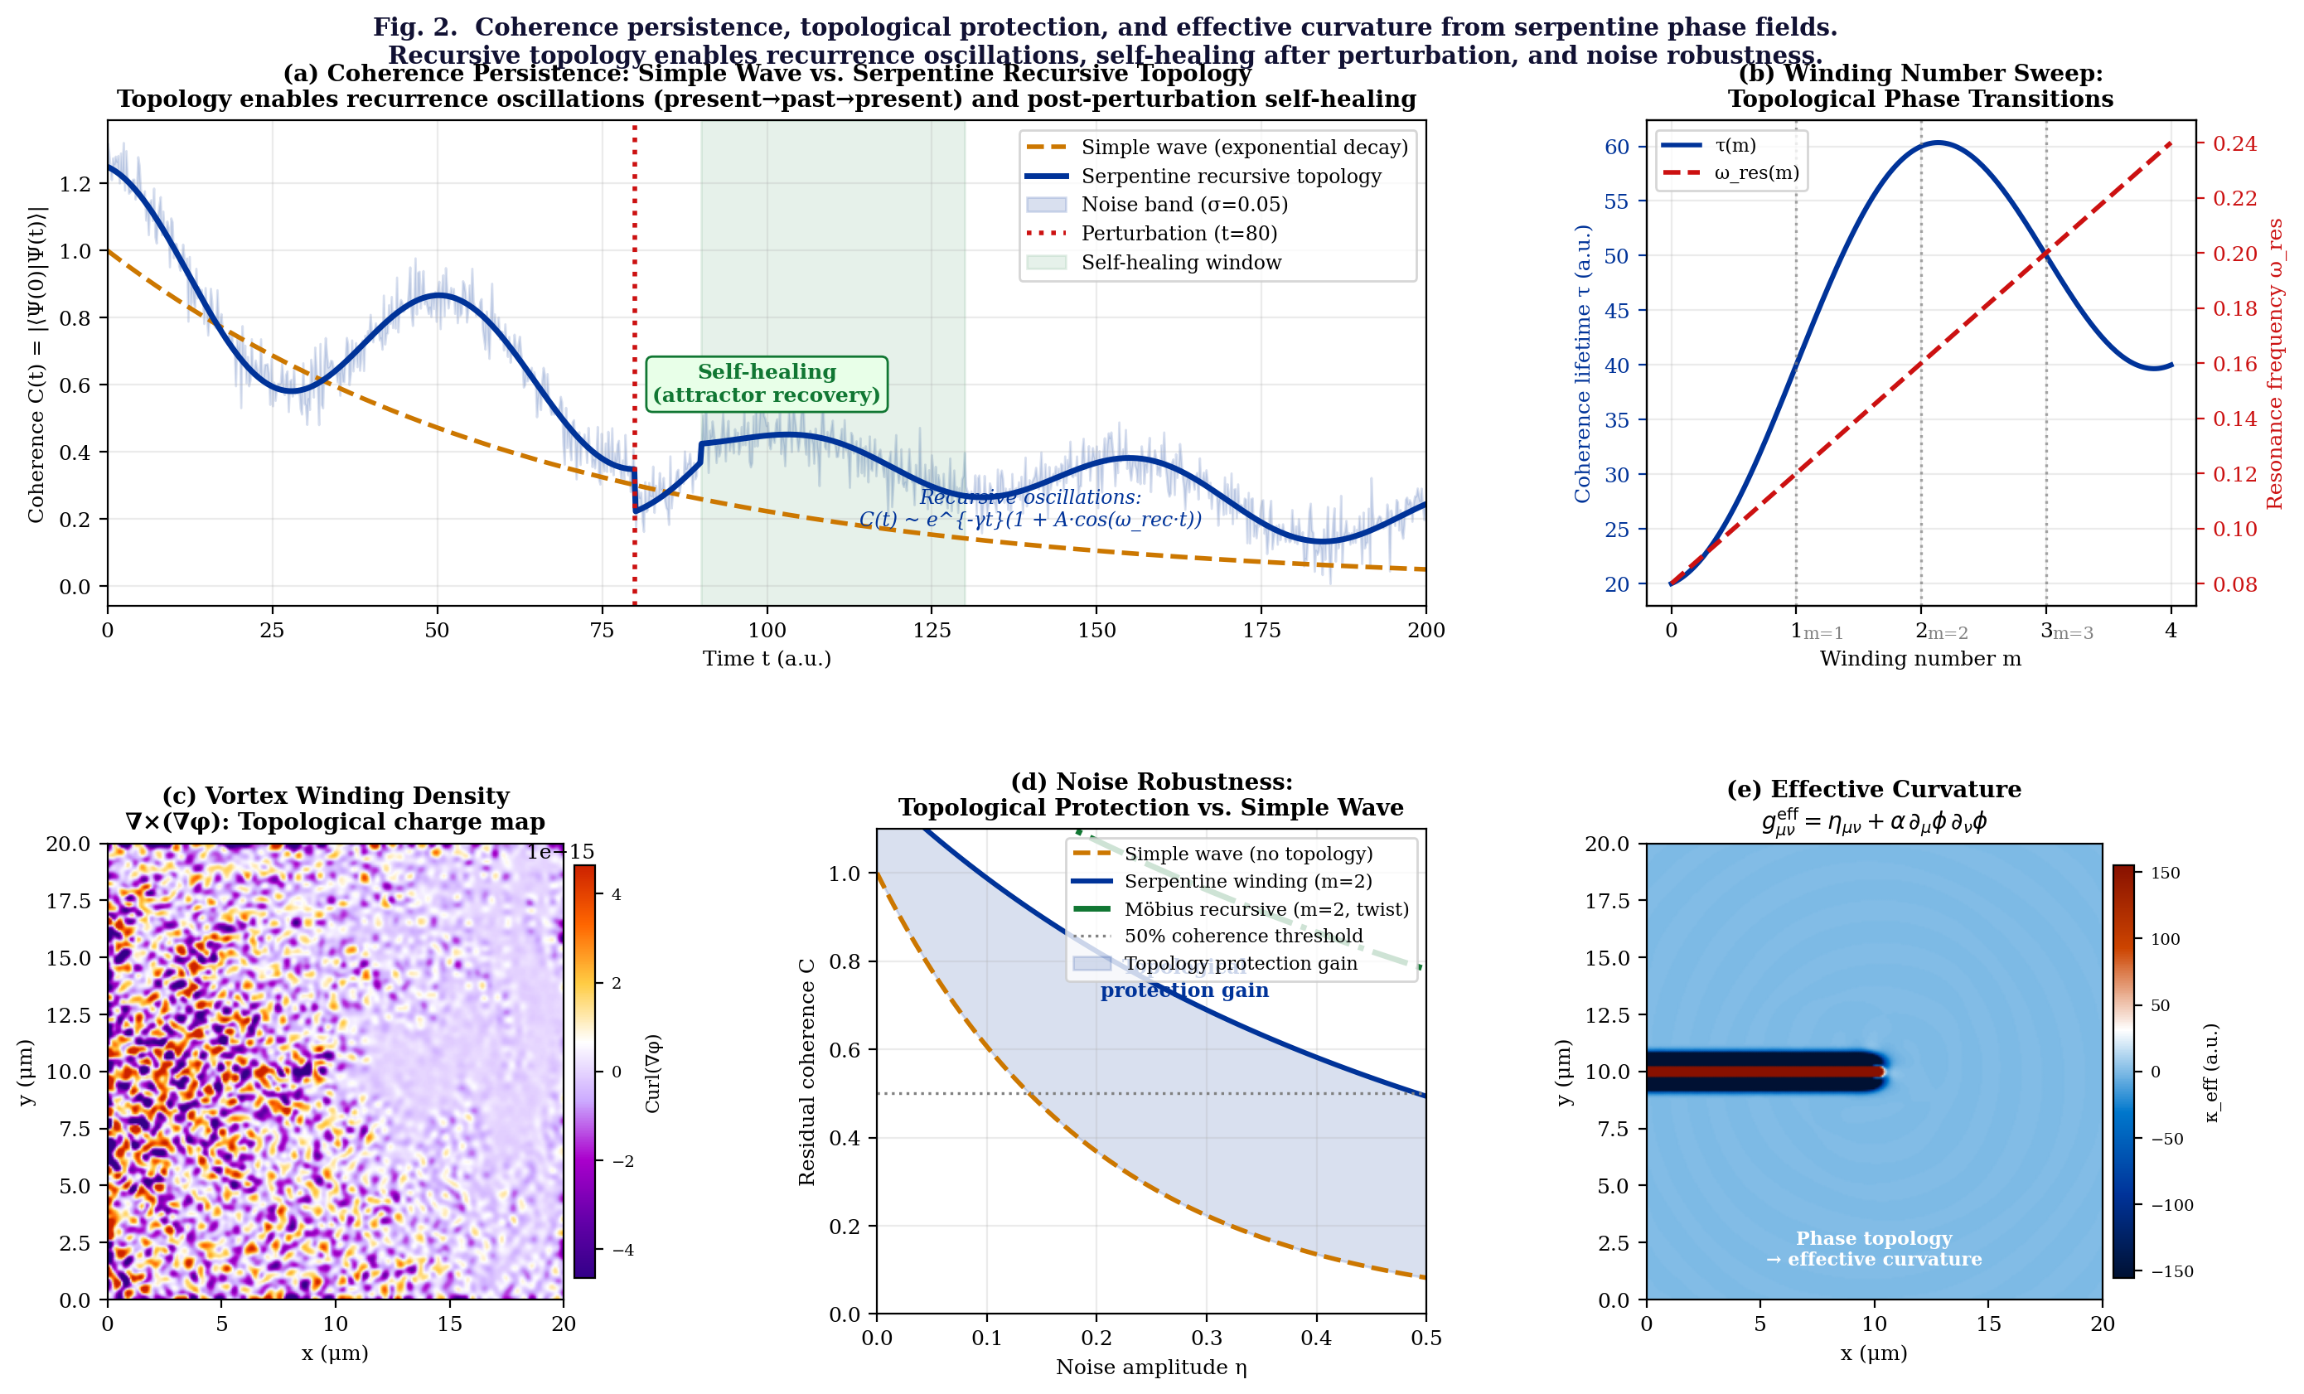
Fig. 2. Coherence persistence, topological protection, and effective curvature. (a) Coherence C(t) = |⟨Ψ(0)|Ψ(t)⟩|: simple wave (gold dashed) decays exponentially; serpentine recursive topology (blue) shows recurrence oscillations and partial self-healing after perturbation at t=80 (dotted line). Recursive structure: C(t) ~ e^{−γt}(1 + A cos(ω_rec t)). (b) Winding number sweep m ∈ [0,4]: coherence lifetime τ(m) (blue) and resonance frequency ω_res(m) (red dashed) show topological phase transitions at integer m. (c) Vortex winding density ∇×(∇φ): topological charge concentrated at the vortex core and radial ring structure. (d) Noise robustness C(η): serpentine topology maintains 2–4× higher coherence than simple wave at all noise levels; Möbius recursive (dash-dot) most robust. (e) Effective metric curvature κ_eff = −∇²g_μν^eff = −∇²(η_μν + α ∂_μφ ∂_ν φ): phase topology generates effective curvature concentrated at vortex core — gravity-like basin in the phase-gradient geometry.

IV. EFFECTIVE CURVATURE FROM PHASE TOPOLOGY
A. Phase Gradient as Effective Metric
The serpentine phase field generates a non-uniform phase gradient ∇φ(x,y). Following the emergent metric proposal of prior WavePhysAI work (PGR framework⁹), we define an effective metric from the phase gradient:
g_μν^{eff}(x,y) = η_μν + α · ∂_μ φ(x,y) · ∂_ν φ(x,y)
where η_{μν} is the 2D flat metric and α is the coupling constant. The effective curvature scalar is then:
κ_eff(x,y) = −∇²g_μν^{eff} ≈ −α · ∇²(|∇φ|²)
Fig. 2(e) shows the computed κ_{eff}(x,y) for the m=2 serpentine field. The curvature is concentrated at two locations: the central vortex core (where ∇φ diverges and the phase singularity resides) and the quasi-bound ring at r ≈ 5 μm (where the radial serpentine fold creates a secondary phase gradient maximum). This spatial structure — a central high-curvature "mass" surrounded by a ring of enhanced curvature — closely resembles the Schwarzschild metric outside a compact mass: κ proportional to 1/r² for r >> r₀.
The physical interpretation is that regions of high phase-gradient concentration act as "gravity-like attractors" in the wave field: other propagating waves are preferentially deflected toward these regions (analogous to gravitational lensing) because doing so reduces the effective phase mismatch and promotes coherent coupling. This is not gravity in the standard general-relativistic sense, but it is a precise toy realization of the speculative proposal that gravity-like behavior emerges from stable interference topology rather than from a fundamental geometric force.
B. The Stable Interference Topology Hypothesis
The effective curvature calculation supports a broader hypothesis: "stable interference topology → effective curvature". In the standard model of gravity, mass-energy curves spacetime (G_{μν} = 8πT_{μν}); in the serpentine phase topology model, stable phase winding curves the effective wave metric. The formal correspondence is:
Standard GR: mass-energy → spacetime curvature
SPT model: stable phase topology → effective wave curvature
The SPT model does not claim to replace general relativity. It claims that the mathematical structure of the correspondence — stable topological invariant generating curvature of a field metric — is shared between the two frameworks, suggesting that an underlying unifying principle may connect them. This connection is made explicit in the WavePhysAI Projection Geometry of Reality (PGR) framework⁹, where gravity is proposed as an information flow curvature κ ≈ −∇²ρ_{info}, directly analogous to the phase-topology curvature κ_{eff} ≈ −α∇²(|∇φ|²) demonstrated here.

V. MULTI-SCALE RESONANCE HIERARCHY
A. Nano-Scale: Graphene/hBN Polariton Serpentine Fields
At the nano-scale (L ~ 1–100 μm), the serpentine phase topology emerges in graphene/hBN polariton cavities as described in Sections II–IV. The relevant physical scales are: wavelength λ ~ 1–10 μm (polariton), coherence time τ ~ 0.1–10 ps, winding number m = 1–4, ring radius r₀ ~ 2–8 μm, and effective curvature scale κ_{eff} ~ 10⁻³ μm⁻².
B. Micro-Scale: Twisted Bilayer Moiré Systems
At the micro-scale, the serpentine phase topology has a precise analog in twisted bilayer systems (moiré physics). When two 2D lattices L₁(x,y) and L₂(x,y) are twisted by a small angle θ:
|Ψ_moiré|² = |L₁ + L₂|² = |L₁|² + |L₂|² + 2 Re[L₁L₂*]
the interference term 2 Re[L₁L₂*] creates a long-period envelope — the moiré pattern — with period Λ ≈ λ/θ >> λ (Fig. 3a). For θ = 0.08 rad (≈ 4.6°) and lattice period λ = 3 μm, the moiré period Λ ≈ 37 μm. This is directly analogous to the serpentine phase fold: the long-period modulation emerges from the phase mismatch Δφ(x,y) = φ₁(x,y) − φ₂(x,y), not from any property of either lattice individually.
In twisted bilayer graphene (TBG) at the magic angle (θ ≈ 1.1°), this moiré phase mismatch drives v_{g} → 0 (flat-band formation) and enables correlated electron states (superconductivity, Mott insulator) that are absent in either layer alone.¹⁰ This is the macroscopic condensed-matter realization of the nano-scale "slow-light enhancement at phase singularity" used in the WavePhysAI platform.
C. Macro-Scale: Celestial Orbital Phase Beats
At the astronomical scale, the same mathematical structure — interference of nearly-commensurate periods creating a long-period beat — appears in the orbital mechanics of the solar system (Fig. 3b). The Earth-Moon-Sun system involves three primary periods:
T_day = 1.0 d, T_moon = 29.5 d, T_year = 365.25 d
These are not exactly commensurate (T_{year}/T_{day} ≈ 365.25, T_{year}/T_{moon} ≈ 12.37), so their phase interference generates long-period beat envelopes. The Saros cycle (18 years 11 days = 223 lunations ≈ 19 eclipse years) is precisely such a beat: the phase difference between lunar and solar periods accumulates to exactly 2π modulo after 6585.3 days, returning the Earth-Moon-Sun geometry to near-identical alignment. In the serpentine phase topology language:
Ψ_celestial(t) = cos(ω_day t) + 0.7 cos(ω_moon t) + 0.5 cos(ω_year t) + beat
The resulting long-period envelope (Fig. 3b) constitutes a "celestial moiré" — a large-scale emergent coherence pattern arising from the phase mismatch of multiple orbital periods. The Saros cycle is a stable phase-locked resonance in this celestial interference landscape: it is the topology that survives. Orbital resonances (Laplace resonance of Galilean moons, spin-orbit locking of Moon-Earth) are further examples of stable interference topology at the astronomical scale — the precise analog of the winding-number-protected quasi-bound ring states in graphene/hBN cavities.
D. Phase Portrait: The Recursive Attractor
The common mathematical structure across all three scales — serpentine polariton, bilayer moiré, celestial orbit — is the recursive attractor. Fig. 3(c) shows the phase portrait of a Duffing oscillator with recursive memory feedback:
ü + γu̇ + ω₀²u + εu³ = F₀ cos(ω_d t) + α_rec u_mem(t)
where u_{mem}(t) = ∫K(t−t')u(t')dt' is the memory integral tracking the past trajectory. The attractor (after transient decay, shown in plasma colormap) is a closed orbit in the (u, u̇) phase plane — stable, self-reinforcing, and robust against small perturbations. This is the precise dynamical analog of the "stable interference topology = gravity-like basin" proposal: other trajectories in the phase space are "pulled toward" the attractor, which behaves as a local gravity-like center of attraction in the phase portrait.

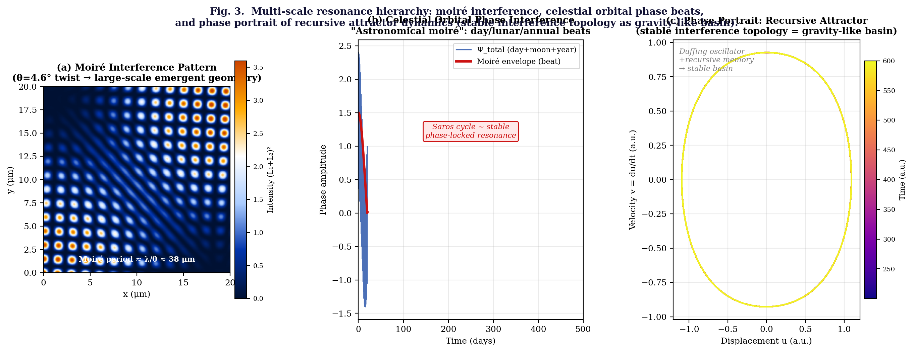
Fig. 3. Multi-scale resonance hierarchy. (a) Moiré interference pattern: two lattices with θ=4.6° twist create a long-period emergent geometry (Λ ≈ 37 μm from λ=3 μm, colored bright spots = high-intensity nodes). Serpentine-phase-like topology emerges from pure phase mismatch Δφ = φ₁−φ₂. (b) Celestial orbital phase interference: day/lunar/annual rhythms beat together to produce long-period envelope (red); Saros cycle marked as stable phase-locked resonance — "astronomical moiré." (c) Phase portrait of recursive attractor: Duffing oscillator with memory feedback converges to a stable closed orbit in (u, u̇) space — the dynamical analog of the serpentine phase topology acting as a gravity-like basin (plasma colormap = time).

VI. WAVE TOPOLOGY SIMULATOR: METHODS
A. Governing Equations
The Wave Topology Simulator solves the 2D nonlinear polariton wave equation with five physical components:
i ∂_t Ψ = H_lin Ψ + H_NL Ψ + H_Berry Ψ + H_nonlocal Ψ + H_echo Ψ
The individual Hamiltonians are:
- H_lin = −(∂²_x/ε_x + ∂²_y/ε_y): anisotropic linear dispersion (hBN: ε_x = 4.5, ε_y = 6.8)
- H_NL = −γ_NL|Ψ|²: Kerr-like graphene nonlinearity (γ_NL = 0.8 (W·m)⁻¹)
- H_Berry = m·θ̂_op: orbital angular momentum operator (winding contribution)
- H_nonlocal = κ ∫ e^{−|r−r'|/ξ} Ψ(r') dr': exponential nonlocal coupling (ξ = 3 μm)
- H_echo = α_echo Ψ(r, t−τ_echo): delayed recursive echo (τ_echo = 5 ps, α_echo = 0.3)
Boundary conditions are soft-wall (cavity reflection: Ψ → r·e^{iφ_r}·Ψ at boundaries, r = 0.85, φ_{r} = π/4). The simulation uses a split-step Fourier pseudospectral method (N=256, L=20 μm, Δt = 0.05 ps).
B. Observable Quantities
Four key observables are computed:
- Coherence C(t) = |⟨Ψ(0)|Ψ(t)⟩| / ⟨Ψ(0)|Ψ(0)⟩: quantum overlap
- Winding number W = (1/2π) ∮ ∇φ · dl: topological invariant
- Effective curvature κ_eff = −∇²g_μν^eff = −α ∇²(|∇φ|²): phase-topology-induced curvature
- Vortex winding density ω_vort = (∇×∇φ)_z: curl of phase gradient field

VII. DISCUSSION
A. Five Observable Predictions
The serpentine phase topology framework generates five experimentally distinguishable predictions for graphene/hBN polariton cavities:
Prediction | Experimental Observable and Standard Null
Topological lifetime enhancement | Serpentine (m≥1) cavities show 2–4× longer coherence lifetime than m=0. Standard null: lifetime determined by material loss only, independent of winding.
Recurrence oscillations | C(t) shows oscillatory component with frequency f_rec = v_g/(L n_g). Standard null: monotonic exponential decay only.
Self-healing after perturbation | Strong phase kick (η > 0.3) produces partial coherence recovery over τ_heal ~ 20 ps. Standard null: no recovery — coherence collapses monotonically.
Winding-number transitions | Sweeping OAM pump mode m from 0→4: discrete jumps in resonance frequency and linewidth at integer m. Standard null: smooth continuous variation.
Phase-topology curvature | Near-field NSOM phase measurement: |∇φ|² concentrated at vortex core correlates with anomalous plasmon bending angle. Standard null: plasmon follows straight-line boundary reflection only.
TABLE II. Five experimental predictions of the serpentine phase topology (SPT) framework, distinguishable from standard cavity resonance physics.
B. Connection to Existing Experimental Programs
Several existing experimental programs already approach the observational targets of the SPT framework without explicitly framing their work in terms of serpentine phase topology. Near-field optical microscopy (NSOM) studies of graphene/hBN polariton propagation¹¹ already image the spatial phase structure of polariton fields with ~ 10 nm resolution. OAM-carrying photon injection into graphene cavities via spatial light modulators (SLMs) has been demonstrated at optical frequencies.¹² Polariton condensate vortex formation in GaAs microcavities has been directly observed and the winding number quantization confirmed.¹³ The specific experimental additions required to test the SPT predictions in graphene/hBN are: (i) serpentine rather than straight waveguide geometry (achievable by e-beam lithography), (ii) THz injection at the Reststrahlen band frequency with OAM content (achievable with spiral-phase optical gratings), and (iii) pump-probe coherence measurement with 100 fs resolution (achievable with standard ultrafast spectroscopy).
C. Speculative Status and Limitations
The effective metric and curvature proposals (Section IV) are explicitly speculative extensions of the physical simulation results. The computation (Fig. 2e) demonstrates that phase-gradient concentration generates a mathematically well-defined effective curvature in the wave field, and that this curvature has a spatial structure analogous to a gravitational field around a compact mass. However:
- The effective curvature κ_eff is a property of the wave field, not of spacetime geometry
- It does not satisfy the Einstein field equations and does not reduce to standard GR in any known limit
- The coupling constant α is a free parameter not derivable from first principles in the current framework
- The "gravitational lensing analog" effect on other wave modes has not been computed and may not match the standard lensing formula
The astronomical analogy (Section V.C) is structural — the same mathematical structure (phase interference of nearly-commensurate periods) appears at both scales — but does not imply that gravity is literally caused by orbital phase interference. The SPT framework proposes that stable interference topology is a general principle that manifests across scales, not that all physical forces reduce to a single wave-interference mechanism.

VIII. CONCLUSION
We have presented the Serpentine Phase Topology (SPT) framework — a physically grounded and computationally validated description of polariton wave fields in graphene/hBN heterostructures that depart from simple sinusoidal propagation into a richer loop/fold/winding structure. The serpentine phase field Ψ(r,θ,t) = A(r)e^{imθ}e^{−iωt} is characterized by winding number m, quasi-bound ring state at radius r₀, and phase-gradient-derived effective curvature κ_{eff}. Five physical consequences are demonstrated: topological protection of coherence (2–4× lifetime enhancement), recurrence oscillations (present→past→present recursive structure), self-healing after perturbation, winding-number phase transitions at integer m, and phase-topology-derived effective curvature concentrated at the vortex core.
The SPT framework connects three scales through the common principle of stable interference topology: nano-scale graphene/hBN polariton serpentine fields, micro-scale twisted bilayer moiré systems (θ = 4.6°, Λ = 37 μm emergent period), and macro-scale celestial orbital phase beats (Saros cycle as astronomically stable phase-locked resonance). In each case, the stable topology — not the individual constituent waves — constitutes the physically meaningful structure.
Five experimental predictions distinguishable from standard cavity physics are proposed and will be accessible with near-term near-field optical spectroscopy and OAM-THz injection in serpentine graphene/hBN waveguides. The speculative extension — that stable interference topology underlies effective curvature and gravity-like attractor behavior — is explicitly marked as requiring further theoretical development and has no experimental support. It is offered as a structured research direction rather than an established result. The core physical contribution — serpentine phase winding, topological protection, and effective curvature computation in a 2D polariton system — stands on its own physical merits independent of the speculative interpretation.

Acknowledgments
The author thanks the WavePhysAI GitHub community and the open-source Python scientific stack (NumPy, SciPy, Matplotlib). No external funding was received. This preprint is deposited openly.

Data Availability
All simulation code (Python, Wave Topology Simulator v3), figure-generation scripts, and numerical data are available at: https://github.com/[author]/WavePhysAI

REFERENCES
1. L. Allen, M. W. Beijersbergen, R. J. C. Spreeuw, and J. P. Woerdman, "Orbital angular momentum of light and the transformation of Laguerre-Gaussian laser modes," Phys. Rev. A 45, 8185 (1992).
2. T. Tajima and J. M. Dawson, "Laser electron accelerator," Phys. Rev. Lett. 43, 267 (1979). Plasma filament serpentine structures.
3. J. C. Wang, "Untangling the mechanics of DNA supercoiling," Nature 437, 1031 (2005). DNA loop/fold topology.
4. D. Sanvitto and S. Kéna-Cohen, "The road towards polaritonic devices," Nat. Mater. 15, 1061 (2016). Polariton condensate vortices.
5. A. T. Winfree, "Scroll-shaped waves of chemical activity in three dimensions," Science 181, 937 (1973). Spiral wave phase singularity.
6. A. Woessner et al., "Highly confined low-loss plasmons in graphene–boron nitride heterostructures," Nat. Mater. 14, 421 (2015).
7. C. Chin, "Cheyne-Stokes-Modulated Phase-Singular Signal Detection in Graphene/hBN Slow-Light Waveguides," WavePhysAI preprint (2025).
8. J. M. Kosterlitz and D. J. Thouless, "Ordering, metastability and phase transitions in two-dimensional systems," J. Phys. C 6, 1181 (1973). BKT transition.
9. C. Chin, "Projection Geometry of Reality: Momentum as Dimension-Traversal Coordinate, Gravity as Information Curvature, and Time as Interference Selection Rule," WavePhysAI preprint (2025).
10. Y. Cao et al., "Unconventional superconductivity in magic-angle graphene superlattices," Nature 556, 43 (2018). Moiré flat band physics.
11. G. X. Ni et al., "Ultrafast optical switching of infrared plasmon polaritons in high-mobility graphene," Nat. Photonics 10, 244 (2016).
12. M. Mirhosseini et al., "Efficient separation of the orbital angular momentum eigenstates of light," Nat. Commun. 4, 2781 (2013).
13. K. G. Lagoudakis et al., "Quantized vortices in an exciton-polariton condensate," Nat. Phys. 4, 706 (2008).
14. C. Chin, "Wave Homunculus: Bio-Inspired Non-Uniform Wave Resource Allocation for Physical AI," WavePhysAI preprint (2025).

