Annual summary report: central_fife Centre of Mission

Church Army’s Research Team

## This is Central Fife CoM

## Age

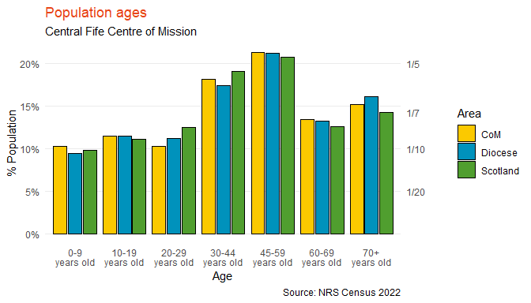

|  | CoM | Diocese | Scotland |
| --- | --- | --- | --- |
| 0-9 years old | 10% | 9% | 10% |
| 10-19 years old | 11% | 11% | 11% |
| 20-29 years old | 10% | 11% | 12% |
| 30-44 years old | 18% | 17% | 19% |
| 45-59 years old | 21% | 21% | 21% |
| 60-69 years old | 13% | 13% | 13% |
| 70+ years old | 15% | 16% | 14% |

## Ethnicity

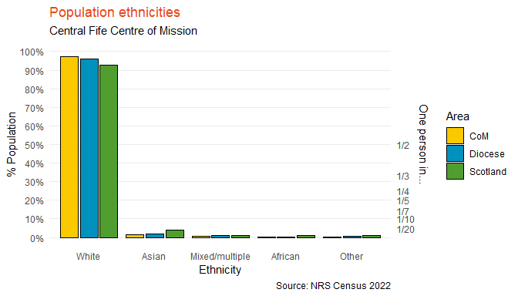

|  | CoM | Diocese | Scotland |
| --- | --- | --- | --- |
| White | 97% | 96% | 93% |
| Asian | 2% | 2% | 4% |
| Mixed/multiple | 1% | 1% | 1% |
| African | 0% | 0% | 1% |
| Other | 0% | 1% | 1% |

## Religion

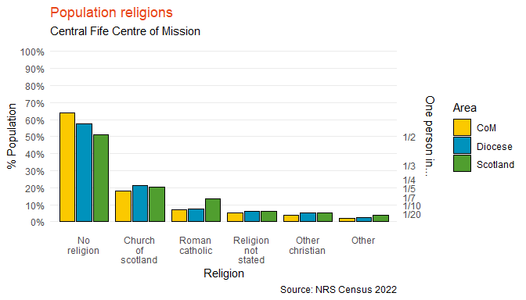

|  | CoM | Diocese | Scotland |
| --- | --- | --- | --- |
| No religion | 64% | 57% | 51% |
| Church of scotland | 18% | 21% | 20% |
| Roman catholic | 7% | 8% | 13% |
| Religion not stated | 5% | 6% | 6% |
| Other christian | 4% | 5% | 5% |
| Other | 2% | 2% | 4% |

## General Health

NULL

## Household Composition

### Overview of household composition

NULL

### Couples

NULL

### Lone occupants & single parents

NULL

### Other

NULL