Annual summary report: west_highlands Centre of Mission

Church Army’s Research Team

## This is West Highlands CoM

## Age

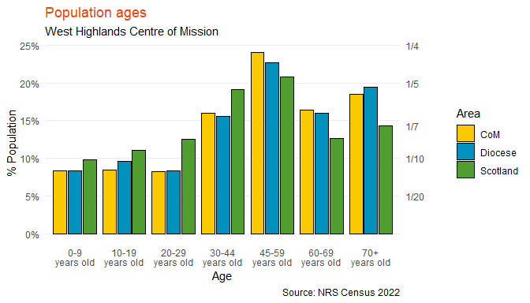

|  | CoM | Diocese | Scotland |
| --- | --- | --- | --- |
| 0-9 years old | 8% | 8% | 10% |
| 10-19 years old | 8% | 10% | 11% |
| 20-29 years old | 8% | 8% | 12% |
| 30-44 years old | 16% | 16% | 19% |
| 45-59 years old | 24% | 23% | 21% |
| 60-69 years old | 16% | 16% | 13% |
| 70+ years old | 19% | 19% | 14% |

## Ethnicity

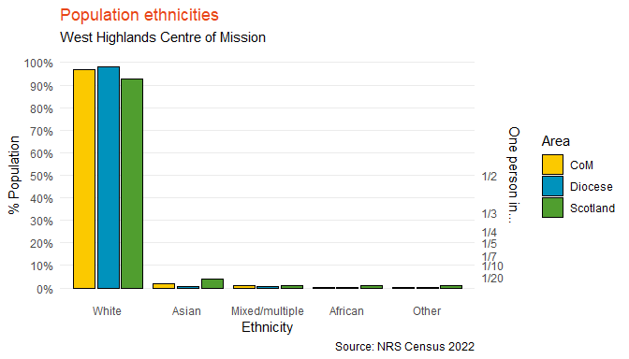

|  | CoM | Diocese | Scotland |
| --- | --- | --- | --- |
| White | 97% | 98% | 93% |
| Asian | 2% | 1% | 4% |
| Mixed/multiple | 1% | 1% | 1% |
| African | 0% | 0% | 1% |
| Other | 0% | 0% | 1% |

## Religion

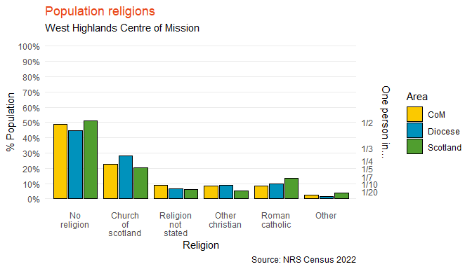

|  | CoM | Diocese | Scotland |
| --- | --- | --- | --- |
| No religion | 49% | 45% | 51% |
| Church of scotland | 23% | 28% | 20% |
| Religion not stated | 9% | 7% | 6% |
| Other christian | 9% | 9% | 5% |
| Roman catholic | 8% | 10% | 13% |
| Other | 2% | 2% | 4% |

## General Health

NULL

## Household Composition

### Overview of household composition

NULL

### Couples

NULL

### Lone occupants & single parents

NULL

### Other

NULL