Mechanical Stress Analysis - housing, battery rack
-

Table of contents

1 Introduction 3
1.1. Purpose of this document 3
1.2. Standards 3
1.3. List of abbreviations 3
1.4. Software used 3
2 Static load 4
3 Impact load 8
4 Emergency stop 16

Introduction
This report covers the structural analysis for several specific load cases of the e-PU10ft container series. Document P000009492 covers the mechanical stress analysis of the battery rack of the e-Pu 10. Document P000009139 covers the mechanical stress analysis of the enclosure assembly which is developed by VDL Energy Systems for different products. This document will cover the specific load cases on the enclosure assembly of the e-Pu 10. These load cases are: static load of the battery rack and modules on a small footprint, impact load when the container is lifted and put down on the floor and emergency stop when the e-Pu is transported on a truck.
Chapter 2 describes the system of interest as well as the different load cases.
Chapter 3 will cover the first load case: static load.
Chapter 4 will cover the second load case: impact load.
Chapter 5 will cover the third load case: emergency stop.

Purpose of this document
The purpose of the document is two sided. Mechanical stress analysis are used to determine required stiffness of structural components.. Secondly, this document will provide information of the structural stresses that occur to provide to supply a CE mark on the structure.

Standards
To include the required information in this report the following standards are conducted:
EN-1993-1-1:2010 | Eurocode 3: Steel structures:  Part 1-1: General rules for design and construction
EN-1993-1-3:2010 | Eurocode 3: Steel structures:  Part 1-3: Additional rules for cold formed members and sheet metal
EN-1993-1-5:2010 | Eurocode 3: Steel structures:  Part 1-5: Buckling of plate-type members
EN-1993-1-6:2010 | Eurocode 3: Steel structures:  Part 1-6: General - Strength and Stability of Shell Structures

List of abbreviations
COM Centre Of Mass

Software used
The software used to perform analysis is SolidWorks simulation premium

Model under investigation
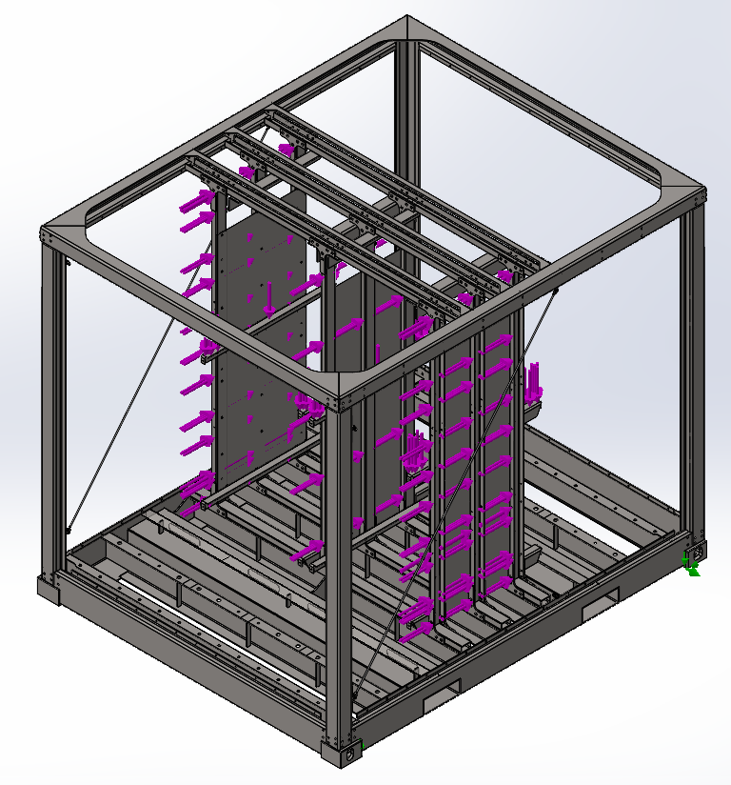
The battery rack is mounted to the floor with three M12 bolts per beam. Asymmetrically, on one side one bolt, the other two bolts. The battery rack is mounted to the roof with six gusset plates
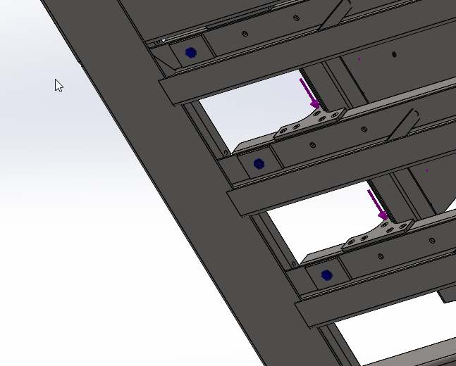
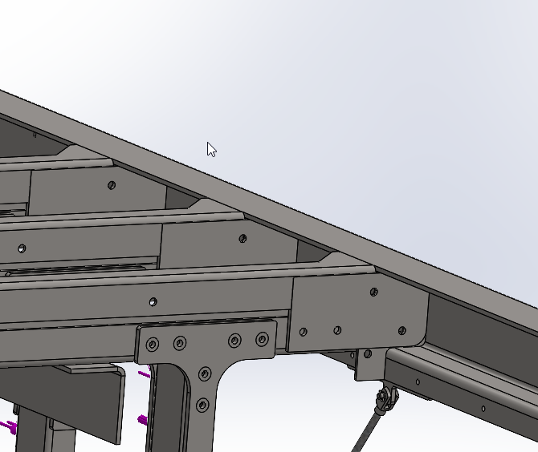
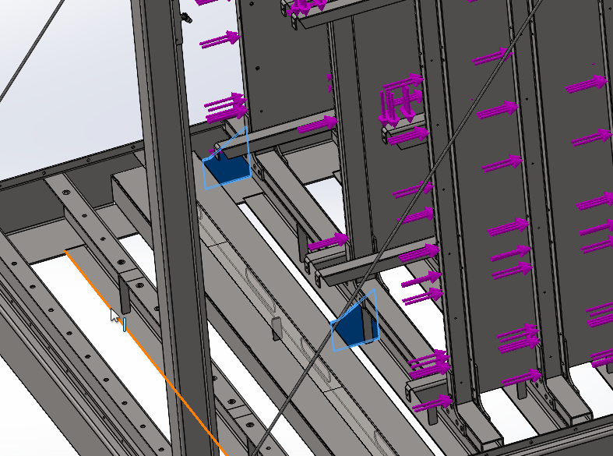

Location of files
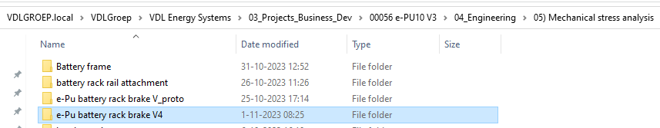

Static load
The first load case is when the e-Pu is stationary on the ground with gravitational force applied. The footprint is smaller than the assumed foot print in the mechanical stress analysis of the enclosure (P000009139), furthermore the weight is slightly higher too. The battery rack itself will contribute positively to the structural integrity of the whole. The battery rack and the enclosure have only been analysed separately before.
This load case is not very relevant as the impact load is the same load case, but with higher loads. If the result of the impact load FEM study is positive, so will the static load.
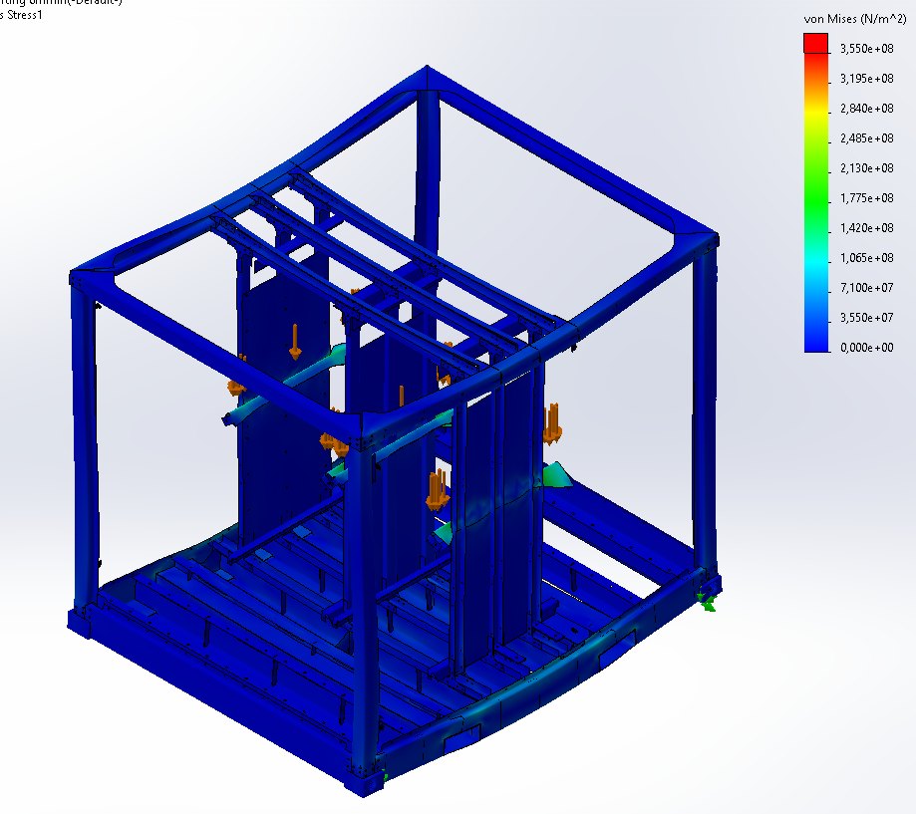

Impact load
When the container is lifted and put down on the floor, the velocity with which it hits the floor will not be zero. Therefor an impact load will occur. To determine the impact force, an impact deflection needs to be determined.

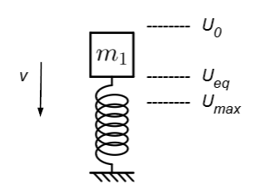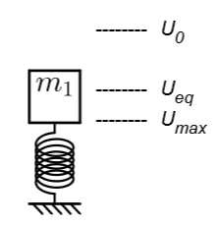
The assembly will be simplified to a vertical mass spring system. The mass represents the battery modules and the spring can be seen as the slightly flexible battery rack and housing floor. The spring will be compressed before it hits the ground, it will be lifted from the floor and gravitational force will precompress the springs. The deflection of the spring in equilibrium position will be:
$$mg=kU_{eq}$$
$$U_{eq}=\frac{mg}{k}$$
The maximum deflection of the spring can be calculated using the law of conservation of energy. The energy on first contact with the floor is:
$$\frac{1}{2}mv^{2}+mg\left(U_{max}-U_{eq}\right)+\frac{1}{2}k{U_{eq}}^{2}$$
In words the energy on first contact is equal to the kinetic energy, gravitational potential energy and potential energy in the spring, since the spring is preloaded. The energy at maximum deflection is all stored in the spring:
$$\frac{1}{2}k{U_{max}}^{2}$$
Energy is conserved so both equations can be equated:
$$\frac{1}{2}mv^{2}+mg\left(U_{max}-U_{eq}\right)+\frac{1}{2}k{U_{eq}}^{2}= \frac{1}{2}k{U_{max}}^{2}$$
This can be simplified to:
$$\frac{1}{2}k{U_{max}}^{2}-mgU_{max}+\frac{{\left(mg\right)}^{2}}{2k}-\frac{1}{2}mv^{2}=0$$
This is a quadratic equation. The spring constant k has to be found to solve this equation. The spring constant is defined as the force required to deflect a spring a unit length:
$$k=[\frac{N}{m}]$$
To determine the spring constant of the battery rack and ePu floor, the FEM simulation of the static load case will be used. The static load case uses a single distributed force of 55000N halfway the battery rack. At this height, the lowest deflection is 3,7 mm. Choosing the lowest deflection here will yield a conservative final result. The spring rate of the battery rack and ePu floor will then be 14.500.000,00 N/m. For the time being, an impact velocity of 6 m/s is assumed, this is equal to the highest velocity of an overhead crane at VDL Energy Systems.
The quadratic equation can now be solved. The resulting maximum deflection is 5,7 mm. Since the spring constant is known, this can be expressed in a maximum impact force when the structure is at maximum deflection, this is 28 kN.
The calculated impact force can be added to the static force and a new FEM simulation will be made.

Impact velocity as specified (6 m/min)
Input parameters
Impact velocity | 6 | m/min
Battery mass | 5500 | kg
Stiffness | 26,6 | MN/m

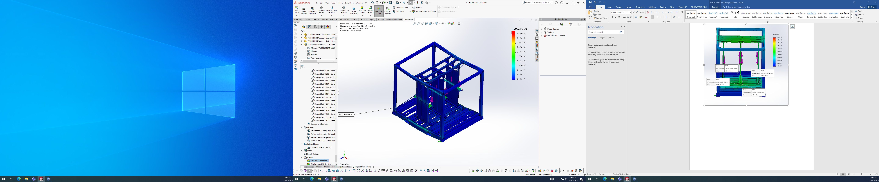


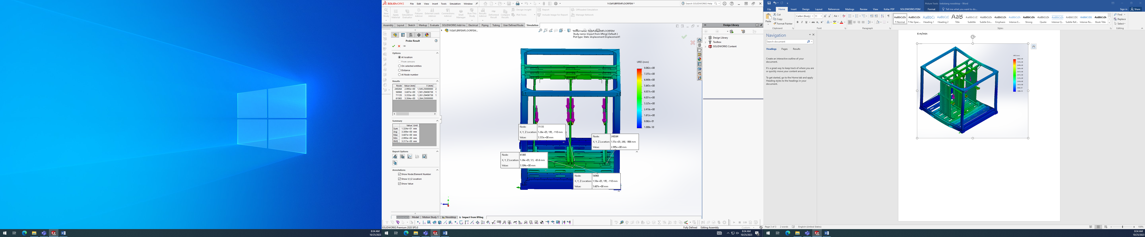
Results
Maximum deceleration at battery modules | 7.15 | m/s²
Maximum impact force | 89 | kN
Maximum deflection at modules (calculation) | 3.3 | mm
Maximum deflection at modules (FEM) | 3.3 | mm
Maximum stress | 137 | MPa
Ground clearance |  | mm

Impact velocity with safety factor (10 m/min)
A safety factor should be introduced. This should be implemented on the impact velocity, as the impact velocity is the measure which is altered by the operator. A safety factor of 1.6 is decided suitable. The specified impact velocity of 6 m/min is already felt as quite high. Furthermore, there is a conservative in the calculation method, as the spring constant of the battery racks at the side columns are used, while in reality the middle columns are less stiff.
Input parameters
Impact velocity | 10 | m/min
Safety factor on velocity | 1.6 | -
Battery mass | 5500 | kg
Stiffness | 26,6 | MN/m

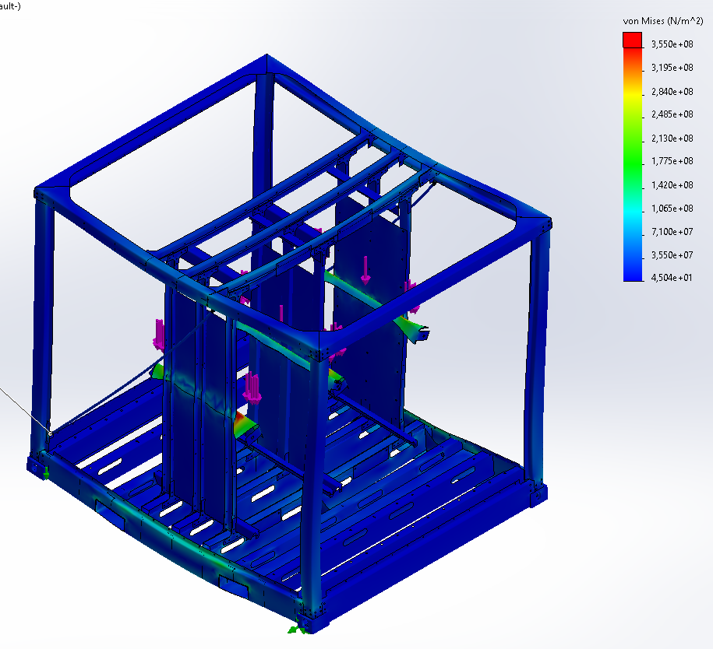
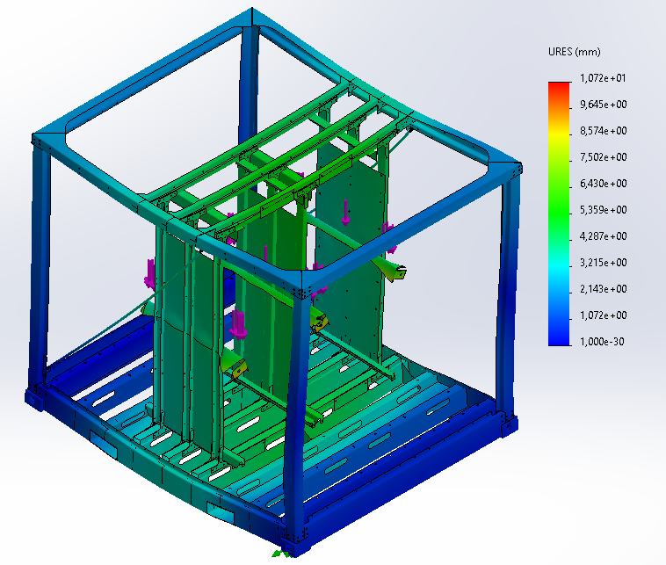
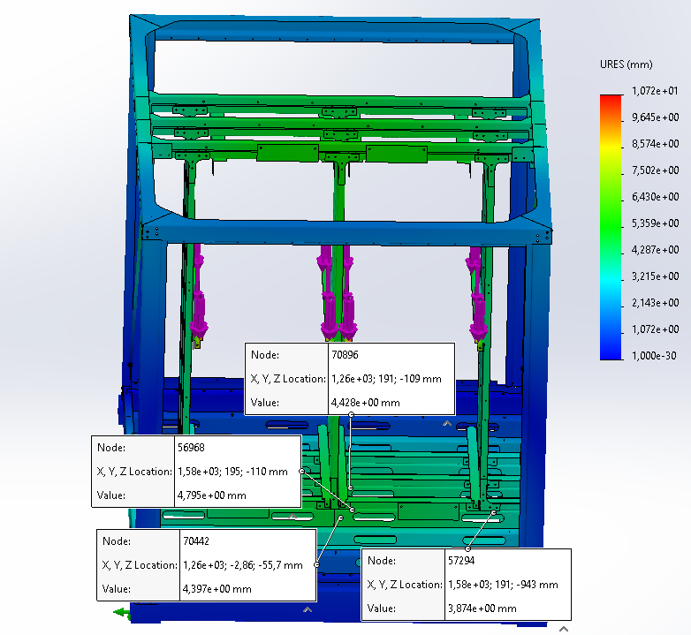
Results
Maximum deceleration at battery modules | 11,9 | m/s²
Maximum impact force | 113 | kN
Maximum deflection at modules | 4.2 | mm
Maximum stress | 199 | MPa
Ground clearance |  | mm

Ground clearance
The ground clearance is minimal to not existing. Probably the ground clearance should be increased. Results from the load test will decide.

Maximum impact velocity at failure

Emergency stop
When the e-Pu 10 is transported on a truck and the truck needs to make an emergency stop, a horizontal inertia force is applied to the battery rack. The battery rack could start behaving like a parallelogram. To avoid this, steel plates will be connected to the vertical pillars of battery rack between the battery rails. The battery rack will create a moment about the floor beams. This is investigated in the following FEM simulation. The brake deceleration which can be expected is 7 m/s². With this deceleration a force of $f=ma=5500*7=38,5 kN$ can be expected. This force is applied as a distributed force on the vertical pillars of the battery rack.

Original design
The original design does not suffice. The floor and roof fail where the beams connect to the side beams.

Strengthened design
A strengthened design of the enclosure has been made. It consists of thicker floor beams (4 to 6 mm wall thickness), bracing between the outer floor beams the battery rack is connected to and the forklift pockets, bracing in the container walls made from 8 mm studs and bracing to strengthen the roof beams against forward force. Furthermore the sizes of the beams of the battery frame have been determined. The side vertical beams are u shaped 4 mm WT, the vertical beams in the middle are 5 mm 80x40 mm, the lower horizontal beams are made 5 mm 80x40 mm, the upper horizontal beams are 5 mm U shaped. Every set of three vertical beams are strengthened against in plane moments by placing a 3 mm plate against them. The material of every component is S355. The container should be strengthened against two directions, as it can be placed on a trailer in two directions.

Direction positive X

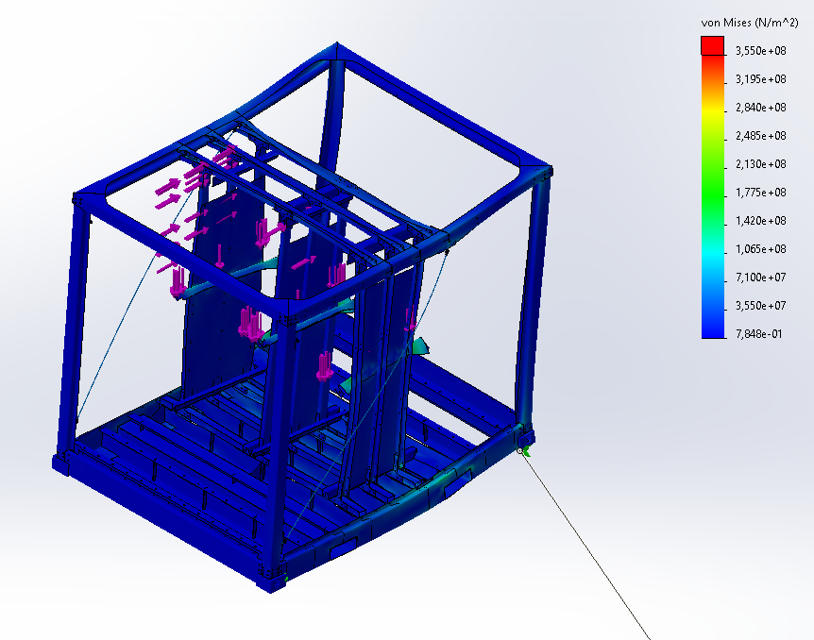

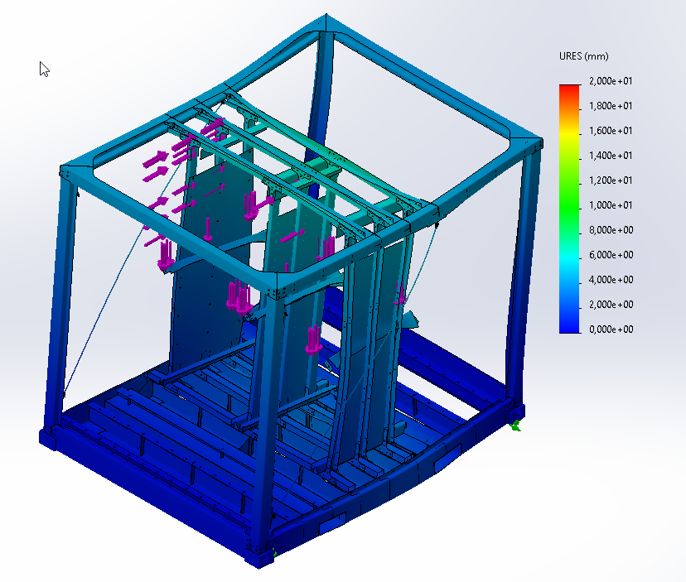
High stress points:
- Side beam
- Lower part of vertical battery rack c-beams, including middle tube.
- Floor beams to side beams, middle beam, upper tab
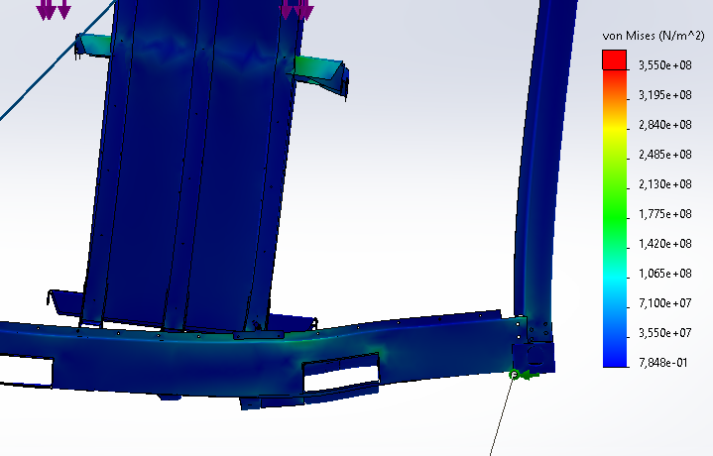
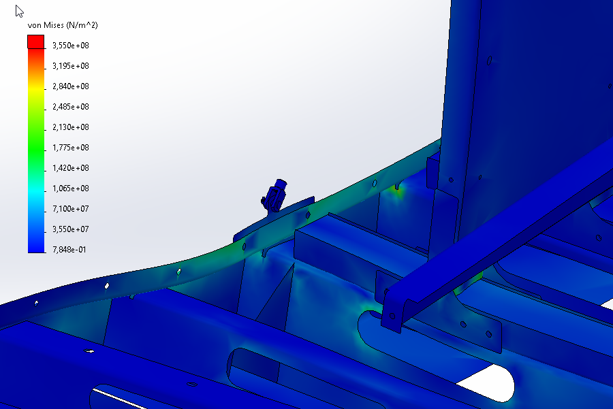
Maximum stress ~213 mPa

Direction negative X

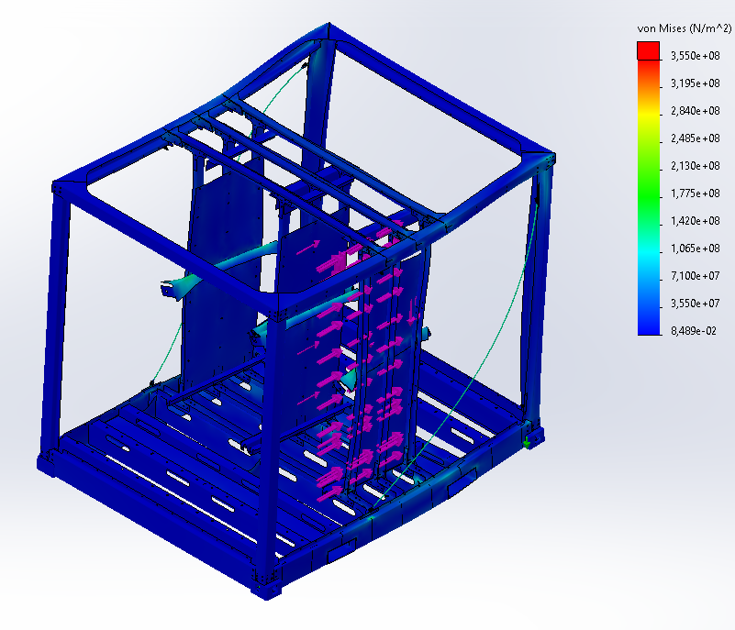
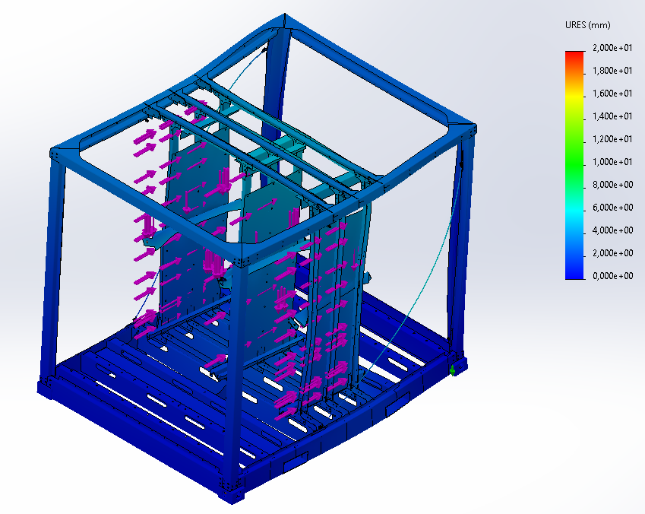

High stress points:
- Side beams
- Lower part of vertical c-beams and tubes of battery rack
- M8 stud used as brace
- Upper corner of enclosure
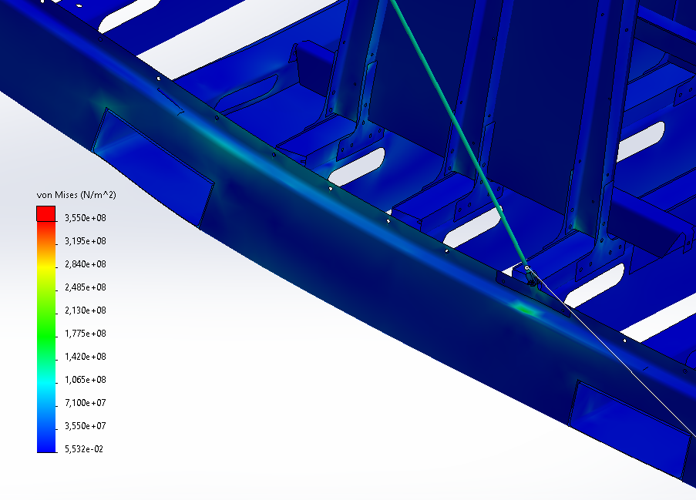
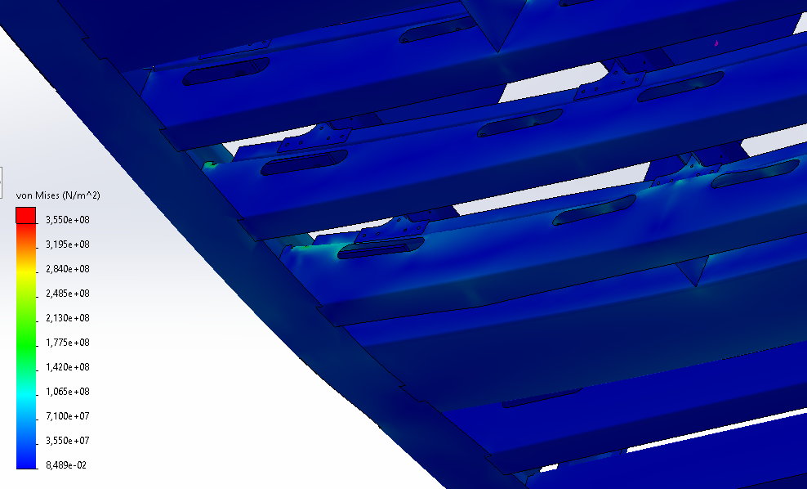
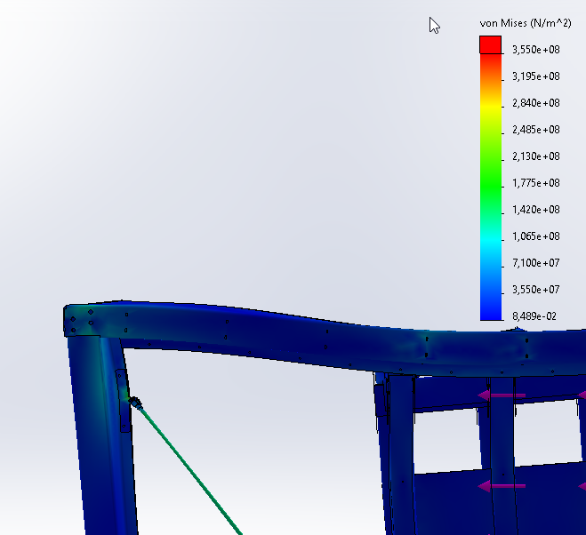
Highest stress: 200 mPa.

Update 5-5-2025 with “boomerangs”
Found no viable solution to removing the cross bracing rods. Rods are now M12 SS304.
Scale has changed to 175 MPA!
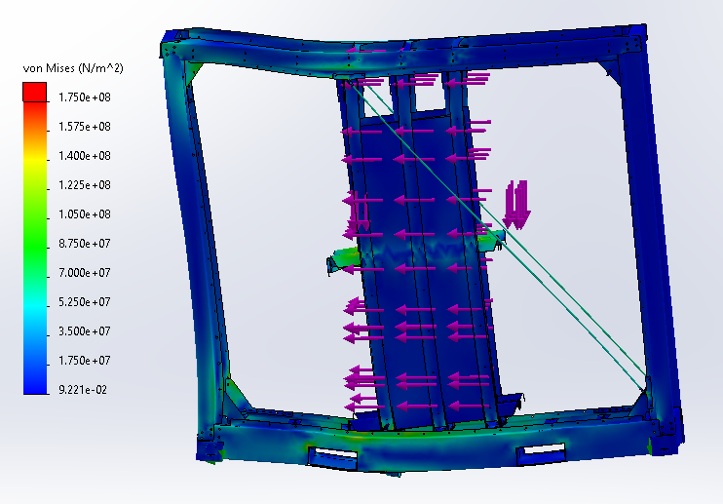
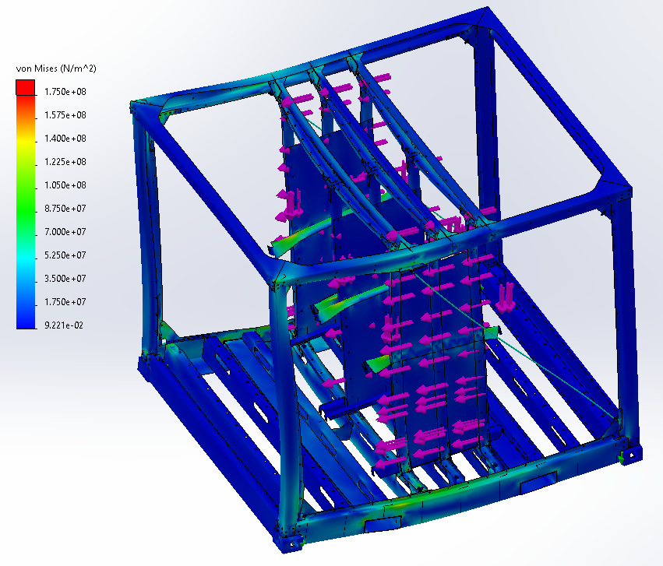
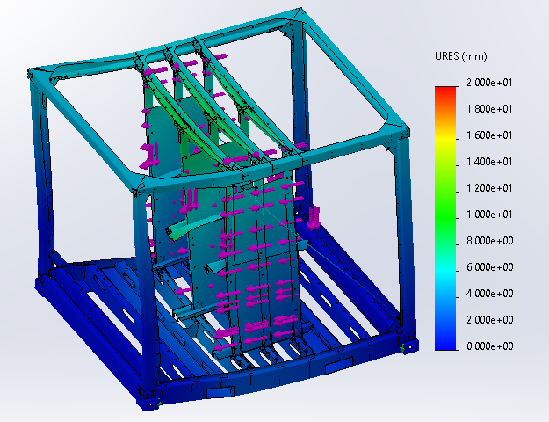
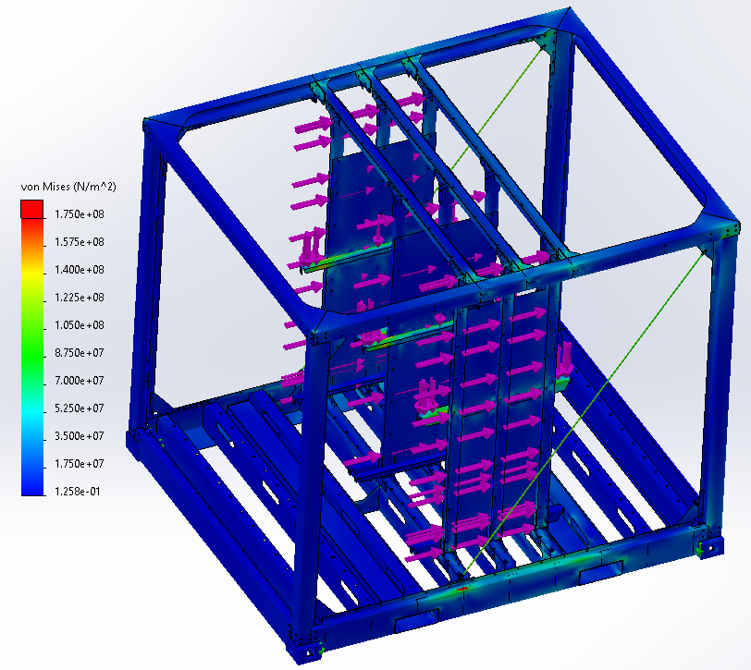
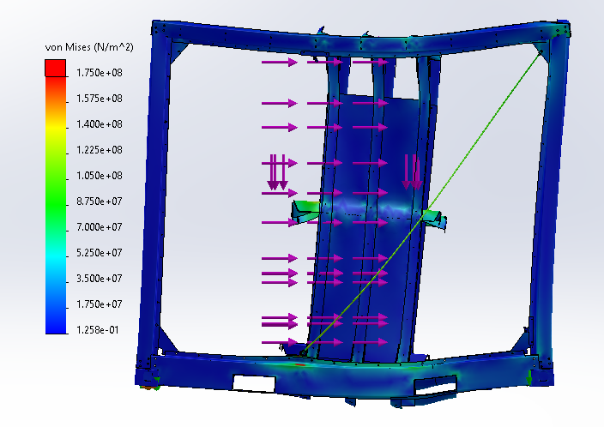
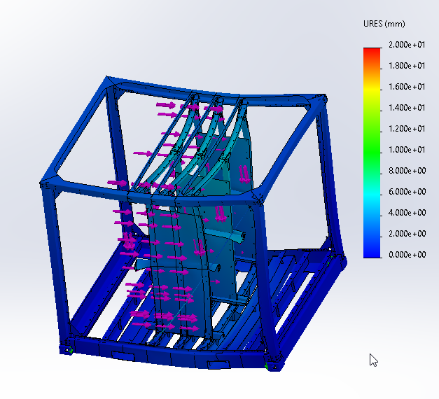

Update October 2025
A new design of the floor has been made. This design removes the bottom lip of the beams, which makes them L beams instead of U beams. Furthermore the forklift pockets have been made higher. The strength and stiffness in downward movement (normal to floor) are a concern. A FEM similar to section 4.2 has been made with the new floor.
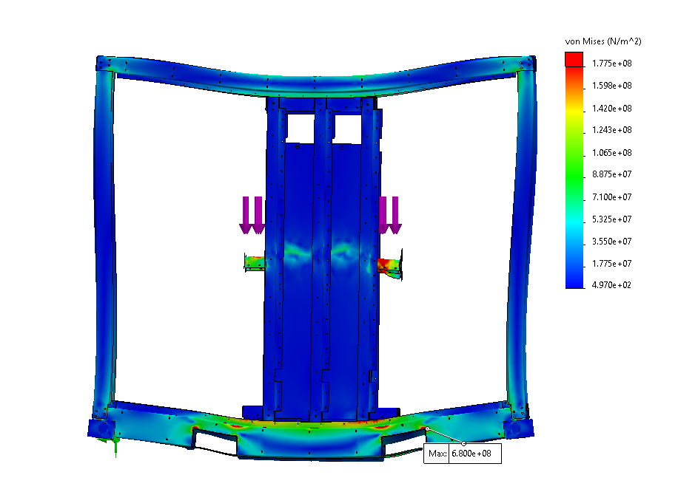
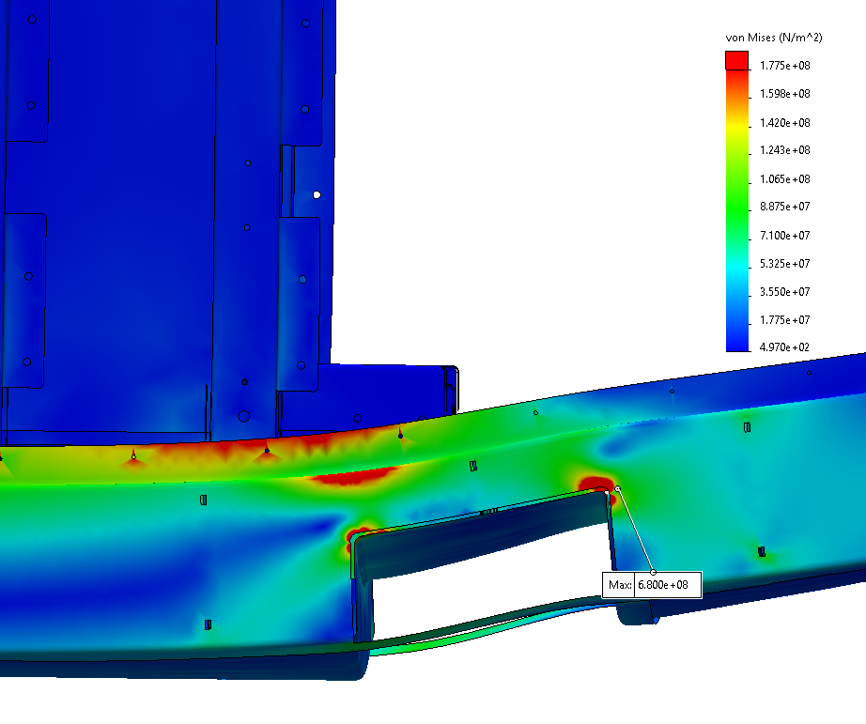
This floor gives high stress points at the corners of the fork lift pockets. A gusset plate of 10 mm thickness has been added to the outside of the side beam of the fork lift pocket. This gusset plate also gives the benefit of collision protection when a forklift lifts the e-PU, the walls of the e-PU are flush with the side beam without this gusset plate. The FEM with gusset plate has been done without the roof and battery rack. But with the same impact load. This is conservative, the roof and poles also relieve some load to iso corners. This gusset plate removes the high stress points.
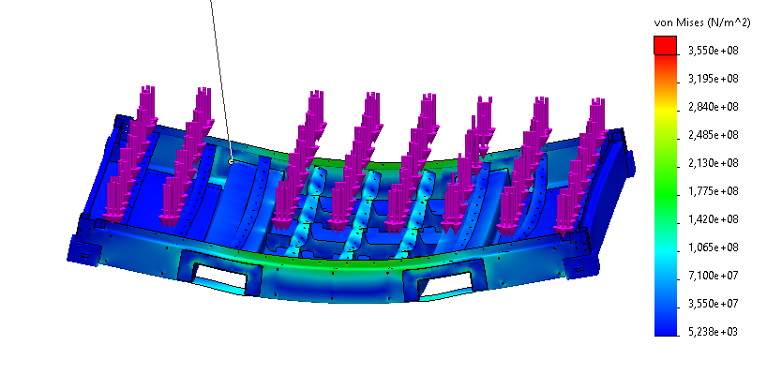
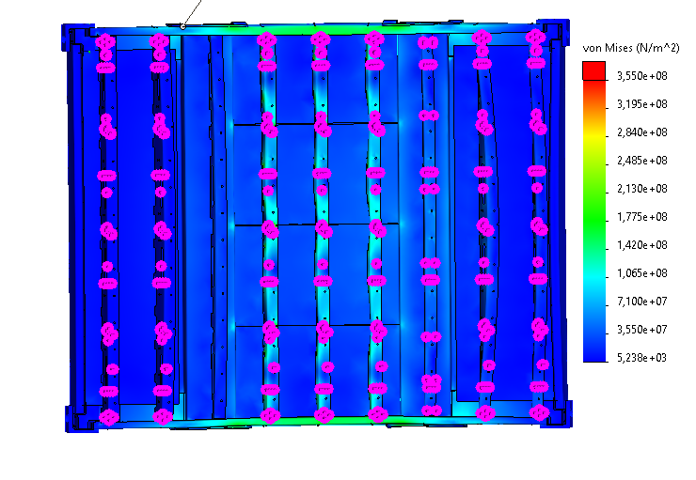

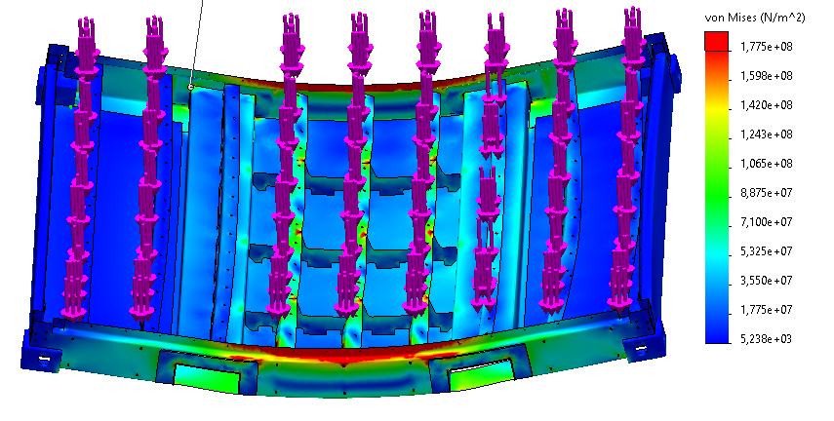

Appendix

6 m/min prototype design
The following model has been load tested.
Input parameters
Impact velocity | 6 | m/min
Battery mass | 5500 | kg
Stiffness | 14,5 | MN/m

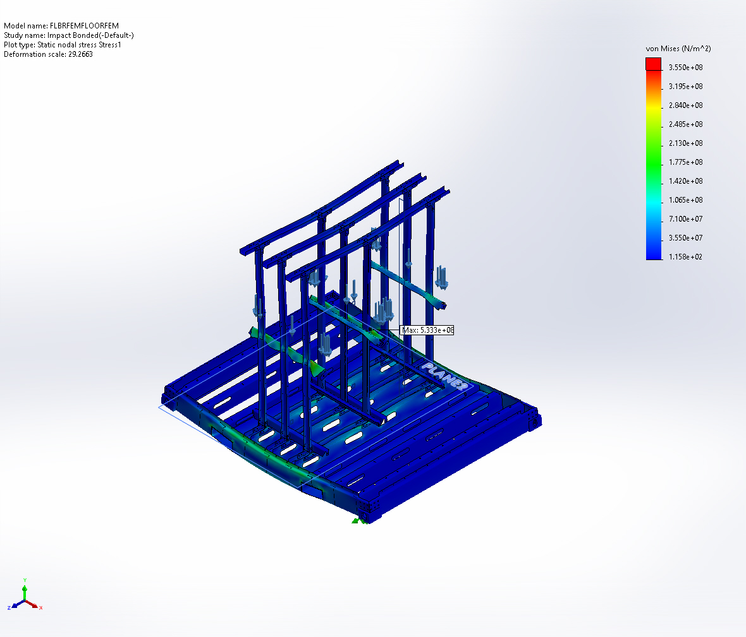
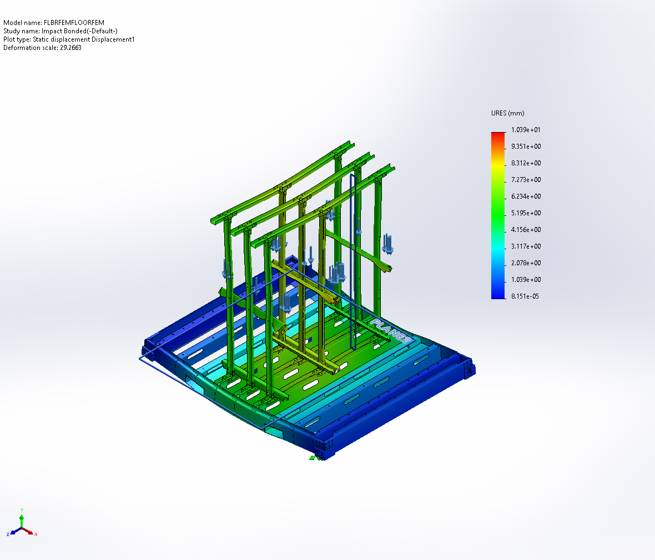
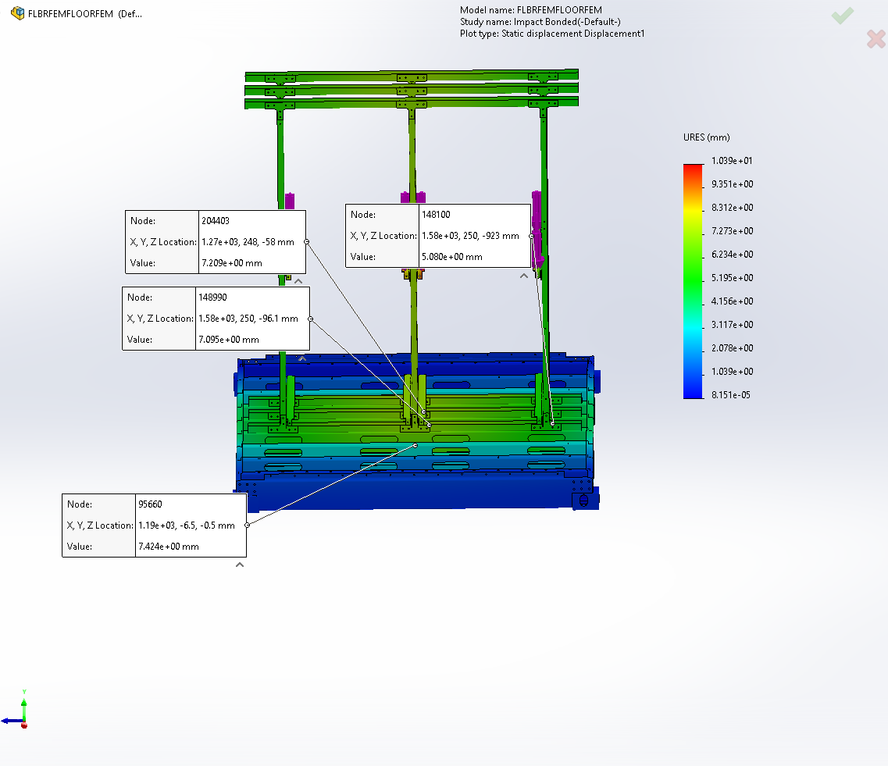

Results
Maximum deceleration at battery modules | 5.1 | m/s²
Maximum impact force | 82 | kN
Maximum deflection at modules (calculation) | 5.7 | mm
Maximum deflection at modules (FEM) | 5.5 | mm
Maximum stress | 350 | MPa
Ground clearance | 1.1 | mm

Prototype emergency brake

The prototype enclosure has also been modelled, it was strengthened by:
- Bracing plates between floor beams and forklift pockets
- Bracing plates between roof strips and roof side beams

Positive X direction:
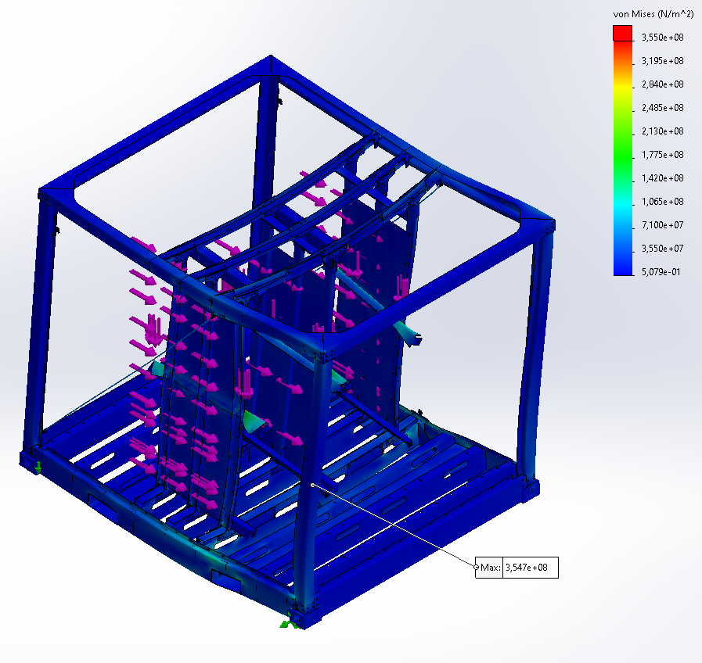
A safety factor of 1 is found at the vertical beams of the battery rack.

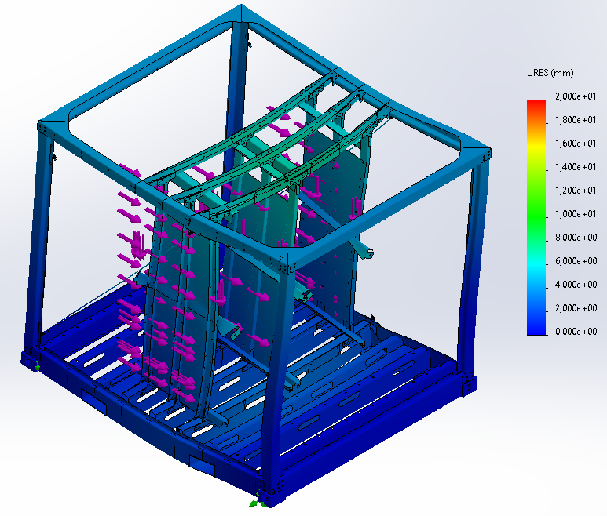
Negative X direction:
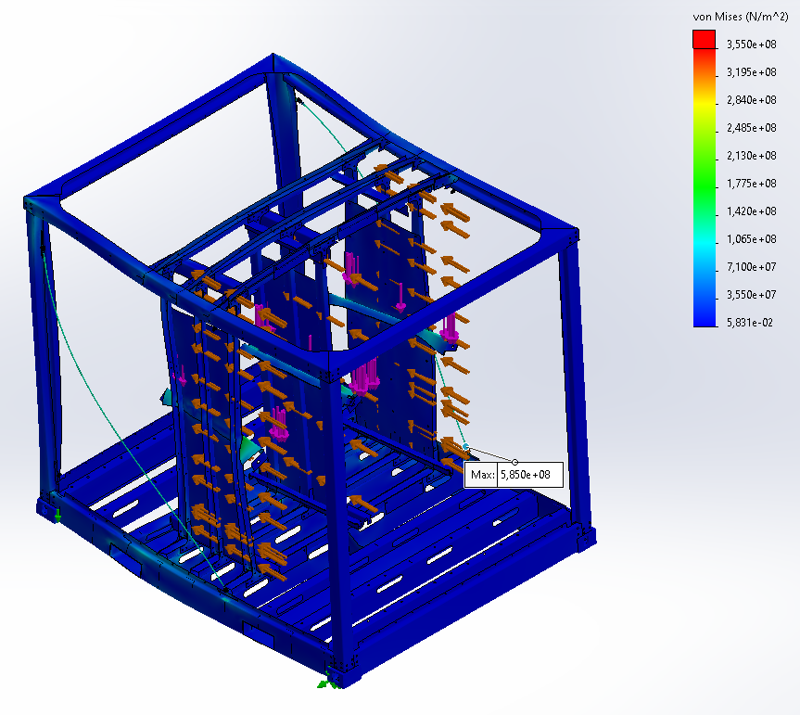
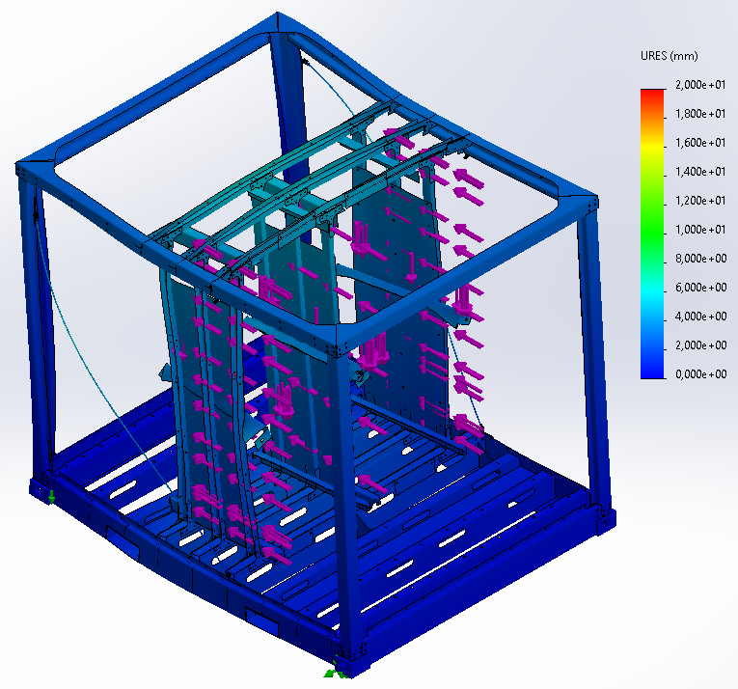

List of discrepancies between FEM model and reality

- Floor and roof plate not included
- Impact of other modules not included
- Roof beam of battery rack is strengthened from U 80x60x5 to square tube 80x80x6
- For impact studies, new connection rack to frame are not included. Construction without hard to reach gusset plates in the middle of beams, but with bolts and thick plates under nut. It is not expected that this will influence the result.

Attempted removal of rod

Enclosure and battery rack with 11 kN in opposite direction of inertia force applied to middle battery support plate:
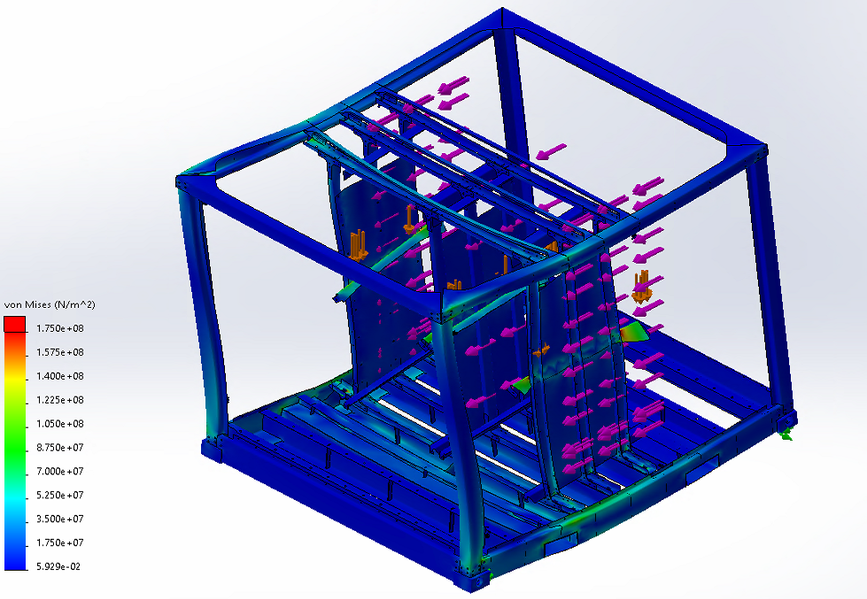
Seems acceptable. Displacement at middle column is 4,4 mm.

Power module with 11 kN distributed over three holes on top of power module:
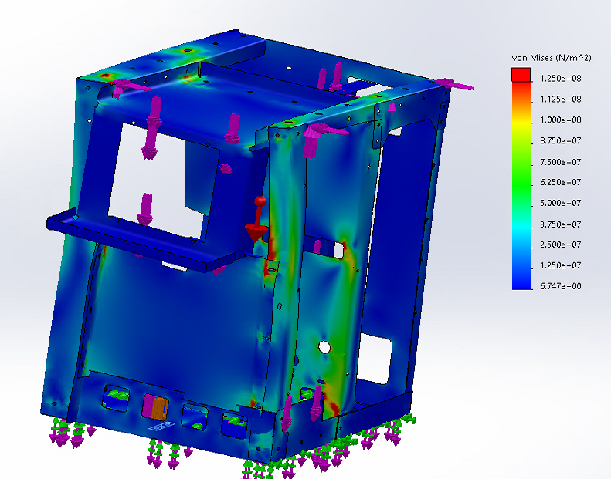
Does not meet safety factor 2 in vertical pillars along cooler. Does not meet safety factor 2 at middle plate.
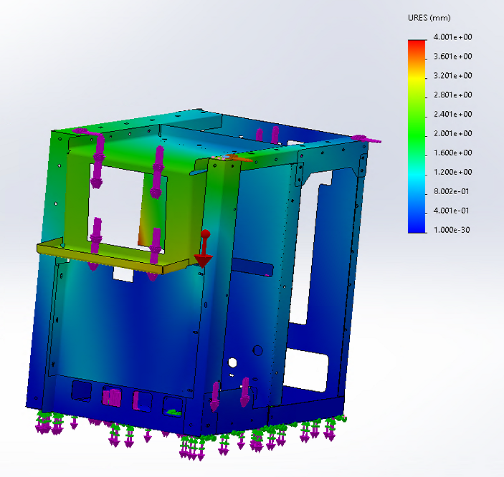
Displacement at cooler side of power module is 2,5 mm, at other side of power module 0,75 mm.

