Gas venting calculations
-

Table of contents

1 Introduction 3
2 Situation 4
2.1 Free gas capacity 4
2.2 Battery gas venting 5
2.2.1 Gas compositing 5
2.2.2 Venting mechanism 6
2.3 Hazardous gas volumes 7
2.4 Pressure relief. 7
2.5 Explosion hazard calculations 8
3 Conclusion 8

Introduction
This document provides the calculations used to assess the explosion hazards caused by flammable gases inside the enclosure. The battery system uses lithium iron phosphate (LFP) cells in modules, which can enter thermal runaway in case of severe overheating. During thermal runaway, several gases may be released into the enclosure. It is therefore necessary to verify that the enclosure can safely handle these gas releases.
The explosion hazard has two aspects. First, the released gases increase the pressure inside the enclosure. It must be determined whether the enclosure can withstand this pressure or whether the available openings provide enough venting capacity to prevent excessive pressure buildup.
Second, the composition of the released gases must be evaluated to ensure that the concentration of flammable gases remains below the lower explosive limit (LEL). The design target is to keep the concentration below 25% of the LEL.

Thermal runaway and gas venting theory

Battery gas venting principle
Batteries vent gases when they enter a thermal runaway state. In the figure below, the pressure and temperature relationship is presented by Shen H. It can be observed that the temperature of the cells initially increases gradually up to approximately 175°C. At this point, the safety valve opens, after which both temperature and pressure begin to rise rapidly. The graph indicates that the maximum temperature reaches 302°C.
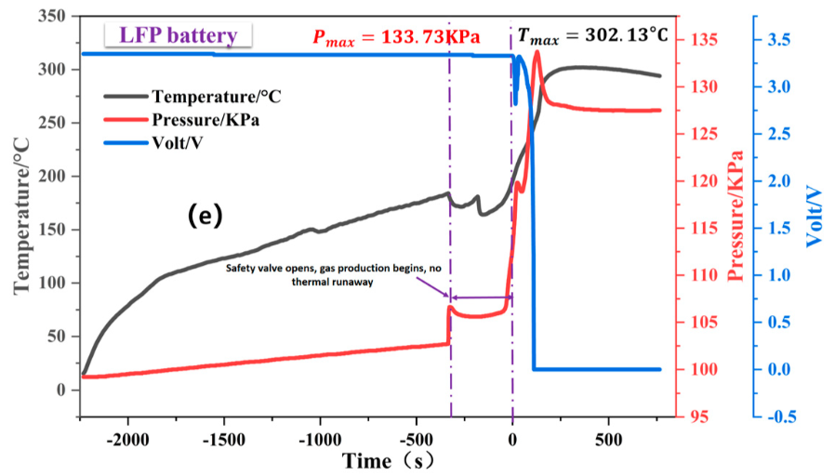
Figure 2 Temperature, pressure, and voltage development during thermal runaway.¹

Gas composition
The composition of the vented gases from the cells is shown in the table 2 below. This is a table from the module test report UL 9540A.
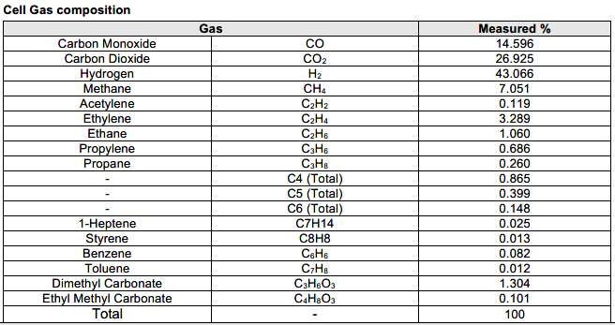
Table 2 Cell gas composition of gases vented during thermal runaway. From module test report UL 9540A.
The following table lists the flammable gases that constitute more than 1% of the total gas production, along with their corresponding Lower Explosion Limits (LEL).
Gas | Gas | Measured % | LEL %
Carbon monoxide | CO | 14.596 | 12.5
Hydrogen | H2 | 43.066 | 4.0
Methane | CH4 | 7.051 | 5.0
Ethylene | C2H2 | 3.289 | 2.7
Ethane | C2H6 | 1.060 | 3.0
Dimethyl Carbonate | C3H6O3 | 1.304 | 4.2
Table 3 Flammable gases that constitute more than 1% of the total gas production with their LEL. .

Venting flow rate
From the module test report UL 9540A, the following figure is extracted. THC stands for total hydrocarbons.
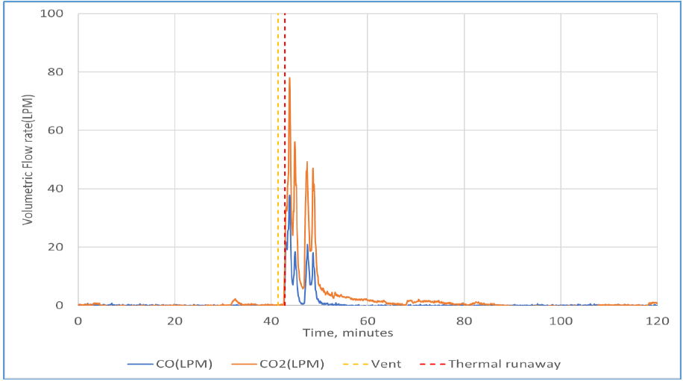
Figure 4 CO, CO2 Volumetric flow rates. From module test report UL 9540A.
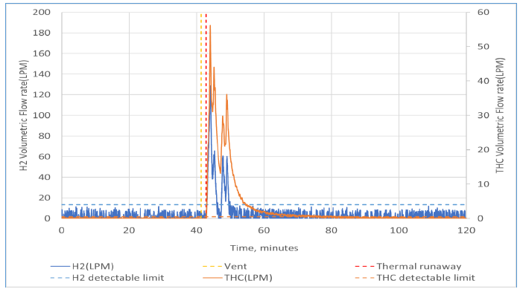
Figure 5 THC, H2 Volumetric flow rates. From module test report UL 9540A.

Calculations and results

Free air capacity of the enclosure
To determine the free air capacity in the enclosure a calculation is setup for the least favourable situation in which most volume is claimed by components. The outer dimensions of the enclosure is the base volume (L1,L2,L3). From this volume the following items are subtracted: (note in the components below only the headlines are given) the excel is inserted in appendix A.
- All metal parts of the enclosure
- The heat pump area (not considered part of the internal volume)
- The battery rack, consisting of a metal frame, 16 battery modules, cabling, and cooling hoses
- The cooling system, including hoses and components
- Two inverter racks, primarily consisting of inverter components, sheet metal, and busbars
- Zero point transformer
- The control module, consisting of sheet metal, and the electrical components mounted on these plates.
- The client connection panel, consisting of components, sheet metal, and busbars.

Table 1 Volume model e-PU10
Volume model e-PU10
Volume component | Volume (L)
Outer dimensions enclosure | 18230
Enclosure | 426
Outside space heat pump | 4378
Battery rack | 3832,4
Cooling system | 74,4
Two inverters | 360
Zero point transformer | 50
Control module | 86,4
Client connection panel | 60
Free gas volume | 8963
Free gas volume corrected (10%) | 8067
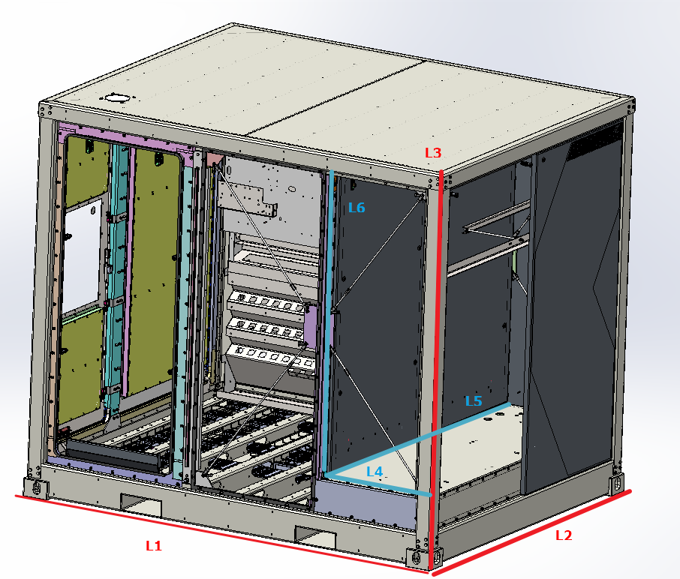
Figure 1 - Schematic overview of e-PU10, with indication of certain lengths.

Hazardous gas volumes
According to the UL 9540A report of the modules the gas volumes at which the hazard calculation must be performed are shown below:
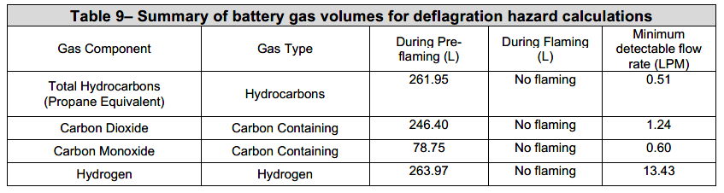
Figure 3 Summary of battery gas volumes for deflagration hazard calculations. From module test report UL 9540A.
When one of the gases reaches above the LEL and an ignition source is present, it will result in an explosion.
We assume that the total volumes of the container remains constant.
We will calculate the percentage of the gases after then venting, when there is no ventilation.
$${\%V}_{H_{2}}=\frac{V_{H_{2}}}{V_{Enclosure gas}}*100\%=\frac{263.97}{8067}*100\%=3,27\%$$
The LEL of hydrogen is 4.0%. So, this LEL is not reached.
For completeness, we will also calculate the other gases.
$${\%V}_{{CO}_{2}}=\frac{V_{{CO}_{2}}}{V_{Freegas}}*100\%=\frac{246.40}{8067}*100\%=3,05\% (not flammable)$$
$$\%V_{CO}=\frac{V_{CO}}{V_{Enclosure gas}}*100\%=\frac{78.75}{8067}*100\%=0,98\%<12.5\%$$
$$\%V_{Hydrocarbons}=\frac{V_{Hydrocarbons}}{V_{Enclosure gas}}*100\%=\frac{261.95}{8067}*100\%=3,25\%$$
For hydrocarbons the average LEL (weighted) is 4,15%. The lowest LEL of the hydrocarbons is 2.7%. Therefore we will also calculate the separate hydrocarbons:
$$\%V_{Methane}=\frac{V_{Methane}}{V_{Enclosure gas}}*100\%=\frac{162.01}{8067}*100\%=2.0\%<5.0\%$$
$$\%V_{Ethylene}=\frac{V_{Ethylene}}{V_{Enclosure gas}}*100\%=\frac{75.57}{8067}*100\%=0.9\%<2.7\%$$
$$\%V_{Ethane}=\frac{V_{Ethane}}{V_{Enclosure gas}}*100\%=\frac{24.4}{8067}*100\%=0.3\%<3.0\%$$

Pressure building from the battery venting in e-PU10 enclosure (without ventilation)
In a sealed enclosure the increase of gas volume will result in an increase in pressure:
$$PV=nRT$$
P = pressure of the gas (Pa)
V = volume of the gas (L)
n = amount of gas (mol)
T = temperature (K)
R = gas constant = 8.314 J/(mol K)
As the V, R and T stay constant, n increases and therefore P increases.
The pressure will increase by the venting of gases:
$$P_{2}=P_{1}*\left(\frac{V_{1}}{V_{2}}\right)$$P₁ = pressure in situation 1
P₂ = pressure in situation 2
V₁ = volume in situation 1
V₂ = volume in situation 2
For these calculations we assume that the gases are ideal gases. We also assume that the gases that are vented are incompressible.
We calculate the worst case, therefore we assume that all the gases have the high venting flow rate of hydrogen of a 130 L/min (see figure 5) and because it is 43,066% of the gases.
To calculate the total volume of 100% of the gases:
$$V_{totaal gas}=\frac{V_{Hydrogen}*100\%}{43.066\%}=302 L/min$$
As we will calculate the worst case scenario, we will use the flow rate and volume of THC.
Calculating the pressure after one minute
$$P_{2}= P_{1}*\left(\frac{V_{1}}{V_{2}}\right)=P_{1}*\left(\frac{V_{1}}{V_{1}-V_{totaal gas}}\right)=1*\frac{8067}{7765}=1,038 bar= 10380 Pa$$

Pressure relief from the enclosure
In a sealed enclosure the increase of gas volume will result in an increase in pressure. The added pressure by the vented gases is 1.038 in the first minute (See chapter 3.2).
The enclosure is IP55 and not completely sealed. There are four openings of 5x50mm² in the corners of the enclosure. See figure 4. Through this opening the pressure can be released.
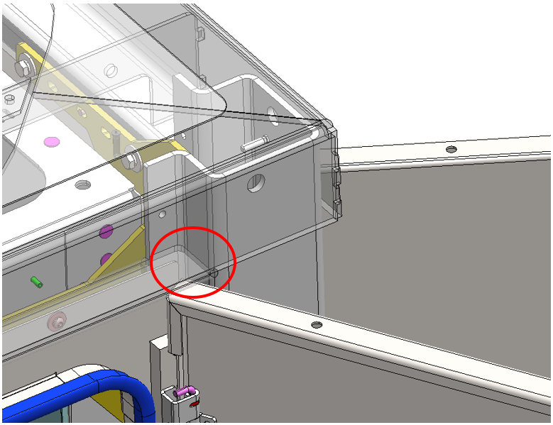
Figure 6 Opening in enclosure e-PU10
The pressure difference between inside and outside the enclosure is:
$$ΔP=P_{2}-P_{1}=0.038 bar=3800 Pa$$
This means that we don’t have a “choked” flow and we don’t have compressibility effects. Therefore, we can use the following formula (Bernoulli):
$$Q=C_{d} A \sqrt{\frac{2 ΔP}{ρ}}$$
Q = flow through the opening (m³/s)
C_{d} = 0.7 (realistic value for air)
A = area of the opening = 4*250 mm² = 4*250*10⁻⁶ m²
ΔP = difference in pressure (Pa)
ρ = density (of air =1.2 kg/m³)
$$Q=C_{d} A \sqrt{\frac{2 ΔP}{ρ}}=0,055\frac{m^{3}}{s}=0,055*60*1000 \frac{L}{min}=3342 \frac{L}{min}$$

Calculate maximum pressure, including ventilation through openings
Here, we will calculate which pressure build up is necessary inside the enclosure to achieve a flow that is the same as the flow that is created by the battery venting.
To calculate the worst case, we will calculate with the gases that have the highest flow rate (THC). 1667 L will be injected per minute during the first minute. To not get an overpressure, a flow of at least 1667 L/min is necessary through the openings.
$$1667 \frac{L}{min}=0.028\frac{m^{3}}{s}$$
Rewrite to formula from 3.6 to determine the pressure:
$$Q=C_{d} A \sqrt{\frac{2 ΔP}{ρ}} → ΔP= \frac{1}{2}ρ{\left(\frac{Q}{C_{d}*A}\right)}^{2}$$
$$ΔP= \frac{1}{2}ρ{\left(\frac{Q}{C_{d}*A}\right)}^{2}= \frac{1}{2}*1.2*{\left(\frac{0,028}{0,7*\left(4*250*{10}^{-6}\right)}\right)}^{2}=960 Pa$$
$$P=100960 Pa=1,0096 bar$$

This is not very much, and thus the openings in the enclosure are enough to vent so that there will be no overpressure.

Iterative calculation to determine the flow rate to not reach LEL
The LEL of Hydrogen and the THC must stay below 1.0% and 0.7%, respectively (25% of LEL). To stay on the safe side, we use the lowest LEL of the hydrocarbons (2.7%). To determine if we stay below this limit an iterative calculation is performed.
To calculate the concentration change, we have the following formula:
$$\frac{dC}{dt}=\frac{G(t)}{V}-\frac{Q}{V}C(t)$$C = gas concentration (-)
t = time (s)
G = gas generation (m³)
V = container volume (m³)
Q = ventilation rate (m³/s)
Rewrite this for an iterative calculation, where we assume the timestep is 1s:
$$C\left(t\right)=C\left(t-1\right)+\frac{G(t-1)}{V}-\frac{Q}{V}C(t-1)$$To make an estimation about how many liters of gas are vented during thermal runaway (generation of gas), we look to figure 5. See the rough estimation in the tables below:
Graph (min) | Start of venting (min) | Volume of venting Hydrogen (L/min)
42 | 1 | 130
43 | 2 | 130
44 | 3 | 130
45 | 4 | 60
46 | 5 | 60
47 | 6 | 0
48 | 7 | 0
49 | 8 | 60
50 | 9 | 60
Tabel 1 Number for calculation of volume of Hydrogen of battery venting gases.
Graph (min) | Start of venting (min) | Volume of venting THC (L/min)
42 | 1 | 190
43 | 2 | 190
44 | 3 | 190
45 | 4 | 140
46 | 5 | 140
47 | 6 | 80
48 | 7 | 60
49 | 8 | 100
50 | 9 | 120
51 | 10 | 60
52 | 11 | 40
53 | 12 | 40
54 | 13 | 20
55 | 14 | 20
Tabel 2 Number for calculation of volume THC of battery venting gases.
When we only have the flow through the small openings, we get the following concentration graphs.
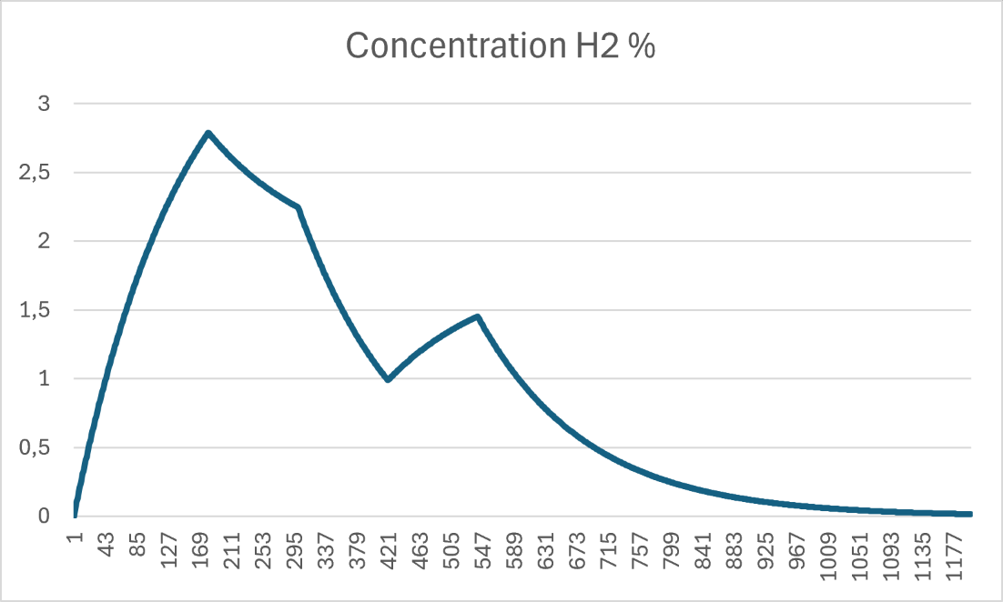
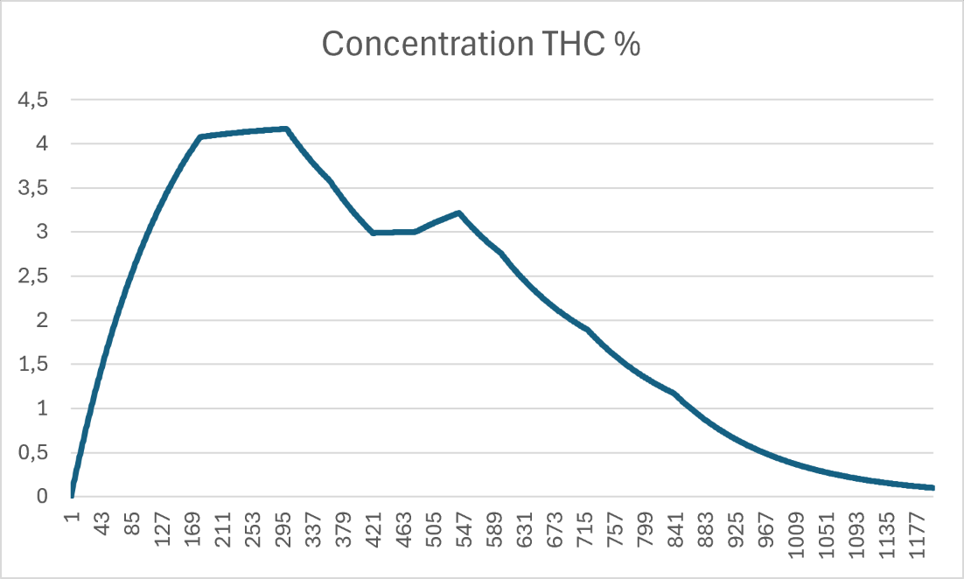
For both gases the concentration is exceeding the LEL.

For both gases to stay below 25% of their LEL, we need an ventilation of 0,5 m³/s (Q). See figures below.
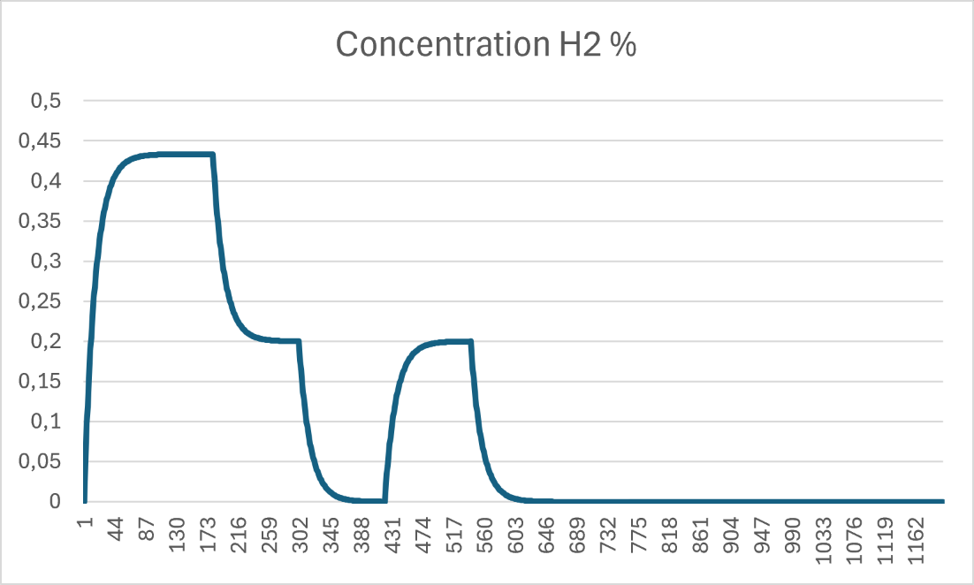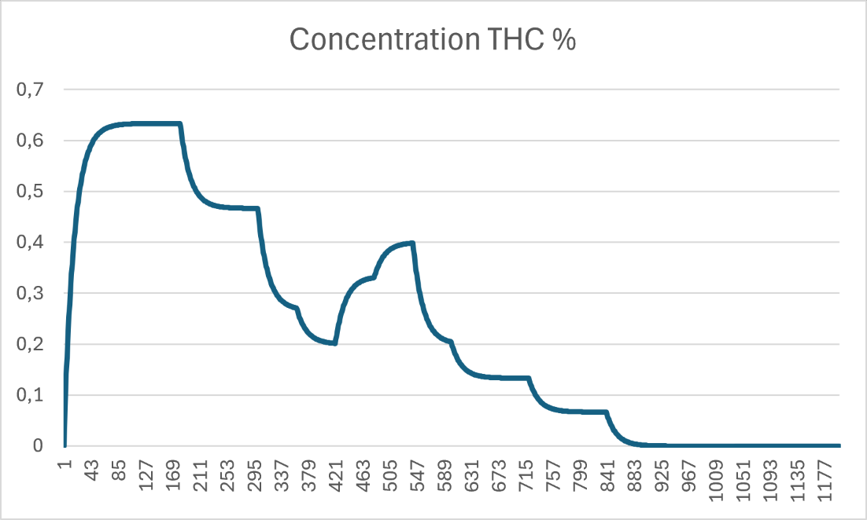

Conclusion
The calculations show that the existing openings in the enclosure provide sufficient venting capacity to accommodate the gas release during a thermal runaway event. As a result, the pressure increase inside the enclosure remains within acceptable limits and no excessive overpressure is expected.
However, the resulting airflow through these openings is not sufficient to keep the concentration of flammable gases below the design criterion of 25% of the lower explosive limit (LEL). Additional ventilation is therefore required to maintain a safe gas concentration.
Based on the results of this assessment, an active ventilation system providing an additional airflow of 0.5 m³/s is required to ensure that the flammable gas concentration remains below the specified design limit.

Shen H., Wang, H.; Li, M.; Li, C.; Zhang, Y.; Li, Y.; Yang, X.; Feng, X.; Ouyang, M. Thermal Runaway Characteristics and Gas Composition Analysis of Lithium-Ion Batteries with Different LFP and NCM Cathode Materials under Inert Atmosphere. Electronics 2023, 12, 1603. https://doi.org/10.3390/electronics12071603
Crysalis Scientific Technologies Inc., Lower and Upper Explosive Limits for Flammable Gases and Vapors (LEL/UEL), https://www.chrysalisscientific.com/pg443-Lower-LEL-Upper-UEL-Explosive-Limits.pdf
Carlroth, Safety data sheet, Dimethyl carbonate, revision 17-09-2024

