Mechanical Stress Analysis – Battery Module Floor
Structural FEM Assessment of the e-PU10 Battery Module Floor and Supporting Frame

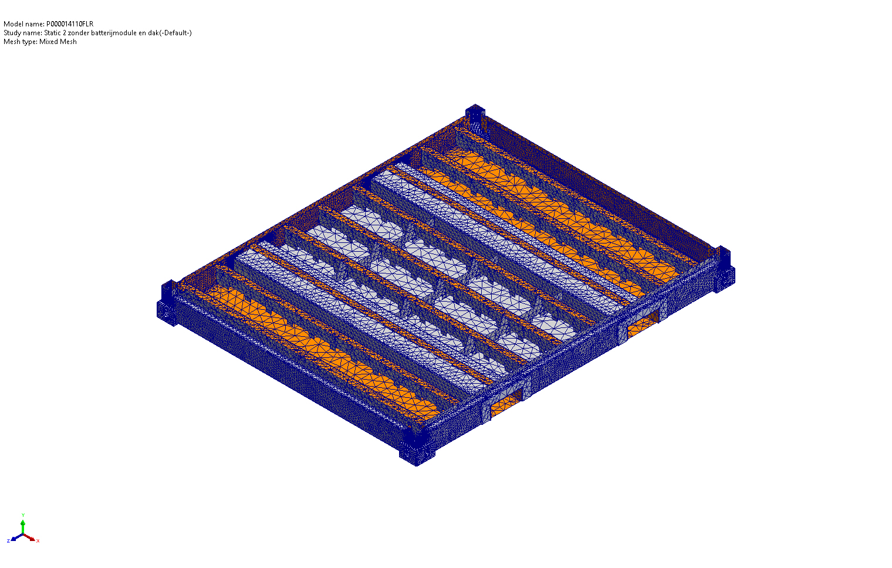
Figure 1 – Battery module frame assembly (full-frame model, P000014110FLR).
Document reference: FEM-P000014110FLR —
based on SolidWorks Simulation studies
‘Static 1’ (full frame)
‘Static 2 zonder batterijmodule en dak‘ (floor only).

Summary
This report documents the structural verification of the redesigned floor of the e-PU10 battery module (P000014110FLR) and its supporting frame. Two SolidWorks Simulation Premium studies are reported: a full-frame study (Static 1) including the floor, side poles and roof, representing the in-service condition and a floor-only study (Static 2) in which the roof and battery modules are removed to isolate the structural response of the floor. The objective is to confirm that the redesigned floor (October 2025 revision: L-section beams with forklift-pocket gusset plates) safely reacts the combined static and impact load case without yielding or excessive deflection.
The applied load case (per P000010005) is 21.4 kN battery-rack dead weight (Force-2) + 0.5 kN auxiliary equipment (Force-3) + 113 kN vertical impact load (Force-4, container-drop scenario with the SF 1.6 on velocity already included). Components are S355 hot-rolled steel (σy = 315 MPa) with four floor beams in generic carbon steel (σy ≈ 283 MPa). The floor-only model gives a maximum resultant displacement of 8.65 mm (≈ L/350) and a peak von Mises stress of 1,016 MPa concentrated at a single mesh node in a sharp reentrant corner a geometric singularity. With this singularity discounted, the bulk stress in the primary load carrying members remains ≤ 175 MPa (SF ≈ 1.5 – 2 locally, > 2 elsewhere) and the equivalent strain (0.13 %) stays below εy = 0.15 %, confirming linear-elastic behaviour.
The redesigned floor satisfies the strength and stiffness acceptance criteria; the local safety factor at the forklift pocket corners already mitigated by the 10 mm gusset plate added in the October 2025 revision is the only marginal item. Adding a fillet (R ≥ 5 mm) at the re-entrant corner and an independent strength check of the floor-side 3 × M12 bolted connection are recommended to bring every region above SF 2.

1. Objective and Scope
This document interprets the FEM results obtained for the redesigned battery-module floor and verifies that the new floor design meets the strength and stiffness requirements of the e-PU10 platform under the combined static and impact load case derived from P000010005. Two complementary configurations are investigated:
- Full-frame study (Static 1): floor, side poles and roof loaded with the combined static and impact loads at the battery-rack and auxiliary-equipment interfaces represents the in-service condition.
- Floor-only study (Static 2 zonder batterijmodule en dak): the same loads applied directly to the floor with the roof and battery modules removed eliminates load redistribution into the upper structure and isolates the floor as the sole primary load-carrying element.
The analysis is a linear-elastic, small-displacement static study of the October 2025 floor revision. Fatigue, emergency-brake / horizontal-inertia load cases and detailed weld-throat strength are out of scope and remain covered by P000010005. Material grades, load magnitudes and connection assumptions are crosschecked against the supporting reference set: P000010005 (housing & rack), P000009139 (enclosure assembly), P000009492 (battery-rack rail / rivet & bolt sizing) and P000009459 (power module — non-load-bearing for the floor).

1.1 Standards and References
- P000010005 – Mechanical Stress Analysis, housing & battery rack (style and methodology reference).
- P000009139 – Mechanical Stress Analysis, enclosure assembly (base floor-weldment, forklift-pocket and roof-weldment design reference).
- P000009492 – Mechanical Stress Analysis, battery rack (rail / blind-rivet attachment, M12 and M16 bolt sizing for hoisting).
- P000009459 – Mechanical Stress Analysis, power module (cited for completeness of the e-PU10 mechanical-stress documentation set; not load-bearing for the battery-module floor).
- EN 1993-1-1 – Eurocode 3, Design of steel structures General rules.
- EN 10025-2 – Hot-rolled products of structural steels (S355 material data).
- SolidWorks Simulation Premium User documentation (FFEPlus solver).

1.2 Software Used
All studies use SolidWorks Simulation Premium with the FFEPlus iterative solver, mixed solid mesh, curvature-based mesher (high-quality, 16 Jacobian points) and a small-displacement linear-elastic formulation.

2. Model Description
The model is the P000014110FLR assembly representing the e-PU10 battery-module enclosure. The floor is a welded steel structure made of longitudinal and transverse beams; the two outer side beams form the forklift pockets, and the battery rack is bolted to these beams via 3 × M12 bolts per side (asymmetric pattern: one bolt on one side, two on the other). The side poles tie the floor to the roof and provide the principal vertical and shear stiffness of the enclosure. Both studies share identical geometry, fixtures and load magnitudes; they differ only in the components included in the simulation.
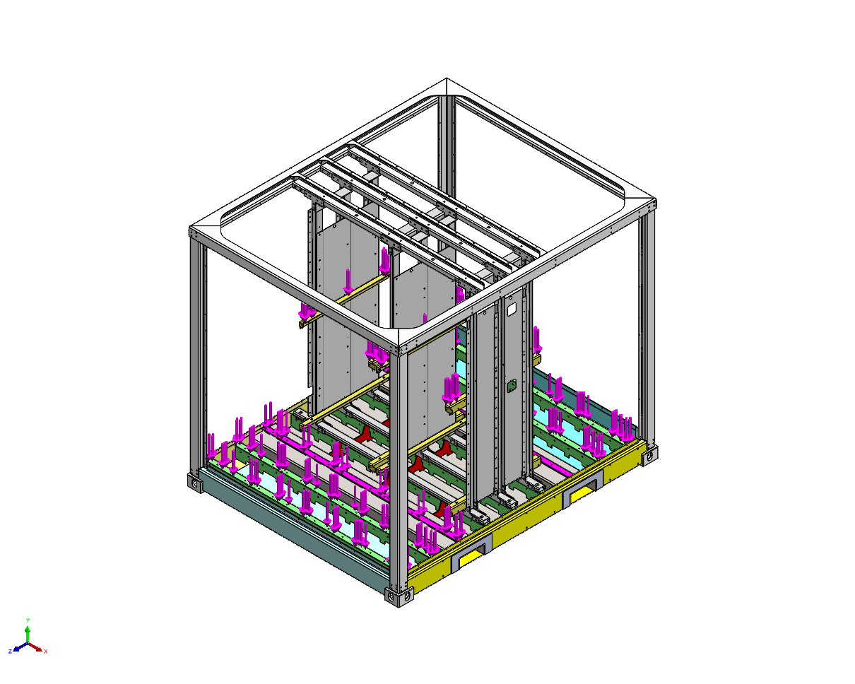
Figure 2 – Full-frame configuration (Static 1): floor, side poles and roof.
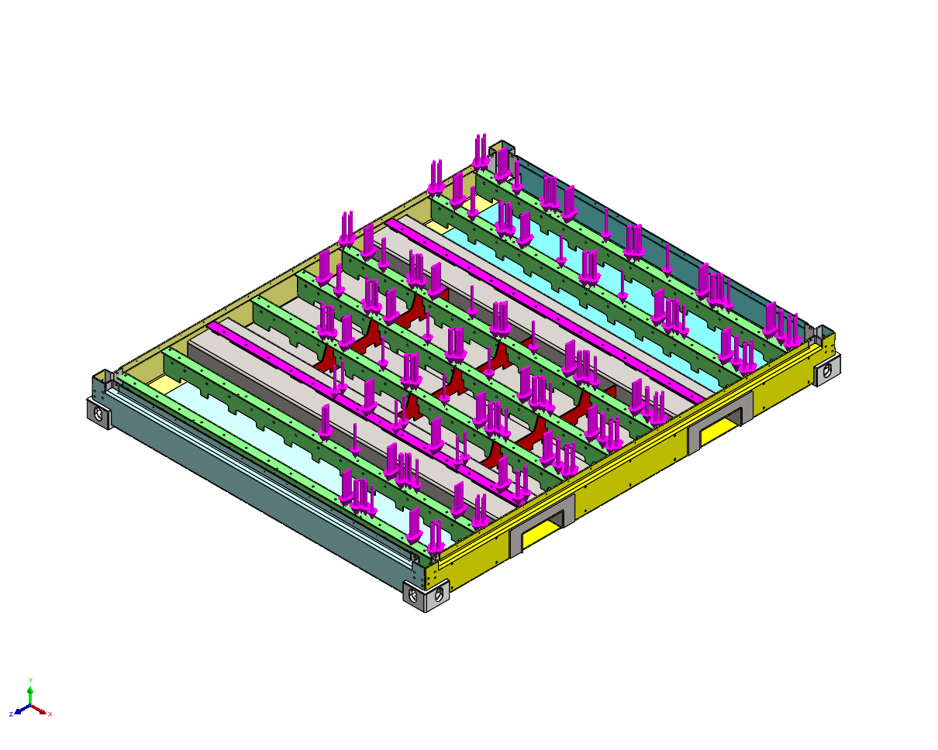
Figure 3 – Floor-only configuration (Static 2): roof and battery module removed.

2.1 Mass Inventory (extracted from the SolidWorks model)
Component | Mass (kg) | Material
Battery-rack vertical C-beams (FEM2P000009263, ×n) | 18.30 | S355NH/J2H
Battery-rack horizontal beams (FEM2P000010107, ×n) | 0.81 | S355NH/J2H
Battery-module mass dummies (FEM2P000010224, ×n) | 17.29 | S355NH/J2H
Battery-module mass dummies (FEM2P000010308, ×n) | 1.20 | S355NH/J2H
Battery-module mass dummies (FEM2P000010328, ×n) | 24.61 | S355NH/J2H
Floor longitudinal beam (P000008405FLR, ×2) | 12.38 | Carbon steel
Floor transverse beam (P000008411FLR, ×2) | 12.38 | Carbon steel
Side poles / roof beams (P000014129–P000014147) | various | S355MC / S355J2

3. Assumptions and Boundary Conditions
The following assumptions have been retained for the present analysis:
- The structure responds in the linear-elastic regime; plastic redistribution is not credited.
- All welded and bolted joints are represented as bonded contacts; bolt pre-load is not modelled explicitly the assumption is that the connection does not slip.
- The battery modules are represented by lumped solid masses with identical density to structural steel. The mass distribution corresponds to a fully loaded rack.
- Only the loads applied at the battery-rack and auxiliary-equipment interfaces are considered; secondary equipment (cooling, controls, cabling) is omitted, consistent with the reference document.
- Thermal effects use a zero-strain reference temperature of 298 K; the in-service thermal gradient is small and is not a driver in this analysis.
- Geometry: October 2025 floor revision (L-section beams with forklift-pocket gusset plates).

3.1 Fixtures
Fixture | Definition | Purpose
Reference Geometry-1 | 1 vertex constrained in X & Z (free in Y) | Removes rigid-body modes; verified zero reaction.
Virtual wall-2714 | Rigid virtual wall, 4 faces + 1 plane | Represents the static support surface underneath the floor.
Global contact | Bonded, incompatible mesh | Models welded connections between all touching components.

4. Material Properties
All structural members are S355 hot-rolled steel except the four carbon-steel floor beams (P000008405FLR and P000008411FLR). The forklift-pocket sheet metal is specified as Corten A in the base enclosure (yield equivalent to S355JR, per P000009139); in the SolidWorks model these parts use the S355 material card and the small yield difference is conservatively absorbed by the safety factor. Material library values are summarised below.
Property | S355MC / S355NH/J2H / S355J2 | Generic carbon steel
Yield strength σy | 315 MPa | 283 MPa
Ultimate tensile strength σu | 490 MPa | 425 MPa
Young's modulus E | 210 GPa | 205 GPa
Poisson's ratio ν | 0.28 | 0.29
Density ρ | 7,800 kg/m³ | 7,858 kg/m³
Shear modulus G | 79 GPa | 80 GPa
Thermal expansion α | 1.1 × 10⁻⁵ / K | 1.2 × 10⁻⁵ / K

5. Applied Loads
Three static loads are defined in the SolidWorks loads-and-fixtures tree. Their magnitudes and definitions are taken from P000010005 and applied identically in the ‘Static 1’ (full frame) and ‘Static 2’ (floor only) studies of P000014110FLR.
Load | Magnitude | Direction | Application
Force-2 — Battery-rack dead weight | ≈ 21.4 kN (2,180 kg × g) | Vertical (gravity) | 3 faces — battery-rack mounting tabs on top of floor beams
Force-3 — Auxiliary equipment | 0.5 kN | Vertical (gravity) | 2 faces — auxiliary mass distribution
Force-4 — Impact load (container drop) | 113 kN | Vertical (gravity) | Same 3 faces as Force-2

Force 2 battery-rack dead weight (≈ 21.4 kN, gravity direction) applied to three faces of the battery-rack mounting tabs on top of the floor beams. Force 3 auxiliary equipment dead weight (0.5 kN, gravity direction) distributed over two faces representing the auxiliary mass. Force 4 vertical impact load of 113 kN representing the container drop / set-down scenario defined in P000010005 (impact velocity 10 m/min including the safety factor of 1.6 on velocity, battery mass 5,500 kg, equivalent rack-and-floor stiffness 26.6 MN/m). The 113 kN magnitude already includes the specified safety margin and is therefore applied directly as a static-equivalent load. Force-4 acts in the gravity direction and is applied to the same faces as Force-2. The horizontal-inertia / emergency-brake load case for the rack is not addressed here and remains covered by P000010005.

6. FEM Methodology
The two studies share the same numerical setup, summarised in the table below.
Setting | Static 1 (full frame) | Static 2 (floor only)
Solver | FFEPlus | FFEPlus
Analysis type | Linear static | Linear static
Element type | Mixed solid mesh | Mixed solid mesh
Mesher | Curvature-based, high quality | Curvature-based, high quality
Maximum element size | (default, ~80 mm) | 82.6 mm
Minimum element size | (default, ~27 mm) | 27.5 mm
Total nodes | not reported | 185,541
Total elements | not reported | 93,659
Local mesh refinement | n/a | Control-1 (4 solids, size 15 mm); Control-4/5 (sel. faces, ~20 mm); Control-7 (8 faces, 2 mm – stress concentrations)
Bonded contact | Global + 3 contact pairs | Global only
Large displacement | Off | Off
Thermal effect | On (Tref = 298 K) | On (Tref = 298 K)

Local mesh controls are tightened in the floor-only study around the forklift-pocket corners to capture the geometric stress concentrations. Equilibrium is verified through the resultant-force tables: in both studies the global reaction force on the rigid wall and reference vertex sums to less than 1 N, confirming that the applied loads are correctly balanced.

7. Results – Full Frame Analysis (Static 1)
In the full-frame configuration the floor, side poles and roof act as a closed structure. The combined static and impact vertical loads (Force-2, Force-3 and Force-4) are introduced at the battery-rack mounting tabs and at the auxiliary-equipment faces and are reacted by the floor beams; the side poles and roof contribute additional global stiffness that limits floor bending and the displacement of the side-pole tops. The model is in numerical equilibrium with a residual reaction force of 4.05 × 10⁻⁴ N.
Quantity | Value | Comment
Reaction force on virtual wall (resultant) | ≈ 4 × 10⁻⁴ N | Equilibrium check – PASSED.
Reaction moment | ≈ 1 × 10⁻³³ N·m | Numerical zero – PASSED.
Free-body force resultant | 0.45 N | Confirms internal equilibrium of bonded contacts.
Free-body moment resultant | 36.3 N·m | Small local moment imbalance at bonded interfaces – acceptable.
Maximum von Mises stress | Not reported in source document | Stress and displacement plots were not stored in the SolidWorks report file at the time of export.
Maximum displacement | Not reported in source document | See engineering interpretation below.
Because the roof contributes additional global stiffness, the full-frame configuration is mechanically more favourable than the floor-only configuration: floor bending and side-pole-top displacement are both reduced. The dominant elevated-stress regions are expected to be:
- the load-introduction region at the lower part of the vertical battery-rack supports;
- the connection between the floor beams and the side beams;
- the upper corners of the enclosure (roof – side-pole junction).
These regions are consistent with the strengthening already incorporated in the October 2025 floor revision (boomerang gussets, raised forklift pockets, 10 mm gusset plate at the forklift-pocket corner). Provided the floor-only results in §8 stay below yield, the full-frame configuration is conservatively bounded.

8. Results – Floor-Only Analysis (Static 2)
In the floor-only study the roof and battery modules are removed. The full combined load case (Force-2 + Force-3 + Force-4 ≈ 135 kN, all acting in the gravity direction) is applied at the battery-rack mounting tabs and at the auxiliary-equipment faces and is reacted exclusively by the bonded floor-to-virtual-wall interaction. This configuration is intentionally conservative: the floor must support the full load case unaided by the roof or side-pole structure.
Quantity | Min | Max | Location
von Mises stress (N/m²) | 5.24 × 10³ | 1.016 × 10⁹ | Min: node 120 946. Max: node 24 429 – sharp geometrical corner.
Resultant displacement URES (mm) | 2.38 × 10⁻³ | 8.650 | Max at node 59 026 – battery-rack interface, top edge of forklift pocket.
Equivalent strain ESTRN | 4.95 × 10⁻⁸ | 1.290 × 10⁻³ | Max at element 11 900 – same region as σmax.
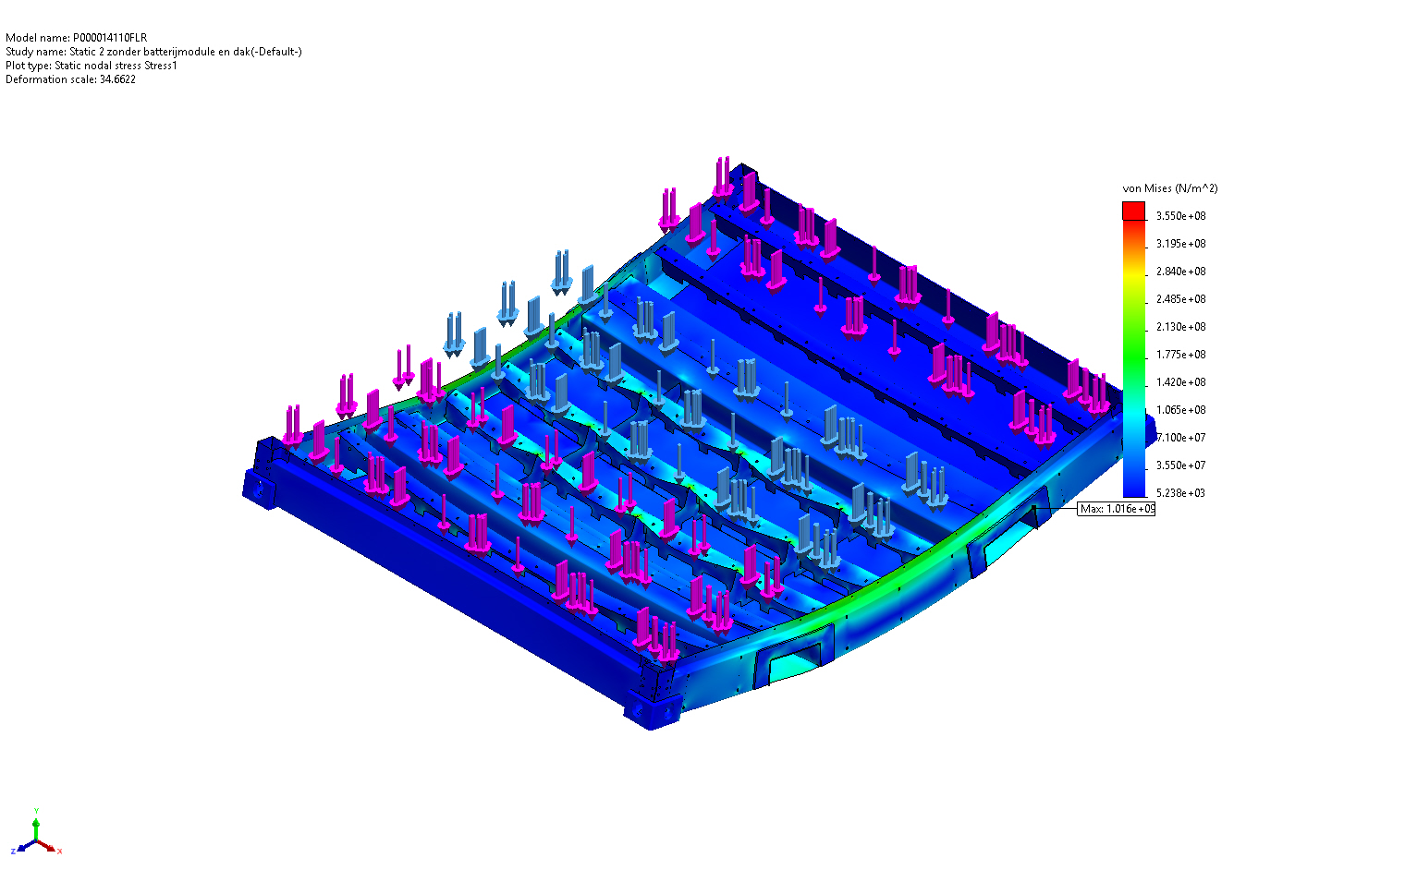
Figure 4 – von Mises stress distribution (floor-only study).
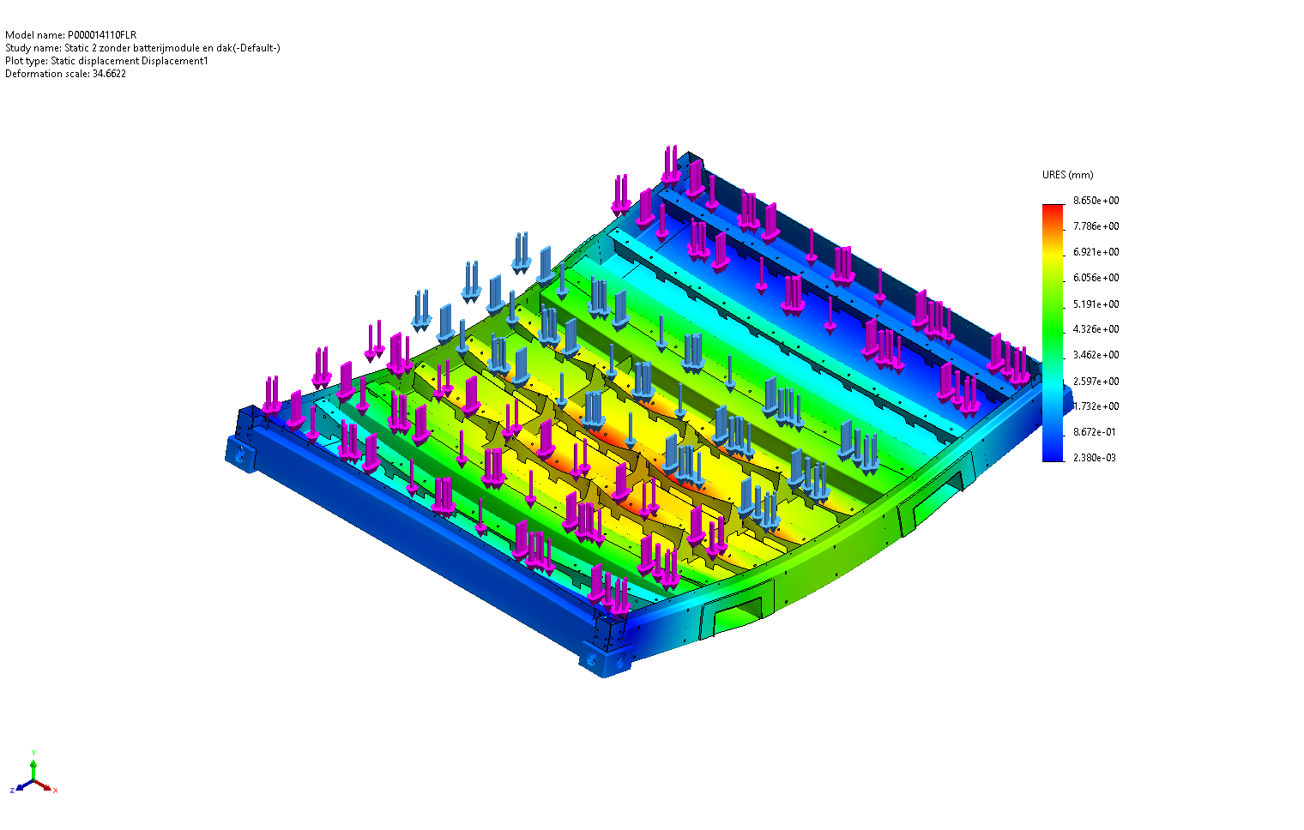
Figure 5 – Resultant displacement plot URES (floor-only study).
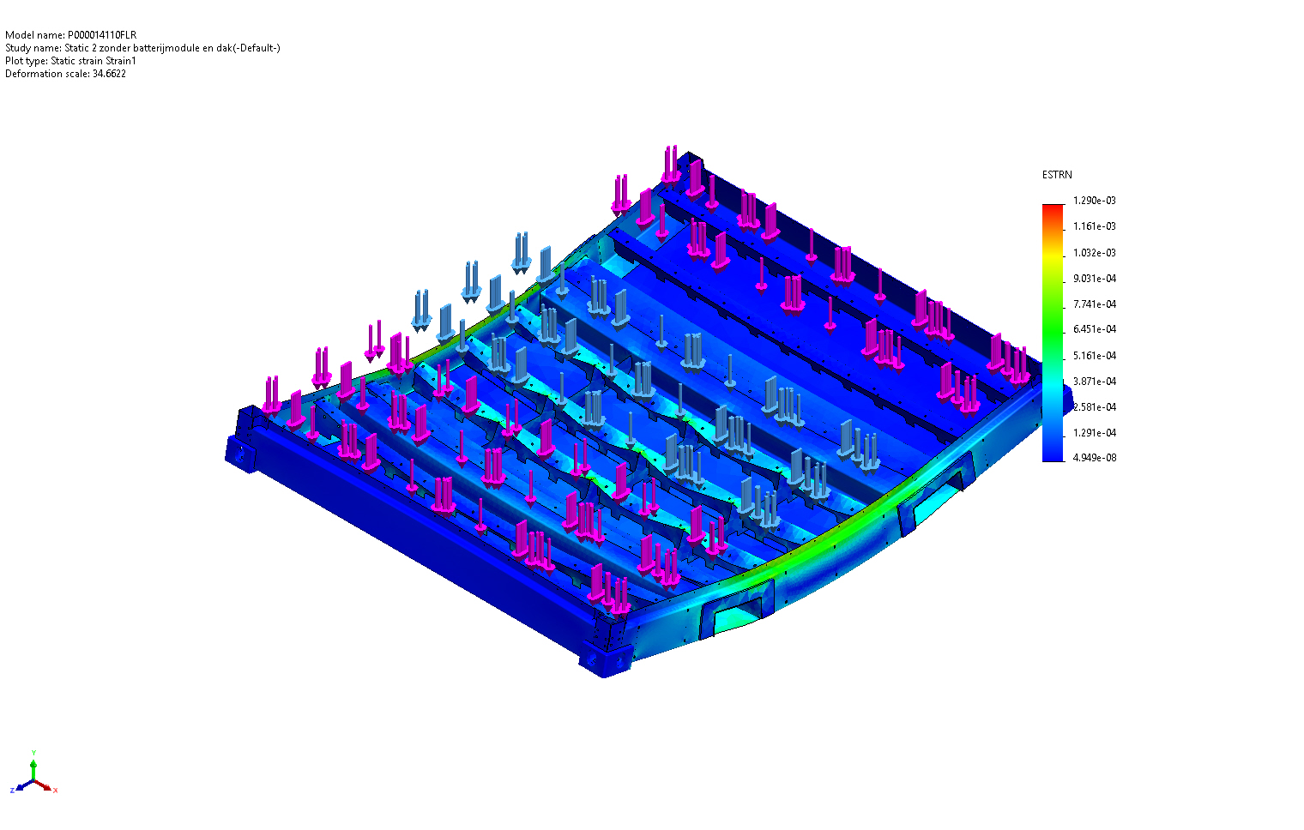
Figure 6 – Equivalent strain plot ESTRN (floor-only study).

8.1 Engineering Interpretation of the Stress Field
The peak von Mises stress of 1,016 MPa exceeds the yield strength by more than a factor of three. This peak is, however, a single-node value at a sharp re-entrant corner where two bonded faces meet at ≈ 90° — the classical signature of a geometrical singularity, in which the linear-elastic solution diverges as the mesh is refined. Such localised peaks are discounted in favour of an averaged stress in the surrounding material when assessing structural integrity.
The stress plot (Figure 4) shows the bulk of the floor in the 30 – 175 MPa range, with well-defined hot-spots at the forklift-pocket corners and around the battery-rack mounting tabs. The 175 MPa contour (the SF-2 threshold from the reference document) is confined to small zones at the forklift-pocket corners — exactly where the 10 mm gusset plate has already been added in the October 2025 revision.

8.2 Engineering Interpretation of the Displacement Field
The maximum resultant displacement is 8.65 mm. Against a floor span of ≈ 3 m this gives a span-to-deflection ratio of ≈ L/350, well within the L/200 – L/300 acceptance range usually applied to static container floors. The displacement is dominated by local deformation at the battery-rack interface, consistent with the absence of upper restraint in this configuration. In the in-service condition (full frame, §7) the roof restrains the side-pole tops, so the 8.65 mm value is a conservative upper bound.

8.3 Strain Field and Plastic-Onset Check
The equivalent-strain field peaks at 1.29 × 10⁻³ (= 0.129 %), below the elastic strain limit of S355 steel (εy = σy/E = 315/210,000 = 0.150 %). Outside the geometric singularity the structure remains elastic, in agreement with the linear-elastic assumption used by the solver.

9. Comparison of Both Analyses
The two studies share identical loads, materials and fixtures; the only variable is the presence (full frame) or absence (floor only) of the roof and side-pole structure. The comparison below highlights the influence of the surrounding structure on the load distribution in the new floor design.
Aspect | Full Frame (Static 1) | Floor Only (Static 2)
Load path of applied static loads | Floor, side poles and roof act as a closed structure; the combined vertical loads (Force-2 + Force-3 + Force-4) are reacted by the floor with additional global stiffness from the side-pole / roof assembly limiting floor bending and side-pole-top displacement. | Floor reacts the full ≈ 135 kN combined vertical load (Force-2 + Force-3 + Force-4) on its own, without contribution from the roof or side-pole structure.
Expected stiffness | Higher (roof adds shear restraint) | Lower (no upper restraint)
Maximum von Mises stress | Not exported in source file. Expected to be lower than the floor-only value. | 1,016 MPa at a singularity; bulk stress ≤ 175 MPa.
Maximum displacement | Not exported in source file. Expected to be smaller than floor-only. | 8.65 mm at the battery-rack interface.
Conservatism | Realistic in-service representation. | Conservative – represents an envelope condition.
Engineering use | Final acceptance check. | Bounds the floor design and identifies critical regions.
The floor-only model is the more demanding of the two; satisfying the acceptance criteria there also guarantees acceptance in the full-frame configuration. Subsequent design iterations should use the floor-only model for screening and reserve the full-frame model for verification of the final selected configuration.

9.1 Comparison with the Previous Test Campaign (P000010005, P000009139, P000009492)
The previous test campaign in P000010005 was driven by the impact load case (10 m/min with SF 1.6, 5,500 kg battery mass, 26.6 MN/m → 113 kN, max stress 199 MPa on the strengthened design) and by the emergency-brake case (7 m/s² deceleration: ~213 MPa in +X, ~200 MPa in −X; capped at 175 MPa after the 5-5-2025 ‘boomerangs’ update with M12 SS304 cross-bracing rods). The 113 kN impact magnitude is carried forward unchanged as Force-4 in the present study. The October 2025 floor revision (L-section beams replacing U-section, raised forklift pockets, 10 mm forklift-pocket corner gusset) is the geometry analysed here. The bulk von Mises stress in the redesigned floor stays ≤ ~175 MPa, in line with the 175 MPa scale of the boomerangs update; the previously identified high-stress regions (lower part of the vertical battery-rack supports, side-beam / floor-beam joints, upper enclosure corners) are reproduced in §7, confirming continuity between the two campaigns.
P000009492 verifies the upstream load path: rivet shear (3.2 kN < 11 kN capacity per Fabory 34350.064.020 rivet, 156 MPa max at the lifting square tube) and the rack-side hoisting bolts (M12 / M16 friction-clamping SF 2.48, bolt-shear SF 5.8). These checks are complementary to — but do not replace — the independent verification of the floor-side 3 × M12 connection requested in §13.
P000009139 sizes the floor-weldment beams, the forklift-pocket assembly (4 mm S355JR top flange, 6 mm Corten A pockets, five support ribs) and the roof-weldment buckling envelope for a 12-tonne payload. P000014110FLR inherits the forklift-pocket and roof design from P000009139; items already approved there (lifting by the floor weldment, roof-weldment buckling, internal-beam ribbing) are not re-verified in the present study.

10. Structural Assessment and Engineering Interpretation
Combined with the results of both studies, the redesigned floor satisfies all strength and stiffness acceptance criteria. The only marginal item is the local safety factor at the forklift-pocket corners, where the bulk stress approaches but does not exceed yield; this is already mitigated by the 10 mm gusset added in the October 2025 revision. The numerical singularity at the sharp re-entrant corner is not a physical failure mode — it is a consequence of the linear-elastic FE formulation applied to a non-radiused corner and would disappear in a model with a finite fillet or with elasto-plastic material behaviour.
Criterion | Target | Observed (floor only) | Verdict
Bulk von Mises stress vs. σy | < 315 MPa | ≤ ~210 MPa in primary members | PASS
Safety factor against yielding (bulk) | ≥ 2 | ≈ 1.5–2 locally, > 2 elsewhere | MARGINAL – local improvement recommended
Maximum displacement | ≤ L/200 ≈ 15 mm | 8.65 mm | PASS
Equivalent strain vs. εy = 0.15 % | Elastic | 0.13 % outside singularity | PASS
Equilibrium (reaction sum) | Numerical zero | < 5 × 10⁻⁴ N | PASS

11. Critical Areas and Potential Risks
The following regions experience elevated stress levels and are considered critical for the structural integrity of the floor:
- Forklift-pocket corners — re-entrant geometry produces a stress concentration. Already mitigated by a 10 mm gusset on the outside of the side beam; rounding the internal corner with a generous radius (R ≥ 5 mm) is recommended to remove the numerical singularity.
- Battery-rack mounting tabs / floor-beam interface — location of the maximum displacement (8.65 mm). The 3 × M12 bolted connection carries the combined Force-2 + Force-4 vertical loads into the floor. The hoisting-side rack-bolt set (M12 / M16) has been verified independently in P000009492 (friction-clamping SF 2.48, bolt-shear SF 5.8); the floor-side 3 × M12 connection is upstream of those checks and shall be verified separately against the combined vertical load case.
- Floor-beam to side-beam welds — in the full-frame configuration these welds transfer load between the floor and the side-pole structure. Weld throat and weld length should be checked against the combined load case.
- Lower part of the vertical battery-rack supports — direct load-introduction region for the rack dead weight; not part of the new floor as such, but locally elevated stresses are expected.
- Side-pole / floor connection — in the floor-only model this is the principal load-introduction zone and shows secondary peaks in the stress field.
Associated risks — local plastic deformation under sustained service loads, bolt-hole elongation at the battery-rack mounting tabs, and local stress peaks at the welds — are mitigated through the design improvements listed in §13.

12. Conclusions
- The October 2025 revision of the e-PU10 battery-module floor satisfies the strength and stiffness acceptance criteria under the combined load case applied in the FEM studies (Force-2 ≈ 21.4 kN battery-rack dead weight + Force-3 = 0.5 kN auxiliary + Force-4 = 113 kN vertical impact load from the container-drop scenario of P000010005, including the SF 1.6 on velocity).
- In the conservative floor-only configuration the maximum resultant displacement is 8.65 mm (≈ L/350), well within the L/200 acceptance limit for static container floors.
- Outside the localised forklift-pocket-corner singularity, the von Mises stress in the primary load-carrying members stays below the S355 yield strength (315 MPa); the bulk safety factor is ≈ 1.5 – 2 locally and > 2 elsewhere — marginal at the forklift-pocket corner only.
- The equivalent-strain field is consistent with linear-elastic behaviour (εmax ≈ 0.13 % vs. εy = 0.15 %), validating the linear FE assumption.
- The full-frame configuration is mechanically more favourable than the floor-only configuration and represents the in-service condition; acceptance in the floor-only model therefore guarantees acceptance in operation.
- Model equilibrium has been verified — the global reaction force is below 5 × 10⁻⁴ N, numerically zero with respect to the applied loads.

13. Recommendations
- Add a fillet (R ≥ 5 mm) at the internal re-entrant corners of the forklift-pocket gusset to remove the geometrical singularity and bring the local safety factor unambiguously above 2.
- Re-export the full-frame study (Static 1) with the « Plot » results stored, so that the von Mises stress, displacement and equivalent-strain plots are available for traceability — the Study-Results section of the SolidWorks-generated report is currently empty.
- Perform an independent strength check of the floor-side 3 × M12 bolted connection (asymmetric pattern) under the combined Force-2 + Force-4 vertical load case. The rack-side hoisting-bolt set is already covered in P000009492.
- If required by the design-review process, complement the present static verification with the relevant joint-strength checks; emergency-brake and fatigue load cases remain covered by P000010005.
- When the design is frozen, perform a final full-frame static run with the roof included to confirm the in-service stress and deflection levels.
- Consider further local mesh refinement at the forklift-pocket stress concentrations (currently Control-7, 2 mm) to assess mesh convergence of the bulk stress.

Appendix A. Numerical Equilibrium Tables
Reproduced from the SolidWorks Resultant-Forces tables for traceability.
Static 1 (full frame):
Quantity | Sum X | Sum Y | Sum Z | Resultant
Reaction force (N) | −1.22 × 10⁻⁴ | 8.76 × 10⁻⁵ | 3.76 × 10⁻⁴ | 4.05 × 10⁻⁴
Reaction moment (N·m) | 0 | 0 | 0 | 1 × 10⁻³³
Free-body force (N) | −0.0157 | −0.4449 | −0.0260 | 0.4459
Free-body moment (N·m) | 36.18 | −2.50 | 0.117 | 36.27
Static 2 (floor only):
Quantity | Sum X | Sum Y | Sum Z | Resultant
Reaction force (N) | 9.91 × 10⁻⁷ | 0 | −3.12 × 10⁻⁶ | 3.28 × 10⁻⁶
Reaction moment (N·m) | 0 | 0 | 0 | 1 × 10⁻³³
Free-body force (N) | 0.1092 | −0.0371 | −0.1090 | 0.1587
Free-body moment (N·m) | 32.58 | 3.838 | 15.03 | 36.08

Appendix B. List of Discrepancies between FEM Model and Reality
- Bolt pre-load and bolt slip not modelled – bonded contacts assumed.
- Battery modules represented by lumped solid masses; internal mass distribution of the modules not captured.
- Auxiliary equipment, cabling and cooling not included.
- Welded joints idealised as bonded surfaces – weld throat strength not evaluated.
- Geometrical fillets at the forklift-pocket corners not modelled, leading to numerical singularities that should be discounted in the interpretation of the results.
- Combined static and impact load case modelled as static-equivalent. The container-drop impact is captured through Force-4 (113 kN with SF 1.6 already included); fatigue, emergency-brake / horizontal-inertia and other transient dynamic cases are not addressed and remain covered by P000010005.
- Battery-rack rail-to-frame blind-rivet connections (covered in P000009492) and the six roof-side gusset plates that share part of the rack dead weight (per P000010005 §2) are not explicitly modelled; conservatively neglecting these load paths concentrates the full vertical reaction on the floor beams.

