Mechanical stress analysis
Enclosure assembly

Introduction
This report covers the structural analysis for the enclosure assembly that will be used for multiple products created by VDL Energy Systems.
Chapter 2 described the enclosure structure of interest.
In Chapter 3, a study is performed to the possibilities to lift the enclosure at the roof structure. Resulting in the conclusion that an impactful design change is needed to be able guarantee save lifting by the roof weldment. It is stated that: The enclosure can not be lifted by the roof weldment. To be able to lift the enclosure at the floor weldment using hoisting straps results in the criteria that the roof weldment needs to withstand the buckling forces .This is analysed in chapter 5.
In chapter 4, a study is performed to the floor weldment. Which needs to translate the forces of the internal load to the enclosure corner castings. In this study the required plate thickness of the structure is determined. Based on the different load scenarios. It is concluded that the floor construction beams need to be supported by vertical pillars, some sheet metal plates requite to be thickened and require material enhancements.
In chapter 5, the roof weldment is analysed if it can withstand the bucking forces induced by lifting the enclosure by the floor weldment with hoisting straps. Some design changes are proposed to lower the amount of material and prevent buckling.
Finally, it is concluded that the design proposed can will not fail during the set conditions.

Purpose of this document
The purpose of the document is two sided. Mechanical stress analysis are used to determine required stiffness of structural components.. Secondly, this document will provide information of the structural stresses that occur to provide to supply a CE mark on the enclosure assembly.

Standards
To include the required information in this report the following standards are conducted:
EN-1993-1-1:2010 | Eurocode 3: Steel structures:  Part 1-1: General rules for design and construction
EN-1993-1-3:2010 | Eurocode 3: Steel structures:  Part 1-3: Additional rules for cold formed members and sheet metal
EN-1993-1-5:2010 | Eurocode 3: Steel structures:  Part 1-5: Buckling of plate-type members
EN-1993-1-6:2010 | Eurocode 3: Steel structures:  Part 1-6: General - Strength and Stability of Shell Structures

List of abbreviations
COM Centre Of Mass

Software used
The software used to perform analysis is SolidWorks simulation premium

Situation
This chapter describes the mechanical structure of interest. With both welded structures and bolted connections. This structure must supply the structural integrity of the enclosure without the additional strength that is introduced by walls and internal structures that are design and product specific. Most metal parts are design to be structural steel S235JR. The results of this analysis show that the following components require a different metal type:
- Internal horizontal beam: S355JR
- Horizontal beam on top of forklift pockets: S355JR
- Forklift pockets: Corten steel, yield strength equivalent to S355JR

Mechanical structure
The mechanical structure contains a welded floor construction, a welded roof construction and 4 pillars. The floor construction must convert the load of the internals to the “Isofix” corner castings. From there the forces are either converted to the ground or to the vertical pillars when lifted by the top “Isofix” corner castings.
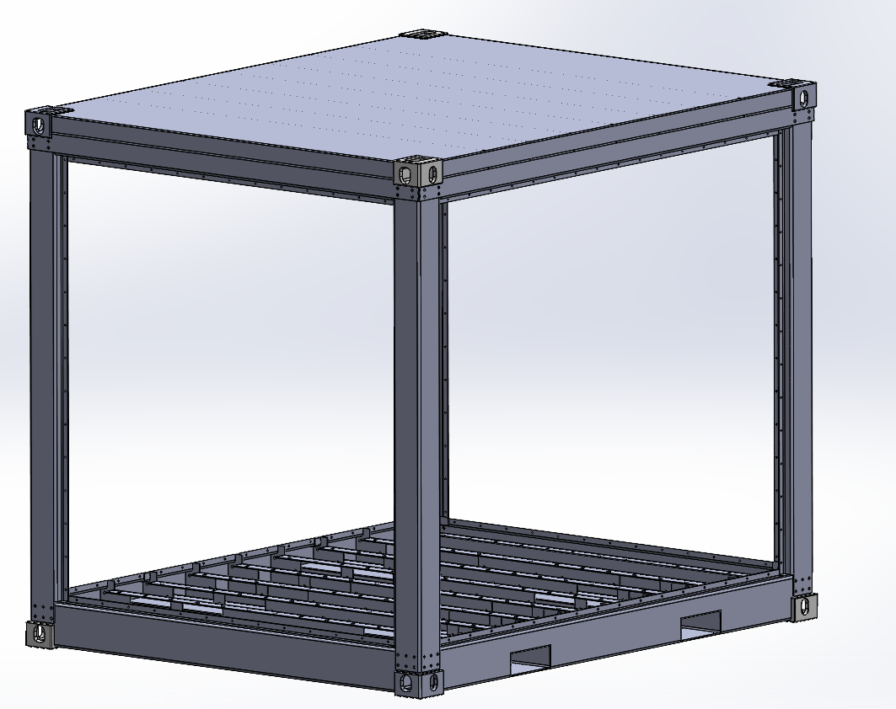
Figure 1; General assembly enclosure

Floor construction
The floor weldment is build of 9 internal C profiles equally spaced out. Combined by 4 bended outer plates. Additionally 2 pockets are introduced for transportation with a forklift. This structure is welded and coated. In a later stage the floor plate is added by bolting to the structure and will not be taken into account for the mechanical analysis. The forklift pockets are made out of Corten steel for use porpuses.
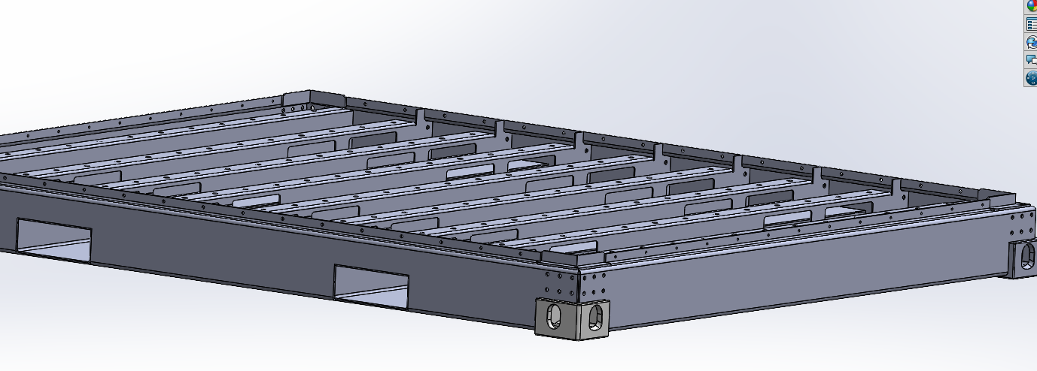
Figure 2; Floor weldment overview
The C profiles have a consistent hole pattern which allows to attach different applications. The beams must be capable of translating the forces of the internals to the side plated with allowed deformation.
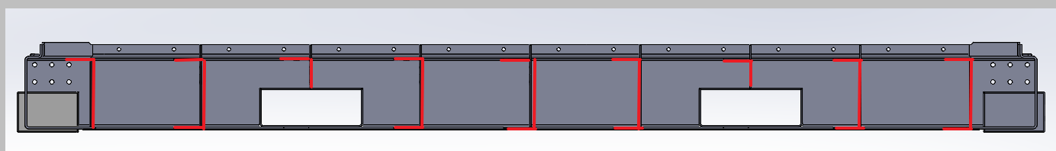
Figure 3; Floor weldment internal structure
The side plated must be able to translate the forces of the C profiles to the Isofixes where the interphase is with the environment.
The analysis to the structural integrity of the floor weldment is described in Chapter 4…..

Roof construction
The roof construction is welded construction which main purposes are: create a water tight top of the enclosure, have supporting ribs to which internal structures can be bolted.
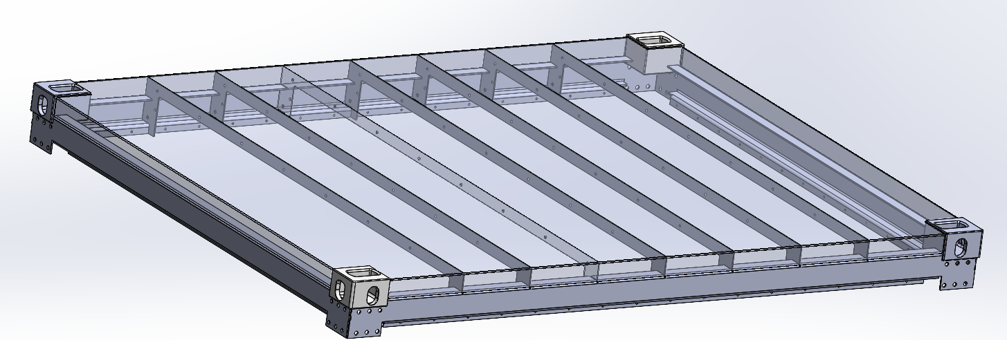
Figure 4; Roof weldment genernal layout
The roof construction must withstand the buckling forces that occur when the construction is lifted this effect is researched in Chapter 5.

Lifting by the roof weldment.
It can useful for transportation when the structure is lifted by the roof. In this chapter the load cases that occur are determined when this lifting methods are applied. The results of the Structural analysis to the pillars of the enclosure are shown. Concluding in the decision to not lift by the roof weldment.

Load cases

Static vertical lift
When the enclosure is lifted the load of the internals and the weight of the floor weldment must be converted from the floor weldment to the roof weldment by the 4 pillars. Additionally to the load the mass of the floor weldment also needs to be lifted resulting in a load of 110 kN to the pillars. The total weight of the structure, 120kN, must by lifted by a lifting chain 4 jump under a 50 degree angle.
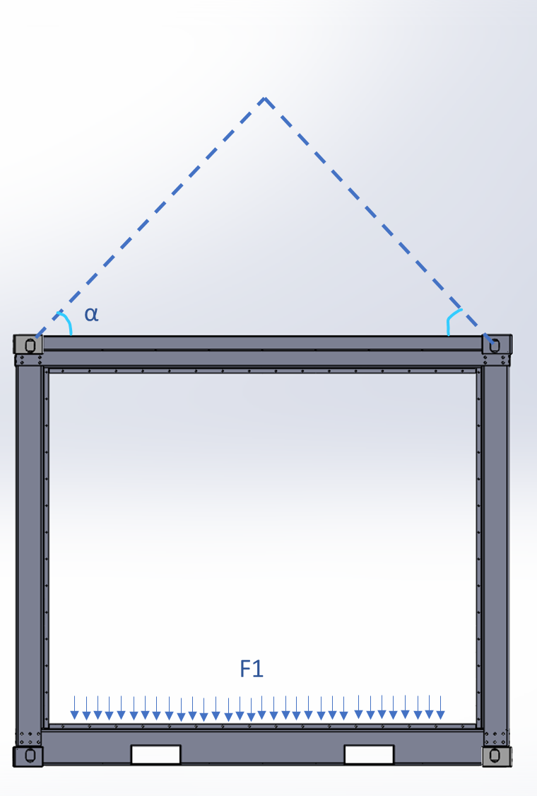
Figure 5; Load case: Vertical roof lift

Static angular vertical lift.
When the load is unevenly spread the enclosure will tilt during lifting meaning that the forces will be unevenly, spread over the 4 pillars. The maximum allowed tilt during lifting is 10 Degrees in one direction.
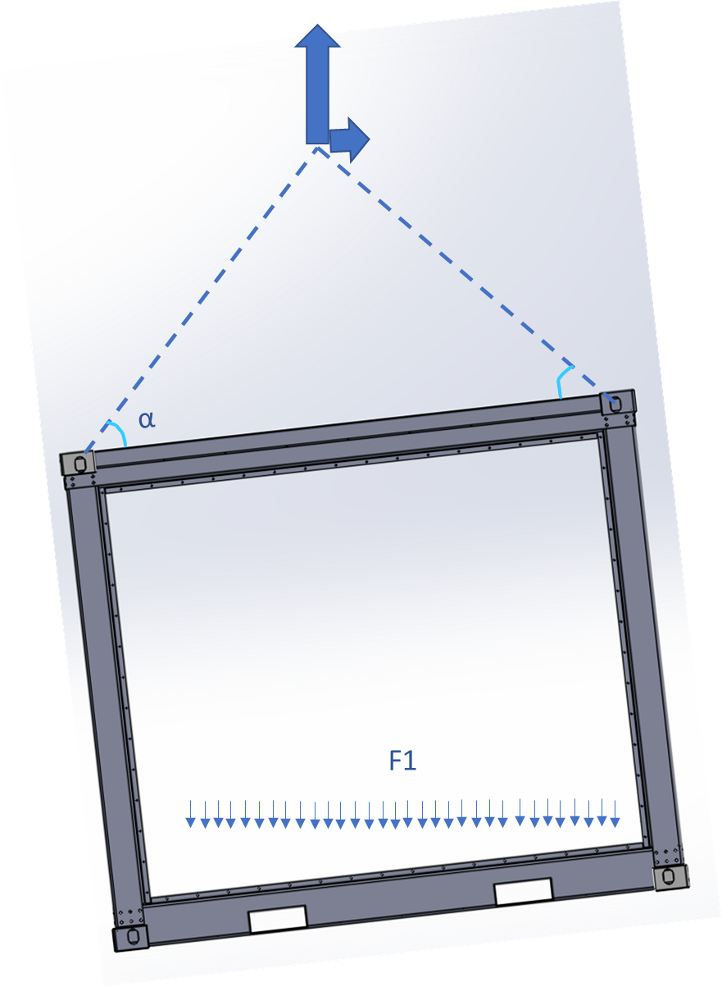
Figure 6; Load case: Angular roof lift

Horizontal force during vertical lift
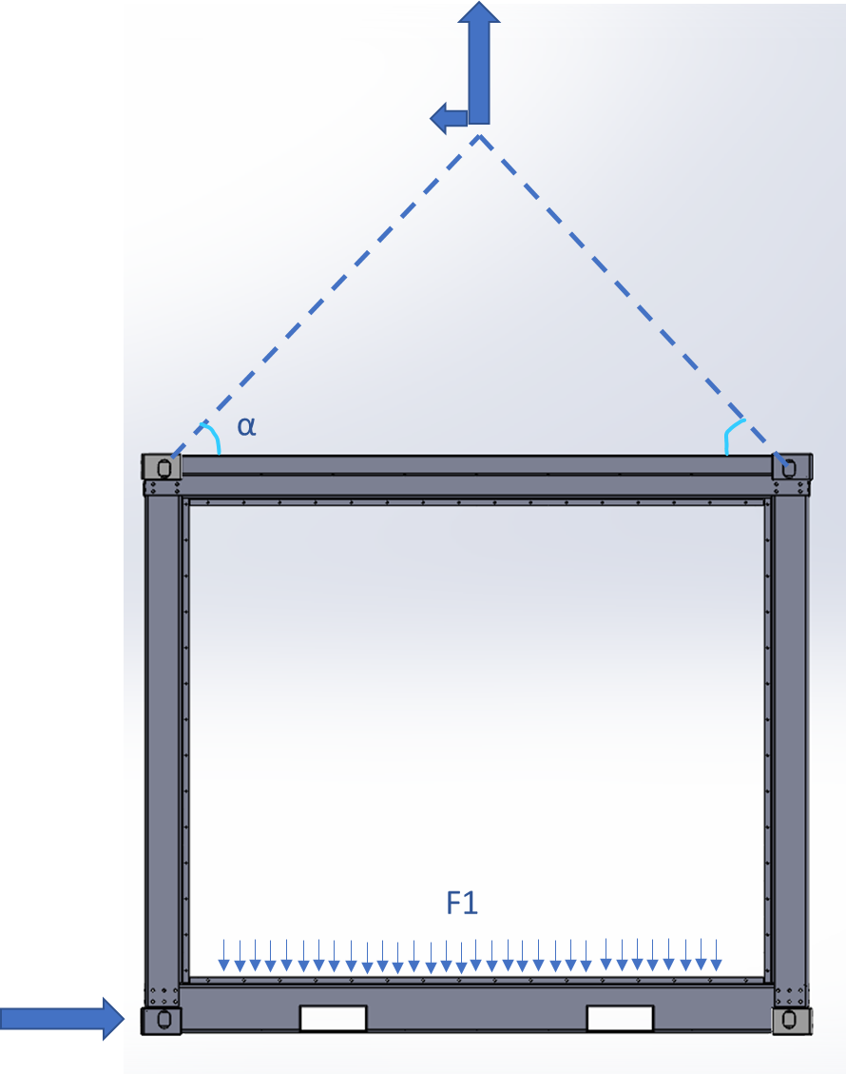
Figure 7; Load case: Horizontal roof lift with obstruction
The situation can occur that during lifting and moving in the horizontal plane an obstruction is hit and a horizontal impact force is created.

Results.

Static vertical lift
It is assumed that the floor weldment is capable of translating the internal load to the Corners in previous section. The floor weldment and roof weldment are bolted to the pillars the amount of bolts and bolt dimensions are determined to translate the load by friction of the sheet metals. Finally it is determined if the vertical pillars are thick enough to prevent failure due to high stresses.

Bolt connection
The connection between the vertical pillars and roof/bottom weldment is based on the friction between the plates induced by the bolts.
The amount of bolts can be calculated by:
$n_{bolts}=\frac{F_{pillar}}{F_{Bolts tensions}*ϑ_{friction}}=4.58$
When 8 bolts are used to create the connection the following safety factors are valid:
$$S_{friction}=\frac{n_{boltsreal}}{n_{bolts}}=\frac{8}{4.56}=1.75$$
When a bolt is untightened and loses its friction the shear force is introduced in the bolt and the plate material. The bolt have a 640Mpa strength with a area of 156.7mm2
$$s_{shearforcebolt}=\frac{σ_{bolt}*A_{bolt}*n_{boltsreal}}{F_{pillar}}=29.18$$
On the other side are stresses induced on the plate material here the tensile strength of the plate material 235Mpa ties the area of the plate material in the holes must overcome the load.
$$s_{shearplate}=\frac{σ_{plate}*A_{halfhole}*n_{boltsreal}}{F_{pillar}}=10.63$$
Concluding when 8 bolts are used ot make the connection the vertical loads can be translated by friction force. When a bolt untightened, the bolt and plate material can overcome the forces.

Vertical pillars
The vertical pillar is sheet metal plate of S235. The required plate thickness can be defined by dividing the force on the pillar 27500N by the tensile strength and the length of the plate.
The plate had a length of 2*(150+50+40)= 480mm
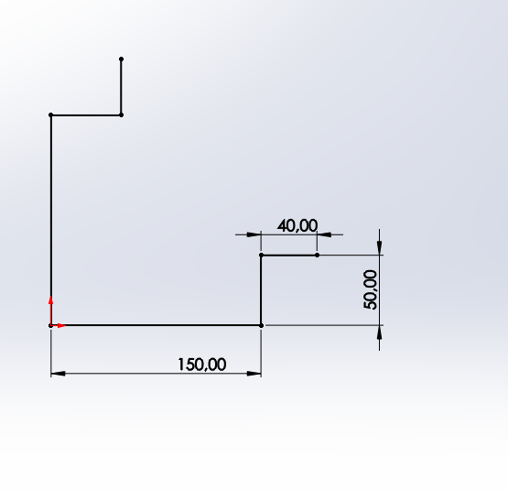
Figure 8; Vertical pillar shape

$$Pillar_{thickness}=\frac{F_{Pillar}}{σ_{plate}*length_{plate}}=\frac{27500}{235*240}=0.243 mm$$

When a thickness of 6mm is chosen a safety factor of 24 is valid since there are holes introduced this value lowers but remains acceptable.

Static angular lift
When the internal load is unevenly spread the enclosure will tilt during lifting. This implies that the floor weldment U profiles are required to translate these forces. When verified that the floor weldment is strong enough it can be assumed that the forces are translated to the corner castings and thus a vectorized force is introduced on the pillars.
There are 2 ultimate lifting angle situation. In the first scenario the forces are unevenly spread over 1 axis (orange) and the load shift is converted to 2 corner pillars. The second situation occurs when the angle is evenly spread over 2 axis resulting in the an increase load in 1 corner pillar.
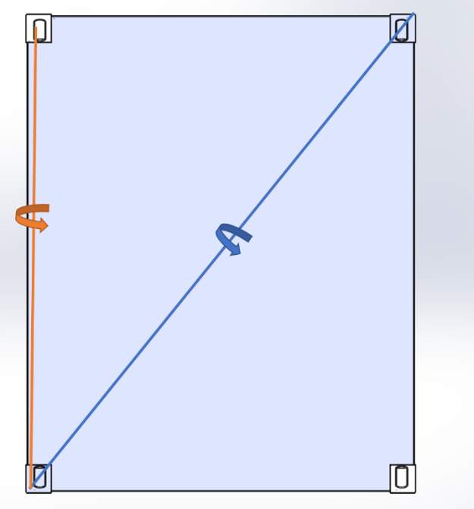  Figure 9; Angular lift rotations | 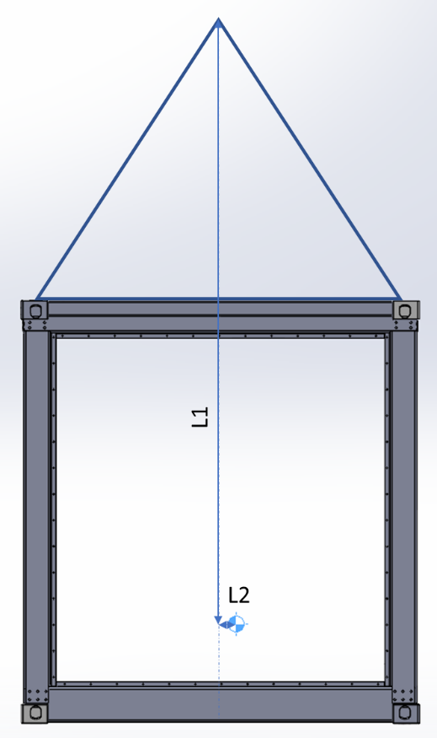  Figure 10; Angular lift rotations

1-Axis rotation
For the system to rotate around 1 axis the centre of gravity is displaced in 1 direction. When the system is lifted with lifting chains of equal length and infinite strength the enclosure will rotate around joint of the lifting until the centre of gravity is vertically placed under the lifting joint.
The height of the Centre of Mass is assumed at 1/3 of the structure height. In the least favourable situation the lifting chains are at an angle of 50 Degrees which result in high buckling forces on the roof weldment and a short distance between the centre off mass and the joint of the chains.
For this scenario the length L1 is determined to be 3518 mm with a 10 degree angle this results in 611mm deviation form the COM from the origin. When the load of 11kN is divided over the 4 pillars under an angle the forces on pillar 1 and 2 are 13.7 kN, the forces translated by opposite pillars are 41.3 kN per pillar.

2-Axis rotation
For the system to rotate around 2 axis the centre of gravity is displaced in 2 directions. When the system is lifted with lifting chains of equal length and infinite strength the enclosure will rotate around joint of the lifting until the centre of gravity is vertically placed under the lifting joint.
The height of the Centre of Mass is assumed at 1/3 of the structure height. In the least favourable situation the lifting chains are at an angle of 50 Degrees which result in high buckling forces on the roof weldment and a short distance between the centre off mass and the joint of the chains.
For this scenario the length L1 is determined to be 3518 mm with a 10 degree angle this results in 611mm deviation form the COM from the origin. The figure below shows a representation of the displacement.
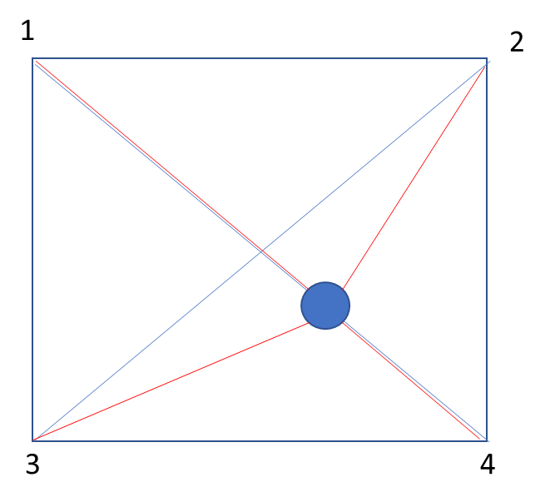
Figure 11; COM displacement
A Solidworks analysis showed that in the first 10 degrees rotation of the structure the placement of the COM results that the force on pillar 1 reaches to 0. At 10 degrees the relative force on the pillars becomes pillar 1: 0N, Pillar 2: 1N, Pillar 3: 1N, and Pillar 4: 2N. For the required force of structure this becomes a force per pillar of. Pillar 1: 0N, Pillar 2: 27.5kN, Pillar 3 27.5 kN, Pillar 4: 55kN

Bolt structure
The calculations from Section 3.1.1.1 need to be recalculated with the highest load possible that occurs in the system. This in 55 kN for 1 pillar. Resulting in the application of 12 bolts
$n_{bolts}=\frac{F_{pillar}}{F_{Bolts tensions}*ϑ_{friction}}=9.16$
$$S_{friction}=\frac{n_{boltsreal}}{n_{bolts}}=\frac{12}{9.16}=1.3$$
$$s_{shearforcebolt}=\frac{σ_{bolt}*A_{bolt}*n_{boltsreal}}{F_{pillar}}=21.88$$
On the other side are stresses induced on the plate material here the tensile strength of the plate material 235Mpa ties the area of the plate material in the holes must overcome the load.
$$s_{shearplate}=\frac{σ_{plate}*A_{halfhole}*n_{boltsreal}}{F_{pillar}}=7.97$$

Pillar
The pillar needs to resist both the tension of forces induded to lifting and the moment created by the angular lift. For the 1 axis rotation the pillar will create a momentum around the orange axis. For a 2 axis rotation the momentum will be generated around the blue axis.
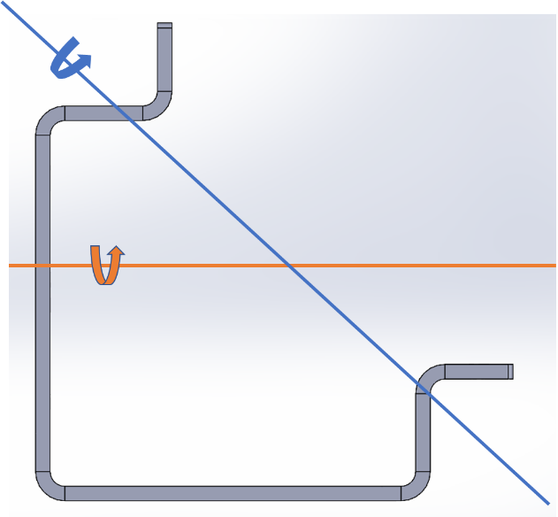
Figure 12; Rotation axes vertical pillar
1-Axis rotation
When rotating around 1 axis a total force of 41.3 kN is placed on the beam structure under a 10 degree angle. Resulting in the forces below. The top of the pillar is fixed in the place at which the bolted connections are placed.
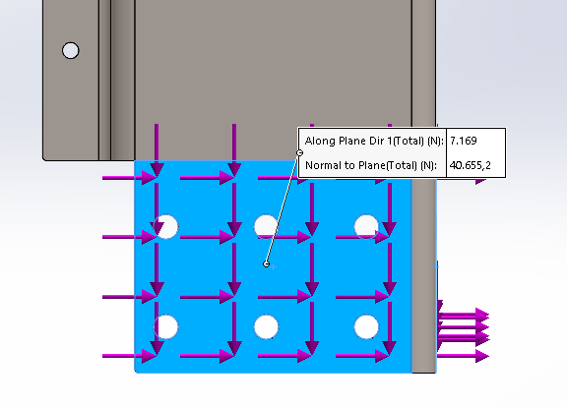  Figure 13; Vertical pillar forces and fixations | 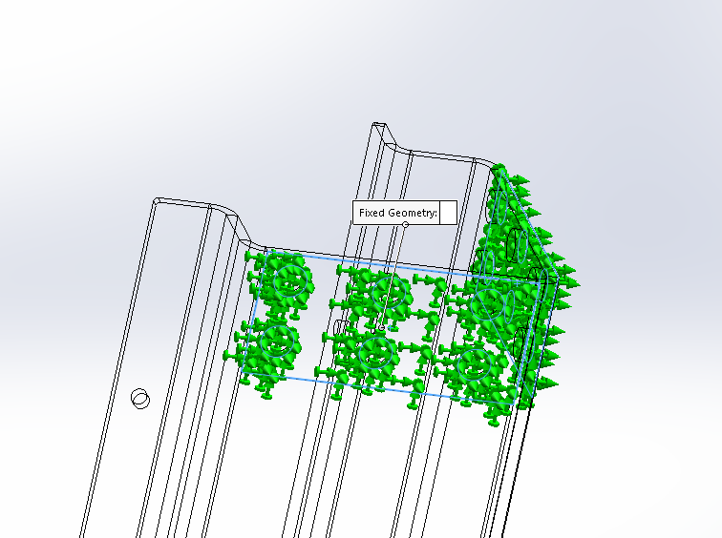

As expected the highest stresses occur at the boundary off the fixed geometry since here the bending momentums increase when the distance to the force increase. The extreme high stresses hotspot at the boundary of the geometry fixation due to infinite stiffness wouldn’t occur in reality and can thus be neglected. Overall the pillar can withstand stresses of moments created by the horizontal force vector created by the 1 axis angular lift.
.
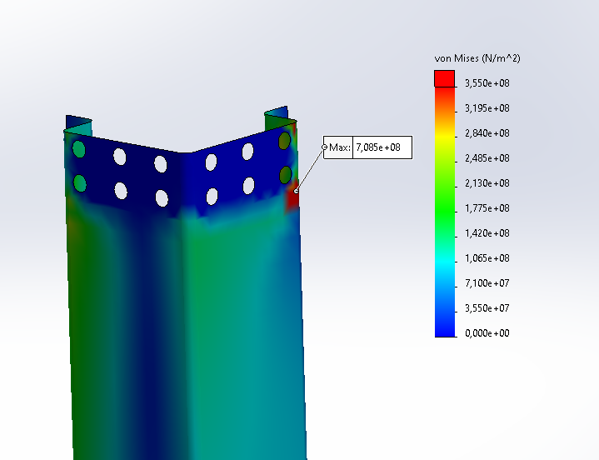
Figure 14; Vertical pillar result

2-axis rotation
When rotating around 2 axis, the resulting force is diagonal resulting in a vectorized force as shown below. The forces going downwards for the mass force and the horizontal forces are facing outward due to vectorization of a 10 degree gravitational force. As expected the highest stresses occur at the top where the moment stresses increase. The stresses are higher than the 1-axis rotation situation but mostly remain below 260 MPA. This means that structural steel S235 is not a feasible option and a stronger material must be applied. At the edges of the fixed geometry plane the stresses increase to an hotspot of 800MPA which is a limitation of the calculation, in reality these stresses will be equalized into the fixation plane. From this simulation setup the pillar can withstand the required bending forces.
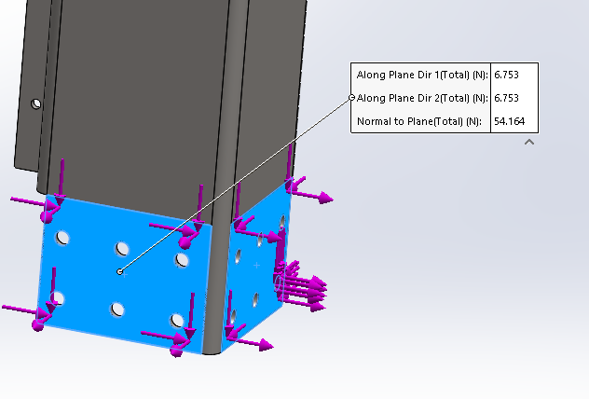 | 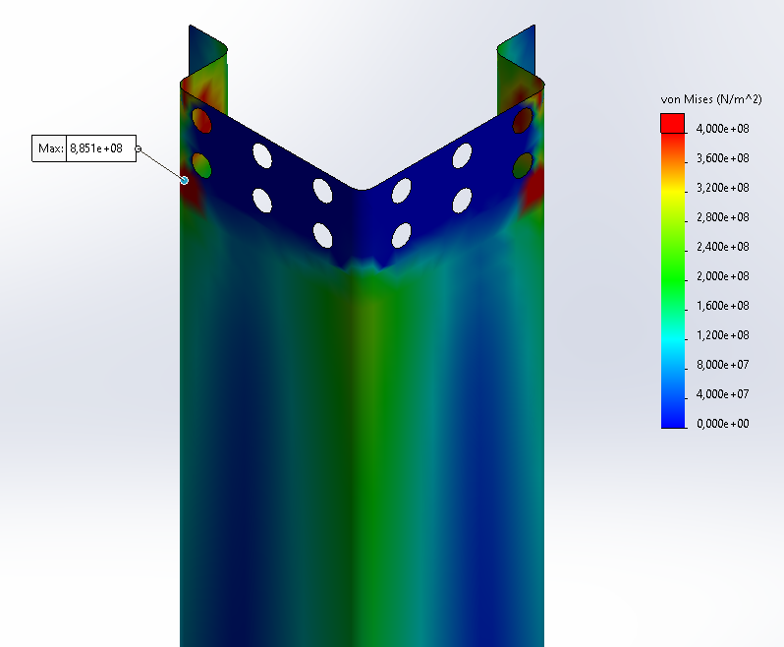
Figure 15; vertical pillar: forces and fixations

Bolt structure

The purpose of this calculation is to define the required bolt distance from the corner castings to translate the forces in the pillar to the roofweldment and the floorwelment. The pillar weldment connections should be able to withstand a moment of 15*10^6 Nmm

1-axis rotation for top connections.
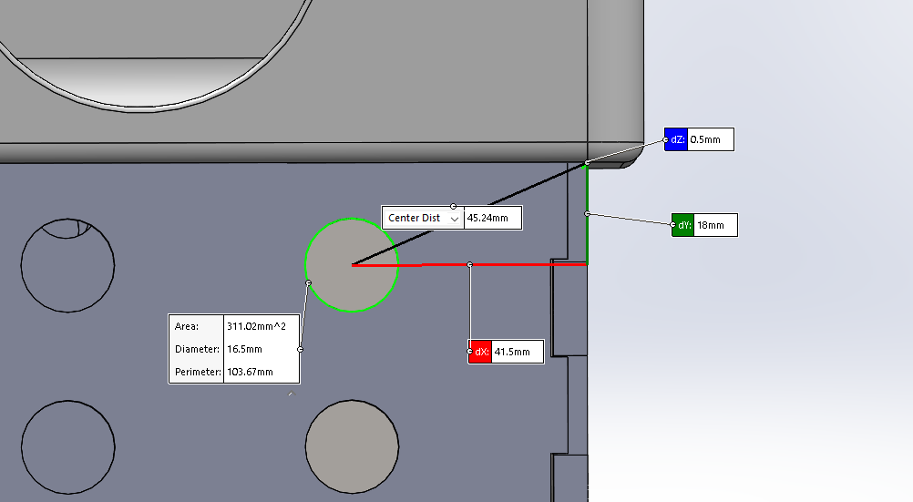
Figure 16; bolt setup roof weldment
When the distance dY increases the forces in the bolts decrease. In this calculation this distance is calculated.
When enclosure is rotated in 1 direction the bolt connections on the two sides of pillars have a different force translation. The bolts in plane of the screenshot have to translate a bending momentum to a friction force. The friction force required for the vertical lift need to be subtracted. Resulting in an available friction force per bolt of 1.4kN per bolt this friction force times the distance to the rotation point is the available momentum.
The bolts in the face of in the depth of the screenshot can translate a force equal to resultant bolt force, which is 60KN. Per bolt this friction force times the distance to the rotation point is the available momentum.
The vertical distance between the holes is determined to be the free variable. When this distance is increased to 90 mm the bolts should be able to translate the moment. with this setup there are no margins taken into account. The bolts in the plane of the screenshot which are based on frictional forces bring over 6% of the forces since. The bolts that are pulled have to translate 94% of the force.
An increase of the bolt distance to 90mm is optional in the design.

1-axis rotation for bottom connections
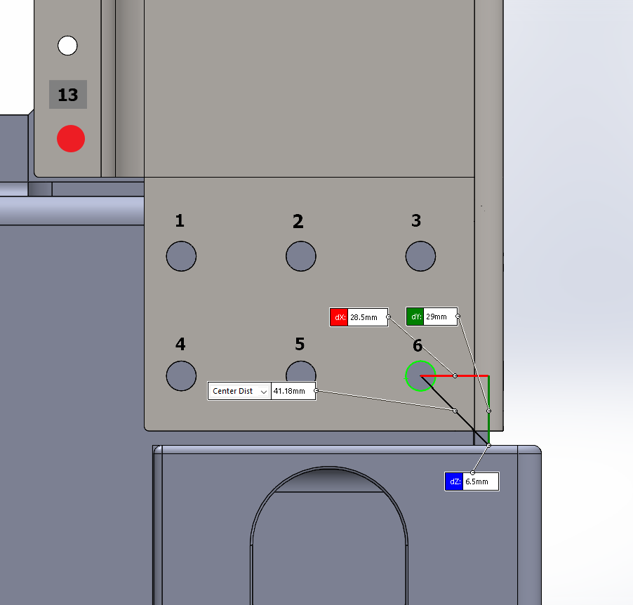
Figure 17; bolt setup floor weldment
When enclosure is rotated in 1 direction the bolt connections on the two sides of pillars have a different force translation. The bolts in plane of the screenshot have to translate a bending momentum to a friction force. The friction force required for the vertical lift need to be subtracted. Resulting in an available friction force per bolt of 1.4kN per bolt this friction force times the distance to the rotation point is the available momentum.
The bolts in the face of in the depth of the screenshot can translate a force equal to resultant bolt force, which is 60KN. Per bolt this friction force times the distance to the rotation point is the available momentum.
The distance between the holes is set constant and the distance of the lowest bolt range to the isofix are set variable.
When the distance between the lowest bolts and the isofix is increased to 40 mm the bolts should be able to translate the moment. with this setup there are no margins taken into account.
The bolts in the plane of the screenshot which are based on frictional forces bring over 9% of the forces since. The bolts that are pulled have to translate 91% of the force.

Sub conclusion
From the analysis it is shown that the pillar construction with bolted connections is capable to perform a vertical lift. However this pillar setup with relatively low bolt distances compared to the total height is not an optimal design when the centre of gravity is shifted and a angular lift is introduced. The introduced moments result in high tensional forces and current design the bolt setup is not capable of translating the forces from floor weldment into the pillars and from the pillars into the roof weldment.
It is insurant whether the construction will fail to high forces in the bolt connections, or by yielding/buckling of the pillars. Also the effect of the deformation of the floor weldment / roof weldment is not taken into account. Furthermore, the risk when a peak load is in introduced are not taken into account.
To take these effects into account large safety margins need to introduced resulting in impactfull design changes. An increase of the distance between the bolts and the isofix is not possible in the design. Since this would increase the height of the floor weldment which lowers the internal available space of the enclosure.
Concluding, the mechanical structure as described in chapter 2 is not feasible to perform an angular lift which is necessary. Thus, this structure can not be lifted by the roof weldment.

Floor weldment
The floor weldment is the base of the construction the main components will be placed on the C profiles which need to translate the force to the outer beam which has to translate to the isofix corner castings. In this chapter the components in this force translation principle are analysed. Different situations are analysed, the situation that induce the highest stresses is further analysed for an angular lift situation.

Situation
With the knowledge of the moment the enclosure will be used for both batteries and fuel cells. For these applications the floor weldment must withstand possible load cases. For the fuel cell the heaviest component is the super capacitor, with a weight of 900 kg with a footprint of 1x1m.
The battery container has different heavy components. Namely the Transformer 1300 kg with a footprint of 1x1 m. And the battery modules with a total weight of 5000 kg for 800 kWh with a footprint of 1.1x 1.8 m.
In the future a possible load case might be an enclosure complete filled with battery modules to the maximum of 12 metric tons. Which would be 10 tones with a footprint of 2.2 x 1.8m
The stresses and displacement of the floor beam are analysed to determine the shape factor. Before the total floor weldment can de analysed.

Load cases
For the situation described the load cases on the beams are analysed.
Transformer
With a footprint of 1x1m the load would be divided over 2 floor beams resulting in a force of 6500N, in the centre of the beam. This beam can withstand these stresses.
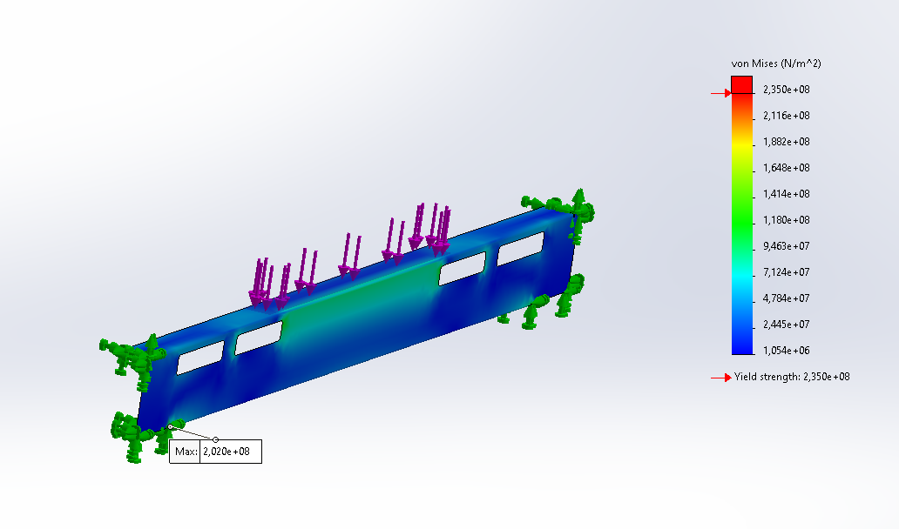
Figure 18; internal beam, load: transformer

Battery modules
A battery module of 800 kWh is assumed to be 5 metric ton over an area of 1.1x1.8m. this would share the load over 4 beams resulting in 12.5 kN per beam over the total width.
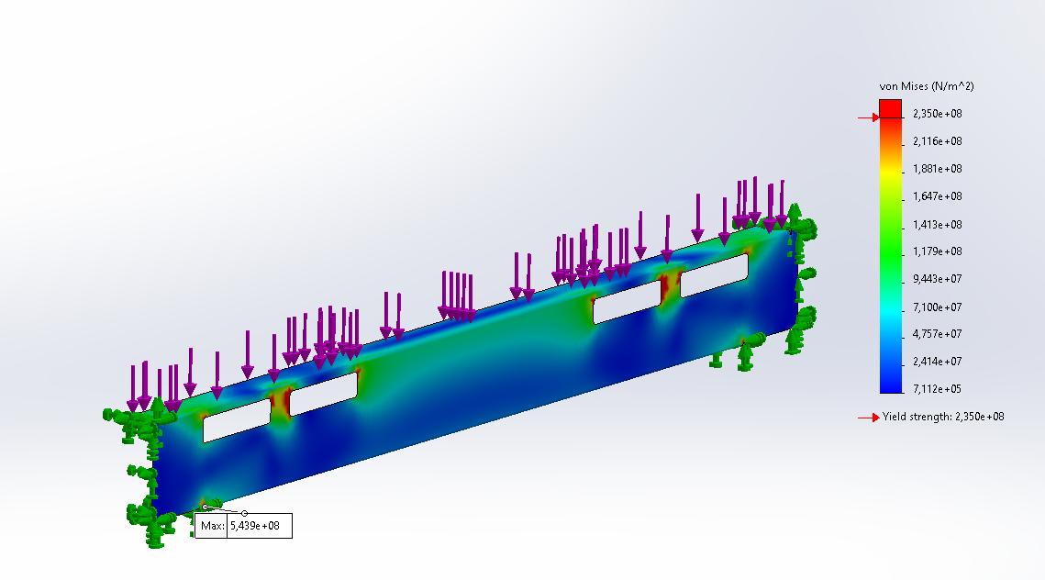
Figure 19; internal beam, load: battery module
The stresses induced by this load are to high. Due to the shape of the inserted holes plate material will not solve this issue. A design change is advised. An supporting rib around the holes can reduce the stresses.

Iteration 1
By inserting 3 ribs per side the high tension around the holes are solved. In this case the ribs are fully welded.
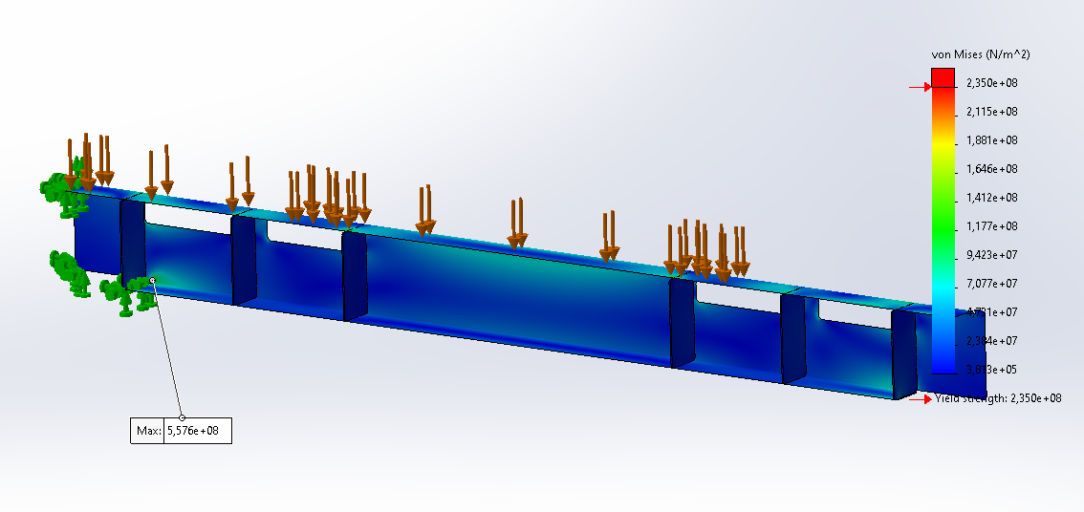
Figure 20; Internal beam: iteration 1, results
In the result is shown that the stresses around the holes are reduced. However fully welding 6 strips per beam is costs enlarging. The peak stresses are in the lower corner where the flange stops. But this is absorbed by the surrounding weldment structure.

Iteration 2
By inserting 3 ribs per side the high tension around the holes are lowered. When strips are inserted that are not fully welded they can only translate stresses from the top flange to the bottom flange and not dilute stresses around the holes.
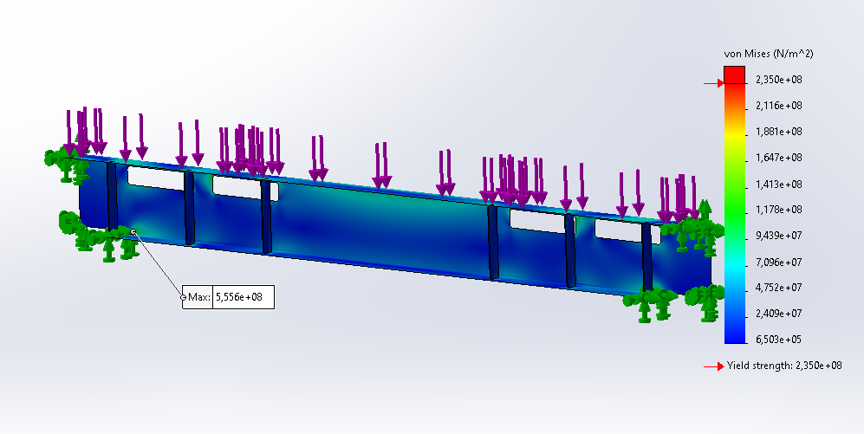
Figure 21 Internal beam: iteration 2, results

It is shown that these ribs add strength and translate stresses to the bottom flange and reduce the stresses around the holes. The peak stresses are in the lower corner where the flange stops. But this is absorbed by the surrounding weldment structure.

Iteration 3
By lowering the amount of ribs to a total of 3, a reduction around the corners of the holes can be achieved. Additionally enlarging the corner fillet radius to 20mm lowers the tensions even further. To increase the safety factor S355 steel must be used!
Note: the placement of two holes are shifted inwards for engineering purposes
The peak stresses are still In the lower corner where the flange stops. But this is absorbed by the surrounding weldment structure.

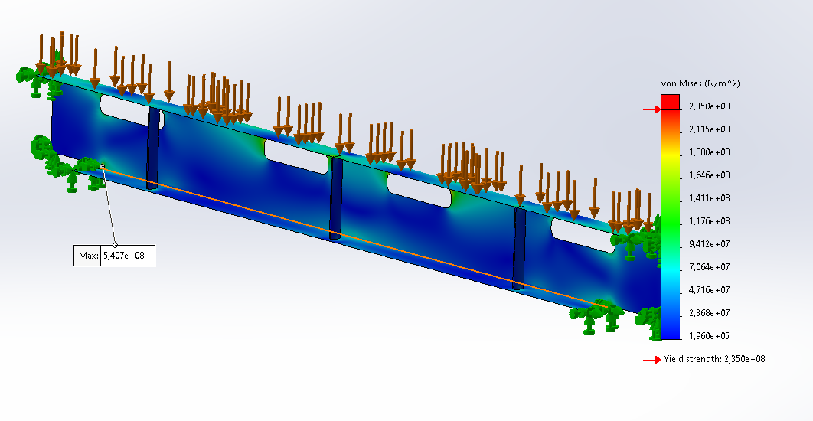
Figure 22; Internal beam: iteration 3, results
The inserted ribs have a width of 30mm and a thickness of 4mm
And are placed as follows:
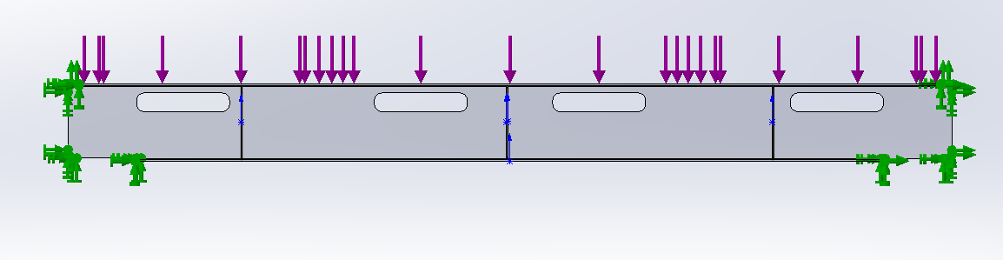
Figure 23; Internal beam: Final design

Forklift pockets
The forklift pockets have beside the load of the battery module. The addition of the stress induced when the total mass of 12metric ton is lifted by a forklift. The forklift pocket consists of 3 welded sheet metal parts. 4 mm thick top flange S235. Forklift pockets 6 mm Corten a steel (S355)

Iteration 1
The base iteration has just like the other floor beams no supporting ribs. And the results show that this structure will fail due to the induced load.
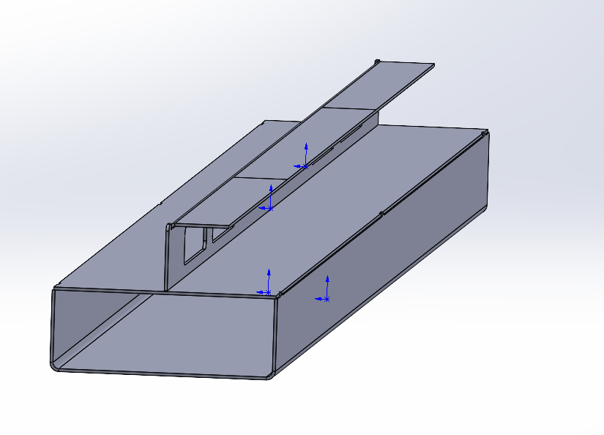
Figure 24; Forklift pocket iteration 1, setup

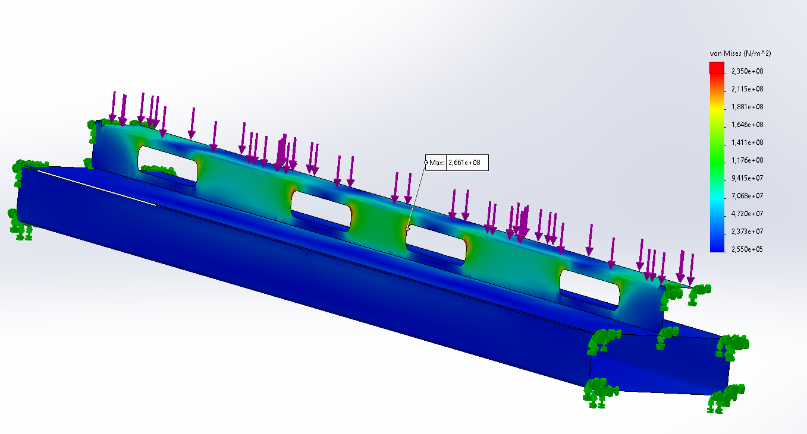
Figure 25; Forklift pocket iteration 1; results

Iteration 2
The material of the top flange is upgraded to S355JR, which has a higher yield strength. Additionally, support ribs are introduced to translate the forces from the top flange to the forklift pockets. The design of the flange will always remain a tension increase near the inserted holes but by upgrading to S355 a safety margin is still applicable.
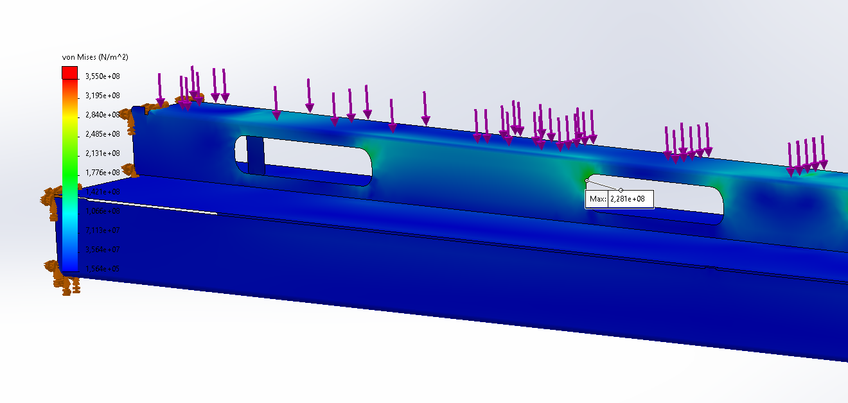
Figure 26; Forklift pocket iteration 2: results

Lifting the floor weldment with a forklift
When the floorweldment is lifted by a forklift a total of 6 tons per forklift pockets are introduced. These forces must be translated to the side plate shown as the green and orange fixation. When the forklift pockets bends the beam on top will have a great impact in the force translation.
As shown in the figure below the top flange will fail around the inserted holes. The forklift pockets itself have low tensions. The goal is to lower the stresses in the flange and increase in the forklift pockets

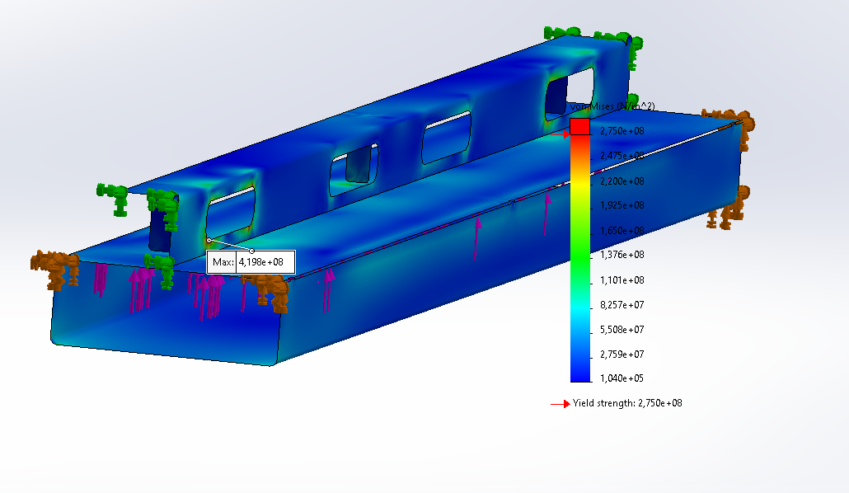
Figure 27; Forklift pocket iteration 2: Lifting results

Welding methods
The weakness of an analyses of an isolated structure is the fixed geometry at the boundary of the model where in reality the structure is welded to a different metal part which will also deform. In upcoming analyses the impact of welding the top flange to the outer construction, the hypothesis is that when not welding the flange the lower pocket will translate more forces.
In the two figures, below two fixation mechanisms are compared. In the left situation the total structure is welded and the highest stresses will be translated by the top flanged metal sheet. The right figure shows the situation in which the top flange is not fixed, this means the forces must be translated by the forklift pocket.

  Figure 28; Forklift pocket iteration 3: total fixation | 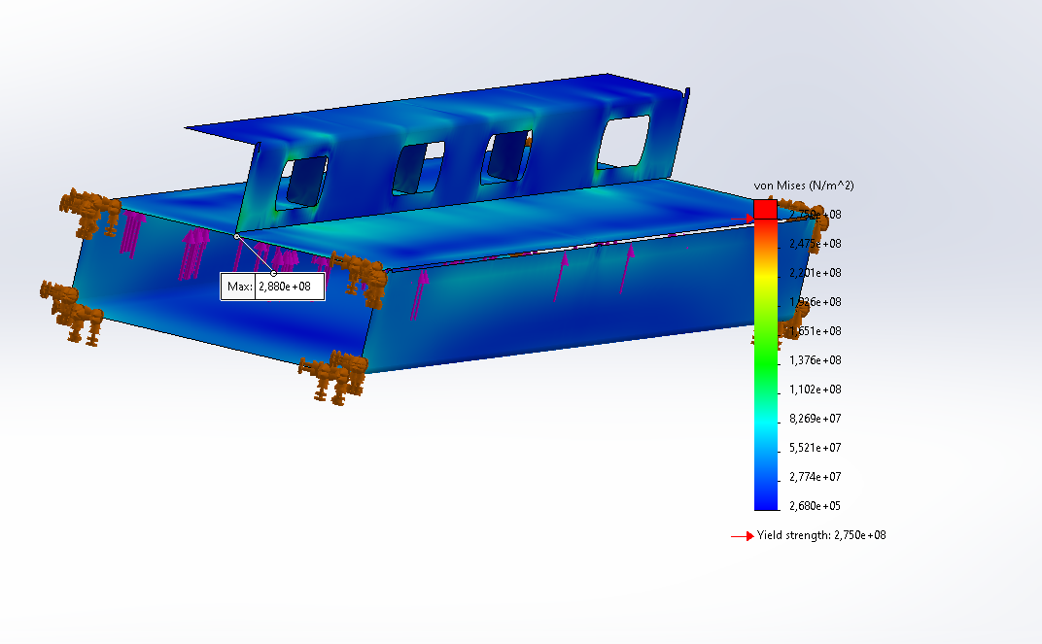  Figure 29; Forklift pocket iteration 3; lower fixation

In the figures above, it can be seen that the high tension areas in the top flange are gone, when the structure is only welded at the bottom forklift pocket. This is the result of a free moving top flange and the forces must be translated to the outer structuer by the pockets.

Lifting by the forklift pockets and an induced load
When the forklift pocket is used to lift the system and there is load induced the following stresses are introduced. The stresses in the top at the flange at the edge of the inserted holes increase since there is no fixation at the edge of the flange to the outer structure. Since the flange is not allowed to be welded to the outer structure, an additional support rib is needed.
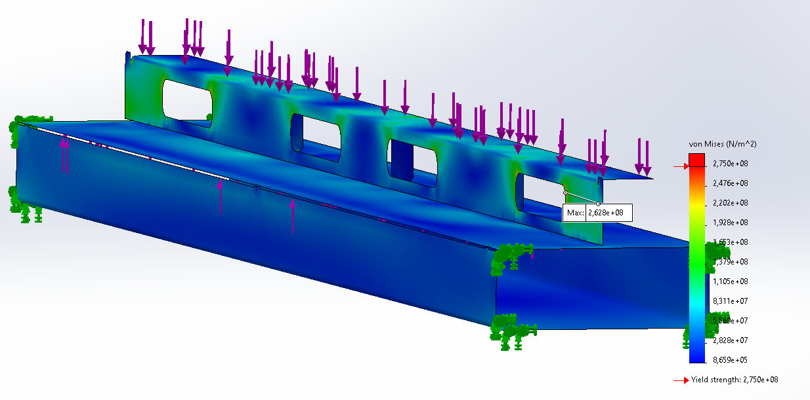

Iteration 3
With in introduction of 2 additional support ribs and modelling with S355 steel the structure looks like:
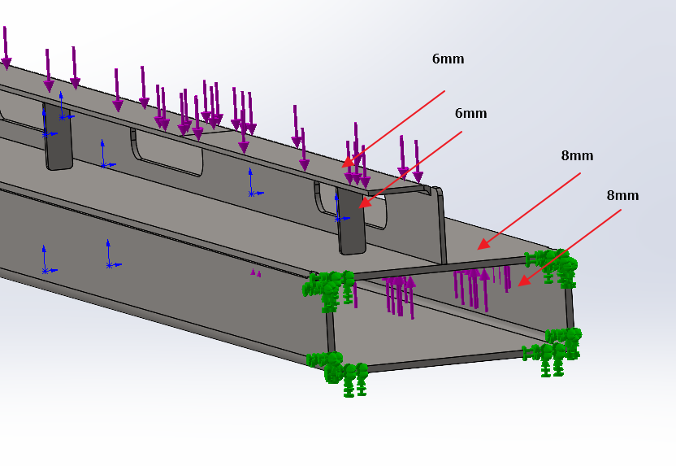
Figure 30; Forklift pocket final design
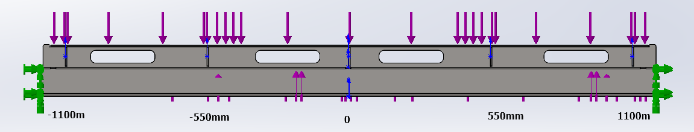
Figure 31; Forklift pocket final design
With a total of 5 supporting ribs 1 located in the center of the beam, the forklift pocket is made out of Corten a steel 6mm thick , the top flange is S355JR steel 4mm thick the support ribs are 4mm thick and have width of 30 mm. the material can be S235JR or a higher grade if chosen.
The results of the load cases are as follows:
Note that the color are shown to maximum of 200MPA to show more detail of the hotspots the maximum yield strength is 275 MPa
Static load
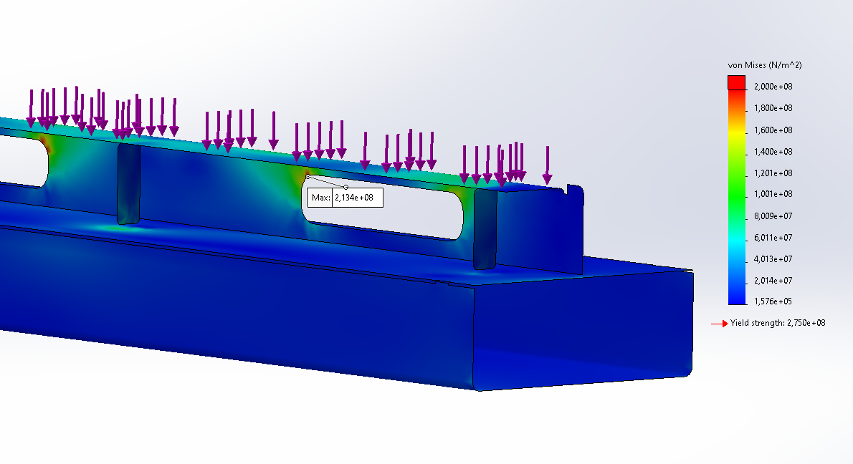
Figure 32;Forklift pocket final design; static load stresses
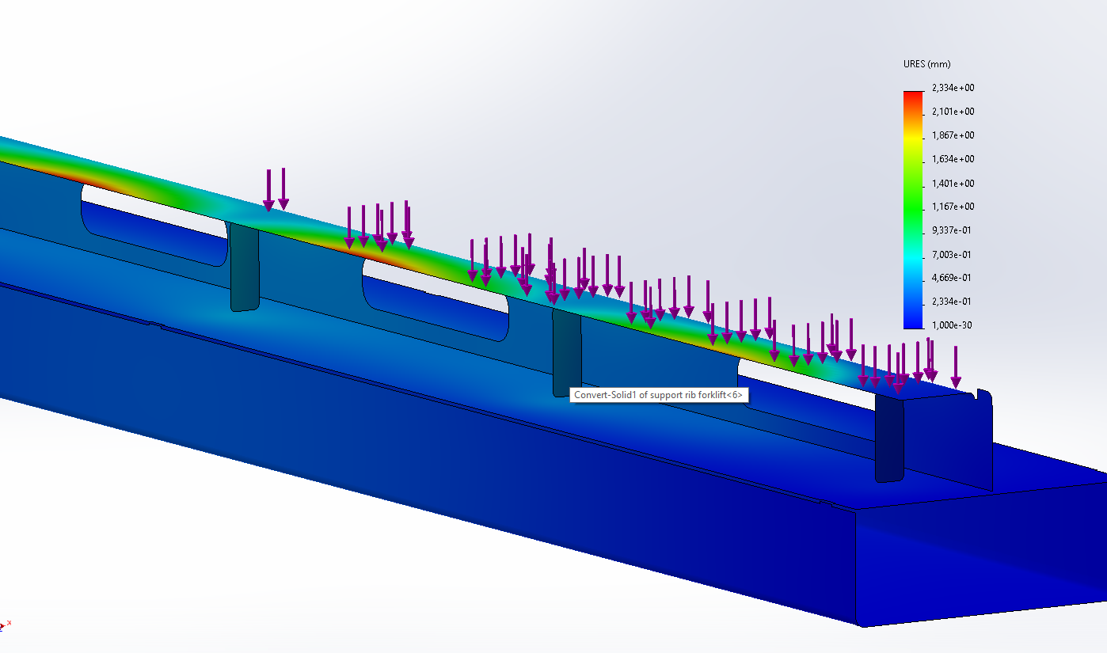
Figure 33; Forklift pocket final design: static load displacement
The maximum displacement of 2.3 mm, this value must be taken into account when designing the internal structures that will rest on these flanges.
Forklift lifting without load
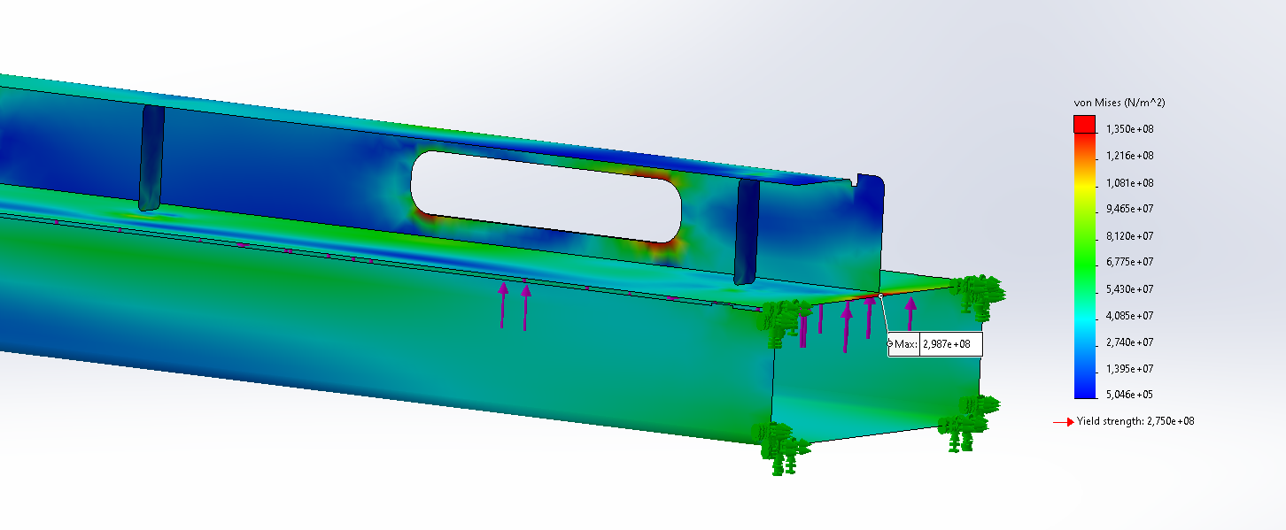
Figure 34; Forklift pocket final design: lifting, stresses
The stresses plot is capped at 135 N/m2, to determine show the stresses with a safety factor higher than 2.
Is can be seen that when the top flange is not fixated it still has the lowest safety factor spots of the structure. There is a stress hotspot at the edge of fixation point. This will be lowered due to the deformation of the surrounding structure and can be neglected.

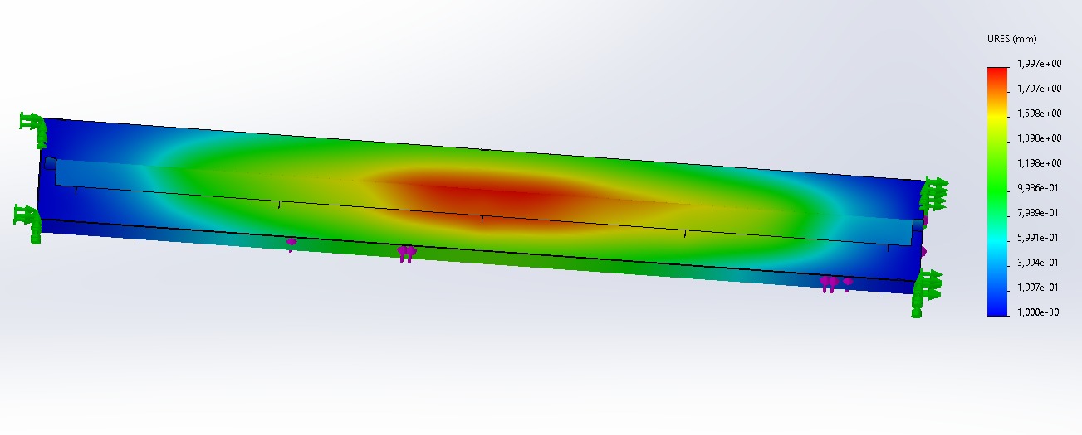
Figure 35; Forklift pocket final design: lifting, displacement
When lifting without load a displacement of 2 mm in the vertical direction occurs. This displacement must be taken into account when engineering components and sealings methods on top of this flange.

Forklift lifting and load
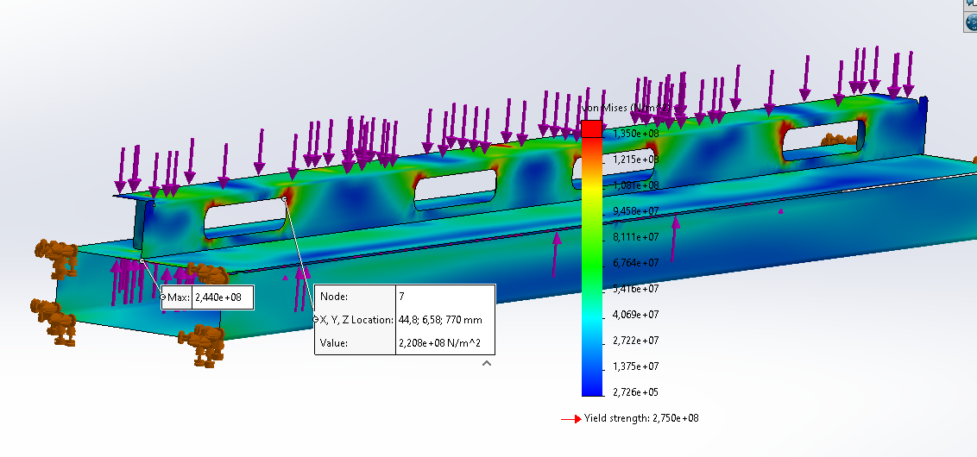
Figure 36; Forklift pocket final design: lifting+load, stresses
The stresses plot is capped at 135 N/m2, to determine show the stresses with a safety factor higher than 2.
The highest stresses occur in the top flange around the holes however. The stresses do not exceed the yield strength of 275 MPa
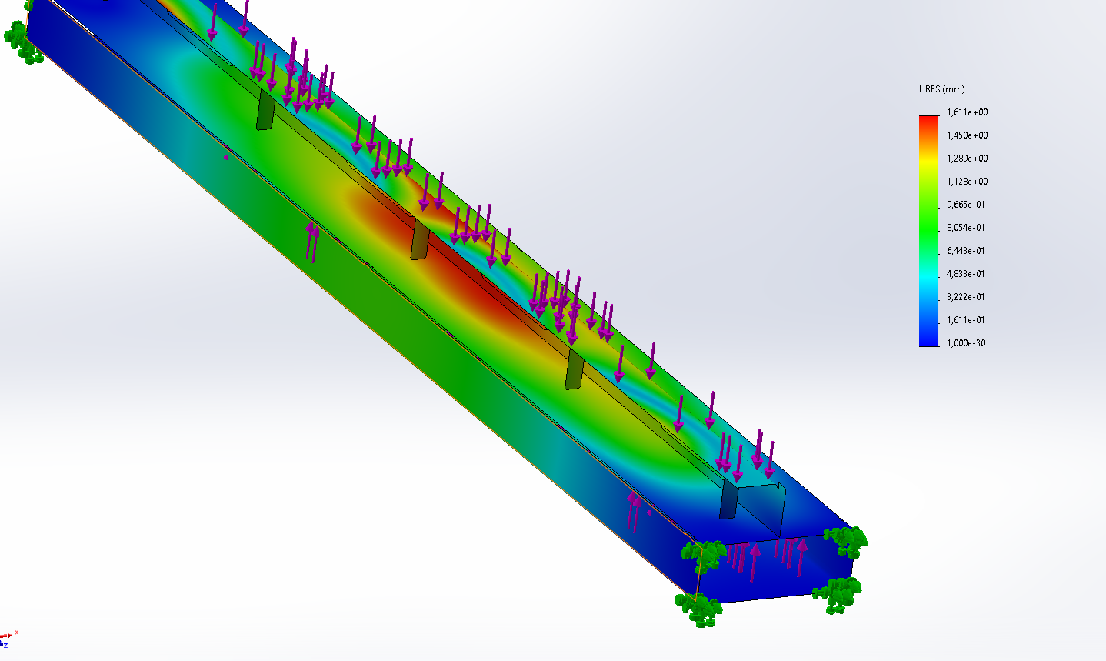
Figure 37; Forklift pocket final design: lifting+load, displacement
When lifting without load a displacement of 1.6 mm in the vertical direction occurs. This displacement must be taken into account when engineering components and sealings methods on top of this flange.

From the study results it can be stated that this design can withstand the induced forces. This stresses will be translated to the side beam by the forklift pockets which lower the stresses in the top flange. The deflection of the top flange at the edge is 0.5mm this deflection outward (shown below) must the minimal clearance to the side beam of the floor weldment.
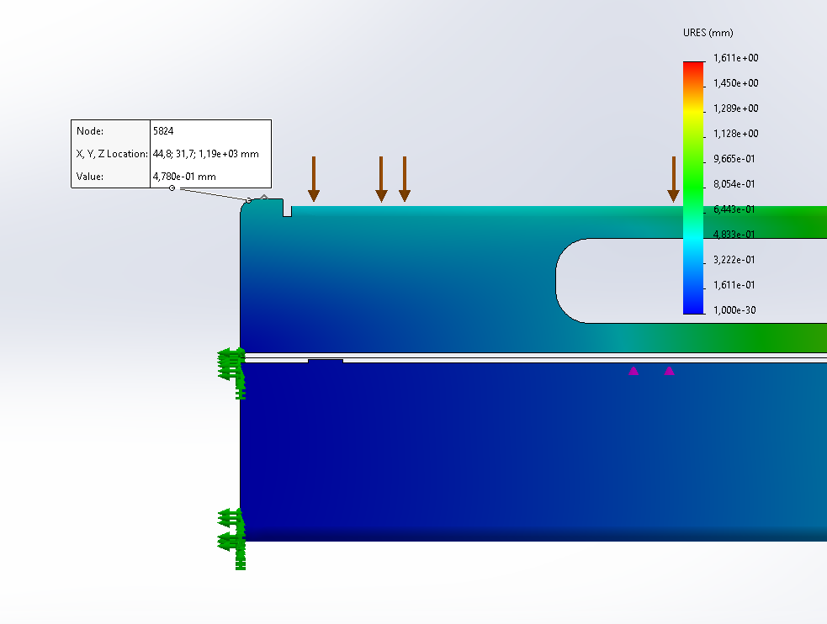
Figure 38; Forklift pocket final design: welding instruction

Sub conclusion
The forklift pockets with the flanged beam on top can withstand the load forces when the beam is 4mm thick and has 5 supporting brackets made out of S355JR steel. The forklift pockets must be 6 mm thick made out of Corten a steel. The top flange must not be welded to the outer structure!

Floor weldment
In this analysis the total floor weldment is analysed. At first the internal beams are updated to match the outcome of the analysis in previous sections. This analysis has two functions validate the stresses that occur in the beams during such that the analysis of previous sections can be stated as true. Determine the safety factor of the outer beams. That must translate the forces into the isofix corner castings.

Load cases
Normally distributed maximum load
The first load case is the maximum allowed load of 11 metric tons internals, normally distributed over the floor weldment beams.
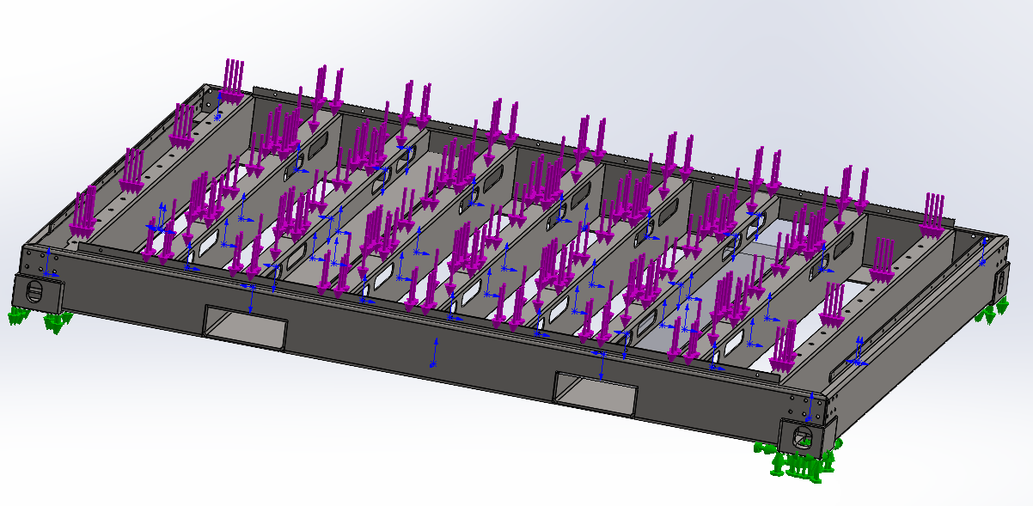
Figure 39; Floorweldment: static load
As expected for the internal beams the highest tensions occur are around the inserted holes. With a peak tensions at the fixation to side beams but this gap will be fully welded to lower these stresses.
From this study it can be stated that the outer beams have low stresses induced so a plate thickness reduction can be achieved if wanted.
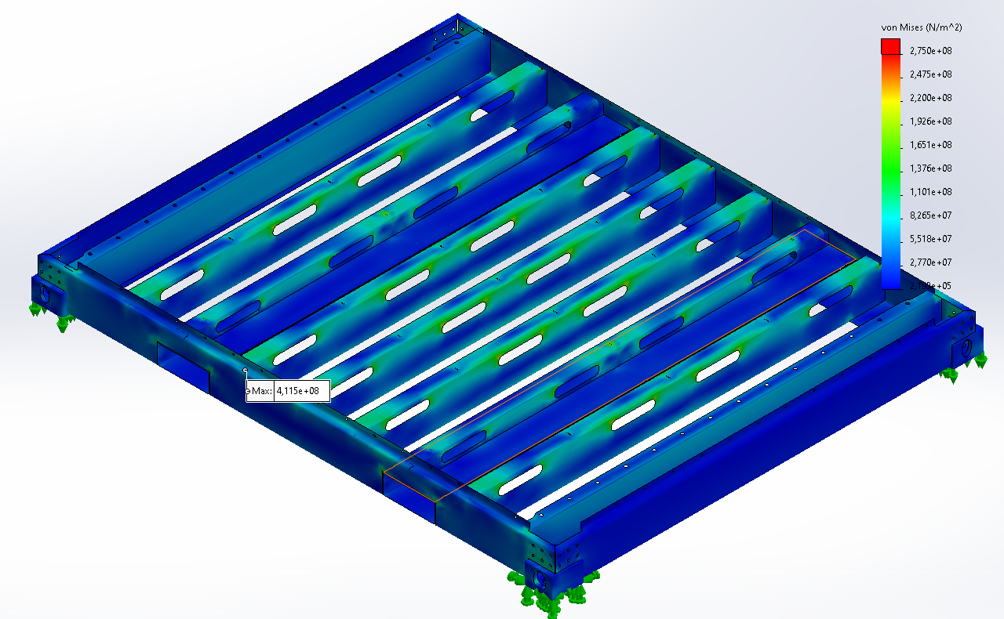
Figure 40; Floorweldment: static load, stresses
The deformed displacement with a maximum of 1.1mm for the centre beams show that the contact sets are set correctly since all elements that require to be welded are fixed together.
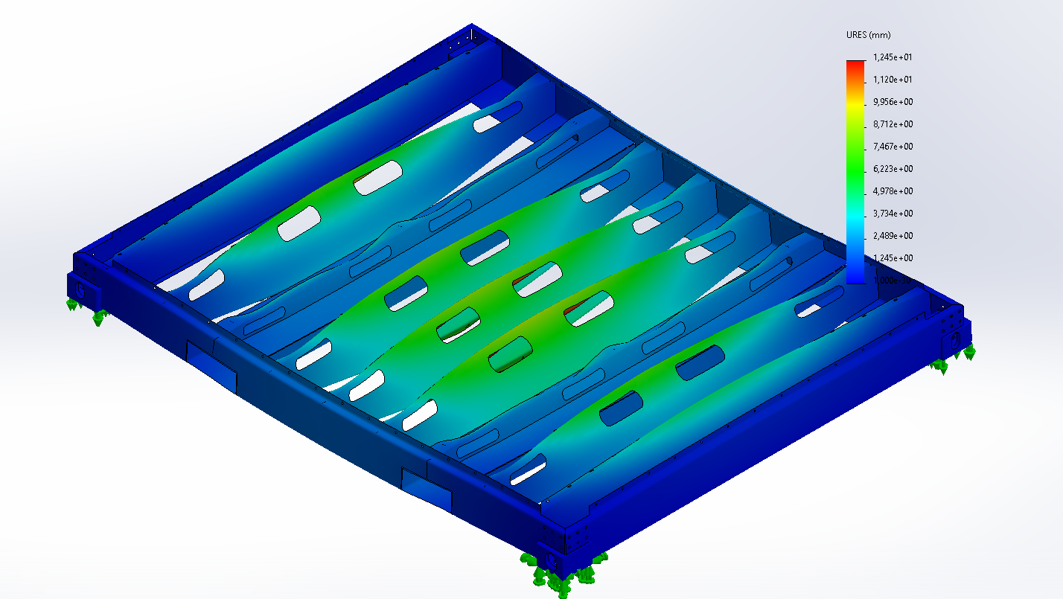
Figure 41; Floorweldment: static load, displacement
Load+lift
When the weldment is lifted by a forklift and is fully loaded to weight a total 12 metric tons. The forces need to be translated from the internal beams to the forklift pockets by the outer beam.
The results show that the highest forces are introduced in the internal beams which have been investigated before. The main part of interest is the outer beam which shot low stresses.
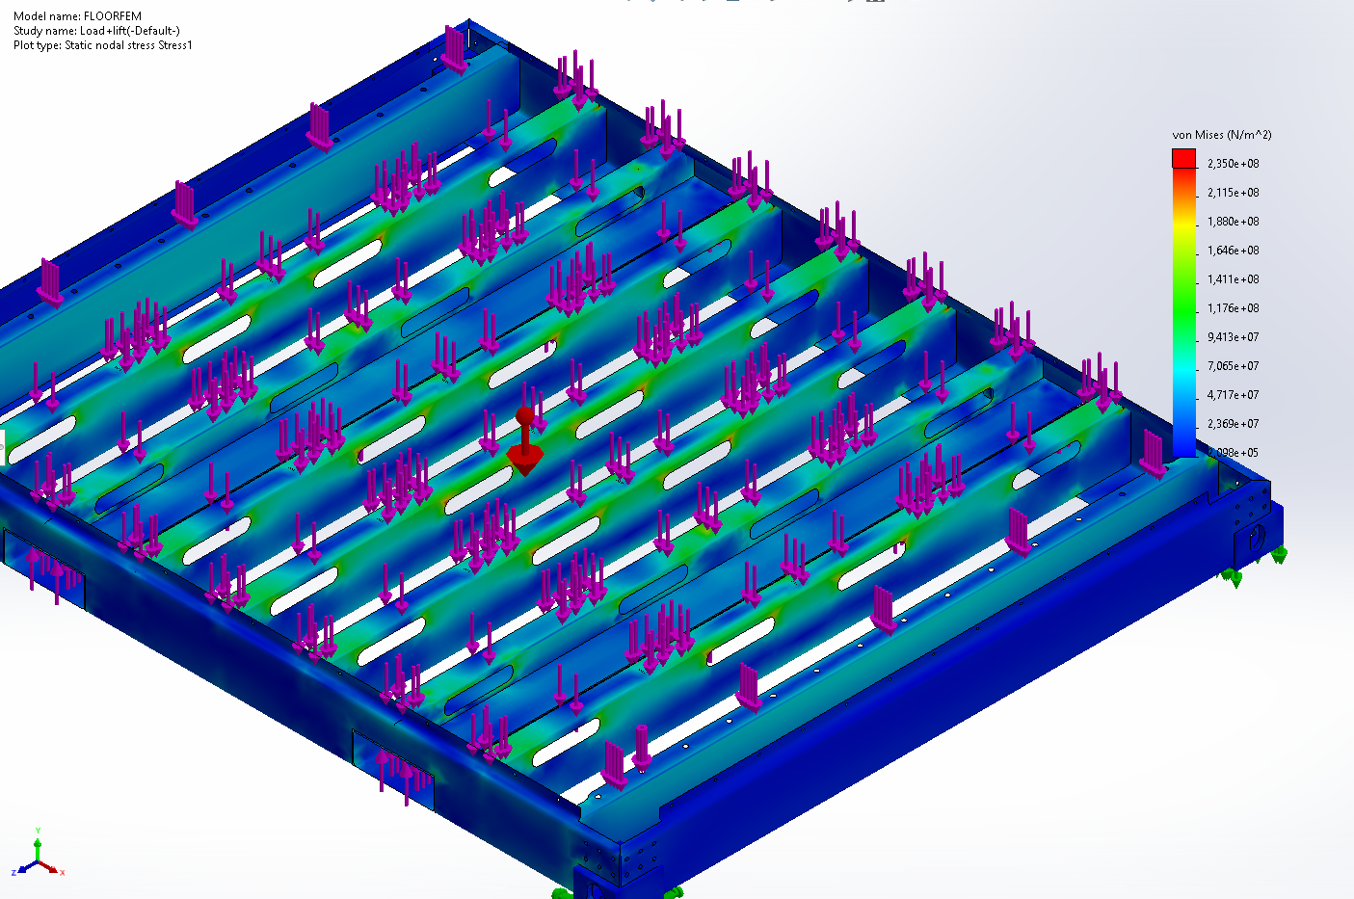
Figure 42; Floorweldment: load+lift, stresses
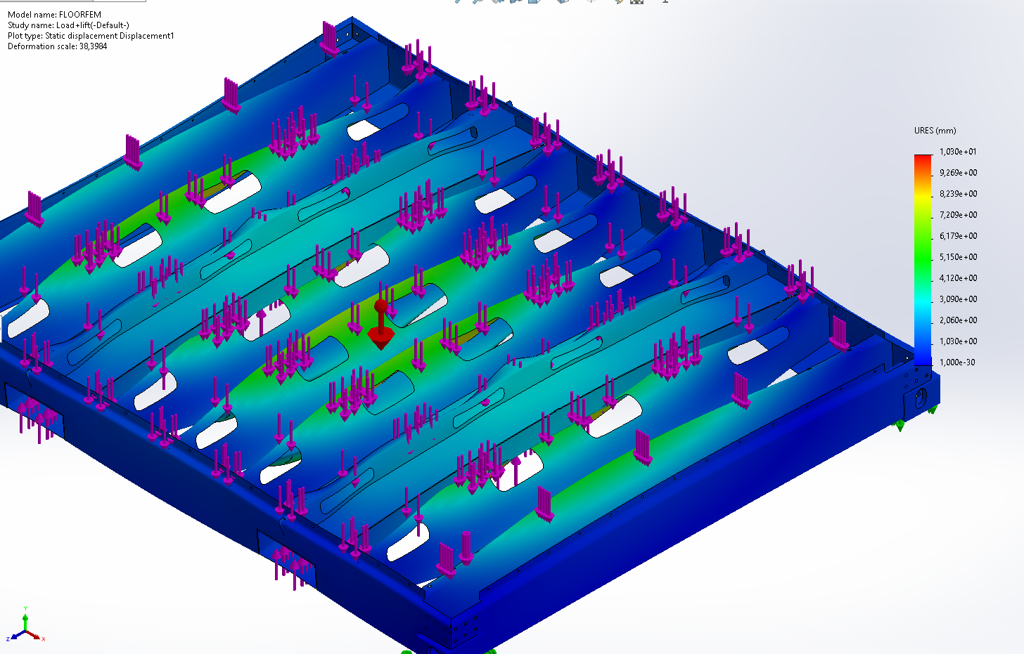

Sub conclusions
The design above is validated to not fail under the conditions set. The displacement is maximum 1 mm for the internal beam.

Roof weldment

Situation
Since the enclosure is unevenly length during hoisting the enclosure with lifting straps the lifting equipment will be placed around the long side of the enclosure. See figure below. However the enclosure can be lifted inappropriate when the hoisting straps are placed over the short side of the enclosure. The enclosure must be able to withstand these forces.
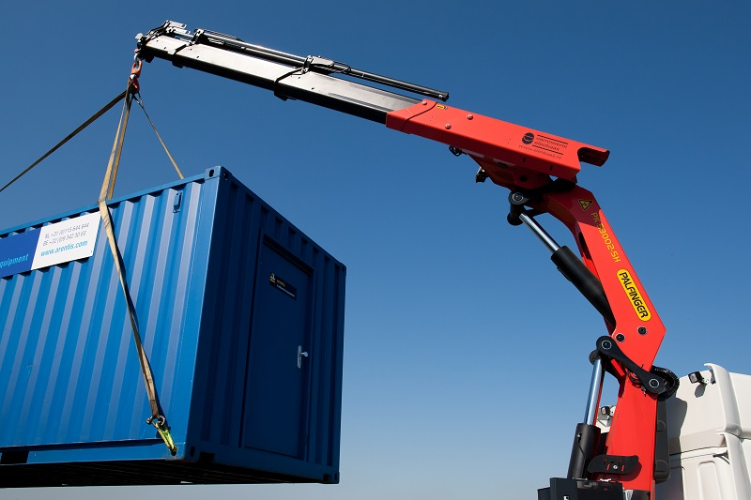  Figure 43; Enclosure lifting example | 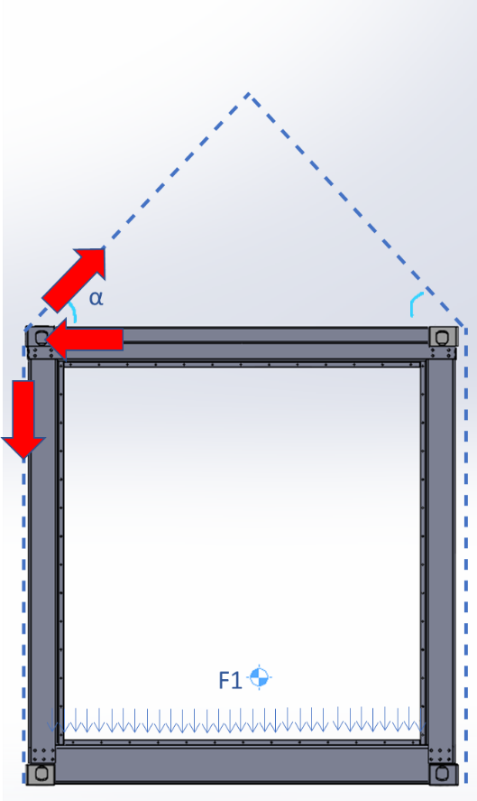  Figure 44; enclosure lifting principle

This liftting method results in a reactional force outwards of the enclosure. When a spreader beam is used no forces on the reef weldment are induced;
The Roof weldment consists of 4 thick sheet metal parts that must be able to withstand the buckling forces of hoisting equipment during lifting. the ISOfix conrer castings are redundant.
The internal ribs are placed in line of the induced forces when lifted correctly

Figure 45; Roof weldment layout

Load case
The least favourable load case is when the enclosure is lifted with hoisting straps at the bottom of the enclosure and the angle of alpha is small, for this analyses an angle of 50Degrees is assumed.
When the load per hoisting strap is 27500N the resulting force in the horizontal place of the roof weldment is 17.6 kN

Figure 46; ; enclosure lifting principle induced forces

Iteration 1
A fragment of the roof construction is modelled for efficiency. In the least favourable situation the hoisting strap is located between two supporting ribs. This indicates that the roof plate must translate the force to the ribs.
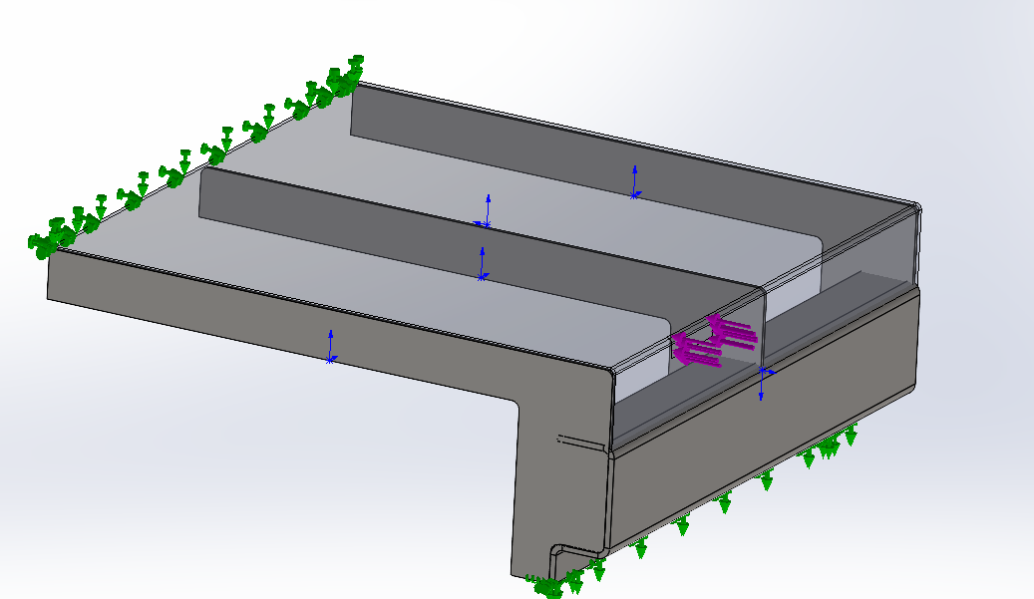
Figure 47; Roof weldment iteration 1: simplified

The result is that the roof plate is not thick enough to translate the force to the internal ribs. This implies that when the enclosure is lifted inappropriate the stresses will rise even higher.
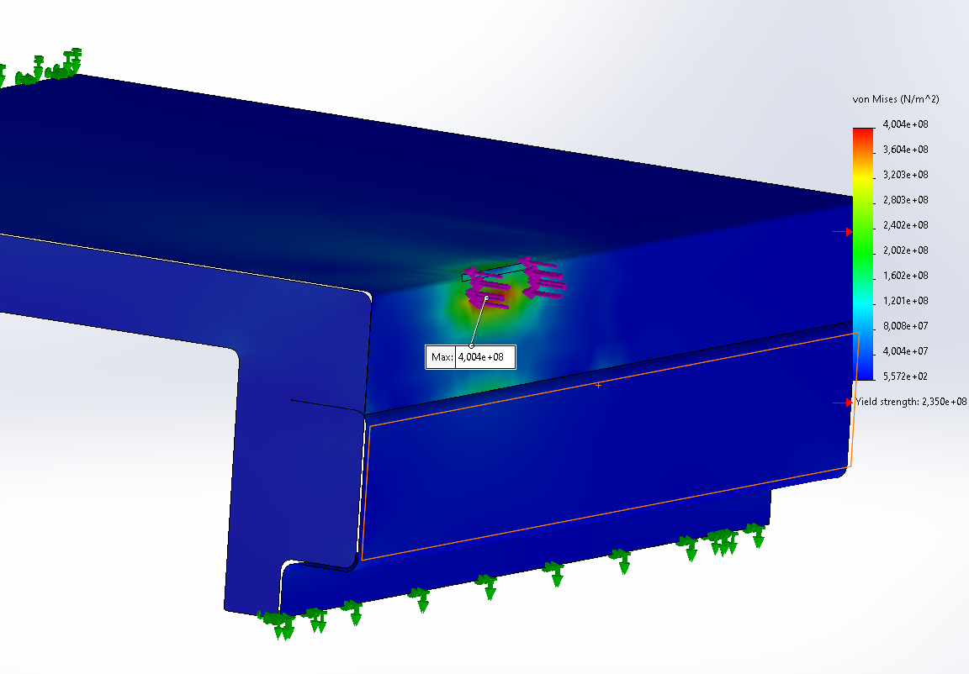
Figure 48; Roof weldment iteration 1: simplified, results
This design is not valid. An iteration is needed.

Iteration 2
It is not efficient to enlarge the plate thickness of the roof plate for this local high tension spot. In the second iteration the roof plate assumed to be a flat and welded to a thicker sheet metal at the boundary. This way the roof is thinner which is economically beneficial.

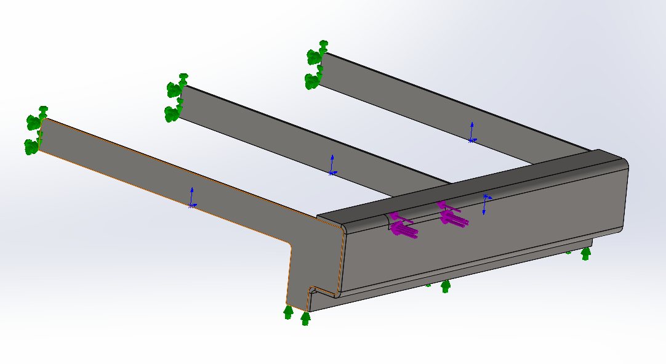
Figure 49; Roof weldment iteration 2: simplified
In the figure below it can be seen that the stresses are lower for the thicker plate. There are neglectable tension hotspots due to numerical iteration limitations. However, the stresses in the location of interest are not exceeding 141 MPa which is a high safety factor.
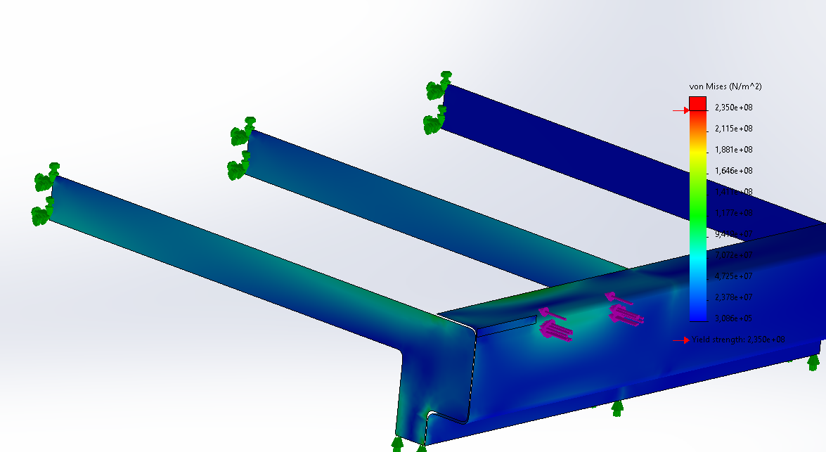
Figure 50;; Roof weldment iteration 2: simplified, results

Iteration 3
When the enclosure is lifted incorrectly the internal ribs have no effect on the system. Meaning the inward forces need to be translated to the corners where high stresses will occur.
Since there are no ways to place internal ribs near these internal forces the corner positions require enhancements. 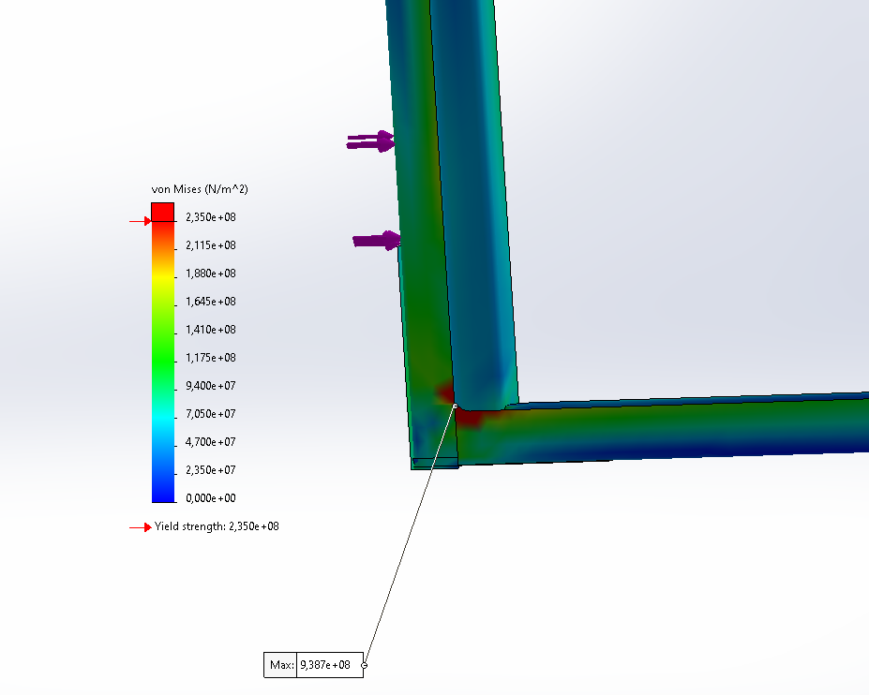

To translate the bending momentum the corner needs to be less sharp. Also the beams are to small. By increasing the length of the horizontal flange and adding an internal fillet the beams become strong enough. The plate requires to be 6mm thick
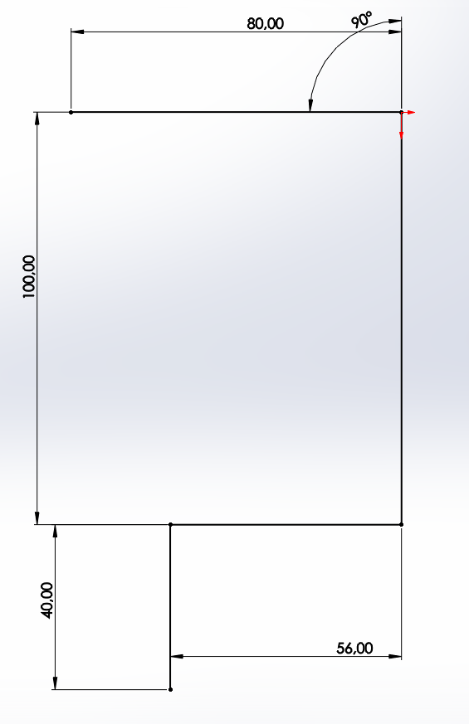  Figure 51; Roof weldment: iteration 3: Final design, roof profile | 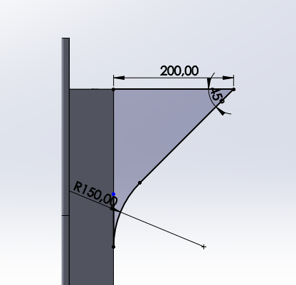  Figure 52;; Roof weldment: iteration 3: Final design, roof profile corner champher

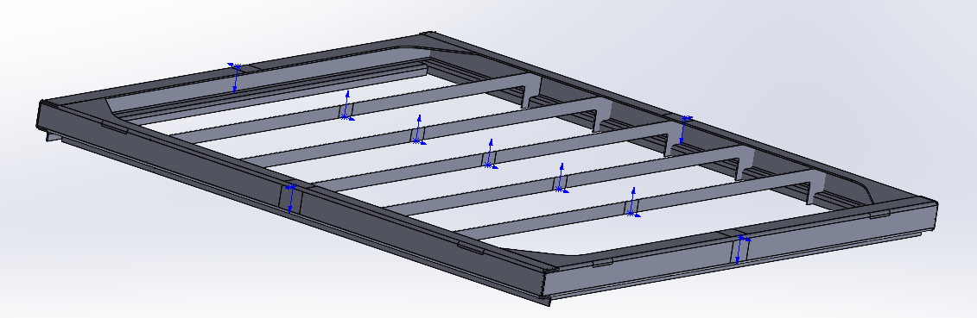
Figure 53; Roof weldment: iteration 3: Final design, layout

The model results in a tension hotspot at the weldment of the 2 plates. However the maximum stresses are reduced to 173 MPA. Which is allowed.
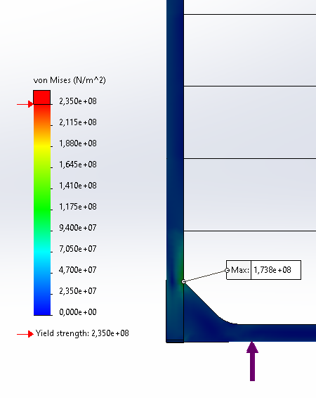  Figure 54; Roof weldment: iteration 3: Final design, results | 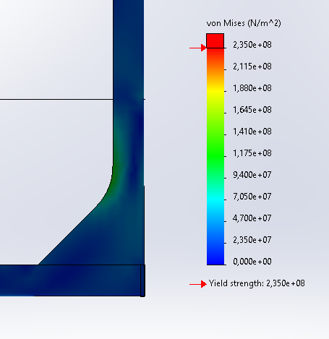

Sub conclusion.
When the model of iteration 2 is used with a plate thickness of 6mm for the horizontal sheet metal plate, the stresses are maintained within allowed levels when lifted correctly. The internal ribs for the roof construction can be minimized to 2 mm for attachment of components.
However when the enclosure is lifted incorrectly, on the short side of the enclosure where no internals ribs are connected the enclosure will fail. By increasing the length horizontal flange of the beam and inserting fillets in the corners this enclosure can be lifted in both ways.

Conclusion
To be written…

Appendix A
In this section the verification is done to minimize the the plate thickness by choosing a different design approuch.
When the design of the forklift pocket is changed such that the beam is located at the edge of the forklift the displacement of and thus the stresses of induced by the lift are lower in the beam. In the design below the beam is not welded on top of the forklift but is becomes part of the forklift with a welded top plate.
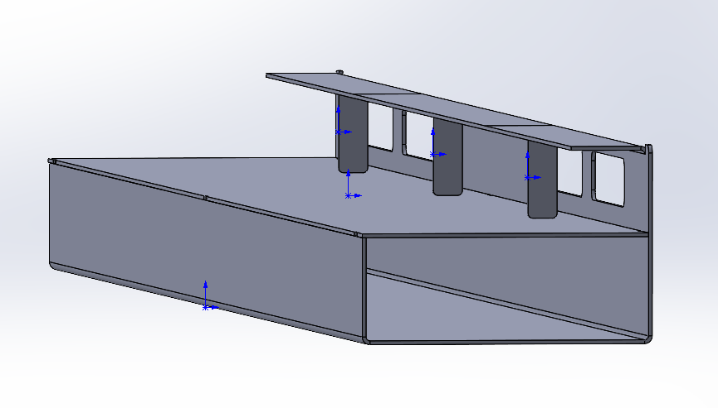  Figure 55; Forklift additional design | 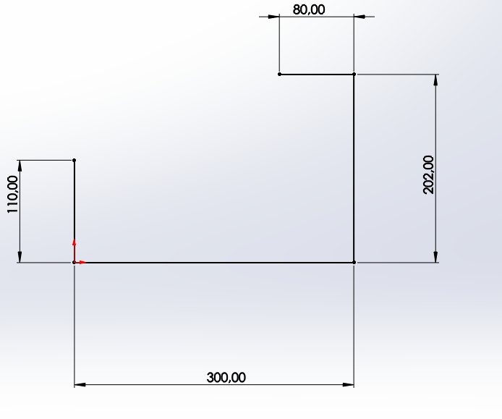

The plate in right figure above has a thickness of 6 mm.
This structure can withstand the load forces with the use of 3 support pillars.
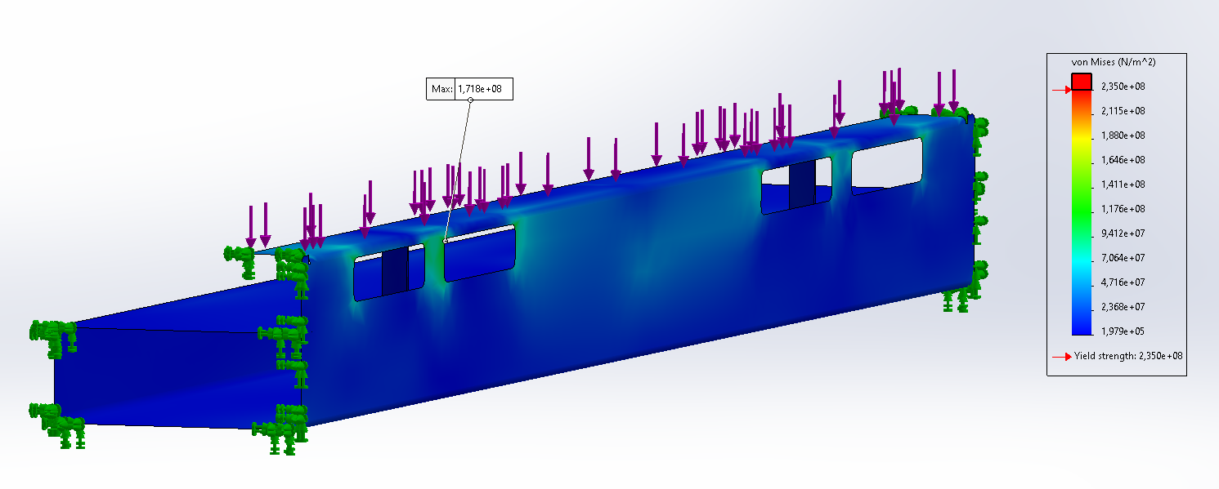
Figure 56; Forklift additional design, load, results
The structure can also withstand the forces of the combined lifting and load forces.
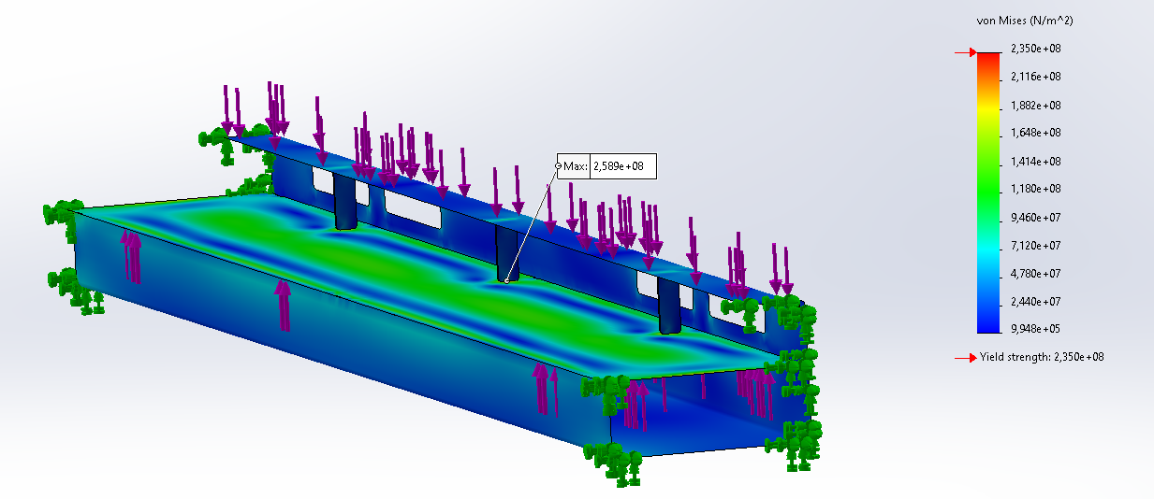
Figure 57;Forklift additional design, load+lift, results

The same effect is reached when the beam is not the same as sheetmetals part as the forklift, but is welded on top near the edge like the figure below
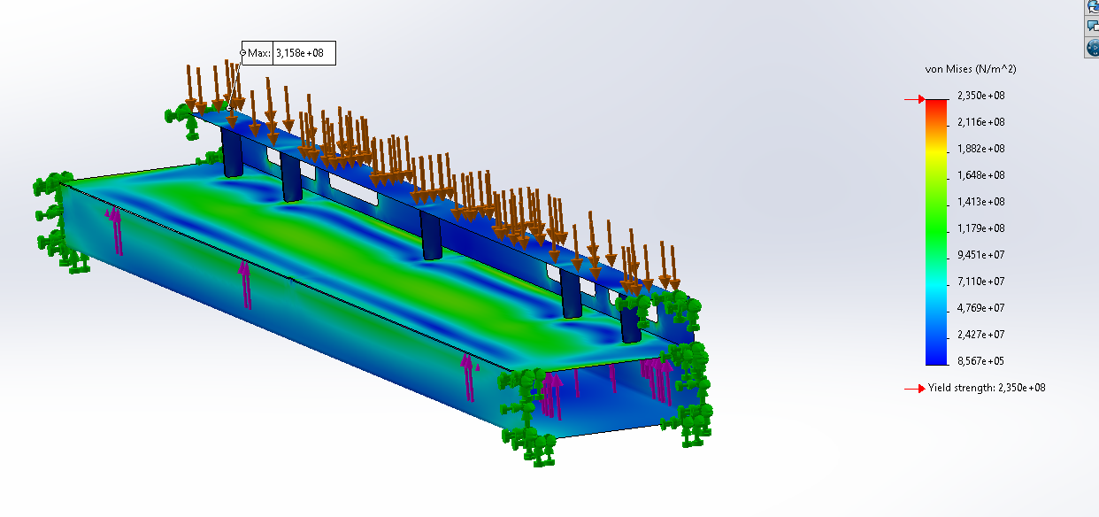
Figure 58;Forklift additional design, load+lift, results
However this design is not possible in the enclosure but shown a relations between this design and the stresses that may be used in a different project.

