Mechanical Stress Analysis- Power Module
-

Table of contents

1 Introduction 3
1.1. Purpose of this document 3
1.2. Standards 3
1.3. List of abbreviations 3
1.4. Software used 3
2 Situation 4
2.1 Mechanical structure 4

Introduction
This report covers the structural analysis for the Power module of a 520A inverter with filter system
Chapter 2, described the structure the goal and describes the components and there in the system
Finally, it is concluded that the design proposed can will not fail during the set conditions.

Purpose of this document
The purpose of the document is two sided. Mechanical stress analysis are used to determine required stiffness of structural components.. Secondly, this document will provide information of the structural stresses that occur to provide to supply a CE mark on the structure.

Standards
To include the required information in this report the following standards are conducted:
EN-1993-1-1:2010 | Eurocode 3: Steel structures:  Part 1-1: General rules for design and construction
EN-1993-1-3:2010 | Eurocode 3: Steel structures:  Part 1-3: Additional rules for cold formed members and sheet metal
EN-1993-1-5:2010 | Eurocode 3: Steel structures:  Part 1-5: Buckling of plate-type members
EN-1993-1-6:2010 | Eurocode 3: Steel structures:  Part 1-6: General - Strength and Stability of Shell Structures

List of abbreviations
COM Centre Of Mass

Software used
The software used to perform analysis is SolidWorks simulation premium

Situation
This chapter describes the mechanical structure of interest. And the components with there specifications. The mecha

Mechanical structure
The mechanical structure contains of sheet metal parts. Two sheets will form the main base. After placing the main components the top beams can be placed. After assembling the cover plates are placed for ventilation purposes. The cover plates are not taken into consideration for the structural strength thus remaining the following components:

PDM number | Description | Material | Thickness (mm)
P000009069 | Plate 003 | S235JR | 2
P000009074 | Plate 005 | S235JR | 5
P000009143 | Plate 008 | S235JR | 2
P000009144 | Plate 009 | S235JR | 2
P000009145 | Plate 010 | S235JR | 2
P000009146 | Plate 011 | S235JR | 2
P000009171 | Plate 019 | S235JR | 2
P000009282 | Plate 020 | S235JR | 2
P000009283 | Plate 021 | S235JR | 5
P000009396 | Plate 024 | S235JR | 2

Bolt holes
The components that are fixed by bolts can only translate forces through these holes. It is assumed that a bolted holes connection translates it forces over the surface of the washer for a m12 hole this is typically 24mm outer diameter. In the figure below the a typical hole is shown. The blue surface is the back of the plate and orange is the front of the plate. Vertical forces are translated by both sides of the plate. Forces pulling outward or inwards the plate are translated by the opposing plate surface.
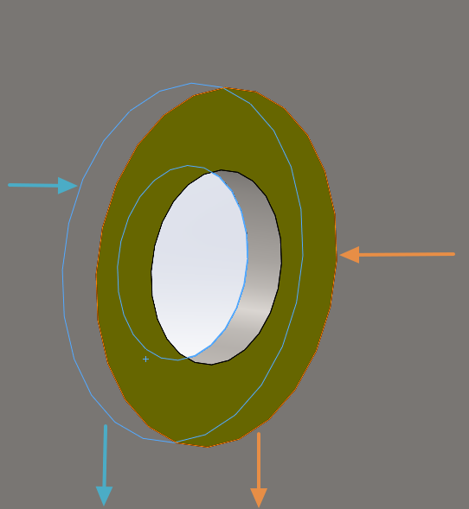

Figure 1; General assembly enclosure

Components
The module will contain multiple components that can be neglected for there stress impact. The following components do have a significant mass that need investigation into structural strength.
Component | Width (mm) | Depth (mm) | Height (mm) | Mass (kg) | Connection
Inverter | 246 | 373 | 677 | 55 | Back plate screwed
SiSo filter Gride side choke | 245 | 274 | 459 | 56 | Bottom studs
SiSo Filter Drive side choke | 222 | 450 | 634 | 199 | Bottom studs
Capacitor bank | 580 | 320 | 655 | 31 | Back plate screwed
Cooling fan | 390 | 115 | 300 | 12 | Flanged
MCCB + copper |  |  |  | 15
All round components |  |  |  | 75

Inverter
The inverter has a significant weight that is bolted onto the back plate. The back plate has 4 holes evenly spaced from the COM. The forces induced by mass of the inverter is shared by the 4 bolt connections. And according Section 2.2 by both sides of the plate. The moment induced by the distance of the COM to the plate is rewritten to the 4 holes. By the following equation:
$$F_{bolt in plane}=\frac{F_{g}*L_{a}}{L_{b}*N_{bolts}}=61,3 N$$
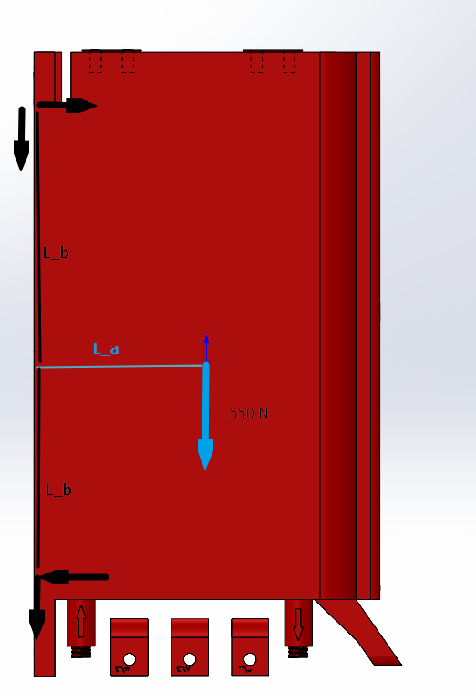

Loads in model
The components named above are described in the forces shown below. As can be seen force 21 is a force of 12KN this force is placed vertically upwards in the plane of the lifting lug. This 12kN describes the situation of 2 inverter frames connected.
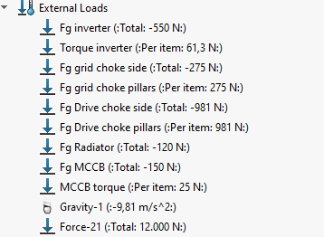

Analysis
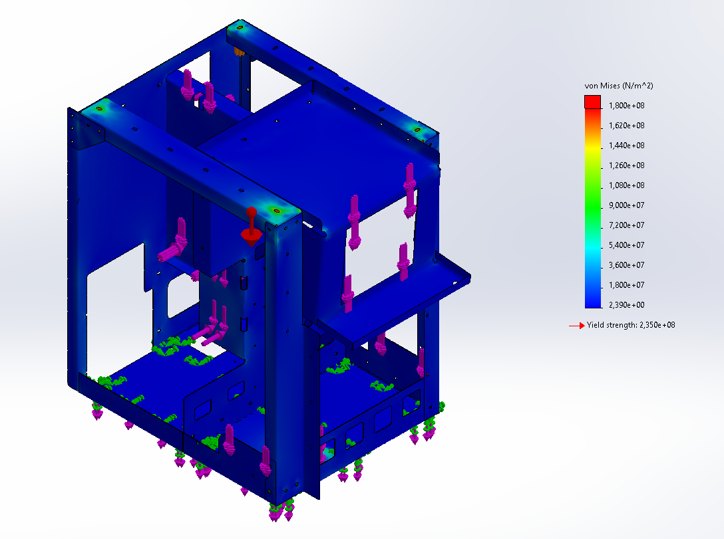
The result show that the structure does not exceed the limit of 180MPa and thus concluded to be save.

