Mechanical stress Analysis battery Rack
-

Table of contents

1 Introduction 3
1.1. Purpose of this document 3
1.2. Standards 3
1.3. List of abbreviations 3
1.4. Software used 3
2 Situation 4
2.1 Load case 4
2.2 Blind rivets 5
2.3 Model 5
3 Analysis 6
3.1 Hand calculations. 6
3.2 FEM Analysis. 7
4 Emergency stop 9

Introduction
This report covers the structural analysis for the battery rack of the e-PU10ft container series.
The files can be found here:
G:\03_Projects_Business_Dev\00056 e-PU10 V3\04_Engineering\05) Mechanical stress analysis\battery rack rail attachment

Purpose of this document
The purpose of the document is two sided. Mechanical stress analysis are used to determine required stiffness of structural components.. Secondly, this document will provide information of the structural stresses that occur to provide to supply a CE mark on the structure.

Standards
To include the required information in this report the following standards are conducted:
EN-1993-1-1:2010 | Eurocode 3: Steel structures:  Part 1-1: General rules for design and construction
EN-1993-1-3:2010 | Eurocode 3: Steel structures:  Part 1-3: Additional rules for cold formed members and sheet metal
EN-1993-1-5:2010 | Eurocode 3: Steel structures:  Part 1-5: Buckling of plate-type members
EN-1993-1-6:2010 | Eurocode 3: Steel structures:  Part 1-6: General - Strength and Stability of Shell Structures

List of abbreviations
COM Centre Of Mass

Software used
The software used to perform analysis is SolidWorks simulation premium

Situation
(PICTURE)
The mechanical structure of interest is a single sheet metal plate which supports half of the battery module. The properties are shown below
PDM number | Description | Material | Mass (kg) | Thickness (mm)
ES00003830 | ENERONE+ M1 SHORT MODULE, LiFePo4, 306Ah, 0.5C, 1P52S | N.A. | 327.5 | N.A.
P000009753 | Battery rack Rail | S355MC | 4 | 4
P000009753M | Battery rack Rail | S355MC | 4 | 4

Load case
When the enclosure is placed on the ground with a velocity of 10 m/s the impact force of the battery module to the mechanical structure is 2.2G. resulting in a equivalent static load of 3.534N

The second case an emergency stop will be simulated with 7m/s² resulting in a force forward based on the battery module weight. The force is the forward acceleration and the mass.
$$F_{forward}=\frac{Accelation}{G}*mass=1146N$$

Blind rivets
The battery module rest on the battery rack rails, the mass off the modules needs to be translated to the battery frame. The connection between the rails and the frame are made by blind rivets. The Rivets used are the Fabory 34350.064.020. with the following properties:
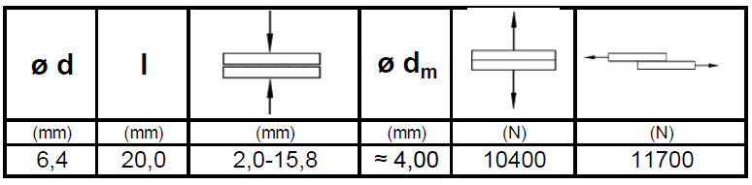
Additionally the rivets has a head diameter of 12.7mm

Model
The equivalent weight is placed on the support rail on contact squares. As shown below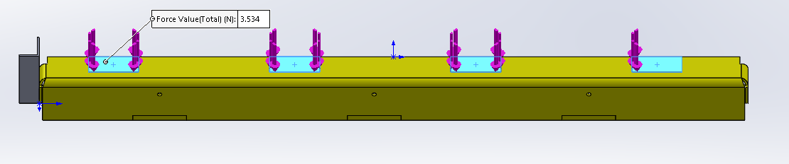

The rivets are modelled by 2 fixations: a radial fixation in the hole of the plate which models the shaft of the rivet. Secondly, a roller fixation that models the clamping of the rivet head.
When the weight of the module pushes on the rial it will rotate such that the vertical pillar will have to create reaction force.
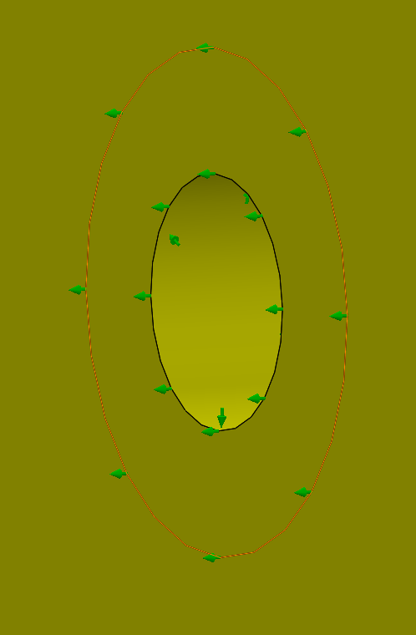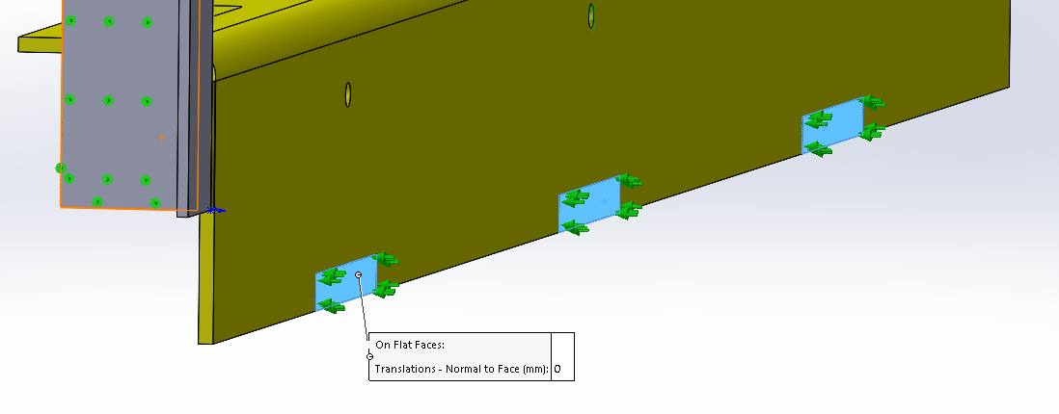

Analysis

Hand calculations.
The rivets are affected by two forces: A shear force directly related to the equivalent of the battery module and the rail. Which is 3534N, divided over 3 rivets. Resulting in 3.2 kN per rivet which is below 11kN. For a single rivet.
The shear forces also need to translate through the steel plate, which are limited by the tensile strength. The minimum required amount of holes in the plate is:
$$n_{holes}=\frac{F_{load}}{σ_{plate}*A_{halfhole}}=0.3$$
Each Battery rack rails are riveted to the frame by 3 rivets. Which is more than required.

Since the force is 40 mm linear of the attachment and the rivet is placed 64 mm above the rotation point. The rivets will have to withstand a combined 0.7 kN pulling force according:
$$F_{Rivet}=F_{load}*\frac{40}{\begin{aligned}64*n_{rivet} \\ \end{aligned}}$$

Since a single rivet can withstand 11kN this is a save margin.
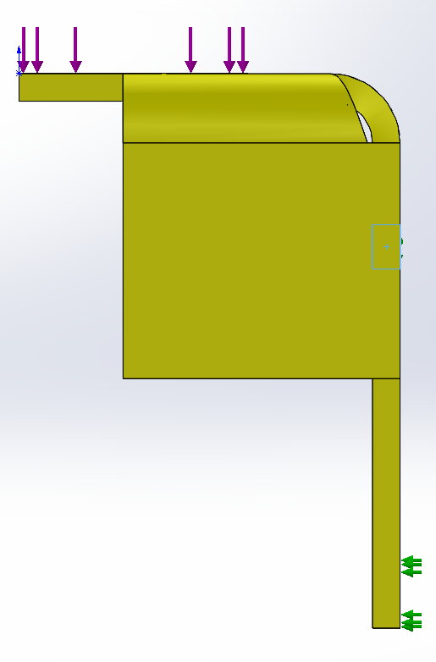

FEM Analysis.
The result of the analysis is shown below, the maximum force occurs above the rivet due to the moment forces. However the maximum stress is below 335 MPa thus, will not fail.
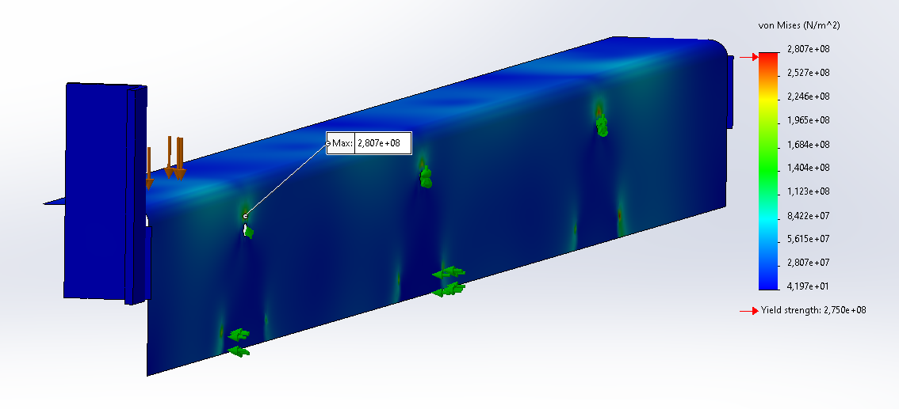

Emergency stop
The load induced due to the emergency stop gives a forward force of the module s shown below
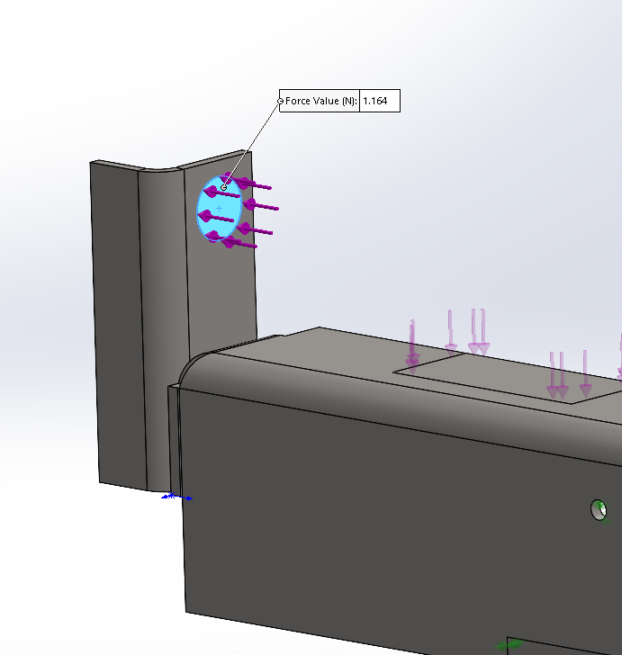
The results are shown below: The stresses maintain below a 275MPa which is enough to conclude the simulation.
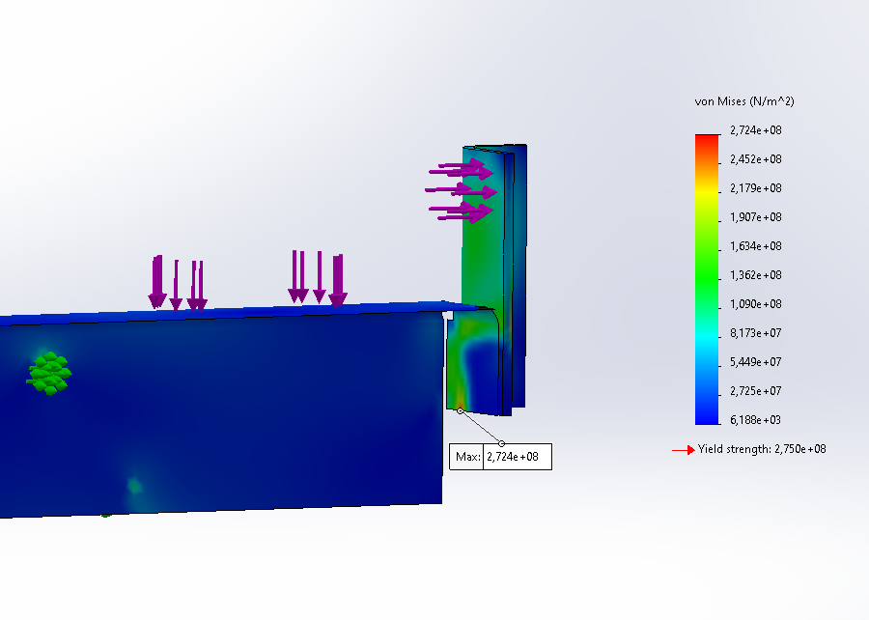

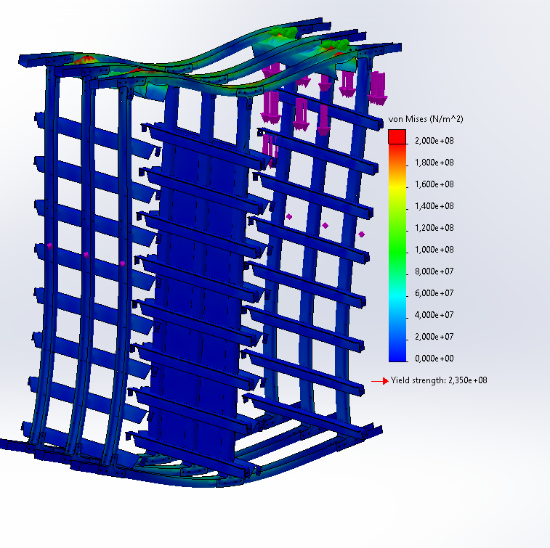
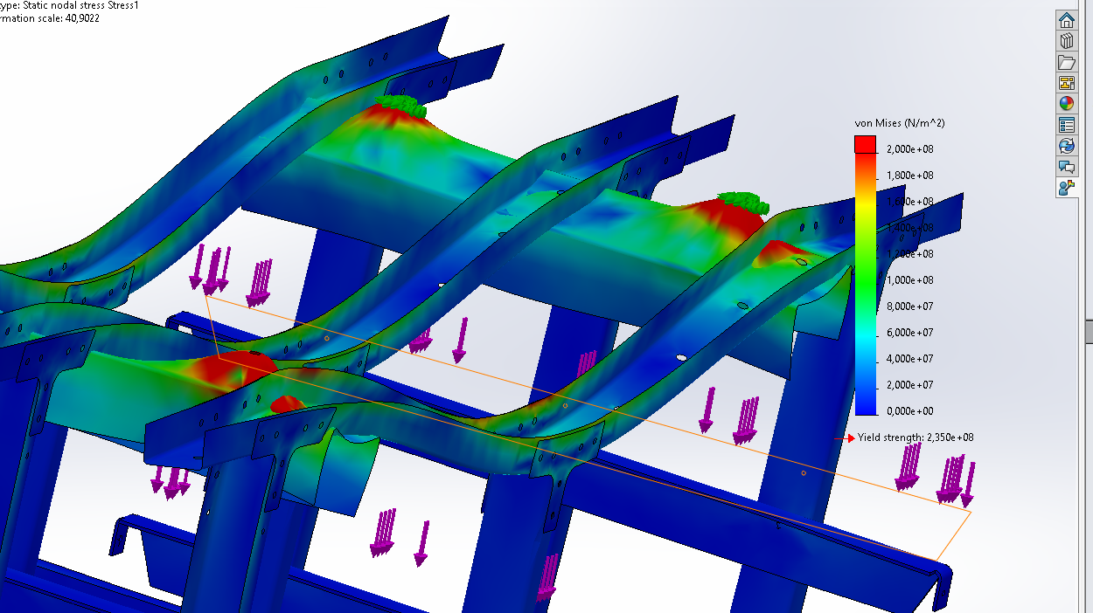

Optimization in the upper beams where lifting occurs
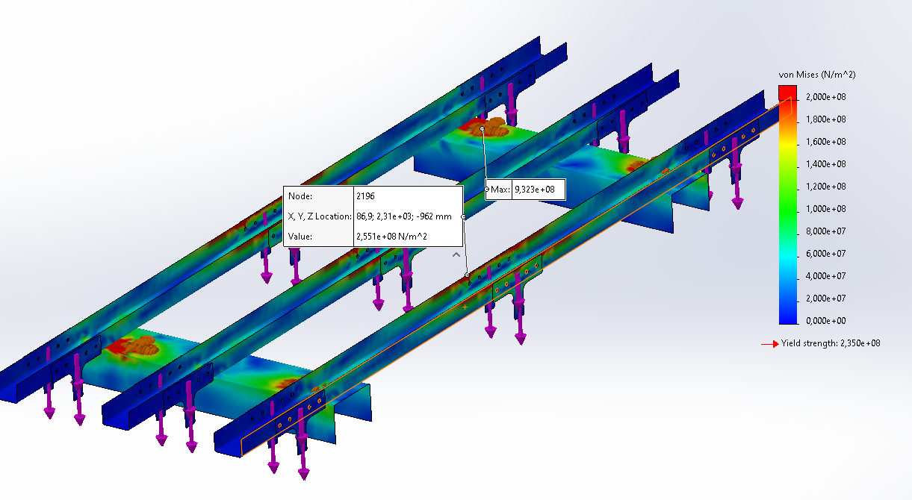
The C-beams at the top changed to square tubes 80x80x6 mm thickness. The lifting point is moved to 1/3 of the length of the beam, directly above the battery modules. The material is S355. Lifting is done by RUD VWBG-V 3.5 M24 lifting hooks. This yields the following result:
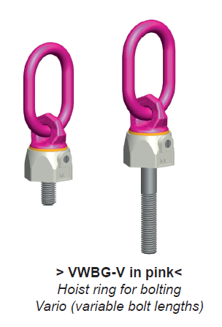
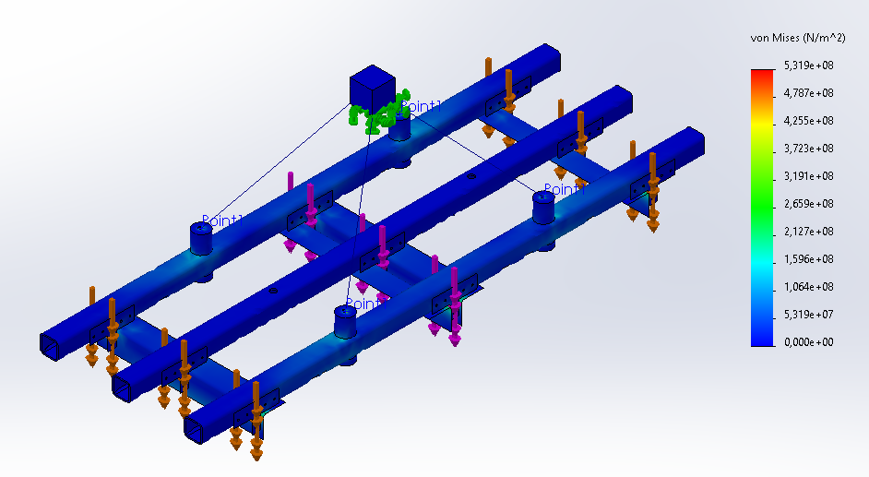

Maximum stress is 156 MPa at the square tube around the lifting eyelet.
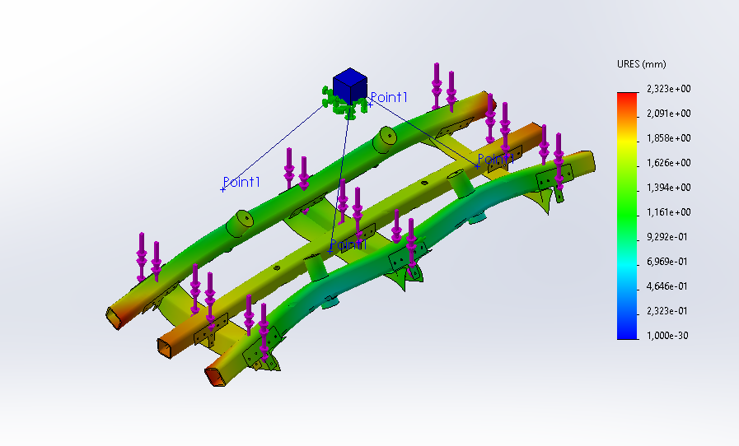

Bolt sizing
Bolts were sized based on estimation/practicality and checked for strength afterwards.
During hoisting highest stress bolts are located at the top of the frame, in the middle. The middle of the frame takes ½ of the weight, which is then transferred though 3 poles evenly. The weight is taken by 2x M12 and 1x M16 bolts.
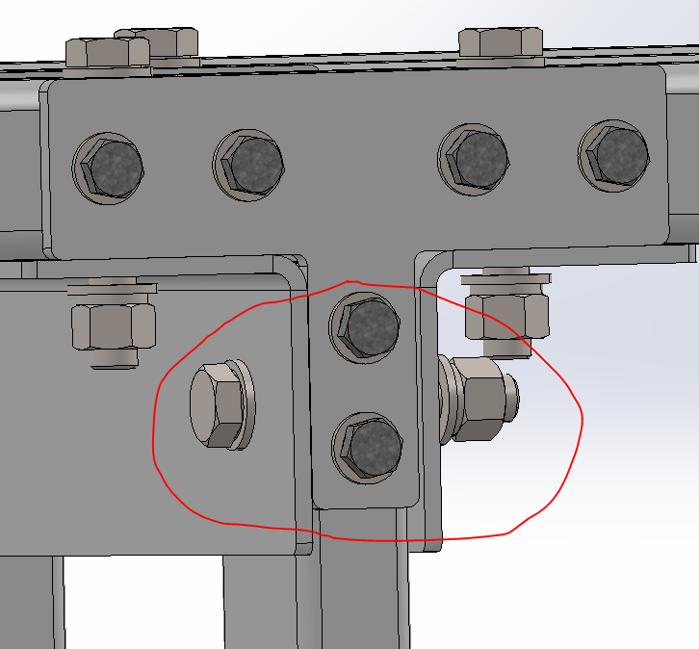
Force = 60kN / 2 / 3 = 10kN

Clamping force
Clamping force of torqued bolts M12 = 32kN, M16 = 60kN. (https://www.werktuigbouw.nl/sub9.htm)
Friction coefficient galvanized steel = 0.2
F friction max = 60kN * 0.2 + 2* 32kN *0.2 = 24,8 kN -> safety factor of 2.48, Ok.
Bolt shear
It is calculated if the bolted assembly stays intact when not correctly torqued.
Max shear M12=17kN, m16=24kN.
17*2+ 24 = 58kN safety factor 5.8, Ok.
Stuikspanning
Max stuikspanning is assumed to be equal to yield strength. Plate thickness is 5mm.
Max Stuik of 1x M16 bolt = 1/2Pi * 16 * 5 = 125,5 mm2 * 355N/mm2 = 44.5kN safety factor of 4.45, even on 1 bolt only, there are three. OK.

